WGA5

Laravel 5.6

Install Laravel 3

Setup Virtual Host 3

Database 4

Laravels Auth Shortcut 4

**Tab Title** 5

Tab Titles using Sections 6

Pages Controller for Welcome and Blog List 7

Setup Git 8

Comment Out Vue Const App 8

Install Font-Awesome 8

Set Time Zone 9

Set Mailtrap 9

Production 9

# Install Laravel

Run **$cd** **C:\Users\pikej\Desktop** then **$composer create-project --prefer-dist laravel/laravel wga5**.

Run **$npm install** to install Bootstrap 4 and Vue etc.

# Setup Virtual Host

For the virtual host to work, it cannot be stored in www directory.

Inside *Wamp* go to *Your VirtualHosts* > *VirtualHost Management* and enter:

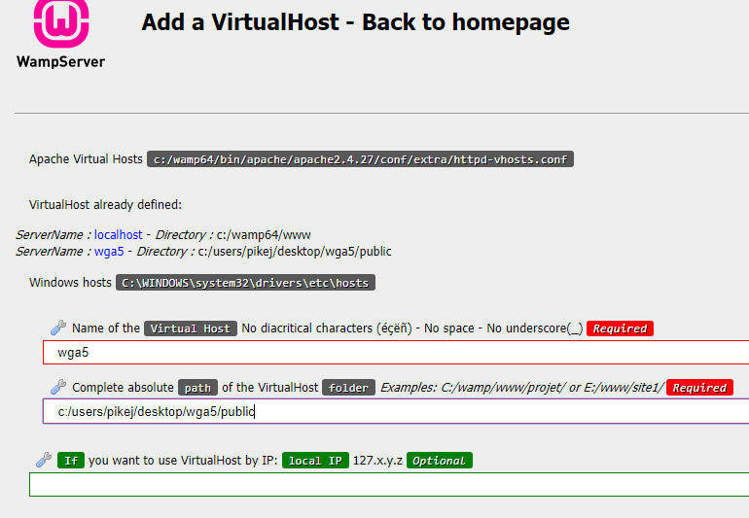

Restart DNS (right click on Wamp icon).

Go to wga5 in browser to access the new site.

# Database

Create a new database with the same name.

Inside .env enter this:

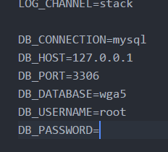

# Laravels Auth Shortcut

Run **$php artisan make:auth.**

Before running **$php artisan migrate** for the database tables to be setup, inside*app > Providers > AppServiceProvider.php* to prevent the ‘key too long’ error enter this:

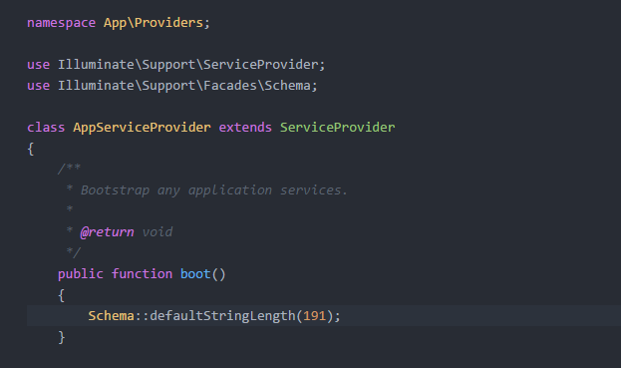

After running **$php artisan make:auth**,

**Tab Title**

Inside .env change APP_NAME to WGA5

Inside the head title enter:

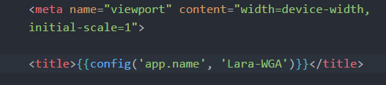

Inside config > app.php enter:

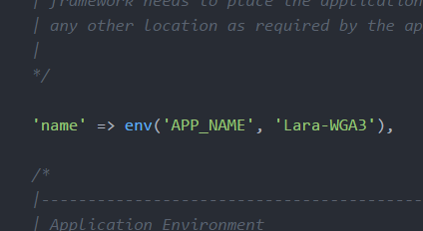

# Tab Titles using Sections

Inside layouts > blog.blade.php enter this code in the title tags:

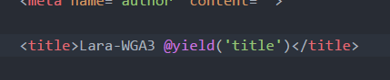

Inside views > blog.blade.php enter this code for the page title:

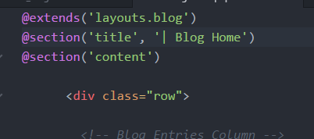

Inside config > app.php copy the form and html aliases from LaravelCollective.com:

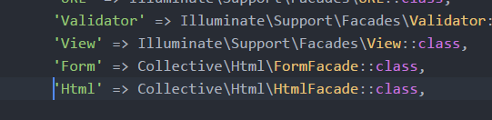

# Pages Controller for Welcome and Blog List

Inside views create a new folder named pages, inside that create a new file named blog.blade.php and move welcome.blade.php into the new folder also.

Copy the StartBootstrap Blog into views > pages > blog.blade.php.

Run **$php artisan make:controller PagesController**.

Inside PagesController enter:

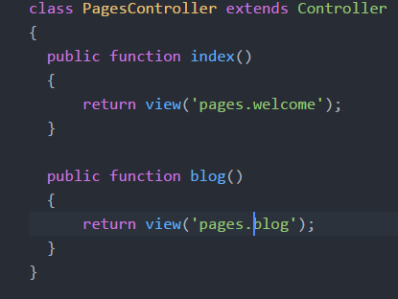

Inside routes > web.php enter:

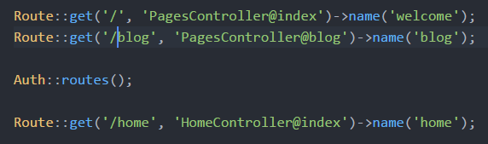

Run **$php artisan make:controller PostController --resource**

# Setup Git

Run **$cd C:\Users\pikej\Desktop\wga5.**

**$Git init.**

Inside Github create new repository.

Copy **git remote add origin** [**https://github.com/james20381/WGA5.git**](https://github.com/james20381/WGA5.git)into cmd.

**$git add .**

**$git commit –m “Initial Commit – Laravel Install”**

**$git push –u origin master.**

## Push the New Edits to Github

**$git add .**

**$git commit –m “”**

**$git push.**

# Comment Out Vue Const App

Inside resources > assets > js > app.js comment out ‘Vue const app’.

# Install Font-Awesome

**$npm install font-awesome –save**

Inside resources > assets > sass > app.scss enter:

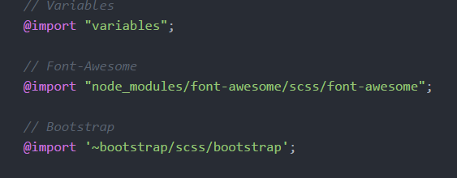

Run **$npm run dev.**

# Set Time Zone

Inside config > app.php enter:

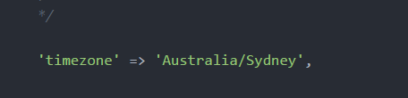

# Set Mailtrap

Go to mailtrap.io, sign up using Github login option and click on ‘demo inbox’. Copy and paste the smtp credentials – username, password and port into .env.

Set a default email sending address.

# Setup Gmail (America)

Inside .env enter:

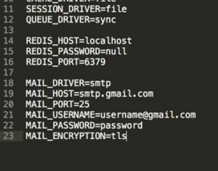

In your Gmail account turn on ‘Let less secure apps use your account’.

<https://support.google.com/accounts/answer/6010255?hl=en>

# Production

To minify run **$npm run production.**

# Troubleshooting Laravel

Run **$composer dump-autoload** to clear Laravel cache.

# To Do

Setup Forgot Password.