WGA6

One Page Scroll Front with Blog and CMS Admin Panel

* Laravel 5.6
* Bootstrap 4

Install Laravel 3

Configure PHP to be Accessed by the CMD 3

Setup Virtual Host 3

Set App Environment 4

App Name 4

Database 4

Mailtrap 4

Set App Configs 5

Time Zone 5

App Name 5

Npm Install Dependencies or DevDependencies 5

Install Laravel’s DevDependencies 6

Install Font-Awesome 6

Laravels Auth Shortcut 6

Tab Title 7

Tab Titles using Sections 7

Push the New Edits to Github 8

Re-organise the Auth Files 8

Install and Setup Laratrust 10

Create the Models 11

Troubleshooting and Laravel How To’s 13

CMD 13

Error In Cmd When Trying To Install Font-Awesome: 13

Clear the Npm Cache: 14

Vue 14

The Asset Helper 15

The Route Helper 15

Clearing Cache’s 15

Laravel config cache: 15

Npm Cache: 15

Reload Laravel: 15

# Install Laravel

CMD opens up in C:\Users\pikej>

Run **$composer global require "laravel/installer"**

Run **$cd C:\wamp64\www**

Run **$laravel new wga6**

# Configure PHP to be Accessed by the CMD

Inside Wamp select PHP Version 7.1.9

Copy the php.exe location (C:\wamp64\bin\php\php7.1.9) into Windows Environment Variables found at Control Panel, System, Advanced, Environment Variables, System, Edit.

# Setup Virtual Host

For the virtual host to work, it cannot be stored in www directory. Also, it will only work in Chrome.

Inside Wamp go to Your VirtualHosts > VirtualHost Management and enter:

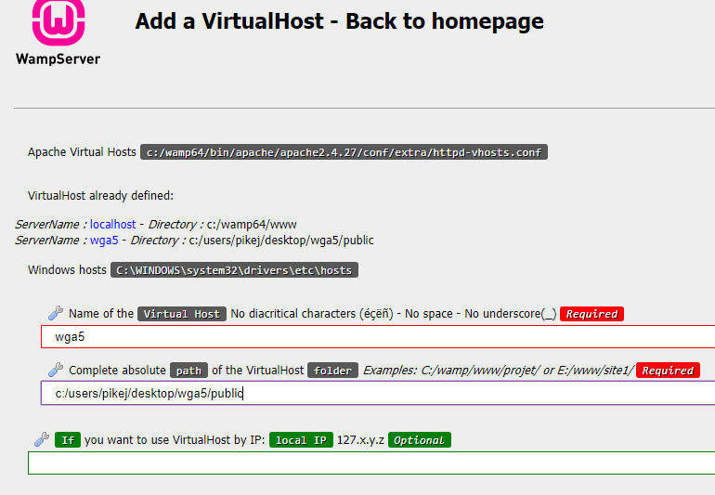

Restart DNS (right click on Wamp icon).

Go to wga6 in browser to access the new site.

# Set App Environment

## App Name

Inside .env set APP_NAME to WGA6

## Database

In phpMyAdmin create a new database with the same name - wga6.

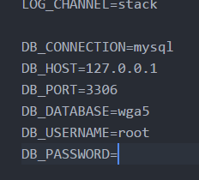Inside .env enter this:

## Mailtrap

Go to mailtrap.io, sign up using Github login option and click on Demo Inbox. Copy and paste the smtp credentials – username, password and port into .env.

# Set App Configs

Inside config > app.php enter:

## Time Zone

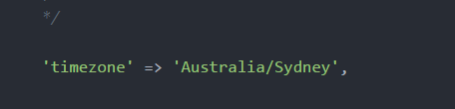

## App Name



# Npm Install Dependencies or DevDependencies

Dependencies are required for the application during runtime. (When the site is live).

E.g:

**$npm install - -save**

**$npm install - -save font-awesome**

Dev Dependencies are required for the application during development.

E.g:

**$npm install --save-dev**

"devDependencies": {

"axios": "^0.18",

"bootstrap": "^4.0.0",

"popper.js": "^1.12",

"cross-env": "^5.1",

"jquery": "^3.2",

"laravel-mix": "^2.0",

"lodash": "^4.17.4",

"vue": "^2.5.7"

}

# Install Laravel’s DevDependencies

Inside project root run **$npm install**

# Install Font-Awesome

<https://www.npmjs.com/package/font-awesome/tutorial>

Inside project root run **$npm install - -save font-awesome**

# Laravels Auth Shortcut

Run **$php artisan make:auth.**

# Tab Title

Inside .env change APP_NAME to WGA5

Inside the front page head title enter:

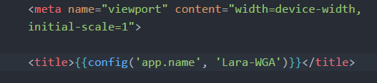

# Tab Titles using Sections

Inside layouts > blog.blade.php enter this code in the title tags:

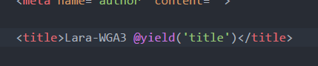

Inside views > blog.blade.php enter this code for the page title:

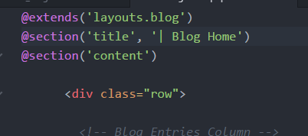

**Setup Git**

Run **$cd C:\Users\pikej\Desktop\wga6**

**$Git init.**

Inside Github create new repository.

Copy **git remote add origin** [**https://github.com/james20381/WGA6.git**](https://github.com/james20381/WGA6.git)into cmd.

**$git add .**

**$git commit –m “Initial Commit – Laravel Install”**

**$git push –u origin master.**

## Push the New Edits to Github

**$git add .**

**$git commit –m “”**

**$git push.**

# Re-organise the Auth Files

Inside views rename home.blade.php to dashboard.blade.php and move it into the views > auth folder.

Rename the HomeController to AuthController along with the class. Rename the public function to auth.dashboard.

Rename the HomeController@index route to AuthController@index. Rename the route url to /dashboard and name to dashboard also.

Rename all the /home links inside LoginController, RegisterController and ResetPasswordController to /dashboard.

Rename layouts > app.blade.php to auth.blade.php.

Rename all the @extends inside views > auth > dashboard.blade.php, login.blade.php, register.blade.php along with passwords > email.blade.php and reset.blade.php to layouts.auth

Before running **$php artisan migrate** for the database tables to be setup, insideapp > Providers > AppServiceProvider.php to prevent the ‘key too long’ error enter this:

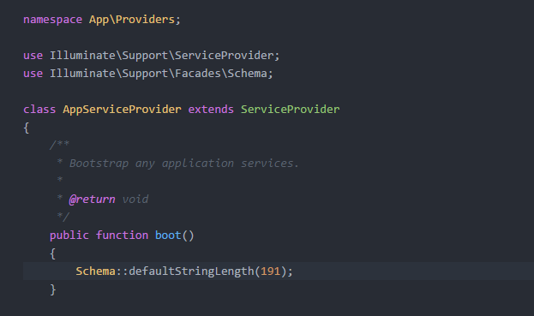

Git Push from here - Wednesday 28th Feb

# Install and Setup Laratrust

**$composer require "santigarcor/laratrust:5.0.*"** – require will add it to the composer.json file instead of just locally for one time only.

Inside config > app.php add the following to the providers array:

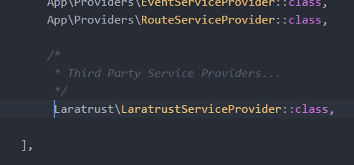

In the same config > app.php add the following to the aliases array:

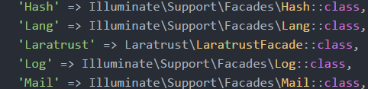

Publish all the configuration files:

**$php artisan vendor:publish --tag="laratrust"**

The middleware are registered automatically as role, permission and ability . If you want to change or customize them, go to your config/laratrust.php and set the middleware.register value to false and add the following to the routeMiddleware array in app/Http/Kernel.php:

'role' **=>** \Laratrust\Middleware\LaratrustRole::class,

'permission' **=>** \Laratrust\Middleware\LaratrustPermission::class,

'ability' **=>** \Laratrust\Middleware\LaratrustAbility::class,

**Don’t know whether to set it to false or not, so I just left it as ‘true’.**

Inside app > Http > Kernel.php add role, permission and ability to the routeMiddleware array:

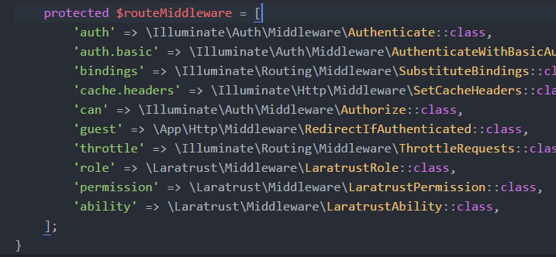

Run **$php artisan laratrust:migration** to generate the Laratrust migration.

Run **$php artisan migrate**

## Create the Models

Run **$php artisan make:model Role**

Run **$php artisan make:model Permission**

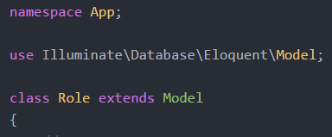Inside the Role model update ‘use’ and ‘class’ from this:

To this:

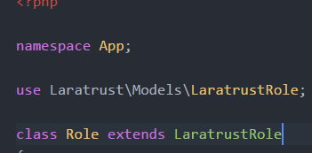

Do the same for Permission model:

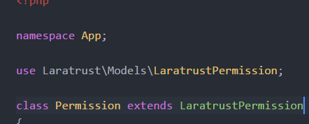

Inside the User model add the Laratrust traits:

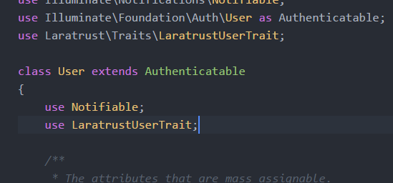

Run **$composer dump-autoload** to refresh the models.

## Seed the Database

Run **$php artisan laratrust:seeder**

Inside database > seeds > DatabaseSeeder.php enter this to call it from the database seeder:

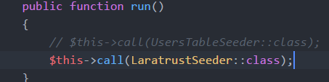

Inside laratrust_seeder.php delete the permission structure content:

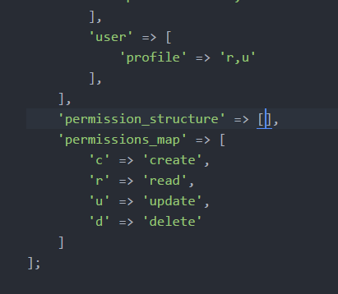

These are DevMarketer permissions:

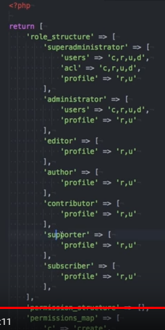

I’m just going to use Laratrust default permissions:

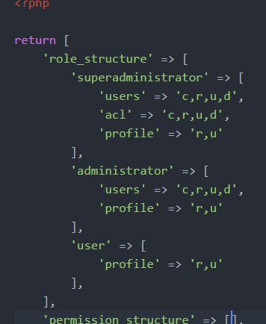

Run **$composer dump-autoload.**

Run **$php artisan db:seed.**

By default there are 3 registered users, they log in with their email and the password is password:

[superadministrator@app.com](mailto:superadministrator@app.com) – password

[administrator@app.com](mailto:administrator@app.com) – password

[user@app.com](mailto:user@app.com) - password

# Troubleshooting and Laravel How To’s

## CMD

### Error In Cmd When Trying To Install Font-Awesome:

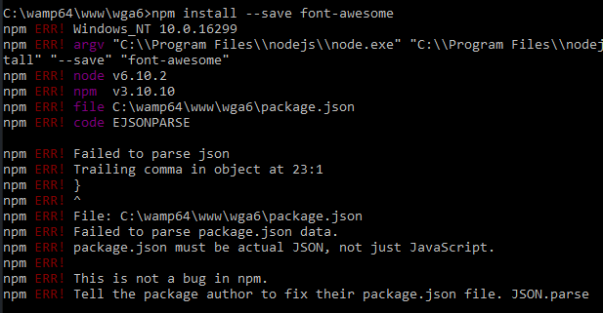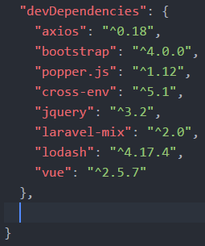

The error is in:

It is on line 23.1 and it’s a trailing comma:

### 

### Clear the Npm Cache:

**$npm cache clean**

## Vue

Vue components can only be used inside of a Vue object.

Inside resources > assets > js > app.js enter:

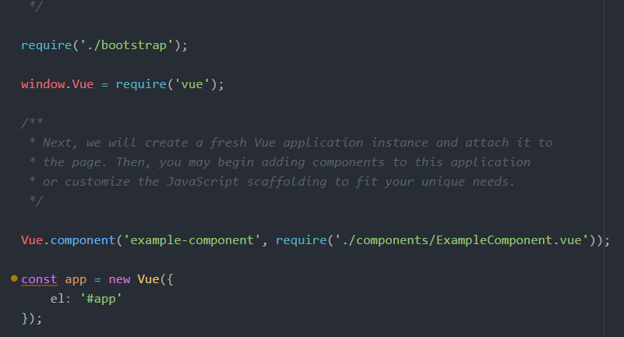

Then place the id around where ever there’s a Vue component.

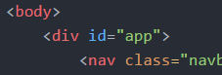

## The Asset Helper

The asset helper targets anything inside of the public folder:

\



## The Route Helper

The route function generates a URL for the given named route:



## Clearing Cache’s

### Laravel config cache:

$php artisan config:clear

### Npm Cache:

$npm cache clean

### Reload Laravel:

$composer dump-autoload