Flatsome

**flatsome-3.7.1.zip** installed into its own WP install in Local by Flywheel

**Envato Market**

**Purchase Flatsome 🡪 Download**

**PC Downloads**

themeforest-5484319-flatsome-multipurpose-responsive-woocommerce-theme.zip:

* **Extract All**

themeforest-5484319-flatsome-multipurpose-responsive-woocommerce-theme

flatsome-main

**WP Admin 🡪 Upload Theme (flatsome-3.7.1.zip)**

1. Activate Flatsome with purchase number
2. Update WP and Flatsome
3. Install recommended plugins
4. Install demo content
5. New Page – James 1 – Page comes with WooCommerce dummy content, add it to the main nav
6. Create git repository for flatsome, backing up flatsome and WP, git init in flatsome root.
7. Update WP to version 5.2

Flatsome Copy

* In Local by Flywheel, created a New Site (WP) ‘flatsome-copy’

Shows the 2019 WP site, but not correctly (I don’t think?)

* Switch themes to 2017
* Upload, Install and activate flatsome-3.7.1.zip
  + Skip – Install recommended plugins
  + Skip – Demo content
* New Page – Jimmy 1 – No WooCommerce content because we didn’t install WooCommerce at Startup:

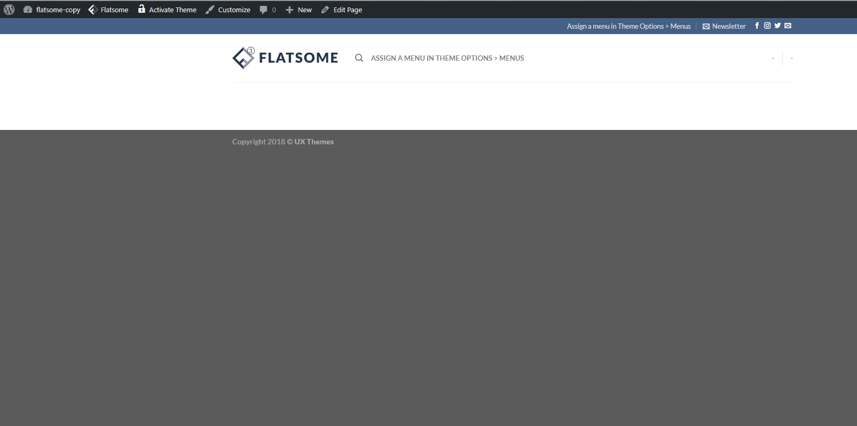

* Create git repository for flatsome-copy, backing up flatsome and WP, git init in flatsome-copy root.
* Update WP to version 5.2