WGA2

Static Site Using Bootstrap 4 and a Gulp Workflow

<http://www.wga2.com.s3-website-ap-southeast-2.amazonaws.com/>

Install Bootstrap 4 Sass, Gulp, DevDependencies and Create Folder Structure 3

Setup the gulpfile 4

Deploy to Heroku 4

Add Auto-Prefixer 5

Add Sourcemaps 5

# Install Bootstrap 4 Sass, Gulp, DevDependencies and Create Folder Structure

In Desktop create a folder named wga2

$cd into wga2 and run $npm init

Change the main entry js to “app.js”

In wga2 run $npm install bootstrap - -save

In wga2 run $npm install gulp gulp-sass gulp-clean-css gulp-autoprefixer gulp-sourcemaps gulp-html-minifier gulp-rename --save-dev (run $npm init again if the saves don’t work) (browser-sync isn’t accepting styles, so forget it)

In wga2 root create a folder named src, inside src create a folder named scss

In node_modules > bootstrap > scss copy bootstrap.scss and paste it into src > scss and rename it main.scss

Add the new path to all the scss files, comment them all out and uncomment the ones required

In src add a file named index.html with doctype and an h1, just so we can see if gulp works we’ll have content in the browser. Add the link to the main.min.css

In main.scss add a style for the h1

# Setup the gulpfile

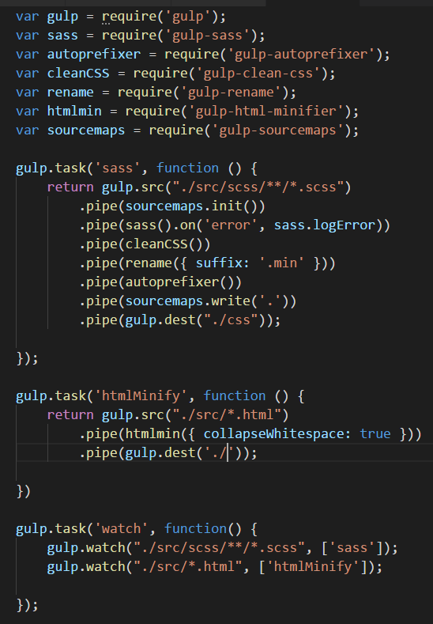

# Setup Git

Add a .gitignore file with cancelling out node_modules and the text files.

Run $git init, $git add ., and $git commit –m “Initial commit of wga2”

# Deploy to Heroku

Inside Heroku > Dashboard click on New App, follow the prompts using cmd. Before pushing to Heroku, in the root add an empty composer.json file and a Procfile (with a capitol P), add an index.php file to the dist folder and change the index.html to home.html.

In wga2 root add a .gitignore file with:

In the index.php file enter: <?php include_once("home.html"); ?>

In the composer.json file enter: {}

In the Procfile enter: web: vendor/bin/heroku-php-apache2 public/

Add js concat, js minify and js babel