Developer Guide for Command-line Kanban System
Version 1.0

Prepared by Caleb TONG (1155176563),
Ho Lun Roland TSANG (1155194057),
Ming Hon Rodney HUI (1155213464),
Tung Chun LAM (1155211513)

Group 21, Software Engineering (CSCI3100), The Chinese University of Hong Kong

28/11/2025

Table of Contents
Introduction 2
Purpose 2
Developing Convensions 2
Overview of the Design 2
Plan Overview 2
Source Control and Installations 3
UML Usecase diagram 3
UML Component Diagram 3
UML Class Diagram 4
Database Layer Design 4
Developing Detail 5

Introduction

Purpose

This developer guide shows an overview of designing a Command-line Kanban system, which is a convenient system for users to manage their tasks. Key functions of the system include Visual Task Management, User Role Management and Notifications. In the following, important guides for developers will be mentioned, including developing timeline, structure and detail of the system.

Developing Convensions

Programming Language | Python 3
Python Libraries | CLI: pathlib.Path  DataStructures: datetime.datetime as dt  Database: sqlite3, pathlib.Path, bcrypt  KanbanInfoDatabase: sqlite3, pathlib.Path
Coding | UTF-8
Developing Environment | Linux terminal
Naming Convensions | CamelCase should be used, without using underscores
ID Convensions | Starting from 1
SQL Convensions | Table name should be capitalized, such as table USER  Field name should be in proper case, such as First name

Overview of the Design

Plan Overview

The Kanban system will be developed by using Agile methodologies.

Phase 1 | Phase 2 | Phase 3 | Phase 4
Requirement Analysis | Design | Implementation | Testing

Source Control and Installations

All source codes and documentations will be shared on GitHub.

Project structure: Command-line Kanban System/
|-- Kanban.py
|-- DataStructure.py
|--

Access Link: https://github.com/RodneyHui/CSCI3100_Gp21

UML Usecase diagram

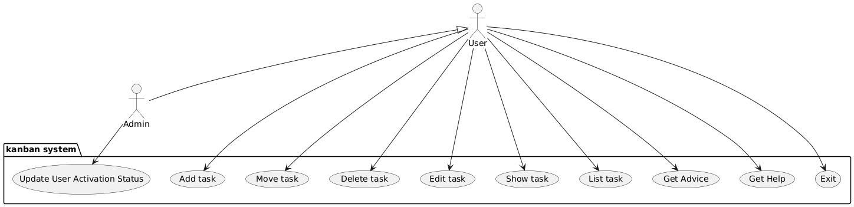

UML Component Diagram

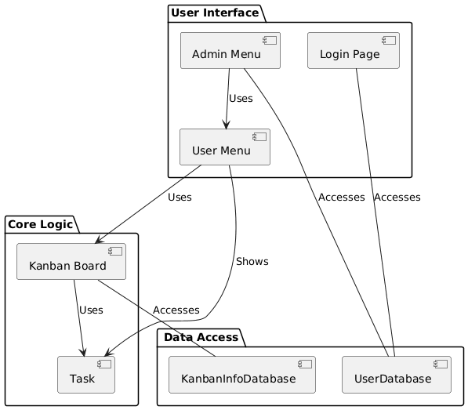

UML Class Diagram

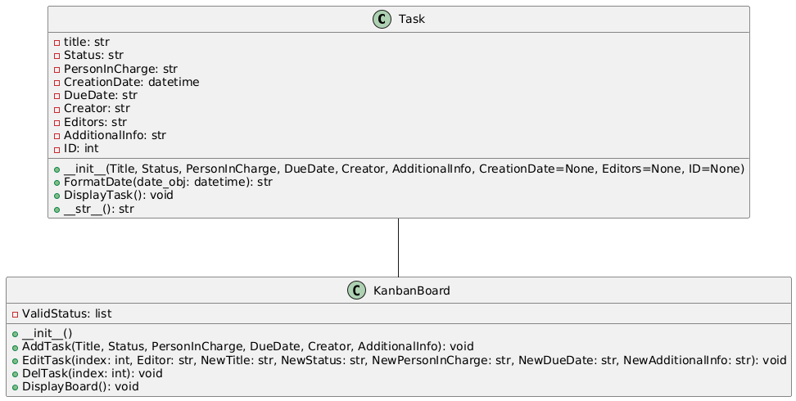

Database Layer Design
ER-Diagram
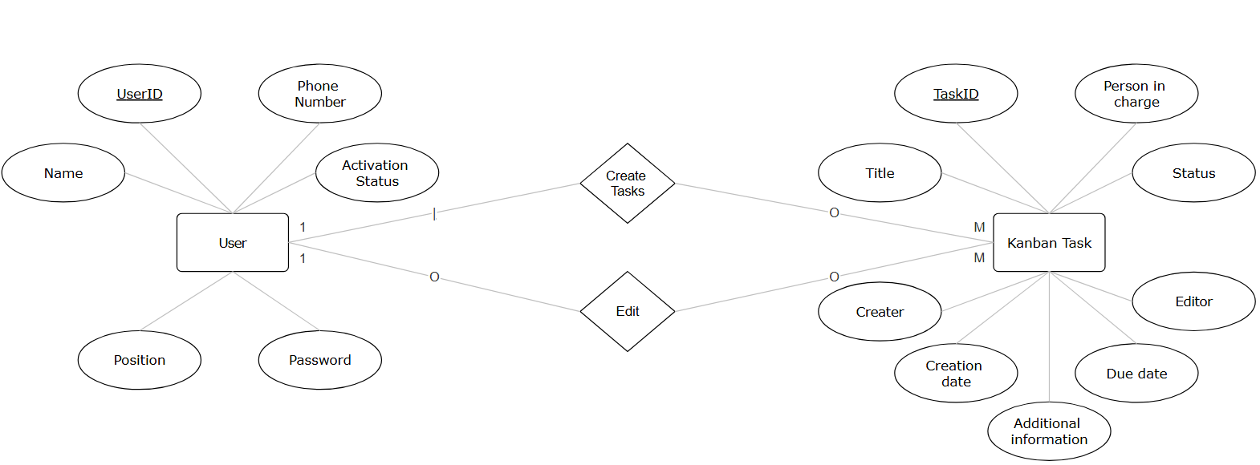
Database Schema
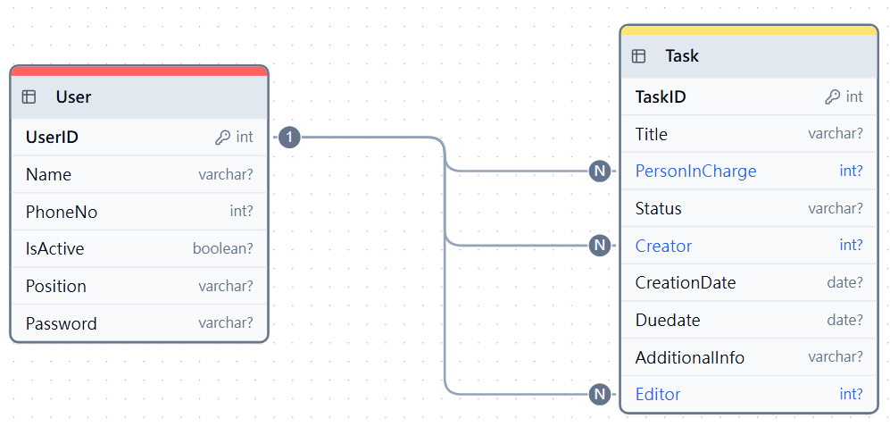

Developing Detail

