OS project1 report

第六組

1. 設計

We can’t get time with resolution of nanosecond. The resolution of time is microsecond. Therefore; the start time of all processes FIFO_1 are the same.

1. 執行範例測資的結果

FIFO_1

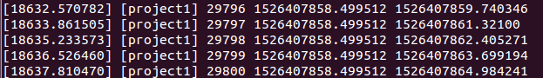

FIFO_2

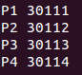 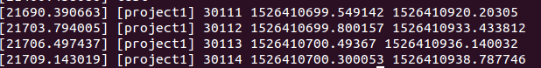

FIFO_3

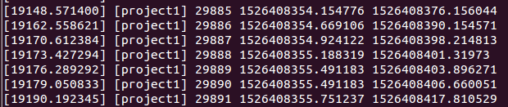

SJF_1

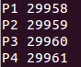 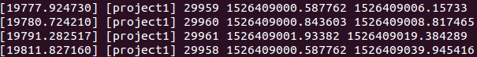

SJF_2

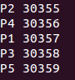 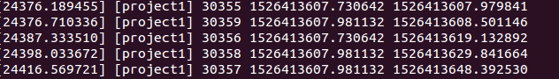

SJF_3

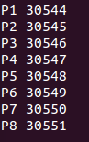 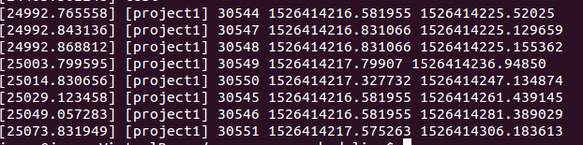

PSJF_1

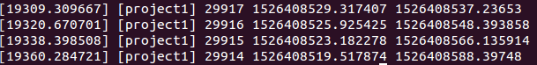

PSJF_2

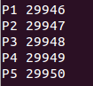 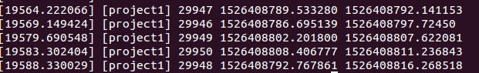

PSJF_3

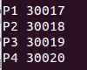 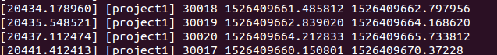

RR_1

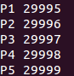 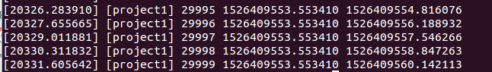

RR_2

 

RR_3

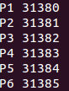 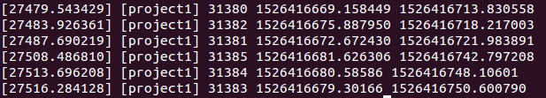

1. 比較實際結果與理論結果，並解釋造成差異的原因

In any testing data, Pi STs equal to Ri.

1. 各組員的貢獻

簡暐晉:write src code, compile kernel, run testing data, discuss how to write report.

周明德:discuss how to write src code, write report.

沙佳哲:none

劉昕:none