Question 1:
def difference(self, node):
char_difference = []
for i, c in enumerate(node):
if c != self.goal[i]:
char_difference.append(self.goal[i])
return char_difference
Steps
difference = self.difference(node.state)
h(n)= len(difference)
- every letter in the wrong position adds an unavoidable cost with steps. each letter will have to be swapped for the correct one and each swap will cost 1. This is under the best case assumption that all transition words are in the dictionary. The best case would have the minimum amount of swaps compared to average and worst case. Therefore the number of incorrect letters will always be the minimum cost.
Scrabble
estimate = 0
for char in difference:
estimate += self.scrabble_value(char)
h(n)= estimate
- for scrabble every letter in the wrong position must be swapped, but now the cost reflects the value of the new letter. Therefore, all incorrect letters must be swapped with the new letter and the minimum cost will be the sum of the correct letter values. This is under the best case assumption that all transition words are in the dictionary which is a lower bound. Therefore summing the value of the newly placed letters will always be the minimum cost.
Frequency
difference = self.difference(node.state)
h(n)= len(difference)
- for frequency every incorrect letter means a new transition word must be made. Each transition word has a value of 1 + unknown probability which is > 1. Therefore, the total number of incorrect letters X means a minimum cost of 1 * X = X. This considers the best case which a lower bound for cost.
Question 2:
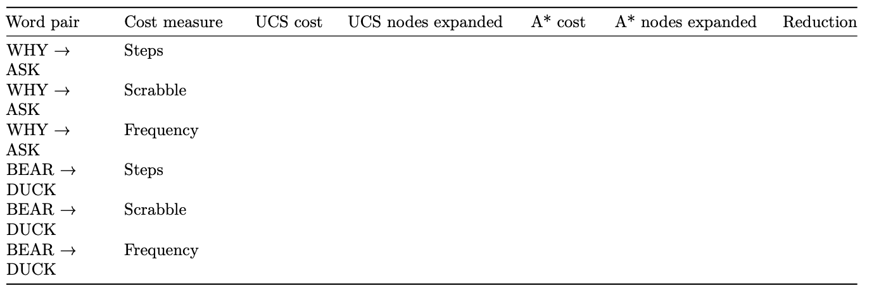
33.5
99.8

99.1

6.5

98.3

97.9
720

755

38.2

38.8

1084
2981
691
808
765
773
38.2
38.8
5

6

6

11

4
9
13
16
5

4
11

9
- optimal cost: UCS and A* returned the same optimal cost

- why, ask: scrabble had the largest reduction
- bear, duck: scrabble had the largest reduction

- why, ask: frequency was the least informative
- bear, duck: frequency was the least informative

- steps heuristic counts all the unavoidable replacements
- scrabble heuristic sums the value of all the unavoidable replacements
- frequency heuristic counts the number of replacements, but omits the rarity value which can have a larger range. therefore its admissible but not accurate.

Question 3:
- steps: yes, reversible actions have symmetric costs. W1→W2 and W2 →W1 have the same number of swap actions and since all actions have uniform cost of 1, they have symmetric costs.
- scrabble: no, there are unsymmetric costs. W1→W2 depends on the value of letters in W2 and W2→ W1 depends on the value of letters in W1, however W1 value != W2 value. EX: call→fall cost = 4 but fall→call cost =3. 4 != 3.
- frequency: no, unsymmetric cost. Cost depends on the rarity of transition words, which are different values. wall→fall cost = 1+3.86= 4.86 but fall→wall cost = 1 + 4.71 = 5.71. 4.86 != 5.71.

Question 4:
Claude Sonnet 5
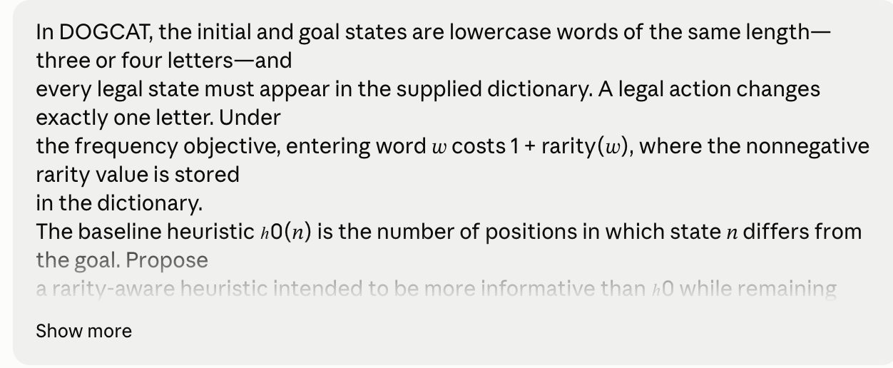
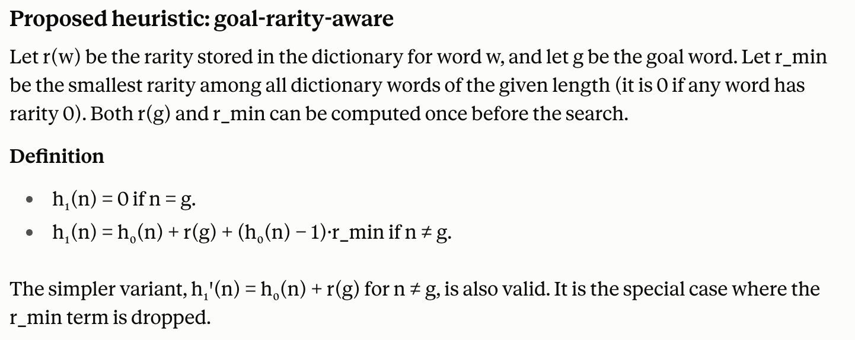
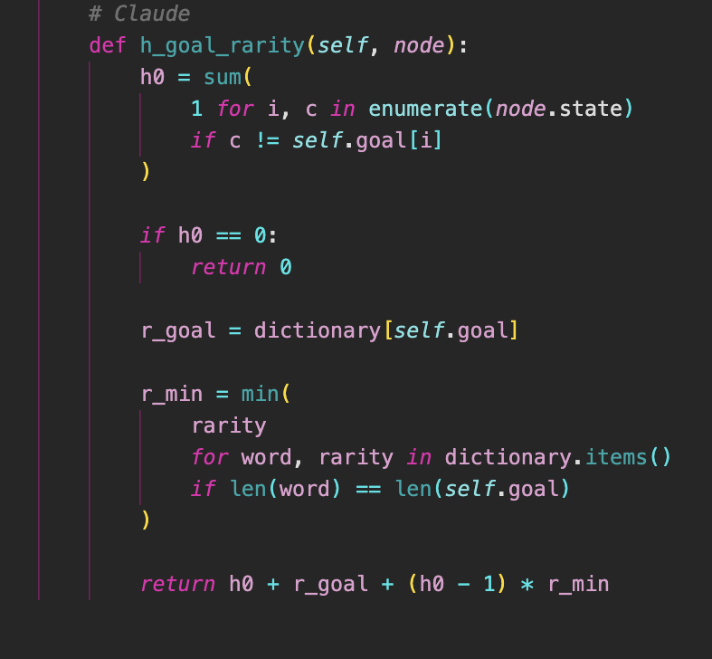
AI was used to generate the h1 code

It’s an admissible heuristic.
The heuristic tracks the positions of incorrect letters X, which are unavoidable. Since frequency is 1+ rarity, the lower bound is 1 with min cost 1*X= X. Then the exact cost for the goal word is added. For unaccounted X-1 transitions the minimum rarity value in the dict is used, creating a min cost. All parts consider the min cost value of the words, so their summation becomes the minimum total cost. And the goal cost returns 0, therefore it is admissible.

why-ask:
h0: cost = 38.8 nodes= 755 reduction= 16
h1: cost= 38.8 nodes=634
bear-duck:
h0: cost=38.2 nodes=720 reduction = 64.3
h1: cost=38.2 nodes= 257
Optimal cost didn’t change but fewer nodes were expanded, so h1 more informative and accurate. However we cant prove admissibility with these examples.

