Supplemental Materials to Submission: Hierarchical Multiagent Reinforcement Learning for Maritime Traffic Management
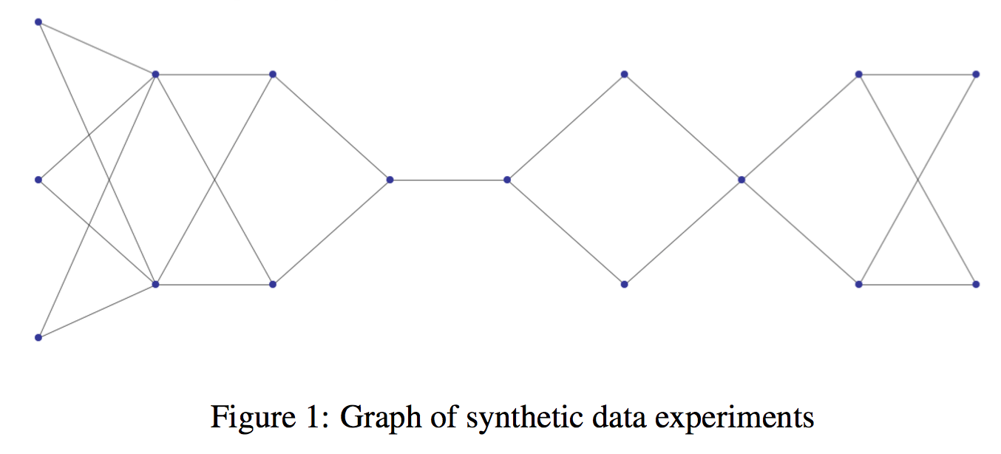
1. Synthetic Data Experimental Setup:
  - Synthetic Graph Generation

  - Implementation Details:
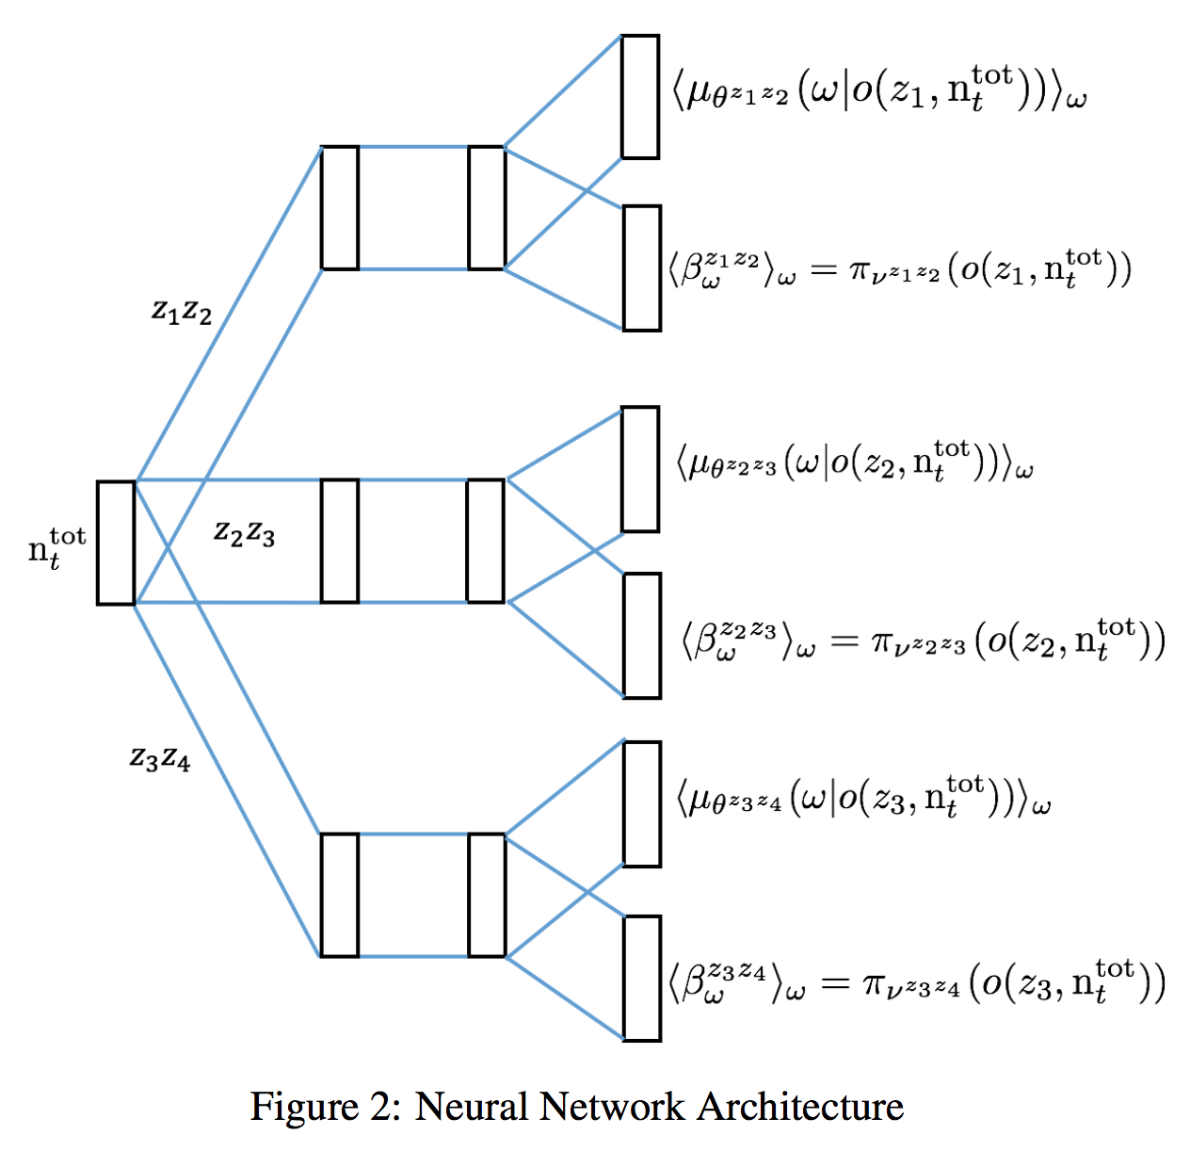

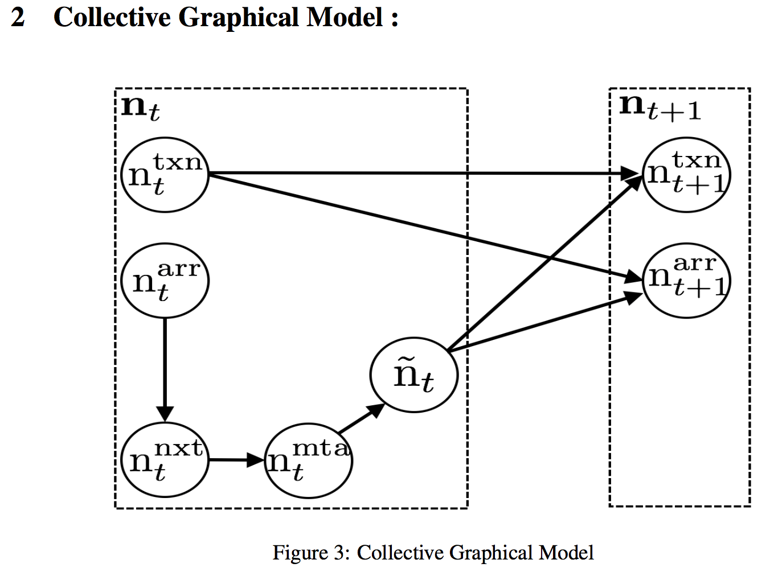
2. Sampling Process :
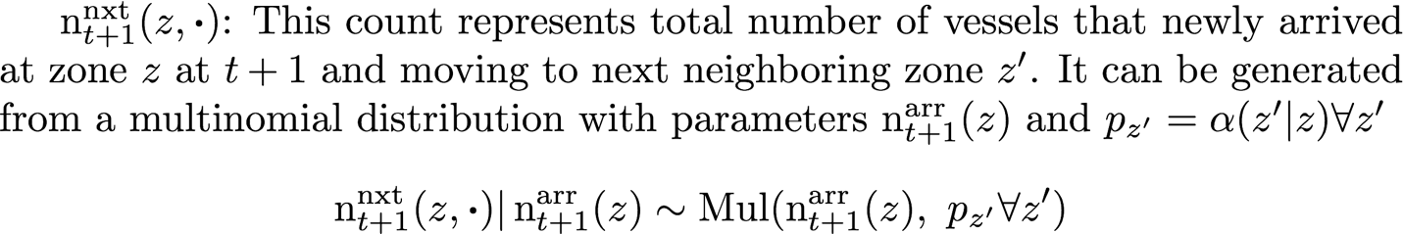

References
[1] Jimmy Ba, Ryan Kiros, and Geoffrey E. Hinton. Layer normalization. CoRR, abs/1607.06450, 2016.
[2] Diederik P. Kingma and Jimmy Ba. Adam: A method for stochastic optimization. CoRR, abs/1412.6980, 2014.
[3] Adam Paszke, Sam Gross, Soumith Chintala, Gregory Chanan, Edward Yang, Zachary DeVito, Zeming Lin, Alban Desmaison, Luca Antiga, and Adam Lerer. Automatic differentiation in pytorch. In NIPS-W, 2017.

