Supplemental Materials to Submission: Hierarchical Multiagent Reinforcement Learning for Maritime Traffic Management

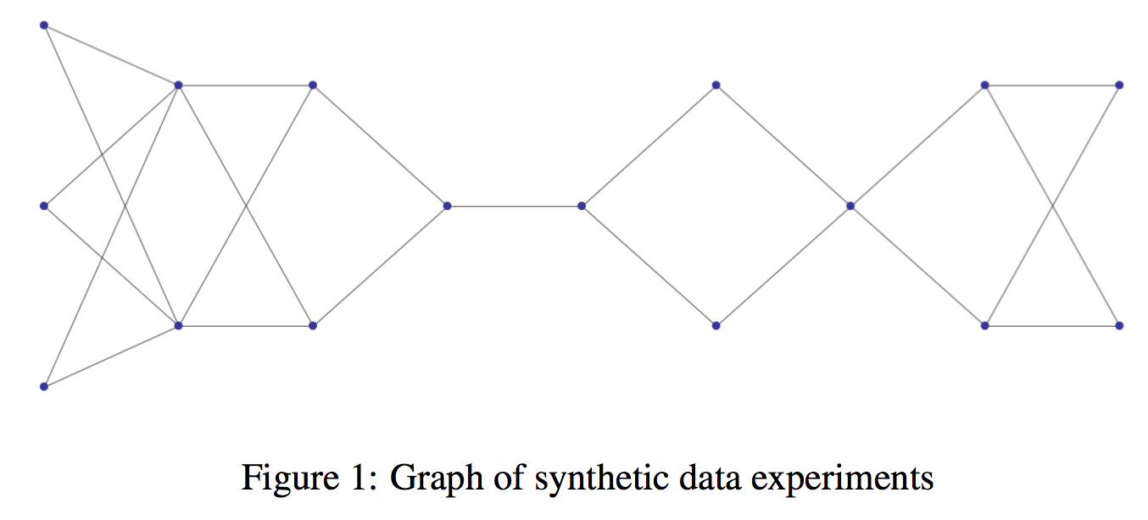**1. Synthetic Data Experimental Setup:**

* 1. **Synthetic Graph Generation**
  2. **Implementation Details:**

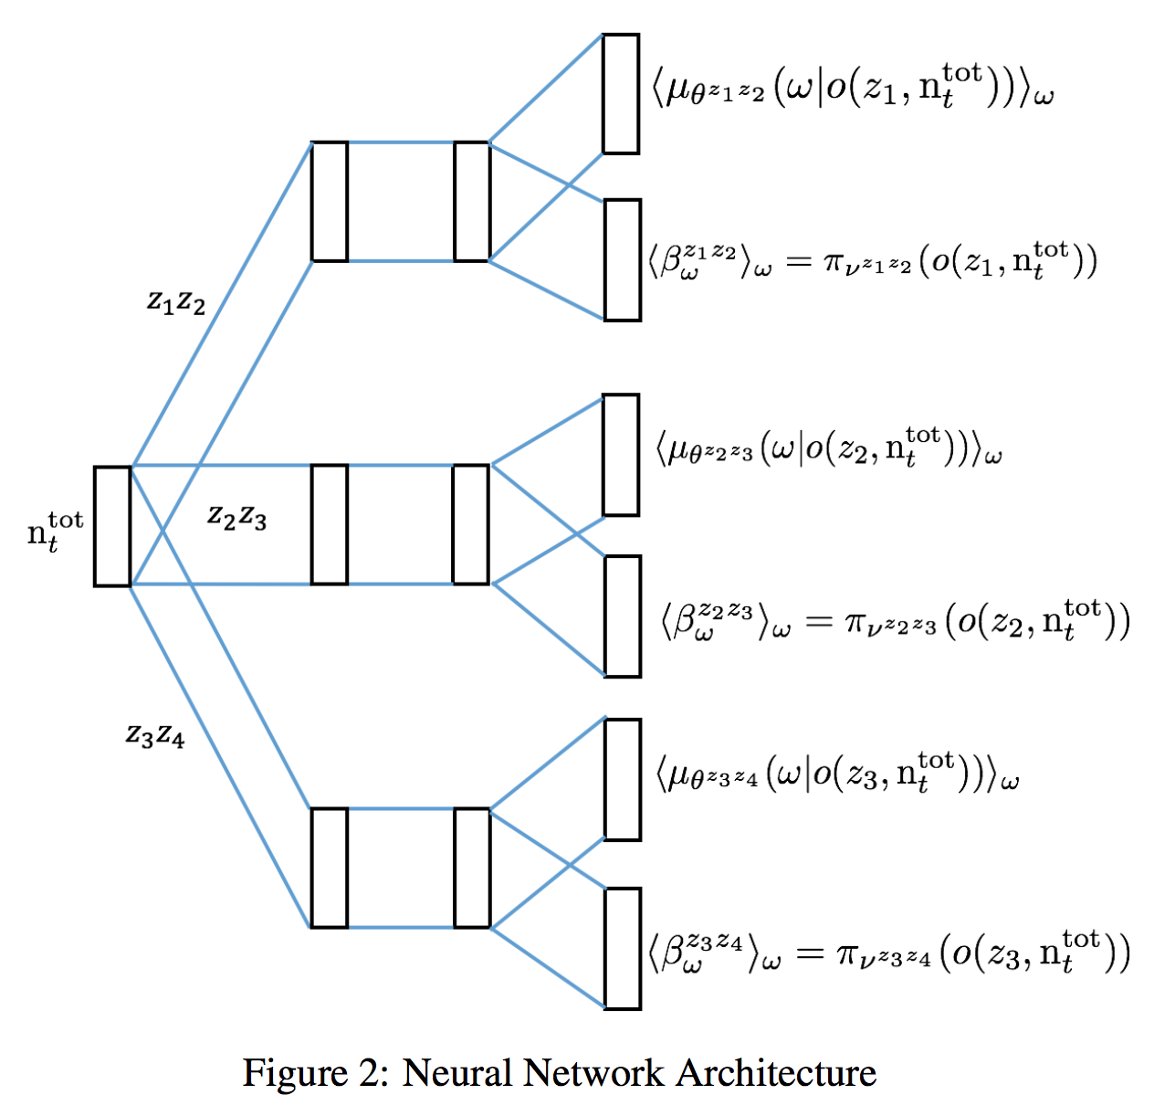

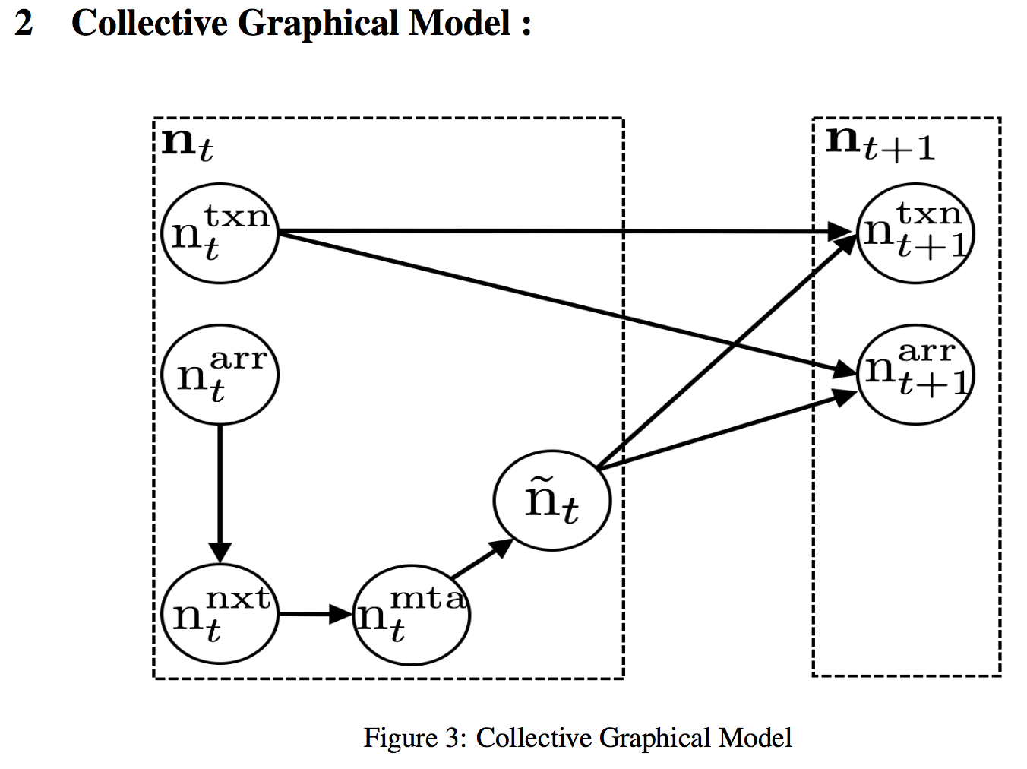

**2. Sampling Process :**



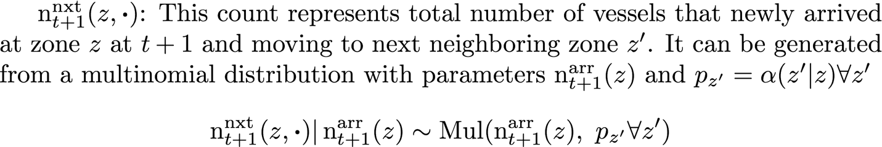







**3. Simulator Accuracy :**

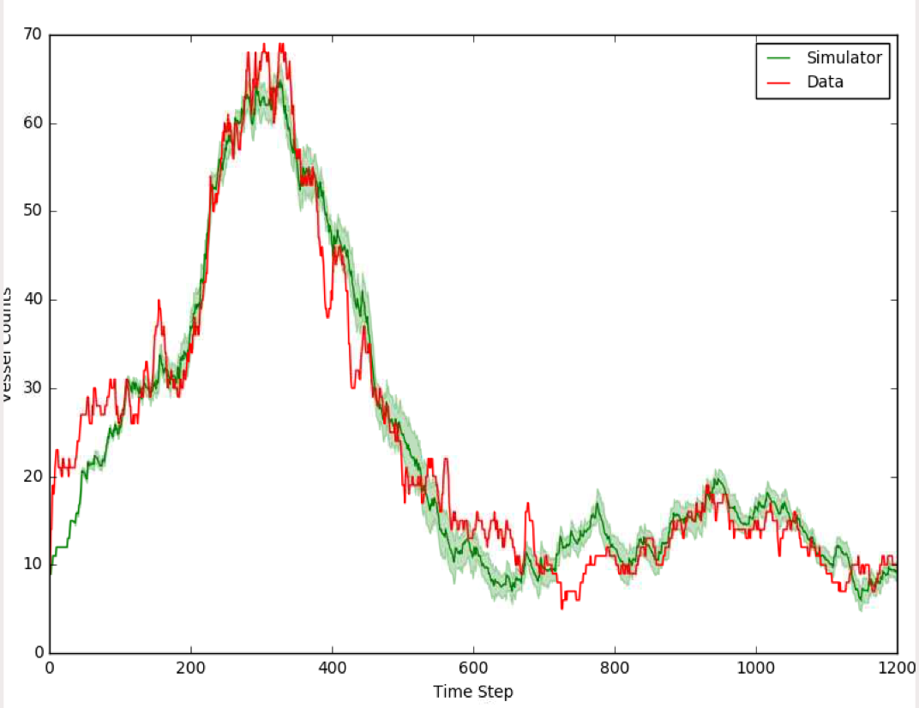

References

[1]  Jimmy Ba, Ryan Kiros, and Geoffrey E. Hinton. Layer normalization. *CoRR*, abs/1607.06450, 2016.

[2]  Diederik P. Kingma and Jimmy Ba. Adam: A method for stochastic optimization. *CoRR*, abs/1412.6980, 2014.

[3]  Adam Paszke, Sam Gross, Soumith Chintala, Gregory Chanan, Edward Yang, Zachary DeVito, Zeming Lin, Alban Desmaison, Luca Antiga, and Adam Lerer. Automatic differentiation in pytorch. In *NIPS-W*, 2017.