[Medical Economics](http://medicaleconomics.modernmedicine.com/)[EHR](http://www.modernmedicine.com/tag/ehr)

**2016 EHR Report** <http://medicaleconomics.modernmedicine.com/medical-economics/news/2016-ehr-report>

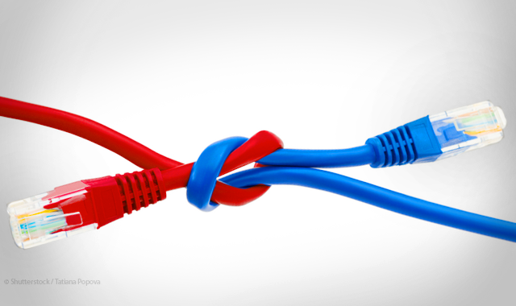

October 25, 2016

Physicians expect more from their [electronic health records (EHRs)](http://medicaleconomics.modernmedicine.com/tag/ehr). These systems were supposed to provide efficiency and troves of useful data, enabling doctors to manage patient populations and meet the demands of quality care. But EHRs are lacking in all of these areas.

[Read last year's EHR Report Card here](http://medicaleconomics.modernmedicine.com/medical-economics/news/ehr-report-card)

 For the fourth year, [*Medical Economics*](http://medicaleconomics.modernmedicine.com/medical-economics/news/2016-ehr-report?page=0,1) has asked physicians to rate and review their EHRs. The goal this year is to provide our readers with insight into how EHRs are performing and how physicians are coping with the challenges of this technology.

For our exclusive report, we surveyed more than 2,000 physicians to learn what they think of their EHRs, and how the technology affects the condition of their practices. **Our data show that doctors remain largely dissatisfied with the systems they have purchased. Said one physician respondent: “EHRs are not designed with the doctor or patient in mind. They are mostly data collection for someone else.”**