
Optical Automation, LLC

Software Development Information Technology

“The Importance Of eCommerce”

Authored By

JamesAvakian, Engineering Technologist

Lead Software Developer

Four Pages

http://www.OpticalAutomation.com

JamesAvakian62@yahoo.com

Optical Automation, LLC
5065 Amigo Avenue
Tarzana, CA 91356
(818) 214-9086

The Importance of eCommerce Websites

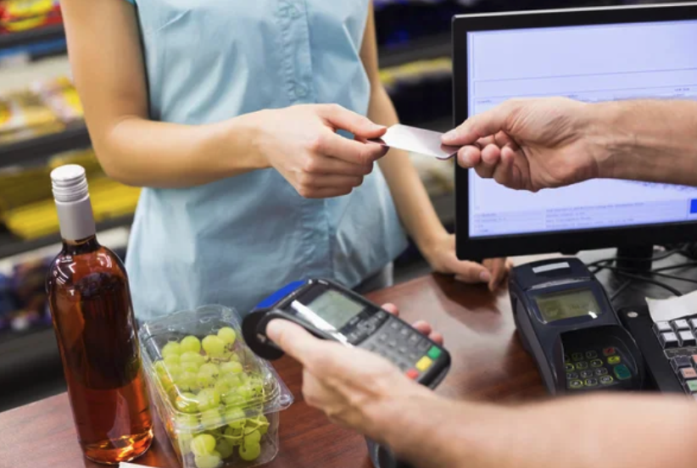

E-commerce (electronic commerce) is the activity of electronically buying or selling of products on online services or over the Internet. E-commerce draws on technologies such as mobile commerce, electronic funds transfer, supply chain management, Internet marketing, online transaction processing, electronic data interchange (EDI), inventory management systems, and automated data collection systems. E-commerce is in turn driven by the technological advances of the semiconductor industry, and is the largest sector of the electronics industry.

Defining e-commerce
The term was coined and first employed by Dr. Robert Jacobson, Principal Consultant to the California State Assembly's Utilities & Commerce Committee, in the title and text of California's Electronic Commerce Act, carried by the late Committee Chairwoman Gwen Moore (D-L.A.) and enacted in 1984.
E-commerce typically uses the web for at least a part of a transaction's life cycle although it may also use other technologies such as e-mail. Typical e-commerce transactions include the purchase of products (such as books from Amazon) or services (such as music downloads in the form of digital distribution such as the iTunes Store).[1] There are three areas of e-commerce: online retailing, electronic markets, and online auctions. E-commerce is supported by electronic business.[2] The existence value of e-commerce is to allow consumers to shop online and pay online through the Internet, saving the time and space of customers and enterprises, greatly improving transaction efficiency, especially for busy office workers, and also saving a lot of valuable time.[3]
eCommerce People Buying Your Products
Introduction
Bring people, consumers, to your business by use of the Internet!

No real estate of store front business and no expensive rent or lease. Buy your own eCommerce website with electronic financial transactor. Your freedom to a money machine and twenty-four hours a day, seven days a week. Your means for selling items all day and night everyday.

Visit our website for eCommerce,
http://www.DollarDiscount.com

Online shopping is a form of electronic commerce which allows consumers to directly buy goods or servicesfrom a seller over the Internet using a web browser or a mobile app. Consumers find a product of interest by visiting the website of the retailer directly or by searching among alternative vendors using a shopping search engine, which displays the same product's availability and pricing at different e-retailers. As of 2020, customers can shop online using a range of different computers and devices, including desktop computers, laptops, tablet computers and smartphones.

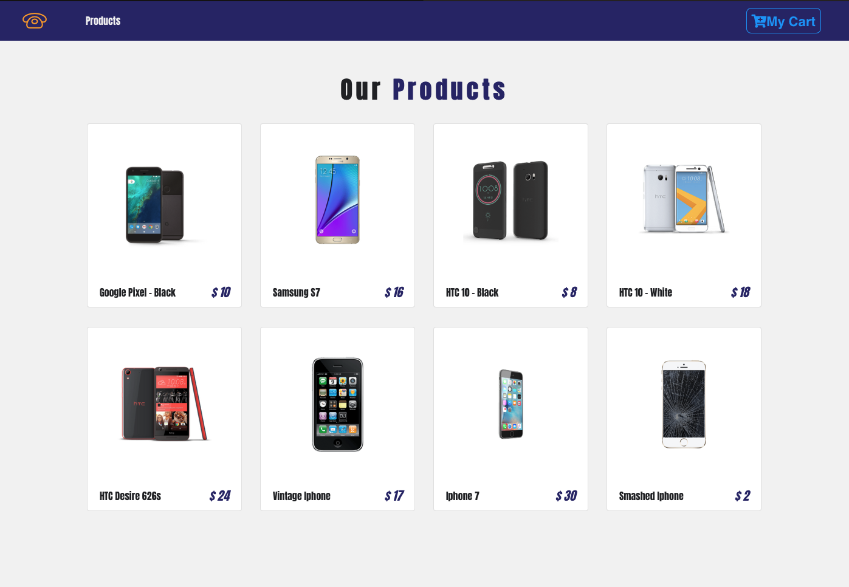

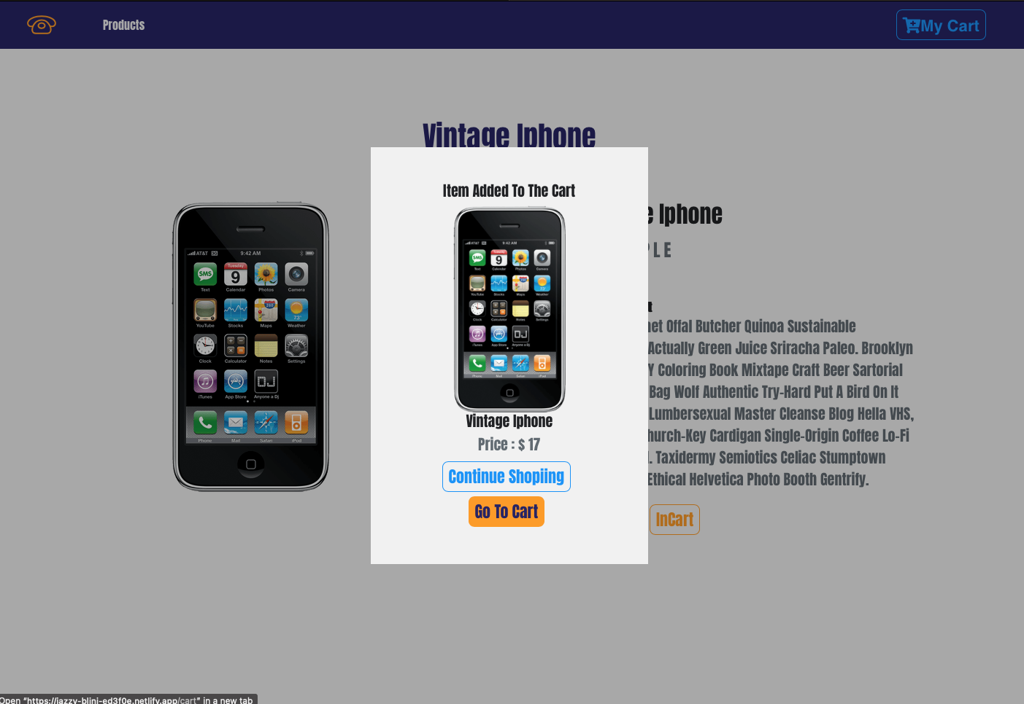

And the most important part the Cart. This is where clients have selected products and is ready buy pay money for your items.

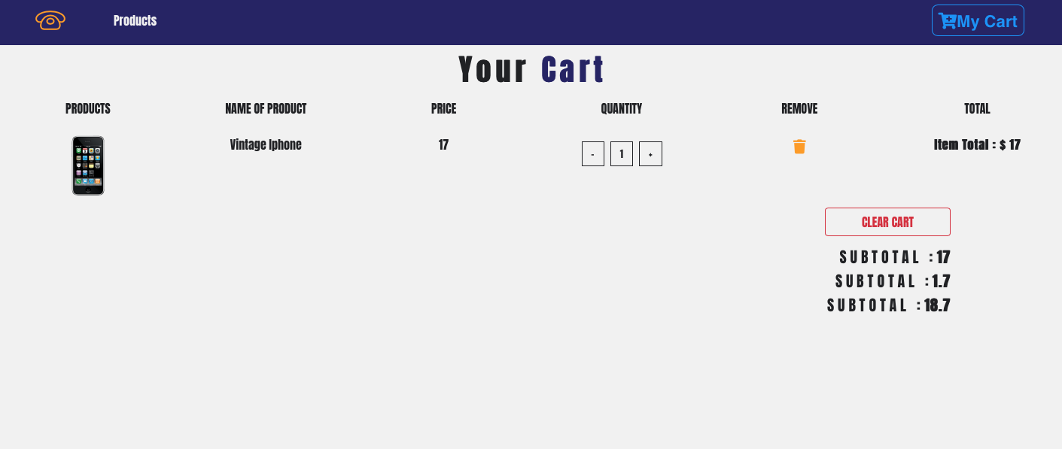
An online shop evokes the physical analogy of buying products or services at a regular "bricks-and-mortar"retailer or shopping center; the process is called business-to-consumer (B2C) online shopping. When an online store is set up to enable businesses to buy from another businesses, the process is called business-to-business (B2B) online shopping. A typical online store enables the customer to browse the firm's range of products and services, view photos or images of the products, along with information about the product specifications, features and prices.
Online stores usually enable shoppers to use "search" features to find specific models, brands or items. Online customers must have access to the Internet and a valid method of payment in order to complete a transaction, such as a credit card, an Interac-enabled debit card, or a service such as PayPal. For physical products (e.g., paperback books or clothes), the e-tailer ships the products to the customer; for digital products, such as digital audio files of songs or software, the e-tailer usually sends the file to the customer over the Internet. The largest of these online retailing corporations are Alibaba, Amazon.com, and eBay.[1]

Terminology
Alternative names for the activity are "e-tailing", a shortened form of "electronic retail" or "e-shopping", a shortened form of "electronic shopping". An online store may also be called an e-web-store, e-shop, e-store, Internet shop, web-shop, web-store, online store, online storefront and virtual store. Mobile commerce (or m-commerce) describes purchasing from an online retailer's mobile device-optimized website or software application ("app"). These websites or apps are designed to enable customers to browse through a companies' products and services on tablet computers and smartphones.
Pricing of our websites are offered at $ 50 an hour of work. It usually takes 100 hours of work or two and a half months of time. At full time 40 hours a week of work our talent will present you a complete website in your choice of formats, color, and information components. As a full size website, use of our Responsive Website Design, you get additional sized formats to include Tablet and Cellphone size website products. So when your client access your website by computer, laptop, tablet, and cellphone each will display fast and clearly for your business. That's quality from Optical Automation, LLC in Tarzana, California 91356

Optical Automation, LLC
5065 Amigo Avenue
Tarzana, CA 91356
(818) 214-9086

JamesAvakian62@yahoo.com

http://www.OpticalAutomation.com

