+15 Partner Portal
Database Schema, ERD, and Schema Explanation
BANA 5140 — Data Management
Final Project — Database design for a CRUD application
Implemented in SQLite3

Contents

1. Schema Overview
The +15 Partner Portal is supported by a relational database implemented in SQLite3. The schema contains seven tables designed in third normal form (3NF): there are no repeating groups, every non-key attribute depends on the whole primary key, and no non-key attribute depends on another non-key attribute. The design eliminates the duplicated, inconsistent data that motivated the project and enforces the relationships between business objects so that the application's create, read, update, and delete operations always leave the database in a valid state.
Every table uses a system-generated integer surrogate primary key (for example partner_id). Surrogate keys are used so that business-facing values such as a business name or email address can change over time without breaking the foreign-key references that connect tables. Relationships are enforced with FOREIGN KEY constraints, and the application enables PRAGMA foreign_keys = ON on every database connection because SQLite does not enforce foreign keys by default. Data integrity is further protected by NOT NULL, UNIQUE, and CHECK constraints declared directly in the schema.
Data provenance: the buildings are real +15-connected buildings from City of Calgary open data, and the partners are 51 real restaurants currently operating in the network, loaded from a directory the project author compiled (with their real addresses, descriptions, and opening hours; values missing in the source are stored as NULL). Promotions and lease terms are not public information, so a small set of realistic sample records is attached to a few partners purely to demonstrate those operations. Using real partner data validates that the schema handles genuine, sometimes-incomplete records rather than idealized placeholders.
Entity | Purpose | Relationship
building | The +15-connected buildings (reference data from City of Calgary open data). | One building hosts many partners.
category | Controlled list of business types. | One category classifies many partners.
partner | The core business record with a public listing. | Belongs to one building and one category; has many promotions, hours, and leases.
opening_hours | A partner's hours, one row per weekday. | Many hours rows belong to one partner.
promotion | A marketing offer run by a partner. | Many promotions belong to one partner.
lease | The commercial lease under which a partner occupies space. | Many lease records belong to one partner.
portal_user | Staff accounts that administer the portal. | Independent; supports authentication.

2. Entity-Relationship Diagram
The diagram below shows the seven entities, their key attributes, and the relationships between them in crow's foot notation. The single-bar end of each connector marks the “one” side of a relationship and the crow's-foot end marks the “many” side. Primary keys are underlined and labelled PK; foreign keys are labelled FK.
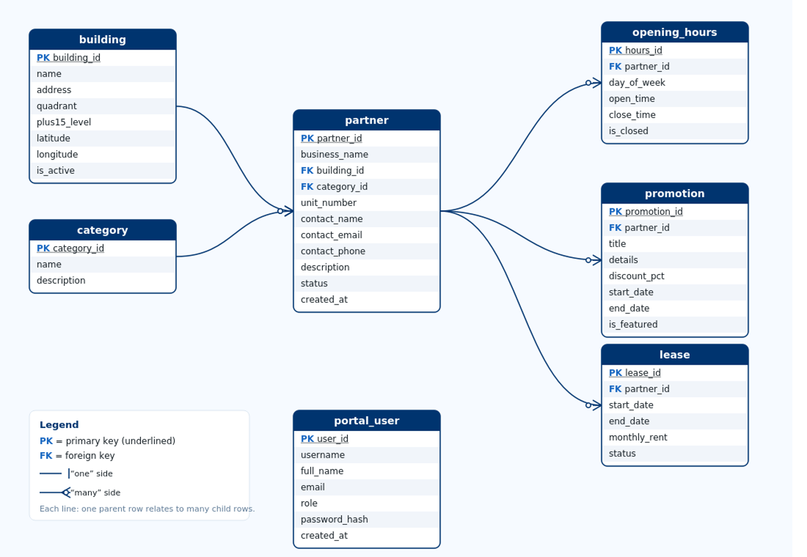
Figure 1. Entity-Relationship Diagram for the +15 Partner Portal.

3. Entity and Attribute Explanation

3.1 building
The building entity stores the buildings that the +15 skywalk connects. It is needed because every partner is physically located in a building, and the organization frequently needs to group, count, and locate partners by building. Seeding this table from the City of Calgary open “Plus 15” dataset grounds the application in real network data.
Attribute | Type | Key | Description
building_id | INTEGER | PK | Surrogate primary key uniquely identifying each building.
name | TEXT |  | Building name, e.g. “Bankers Hall”. UNIQUE to prevent duplicates.
address | TEXT |  | Street address where known.
quadrant | TEXT |  | City quadrant (SW/SE/NW/NE), constrained by CHECK.
plus15_level | INTEGER |  | Floor the +15 runs on; defaults to 1.
latitude / longitude | REAL |  | Map coordinates for the building.
is_active | INTEGER |  | 1 if currently part of the network, else 0 (CHECK 0/1).

3.2 category
The category entity is a controlled vocabulary of business types such as Food & Beverage or Health & Wellness. It exists as its own table rather than as a free-text column on partner so that the list of categories is governed centrally and a partner cannot be miscategorized by a typing inconsistency. This is a deliberate normalization decision that removes duplicate text and supports reliable grouping in reports.
Attribute | Type | Key | Description
category_id | INTEGER | PK | Surrogate primary key for each category.
name | TEXT |  | Category label; UNIQUE so each type appears once.
description | TEXT |  | Short explanation of what the category includes.

3.3 partner
The partner entity is the core of the system: each row is a business with a public listing in the +15 portal. It carries two foreign keys, building_id and category_id, which place the business in a building and a category. Keeping these as foreign keys rather than repeated text means a building can be renamed in one place and every partner reflects the change, and partners can be counted per building or category with a simple join. The status attribute (active, pending, suspended, closed) supports filtering and is constrained by a CHECK so only valid values can be stored. The real seed data illustrates why building_id belongs here as a many-to-one foreign key rather than a one-to-one attribute: several chains (for example Alforno and Marcello's Market & Deli) operate four separate +15 locations, each stored as its own partner row pointing to a different building.
Attribute | Type | Key | Description
partner_id | INTEGER | PK | Surrogate primary key for each partner business.
business_name | TEXT |  | Public name of the business (NOT NULL).
building_id | INTEGER | FK | References building(building_id); the building it occupies.
category_id | INTEGER | FK | References category(category_id); its business type.
unit_number | TEXT |  | Suite or unit within the building.
contact_name / _email / _phone | TEXT |  | Primary contact details for the business.
description | TEXT |  | Short public blurb shown in listings.
status | TEXT |  | Lifecycle status; CHECK restricts to four values.
created_at | TEXT |  | Timestamp the record was created (defaults to now).

3.4 opening_hours
Opening hours are stored in their own table with one row per partner per weekday, rather than as fourteen columns on the partner table. Hours of operation are a repeating group, so placing them in a separate table keeps partner in first normal form and lets each day be open with distinct times or marked closed. A UNIQUE constraint on (partner_id, day_of_week) guarantees a partner has at most one record per day. The foreign key uses ON DELETE CASCADE so a partner's hours are removed automatically when the partner is deleted.
Attribute | Type | Key | Description
hours_id | INTEGER | PK | Surrogate primary key for the hours row.
partner_id | INTEGER | FK | References partner(partner_id); cascades on delete.
day_of_week | INTEGER |  | 0=Monday … 6=Sunday (CHECK 0–6).
open_time / close_time | TEXT |  | Times in HH:MM; NULL when closed.
is_closed | INTEGER |  | 1 if the partner is closed that day (CHECK 0/1).

3.5 promotion
The promotion entity records the time-limited offers that partners run, which are central to the business case because they drive skywalk foot traffic. A partner can run many promotions over time, so promotions are a child of partner via the partner_id foreign key. A table-level CHECK ensures end_date is not earlier than start_date, and discount_pct is constrained to 0–100, so the database refuses to store an invalid promotion even if application validation were bypassed.
Attribute | Type | Key | Description
promotion_id | INTEGER | PK | Surrogate primary key for each promotion.
partner_id | INTEGER | FK | References partner(partner_id); cascades on delete.
title | TEXT |  | Headline of the promotion (NOT NULL).
details | TEXT |  | Longer description of the offer.
discount_pct | INTEGER |  | Optional percentage discount (CHECK 0–100).
start_date / end_date | TEXT |  | Active window; CHECK end_date ≥ start_date.
is_featured | INTEGER |  | 1 if highlighted on the dashboard (CHECK 0/1).

3.6 lease
The lease entity captures the commercial agreement under which a partner occupies its space. It is modelled separately from the partner's public listing because lease terms (rent, dates, status) are conceptually distinct and are typically managed by leasing staff rather than marketing staff. Separating them keeps each table cohesive and lets the two stakeholder groups work without overwriting each other's data, while the partner_id foreign key still ties a lease to exactly one partner.
Attribute | Type | Key | Description
lease_id | INTEGER | PK | Surrogate primary key for each lease.
partner_id | INTEGER | FK | References partner(partner_id); cascades on delete.
start_date / end_date | TEXT |  | Lease term; CHECK end_date ≥ start_date.
monthly_rent | REAL |  | Monthly rent; CHECK ≥ 0.
status | TEXT |  | active, expired, or terminated (CHECK).

3.7 portal_user
The portal_user entity stores the staff accounts that administer the portal and perform the CRUD operations. It supports the application's authentication and role-based access (administrator, steward, read-only viewer). Passwords are stored only as salted hashes, never as plain text. This entity is intentionally independent of partner because a single user manages many partners across the whole portal, so there is no foreign-key relationship between them.
Attribute | Type | Key | Description
user_id | INTEGER | PK | Surrogate primary key for each staff account.
username | TEXT |  | Login name; UNIQUE.
full_name | TEXT |  | Display name of the user.
email | TEXT |  | Contact email; UNIQUE.
role | TEXT |  | admin, steward, or viewer (CHECK); governs access.
password_hash | TEXT |  | Salted hash of the password (never plain text).
created_at | TEXT |  | Timestamp the account was created.

4. Primary Keys and Foreign Keys
Each table has a single-column integer primary key that uniquely identifies its rows. Because these keys are surrogate values generated by the database, they are stable: a business can be renamed or moved without affecting the key that other tables reference. The foreign keys below connect related records across tables and are what make the relational design work.
Foreign key | From → To | Meaning
partner.building_id | partner → building | Each partner is located in exactly one building.
partner.category_id | partner → category | Each partner has exactly one business category.
opening_hours.partner_id | opening_hours → partner | Each hours row belongs to one partner (cascade delete).
promotion.partner_id | promotion → partner | Each promotion belongs to one partner (cascade delete).
lease.partner_id | lease → partner | Each lease belongs to one partner (cascade delete).
Referential integrity is enforced by these constraints together with PRAGMA foreign_keys = ON. An attempt to insert a partner with a building_id that does not exist is rejected by the database, and deleting a partner automatically removes its dependent promotions, hours, and lease through ON DELETE CASCADE, so no orphaned child records are ever left behind.

5. How the Design Solves the Business Problem
The schema directly resolves the data management problems identified in the business case. The combination of a single partner table with governed building and category reference tables removes the duplicate and inconsistent records that previously lived across spreadsheets: a building or category name exists once and is referenced everywhere, so partners can be counted and reported reliably. Because promotions, hours, and leases are stored in their own related tables rather than crammed into the partner row, the design stays in third normal form and each kind of information can be created, read, updated, and deleted independently while remaining tied to the correct partner.
The CRUD operations map cleanly onto the schema. A create inserts one row into partner (or promotion); a read joins partner to building and category to present a complete, human-readable listing; an update modifies a single row in place, preserving its key and its relationships; and a delete removes a partner and, through cascading foreign keys, all of its dependent records in one consistent action. Constraints guarantee that these operations cannot corrupt the data: status and role values are limited by CHECK constraints, date ranges cannot be inverted, names and emails are kept unique, and required fields cannot be null.
Several design decisions improve efficiency and quality. Normalization reduces storage and update anomalies. Appropriate data types (INTEGER keys, REAL for rent and coordinates, TEXT for ISO dates) keep the data well-formed. Indexes are created on every foreign key and on the columns used for search and filtering — business_name, status, category, and promotion dates — so that the read operations that staff use most often remain fast as the number of partners and promotions grows. Together these choices give the organization a single, trustworthy source of partner data that supports day-to-day operations and stakeholder reporting.

