JEWEL BESPOKE BUILD · AUTOMATED PROJECT INBOX
Project Delivery Agent System
A process-based agent architecture mapped to the JBB Project Delivery Framework

Companion to JBB-PDF-v1.2 · June 2026 · Status: draft for discussion
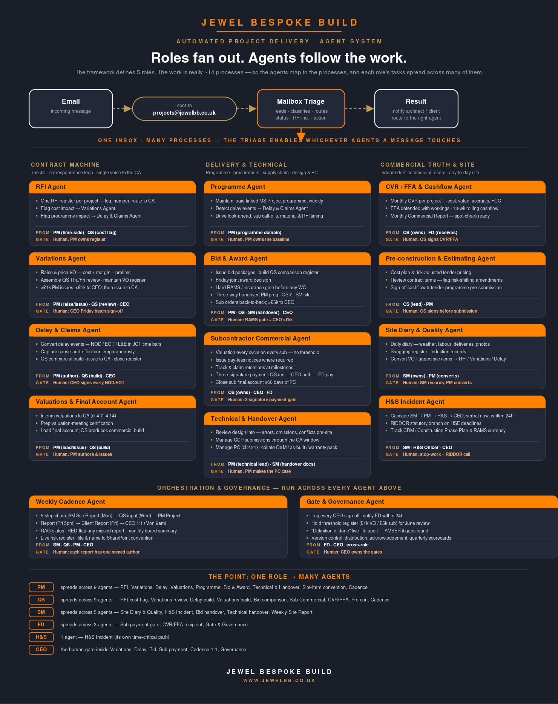
The agent map — full diagram saved alongside this document as JBB-Agent-Map.svg

Why the agents don’t follow the roles
The framework is written by role — PM, QS, SM, FD, H&S Officer. That is the right way to assign accountability to people. It is the wrong unit for building agents.
Almost every line of real work in the framework is a process that already crosses role boundaries. A variation is raised and priced by the PM, reviewed by the QS, signed by the CEO, issued by the PM and logged by the QS — one process, four roles. A delay notice, a sub payment, a weekly report: same pattern. If we built one agent per role, each agent would have to do a slice of a dozen unrelated processes, and every process would be split across several agents that don’t talk to each other.
So the agents are drawn around the processes, not the roles. Each role’s tasks then spread across many agents — the PM’s work alone lands in nine of them — and conversely each agent pulls its tasks from whichever roles the process touches. The role still owns the outcome and still signs at the gate; the agent just carries the process between gates.

Design principles
- Process, not person. An agent owns an end-to-end workflow (a variation, an RFI, a sub lifecycle), not a job title.
- One role fans out to many agents. PM → 9 agents, QS → 9, SM → 5, FD → 3. The role-coverage map below proves nothing is dropped.
- Agents prepare and route; humans hold every gate. The agent drafts the VO, assembles the review, files the notice — then stops. Every sign-off in the framework stays human.
- One front door. Mailbox Triage reads, classifies and routes every message to projects@jewelbb.co.uk, and enables whichever agents it touches.
- Everything lands in a register. Each agent reads from and writes to the same registers the framework already defines — the file stays spot-check-ready.

The agent catalogue
Fourteen agents in four clusters, plus the existing Mailbox Triage front door. Each agent’s human gate is the last row — that is where it hands back to a person.

Contract machine — the JCT correspondence loop

1 · RFI Agent
Does | Runs one RFI register per project — logs, numbers and routes each query to the CA.
Triggered by | Inbound RFI / design query identified at triage.
Absorbs (role-tasks) | PM time-side register ownership; QS cost-impact flag.
Hands off to | Cost impact → Variations Agent; programme impact → Delay & Claims Agent.
Human gate — stops here | Human: PM owns the register; QS confirms any cost flag.

2 · Variations Agent
Does | Raises and prices variations at full contractual value (cost + margin + prelims), assembles the QS review, and maintains the variations register.
Triggered by | A change, instruction or cost-impacting RFI/site item.
Absorbs (role-tasks) | PM raise/price/issue; QS Thu/Fri price review + register integrity.
Hands off to | Below £1k → PM issues with QS review attached; above £1k → CEO; then issued to CA, ingested to FFA.
Human gate — stops here | Human: CEO Friday batch sign-off (>£1k).

3 · Delay & Claims Agent (NOD / EOT / L&E)
Does | Converts delay events into Notices of Delay, EOT and Loss-&-Expense claims inside JCT time bars, with cause-and-effect captured contemporaneously.
Triggered by | Delay event flagged by the Programme, RFI or Site Diary agent.
Absorbs (role-tasks) | PM authors/issues and is single voice to CA; QS builds the commercial workings.
Hands off to | Issues to CA; closes the NOD/EOT register on the CA response.
Human gate — stops here | Human: CEO signs every NOD and EOT before issue.

4 · Valuations & Final Account Agent
Does | Drafts interim valuations to the CA (cl 4.7–4.14), preps certification, and assembles the final account.
Triggered by | Valuation cycle date; or PC approaching (final account).
Absorbs (role-tasks) | PM leads/authors/issues; QS produces the commercial build behind the submission.
Hands off to | Final account closure feeds CVR/FFA and Sub Commercial closeout.
Human gate — stops here | Human: PM authors and issues (no CEO gate); CEO informed on final account.

Delivery & technical — programme, procurement, supply chain, design & PC

5 · Programme Agent
Does | Maintains the logic-linked MS Project programme, updates it weekly, and drives look-ahead, sub call-offs and material/RFI timing.
Triggered by | Weekly cycle; any progress or sequence change.
Absorbs (role-tasks) | PM programme & time-management domain.
Hands off to | Delay events → Delay & Claims Agent; call-offs → Bid & Award Agent.
Human gate — stops here | Human: PM owns and baselines the programme.

6 · Bid & Award Agent
Does | Issues bid packages, builds the QS comparison register, runs the Friday joint award, enforces the RAMS/insurance gate, and handles the three-way handover.
Triggered by | A work package ready to procure.
Absorbs (role-tasks) | PM (programme need) + QS (comparison + order) + SM (site handover) + CEO.
Hands off to | Awarded sub → Subcontractor Commercial Agent; programme dates → Programme Agent.
Human gate — stops here | Human: hard RAMS/insurance gate; CEO sign-off on sub orders >£5k.

7 · Subcontractor Commercial Agent
Does | Runs the sub commercial lifecycle — a valuation every cycle on every sub (no threshold), pay-less notices, retentions, and final accounts.
Triggered by | Monthly sub valuation cycle; milestone; PC.
Absorbs (role-tasks) | QS owns end-to-end; CEO authorises; FD pays.
Hands off to | Payment recommendation → Gate & Governance log; closure → CVR/FFA.
Human gate — stops here | Human: three-signature payment — QS recommends, CEO authorises, FD pays.

8 · Technical & Handover Agent
Does | Reads the design information for errors, omissions and conflicts before they hit site, manages CDP submissions through the CA window, and drives Practical Completion and the close-out pack.
Triggered by | New design info issued; CDP submission due; PC approaching.
Absorbs (role-tasks) | PM quality & technical domain (incl. PC cl 2.21); SM hands over O&M / as-built / warranties.
Hands off to | Design conflicts → RFI / Variations agents; PC → Valuations final account.
Human gate — stops here | Human: PM manages PC under cl 2.21 — including making the case to the CA.

Commercial truth & site

9 · CVR / FFA & Cashflow Agent
Does | Produces the monthly CVR per project, the defended FFA, the 13-week rolling cashflow, and the monthly Commercial Report.
Triggered by | Monthly close; weekly cashflow update (Fri 5pm).
Absorbs (role-tasks) | QS commercial-truth domain; FD is the recipient.
Hands off to | Commercial Report → FD/CEO; figures → Weekly Cadence Agent.
Human gate — stops here | Human: QS signs the CVR and FFA.

10 · Pre-construction & Estimating Agent
Does | Builds cost plans and risk-adjusted tender pricing, and reviews proposed contract terms for risk-shifting amendments before signing.
Triggered by | A new opportunity or tender.
Absorbs (role-tasks) | QS estimating/pre-con domain; PM input on programme.
Hands off to | Won work → Programme + Bid & Award + CVR/FFA agents at mobilisation.
Human gate — stops here | Human: QS signs cashflow forecast and tender programme before submission.

11 · Site Diary & Quality Agent
Does | Captures the daily site diary, snagging register and induction records, and converts cost/time-flagged site items into formal mechanisms.
Triggered by | Every working day; any site event raised by the SM.
Absorbs (role-tasks) | SM ownership; PM converts diary items the next morning.
Hands off to | VO-flagged items → RFI / Variations / Delay agents; snags → PC closeout.
Human gate — stops here | Human: SM records, PM converts. No commercial visibility at SM level.

12 · H&S Incident Agent
Does | Runs the time-critical incident cascade (SM → PM → H&S → CEO), the RIDDOR statutory branch, and tracks CDM / Construction Phase Plan & RAMS currency.
Triggered by | Any site incident or safety risk; scope change affecting RAMS.
Absorbs (role-tasks) | SM first response; H&S Officer owns the RIDDOR call; CEO decision authority.
Hands off to | Statutory route to HSE on RIDDOR-reportable cases.
Human gate — stops here | Human: H&S Officer stop-work authority and RIDDOR call; CEO on stop-work.

Orchestration & governance — across every agent

13 · Weekly Cadence Agent
Does | Drives the five-step weekly chain and RAG status, and files everything to the SharePoint naming convention.
Triggered by | The weekly calendar — Mon, Wed, Fri 5pm, Fri, Mon 9am.
Absorbs (role-tasks) | SM Site Report + QS commercial input + PM Project & Client Reports + CEO 1:1.
Hands off to | Aggregated Project Report → CEO/FD; decisions → Gate & Governance.
Human gate — stops here | Human: each report has one named author; CEO holds the Monday 1:1.

14 · Gate & Governance Agent
Does | Logs every CEO sign-off, notifies the FD within 24h, holds the threshold register, and runs the live-file “definition of done” audit.
Triggered by | Any sign-off event; any director spot-check; quarterly review.
Absorbs (role-tasks) | FD 24h-informed route; CEO gate ownership; cross-role file discipline.
Hands off to | Scorecards → quarterly review; AMBER flags → PM/QS.
Human gate — stops here | Human: CEO owns the gates; FD acts as deputy in CEO absence.

Role-coverage map
Read this as the answer to “does every task in every role still get done?” Each role’s domains are listed against the agents that now carry them.
Role | Agents its tasks spread into
Project Manager | Programme · RFI · Variations · Delay & Claims · Valuations & Final Account · Bid & Award · Technical & Handover · Site Diary (conversion) · Weekly Cadence (9)
Quantity Surveyor | RFI (cost flag) · Variations (review/register) · Delay (build) · Valuations (build) · Bid & Award (comparison) · Subcontractor Commercial · CVR/FFA · Pre-construction · Weekly Cadence (9)
Site Manager | Site Diary & Quality · H&S Incident · Bid & Award (handover) · Technical & Handover (O&M/as-built) · Weekly Cadence (Site Report) (5)
Finance Director | Subcontractor Commercial (pays) · CVR/FFA (receives) · Gate & Governance (24h-informed, deputy) (3)
H&S Officer | H&S Incident Agent — its own time-critical path (1)
CEO | The human gate inside Variations, Delay, Bid & Award, Sub payment, Weekly 1:1 and Governance

Framework workflow → agent
Every named workflow and sign-off gate in JBB-PDF-v1.2, mapped to the agent that now carries it and the human gate it preserves.
Framework workflow / gate | Carried by | Human gate preserved
Variation Order workflow | Variations Agent | CEO Friday batch (>£1k)
RFI lifecycle | RFI Agent | PM owns register
Notice of Delay & EOT cascade | Delay & Claims Agent | CEO signs every notice
L&E claim | Delay & Claims Agent | PM authors / CEO informed
Interim valuations & final account | Valuations & Final Account Agent | PM authors and issues
Programme — build/baseline/update | Programme Agent | PM baselines
Sub bid » WO award workflow | Bid & Award Agent | RAMS gate + CEO >£5k
Subcontractor lifecycle | Subcontractor Commercial Agent | QS → CEO → FD payment
CVR / FFA (monthly) | CVR/FFA & Cashflow Agent | QS signs
Pre-construction & estimating | Pre-construction & Estimating Agent | QS signs pre-submission
Design info review & CDP submissions | Technical & Handover Agent | PM owns CDP / CA window
Practical Completion (cl 2.21) & close-out | Technical & Handover Agent | PM makes the PC case
Daily diary / weekly site report | Site Diary & Quality Agent | SM authors
H&S incident cascade | H&S Incident Agent | H&S stop-work + RIDDOR
Weekly reporting flow | Weekly Cadence Agent | One named author per report
Sign-off thresholds & gates | Gate & Governance Agent | CEO owns gates; FD deputy
Definition of done — live file | Gate & Governance Agent | Director spot-check (AMBER)

The front door stays the same
Nothing above changes the triage diagram you drew — it extends it. Mailbox Triage is still the single entry point: it mirrors the inbox, gives every message a status (open/closed), an RFI number and an action, then enables the agent(s) the message touches. The only change is that “the action” now resolves to fourteen processes instead of three, and one message can legitimately enable several at once — a single site email can open an RFI, flag a variation and trigger a delay notice in the same pass.
Suggested next step: pick one process to pilot on 17a Abbot Road — the Variations Agent is the cleanest, since it has the tightest register and the clearest weekly gate — and prove the route from inbound email to CEO Friday batch before widening to the rest.
JEWEL BESPOKE BUILD · www.jewelbb.co.uk

