What if we pulled the entire top column and had a master array of size according to the number of columns, and created (or reused) an array for each student and just matched up the values of the top columns to the current index of the student array.

Instead of deciding on the fly for each cell, we iterate through and push every token to an array and compare the values of each index in an array.

Such as:

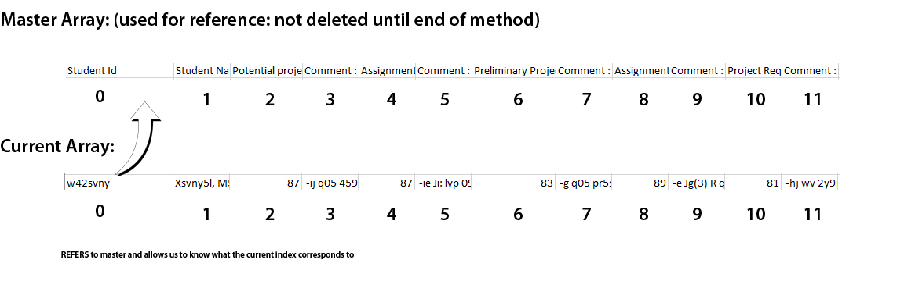

Enables us to do:

* Check master index and see if the index contains certain keywords
* Eliminates complexities with only looking at one token at a time

Issues I foresee:

* Still won’t resolve the split of first name/last name will have to add logic to account for this…
* The actual adding the assignment data to the array list, may have to make a couple of methods to pass values through two classes.
* How will we know that the assignment title corresponds to the comment after?
  + Should we look for the keyword “comment” and then compare all the assignment strings in our list to find the title and then match them up according to titles?
    - Just push every string we see that doesn’t fit certain keywords? Then match up the comments as we see them?
    - Maybe we can use a TreeMap to organize this somehow? Seems doable in an arrayList, might eliminate complexity to try a TreeMap though.
      * I think we have to have both strings before we can create an object for a TreeMap…may not be able utilize it.
    - We have to do this because sometimes there are singular grades such as an exam or project that doesn’t have a comment involved.
    - After the colon, it ALWAYS has the same string as the assignment it is associated with.