CzeLex: A megastudy dataset of concreteness, imageability, age of acquisition, valence and gender ratings for 9,601 Czech words

James Brand¹, Filip Smolík², Jan Chromý³, Markéta Ceháková³ & Mikuláš Preininger²
¹Department of Psychology, Edge Hill University, UK
²Institute of Psychology, The Czech Academy of Sciences, Czechia
³Faculty of Arts, Charles University, Czechia

Corresponding author address:
Dr James Brand
Department of Psychology
Edge Hill University
St Helens Rd
Ormskirk
L39 4QP
United Kingdom

Corresponding author email:
James.brand.ac@gmail.com

Corresponding author ORCID:
https://orcid.org/0000-0002-2853-9169

Abstract
Understanding how semantics are processed at the lexical level has been a key aim for the cognitive sciences, with large-scale semantic rating studies in different languages playing a crucial role in facilitating the advancement and development of theories of lexical processing, as well as providing valuable methodological resources that can be used in empirical investigations. In this paper, we present the CzeLex database, a megastudy of 9,601 Czech words that have been normed along 5 psycholinguistic dimensions from a large sample of 4,391 Czech speaking participants. We make available the individual rating data at the item and participant level, as well as aggregated data derived from both the mean ratings and latent means using cumulative-link mixed modelling, with a comprehensive analysis comparing the different aggregation methods. We demonstrate that the dataset has good reliability and that specific dimensions predict measures of lexical processing in a lexical decision task, irrespective of the aggregation method used. These norms are the largest available subjective rating resource for Czech and further contribute to the growing body of languages for which these dimensions have openly available data. We hope that the dataset will be a valuable resource for researchers working on Czech, in addition to opening up new opportunities for cross-linguistic semantic investigations. All data, code and analyses are available at https://osf.io/tqxfm.

Keywords: Norms; Word Processing; Lexical Semantics; Czech; Megastudy
OSF repository: https://osf.io/tqxfm

Total word count: 7,810
Abstract word count: 213

Introduction
The measurement of meaning has been a long-standing goal for interdisciplinary work in the cognitive sciences, linguistics and psychology since the early work of Osgood, Suci and Tannenbaum (1957). At the core of this work has been the production of megastudy datasets that provide normative ratings for large sets of items in a given language, which can be used as gold-standard benchmarks for experimental designs or empirical investigations. Semantic dimensions such as concreteness (Brysbaert et al., 2014a) and valence (Warriner et al., 2013) have been a cornerstone of such research, whereby large datasets can be used to quantifiably estimate the semantic representation of an item, for example knowing that trombone is more concrete and positive compared to tax, which is more abstract and negative, allowing researchers careful control and exploration of thousands of items within a given language.

Any work that aims to quantify word meaning has been motivated by theoretical perspectives not only on what a word means, but also how it is represented semantically. Some approaches assume that word meaning can be represented through relatively stable lexical content, such as semantic features or category structures (e.g., Collins & Quillian, 1969; Rosch & Mervis, 1975). Other accounts place greater emphasis on the role of inference, context and world knowledge in meaning construction (e.g., Elman, 2009). Distributional approaches, which propose that semantic representations emerge from patterns of linguistic co-occurrence, such that words derive meaning from the contexts in which they appear have also been influential (e.g., Firth, 1957; Landauer & Dumais, 1997). Finally, embodied perspectives place more emphasis on the role of perceptual, motor and affective experiences that help ground semantic knowledge (Barsalou, 1999; 2008). Normative datasets that aim to quantify semantic dimensions for the lexicon of a language, such as concreteness and valence, have acted as key resources allowing researchers to better test these theories and crucially, how to address issues related to how we understand semantic representation more broadly (see e.g. Davis & Yee, 2021; Wingfield & Connell, 2022).

The methodological approach taken to collect such normative datasets has been relatively stable, with the design involving a clear definition of the dimension being investigated, a set of items to be normed and a corresponding scale that can be used by participants to provide their subjective ratings (this is typically an ordinal Likert scale with numeric or text based choices, but see Hollis and Westbury, for alternative formats). Given a large enough sample size and a large enough item list, such megastudies can provide coverage with high reliability for a large portion of the human lexicon, meaning that researchers can freely and efficiently address novel research questions in lexical processing (e.g., Kousta et al., 2011), semantic representation (e.g., Wingfield & Connell, 2023) or careful experimental control (e.g., Taylor et al., 2020).

In recent years, there has not only been a shift in focus on which specific semantic dimensions of meaning are being normed, with a wider and diverse range of theoretically motivated datasets being published (e.g., cognition: Corenblum & Pexman, 2025; humour: Engelthaler & Hills, 2018; motivation: Giurgea et al., 2025; social-semantics: Diveica et al., 2023; Preininger et al., 2025; survival: Alonso et al., 2021; Bonin et al., 2024), but there has also been more attention on the types of languages for which these datasets are available. With the majority of studies in the literature focussing on English speaking samples from either the Canada, the US or the UK, there has been an overreliance on these datasets to study aspects of human cognition, leading to calls for broader linguistic diversity to address questions of generalisability (Berghoff & Bylund, 2025; Blasi et al., 2022; Brysbaert, 2026). The availability of diverse norming datasets across many different languages has been an area for which promising developments have been made, with a growing body of resources openly available across different language families, varieties and modalities. In Table 1, we provide an overview of the available datasets for languages that have, to the best of our knowledge at the time of writing, at least one large-scale norming study for the five dimensions covered in the current paper. Naturally, having reliable datasets available for researchers to use, leads to more diverse work on language specific phenomena (Smolík & Kříž, 2015), as well as opening up valuable new opportunities for cross-linguistic comparisons (Łuniewska et al., 2016).

--------
Table 1 here
See end of manuscript for tables/figures
--------

A further development in the literature has been the use of Large Language Models (LLMs) to generate and scale up normative datasets. For example, there now exist LLM augmented datasets for a range of different psycholinguistic variables (e.g., Conde et al., 2025, 2026; Martínez et al., 2025b, 2025a; Trott, 2024). Given the efficiencies in which these datasets can be created, in comparison to traditional crowd-sourced datasets from human participants, where financial and time constraints can limit the development of such resources, the increase in popularity of these LLM derived datasets is understandable (Heyman & Heyman, 2024). Nevertheless, an important component in ensuring the data produced using LLMs has been direct validation to the human generated datasets.

As most of the work emerging from the LLM approach has focussed predominantly on English and Spanish – languages where the models have much more training data – having large-scale ‘gold-standard’ reference points derived from human participants in different languages is more pertinent than ever if these approaches are to be validated and evaluated more widely (see Chang & Bergen, 2024; Trott, 2024b). Although there have been attempts to automatically estimate rating data using word embedding models across multiple languages (e.g., Buechel et al., 2020; Thompson & Lupyan, 2018), it is still unclear when such approaches work most accurately. Thus, human derived datasets across different languages, which have been shown to be validated and have sufficiently large samples of participants and items, remain a vital and irreplaceable resource for researchers to better test theories of word meaning and address issues related to theoretical accounts of semantic representation.

The CzeLex Norms
In this paper, we introduce the CzeLex norming database, a multidimensional set of psycholinguistic estimates for 9,601 Czech words. Each word has human derived ratings from a total sample of 4,405 participants along 5 distinct dimensions of semantic representation: concreteness, imageability, age of acquisition, valence and gender, representing the largest available resource of psycholinguistic norms for Czech. We will first outline some properties of Czech that highlight why it is a language of interest from a psycholinguistic perspective, followed by an introduction of the dimensions of interest from a theoretical standpoint and the motivation for their inclusion in the database. Next, we justify the need for different types of summative data for norming studies, emphasizing the need for other statistics than the mean, especially for ordinal based Likert scales. Finally, we outline the key aims for the present study and outline the way the norms will be validated and tested for reliability, ensuring that they can act as a ‘gold-standard’ reference point for the Czech language.

Linguistic properties of Czech
Czech is a Slavic language and has a number of properties that have made it a valuable source for studying different aspects of language processing, acquisition and representation, not only from a general perspective, but also when examining research questions of a comparative nature. There is a highly inflectional morphology, with most nouns, verbs, adjectives, numerals and pronouns appearing in different forms depending on the type of syntactic structures they are used in. Although the focus of the current paper is not on whether the semantic properties of words differ across individual inflectional forms (for example, it would not be expected that okno [window] would exhibit any large shifts in semantic representations when presented in different inflectional variants, e.g. okno, okna, oknu, okně, oknem, oken, oknům, oknech, okny), there is evidence that semantic characteristics tend to be associated with formal features such as length, and it is possible that such association also exists with inflectional properties such as number of distinct inflected forms (Reilly & Kean, 2007). Similar associations could exist with inflectional properties, such as the number of distinct inflected forms, but these possibilities cannot be properly addressed in languages with limited or absent inflectional system. Furthermore, Czech has a highly transparent orthography, where the correspondence between graphemes and phonemes is predictable. Semantic variables such as imageability were shown to affect reading in languages with opaque orthography (Bakhtiar & Weekes, 2015; Ellis & Lambon Ralph, 2000) but the pattern of effects could be different in a transparent system. Taken together, these language specific properties could allow the data to be used in a variety of novel ways to further our understanding of how structural features may interact with semantic representations during tasks such as reading.

Dimensions being normed
Below, we outline the theoretical and empirical background for each of the 5 dimensions that there is data for within the CzeLex norms. We focussed on these dimensions to ensure there is a multidimensional dataset available of distinct semantic norms for Czech, as was the case for other languages (e.g. Scott et al., 2019). Whilst there are a number of dimensions being presented, we acknowledge that this is not an exhaustive list and there are many other theoretically motivated dimensions of semantic representation (see Binder et al., 2016), that could be further investigated to better understand semantic representations.

Age of Acquisition (AoA): This dimension captures the age at which a participant subjectively assesses an item to have been acquired. Although there are a number of different methodological ways to measure this (e.g., test-based: Brysbaert & Biemiller, 2017; corpus-based Grimm et al., 2019; Smolík & Filip, 2022), it is typically estimated by asking adults to provide an estimate of the age at which they first understood the word (Kuperman et al., 2012), with values ranging from very early (e.g. mummy) to very late (e.g. taxonomy). It has been argued that words learnt earlier in life are easier to process, even when controlling for lexical variables such as frequency and length (Monaghan & Ellis, 2010; Zevin & Seidenberg, 2002), as well as predicting retention in cognitive impairment (Brysbaert & Ellis, 2016).

Concreteness: This dimension captures an aspect of sensorimotor experience, where participants are typically asked to judge the extent to which the item is either abstract (not experienced through any sensory modality or motor responses, e.g., hydrogen) or concrete (greatly experienced through one or more sensory modalities or motor response, e.g., lettuce). There is an acknowledgement that a unidimensional approach to sensorimotor experience through an abstract/concrete continuum leads to a larger bias towards visual and haptic experiences and underestimates other modalities (Brysbaert et al., 2014; Connell & Lynott, 2012). This has led to a range of different approaches to capture the underlying construct of sensorimotor experience, such as through multidimensional ratings (Lynott et al., 2020) or more specialised definitions (e.g., body-object interaction: Pexman et al., 2019; sensory experience ratings: Juhasz & Yap, 2013). Nevertheless, the theoretical importance of concreteness has allowed for a deeper understanding of the way certain concepts are processed, acquired and represented, with a focus on embodied or grounded accounts of conceptual representation (Barsalou, 2020; Borghi et al., 2019).

Gender: This dimension captures the semantic representation of gender for concepts, whereby items are typically rated along a bipolar scale anchored by feminine (e.g. womb) and masculine (e.g. beard). To our knowledge, there has only be a small number of published datasets with norms for semantic gender, in Czech (Preininger et al., 2025), Dutch (Vankrunkelsven et al., 2024) and English (Crawford et al., 2004; Scott et al., 2019), although it has been explored using corpus-based methods (see Sap et al, 2014). The dimension has been relatively underexplored in the lexical processing literature, but has been utilised in studies of linguistic relativity (e.g., Brand et al., 2025), where it is of theoretical interest when exploring hypotheses about the interaction between grammatical systems (that formally mark gender by assigning nouns a grammatical gender, e.g. masculine/feminine/neuter) and the conceptual representation of gender information (see Samuel et al., 2019).

Imageability: This dimension also captures an aspect of sensory experience, but the focus is more on the ease with which an individual can form an internal sensory image of a concept, typically assessed through a continuum of highly unimageable (e.g. theoretical) to highly imageable (e.g. carrot). Theoretically, the greater the imageability of a concept, the easier it should be to process, in line with dual coding accounts of processing (Paivio, 1990), as highly imageable concepts can utilise both verbal and nonverbal channels. Although the magnitude of imageability effects in lexical processing has been scrutinized (e.g., Dymarska et al., 2023), they have been argued to be a theoretically distinct construct to other sensorimotor based dimensions, such as concreteness (Kousta et al., 2011) and can be of specific interest for clinical studies where mental imagery is difficult, e.g. aphantasia (Muraki et al., 2023).

Valence: This dimension captures the extent to which a concept is related to emotional affect, typically through a bipolar scale anchored by negative and positive, with a neutral midpoint (Warriner et al., 2013). Although words can be classified as negative (e.g. bully), neutral (e.g. tepid) or positive (e.g. peace) along the continuum, the extent to which polarity impacts processing has been examined, with items that have high absolute valence being processed faster than neutrally valenced items (Kousta et al., 2009). This is in line with Lang et al’s (1997) motivated attention account, placing the priority on processing of motivationally significant stimuli, over ones that do not engage reward or aversion.

Data summaries for norming studies
As outlined in most of the norming studies mentioned in the paper so far, a typical methodological approach has been to use a Likert scale to collect subjective judgments from participants, which are used to capture the underlying construct of the dimension being investigated. However, when studies provide the summative data at the item level, the dominant descriptive statistics that are provided are almost exclusively the mean (as a measure of central tendency that represents the average over all participants) and the standard deviation (as a measure of variation in the data across participants). However, the sensitivity and suitability of such measures have been critiqued. The main criticism is that Likert scales are fundamentally ordinal in nature, i.e. they represent ordered categories, not a continuous metric scale, which can lead to distortions in the way the data is summarised and even introduces higher rates of Type I and Type II errors (Liddell & Kruschke, 2018). To counteract this, Taylor et al. (2023) demonstrated that, in order to account for participant-level variation and the ordinal structure of Likert scales, rating norms should be calculated using cumulative link mixed-effects models (CLMMs). Instead of using means, CLMMs allow the raw data to be modelled in a way that can utilise random effects, such as participant or item ID, and use them to account for variance in the data, but also as estimates of how those effects vary within the population, thus providing a latent estimate that can be used as the summative norm.

Another benefit of using the CLMM approach is the option to utilise Bayesian methods in the modelling of the estimates, a point highlighted by both Taylor et al. (2023) and Veríssimo (2021), where convergence issues are removed and flexibility in the complexity of the model can also be increased. Whilst having a traditional mean as the summary variable for a norming database is useful for comparison to existing datasets, often the raw data is not publicly available to derive CLMM based estimates, so there still remains the question of whether the approaches lead to meaningful differences when validating the norms in lexical processing tasks.

Aims of the present study
The core aims of the present study are:
- To make openly available a novel dataset that provides normative estimates for a large set of Czech words with good validity, along with the raw participant-level response data and basic demographic information for each of the participants.
- Validate the resulting norms through a series of analyses that use them as predictors in regression models predicting performance on a lexical decision task focussing on accuracy and reaction times (RTs).
- Assess the extent to which different aggregation methods – traditional means or CLMM derived latent means – provide any differences in the outcomes when predicting lexical processing.
- Outline potential future uses of the norms as a large-scale gold-standard human derived dataset.

Method

Participants
A total of 4,626 participants were originally recruited to participate in the study and were recruited using a university wide participant pool at Charles University, located in Prague, Czechia. Participants took part for course credit. We subsequently filtered out any participants who reported that Czech was not their native language (n = 217), in addition to any participant who reported to be under the age of 18 years (n = 3). One participant was further removed on the basis of quality checks, see data filtering section below. The final participant sample comprised 4,406 participants (3,350 females, 1,022 males, 23 non-binary, 10 undisclosed, Median_{age} = 21, SD_{age} 4.73, range_{age} = [18:62]). Ethical approval was granted by the Charles University ethics committee.

Stimuli
Our original stimuli set comprised 9,723 items, which spanned a range of different parts of speech. The items were derived from two different sources - firstly, the HeCz corpus (Chromý et al., 2025), which sourced newspaper headlines from a popular Czech newspaper website seznamspravy.cz for a self-paced reading corpus, and secondly the SocioLex database (Preininger et al., 2025), which is a large socio-semantic norming study on Czech. After a number of data cleaning steps were applied to the raw data (see subsection below), our final dataset contained a total of 9,601 items for which we had at least 10 ratings for a dimension. There were 1,745 adjectives, 5,713 nouns, 1,462 verbs and 681 items that had a different part of speech (such as adverbs, propositions, numerals, conjunctions), see (Chromý et al., 2025) for details on the morphological annotation.

Procedure
The experiment was programmed using jsPsych (De Leeuw, 2023) and was accessible online via a browser, with a JATOS server being used to host and store the data (Lange et al., 2015). We set up the experiment so that participants could only complete it using Google Chrome on non-mobile devices, this was to ensure there were no technical differences across participants in the way the experiment was presented visually. All code and scripts for the experiment are available on the OSF repository. Participants first read a detailed instruction page, provided informed consent and completed a brief demographic questionnaire. Participants were then asked to rate each of the words from a randomly selected list (each starting with a calibrator word followed by a randomly ordered set of 121, or 122 words). Each list contained a range of words with different parts of speech, specifically we ensured that each list would contain 18/19 adjectives, 70/71 nouns, 20/21 verbs and 11/12 items that had a different part of speech. Participants rated a different list of words for each of the dimensions, with all participants being presented with all 5 of the dimensions during the experiment, but the lists were always randomly assigned within participants, so they never completed the same list of words across dimensions. There were 80 different lists of words in total.

Within each list there was also a control word that was presented randomly with the other items. The calibrator words were included to ensure that participants were using the scale as intended at the very start of rating each dimension, whereas the control words were included primarily as a quality check within each dimension to ensure participants were rating the items in a suitable manner. See the data cleaning section for more details on this. Both the calibrator and control words were selected on the basis of them having reliable ratings with low variance in a pilot version of the experiment. See Table 2 for details of what the calibrator and control words were for each of the dimensions.

The instructions given to participants for each dimension, together with their English translations, can be found on the OSF repository, with a screenshot for the imageability dimension provided in Figure 1. Participants were presented each dimension sequentially, with the order of presentation for dimensions and items being randomised for each participant (apart from AoA which was always the final dimension to be presented, and the calibrator words, which were always the first to be presented). All dimensions included an additional option for each item where participants could choose “toto slovo neznám”, indicating that they did not know the meaning of the word, so no rating for that item was provided.

-----------------
Table 2 here
See end of manuscript for tables/figures
-----------------
-----------------
Figure 1 here - experiment_imageability.png
See end of manuscript for tables/figures
-----------------

Data cleaning
All cleaning, processing and analyses reported below were conducted using R version 4.5.2 (R Core Team, 2025). All the code and data (raw and processed) can be found in the OSF repository. Following the initial demographic filtering of native language and age, we carried out a number of data quality checks to ensure that we detected any low-quality responses/participants; this process is visualised in Figure 2. The code used to run these checks can be found in the OSF repository.

- Word knowledge: Across the whole sample, the mean number of items reported to be unknown by participants was very small at ~4%. Therefore, we decided to remove data on a per-dimension basis, whereby any participant who reported not knowing >25% of the items for a given dimension would have the data for that dimension removed, which resulted in the removal of 4,253 rows of data. Although no individual participant was completely removed as a result of this, 33 participants were affected.

- Straightlining: We inspected the variance in the participants’ ratings to identify ‘straightliners’, i.e. participants who selected the same response for the majority of the items (Kim et al., 2019; Winter et al., 2024). If a participant straightlined on more than 95% of the items for a dimension, we removed the data for that participant on that dimension. This led to the removal of 6,237 rows of data affecting 45 participants, including the complete removal of 1 participant.

- Calibrator/control words: We analysed the responses to the calibrator and control words for each of the five dimensions to ensure that participants could demonstrate that they were using the rating scales as expected. For each calibrator/control word, we identified participants who responded to the word in the opposite side as expected. For example, the word štěstí [happiness] for the valence dimension was expected to have a response somewhere on the positive side of the scale, so if a participant responded to this word as negative in any way, this would be flagged. Any participant who responded to both the calibrator and control items in the opposite direction to our original expectations would have their data for the dimension removed. This resulted in 903 rows of data being removed, affecting 7 participants, although no participant was removed completely.

- AoA responses: In order to address some issues with the free response data on the AoA dimension, we conducted the following filtering steps. If a participant provided an age that was higher than reported age, e.g. saying a word had an AoA of 28 when they reported being 20, we removed this data at the item level. Similarly, we also removed any data containing negative values, e.g. -5. If any participant had more than 10 items where either of the first two conditions were flagged, we removed their data for the AoA dimension altogether. These steps led to the removal of 282 rows of data, affecting 23 participants, but no participant was removed from the data completely.

- Low N words: In order to ensure each item had sufficient data to obtain a reliable estimate for the dimension, we applied a filter to remove any item with <10 responses (as was the case in Winter et al., 2024). This resulted in the removal of 25,844 rows of data, with 352 items affected. Although an item may have a low N for a specific dimension, we did not remove the item completely if it had sufficient N ratings on other dimensions.

-----------------
Figure 2 here - data_filtering.png
See end of manuscript for tables/figures
-----------------

Additional lexical and processing variables
To supplement our dataset, we also provide a number of additional variables that researchers may find useful for additional analyses or to control for when choosing stimuli. As these are not readily available for Czech, but are used in subsequent analyses within this paper, we will provide a brief overview of how these variables were computed or collected. However, we would like to highlight that these variables are not the core focus of the current paper, and we would like to direct readers to Brand et al. (in prep) for a more focussed write up related to them.

ZipfFrequency: Using the SYN2025 corpus of Czech from the Czech National Corpus (Křen et al., 2025), we extracted frequency counts for each item in our corpus, excluding any bigram items. This retuned data for 9,316 items for which there was a frequency count greater than or equal to 1. We then manually coded any remaining unigram items as having a frequency of 0, which applied to 161 items. These values were then converted to a Zipf frequency score (Van Heuven et al., 2014).

OLD20: This is a measure of Orthographic Levenstein Distance, where the values represent the average edit distance in order to transform the item into its 20 nearest neighbours, with low values representing dense neighbourhoods, and large values more sparse neighbourhoods (Yarkoni et al., 2008). The corpus used to calculate this was the Phonological Corpus of Czech (Bičan, 2011), which contains phonological coding for 275,779 words. OLD20 values were calculated using the vwr package in R.

nchar: The orthographic length of the item. This was calculated as the string length in characters, ignoring any whitespace.

rt_intercept: In order to acquire an estimate of lexical processing time, we used reaction times from a large lexical decision task (Brand et al., in prep). The design followed a standard lexical decision paradigm where participants were asked to respond to orthographic word forms on the basis of whether they believed the word to be a real Czech word or not by pressing a button on a keyboard. The experiment was conducted online, and participants were recruited from the same university participant pool as used in the current paper, so their demographics were closely matched for age and gender. Using the raw response data for reaction times (RTs) where participants responded accurately to the item, we ran a linear mixed-effects model, with a global intercept and random intercepts for participant and item, meaning there were no fixed effects included as we did not wish to control for any predictor variables. We then extracted the random intercepts for the item variable, which are mean centred around 0 with lower values representing faster processing times, and higher values representing slower processing times. This approach was preferred over using just the standard mean aggregation, as the values do not need to be log transformed, and they account for other sources of variation at the participant level, see Drager and Hay (2012) for more details on this.

acc_intercept: Using the same data as was used in the calculation of the rt_intercept values, we estimated the accuracy of responses to the items using a generalised linear mixed-effects model, predicting whether the participant had an accurate response (coded as 1) or an inaccurate response (coded as 0). We use the same basic model with random intercepts for participant and item, and extracted the intercepts for the item variable. These values were then used as estimates of accuracy for each item, with lower values representing lower accuracy and higher values representing greater accuracy.

Analysis and Discussion
Our analysis will focus on a range of different approaches to demonstrate the way the raw data can be used for: 1) providing a general description of the data, 2) exploring the relationships between the dimensions and linguistic variables, 3) aggregation into summary estimates, 4) assessing the validity of the summary estimates when predicting measures of lexical processing. Prior to all analyses, we converted the rating data into numeric values, with all responses that were coded as the participant not knowing the meaning of the word as NA values. All analyses reported were conducted in R version 4.5.2, with all scripts available on the OSF repository.

Descriptive statistics

Reliability
In order to assess whether there was good reliability in the ratings for the items, we analysed the raw data using a Intraclass Correlation Coefficient (ICC). This was achieved by using the ICC2.lme function from the psychometric package. This was set up as a linear mixed-effects regression model, predicting the rating value by a random intercept for item and a global intercept as a fixed effect (see Brysbaert, 2019). These were run separately for each dimension, with the results indicating very good reliability across all dimensions: AoA = .98; concreteness = .96; gender = .97; imageability = .93; valence = .97.

Traditional data summaries
As a first step in the analysis of the ratings, we calculated the standard descriptive statistics for each item across each dimension. This included the number of participants who rated the word (n_sample), the number of participants who provided a rating, i.e. not reporting they did not know the meaning of the word (n_known), the proportion of responses that were given, i.e. n_sample/n_known (prop_known). We also calculated basic summary estimates that aggregated the ratings to give the mean and standard deviation (SD). See Figure 3 for a visualization of the aggregated data and Table 2 for examples of words across the range of values based for each dimension. As an additional check of validity, we compared our ratings to those from previous studies on Czech using a Pearson’s correlation analysis, specifically for AoA (Łuniewska et al., 2019), imageability (Smolík, 2019), gender and valence (Preininger et al., 2025), all correlations were found to be very strong (all having r > XX).

-----------------
Figure 3 here - descriptive_plot_all.png
See end of manuscript for tables/figures
-----------------

Relationships between variables
As an exploratory analysis, we decided to explore the correlations between the variables we have collected data for, in addition to a number of lexical variables related to each item. Although not underpinned by any specific theoretical motivation, we were expecting trends in the data that have been previously reported, e.g. strong correlation between concreteness and imageability, AoA to be strongly correlated with word frequency.

The results of the correlation analysis are visualized in Figure 4. As this was an exploratory analysis, we do not provide any null hypothesis significant testing, and simply report the Pearson’s correlation coefficients, to be used as a descriptive indicator of relationship strength. Figure 4 also presents scatter plots of the data, with linear and non-linear fits, which indicates that some of the relationships may be better fit with non-linear models.

-----------------
Figure 4 here - correlation_plot_matrix.png
-----------------

Given the number of correlations presented, we will not report on each individual relationship. However, there were a number of particularly strong linear relationships that can be observed. Concreteness and imageability had the strongest relationship within the five dimensions (r = .796), a pattern that has been well documented in previous studies ; Scott et al., 2019, with Scott et al reporting r = .91), whilst more modest relationships were found between gender and valence (r = .218), replicating the finding in Scott et al (2019) that more feminine words were evaluated more positively (with their study reporting r = -.42, although their gender scale was in the reverse direction to the present study). Likewise, there was also a negative relationship between AoA and imageability/concreteness (r = -.382 and -.216 respectively), with more imageable/concrete items being acquired earlier, which again was reported in Scott et al’s (2019) analysis (with their study reporting r = -.49 and r = -.38 respectively). We do note that compared to Scott et al’s results, the correlations reported here are evidently slightly smaller in size, this may be as a result of a much larger set of items that cover a more diverse lexical inventory. Nevertheless, the patterns are consistent across the English and Czech analyses.

Aggregation methods

Cumulative Link Mixed Effects Models
In section Descriptive statistics, we reported norming summaries using the mean, which is a typical approach used when aggregating rating data from Likert scales, treating the individual item and participant-level ratings as integer values (e.g., very negative on our valence scale coded as –3). However, this approach may not be an optimal way to aggregate such data, as means fail to respect the ordinal nature of Likert-scales (see Liddell & Kruschke, 2018; Veríssimo, 2021). Following the recommendations of Taylor et al. (2023), we instead modelled participant responses using CLMMs implemented in the ordinal package (Christensen, 2018) in R. These models account for variation introduced by participant-specific response biases and thus yield a more accurate estimate of the normative value for each item. For each dimension, we fitted a separate model predicting participant responses (coded as an ordinal factor, e.g. for valence, –3 < –2 < –1 < 0 < 1 < 2 < 3) with random intercepts for both item and participant. From these models, we extracted the random intercepts for each item, which provided numeric estimates of the latent means across each dimension.

Bayesian Models
As an additional aggregation method, Taylor et al. (2023) also demonstrated that these models can be fit in a Bayesian framework using the brms package (Bürkner, 2017; see also Bürkner & Vuorre, 2019), where latent means for items can again be estimated. An additional benefit outlined by Taylor et al. (2023) for using this approach is the ability to estimate a latent measurement of variance in the ratings, which are estimated from ordered regions of the Likert scale, contrasting from the traditional metric of calculating a standard deviation (SD) that are derived from a continuous representation of the Likert scale. A core argument against using the SD as a measure of variance with Likert scale responses is that meaningful differences in the way participants respond to the item being rated, for example when rating ambiguous or polysemous items (Filipović Đurđević & Kostić, 2017), can be conflated with response biases introduced by the participants. To overcome this, Taylor et al. demonstrate that modelling the ordinal ratings using a Bayesian framework allows for the estimation of a latent SD, enabling meaningful variation to be captured, with less influence from participant level artefacts.

Comparison of methods
In the analysis below, we explored the extent to which the different methods of estimating the norms may result in different patterns for item-level values. To do this, we first used the traditional summary statistics reported in Section Descriptive statistics for the mean and SD. Next, we ran CLMMs for each dimension, extracting the item intercepts from each model, which we will refer to as ‘clmm’ values. Finally, we fitted CLMMs using a Bayesian framework using brms models, with the same structure as the clmm method, but with the addition of a discrimination parameter that was used as a predicted variable, with the same random effects structure (see Taylor et al., 2023 for more details or the OSF repository for full model specifications). This method gave us both a latent mean, which we will refer to as ‘brms’ values, in addition to a latent SD, which we will refer to as ‘latent SD’. Note, that we did not run models for AoA, as the nature of the data was not taken to be ordinal, as participants were asked to provide a numeric estimate of the AoA values, not through a Likert scale response. As we are not specifically interested in hypothesis testing within this analysis, we will only provide a descriptive overview of the trends in the data and not report any null-hypothesis significance testing.

Item estimates
As we can see from Figure 5, there is generally strong alignment across all the different approaches when estimating the item norms, with Pearson’s correlation coefficients all being r > .93. This indicates that even though there was variation in the estimates across items for the different approaches, there is generally a very strong linear relationship. The most salient difference was observed when comparing the data within the imageability dimension, where there is a slight cubic non-linear relationship when the clmm and brms estimates are compared to the mean (plots A and B of Figure 5). This is also observed, in a weaker way, with the concreteness data, where like the imageability means, there is a skewed distribution towards the higher values of the scale. However, when comparing the clmm and brms estimates (plot C of Figure 5), we can observe no distinct differences in the relationships, indicating that the two estimates are very strongly related across all dimensions.

-----------------
Figure 5 here - summary_data_comparison.png
See end of manuscript for tables/figures
-----------------

Item variance
As we can see from Figure 6, there are some differences in the relationships between the item estimates (Figure 6A using the mean and Figure 6B using brms) and the way variance was estimated using the traditional SD (turquoise data) and the latent SD (red data) from brms modelling. The trends for the relationship between the mean and SD appear to be similar to previously reported patterns, i.e. smaller SD at the largest values of the scales for concreteness and imageability, whereas the polar values for gender and valence have smaller SD values, with the greatest spread in SD values around the neutral mid-point. These patterns are also seen when using the brms estimates, which is unsurprising given the strong correlation of those values with the mean.

When inspecting the relationships between the latent SD and estimates using the mean and brms values, we observe a similar pattern to that reported by Taylor et al. (2023), there is no longer a distinct trend for extreme values to have lower variance. This suggests that the approach reduces the artefact of response biases and instead preserves the meaningful variability that exists within the ratings. For variables where there is neutral mid-point – gender and valence – there still remains a similar, but perhaps weaker, trend as observed for the traditional SD, i.e. the items with a value around the midpoint have the largest spread of latent SD values. This could indicate that items that have a norm that have been estimated to be around the neutral mid-point may simply have a very uniform rating, where most raters identify it as neutral, whereas other items this may be averaged over due to meaningful variation across raters.(Chromý et al., 2025)

-----------------
Figure 6 here - sd_data_comparison.png
See end of manuscript for tables/figures
-----------------

Predicting measures of lexical processing
In order to assess the validity of the norms, we provide an analysis that aims to assess the extent to which measures of lexical processing can be predicted by the normative estimates across the different dimensions. To do this, we modelled data using a hierarchical regression approach predicting values from a lexical decision task, focussing on the reaction times (RT) and response accuracy for the items (see Section 3 for a description of these variables). This is a standard procedure to assess validity of semantic norms and each of the variables have previously been reported to have significant effects in other languages (e.g. AoA: Kuperman et al., 2012; concreteness: Bonin et al., 2018; gender: Preininger et al., 2025; imageability: Khanna & Cortese, 2021; valence: Kousta et al., 2009). In total, we had complete cases for 9,243 items, and all analyses reported in this subsection use this dataset.

As a first step, we created baseline models for both RT and accuracy using a simple linear regression with predictor variables of Zipf frequency, orthographic length and OLD20. After assessing the variance inflation factors (VIFs) for the models, there was a potential issue with including both orthographic length and OLD20 (VIFs = 4.44 and 4.90 respectively), so we decided to exclude the orographic length variable as OLD20 has been reported to be a more theoretically interesting variable (Yarkoni et al., 2008). The baseline model was used to account for variance explained by linguistic variables, which are known to be reliable predictors of lexical processing.

Our next modelling step included the psycholinguistic variables collected in the current study – AoA, concreteness, gender, imageability and valence. All of these variables were treated as continuous values, however we did transform the valence variable into absolute values to ensure that polarity was not a factor (Kousta et al., 2009). After inspecting the VIFs for the models, we found that both concreteness and imageability both had values around 4.00 (concreteness = 3.92 and imageability = 4.00), as the two dimensions also are theoretically capturing similar constructs, we decided to drop the concreteness variable from the analyses to avoid any potential sources of collinearity and because imageability effects are more consistent in analyses of lexical decision measures (Connell & Lynott, 2012).

We ran three separate versions of these models using the estimates from the mean, clmm and brms methods. This allows us to then compare whether the different methodologies of aggregating the norms provide differing results, although we did not predict any major differences, we did want to explore this as an additional level of analysis.

For reference, as we were using measures for RTs and accuracy derived from mixed-effects modelling, instead of the traditional descriptive statistic of the mean, we conducted parallel analyses of all the results reported below and found no indication that the two approaches led to any differences in the pattern of results, indeed they were almost identical in terms of the general patterns being reported. Whilst there are mixed views on the suitableness of using both the random intercepts (see Houslay & Wilson, 2017; Kliegl et al., 2011) and the mean (Baayen et al., 2008; Drager & Hay, 2012), we report below only the analysis from the random intercepts approach as we feel it provides more control over participant-level variance, which although is outside the scope of the present paper, is explored further in Brand et al (in prep).

RTs
The baseline model had an adjusted R² = .411, with both Zipf frequency and OLD20 being significant predictors of RTs. In the second step, all three different models significantly improved the model fit (all p’s < .001), with adjusted R² = .541 and ΔR² = .130 for the model with the mean values, adjusted R² = .533 and ΔR² = .122 for the model with the clmm values, and adjusted R² = .527 and ΔR² = .116 for the model with the brms values. All of the variables added in this step were significant, see Figure 7 for the standardised coefficient for each of the variables across each of the models.

Accuracy
The baseline model had an adjusted R² = .197, with both Zipf frequency and OLD20 being significant predictors of RTs. In the second step, all three different models significantly improved the model fit (all p’s < .001), with adjusted R² = .381 and ΔR² = .184 for the model with the mean values, adjusted R² = .380 and ΔR² = .183 for the model with the clmm values, and adjusted R² = .378 and ΔR² = .181 for the model with the brms values. All of the variables added in this step were significant, see Figure 7 for the standardised coefficient for each of the variables across each of the models.

-----------------
Figure 7 here - coeffs_full_plot.png
See end of manuscript for tables/figures
-----------------

The pattern of result across each of these analyses align with previously reported findings. For the effect of AoA, items that were acquired earlier were processed faster and with higher accuracy than items that were acquired later. For gender, items that were more feminine were processed faster and with higher accuracy than items that were more masculine. For imageability, items that were easier to imagine were processed faster and with higher accuracy than items that were harder to imagine. For absolute valence, items that were either more positive or negative or process faster and with higher accuracy than items with neutral valence. Although there are some minor differences in the amount of variance explained by the different aggregation methods, we would be hesitant to interpret this as clear evidence in support of using one aggregation method over others.

General Discussion
The present paper has introduced the largest database of psycholinguistic normative ratings for Czech words currently available for researchers, covering a multidimensional space of 5 distinct variables – AoA, concreteness, imageability, gender, and valence. Our first aim was focussed on ensuring the dataset was transparent, accessible and had good reliability, which was addressed through a transparent data processing procedure, making both the raw and summary data freely available to those who wish to use it, as well as including all analysis code so that the analyses can be reproduced easily. Our analysis has presented a range of descriptive statistics within each of the individual variables we collected data for, in addition to exploring the relationships between each of the variables. The distribution of ratings differed depending on the specific dimensions, with concreteness and imageability having a skew towards higher values (more concrete/imageable) and AoA having a skew towards lower values, whereas gender and valence had a much more normal distribution with ratings typically around the neutral mid-point. Such patterns are quite typical and have previously been observed for these dimensions in previous norming studies, see for example Scott et al. (2019).

Our second aim related to assessing the validity of the norms, which was addressed through an analysis of lexical processing measures obtained through a lexical decision task (RTs and accuracy). The results of the analysis revealed expected effects for all of the variables, with the model explaining more variation than a baseline with just linguistic predictors included. Specifically, we observed that items that were acquired earlier, more feminine, more imageable and had a larger absolute valence, all had faster RTs and higher accuracy within a lexical processing experiment, aligning with results from previously reported analyses in other languages (e.g., Khanna & Cortese, 2021; Kousta et al., 2009; Kuperman et al., 2012; Preininger et al., 2025).

Our third aim was focussed on investigating differences across different aggregation methods, with an assessment of item summary estimates and variance being the key measures of interest. Using the raw rating data, we calculated estimates from basic descriptive statistics (the mean and SD) as well as latent values from ordinal mixed-effects modelling using frequentist maximum likelihood to obtain latent means (clmm), as well as using a Bayesian framework to gain both latent means (brms) and SDs, following Taylor et al’s (2023) approach. Although there were no major differences across the aggregation methods for the summary estimates, with all methods correlating highly with each other, there were nuanced differences. When comparing the traditional mean to the latent estimates, the variables of concreteness and imageability had a weakly non-linear relationship, a pattern not observed for the gender and valence variables. This may be explained by the distribution of the ratings along the scales, with both imageability and concreteness having a positive skew towards higher values on the scale, with no clearly defined neutral mid-point. This contrasts with the normal distributions observed for gender and valence, which also have a clearly interpretable neutral mid-point, suggesting that participant level differences in the way participants use the scale are not accurately captured using a summary value such as the mean, but are captured in ordinal mixed-effects modelling approaches, as has been previously argued in the literature (see Liddell & Kruschke, 2018; Taylor et al., 2023; Veríssimo, 2021).

When investigating whether the different aggregation methods lead to differences when used to predict measures of lexical processing, we again note that there were only very subtle differences in the fixed-effect estimates, but no substantial differences in the overall inferences – all the variables were significant predictors for RTs and accuracy irrespective of the aggregation method used. Although some variables had estimates that appeared to slightly differ in magnitude, for example imageability, we would highlight that larger coefficients in the model would not indicate that the aggregation method is any way superior. We would instead advocate again that the estimates derived from mixed-models provide a more reliable estimate of the items normative rating when compared to the traditional mean.

Given the computational demands when running the brms models (each model took approximately 14 hours to complete using 6 chains and 6 cores on a standard computer device without a cluster), we would follow the recommendations of Taylor et al. (2023), who suggest that clmm models are a practical and efficient way to model data for rating norms, whilst also minimising the influence of response bias that would be introduced from multiple participants, therefore offering a more suitable alternative to the traditional mean.

One benefit of using brms modelling can be observed if researchers are particularly interesting in using estimates of item variance. For example, when inspecting the differences between the traditional estimates of variance in the ratings, specifically the SD, and comparing them to estimates derived from ordinal mixed-effects modelling, specifically the latent SD, we observed differences that aligned to Taylor et al’s (2023) results. Response patterns appear to influence the distribution of SD values when compared to item estimates for the ratings, i.e., the mean or brms values, with lower SD values when the item estimates are at the edges of unidirectional scales, e.g. the lowest and highest values such as concreteness and imageability, or also at the neutral mid-point for gender and valence when the scale is more bipolar. This contrasts with the latent SD estimates, where the influence of response patterns appears to also be much more reduced, leading to estimates that more reliable capture variance in the item’s ratings.

Our final aim concerns the wider usage of the norms, specifically as they represent the largest multidimensional dataset of human-derived ratings for a large set of Czech words. Given the current interest and growth in datasets that can be used for research in psychology, linguistics, or the cognitive sciences, these norms will hopefully open up new avenues for researchers working on Czech, allowing them to address new research questions related to acquisition, processing and use, or simply for controlling semantic variables for experimental design.

Moreover, these norms offer a valuable addition to the existing bank of megastudy resources already available for the dimensions of AoA, concreteness, gender, imageability and valence, providing more opportunities for cross-linguistic research on semantic representations. Finally, the opportunity to utilise the raw and summary data alongside LLMs to extrapolate a larger dataset of norms that covers the wider lexicon would be a tangible future direction. Although work using LLMs for this purpose is still relatively novel, there remains a clear need for gold-standard datasets derived from human participants to benchmark such estimated values to, with very little work published that has been applied to languages outside of heavily resourced languages.

In summary, we have presented in the present paper the largest multidimensional psycholinguistic norming dataset for Czech, providing not only the summary values across the dimensions for a large set of Czech words, but also the participant-level response and a range of different aggregation summaries for both the item estimates of ratings and the variance within those ratings.

Funding
The study was funded by the Czech Science Foundation (GAČR), project No. 23-06796S. The funders had no role in the study design, data collection and analysis, decision to publish, or preparation of the manuscript.

Conflicts of interest/Competing interests
The authors declare that the research was conducted in the absence of any commercial or financial relationships that could be construed as a potential conflict of interest.

Ethics approval
This research was conducted with ethical approval obtained from the ethics committee at Charles University.

Consent to participate
All participants provided informed consent prior to participation in the study. They were informed about the purpose of the research, their right to withdraw at any time, and the measures taken to ensure their confidentiality and anonymity.

Consent for publication
All participants involved in this study provided consent for the use of their anonymized data for publication purposes. Participants were informed that their confidentiality and anonymity would be strictly maintained and that any identifying information would be removed before publication.

Availability of data and materials
The anonymised raw data and summary data, as well as the materials and stimuli from the experiments reported in this paper can be accessed on the Open Science Framework at this link: https://osf.io/tqxfm

Code availability
All code used in the data preprocessing, filtering and analysis from the experiments reported in this paper can be accessed on the Open Science Framework at this link: https://osf.io/tqxfm

References
Alonso, M. A., Díez, E., & Fernandez, A. (2021). A set of 750 words in Spanish characterized in two survival-related dimensions: Avoiding death and locating nourishment. Behavior Research Methods, 53(1), 153–166. https://doi.org/10.3758/s13428-020-01434-z
Baayen, R. H., Davidson, D. J., & Bates, D. M. (2008). Mixed-effects modeling with crossed random effects for subjects and items. Journal of Memory and Language, 59(4), 390–412.
Bakhtiar, M., & Weekes, B. (2015). Lexico-semantic effects on word naming in Persian: Does age of acquisition have an effect? Memory & Cognition, 43(2), 298–313. https://doi.org/10.3758/s13421-014-0472-4
Barsalou, L. W. (1999). Perceptual symbol systems. Behavioral and Brain Sciences, 22(4), 577–660.
Barsalou, L. W. (2008). Grounded Cognition. Annual Review of Psychology, 59(1), 617–645. https://doi.org/10.1146/annurev.psych.59.103006.093639
Barsalou, L. W. (2020). Challenges and Opportunities for Grounding Cognition. Journal of Cognition, 3(1), 31. https://doi.org/10.5334/joc.116
Berghoff, R., & Bylund, E. (2025). Diversity in research on the psychology of language: A large-scale examination of sampling bias. Cognition, 256, 106043. https://doi.org/10.1016/j.cognition.2024.106043
Binder, J. R., Conant, L. L., Humphries, C. J., Fernandino, L., Simons, S. B., Aguilar, M., & Desai, R. H. (2016). Toward a brain-based componential semantic representation. Cognitive Neuropsychology, 33(3–4), 130–174. https://doi.org/10.1080/02643294.2016.1147426
Blasi, D. E., Henrich, J., Adamou, E., Kemmerer, D., & Majid, A. (2022). Over-reliance on English hinders cognitive science. Trends in Cognitive Sciences, 26(12), 1153–1170. https://doi.org/10.1016/j.tics.2022.09.015
Bonin, P., Méot, A., & Bugaiska, A. (2018). Concreteness norms for 1,659 French words: Relationships with other psycholinguistic variables and word recognition times. Behavior Research Methods, 50(6), 2366–2387. https://doi.org/10.3758/s13428-018-1014-y
Bonin, P., Thiebaut, G., & Méot, A. (2024). Ratings of survival-related dimensions for a set of 732 words, their relationships with other psycholinguistic variables and memory performance. Current Psychology: A Journal for Diverse Perspectives on Diverse Psychological Issues, 43(9), 8200–8218. https://doi.org/10.1007/s12144-023-04979-2
Borghi, A. M., Barca, L., Binkofski, F., Castelfranchi, C., Pezzulo, G., & Tummolini, L. (2019). Words as social tools: Language, sociality and inner grounding in abstract concepts. Physics of Life Reviews, 29, 120–153. https://doi.org/10.1016/j.plrev.2018.12.001
Brand, J., Preininger, M., Kříž, A., & Ceháková, M. (2025). Feminine fox, not so feminine box: Constraints on linguistic relativity effects for grammatical and conceptual gender. Language and Cognition: An Interdisciplinary Journal of Language and Cognitive Science, 17. https://doi.org/10.1017/langcog.2025.3
Brysbaert, M. (2019). How many participants do we have to include in properly powered experiments? A tutorial of power analysis with reference tables. Journal of Cognition, 2(1), 16.
Brysbaert, M. (2026). Diversity, equity and inclusion in language research: Addressing English-centricity. Research Methods in Applied Linguistics, 5(1), 100286. https://doi.org/10.1016/j.rmal.2025.100286
Brysbaert, M., & Biemiller, A. (2017). Test-based age-of-acquisition norms for 44 thousand English word meanings. Behavior Research Methods, 49(4), 1520–1523. https://doi.org/10.3758/s13428-016-0811-4
Brysbaert, M., & Ellis, A. W. (2016). Aphasia and age of acquisition: Are early-learned words more resilient? Aphasiology, 30(11), 1240–1263. https://doi.org/10.1080/02687038.2015.1106439
Brysbaert, M., Warriner, A. B., & Kuperman, V. (2014). Concreteness ratings for 40 thousand generally known English word lemmas. Behavior Research Methods, 46(3), 904–911. https://doi.org/10.3758/s13428-013-0403-5
Buechel, S., Rücker, S., & Hahn, U. (2020). Learning and Evaluating Emotion Lexicons for 91 Languages (arXiv:2005.05672). arXiv. https://doi.org/10.48550/arXiv.2005.05672
Bürkner, P.-C. (2017). brms: An R package for Bayesian multilevel models using Stan. Journal of Statistical Software, 80, 1–28.
Bürkner, P.-C., & Vuorre, M. (2019). Ordinal Regression Models in Psychology: A Tutorial. Advances in Methods and Practices in Psychological Science, 2(1), 77–101. https://doi.org/10.1177/2515245918823199
Chang, T. A., & Bergen, B. K. (2024). Language Model Behavior: A Comprehensive Survey. Computational Linguistics, 50(1), 293–350. https://doi.org/10.1162/coli_a_00492
Christensen, R. H. B. (2018). Cumulative link models for ordinal regression with the R package ordinal. Submitted in J. Stat. Software, 35, 1–46.
Chromý, J., Ceháková, M., & Brand, J. (2025a). The HeCz corpus: A large, richly annotated reading corpus of newspaper headlines in Czech. Behavior Research Methods, 57(12), 345. https://doi.org/10.3758/s13428-025-02863-4
Conde, J., Martínez, G., Grandury, M., Arriaga, C., Haro, J., Schroeder, S., Hintz, F., Reviriego, P., & Brysbaert, M. (2026). Updating the German Psycholinguistic Word Toolbox with AI-Generated Estimates of Concreteness, Valence, Arousal, Age of Acquisition, and Familiarity. Journal of Cognition, 9(1), 9. https://doi.org/10.5334/joc.482
Conde, J., Saiz, M. G., Grandury, M., Reviriego, P., Martínez, G., & Brysbaert, M. (2025). Psycholinguistic Word Features: A New Approach for the Evaluation of LLMs Alignment with Humans. In O. Arviv, M. Clinciu, K. Dhole, R. Dror, S. Gehrmann, E. Habba, I. Itzhak, S. Mille, Y. Perlitz, E. Santus, J. Sedoc, M. Shmueli Scheuer, G. Stanovsky, & O. Tafjord (Eds), Proceedings of the Fourth Workshop on Generation, Evaluation and Metrics (GEM²) (pp. 8–17). Association for Computational Linguistics. https://aclanthology.org/2025.gem-1.2/
Connell, L., & Lynott, D. (2012). Strength of perceptual experience predicts word processing performance better than concreteness or imageability. Cognition, 125(3), 452–465. https://doi.org/10.1016/j.cognition.2012.07.010
Corenblum, H. T., & Pexman, P. M. (2025). Cognition ratings for 8826 english words. Behavior Research Methods, 57(7), 181. https://doi.org/10.3758/s13428-025-02663-w
Crawford, J. T., Leynes, P. A., Mayhorn, C. B., & Bink, M. L. (2004). Champagne, beer, or coffee? A corpus of gender-related and neutral words. Behavior Research Methods, Instruments, & Computers, 36(3), 444–458. https://doi.org/10.3758/BF03195592
Davis, C. P., & Yee, E. (2021). Building semantic memory from embodied and distributional language experience. WIREs Cognitive Science, 12(5), e1555. https://doi.org/10.1002/wcs.1555
De Leeuw, J. R. (2015). jsPsych: A JavaScript library for creating behavioral experiments in a Web browser. Behavior Research Methods, 47, 1–12. https://doi.org/10.3758/s13428-014-0458-y
Diveica, V., Pexman, P. M., & Binney, R. J. (2023). Quantifying social semantics: An inclusive definition of socialness and ratings for 8388 English words. Behavior Research Methods, 55(2), 461–473. https://doi.org/10.3758/s13428-022-01810-x
Drager, K., & Hay, J. (2012). Exploiting random intercepts: Two case studies in sociophonetics. Language Variation and Change, 24(1), 59–78. https://doi.org/10.1017/S0954394512000014
Dymarska, A., Connell, L., & Banks, B. (2023). Weaker than you might imagine: Determining imageability effects on word recognition. Journal of Memory and Language, 129, 104398. https://doi.org/10.1016/j.jml.2022.104398
Ellis, A. W., & Lambon Ralph, M. A. (2000). Age of acquisition effects in adult lexical processing reflect loss of plasticity in maturing systems: Insights from connectionist networks. Journal of Experimental Psychology. Learning, Memory, and Cognition, 26(5), 1103–1123. https://doi.org/10.1037//0278-7393.26.5.1103
Elman, J. L. (2009). On the Meaning of Words and Dinosaur Bones: Lexical Knowledge Without a Lexicon. Cognitive Science, 33(4), 547–582. https://doi.org/10.1111/j.1551-6709.2009.01023.x
Engelthaler, T., & Hills, T. T. (2018). Humor norms for 4,997 English words. Behavior Research Methods, 50(3), 1116–1124. https://doi.org/10.3758/s13428-017-0930-6
Filipović Đurđević, D., & Kostić, A. (2017). Number, relative frequency, entropy, redundancy, familiarity, and concreteness of word senses: Ratings for 150 Serbian polysemous nouns. Studies in Language and Mind 2, 13–77.
Firth, J. (1957). A synopsis of linguistic theory, 1930-1955. Studies in Linguistic Analysis, 10–32.
Giurgea, D.-I., Pexman, P. M., & Binney, R. J. (2025). Reward as a facet of word meaning: Ratings of motivation for 8,601 English words. Behavior Research Methods, 57(9), 242. https://doi.org/10.3758/s13428-025-02762-8
Grimm, R., Cassani, G., Gillis, S., & Daelemans, W. (2019). Children Probably Store Short Rather Than Frequent or Predictable Chunks: Quantitative Evidence From a Corpus Study. Frontiers in Psychology, 10. https://doi.org/10.3389/fpsyg.2019.00080
Heyman, T., & Heyman, G. (2024). The impact of ChatGPT on human data collection: A case study involving typicality norming data. Behavior Research Methods, 56(5), 4974–4981. https://doi.org/10.3758/s13428-023-02235-w
Houslay, T. M., & Wilson, A. J. (2017). Avoiding the misuse of BLUP in behavioural ecology. Behavioral Ecology, 28(4), 948–952.
Juhasz, B. J., & Yap, M. J. (2013). Sensory experience ratings for over 5,000 mono- and disyllabic words. Behavior Research Methods, 45(1), 160–168. https://doi.org/10.3758/s13428-012-0242-9
Keuleers, E., & Balota, D. A. (2015). Megastudies, crowdsourcing, and large datasets in psycholinguistics: An overview of recent developments. The Quarterly Journal of Experimental Psychology, 68(8), 1457–1468. https://doi.org/10.1080/17470218.2015.1051065
Khanna, M. M., & Cortese, M. J. (2021). How well imageability, concreteness, perceptual strength, and action strength predict recognition memory, lexical decision, and reading aloud performance. Memory, 29(5), 622–636. https://doi.org/10.1080/09658211.2021.1924789
Kim, Y., Dykema, J., Stevenson, J., Black, P., & Moberg, D. P. (2019). Straightlining: Overview of Measurement, Comparison of Indicators, and Effects in Mail–Web Mixed-Mode Surveys. Social Science Computer Review, 37(2), 214–233. https://doi.org/10.1177/0894439317752406
Kliegl, R., Wei, P., Dambacher, M., Yan, M., & Zhou, X. (2011). Experimental effects and individual differences in linear mixed models: Estimating the relationship between spatial, object, and attraction effects in visual attention. Frontiers in Psychology, 1, 238.
Kousta, S.-T., Vigliocco, G., Vinson, D. P., Andrews, M., & Del Campo, E. (2011). The representation of abstract words: Why emotion matters. Journal of Experimental Psychology. General, 140(1), 14–34. https://doi.org/10.1037/a0021446
Kousta, S.-T., Vinson, D. P., & Vigliocco, G. (2009). Emotion words, regardless of polarity, have a processing advantage over neutral words. Cognition, 112(3), 473–481. https://doi.org/10.1016/j.cognition.2009.06.007
Křen, M., Cvrček, V., Čapka, T., Hnátková, M., Jelínek, T., Kocek, J., Kováříková, D., Křivan, J., Marklová, A., Petkevič, V., Skoumalová, H., & Škrabal, M. (2025). SYN2025: Reprezentativní korpus psané češtiny [Computer software]. Ústav Českého národního korpusu FF UK. http://www.korpus.cz
Kuperman, V., Stadthagen-Gonzalez, H., & Brysbaert, M. (2012). Age-of-acquisition ratings for 30,000 English words. Behavior Research Methods, 44(4), 978–990. https://doi.org/10.3758/s13428-012-0210-4
Landauer, T. K., & Dumais, S. T. (1997). A solution to Plato’s problem: The latent semantic analysis theory of acquisition, induction, and representation of knowledge. Psychological Review, 104(2), 211.
Lang, P. J., Bradley, M. M., & Cuthbert, B. N. (1997). Motivated Attention: Affect, Activation, and Action. In Attention and Orienting. Psychology Press.
Lange, K., Kühn, S., & Filevich, E. (2015). "Just another tool for online studies” (JATOS): An easy solution for setup and management of web servers supporting online studies. PloS One, 10(6), e0130834. https://doi.org/10.1371/journal.pone.0130834
Liddell, T. M., & Kruschke, J. K. (2018). Analyzing ordinal data with metric models: What could possibly go wrong? Journal of Experimental Social Psychology, 79, 328–348. https://doi.org/10.1016/j.jesp.2018.08.009
Łuniewska, M., Haman, E., Armon-Lotem, S., Etenkowski, B., Southwood, F., Anđelković, D., Blom, E., Boerma, T., Chiat, S., de Abreu, P. E., Gagarina, N., Gavarró, A., Håkansson, G., Hickey, T., de López, K. J., Marinis, T., Popović, M., Thordardottir, E., Blažienė, A., … Ünal-Logacev, Ö. (2016). Ratings of age of acquisition of 299 words across 25 languages: Is there a cross-linguistic order of words? Behavior Research Methods, 48(3), 1154–1177. https://doi.org/10.3758/s13428-015-0636-6
Łuniewska, M., Wodniecka, Z., Miller, C. A., Smolík, F., Butcher, M., Chondrogianni, V., Hreich, E. K., Messarra, C., Razak, R. A., Treffers-Daller, J., Yap, N. T., Abboud, L., Talebi, A., Gureghian, M., Tuller, L., & Haman, E. (2019). Age of acquisition of 299 words in seven languages: American English, Czech, Gaelic, Lebanese Arabic, Malay, Persian and Western Armenian. PLOS ONE, 14(8), e0220611. https://doi.org/10.1371/journal.pone.0220611
Lynott, D., Connell, L., Brysbaert, M., Brand, J., & Carney, J. (2020). The Lancaster Sensorimotor Norms: Multidimensional measures of perceptual and action strength for 40,000 English words. Behavior Research Methods, 52(3), 1271–1291. https://doi.org/10.3758/s13428-019-01316-z
Martínez, G., Conde, J., Reviriego, P., & Brysbaert, M. (2025a). AI-generated estimates of familiarity, concreteness, valence, and arousal for over 100,000 Spanish words. Quarterly Journal of Experimental Psychology, 78(10), 2272–2283. https://doi.org/10.1177/17470218241306694
Martínez, G., Conde, J., Reviriego, P., & Brysbaert, M. (2025b). Simulating lexical decision times with large language models to supplement megastudies and crowdsourcing. Behavior Research Methods, 57(10), 294. https://doi.org/10.3758/s13428-025-02829-6
Monaghan, P., & Ellis, A. W. (2010). Modeling reading development: Cumulative, incremental learning in a computational model of word naming. Journal of Memory and Language, 63(4), 506–525. https://doi.org/10.1016/j.jml.2010.08.003
Muraki, E. J., Speed, L. J., & Pexman, P. M. (2023). Insights into embodied cognition and mental imagery from aphantasia. Nature Reviews Psychology, 2(10), 591–605. https://doi.org/10.1038/s44159-023-00221-9
Osgood, C. E., Suci, G. J., & Tannenbaum, P. H. (1957). The Measurement of Meaning. University of Illinois Press.
Paivio, A. (1990). Mental Representations: A Dual Coding Approach. Oxford University Press.
Pexman, P. M., Muraki, E., Sidhu, D. M., Siakaluk, P. D., & Yap, M. J. (2019). Quantifying sensorimotor experience: Body-object interaction ratings for more than 9,000 English words. Behavior Research Methods, 51(2), 453–466. https://doi.org/10.3758/s13428-018-1171-z
Preininger, M., Brand, J., Kříž, A., & Ceháková, M. (2025a). SocioLex-CZ: Normative estimates for socio-semantic dimensions of meaning for 2,999 words and 1,000 images. Behavior Research Methods, 58(1), 18. https://doi.org/10.3758/s13428-025-02907-9
R Core Team. (2025). R: A language and environment for statistical computing [Computer software]. https://www.R-project.org/
Reilly, J., & Kean, J. (2007). Formal Distinctiveness of High- and Low-Imageability Nouns: Analyses and Theoretical Implications. Cognitive Science, 31(1), 157–168. https://doi.org/10.1080/03640210709336988
Rosch, E., & Mervis, C. B. (1975). Family resemblances: Studies in the internal structure of categories. Cognitive Psychology, 7(4), 573–605.
Samuel, S., Cole, G., & Eacott, M. J. (2019). Grammatical gender and linguistic relativity: A systematic review. Psychonomic Bulletin & Review, 26(6), 1767–1786. https://doi.org/10.3758/s13423-019-01652-3
Scott, G. G., Keitel, A., Becirspahic, M., Yao, B., & Sereno, S. C. (2019a). The Glasgow Norms: Ratings of 5,500 words on nine scales. Behavior Research Methods, 51(3), 1258–1270. https://doi.org/10.3758/s13428-018-1099-3
Smolík, F. (2019). Imageability and Neighborhood Density Facilitate the Age of Word Acquisition in Czech. Journal of Speech, Language, and Hearing Research, 62(5), 1403–1415. https://doi.org/10.1044/2018_JSLHR-L-18-0242
Smolík, F., & Filip, M. (2022). Corpus-based age of word acquisition: Does it support the validity of adult age-of-acquisition ratings? PLoS ONE, 17(5). https://doi.org/10.1371/journal.pone.0268504
Smolík, F., & Kříž, A. (2015). The power of imageability: How the acquisition of inflected forms is facilitated in highly imageable verbs and nouns in Czech children. First Language, 35(6), 446–465. https://doi.org/10.1177/0142723715609228
Taylor, J. E., Beith, A., & Sereno, S. C. (2020). LexOPS: An R package and user interface for the controlled generation of word stimuli. Behavior Research Methods, 52(6), 2372–2382. https://doi.org/10.3758/s13428-020-01389-1
Taylor, J. E., Rousselet, G. A., Scheepers, C., & Sereno, S. C. (2023). Rating norms should be calculated from cumulative link mixed effects models. Behavior Research Methods, 55(5), 2175–2196. https://doi.org/10.3758/s13428-022-01814-7
Thompson, B., & Lupyan, G. (2018). Automatic Estimation of Lexical Concreteness in 77 Languages. Proceedings of the Annual Meeting of the Cognitive Science Society, 40(0). https://escholarship.org/uc/item/7dz7k3k1
Trott, S. (2024a). Can large language models help augment English psycholinguistic datasets? Behavior Research Methods, 56(6), 6082–6100. https://doi.org/10.3758/s13428-024-02337-z
Trott, S. (2024b). Large Language Models and the Wisdom of Small Crowds. Open Mind, 8, 723–738. https://doi.org/10.1162/opmi_a_00144
Van Heuven, W. J. B., Mandera, P., Keuleers, E., & Brysbaert, M. (2014). Subtlex-UK: A New and Improved Word Frequency Database for British English. Quarterly Journal of Experimental Psychology, 67(6), 1176–1190. https://doi.org/10.1080/17470218.2013.850521
Veríssimo, J. (2021). Analysis of rating scales: A pervasive problem in bilingualism research and a solution with Bayesian ordinal models. Bilingualism: Language and Cognition, 24(5), 842–848. https://doi.org/10.1017/S1366728921000316
Warriner, A. B., Kuperman, V., & Brysbaert, M. (2013). Norms of valence, arousal, and dominance for 13,915 English lemmas. Behavior Research Methods, 45(4), 1191–1207. https://doi.org/10.3758/s13428-012-0314-x
Wingfield, C., & Connell, L. (2022). Understanding the role of linguistic distributional knowledge in cognition. Language, Cognition and Neuroscience, 37(10), 1220–1270. https://doi.org/10.1080/23273798.2022.2069278
Wingfield, C., & Connell, L. (2023). Sensorimotor distance: A grounded measure of semantic similarity for 800 million concept pairs. Behavior Research Methods, 55(7), 3416–3432. https://doi.org/10.3758/s13428-022-01965-7
Winter, B., Lupyan, G., Perry, L. K., Dingemanse, M., & Perlman, M. (2024). Iconicity ratings for 14,000+ English words. Behavior Research Methods, 56(3), 1640–1655. https://doi.org/10.3758/s13428-023-02112-6
Yarkoni, T., Balota, D., & Yap, M. (2008). Moving beyond Coltheart’s N: A new measure of orthographic similarity. Psychonomic Bulletin & Review, 15(5), 971–979. https://doi.org/10.3758/PBR.15.5.971
Zevin, J. D., & Seidenberg, M. S. (2002). Age of acquisition effects in word reading and other tasks. Journal of Memory and Language, 47(1), 1–29. https://doi.org/10.1006/jmla.2001.2834

Table 1. List of languages with at least one human derived large-scale norming database for either AoA, concreteness, imageability, valence or gender. The number of stimuli items being rated and the number of participants (ppts) is given, in addition to the citation. Where multiple sources are available for a given language, we refer to the paper with the largest number of items. If a dimension only has a smaller database available in a language, we also include that information, even if would not be considered large-scale.
Language | AoA | Concreteness | Gender | Imageability | Valence
Arabic | items = 2,467, ppts = 803  Alzahrani et al. (2025) | items = 2,467, ppts = 803  Alzahrani et al. (2025) | - | - | -
British Sign Language | items = 300, ppts = 33  Vinson et al. (2008) | items = 234, ppts = 15  Ortega et al. (2025) | - | - | -
Chinese (Simplified) | items = 19,716, ppts = 1,765  Xu et al. (2021) | items = 9,877, ppts = 1,140  Xu & Li (2020) | - | items = 1,100, ppts = 960  Yao et al. (2017) | items = 11,310, ppts = 1,444  Xu et al. (2022)
Chinese (Traditional) | items = 4,376, ppts = 20  Su et al. (2023) | items = 25,281, ppts = 1,080  Chan & Tse (2024) | - | items = 25,281, ppts = 1,080  Chan & Tse (2024) | items = 25,281, ppts = 1,080  Chan & Tse (2024)
Croatian | items = 6000, ppts = 3630  Peti-Stantić et al. (2021) | items = 6,000, ppts = 3,630  Peti-Stantić et al. (2021) | - | items = 6,000, ppts = 3,630  Peti-Stantić et al. (2021) | items = 3,022, ppts = 933  Ćoso et al. (2019)
Czech | items = 299, ppts = 26  Łuniewska et al. (2019) | - | items = 3,999, ppts = 1,709  Preininger et al. (2025) | items = 435, ppts = 122  (Smolík, 2019) | items = 3,999, ppts = 1,709  Preininger et al. (2025)
Dutch | items = 30,000, ppts = 74  Brysbaert et al. (2014b) | items = 30,000, ppts = 75  Brysbaert et al. (2014b) | items = 24,037, ppts = 80  Vankrunkelsven et al. (2024) | items = 4,600, ppts = NA  van Loon-Vervoom (1985) | items = 24,000, ppts = 94  Speed & Brysbaert (2024)
English | items = 30,121, ppts = 1,960  Kuperman et al. (2012) | items = 39,954, ppts = 4,000  Brysbaert et al. (2014a) | items = 5,553, ppts = 829  Scott et al. (2019) | items = 5,553, ppts = 829  Scott et al. (2019) | items = 13,915, ppts = 1,827  Warriner et al. (2013)
Estonian | - | items = 35,979, ppts = 2,278  Proos & Aigro (2024) | - | - | -
Finnish | items = 299, ppts = 24  Łuniewska et al. (2016) | - | - | - | items = 420, ppts = 996  Söderholm et al. (2013)
French | items = 1,493, ppts = 59  Ferrand et al. (2008) | items = 1,659, ppts = 482  Bonin et al. (2018) | - | items = 1,493, ppts = 30  Bonin et al. (2011) | items = 1,659, ppts = 482  Bonin et al. (2018)
French Sign Language | - | items = 546, ppts = 33  Périn et al. (2024) | - | - | -
German | items = 3,259, ppts = 537  Birchenough et al. (2017) | items = 1,000, ppts = 64  Kanske & Kotz (2010) | - | items = 2,900, ppts = 200  Võ et al. (2009) | items = 2,900, ppts = 200  Võ et al. (2009)
German Sign Language | items = 313, ppts = 62  Trettenbrein et al. (2021) | items = 234, ppts = 18  Ortega et al. (2025) | - | - | -
Indonesian | - | items = 1,490, ppts = 328  Sianipar et al. (2016) | - | - | items = 1,490, ppts = 328  Sianipar et al. (2016)
Italian | items = 1,957, ppts = 507  Montefinese et al. (2019) | items = 1,121, ppts = 400  Montefinese et al. (2014) | - | items = 1,121, ppts = 400  Montefinese et al. (2014) | items = 1,121, ppts = 684  Montefinese et al. (2014)
Persian | items = 299, ppts = 21  Łuniewska et al. (2019) | - | - | - | items = 718, ppts = 463  Mahjoubnavaz et al. (2024)
Polish | items = 4,900, ppts = 400  Imbir (2016) | items = 4,900, ppts = 400  Imbir (2016) | - | items = 4,900, ppts = 400  Imbir (2016) | items = 6,000, ppts = 21,878  Wierzba et al. (2022)
Portuguese (European) | items = 1,749, ppts = 685  Cameirao & Vicente (2010) | items = 3,800, ppts = 2,357  Soares et al. (2017) | - | items = 3,800, ppts = 2,357  Soares et al. (2017) | items = 1,034, ppts = 958  Soares et al. (2012)
Serbian | items = 2,100, ppts = 603  Popović Stijačić & Filipović Đurđević (2025) | items = 2,100, ppts = 603  Popović Stijačić & Filipović Đurđević (2025) | - | items = 2,100, ppts = 603  Popović Stijačić & Filipović Đurđević (2025) | items = 2,100, ppts = 603  Popović Stijačić & Filipović Đurđević (2025)
Spanish | items = 7039, ppts = 2,150  Alonso et al. (2015) | items = 1,400, ppts = 826  Guasch et al. (2016) | - | items = 1,400, ppts = 826  Guasch et al. (2016) | items = 14,031, ppts = 350  Stadthagen-Gonzalez et al. (2017)
Spanish (Rioplatense) | - | items = 1,034, ppts = 483  Sarli & Justel (2022) | - | items = 1,034, ppts = 483  Sarli & Justel (2022) | items = 1,034, ppts = 483  Sarli & Justel (2022)
Turkish | items = 503, ppts = 134  Conca et al. (2024) | items = 2,031, ppts = 1,527  Kapucu et al. (2021) | - | items = 503, ppts = 134  Conca et al. (2024) | items = 2,031, ppts = 1,527  Kapucu et al. (2021)
Table 2. Dimensions that have been normed, with the types of scales used in the experiment and the anchors used for the scale. The calibrator and control words are also given for each of the dimensions, along with example items that have mean values across the span of the scale. English translation equivalents are given in square brackets. The median number of participants who rated items is given in the final column, along the median number of ratings based on how many participants reported knowing the item.

Dimension | Scale | Anchors | Calibrator/control | Examples | Median N ppts  (median N known)
AoA | Free response numeric | NA | pejsek [doggy]/  federalismus [federalism] | mama [mommy] (1.63), bota [shoe] (3.03), plavčík [lifeguard] (6.58), evakuace [evacuation] (8.81), badatel [researcher] (10.19), patologický [pathological] (14.26), bitcoin [bitcoin] (18.06) | 35 (33)
Concreteness | 5-point Likert | 1 = abstract  5 = concrete | teorie [theory]/  neoliberalismus [neoliberalism] | jestli [if] (1.1), rozum [reason] (1.88), úplně [completely] (2.20), jemný [fine] (3.14), francouzština [French] (3.79), kresba [drawing] (4.33), bunda [jacket] (5.0) | 35 (33)
Gender | 7-point Likert | -3 = very masculine  3 = very feminine | náhrdelník [necklace]/  otec [father] | varlata [testicles] (-2.71), mnich [monk] (-2.04), bořit [to demolish] (-0.94), sůl [salt] (0.01), červenat se [to blush] (1.08), zdravotnice [nurse] (2.06), paní [lady] (2.85) | 40 (38)
Imageability | 7-point Likert | 1 = difficult to imagine  7 = easy to imagine | orel [eagle]/  chipsy [crisps] | však [however] (1.55), zda [whether] (2.03), možný [possible] (3.04), apatie [apathy] (3.97), autismus [autism] (5.00), komik [comedian] (6.05), brambor [potato] (7.00) | 34 (33)
Valence | 7-point Likert | -3 = very negative  3 = very positive | šikanovat [to bully]/  štestí [happy] | týrání [abuse] (-2.93), epidemie [epidemic] (-1.94), truc [spite] (-1.03), kapuce [hood] (0.02), mýdlo [soap] (0.99), radovat [to rejoice] (2.08), šťastný [happy] (2.88) | 40 (37)

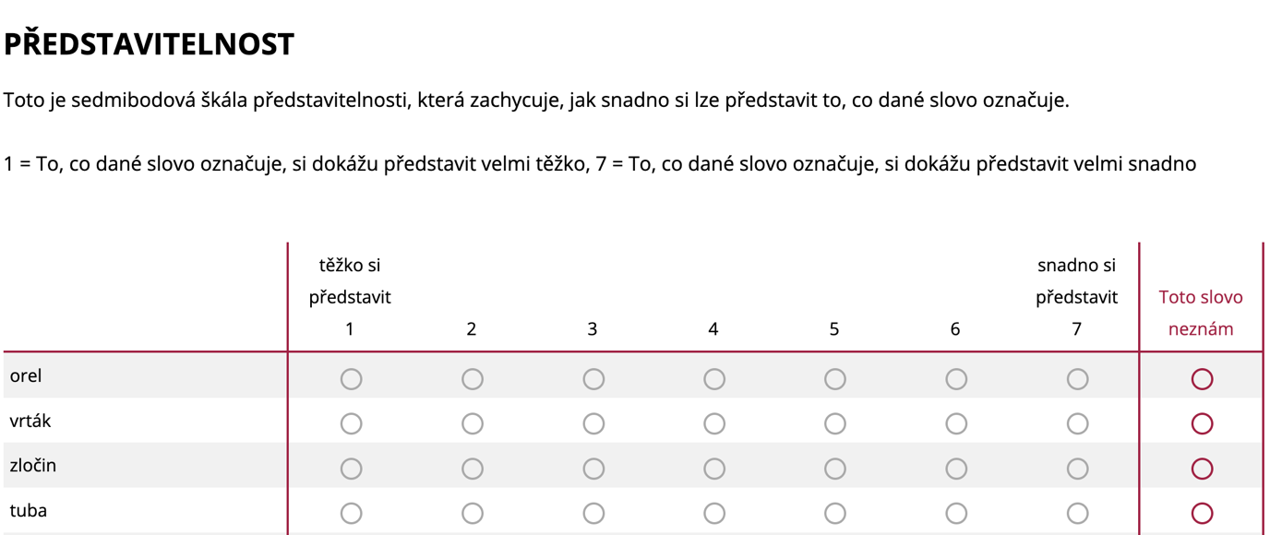
Figure 1. Example screenshot of the experimental set up for the imageability rating part of the experiment. The words being rated are on the right-hand side, with the scale being anchored by ‘těžko si představit’ [difficult to imagine] and ‘snadno si představit’ [easy to imagine], with the option to choose ‘toto slovo neznám’ [I don’t know the meaning of the word’] in the right most column. The instructions are presented at the top of the screen, see the OSF repository for a full list of instructions along with their English translations.

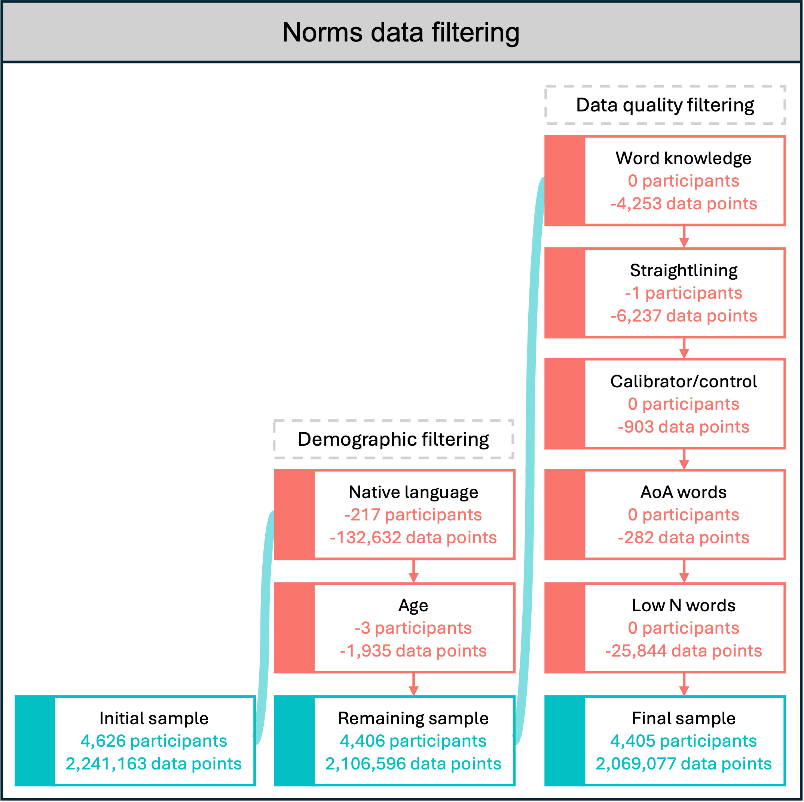
Figure 2. Filtering procedure used on the raw data. Turquoise boxes contain summaries of the data that remain after each filtering block; red boxes contain summaries of the data removed during each filtering step.

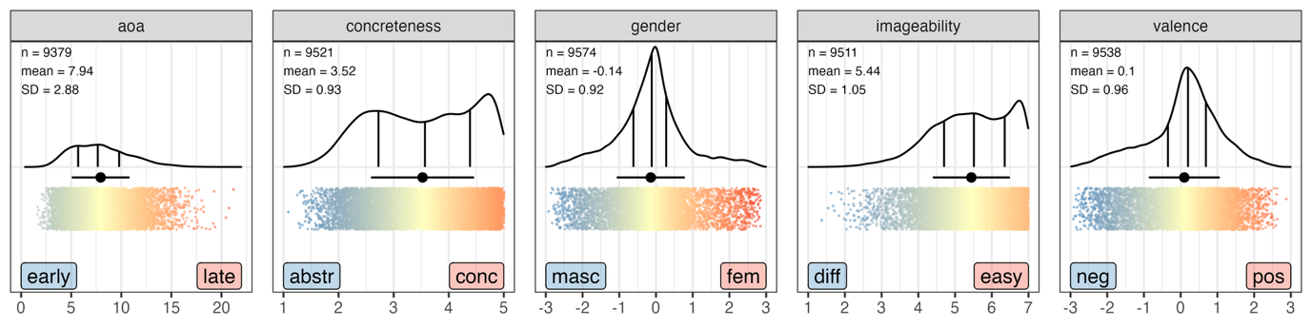
Figure 3. Distribution of mean ratings for the AoA, concreteness, gender, imageability and valence dimensions. Kernel density estimates are shown with 25%, 50% and 75% quantiles marked by solid vertical lines. The black point with a horizontal line represents the mean and standard deviation of the ratings. Each word is represented by a coloured point, with more red/blue colours indicating a stronger association towards a specific side of the scale, and yellow points associating more with the mean across all ratings.

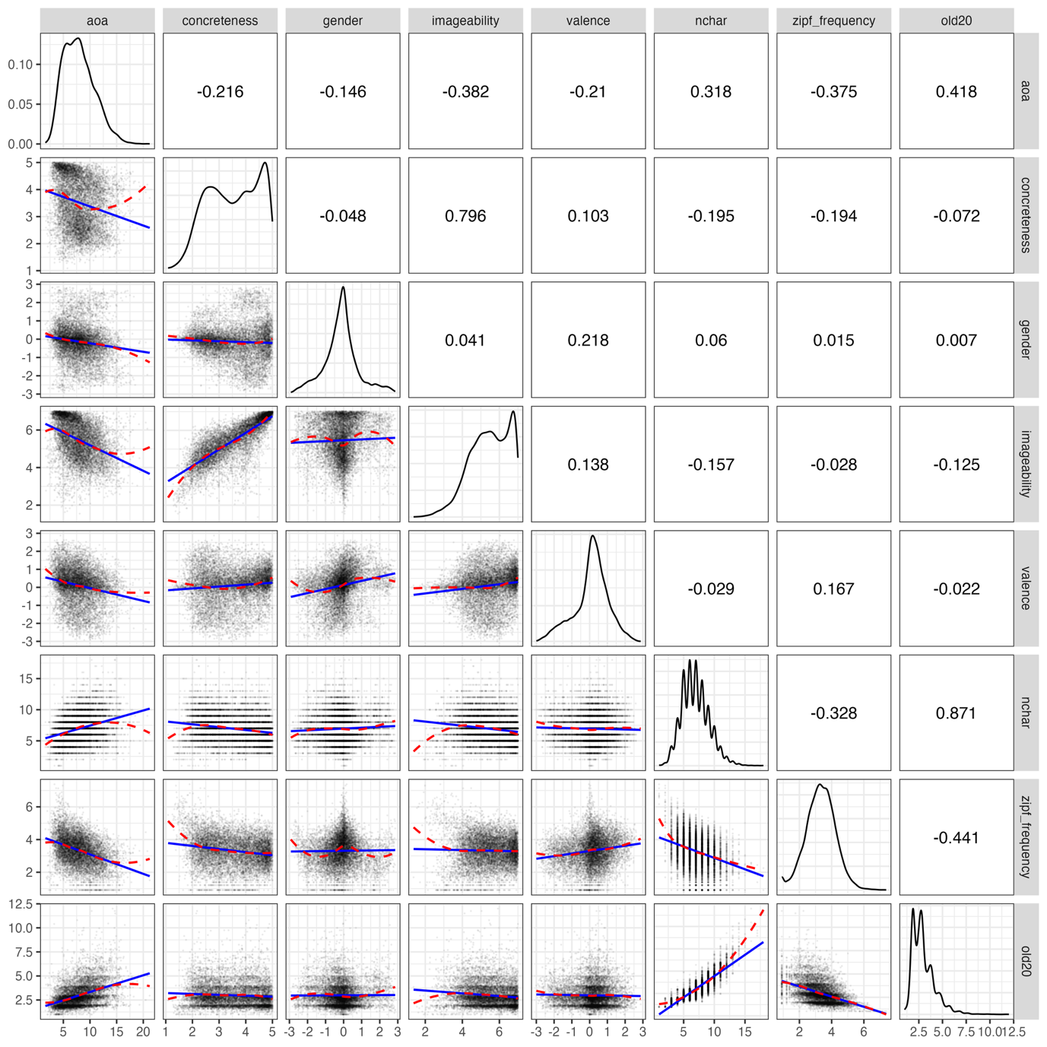
Figure 4. Correlation matrix of all the dimensions in the word ratings dataset. The lower left plots are scatter plots of the data fitted with a linear (blue) and loess (red) fit, with the data from the dimension in the top facets on the x-axis and the data from the right facet on the y-axis. The diagonal plots show kernel density distributions of the variables. The upper right plots give the Pearson correlation coefficients between two dimensions.

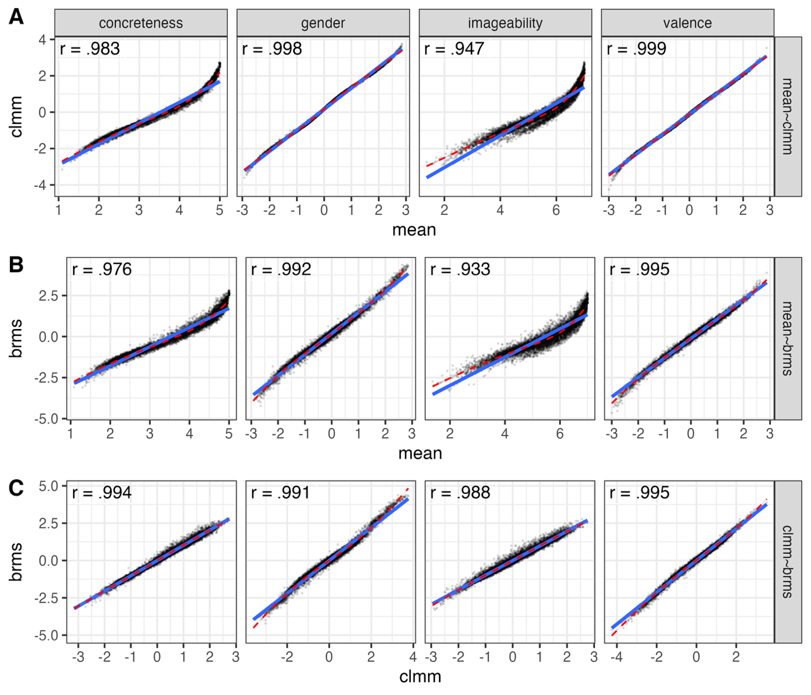
Figure 5. Relationships between the three different aggregation methods across 4 different dimensions (top facets), with A giving the traditional mean on the x-axis and the clmm estimates on the y-axis, B giving the traditional mean on the x-axis and the brms estimates on the y-axis, and C giving the clmm estimates on the x-axis and the brms estimates on the y-axis. The blue lines provide a linear fit to the data, and the red dashed lines a loess fit. The correlation coefficients are given in the top left corner of each sub-plot.

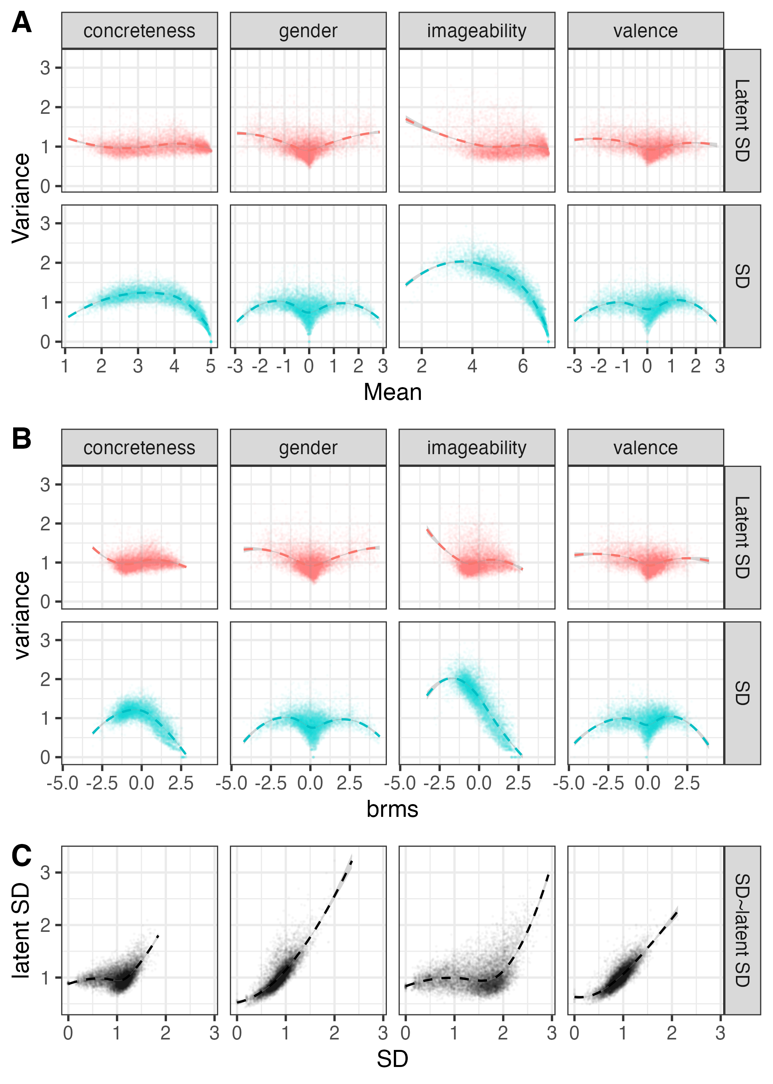
Figure 6. Relationships between the different measures of variance across 4 different dimensions (top facets), with A giving the traditional mean on the x-axis and the variance based on the traditional SD and latent SD on the y-axis. B giving the same relationships as A, but with the brms estimates on the x-axis. C gives the relationship between the traditional SD and the latent SD. All of the plots are fitted with loess smooths.

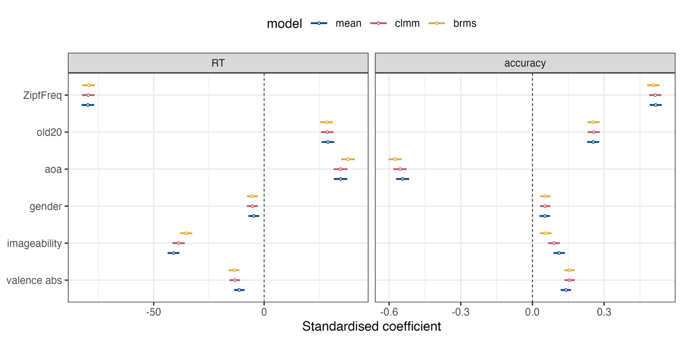
Figure 7. Model coefficients and 95% confidence intervals when predicting data from the lexical decision task. The x-axis provides the standardised coefficients, with the predictor variables given on the y-axis. The left facet visualises RTs and the right facet accuracy. The colours represent the different models from which the values for each predictor variable were derived (blue = mean, red = clmm and yellow = brms).

Whilst there is no definitive criteria for how to classify whether or not a study is ‘large-scale’ (although see Keuleers & Balota, 2015), we did try to focus on published work that reports on at least 400 items for spoken languages and a slightly lower threshold for signed languages. It is certainly not a definitive list of all available data for each language.
We decided to set our lower threshold for the number of participants who knew the word to 10 as this is in line with other rating studies, see e.g. Lynott et al. (2020) and justifications presented by Motamedi et al. (2019) for iconicity.

