KENTUCKY MEDICAID / AVESIS STATEMENT OF NECESSITY
Member Name: __________________________________________DOB: ______________
ID #: _________________________________________Date of Service: _______________
Clinical Justification (Check all that apply):
- [ ] Significant Refractive Change: Patient has experienced a change in vision of ±0.50D or greater in sphere/cylinder or a change in axis of >15º.
- [ ] Functional Impairment: Current eyewear is non-functional due to [ ] Breakage [ ] Severe Scratches [ ] Lost, and is unrepairable.
- [ ] Pathological Change: Change in vision due to [ ] Cataracts [ ] Diabetes
[ ] Other: __________
Provider Statement:
I certify that the replacement of this member’s eyewear is medically necessary to restore the patient's visual acuity to the highest functional level and to ensure safety in daily living activities (e.g., driving, ambulation, employment).
Member Acknowledgment:
I certify that I have not received a pair of eyeglasses through Medicaid within the current benefit period, or my current glasses are lost/broken/unusable.
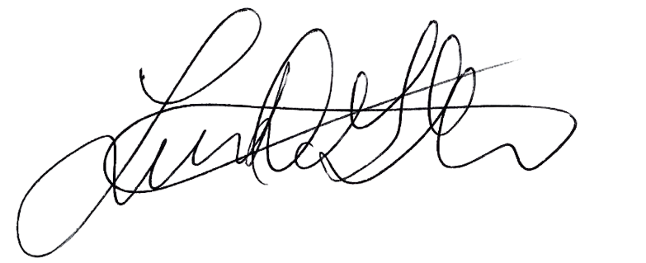
Provider Signature/Title: ___________________________ Date: _________

