BANKING - Development

Created by

[James Fredric](https://visionsoftware.atlassian.net/wiki/people/557058:dfe2405d-baf8-4d23-a69b-3fa1d8856966?ref=confluence&src=profilecard)

**Softwares Required (with their versions)**

* .Net Core 2.1 SDK (v2.1.300)
* Node version v10.15.1
* npm version 6.4.1
* Visual Studio Code IDE (any latest version)
* Postman

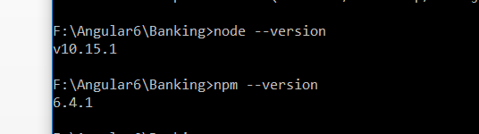

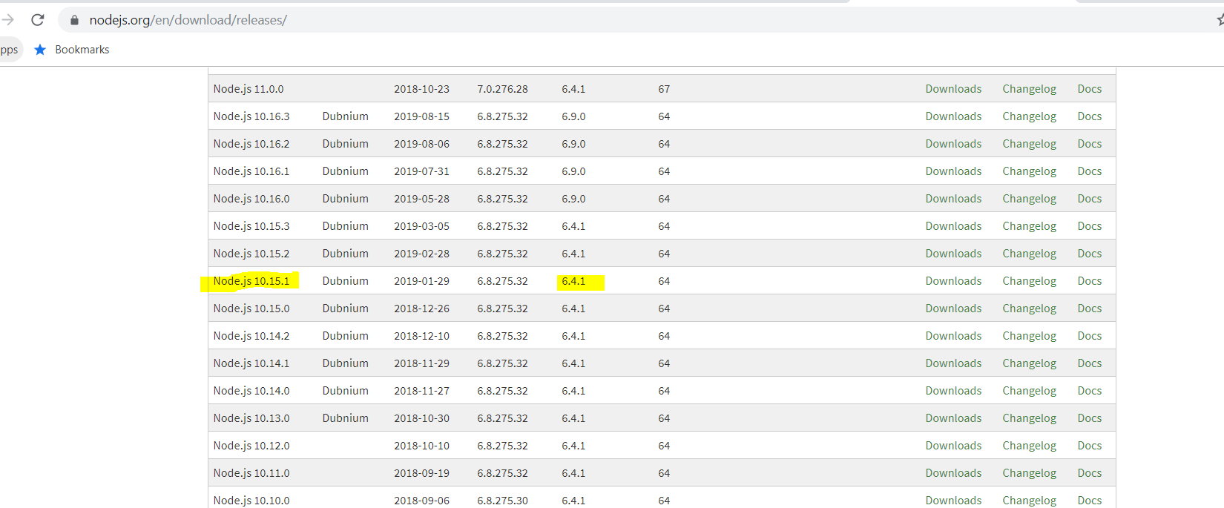

**Create a new empty folder:** BANKING

* Open command prompt with Admin privilege
* Navigate to the BANKING folder

**Create API project using .net CLI comand**  
BANKING >> dotnet new webapi -o BANKING.API -n BANKING.API

**Create a Entity Framework test project using .net CLI comand**  
BANKING >> dotnet new webapi -o BANKING.API.EF -n BANKING.API.EF

**Visual Studio Code - C# extensions**

* C# for visual studio (powered by omni sharp)
* C# IDE Extensions for VSCode
* Nuget Package Manager

**Install Angular CLI in BANKING folder**  
BANKING >> npm install -g @angular/cli@6.0.8

**Create Angular 6 project using the below command**  
BANKING >> ng new BANKING-WEB

**Visual Studio Code - Angular Extensions**

* Angular v6/v7 snippets
* Angular Files
* Angular Language Service
* Angular2-switcher
* Auto rename tag
* Bracket pair colorizer
* Debugger for Chrome
* Material Icon Theme
* Path Intellisense
* Prettier - code formatter
* TSLint

**Postman**

Install Postman to [test.net](http://test.net/) Web API project

**Open BANKING project:**

Open the project from the root BANKING folder using 'code .' from command prompt with admin privilege

**Run .net WebAPI project**

BANKING.API > dotnet run (or) dotnet watch run

**Run Angular 6 project**

BANKING-WEB > ng serve

On running the Angular 6 project first time, if you get any error due to 'rxjs', apply the below solution  
Solution:  
Open package.json  
change "rxjs": "^6.0.0" to "rxjs": "6.0.0"  
After changing the above line in angular project terminal, run the command => npm i  
BANKING-WEB >>npm i  
This will fix the above issue.

In VS Code terminal, run the below packages to install Entity Framework in API project  
BANKING-API >> dotnet add package Microsoft.EntityFrameworkCore.SqlServer -v 2.1.0  
BANKING-API >> dotnet add package Microsoft.EntityFrameworkCore.Design -v 2.1.0

**Entity Framework Database First approach** - to generate model and datacontext class  
BANKING.API.EF >>  
use this command for EF   
dotnet ef dbcontext scaffold 'Server=.\SQLEXPRESS;Database=Banking;Trusted_Connection=True' Microsoft.EntityFrameworkCore.SqlServer -c DataContext -o Models –f

Reference article : <https://www.learnentityframeworkcore.com/walkthroughs/existing-database>

**Bootstrap and font-awesome** (terminal) - (add in styles.css)  
Bootstrap@4.1.1 and font-awesome@4.7.0  
BANKING-WEB >> npm install bootstrap@4.1.1 font-awesome  
angular.json (change the styles .css order by importing bootstrap and fontawesome in styles.css)

**3rd party libraries**

| **Library** | **Commands** |
| --- | --- |
| Alertifyjs | npm install alertifyjs --save |
| Angular JWT | npm install @auth0/angular-jwt@2.0.0 |
| NGX Bootstrap | npm install ngx-bootstrap@3.0.1 --save  ng add ngx-bootstrap --component collapse |
| Bootswatch | npm install bootswatch@4.1.1 |
| NgxSpinner | npm install ngx-spinner --save |
| Telerik kendo UI Dropdown | ng add @progress/kendo-angular-dropdowns |
| cookies | npm install ngx-cookie-service --save |
| Angular material | ng add @angular/material |
|  |  |

**Angular Routeguards**

routeguards => cd src/app/_guards => ng g guard auth --spec=false

**Serilog**

dotnet add package Serilog --version 2.9.0-dev-01116  
dotnet add package Serilog.Sinks.RollingFile --version 3.3.1-dev-00771  
dotnet add package Serilog.Sinks.RollingFile.Extension --version 2.0.2  
dotnet add package Serilog.Extensions.Logging --version 3.0.0-dev-10240

**Angular Build (production)**

ng build --prod --build-optimizer=false  
ng build (development)

**API Build (publish)**

dotnet publish -o D:\websites\VisionIM

**Publish to IIS**

In the application pool >> no managed code  
.net core publish IIS (microsoft documentation) // <https://docs.microsoft.com/en-us/aspnet/core/host-and-deploy/iis/?view=aspnetcore-2.2>  
>> Install the .NET Core Hosting Bundle  
Download .NET Core 2.1 Runtime & Hosting Bundle for Windows (v2.1.10) and install in the server  
Download link : <https://dotnet.microsoft.com/download/thank-you/dotnet-runtime-2.1.10-windows-hosting-bundle-installer>  
>> After installing the above one, please do IIS reset  
Open cmd window and type "iisreset"

**Command to kill existing process in command prompt**

netstat -ano -p TCP | find /I "listening" | find /I "2492"  
taskkill /F /PID 820