Banking Web Application – Default or Login page.

In the page, the user has to register first.

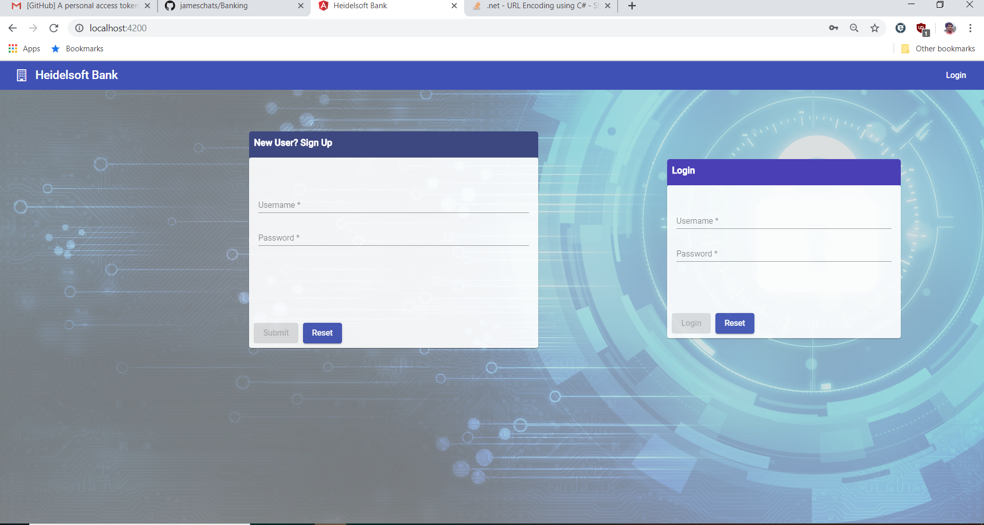

Register a new user

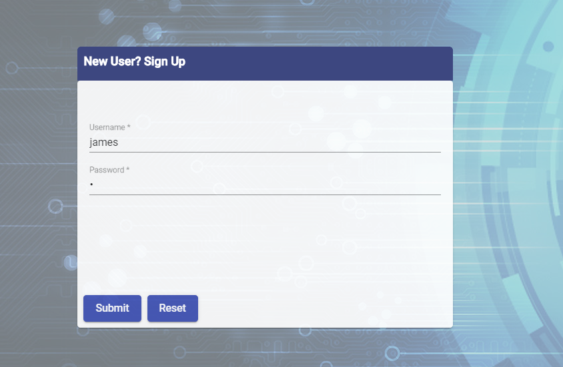

On successful registration, below message will be shown in the bottom of the page. The user can use the login username and password to login to the Banking web application. The password is encryping by hashing and also used salt for encrypting the password. Hence the same password set for different user would be stored as different encrypted format.

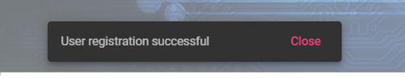

Login

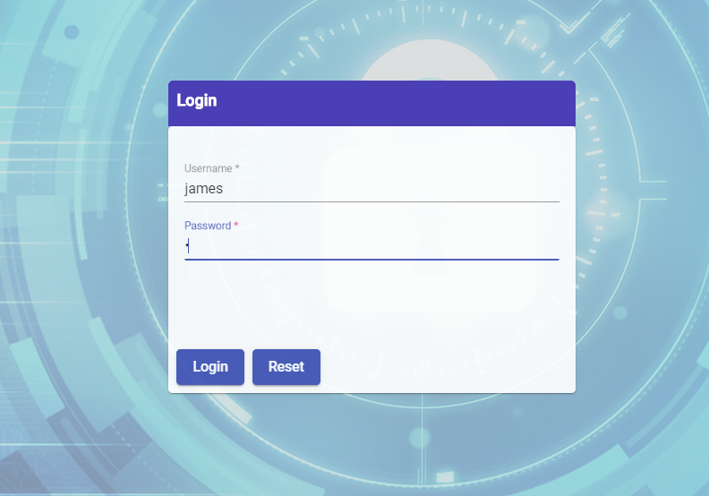

On successful login, the user is redirected to the home page. Technically, a JWT token is created on successful login and used for the user’s session.

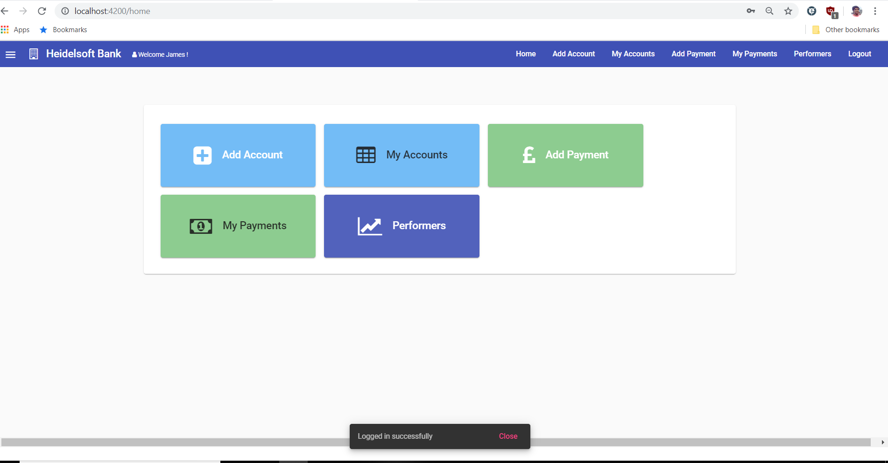

Banking Web Application has the below 5 modules.

* Add Account
* My Accounts
* Add Payment ( or make payment)
* My Payments
* Performers

The user can navigate to the above modules by 3 ways

* using the large buttons in the home page
* using the menu buttons corresponding to the modules
* by the side navbar on click of hamburger menu at the left side top of the menu.

Add Account

The user has to create a new account by using the Account Account Page. User needs to fill in the name and monthly credit limit. The account will be credited on successful completion.

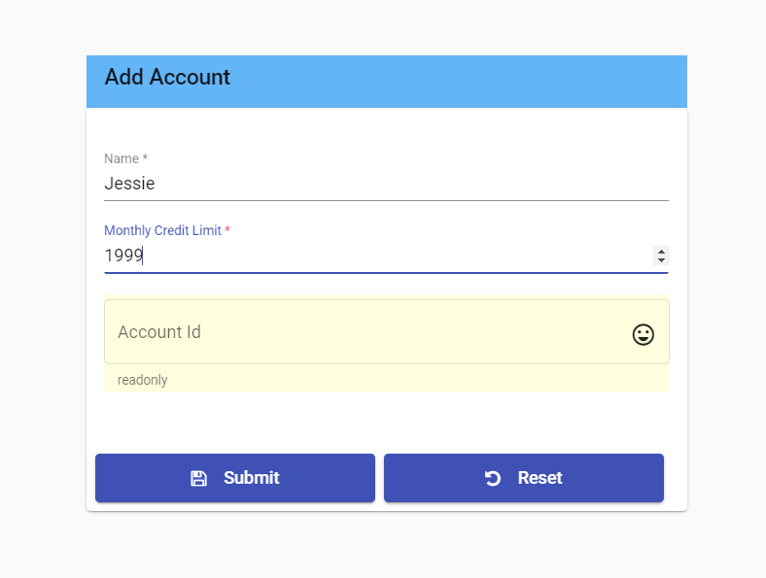 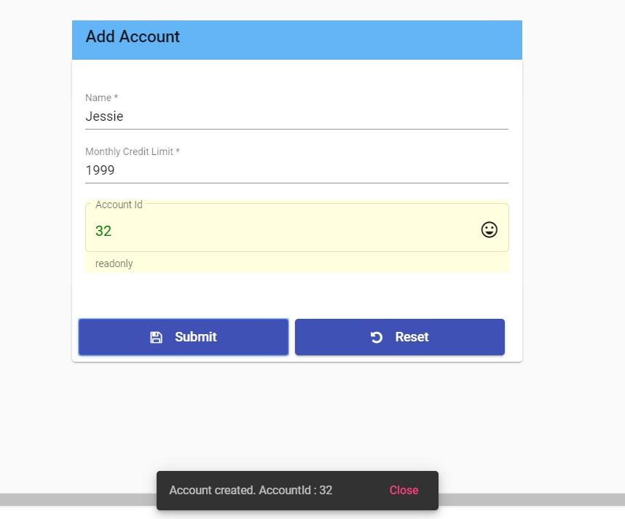

My Accounts

* The user see all the accounts created by using the My Accounts page. Paging is implemented in this page. The user can navigate to different pages and see the accounts if there are more records.
* The user can view the account by clicking on the view button and also update the monthly credit limit.

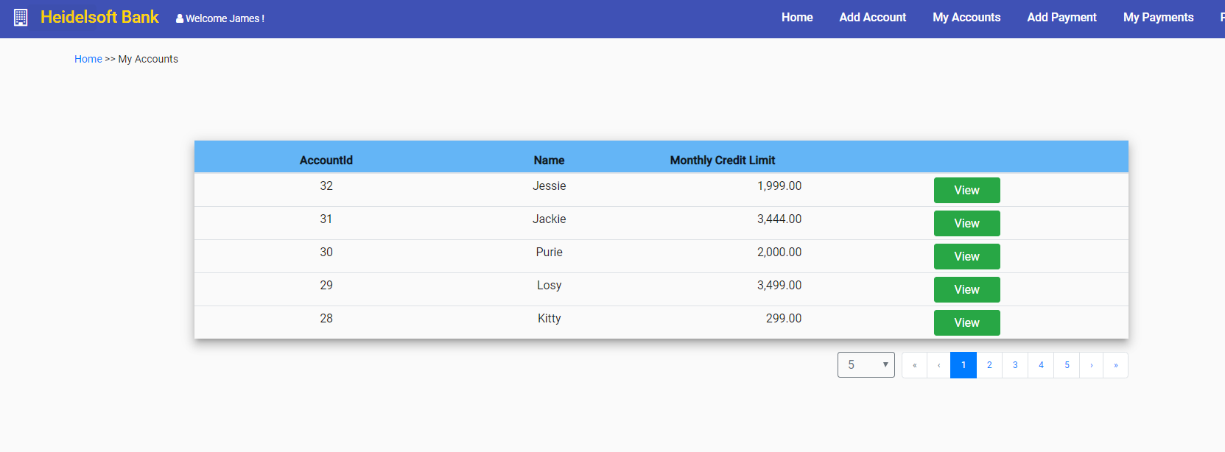

Add Payment (or make payment)

The user can make payment to an account using the Add payment page. The user can make any number of payments to the same account. The user can not make payment more than the monthly credit limit.

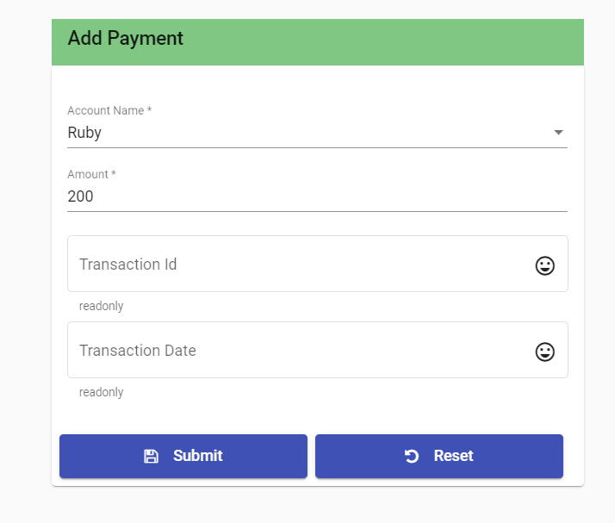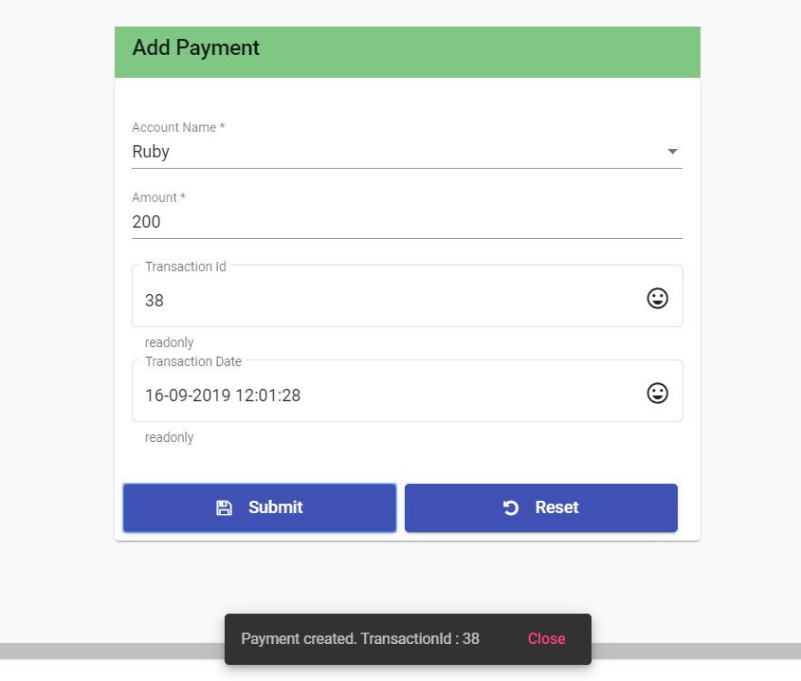

My Payments

* The user can view all the successful payments using the My Payments page. Paging is implemented in this page to navigate across the records.
* The user can click on View button to see the payment and update the amount.

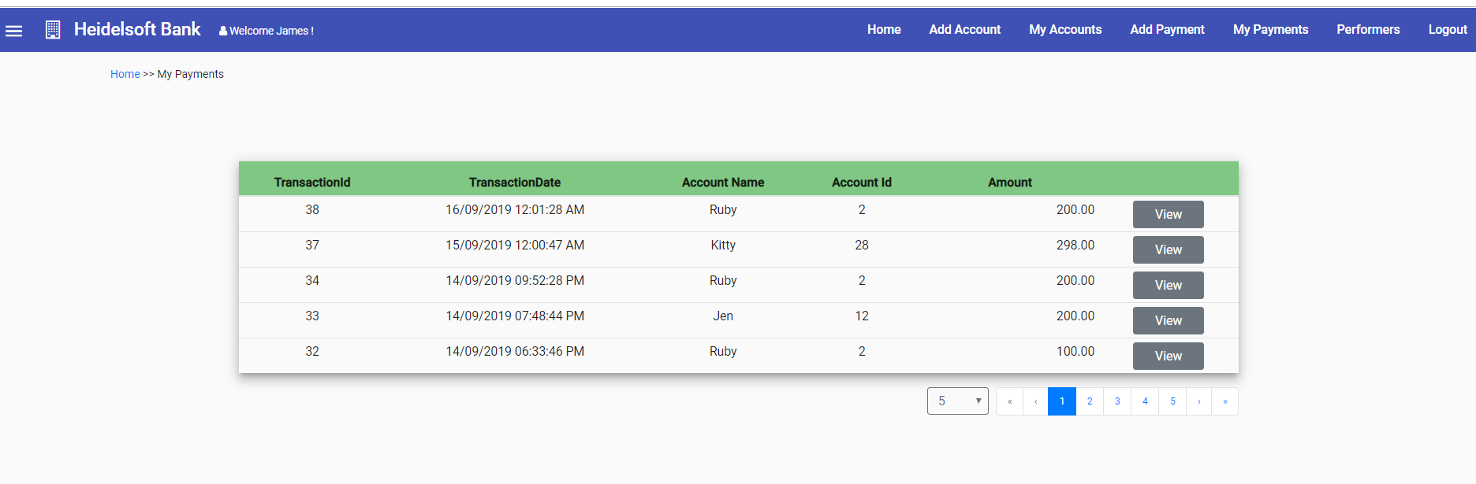

Performers

* User’s performance based on the credit card usage can be seen from the Performers page.
* Here the usage of the user is calculated and the table is sorted by usage in descending order by default.
* The page is implemented sorting for all the columns. On clicking the header the table is sorted by individual columns by ascending and descending order.
* Paging is also implemented in this page.

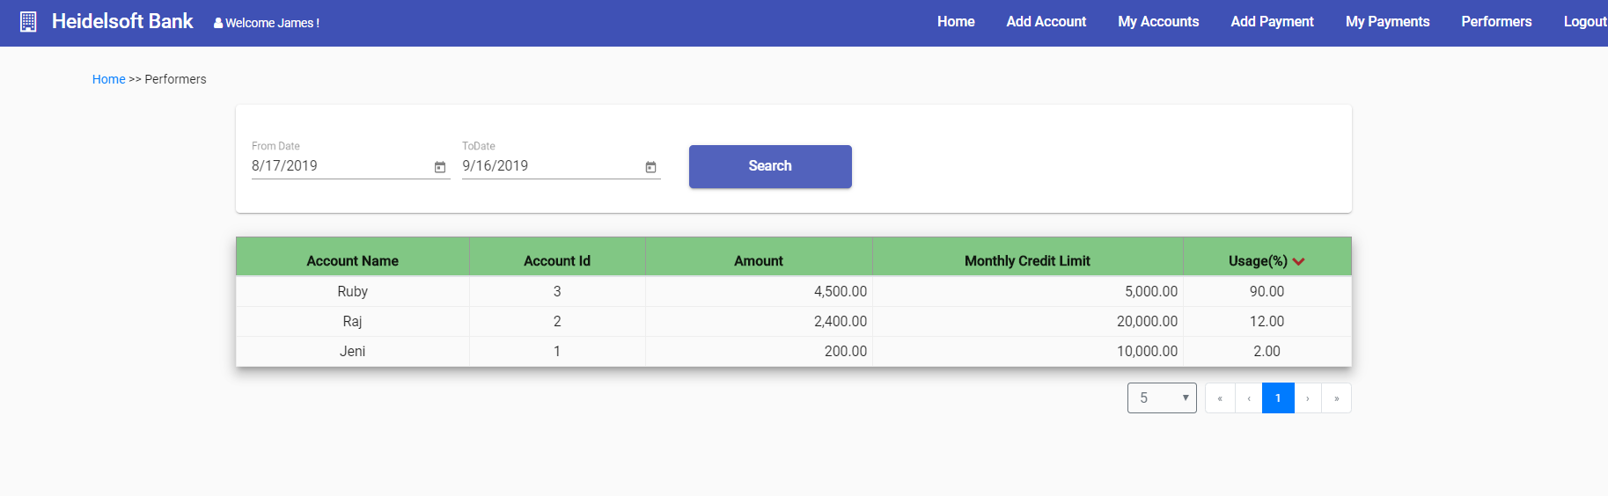

Logout

User on clicking logout will be signed out from the application.