**Banking Web Application – project setup**

The Application has the below folder structure

* **Banking** *– root folder*
  + **Banking-WEB** – Angular 6 project
  + **Banking.API** - .Net Core Web Api project.

**Git Path**

* <https://github.com/jameschats/Banking>
* Download the Banking project from the above git path.

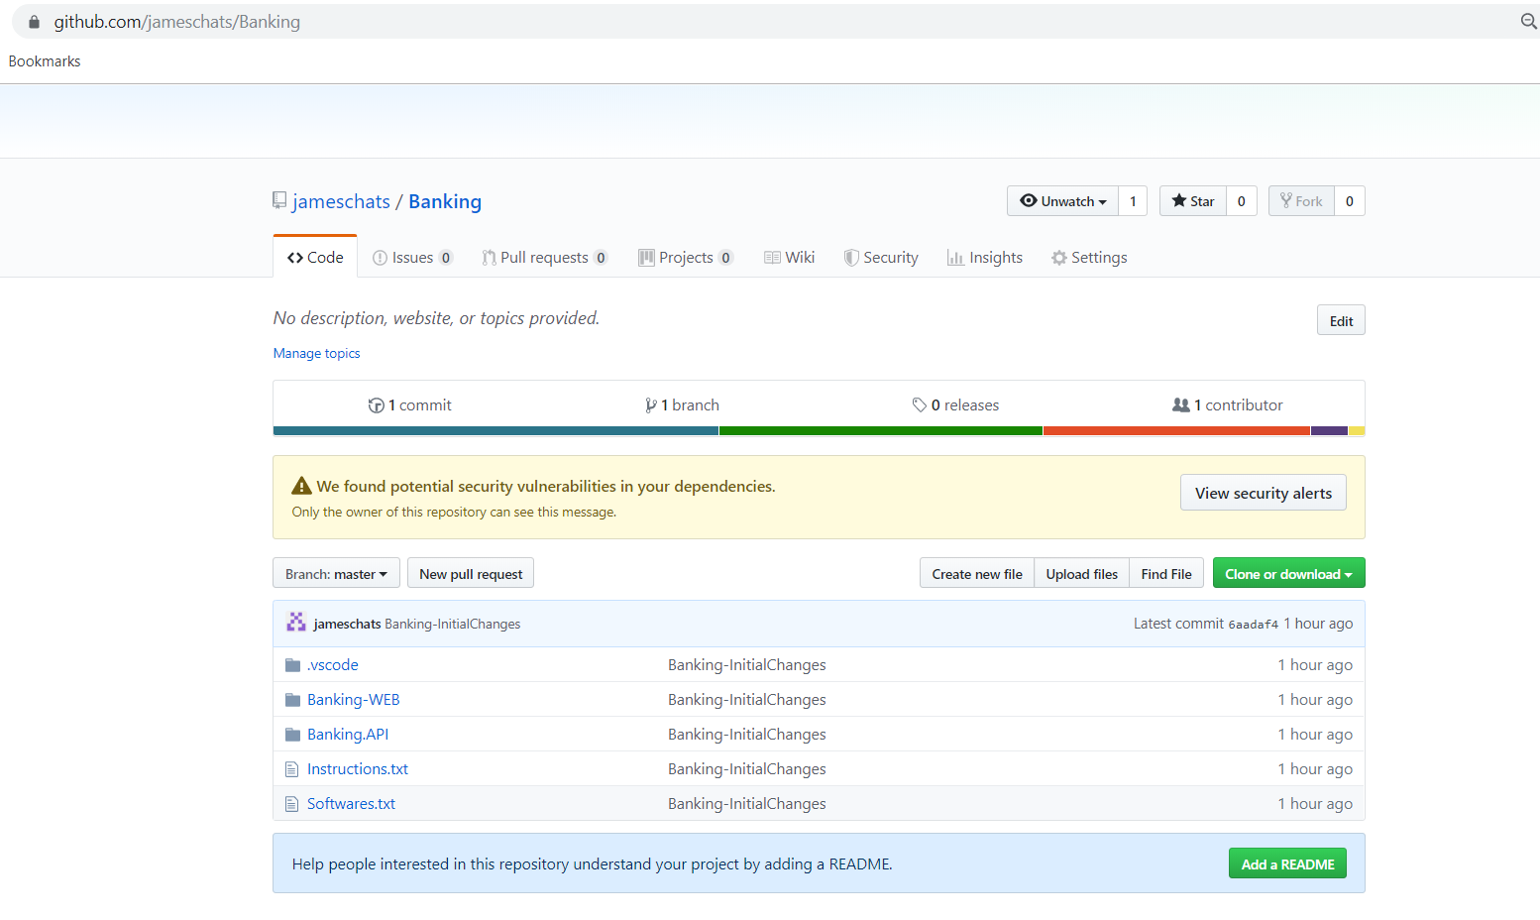

**Softwares Required (with their versions)**

* .Net Core 2.1 SDK (v2.1.300)
* Node version v10.15.1
* npm version 6.4.1
* Visual Studio Code IDE (any latest version)
* Postman

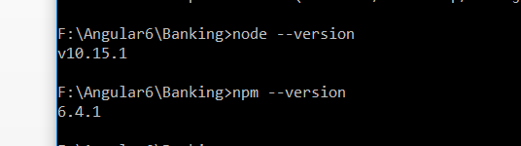

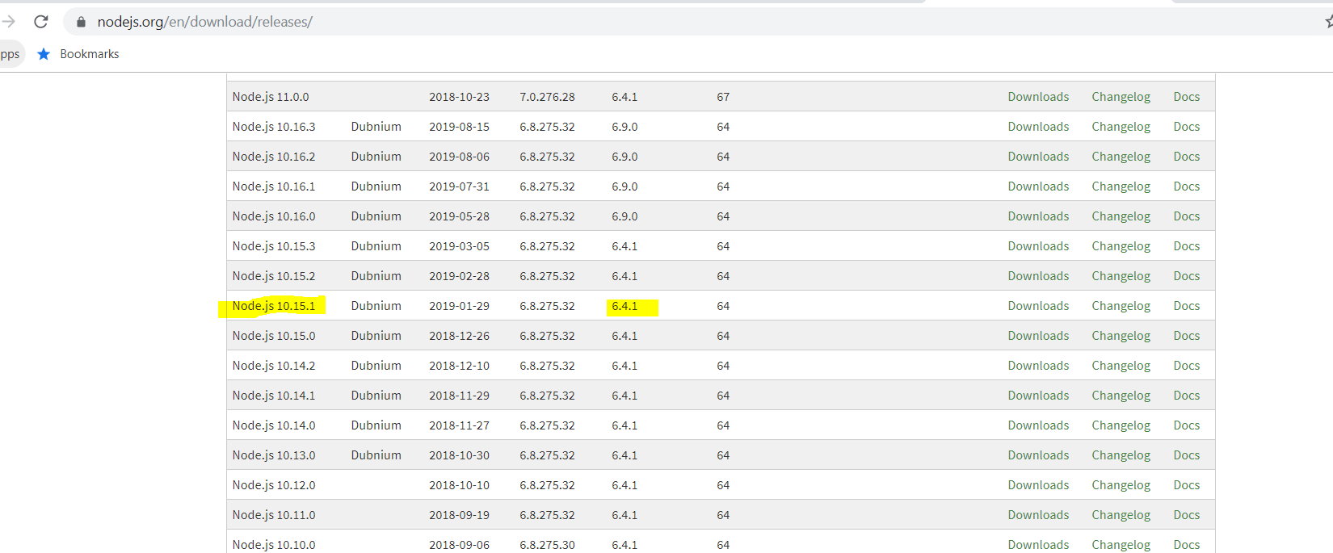

**IDE**

* Used Visual Studio Code IDE to develop the Banking Web Application Project

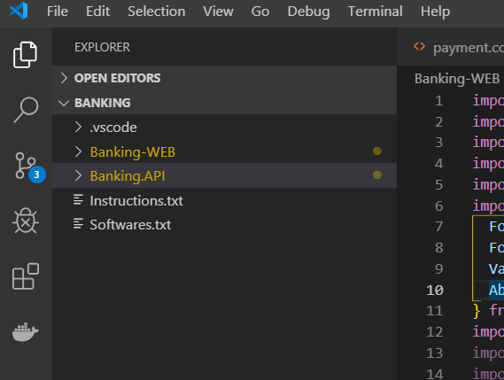

**Database Setup**

* Create a database in SQL Server as **Banking**
* Open the Database Scripts folder and execute the two sql files
  + Tables.sql
  + Procedure.sql

**Banking Project –Visual Studio Code IDE**

* Open the **Banking** root project folder in Visual Studio Code IDE
* In Visual Studio Code terminal, open the two projects as below
  + In the first terminal navigation to Banking>cd Banking-WEB
  + Node_Modules folder is not checked in to Git repository.
  + Hence the below command has to be run in the Banking-WEB terminal. On running the below command, node_modules folder will be download based on package.json file. Please refer below command and screenshot
    - * Banking\Banking-WEB > npm install
  + In the second terminal navigation to Banking>cd Banking.API

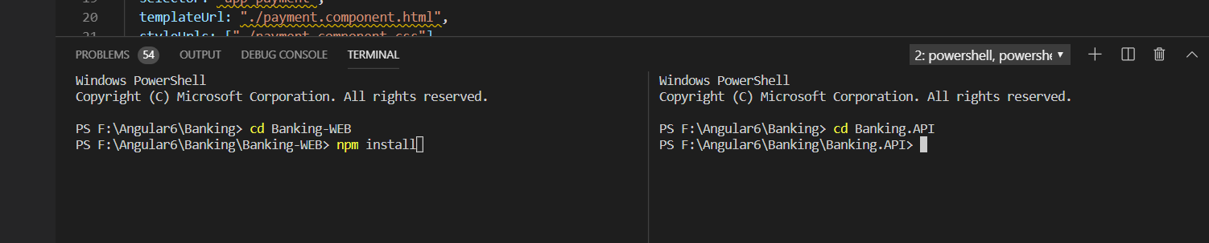

* Set the connection string in the Banking.API project. Encrypt the connection string using base64 encoding and set in the below json file. Please refer the screenshot below.
  + appsettings.Development.json

Sample connection string: Server=localhost\\SQLEXPRESS;Database=Banking;Trusted_Connection=True;

Sample Base64 encrypted string: U2VydmVyPWxvY2FsaG9zdFxTUUxFWFBSRVNTO0RhdGFiYXNlPUJhbmtpbmc7VHJ1c3RlZF9Db25uZWN0aW9uPVRydWU7

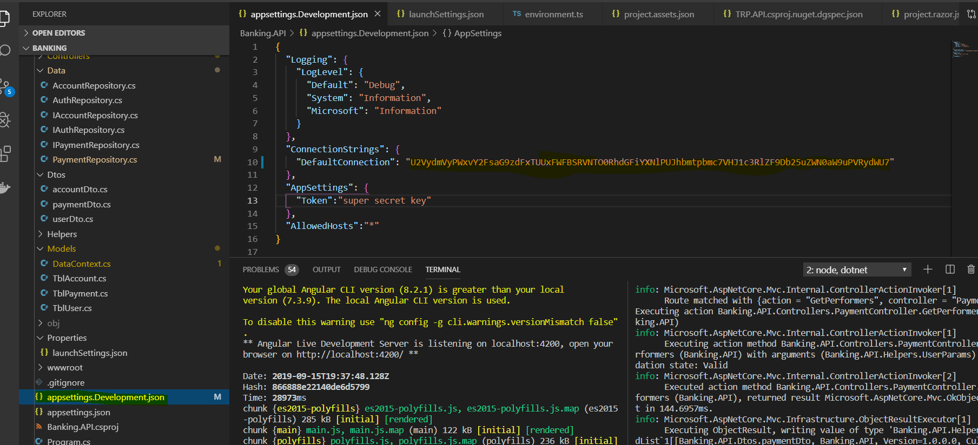

* **Run .net WebAPI project**

Banking.API > dotnet run (or) dotnet watch run

* + API project will start listening in localhost:5001 or localhost:5000 based on what is specified in the launchsettings.json file

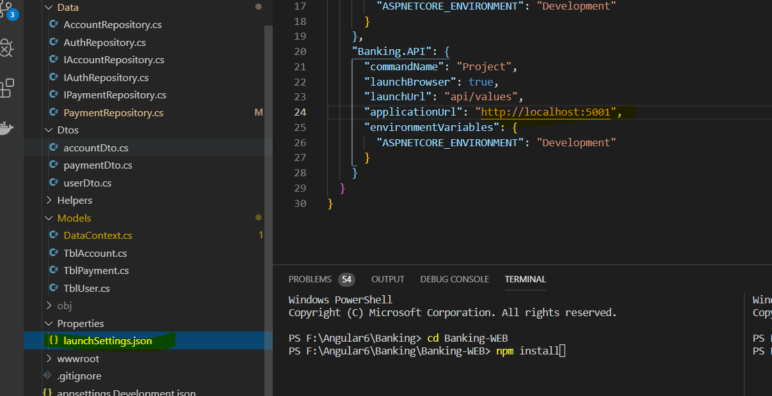

* **Run Angular 6 project**

Banking-WEB > ng serve

* + Banking Web Application will be opened in localhost:4200