Treecrets

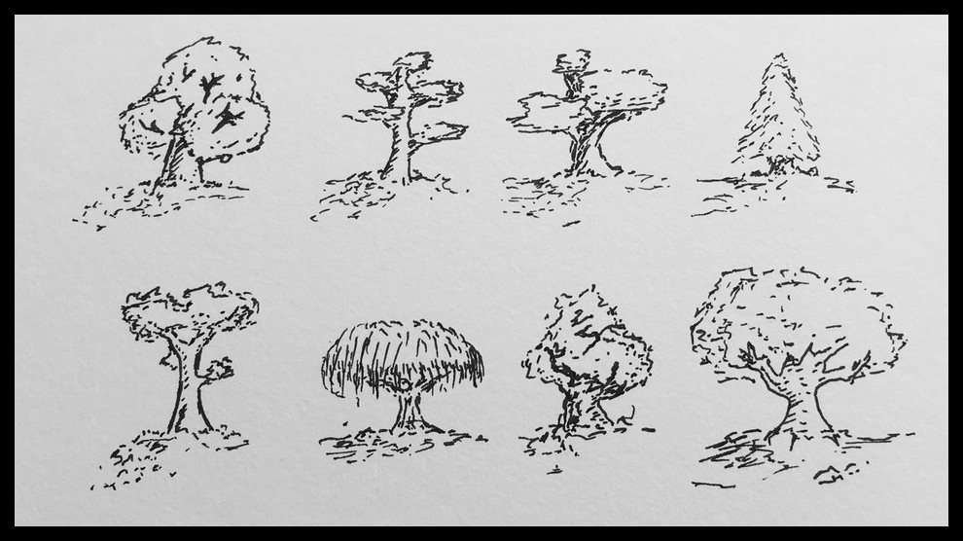
With a friend walk in a park or wooded area until you find a tree that calls out to you both.

Both approach the tree close your eyes and place a hand on it.

Feel the bark. Listen to its leaves. Let the tree tell you its stories.

Let the tree tell you how it got where it is and what events it has seen. Let the tree tell you about the people it has known and the creatures that lived in it. Let the tree tell you how the land has changed around it. Let the tree tell you what it thinks the future will hold.

Take turns sharing the stories the tree has told you with each other.

When the tree has told its story ask it for a message to pass onto another tree.

Ask the tree for a secret only for you.

Do not share this secret, it is a bond between you and the tree.

Open your eyes and thank the tree.

Walk until you find another tree that wants to hear the message you were given.

Touch that tree and deliver the message.

Let that tree tell you its story.

Hear its secret...

