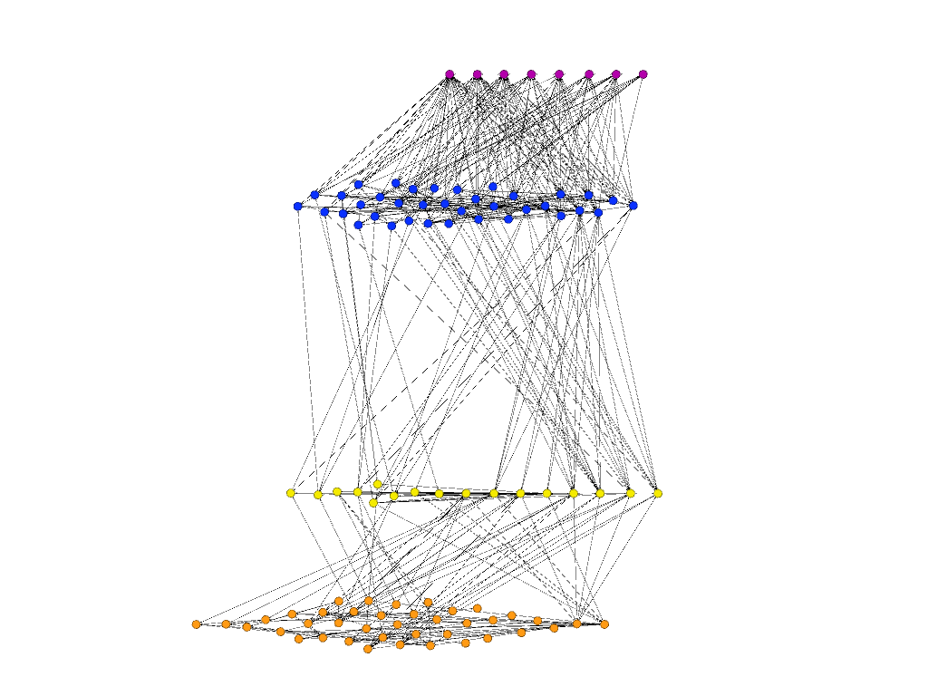

Summarizing Text and Conclusions

Metric Plots will be interactive with a dropdown menu to choose which metrics are displayed. Accompanying text will explain what the metrics are showing.

Metric Visualization

Network will be interactive through time slider and through mouseover highlighting to show connections isolated and tooltip info on individual nodes

Slider for Time Changes

Interactive Network Visualization

Text to introduce the problem and data

Website Header