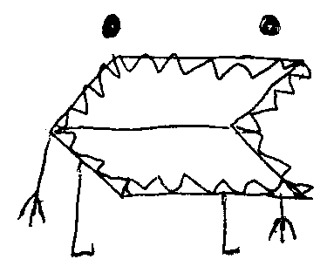
VeilCode
About The Maker

How VeilCode Was Made
VeilCode was created through a conversation between a person with an idea and an AI called Claude, made by Anthropic. The project started with a simple concept — a custom cipher system — and grew into something much bigger.

The Cipher
The VeilCode cipher works by placing letters into groups inside brackets. A pattern like /[hju][oif]/ with the keyword &^ means: pick position 1 from the first group (h) and position 2 from the second group (i), giving the word "hi". Decoy letters fill the other positions to make the cipher harder to crack.

The Encoder/Decoder
The encoder/decoder is a web app built in HTML, CSS, and JavaScript. It lets you type a message, encode it into VeilCode, and decode VeilCode messages back into plain text. It has a dark mode, a symbol key reference, and runs entirely in the browser with no server needed.

The Idle Game
The idle game started as a simple decoder game and grew into a full progression system with six tiers: Normal, Shadow Guild, Void Syndicate, The Eternal, The Infinity, and The End. Each tier unlocks new agents, upgrades, achievements, and words to decode. The game has a cheat code, a credits screen, and a restart button.

The Activity Book
A 150-puzzle activity book was also created, with easy, medium, and hard VeilCode puzzles, a full answer key, a symbol chart, and a two-player mode section.

The Tools
Everything was built using Claude on claude.ai. The code is HTML, CSS, and JavaScript. No external frameworks were used for the games or encoder. The activity book and guides were generated using the docx library in Node.js.

The Logo
The VeilCode logo was hand-drawn by the maker — a creature with a wide flat body, jagged mouth, spiky connectors, two eyes, and two legs. The background was removed so it could sit on the purple header of the game.

Where to Find It
Encoder/Decoder: https://jamesdaymccarthy-ops.github.io/veilcode
Idle Game: https://jamesdaymccarthy-ops.github.io/veilcode/VeilCode_idle.html
Made by Toadboi32 & Claude

