CS AQA A-Level Paper 1 2021
06.2)
Regular Expression: a(ba)*|b(ab)*
SECTION B
07.1)
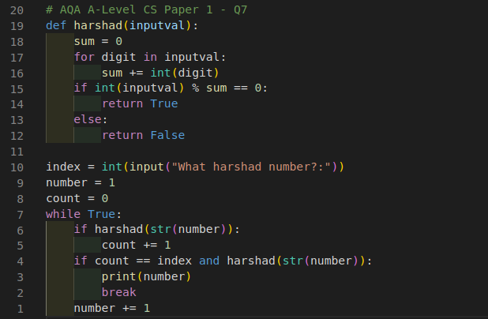
07.2)
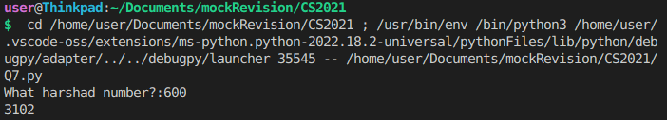
SECTION C
08.1)
You can tell based on whether one of the coordinates of the tile is the same. If so, they are in a straight line with each other.
08.2)
(x//2)
8.3)
The if statement 3 should be changed to 7.
The for loop condition 3 should be changed to also 7.
09.1)
As it needs to be accessed by LessPiece() class when inherited so it cannot be a private attribute.
09.2)
When both players barons are destroyed and it’s player ones turn.
09.3)
Polymorphism is where previously defined methods of classes are redefined by an inherited class.
10.1)
There could be less than five items in the first line of the file which would cause an index error which LoadGame() wouldn’t catch.
10.2)
CheckMoveCommandFormat()
11)
GetDistanceToTileT calculates the distance between two tiles by calculating the difference between the tiles coordinates x,y,z and the target tiles x,y,z. It then uses the largest difference as the final distance between the two.
12.1)
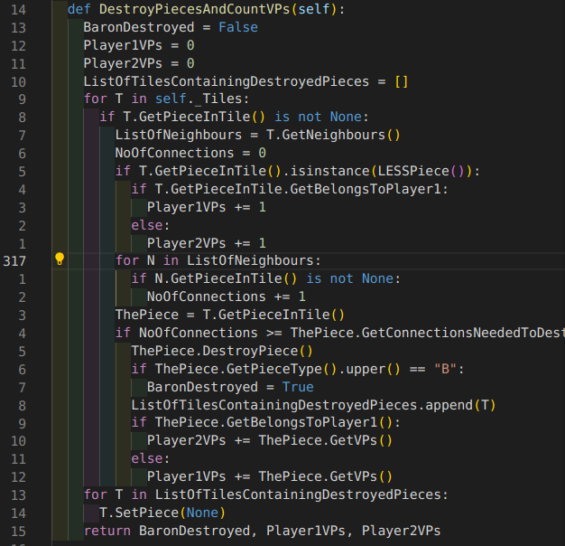
12.2)
Error during execution and loading game1.txt
13.1)
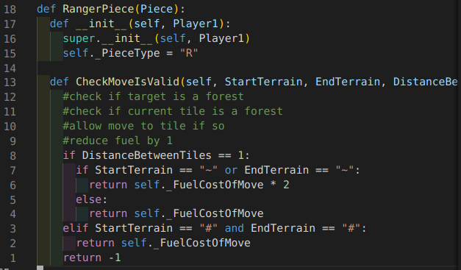
13.2)
Board not displaying properly.
14.1)
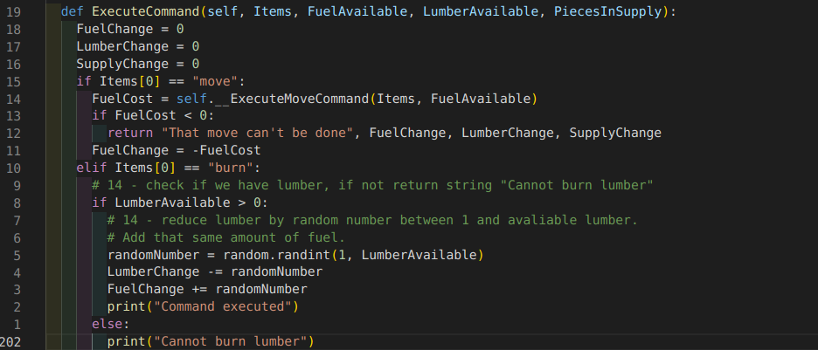
14.2)
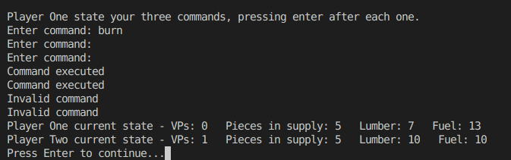
15.1)
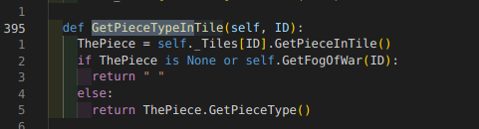
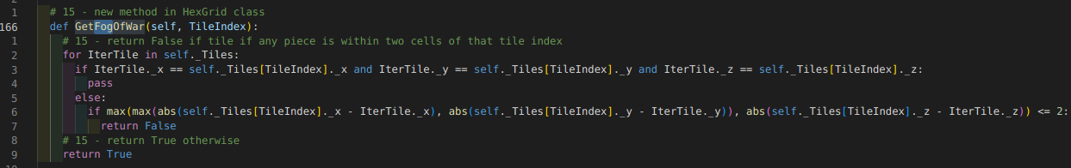
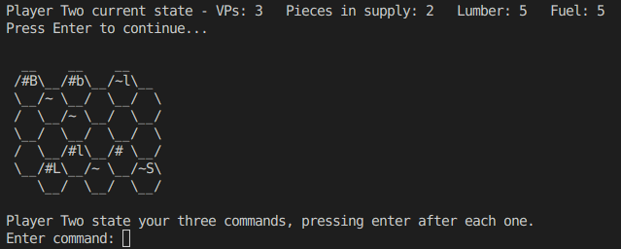
15.2)

