CS Paper 1 2019

Section A
1.1) One change that could be made to the bubble sort algorithm would be have a flag set to True if a swap is made and reset to False at the start of each pass. This would make it stop repeating if no swaps have been made and the list if already sorted thus reducing the number of comparisons. 0/4
1.2) A problem is either tractable or intractable. It does not change from being tractable to intractable due to the size of it’s input. Sorting is a list is a tractable problem. 2/2
1.3) When trying to solve an intractable problem. Attempts could be made to remove contraints or find a close-enough answer which does not always work. This is called a heuristic approach to problem solving. 2/2
2.1)
0 | # | 1* | 0 | 1 | 0 | 0 | S4
0 | #* | 1 | 0 | 1 | 0 | 0 | S4
0 | # | 1* | 0 | 1 | 0 | 0 | S0
0 | # | # | 0* | 1 | 0 | 0 | S1
0 | # | # | 0 | 1* | 0 | 0 | S2
0 | # | # | 0 | 1 | 0* | 0 | S2
0 | # | # | 0 | 1* | 1 | 0 | S3
0 | # | # | 0* | 1 | 1 | 0 | S3
0 | # | #* | 0 | 1 | 1 | 0 | S4
0 | # | # | 0* | 1 | 1 | 0 | S0
0 | # | #* | 0 | 1 | 1 | 0 | S5
0 | #* | 1 | 0 | 1 | 1 | 0 | S5
0* | 1 | 1 | 0 | 1 | 1 | 0 | S5
0 | 1* | 1 | 0 | 1 | 1 | 0 | S6
5/5
2.2) This turing machine duplicates data in memory into the next available set of memory locations. 1/1
2.3) The S5 to S6 transistion places the read head onto the start of the origin set of data in memory. 1/1
2.4) A universal turing machine is one which can simulate any turing machine’s inputs and outputs within itself by storing it’s definition/description on the UTM’s ticker tape. 2/2
3.1)
I | E | H
C | A | B
G | D | F
1/1
3.2) Representational abstraction is where some data is removed in order to repsent data in another way. 1/1
3.3) Abstraction by generalisation is where a problem is made more broad to not be as representative of the original problem. 0/1 this is where data is grouped by common characteristics.
3.4) It has removed the info about what character is actually in each cell. 0/1 it doesn’t show the location of a cell I.e if they are in the same row.
3.5) An adjacency matrix is most suitable when a graph is dense and edges are frequently changed. ½
3.6) The bottom half of an adjancey matrix would only neef to be used in a directional graph. 1/1
4.1) In a regular expression the * metacharacter mean 0 or more of that character. 1/1
4.2) The ? Metacharacter means 0 or 1 of that character. 1/1
4.3)
Y
N
Y
Y
N
N
N
3/3

Section B
5.1) source code
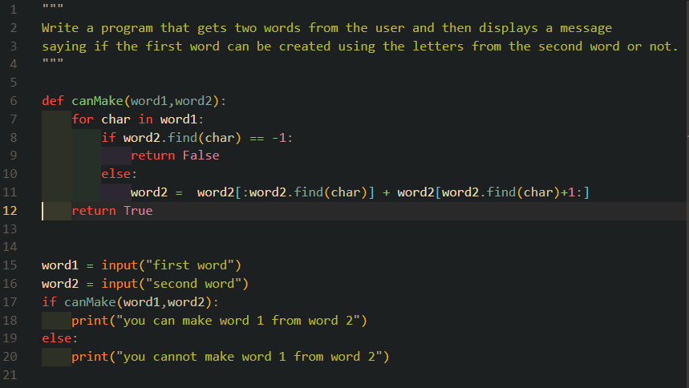
5.2) test 1 & test 2
