CS Paper 1 2020

Section A
1.1) The magnitude of vector b = sqrt(4^2+0^2) = 4
1/1
1.2) a.b = (4*4)+(3*0) = 16
2/2
1.3) The magnitude will double as each element of the vector will be multiplied by 2 which means that the result of it’s magnitude calculation will also be doubled as both elements will be squared and then square rooted. Angle C will not change.
2/2
1.4) The vector’s magnitude will be the same as the square will cancel out the negative. Furthermore the angle will also be unchanged at C.
The magnitude part is correct, however the angle will be 180-C
½
2.1)
True
False
False True
½
2.2)
<sentence> ::= <np><v> | <v><np>
1/1
2.3)
Yes
Yes
Yes
No
1/1
2.4)
<sentence> ::= <np><v>|<v><np>|<n><v>
1/1

2.5) 8*4*3*8*4
2/2
2.6) 4 times more
Infinitely more as it’s recursive. RTQ
3.1) 4*4
No, the calculation would be the factorial of 4! which is 24 not 16.
3.2) n!
1/1
3.3) ???
0/1 the string could contain more than one occurrence of a character.
3.4) An intractable problem is one without a computable solution due to excessive time complexity or impossibility to create an algorithm for.
½ it CAN be solved but not in a reasonable amount of time as the problem size increases.
3.5) 1 is for an intractable problem.
1/1
3.6) O(n) as a linear search will need to parse through each item in the list in the worst case to find the item it’s looking for.
2/2
3.7) binary search has O(log n) as it will increase initially as it gains more items to search but tapers off in increasing complexity as it narrows down the number of items it needs to search into halves in each pass.
2/2
4.1) An advantage of a dynamic data structure is that it can have more or less memory allocated to it depending on what is needed. On the other hand a static data structure has it’s size of allocated memory set at runtime which leads to wasted space if there are fewer actual items in that structure than allocated, a dynamic data structure does not suffer from this issue. However static data structures do not waste storage space on storing pointers to the next memory location as they are always placed continuously and sequentially in memory, dynamic on the other hand needs more storage to store pointers. Finally, it can be simpler to implement a static data structure than a dynamic one as no pointer system is needed.
4/4
4.2) In a linear queue if an item is added it will be placed where the rear pointer is currently in the queue. First the memory location of the rear pointer is found. Once inserted into that memory location, the rear pointer will be moved across to the next free memory location to indicate where the new rear is.
2/3 Need to mention check that queue is not already full as this is static.
4.3) In a priority queue. The location where a new item is inserted is determined by it’s priority rather than just the rear pointer. Starting at the rear pointer of the priority queue, we parse across towards the front of the queue. For each item we check if it’s equal or greater priority to the item we are adding or if it is beyond the queue’s front pointer, if it is we go back one memory location and insert the item there while shuffling any items which are in that location and behind back by one.
3/3

Section B
5.1) source code
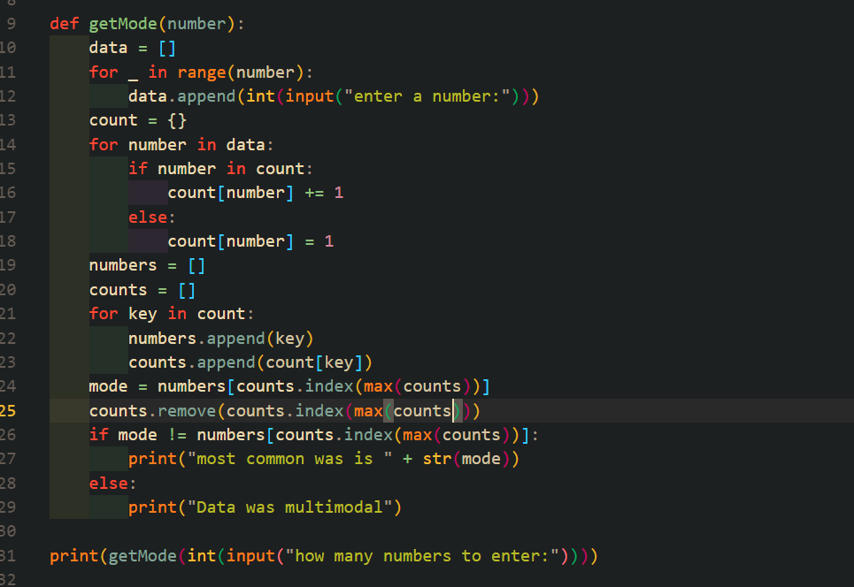
5.2) test 1 & test 2

