Wikibooks Predicted Questions For 2023 Paper 1 Computer Science

Section C
State the name of an identifier for a public method in the Dastan Class [1]
PlayGame()
1/1
Explain why this method is public and not private [2]
As the Main() procedure needs to access and run this method.
½
As the main() procedure, which is outside of the class, needs to access it and run the method, as if it was private it wouldn’t be able to.
How many points do you lose when you choose a move from position 1, 2, and 3 in the queue? [2]
1 for position 1, 4 for position 2, 7 for position 3.
2/2
Supposed you wanted to display the grid with 8 by 8 cells. What would you modify in the program? [1]
I would change the paramteres in the intialisation of the Dastan class in the Main() procedure to be
Dastan(8,8,4)
1/1
State the name of an identifier for a class that inherits from another class [1]
The Kotla() class inherits from the Sqaure() class.
1/1
State the name of an identifier for a private method that has three parameters (including object parameter) [1]
Dastan.__UpdateBoard()
1/1
has three parameters: self, StartSquareReference, FinishSquareReference.
State the name of an identifier that us a boolean variable [1]
Player1HasMirza
1/1
What is the random module used for? [1]
The generation of random values or choices of data.
1/1
State the name of a built-in function used in Dastan. [1]
int()
1/1
What effect does the super routine in class Kotla have? [1]
it runs the intialisation of the parent class which Kotla inherits from, Square().
1/1
Give an example from the code of an object instantiation. [1]
ThisGame = Dastan(6,6,4) in the Main() procedure instantialises the Dastan() class.
1/1

Section D
New Move: TibbleCross
Description of problem: The program is to be extended with a new type of move called the "TibbleCross". This move can allow a piece to go up two spaces diagonally from its starting position in any direction ( NW, NE, SE, SW ).

Add this move so it appears first in the queue of moves for both players.

Select the move and test it by selecting piece "22" and then moving to row/column "44"

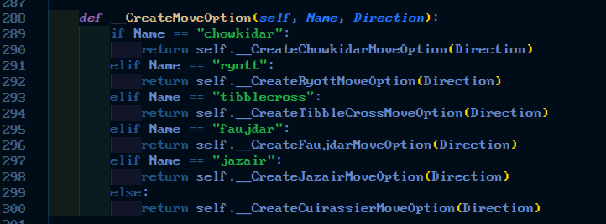
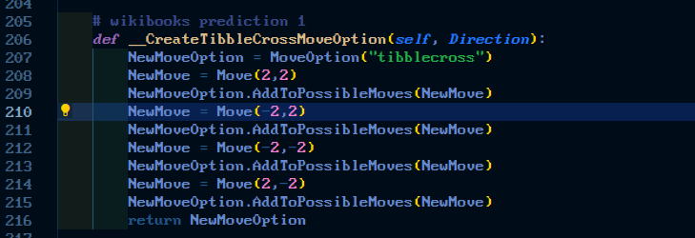

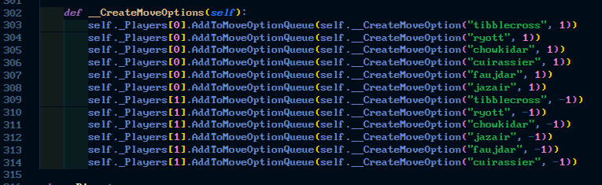
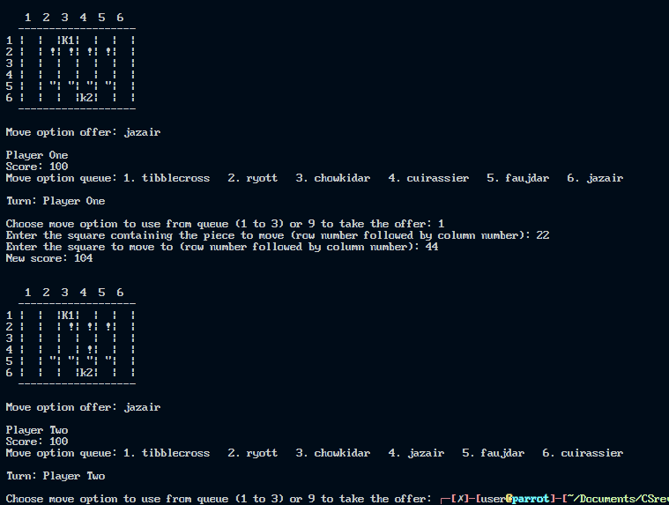
New Move: rook
Description of problem: Add a new move which moves forward until the piece hits the end of the board or hits another piece
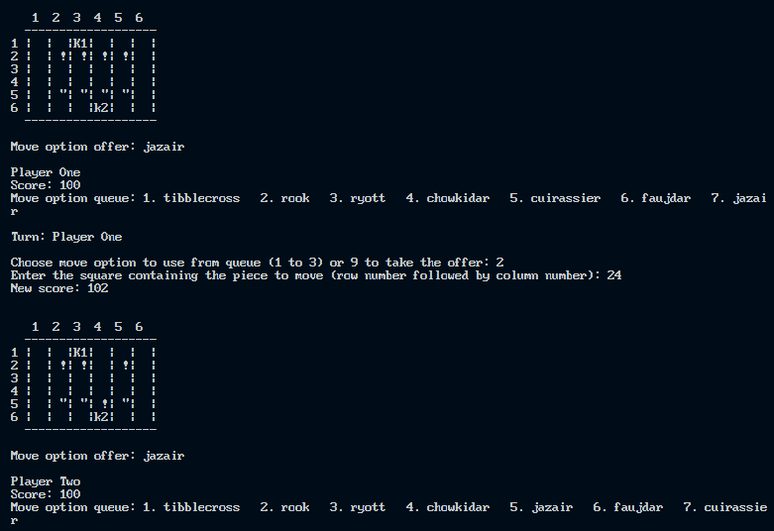

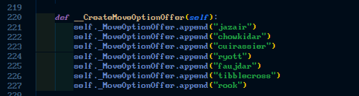

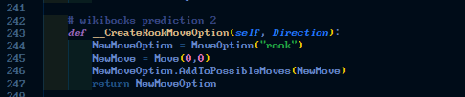
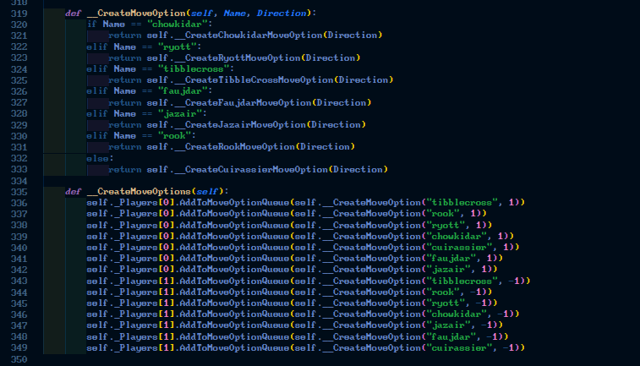
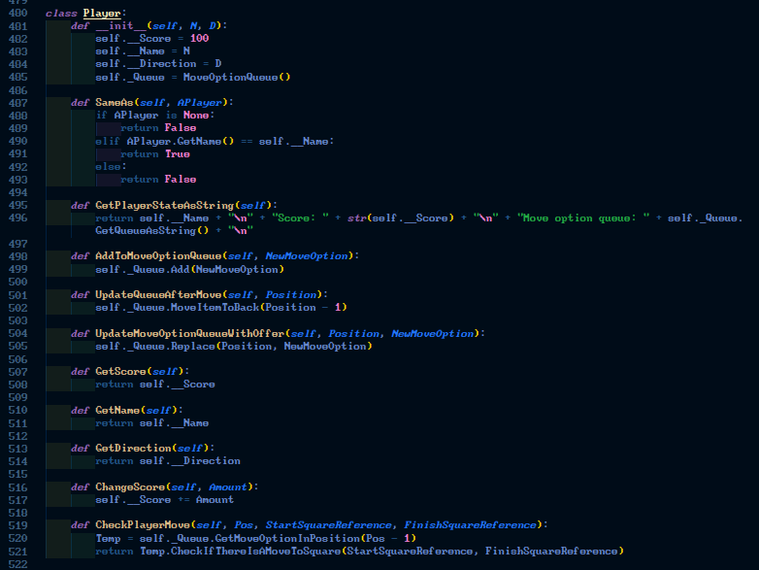

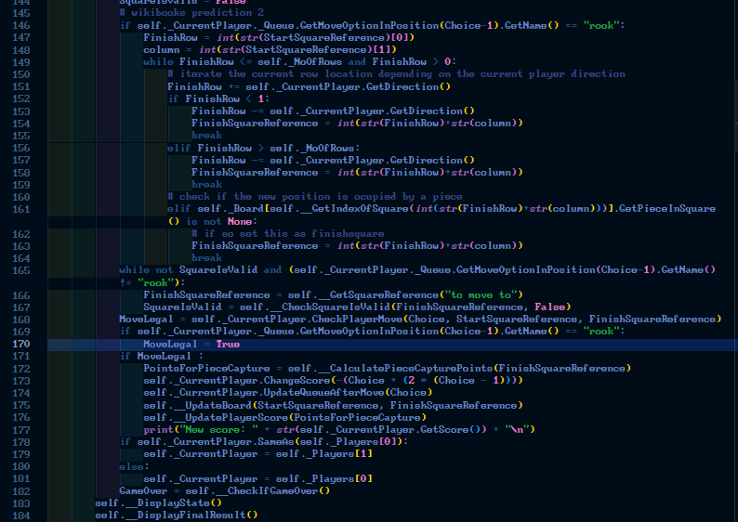
Checking validity of a move
Description of problem: When choosing where to move a piece, you must input the start square and finish square. If a valid start square is chosen, but an invalid destination square, the program will move on without prompting the player to re-enter.

Alter the code to prompt the user to re-enter the finish square until a valid square is given.
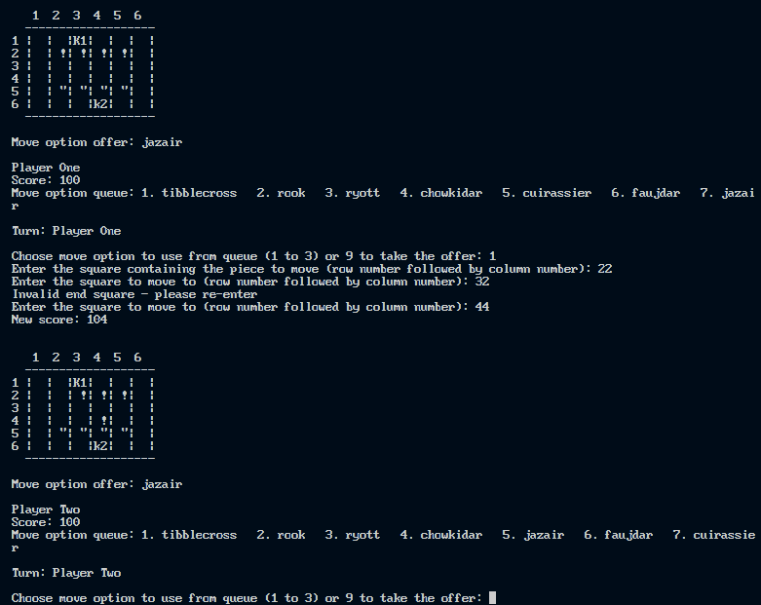
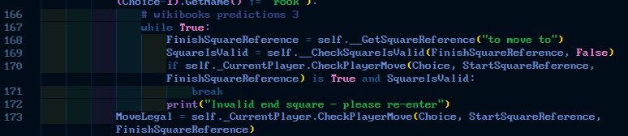
New Move: spacejump
Description of problem: Add a new move called a spacejump which moves the chosen piece to a random place on the board. It can't land on your own pieces, but everywhere else is fine. The player cannot choose where the piece will end up. The spacejump move will not be added to the queue of moves, instead a player is allowed one per game that can be used whenever they choose in lieu of a queue choice. Test by allowing player 1 to use the option from square 22 and then player 2 from square 55. Player 1 will not have the option displayed on their next turn.

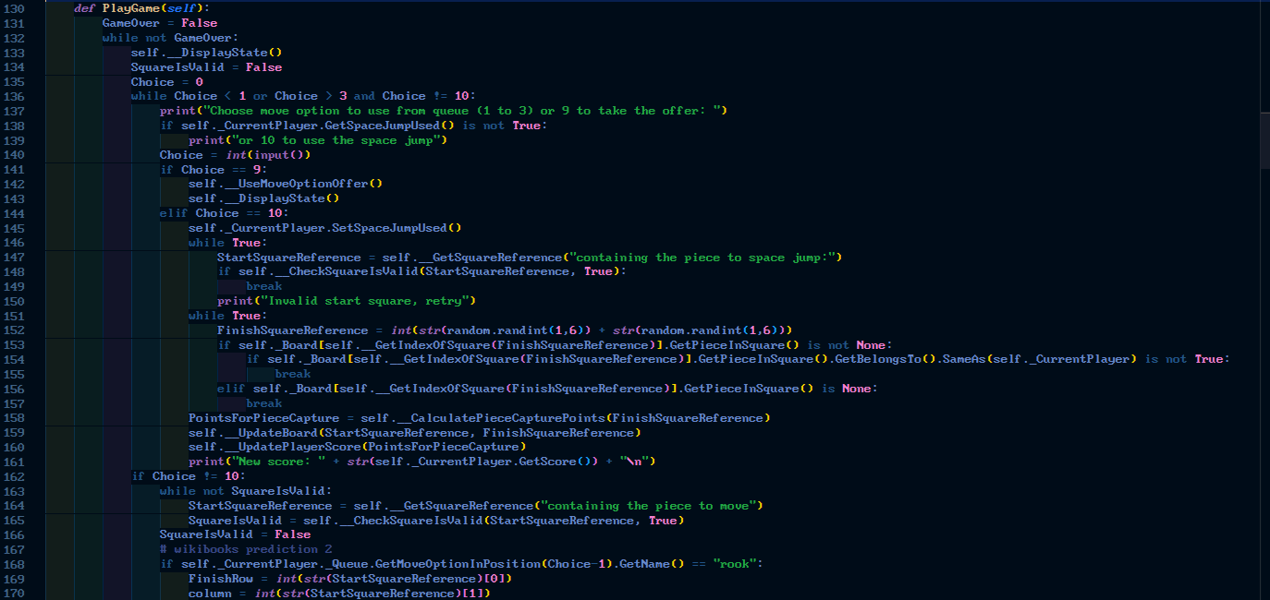
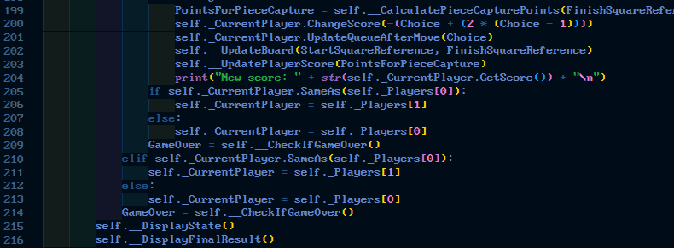

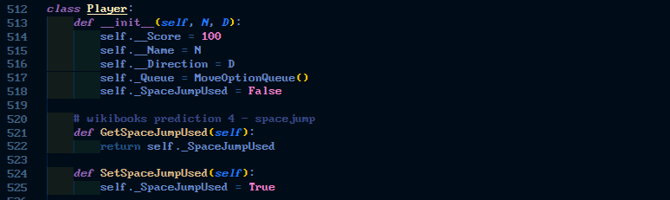

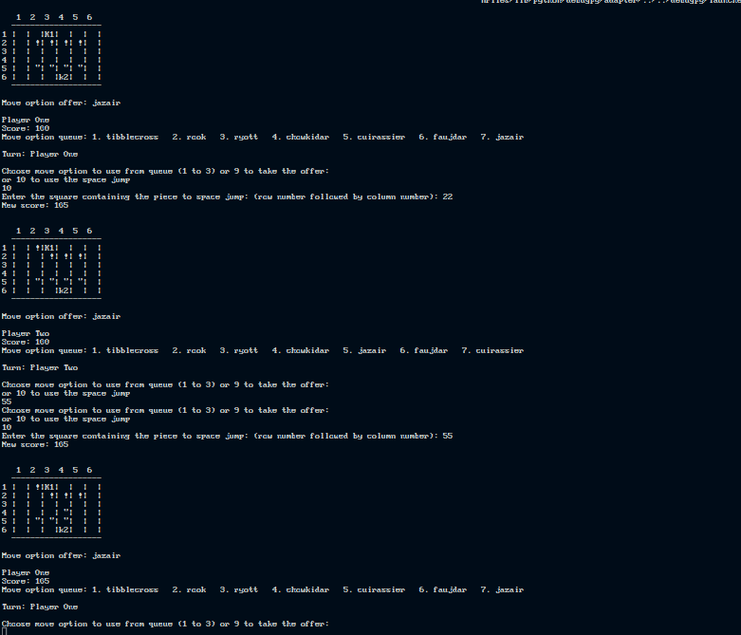

UserName input
At the beginning of the game allow each user to enter their own name to be used as a replacement to "Player One" and "Player Two"
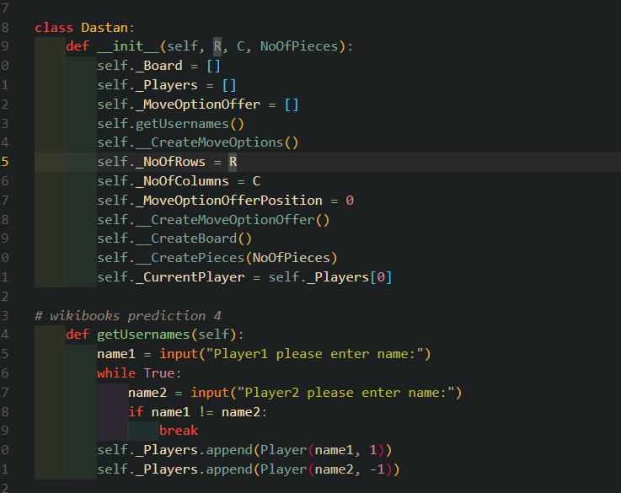
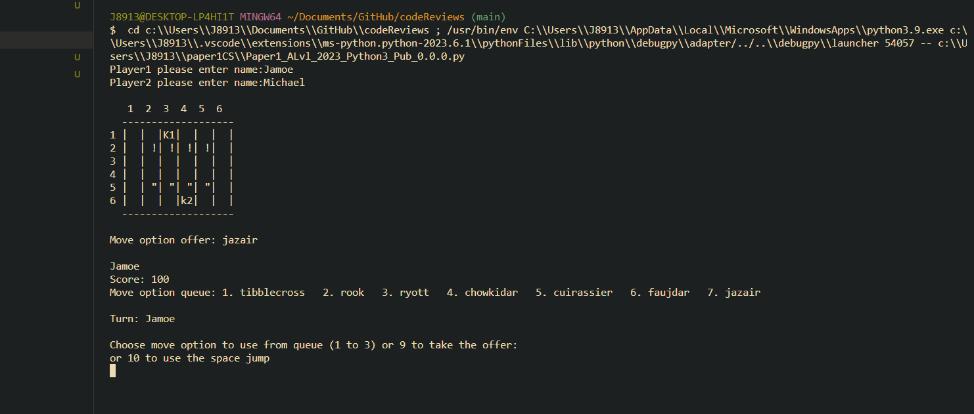

Show where the piece can move
Description of problem: At the moment when selecting a move the player is expected to remember the ways in which move can be applied. Modify the program so that, once a piece has been selected a '^' symbol appears in the squares into which that piece can be moved based on the move selected. - Resolve using method A1 specification

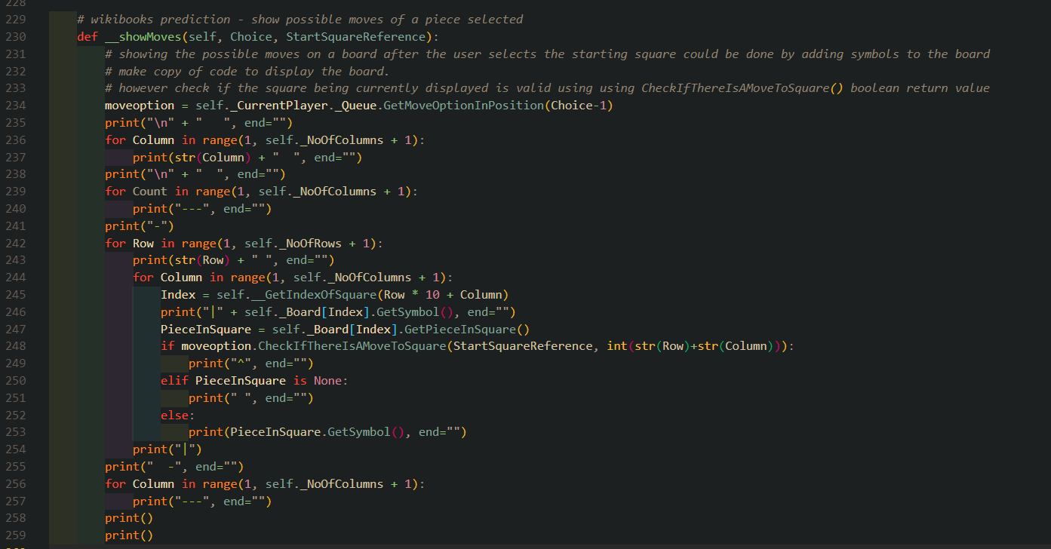
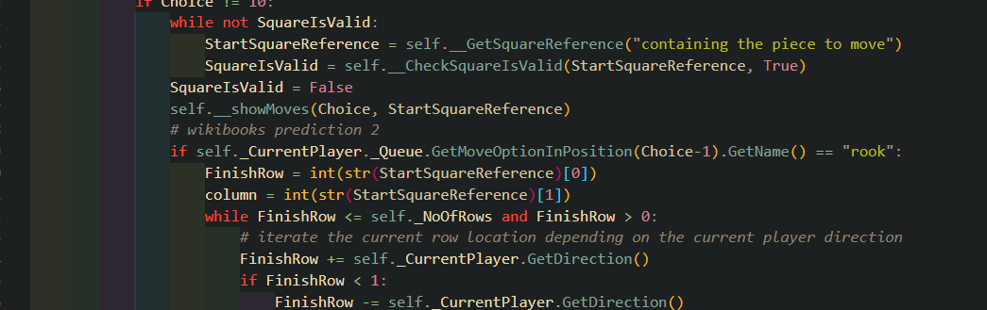
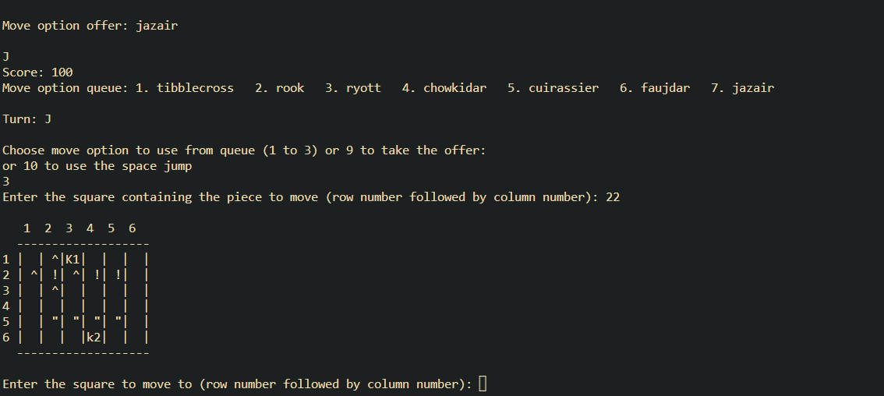
Random start queue
Description of problem: Randomize the players move queue at the beginning of the game so that the players do not start with the same queue at the beginning of every game .
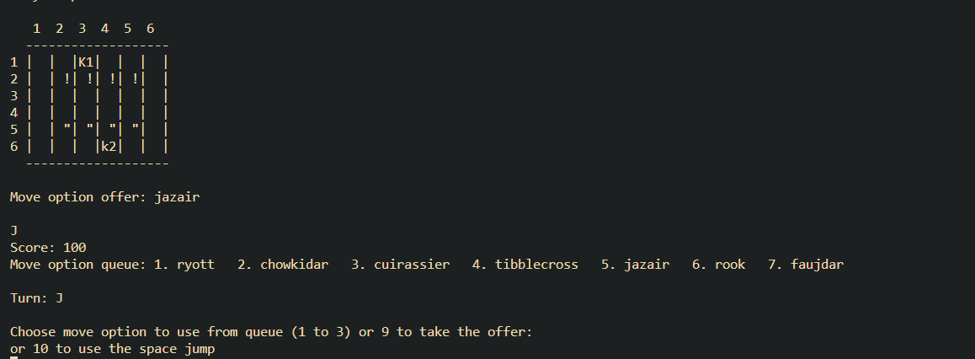
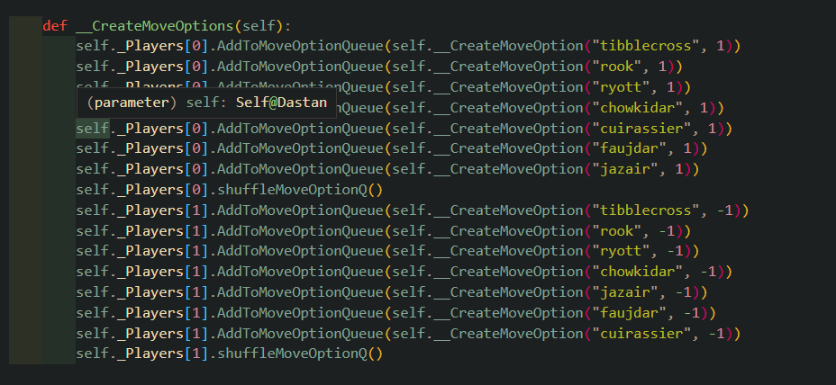
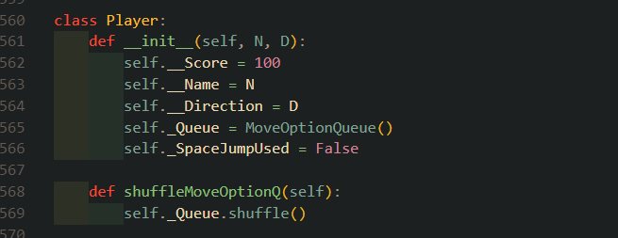

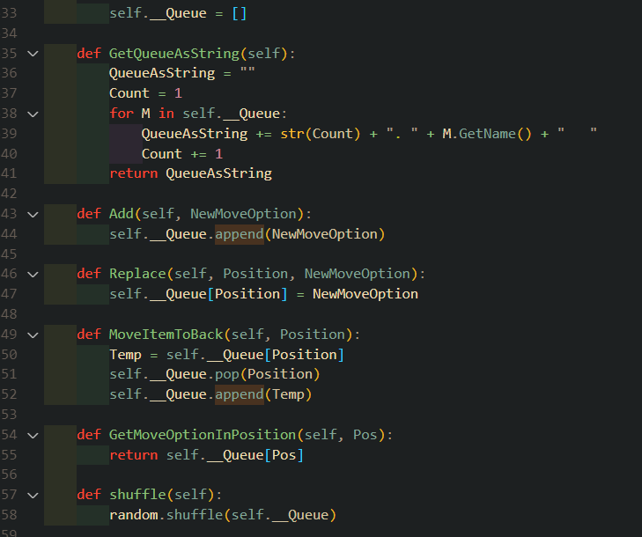
Choose where to put Kotla and Mirza
Description of problem: At the beginning of the game, allow players the option to choose where they place their (Kotla and Mirza) together at the back of their side of the board. For example: Player One can place their Kotla and Mirza between (1,1) to (1,6) and Player Two can place their Kotla and Mirza between (6,1) and (6,6).

