AQA CS Paper 1 2017
1.1)
Real Number | Valid?
87.000 | Yes
97+12 | No
12.31E+12 | Yes
3/3
1.2)
<natural> ::= <digit> | <natural><digit>
2/2
2.1)
S12 means any character has been entered from S10, S11 or S21 and any character will lead to remaining in S12. This is not an accepting state and is an invalid postcode.
1/1
2.2)
S11 means the postcode is not in the town, but is near Ipswich area and go in Van B.
1/1
2.3)
A UK non IP postcode can be a letter followed by a number whereas an IP postcode must be two letters at the start.
1/1
2.4)
\a\a?(\d\d?)|(\d\a)\d\a\a
Above does not work when tested in regexer and not in MS
Correct: \a?\a\d(\a|\d)?\d\a\a
2/4
3.1)
O(n log n) = merge sort
1/1
3.2)
4 – all of them solve tractable problems
1/1
3.3)
bubble sort = O(n^3)
0/1 O(n^2)
3.4)
Bubble sort has an O(n^2) time complexity as each item has to ‘bubble’ up the remaining items in the list while getting swapped in each pass. This makes it a squared complexity. item*items.
1/2
In each pass n items will be examined; there will be n passes through the list. Therefore it is n^2 complexity.
4.1)
A recursive subroutine is a subroutine that calls itself.
1/1
4.2)
One base case is if target is equal to node.
1/1
4.3)
Function Call | Output
TreeSearch(olivia, norbert) | “Visited norbert”
TreeSearch(olivia, phil) | “Visited Phil”
1/3
above is correct answer, originally traced a full search of the tree with the whole table filled.
5.1)
Dot product = multiply each by one another and sum them into a single number.
u.v = (1*3)+(1*-5) = -2
1/1
5.2)
[5,2] + [3,1] = [8,3]
1/1
5.3)
Calculation | Result
U | [1,1]
V = [pos hero] – [pos enemy] | [6,-4]
u.v | 2
EnemyCanSee | True
3/3
5.4)
Heuristic technique?
0/2
A heuristic technique is where a method which is not the best is used;
The algorithm could instead of calculating the absolute shortest path. Calculate a few possible routes and take the best of those options.
5.5)
A static data structure has an allocated size in memory which cannot be changed. These locations for datapoints are sequential and continous in memory. Whereas a dynamic data structure can have it’s datapoints be non-sequential in memory and have other unrelated data inbetween. To solve this a dynamic structure will have a pointer stored with each piece of data which points to the next items location in memory. On the other hand a static structure does not use pointers.
2/2
6.1)
A stack could be used as it allows for the applied actions to be stored. If a user does an action it should be pushed to the stack. If they want to redo an action. The stack can be peeked to see the top value which would be the last completed action. It can then push another of that peeked action to the stack. On the other hand, undo could be done by popping the top item from the actions stack until the stack is empty.
4/4
6.2)
index error
0/1
This is literally called a stack underflow. Or a stack empty error.
Section B
7.1) source code
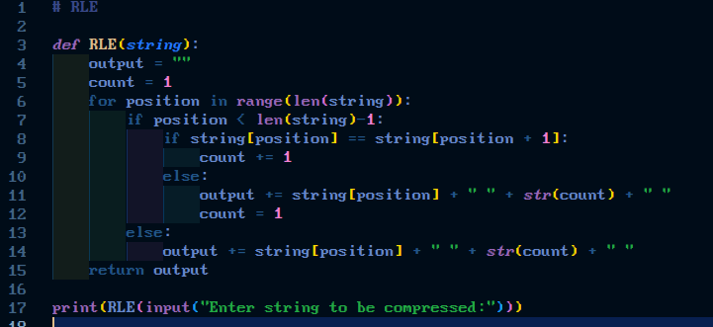
7.2) test 1
7.3) test 2

14/14
Section C
8.1)
Inheritance - NO
Protected method – YES
Private attribute – YES
2/3
There is a PRIVATE method not a protected method.

