CS Paper 1 2021

Section A
1.1)
3 | 5 | 1 | 6 | 4 | 8
3 | 1 | 5 | 4 | 6 | 8
1 | 3 | 4 | 5 | 6 | 8
3/3
2.1) A binary tree is a hierarchical data structure where nodes each have 0 or 2 leaf nodes extending from a root node.
½ it has AT MOST two leaf nodes, not 0 or 2. One mark for “rooted tree” description.
2.2) EIHCYBQ
2/2
2.3) Trace of Traversal(0) call:
Current | Pos | [0] | [1] | [2] | [3] | Output
0 | 0 | 0
0 | -1 |  |  |  |  | C
 | 0 | 4
 | 1 |  | 1
1 | 0 |  |  |  |  | I
 | 1 |  | 3
 | 2 |  |  | 2
2 | 1 |  |  |  |  | E
3 | 0 |  |  |  |  | H
4 | -1 |  |  |  |  | B
 | 0 | 6
 | 1 |  | 5
5 | 0 |  |  |  |  | Y
6 | -1 |  |  |  |  | Q
7/7
2.4) A recursive subroutine is one which calls itself within it’s definition.
1/1
2.5) A base case is the condition where a recursive subroutine will not recur.
1/1
2.6) local variable states, return address.
2/2
3) Procedural decomposition is where a larger problem is broken down into it’s component parts which which can be each be solved as smaller problems which when put together solve the larger one.
1/3 Each of which solves an identifiable task; each of which might be further subdivided.
4) When adding a record to a hash table, the hashing algorithm is applied to the record. Typically this includes a modulo to ensure it’s hash value fits within the size of the hash table. Then the location in the hash table which matches this result is checked. If it is already occupied, the next available location is checked and we continue this process of checking the next available location until we find an empty location, that is where the record is added. This is called collision avoidance.
4/5 need to make it clear that the hashing algorithm is applied to the KEY VALUE. NE data/record/item.
5.1) An advantage of RPN is that it’s simpler for a computer to evaluate and it removes the need for parenthesis.
2/2
5.2) A stack can be used to evaluate RPN expressions by parsing the RPN expression. Then having any operands pushed immediately to the stack. Once we hit a operator, we pop twice from the stack and evaluate those two operands using the operator. We then push the result back onto the stack. Once we have reached the end of the expression and all operators have been used, we should have a single value in the stack which we can pop out. That is the final evaluation.
4/4
6.1)
Current State | Input | New State
S0 | b | S2
S2 | b | S4
S5 | b | S2
S2 | a | S5
2/2
6.2) Regex for FSM:
a(ba)*|b(ab)*
3/3

Section B
7.1) Source Code
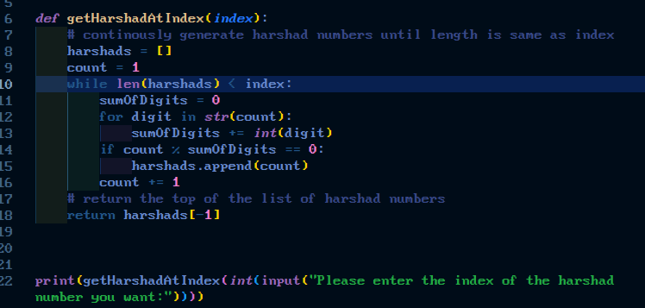
7.2) Testing
