Paper 1 AQA Computer Science 2022

Section A
1)
Bubble Sort = O(n log n) WRONG it is O(n^2)
Linear Search = O(n) CORRECT
Merge Sort = O(n^2) WRONG it is O(n log n)
1/3
2.1) For a static circular queue, removing an item would involve locating the index of the front pointer. The item at that index should be dequed. The front pointer should have 1 added to it to move it across. If adding 1 to the front pointer leads to it reaching the end of static allocated space, it should be changed to the value of the first memory location of allocated data for the circular queue.
2.2) A dynamic data structure can have memory locations allocated or removed from memory as it’s actual number of items required to be stored changes. On the other hand, a static structure has it’s size in memory allocated at runtime which can lead to wasted memory space if not all the allocated spaces are used. A dynamic data structure will require more memory than a static structure to store a pointer to the next item in memory. A static data structure is less complex to implement than a dynamic one.
2.3) peek(s) = “Jib”
2.4) pop(s) = “Jib”
2.5) A stack could be used to reverse the order of items in a queue by pushing each item in the queue into the stack after dequeing. Then we can pop each item out of the stack and enqueue it back into the queue. This will reverse the order of items.
3.1) Statement 1 is not correct as statement 3 contradicts statement 2 which means at least one of the statements below statement 1 is incorrect, despite what statement 1 says.
3.2) Statement 5 is correct.
S1 = False
S2 = False
S3 = False
S4 = False
S5 = True
S6 = False
3.3) Statemennt 6 is not correct as Statement 5 states the same thing as Statement 6. Therefore statement 6 cannot be true as Statement 5 would have to be False which makes it also False.
Also statement 2 is incorrect as statement 5 is True despite it claiming that ‘none of the statements below are correct’.
4.1) Statements about Djikstra’s algorithm:
Calculates the shortest path between a node and other nodes in a graph. | True
Can be used to prove that the Halting Problem cannot be solved. | False
Can be used with both directed and undirected graphs. | True
Can be used with both weighted and unweighted graphs. | False

4.2) A recursive subroutine is one which calls itself within it’s own definition.
4.3) Table to show result of F(graph in figure 6)
Count | Value Returned
0 | None
1 | False
 | True

4.4) Adjancency matrix for Figure 7
 | 0 | 1 | 2 | 3
0 | 0 | 1 | 1 | 1
1 | 1 | 0 | 0 | 1
2 | 1 | 0 | 0 | 0
3 | 1 | 1 | 0 | 0

4.5) Trace table for subroutine call G(0,-1)
Subroutine Call | V | P | [0] | [1] | [2] | [3] | N
 |  |  | False | False | False | False
G(0,-1) | 0 | -1 | True |  |  |  | 1
G(1,0) | 1 | 0 |  | True |  |  | 0
G(0,-1) |  |  |  |  |  |  | 2
G(2,1) | 2 | 1 |  |  | True |  | 0
G(0,-1) |  |  |  |  |  |  | 3
G(3,2) | 3 | 2 |  |  |  | True | 0
G(0,-1)
FINAL RETURN: | True

4.6) Purpose of subroutine G is to explore the connections of all nodes and whether all nodes are directly connected to the start node.
4.7) This is depth-first graph traversal as each route is fully explored before moving on.
4.8) IDK

Section B
5.1) source code
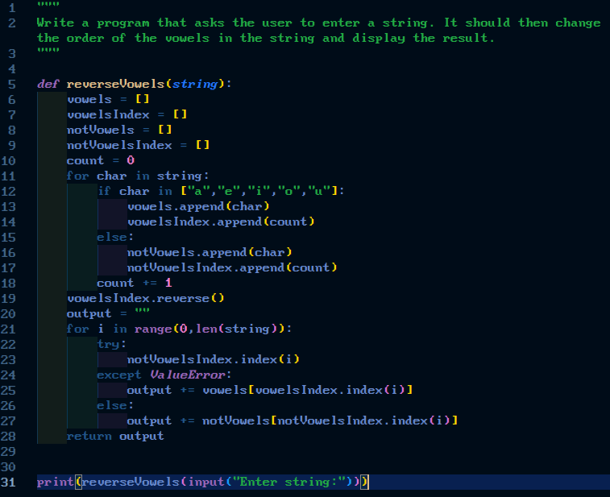
5.2) testing
