Part 1
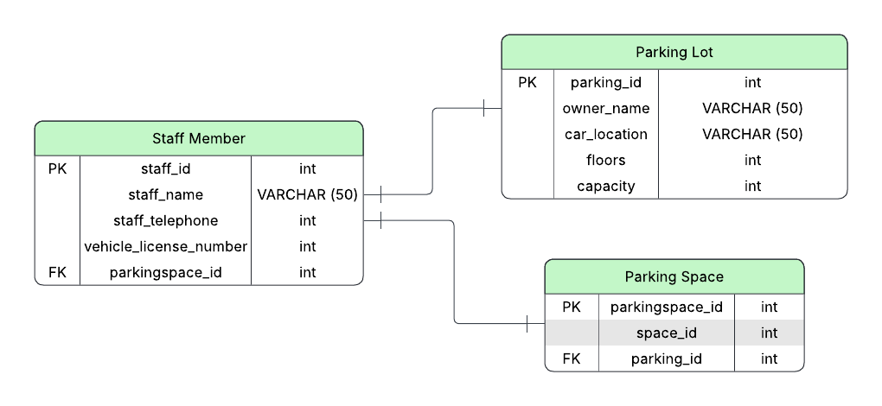
staffNo | dentistName | patNo | patName | appointmentDate | appointmentTime | surgeryNo
1011 | Tony Smith | 100 | Gillian White | 12-Sept 2023 | 10:00 | 15
1011 | Tony Smith | 105 | Jill  Bell | 12-Sept 2023 | 12:00 | 15
1024 | Helen Pearson | 108 | Ian Mackay | 12-Sept 2023 | 10:00 | 10
1024 | Helen Pearson | 108 | Ian Mackay | 14-Sept 2023 | 14:00 | 10
1032 | Robin  Plevin | 105 | Jill  Bell | 14-Sept 2023 | 16:30 | 15
1032 | Robin  Plevin | 110 | John Walker | 15-Sept 2023 | 18:00 | 13

Part 2
1NF

2NF
staffNo | patNo | appointmentDate | appointmentTime
1011 | 100 | 12-Sept 2023 | 10:00
1011 | 105 | 12-Sept 2023 | 12:00
1024 | 108 | 12-Sept 2023 | 10:00
1024 | 108 | 14-Sept 2023 | 14:00
1032 | 105 | 14-Sept 2023 | 16:00
1032 | 110 | 15-Sept 2023 | 18:00

Staff Table
staffNo | dentistName | surgeryNo
1011 | Tony Smith | 15
1024 | Helen Pearson | 10
1032 | Robin Plevin | 15
1032 | Robin Plevin | 13

patNo | patName
100 | Gillian White
105 | Jill Bell
108 | Ian Mackay
110 | John Walker
Patient Table

3NF
Appointment Table
staffNo | patNo | appointmentDate | appointmentTime
1011 | 100 | 12-Sept 2023 | 10:00
1011 | 105 | 12-Sept 2023 | 10:00
1011 | 108 | 12-Sept 2023 | 10:00
1011 | 108 | 14-Sept 2023 | 10:00
1011 | 105 | 14-Sept 2023 | 10:00
1011 | 110 | 15-Sept 2023 | 10:00

Staff Table
staffNo | surgeryNo
1011 | 15
1024 | 10
1032 | 15
1032 | 13

Surgery Table
surgeryNo | Location
10 | Unit 3 Main Building
15 | Unit 3 Main Building
13 | Unit 3 Main Building

Patient Table
patNo | patName
100 | Gillian White
105 | Jill Bell
108 | Ian Mackay
110 | John Walker

