1. **Git –version**  
   git version 2.45.2.windows.1
2. **Git config –global user.name jamesdevbie**
3. **Git config –global user.email** [**jamesdevbie@gmail.com**](mailto:jamesdevbie@gmail.com)
4. **git init**



1. **git status – to check the tracked and untracked files in the current repository.**

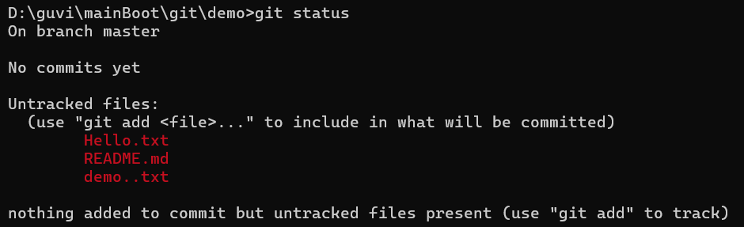

1. **git add** (*-add all files in the folder, . – add all files in the present working directory, -filename – adds files to staging area)

add the local untracked files to staging area(temporary area) from which it can be commited.



1. **git status (i.e recheck status post git add)**

