#### 参数

##### 1-argparse

###### notebook中

import pickle  
pickle_file = open('args.pkl','wb')  
pickle.dump(args,pickle_file)  
pickle_file.close()

import pickle  
  
pickle_file = open('args.pkl','rb')  
  
args = pickle.load(pickle_file)

###### 打印预览参数

print("\nParameters:")  
for attr, value in sorted(args.__dict__.items()):  
 print("\t{}={}".format(attr.upper(), value))

##### 

##### 2-config

#### 模型接收args参数

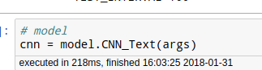

#### train-动态

CNN-text分类

