**OOP Week 6**

**Using mySQL part 2**

**James Donnellan**

**G00434671**

1. **Creating a database**

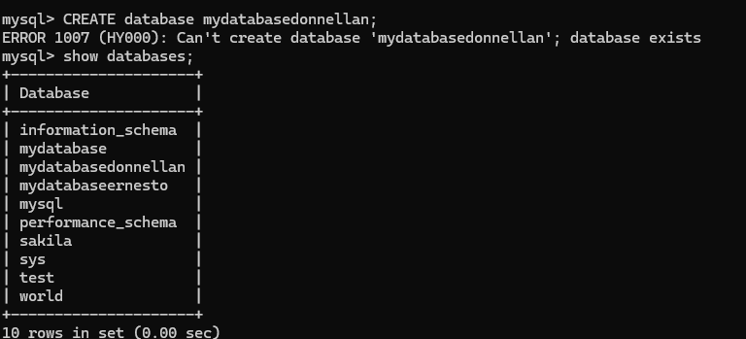

1. **Creating tables**

1. **Inserting data to a table**

1. **Updating table**

1. **Using Transactions**

1. **Deleting Data**

1. **Using mySQL workbench**

