James Ekstract

Professor Arias

CMPT220L-111

24 January 2017

Project 0

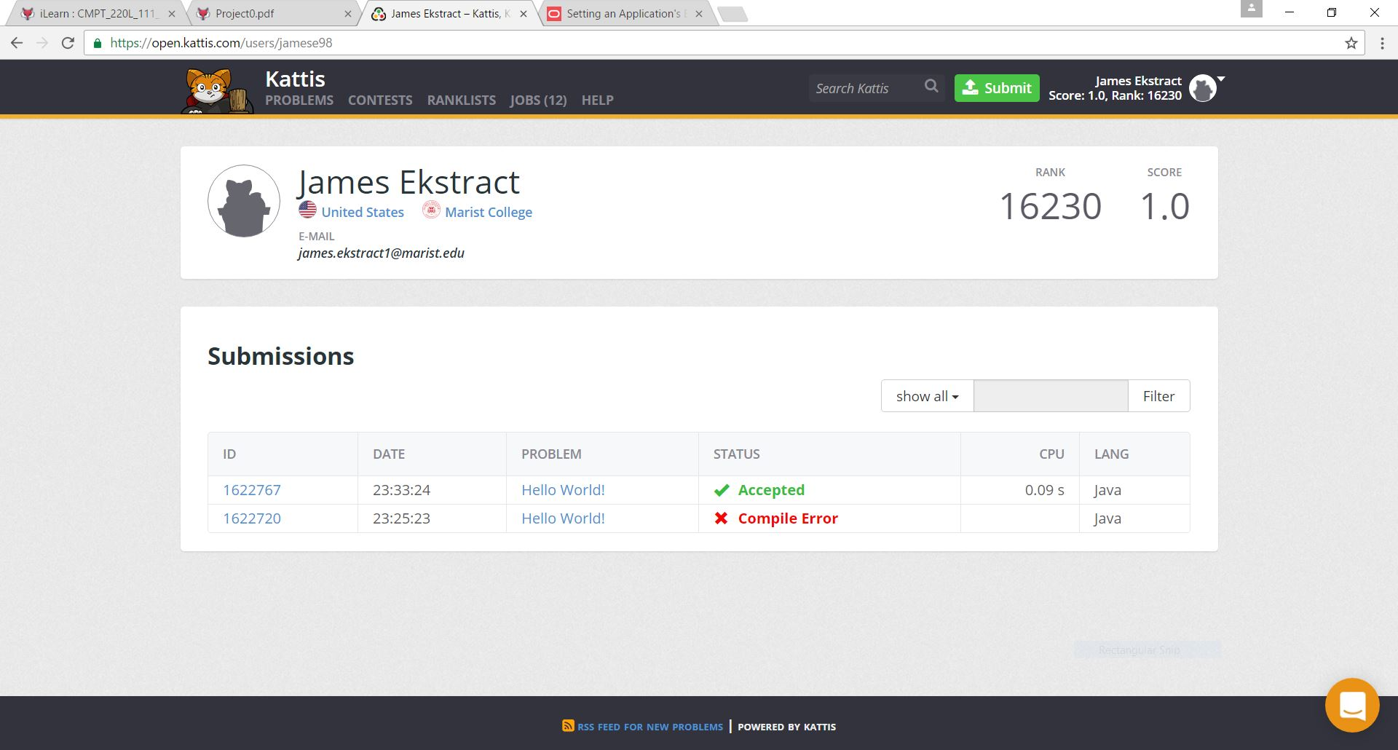

**driver_proj0.java**

public class driver_proj0 {

public static void main(String[] args) {

System.out.println("Hello World!");

}

}