SITECONTROL
Web Program - Operator Guide

Gate check-in and check-out, vehicle trips and in-transit alerts, the muster,
search, corrections and working without a signal.

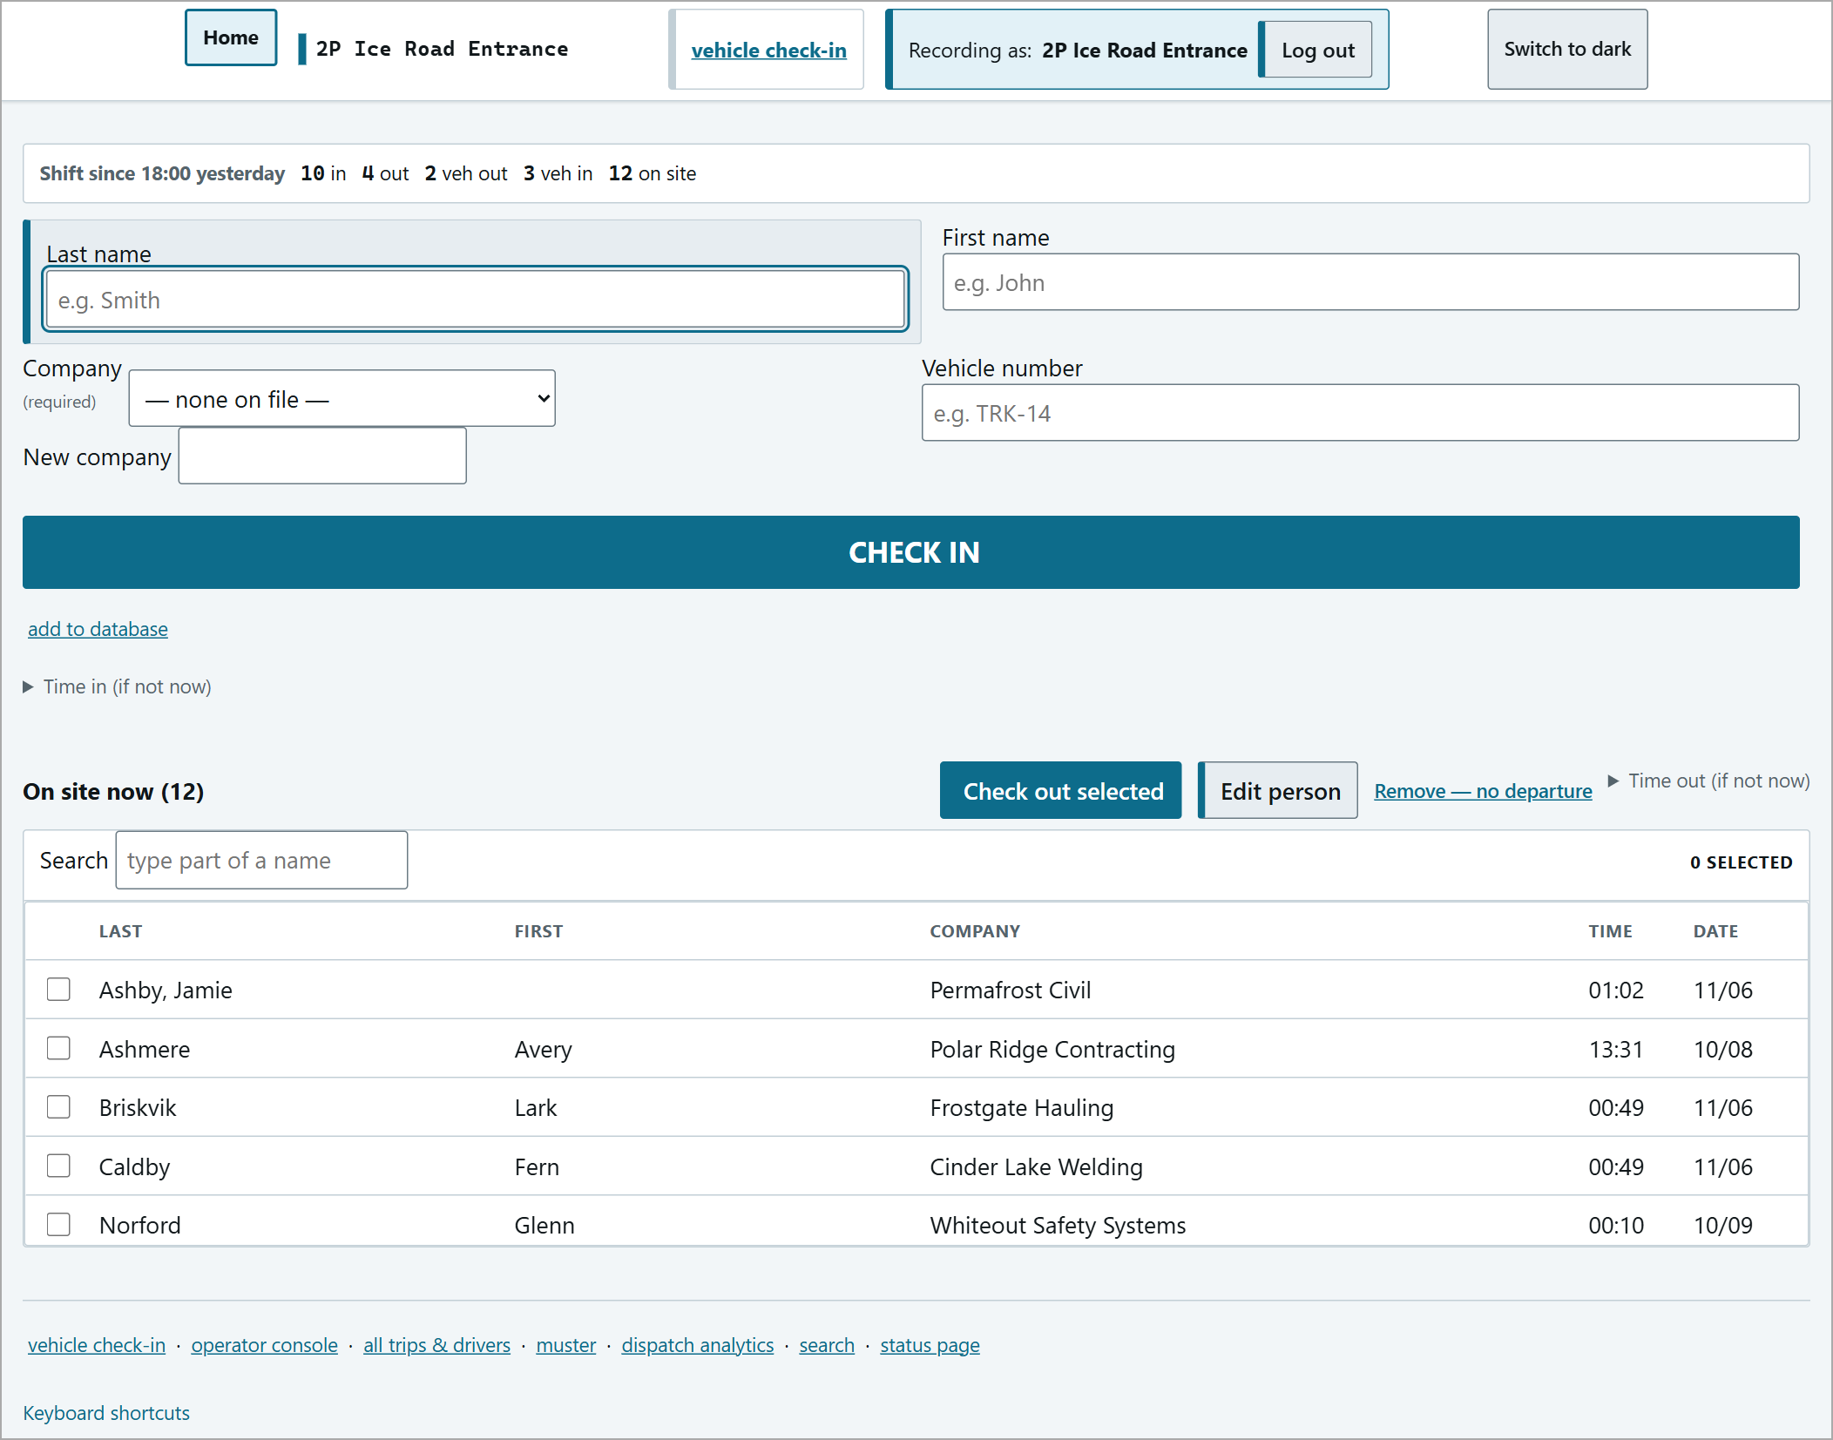

All names in this guide are sample data. Screens shown are from the 2P Ice Road Entrance and Ice Pad posts; every post uses the same screens with its own name.
Contents
Section | Covers | Page
Getting Started | Logging in, the top bar, keyboard shortcuts | 3
Checking People In | One person at a time | 5
Checking People Out | Every check-out is a vehicle departure | 10
Vehicle Check-In | A whole vehicle arriving at once | 14
Expected Arrivals | Vehicles on the road to your post | 17
Operator Console | Trips, countdowns and recording arrivals | 19
Overdue Vehicles | The red alert bar and acknowledging | 21
Orientation | Posts that require orientation first | 25
Muster | Live head count, past muster, printing | 27
Search | Finding people, visits and trips | 32
Corrections | Editing a person, removing an entry, fixing a trip | 35
Roster | Enrolling people and importing a list | 38
Lost Signal | Working while the link is down | 39
Reports and Status | History reports, status page, analytics | 41
Troubleshooting | Things that catch people out | 44
Quick Reference | One-page summary | 45

Getting Started
SiteControl runs in a web browser. Each post (gate) has its own address and its own copy of the records; posts share their records with each other automatically whenever the link is up.
Logging in
Enter the site password, then choose how you are checking people in: Individual check-in (one person at a time) or Vehicle check-in (a whole vehicle load). You can switch later from the top bar.
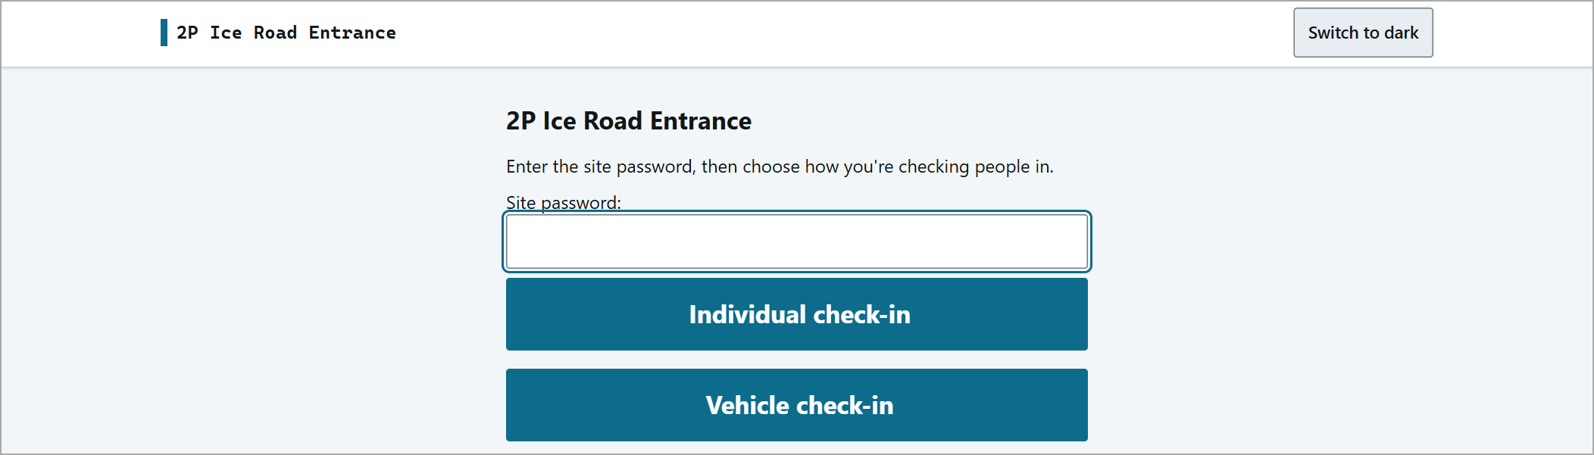  The login page. | 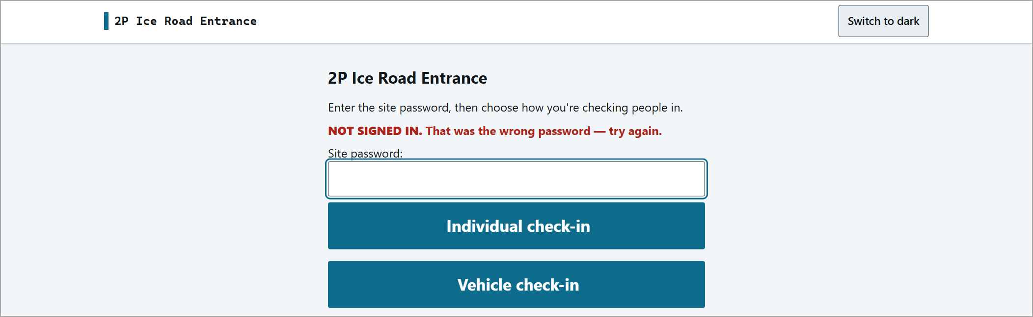  A wrong password: "NOT SIGNED IN. That was the wrong password - try again."

Without logging in you can still view the muster, search, status and reports - but nothing can be recorded.
The top bar
Home | Back to the post's start page.
vehicle check-in / individual check-in | Switches between the two gate screens.
sync pill | Green "sync ... healthy" = in contact with the other posts. Red "degraded" = not (see Lost Signal).
Recording as: <post> | Which post your entries are recorded against. Log out at the end of your shift.
Switch to dark / light | Changes the colour scheme for night use.

Links along the bottom of every page: vehicle check-in, operator console, all trips & drivers, muster, dispatch analytics, search, status page.
Keyboard shortcuts
Click Keyboard shortcuts at the bottom of the gate screen to show the list. The gate can be run without the mouse:
Key | Does
i | Jump to Check in (the Last name box)
o | Jump to Check out (the on-site list)
v | Vehicle check-in page
/ | Search the on-site list
h | Home
? | Show / hide the shortcut list
Enter | Moves to the next box; stops at confirmations
Up / Down, Space | Move through the on-site list and tick a person

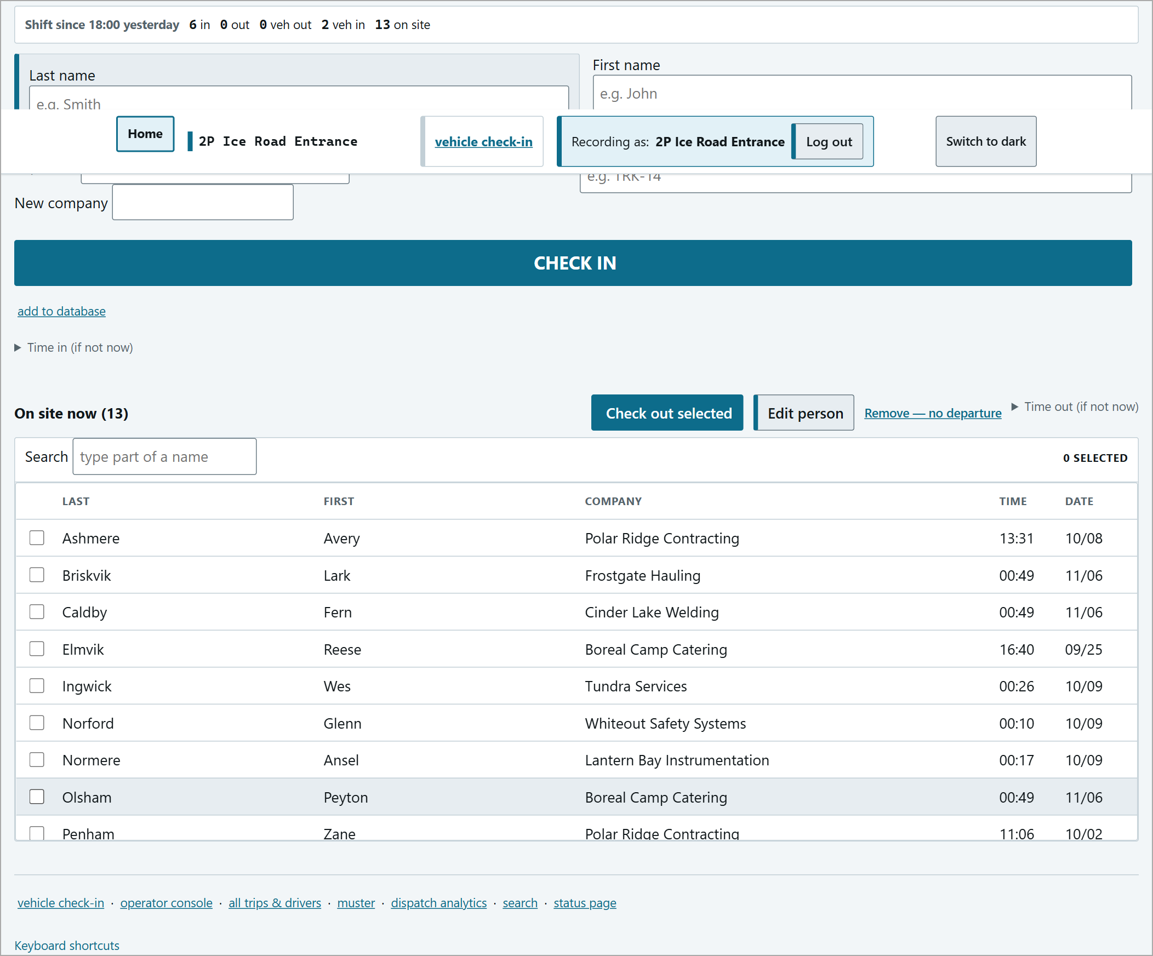
The gate screen with the keyboard shortcut list open (bottom).
Checking People In
The individual gate screen has the check-in form at the top and the On site now list underneath. The strip across the top counts the shift so far: in, out, vehicles out, vehicles in, and on site.
The individual gate screen.
Step 1 - Find the person
Start typing the Last name. A suggestion list appears (Last, First, Company) - pick the person and the form fills in.
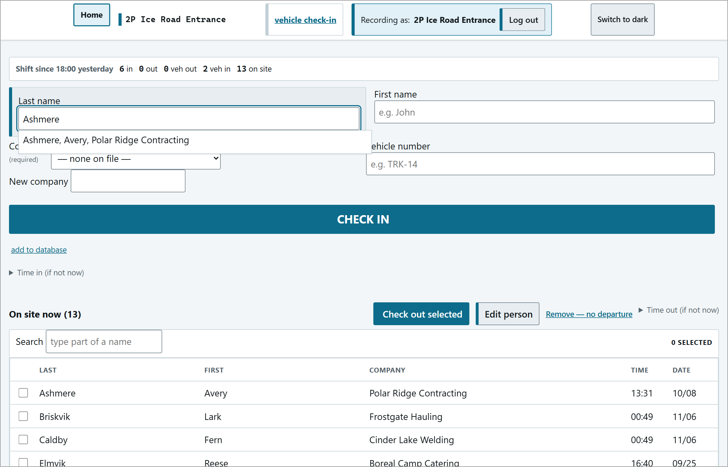
Typing a last name brings up matching people from the roster.
Step 2 - Check the details and press CHECK IN
Company is required (pick it from the list, or choose "not listed: add a new company" and type it). Vehicle number is optional. Press CHECK IN, then OK on the pop-up "Check this person in now?".
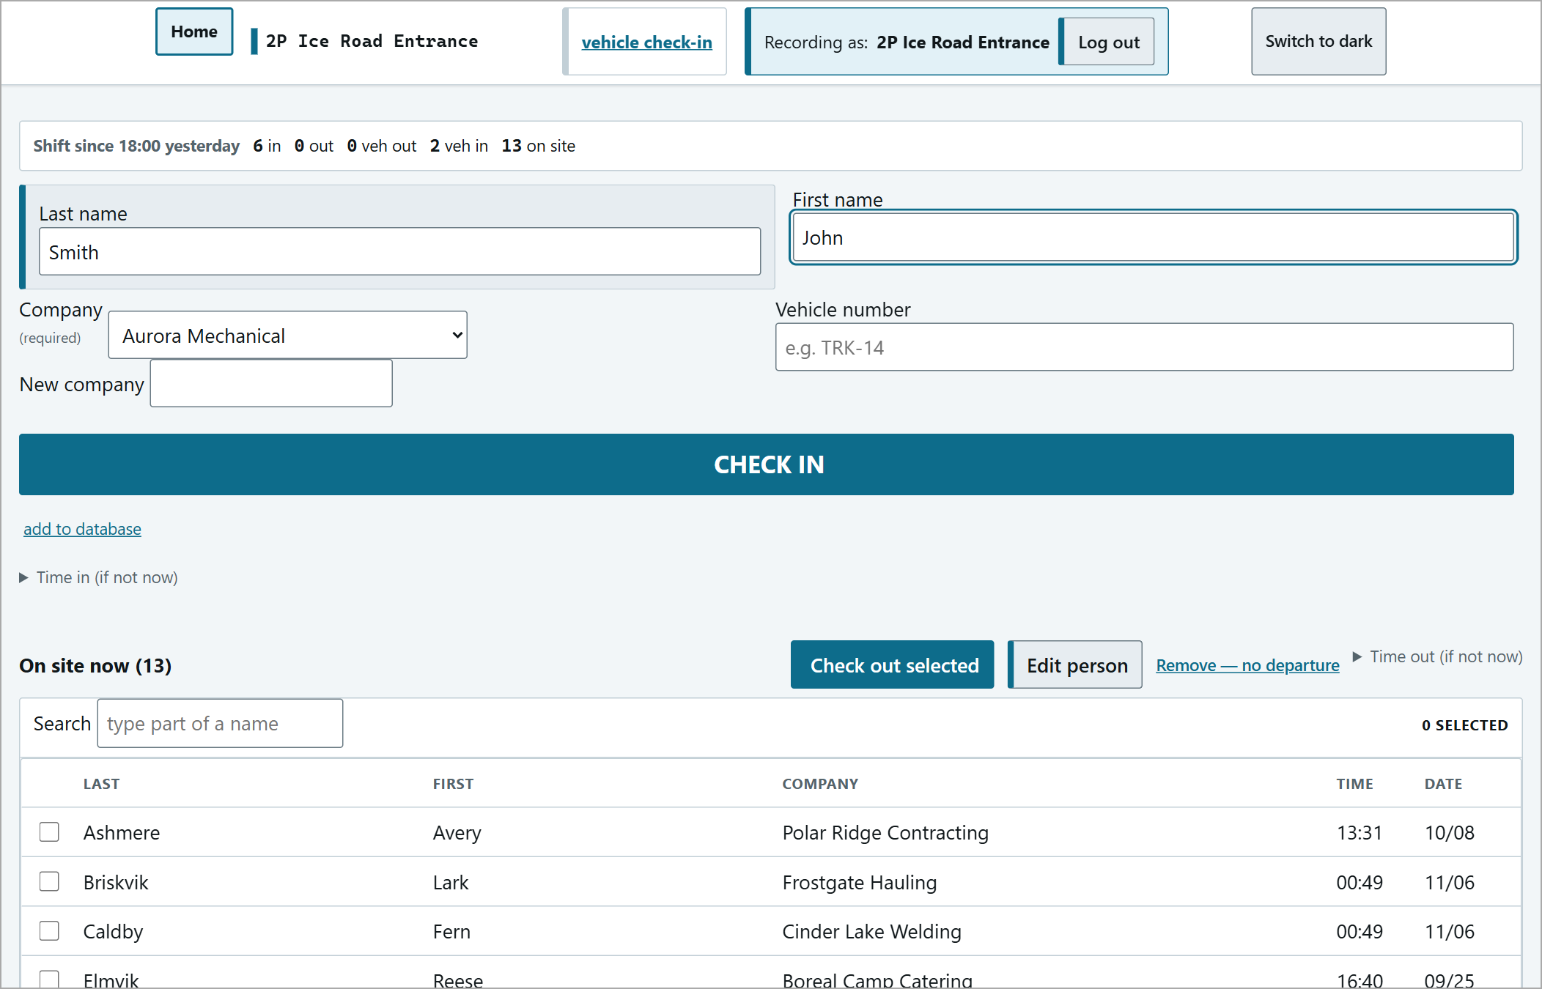
Form filled in. At a road post, someone not yet on the roster is added to it by checking them in. A post that gives its own orientation refuses them until they are enrolled - see Roster.
Step 3 - Confirm they are on the list
There is no "saved" message. A successful check-in is silent: the counters go up, the cursor goes back to Last name, and the person appears in On site now. Always glance at the list to confirm.

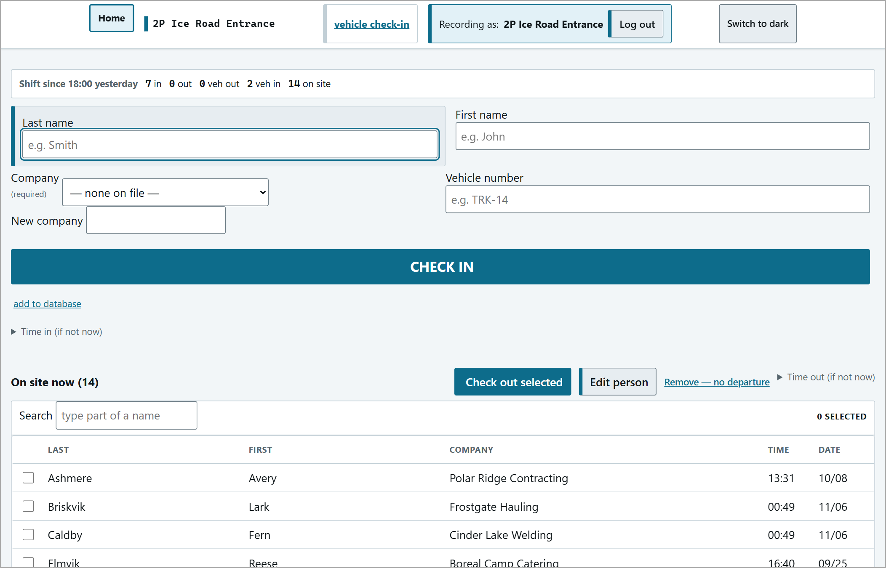
Smith, John now in the On site list; the counter went up.
If it happened earlier
Open Time in (if not now) and choose It actually happened at: with the real date and time. The time is recorded exactly as typed, as your statement of when it happened.
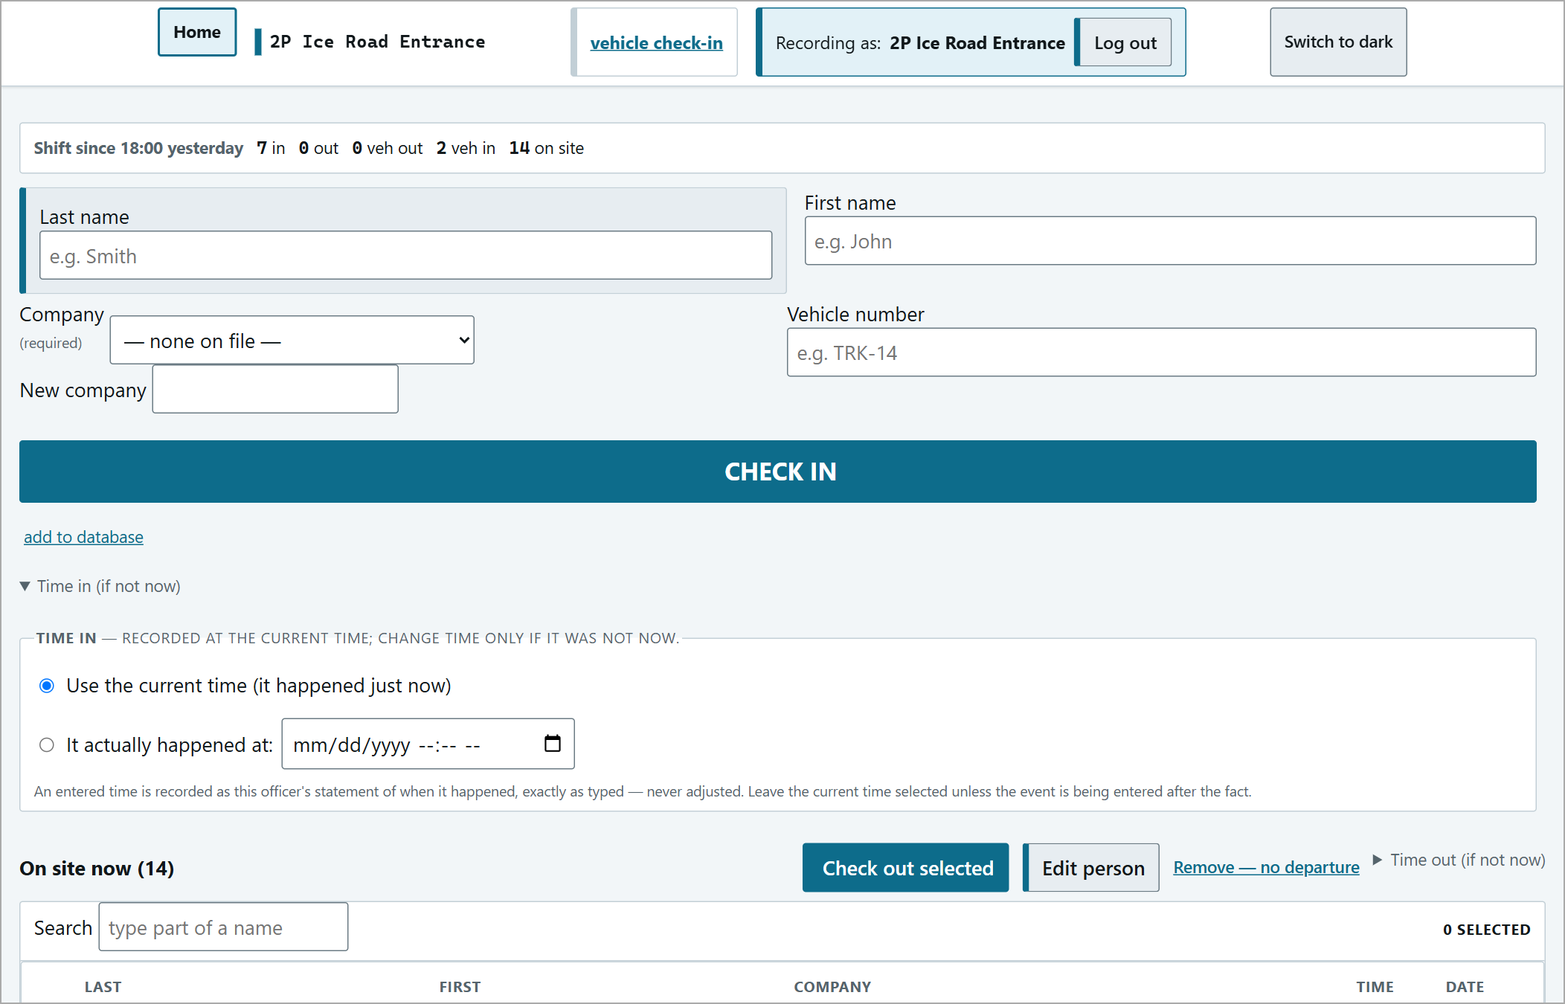
Time in (if not now) opened.
If something is missing
A red "Nothing was recorded." message explains what to fix. Nothing has been saved; correct it and press CHECK IN again.
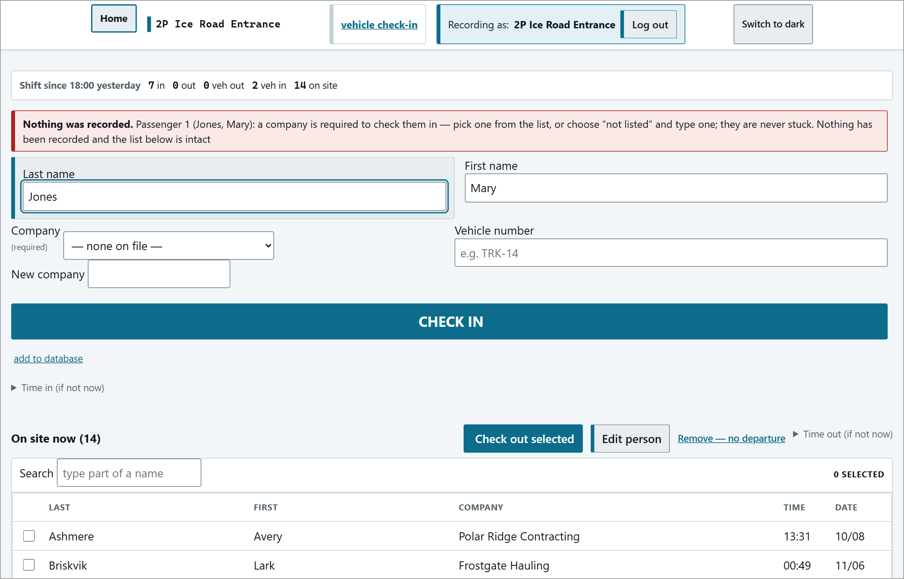
Company left blank. (The message says "Passenger 1" even when checking in one person - that is normal.)
Checking People Out
Every check-out is a vehicle departure. You record who is leaving, the vehicle, who is driving, where it is going and how long the trip should take. That trip time starts a timer: if the vehicle has not arrived in time, every post is alerted.

Step 1 - Tick who is leaving
In On site now, type part of a name in Search to narrow the list, tick each person leaving together on the same vehicle, then press Check out selected.
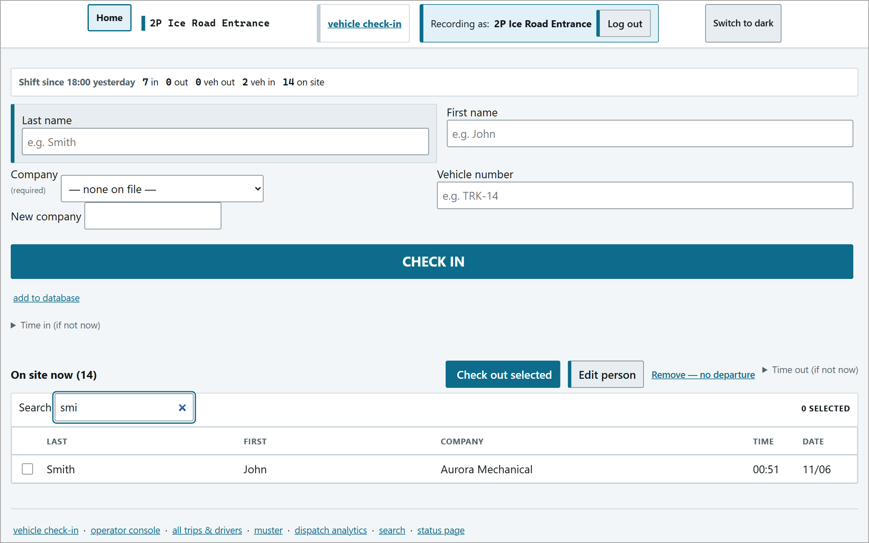  Searching the list. | 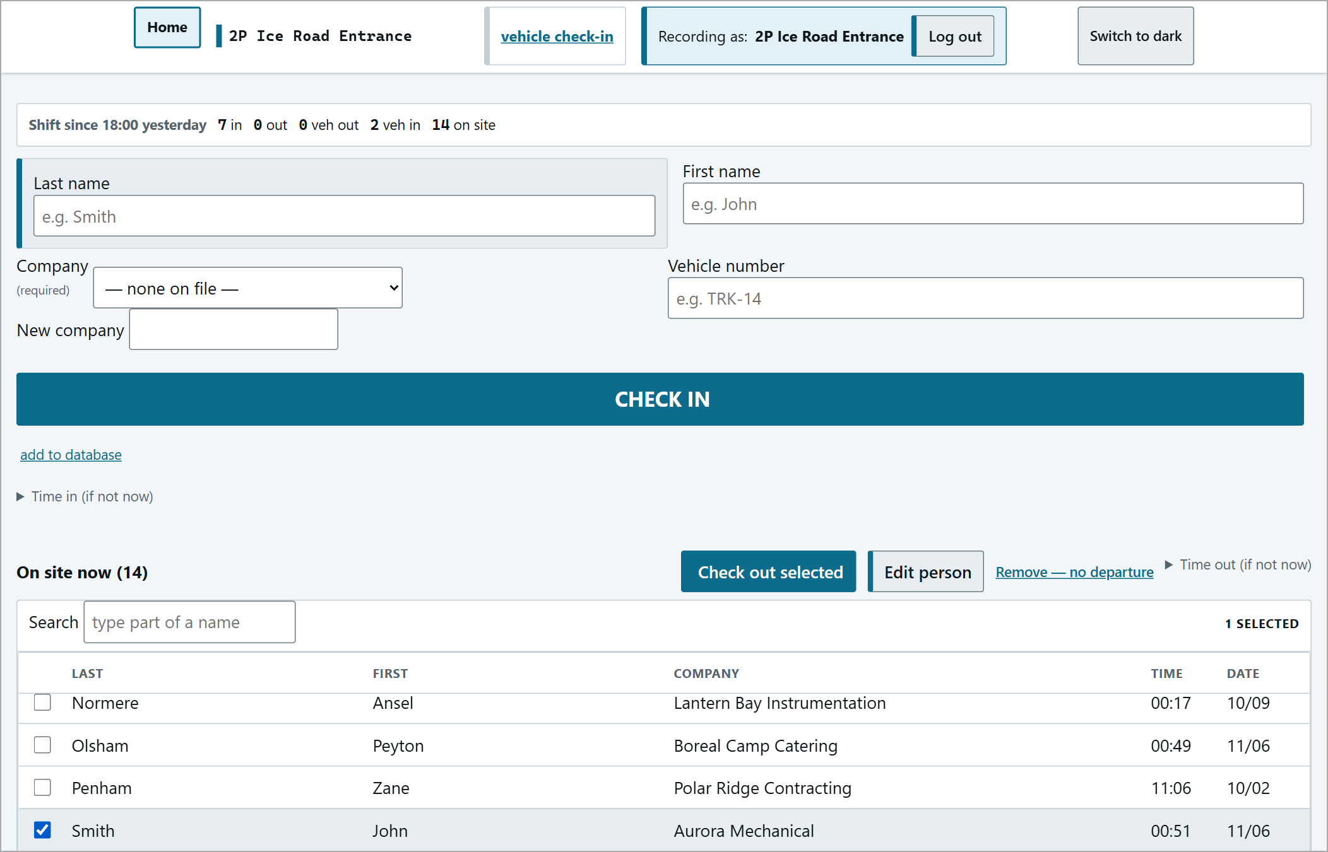  Person ticked.

Step 2 - Fill in the departure
A yellow bar names exactly who is leaving ("everyone else stays on the muster") and the CONFIRM CHECK-OUT panel opens:
Vehicle number | As written on the vehicle. Tick Vehicle unknown only if you genuinely don't know it.
Driver (required) | Chosen from the people being checked out.
Where is it going? (required) | The destination post, e.g. "Ice Pad - deadline timer runs".
Deadline (minutes) | Required for a destination with a gate - and NOT filled in for you. Click "Deadline: not set (change)" and enter the travel allowance in minutes.
Time out (if not now) | Only if they actually left earlier.

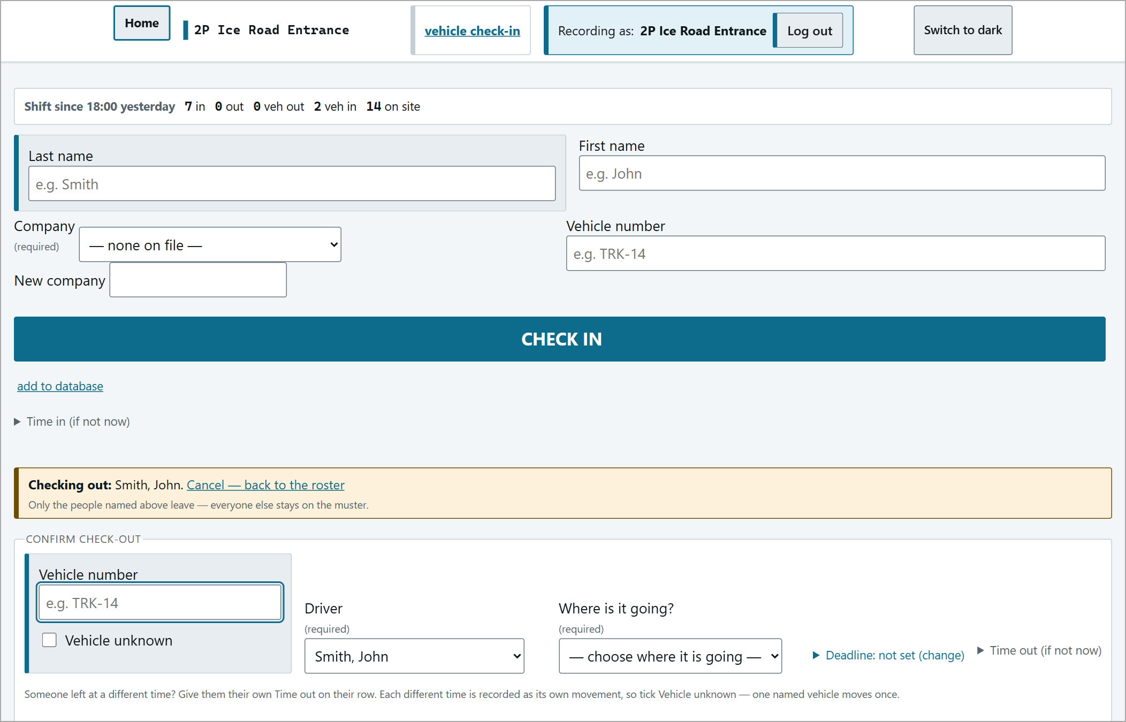
The CONFIRM CHECK-OUT panel after pressing Check out selected.
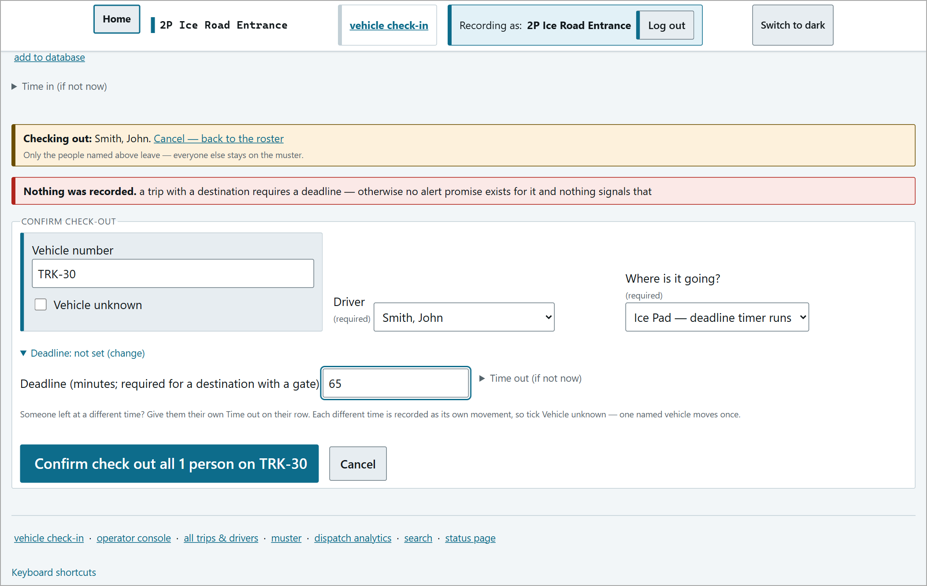
Vehicle, driver, destination and a 65-minute deadline filled in.
Press Confirm check out all N people on <vehicle> (for one person it reads 1 person, and with no vehicle number on this vehicle) and OK on the pop-up.
The most common mistake - no deadline
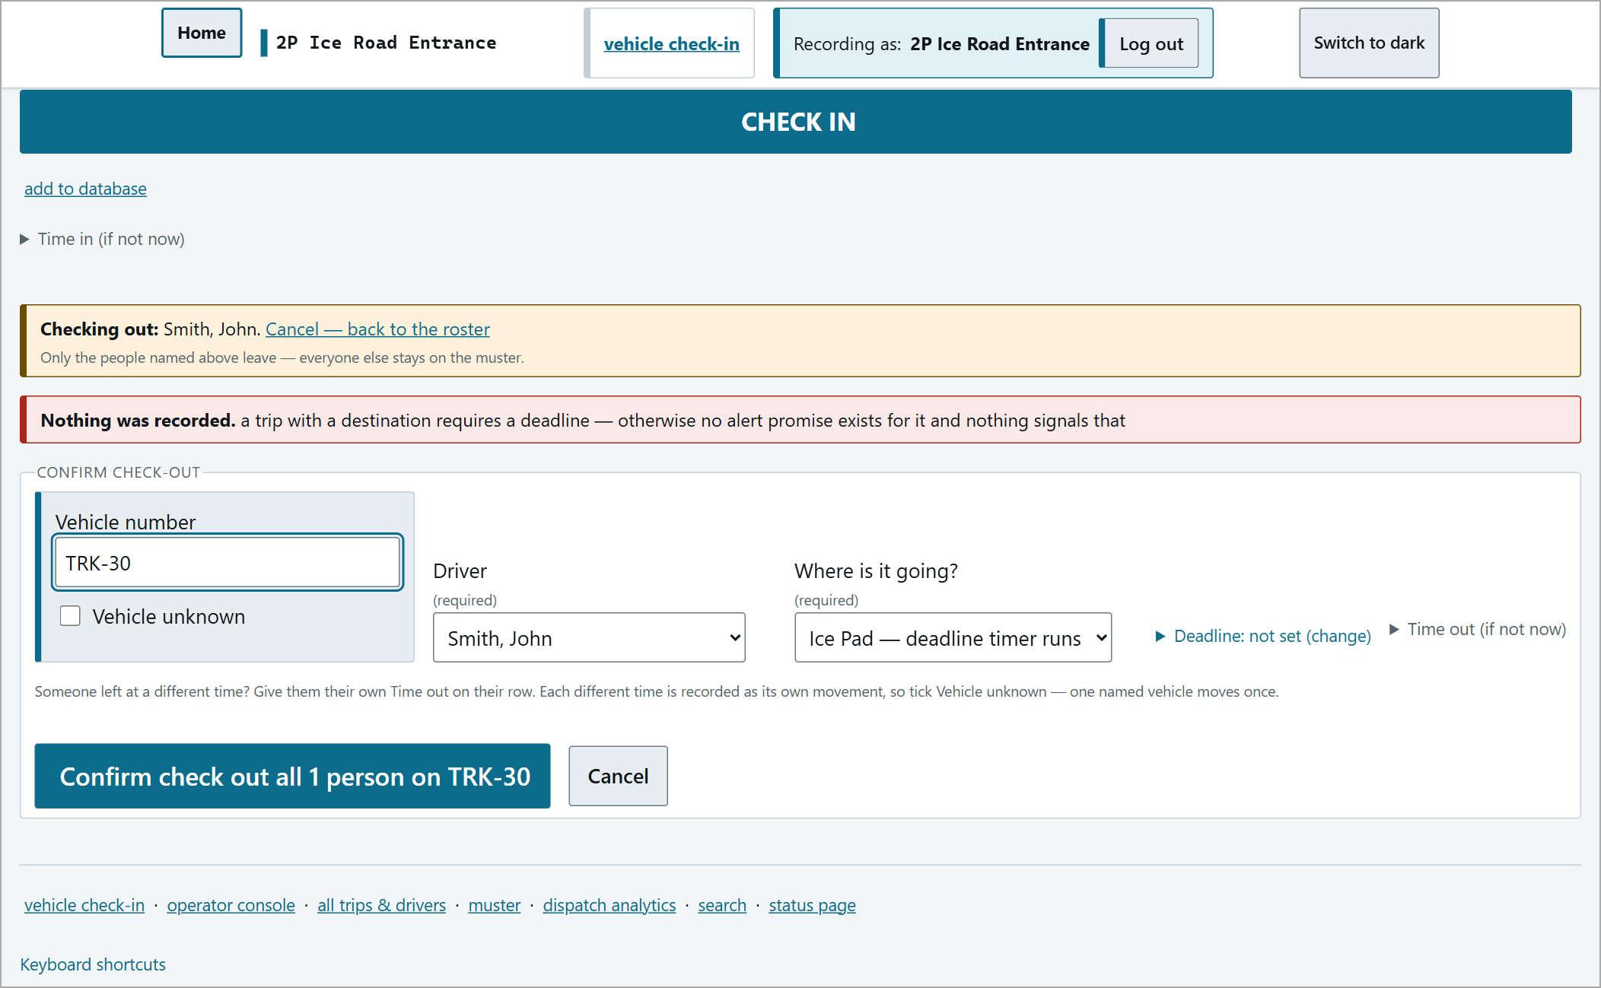
"Nothing was recorded. a trip with a destination requires a deadline..." - open Deadline and enter the minutes.
Two or more people on one vehicle
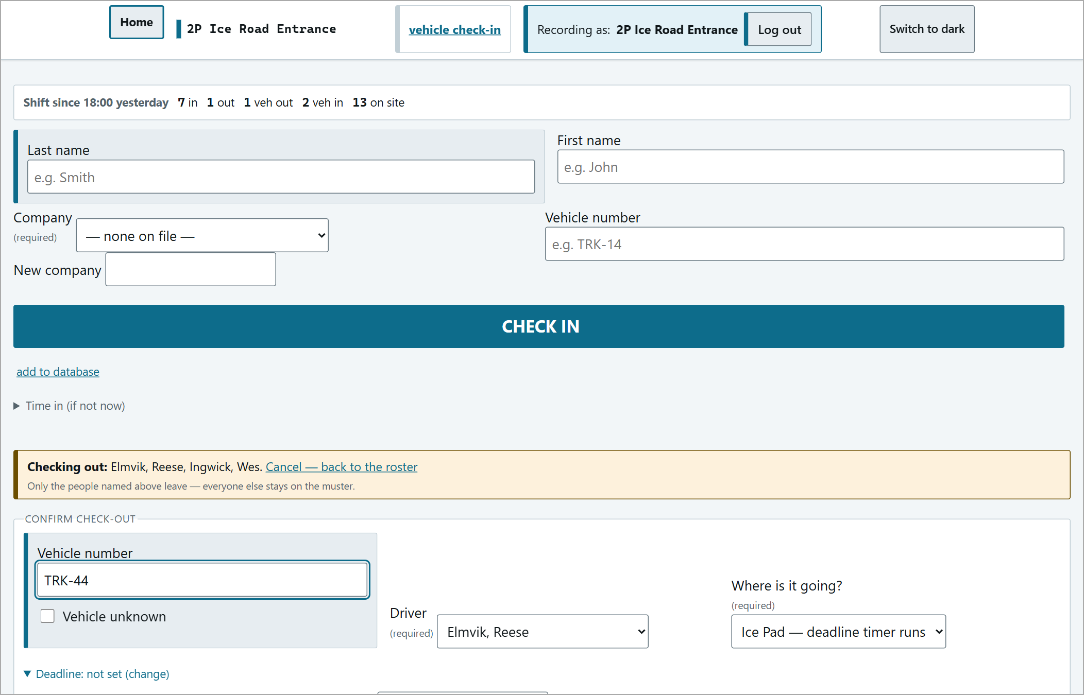
Two people ticked - one becomes the driver, both leave on the same vehicle.
If one of them left at a different time, give them their own Time out on their row - they are then recorded as a separate movement.
Step 3 - Confirm they have gone
Again there is no saved message: the out counters go up and the people disappear from On site now. Their trip now shows on the Operator console with a countdown.
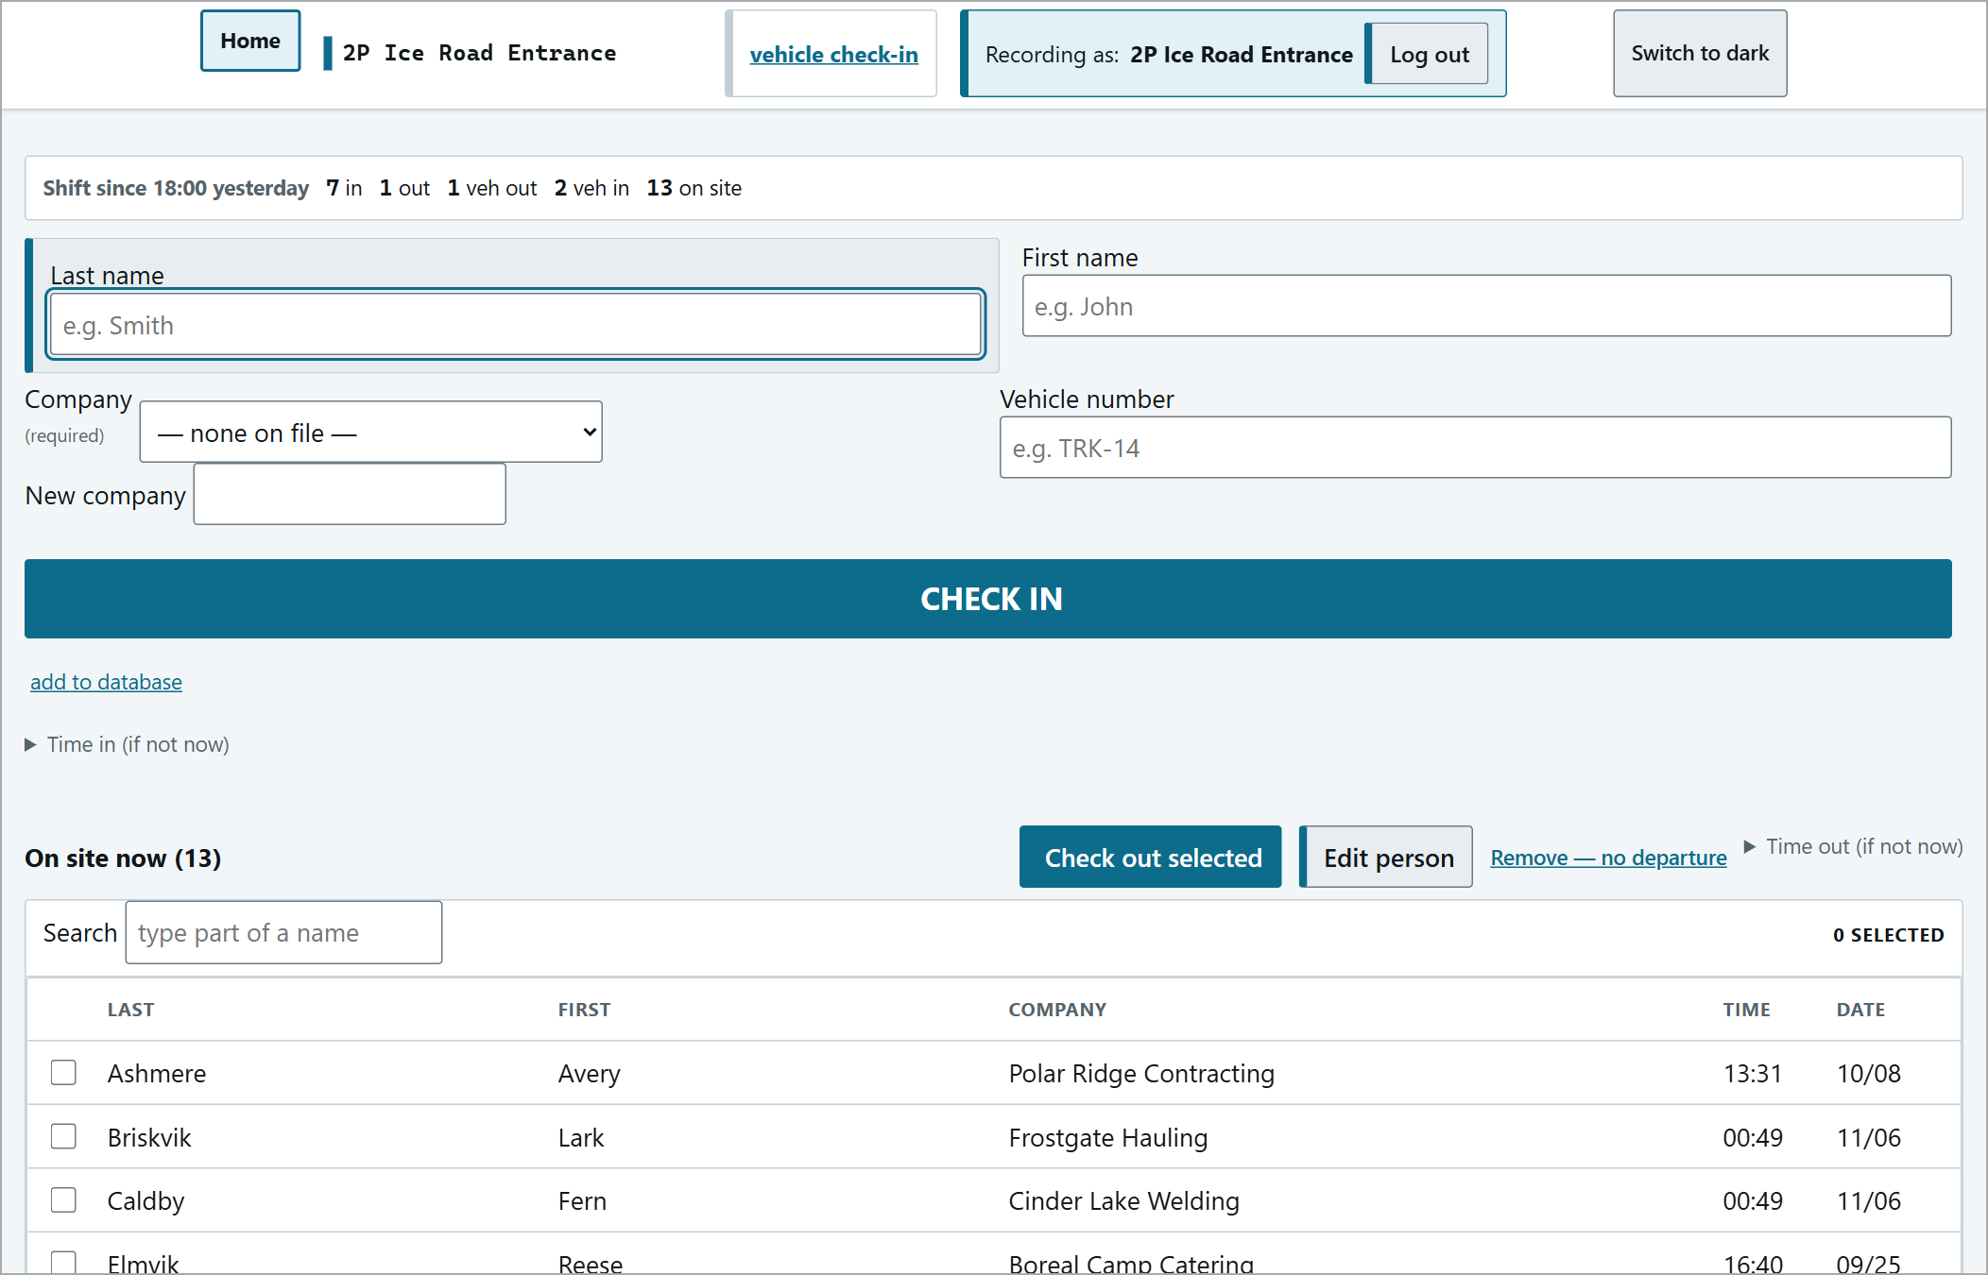
Smith, John has left the list; the shift counters show the departure.
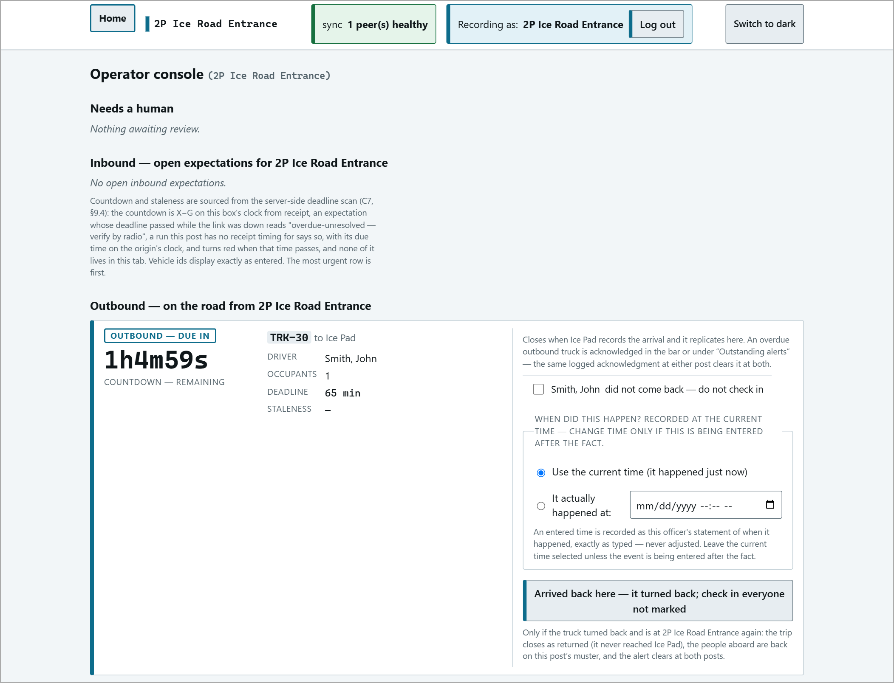
The trip on the operator console: OUTBOUND - DUE IN 1h4m59s.
Vehicle Check-In
Use the vehicle check-in page when a vehicle arrives with several people aboard. Left side: Vehicle arriving (enter the load by hand). Right side: On the road to <post> (vehicles already expected - see Expected Arrivals).
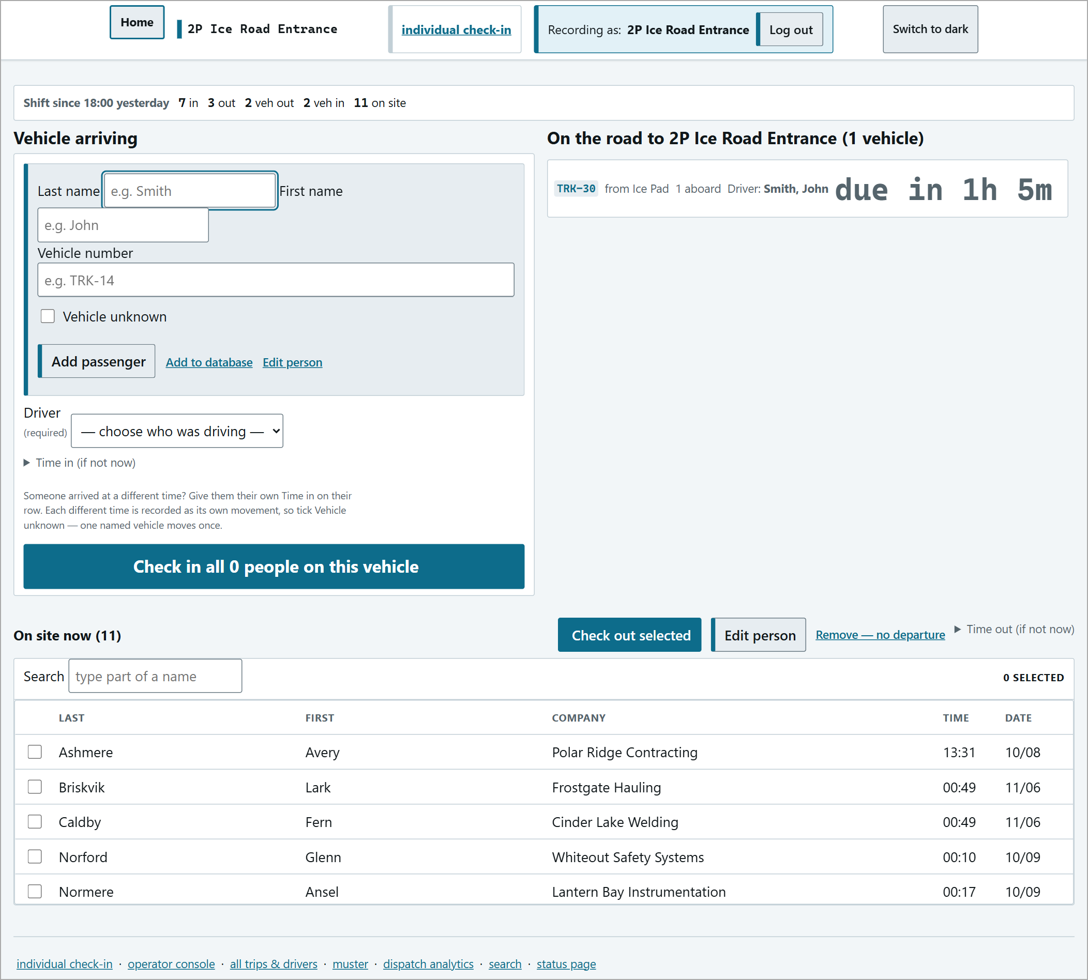
The vehicle check-in page.
1 | Type the Last name / First name of each person and press Add passenger. Enter the Vehicle number (or tick Vehicle unknown).
2 | If the name matches someone on the roster you will be asked "Is this the same person?" - choose Use <name> or No - add as a new person. Enter uses the roster record; Esc goes back to typing.
3 | A new person needs a company before they can be added.
4 | Choose the Driver (required - the button stays greyed out until you do).
5 | Press Check in all N people on this vehicle and OK on the pop-up. Anyone not on the list will not be on the muster.

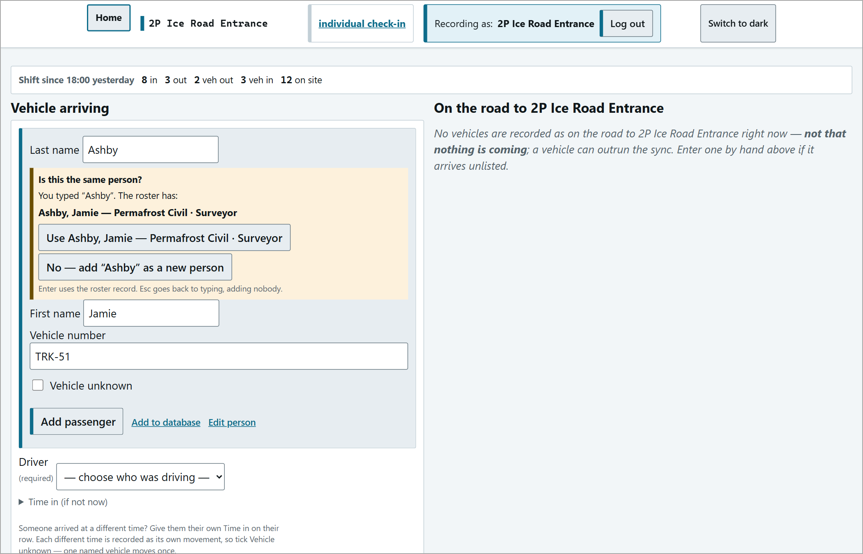  "Is this the same person?" prompt. | 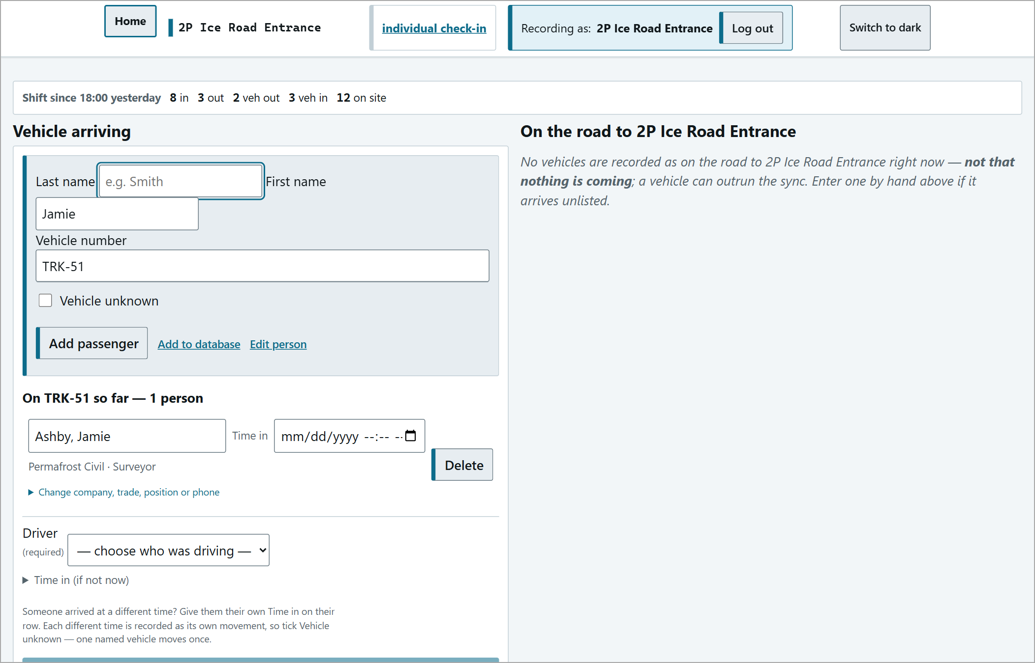  First passenger added to the vehicle.

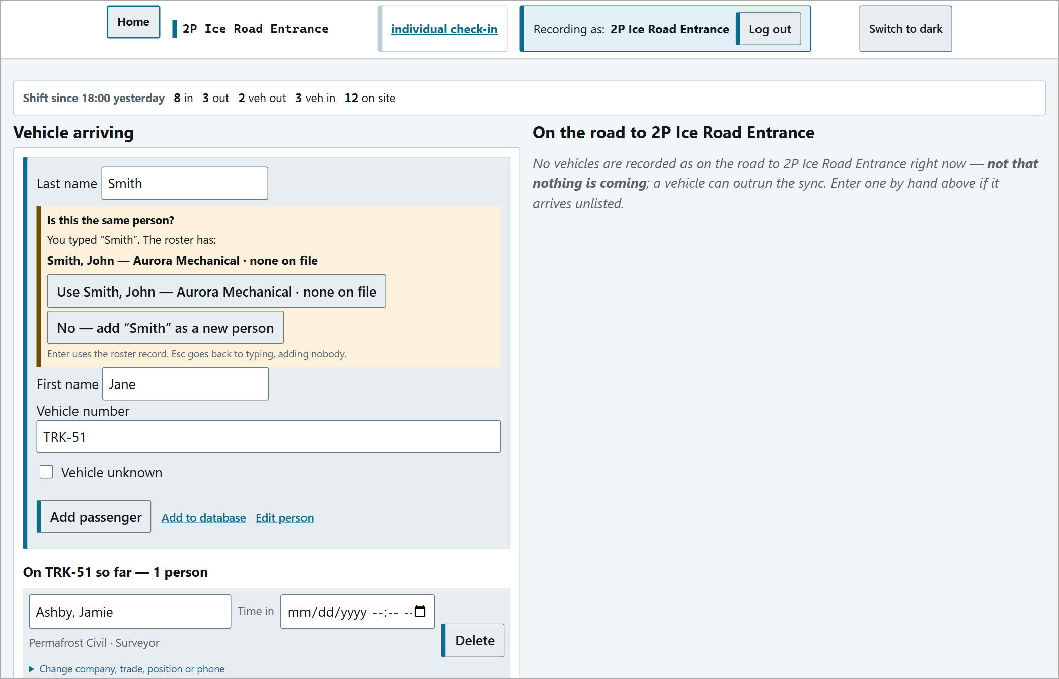  A new person - company required. | 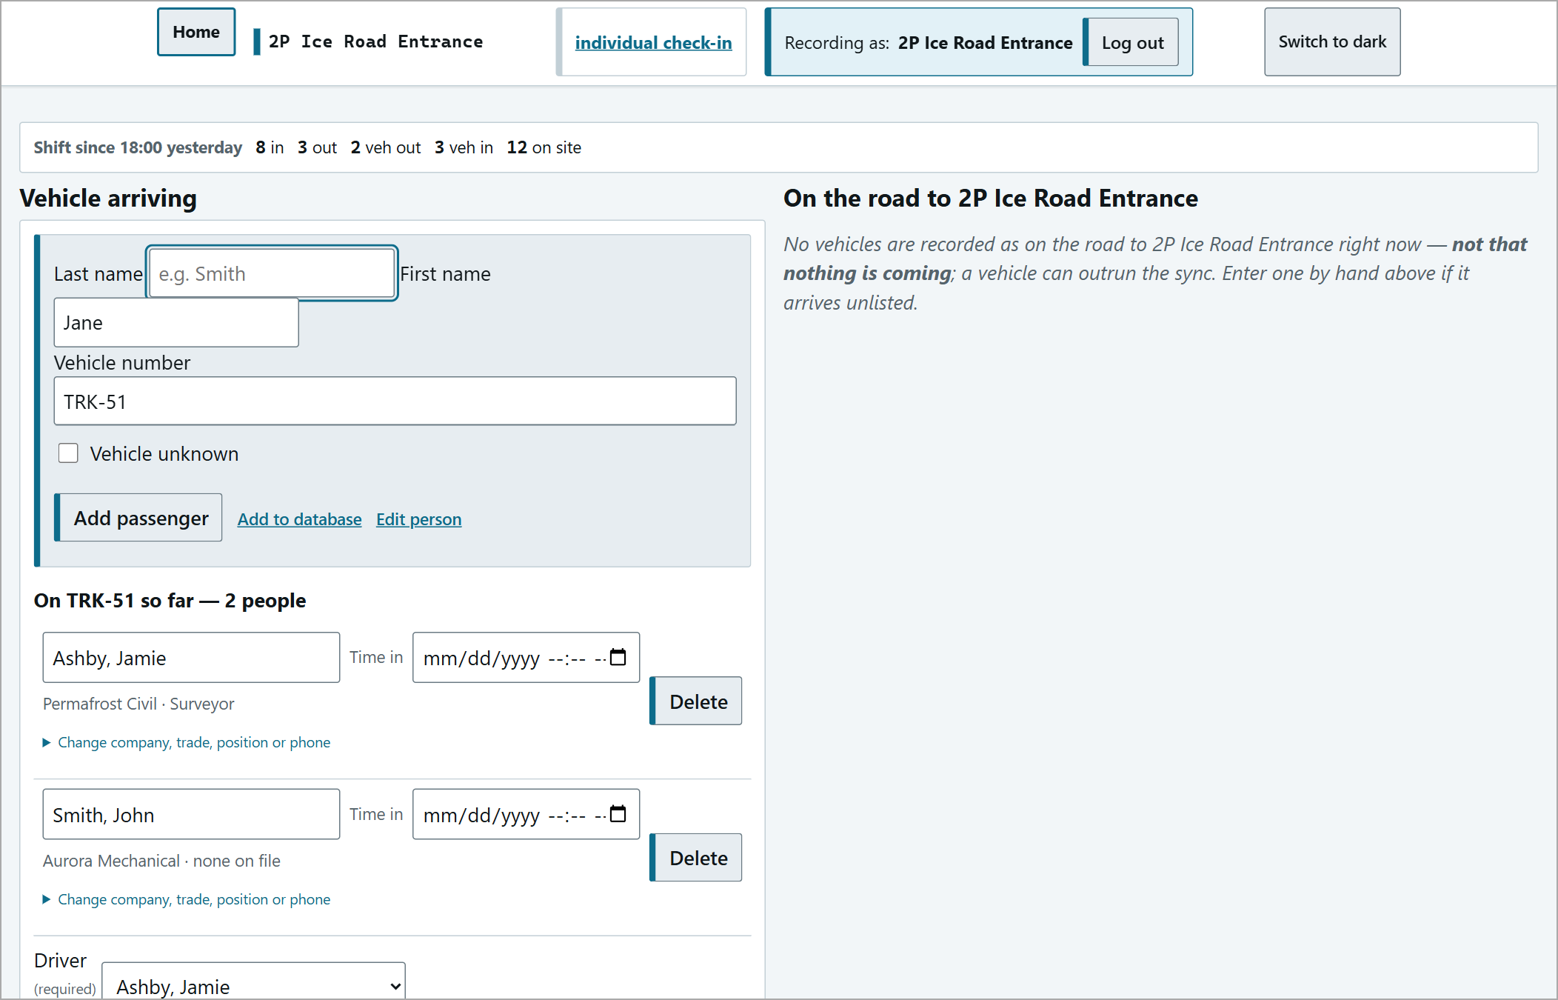  Two people aboard and a driver chosen - ready.

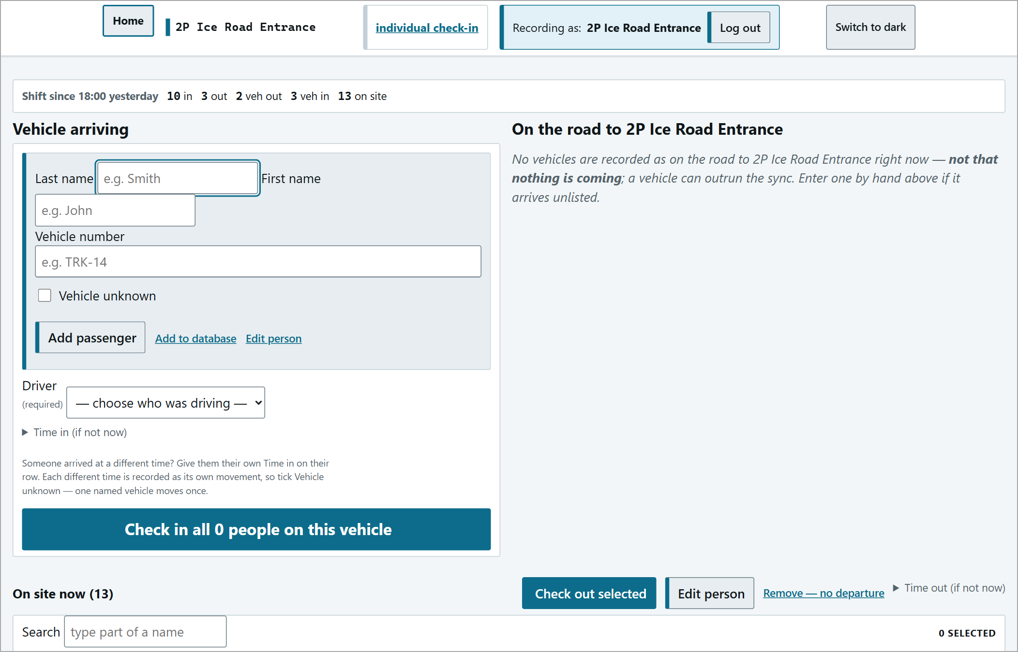
Checked in: counters up, form cleared for the next vehicle.
Expected Arrivals
When another post dispatches a vehicle to you, it appears under On the road to <post> on the vehicle page with its manifest, driver and countdown (e.g. "TRK-30 from Ice Pad - 1 aboard - Driver: Smith, John - due in 1h 5m").
1 | When it arrives, click the vehicle's row to open it.
2 | Press Check in (N) - everyone on the manifest is checked in with one tap.
3 | A green banner confirms, e.g. "TRK-30 arrived: 1 checked in."

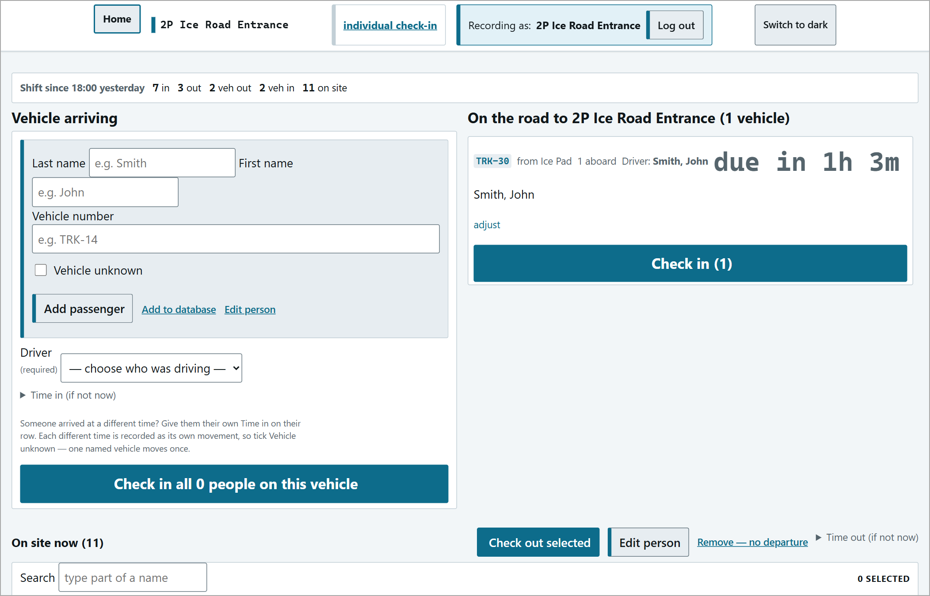
An expected vehicle opened, ready to check in.
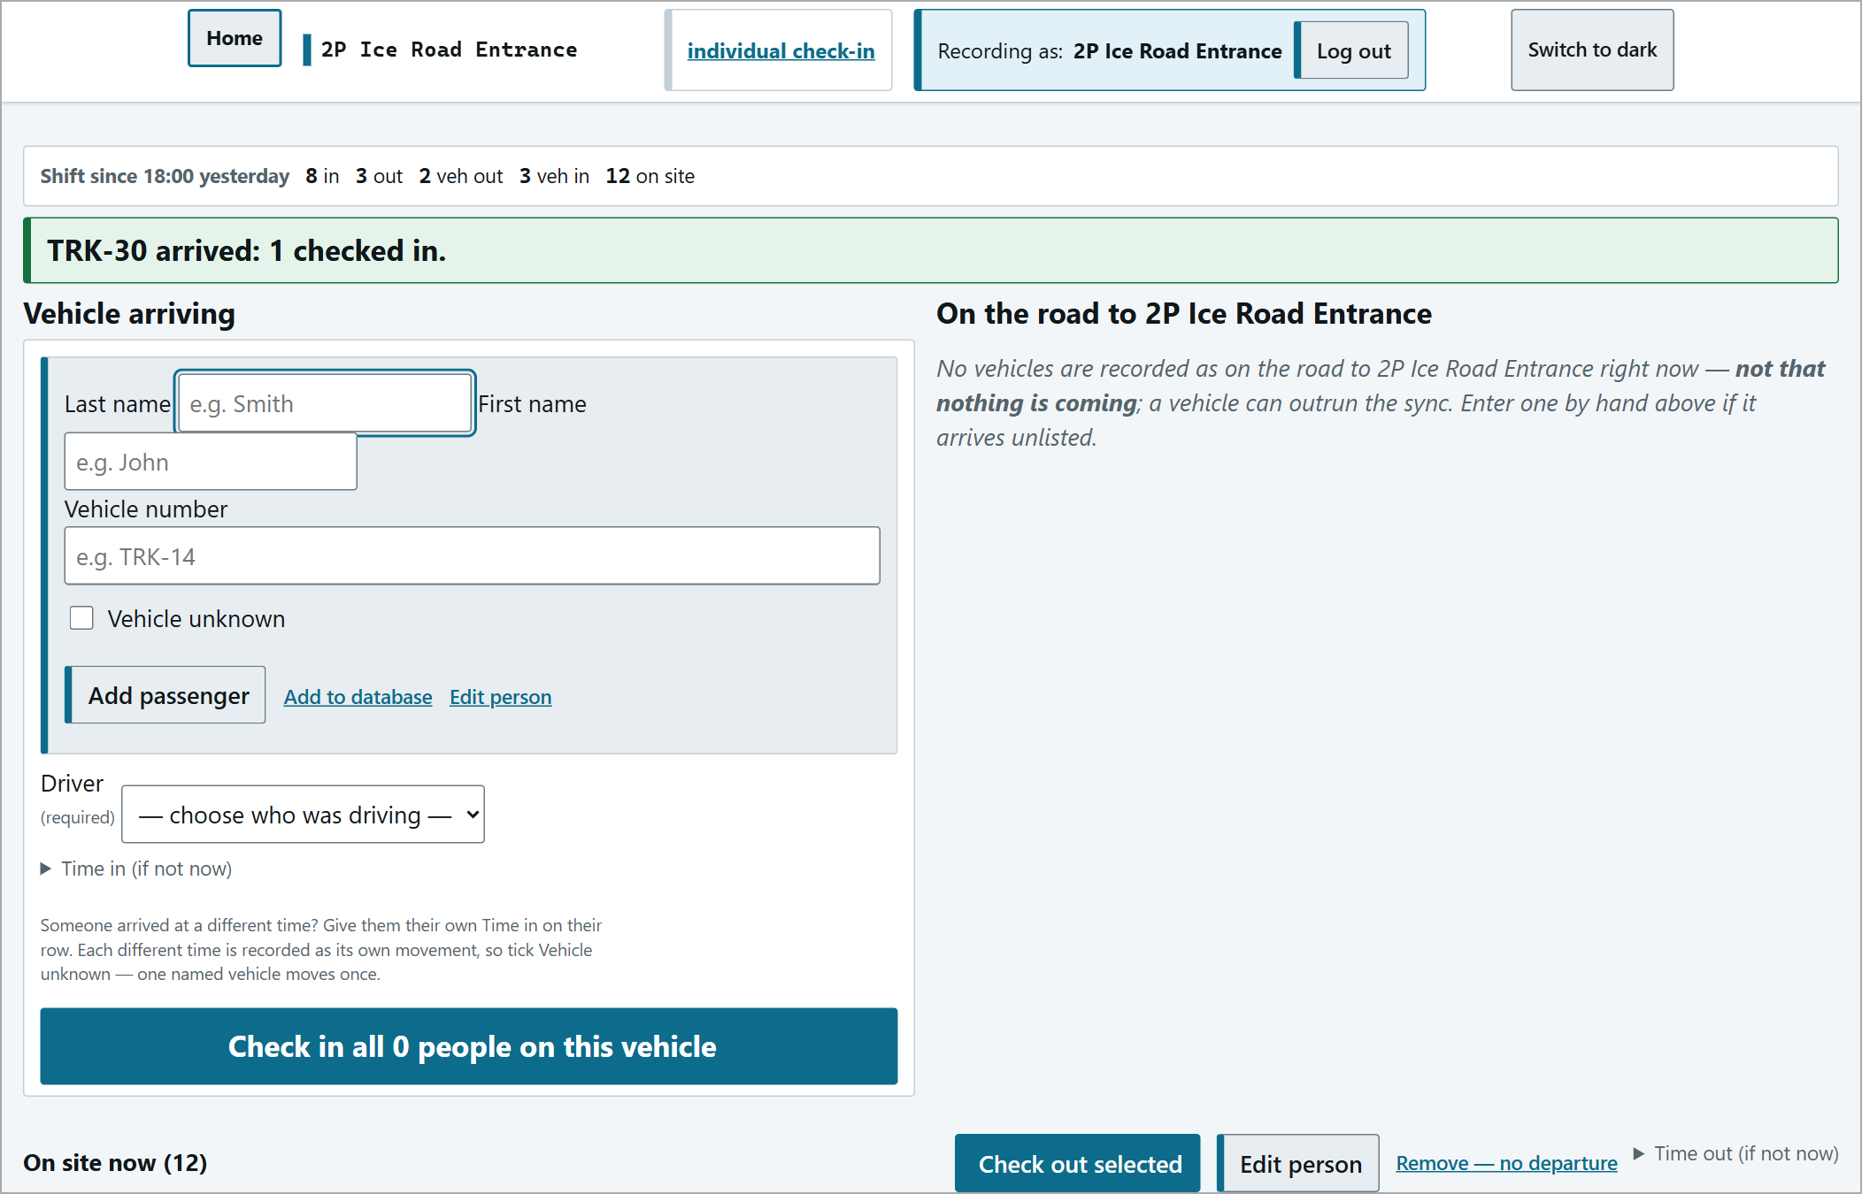
"TRK-30 arrived: 1 checked in."
If nothing is listed it does not mean nothing is coming - a vehicle can arrive before the record syncs. Enter it by hand on the left.
Operator Console
The operator console (footer link) is the trip board. Sections: Needs a human (alerts), Inbound (vehicles coming to you), Outbound (vehicles that left you), Working on the road, Outstanding alerts, and forms for a vehicle leaving or arriving unlisted.
Each trip card shows the state and a big countdown, the vehicle and destination, driver, occupants, deadline and staleness.
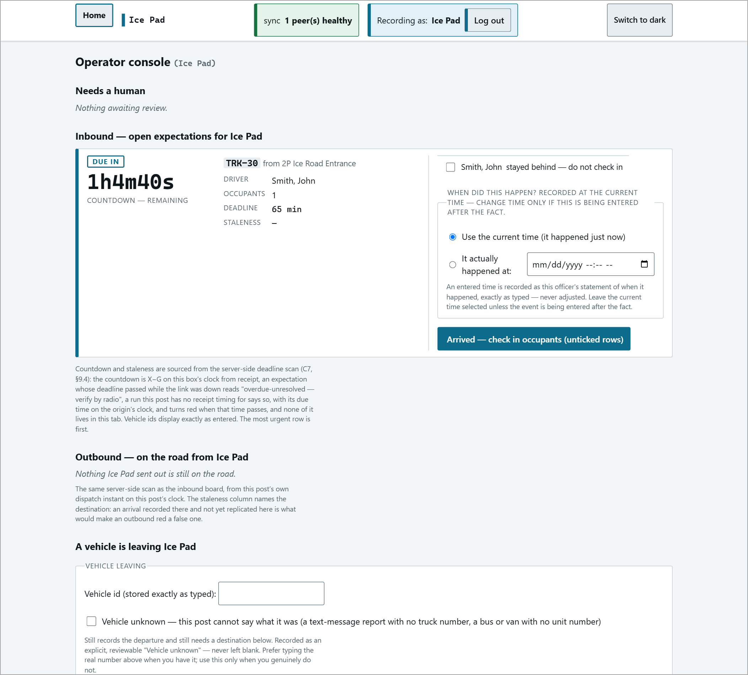
At the destination (Ice Pad): the same trip as an INBOUND card, counting down.
Recording an arrival on the console
Tick boxes mean LEAVE OUT. Each occupant has a box "<name> stayed behind - do not check in". Leave everyone who arrived unticked. Tick only someone who did NOT arrive.

Then press Arrived - check in occupants (unticked rows). The card disappears - there is no message. Other buttons: Arrived back here - it turned back (the vehicle returned to where it started) and Back from the road - check in everyone not marked as stayed (for crews working on the road).
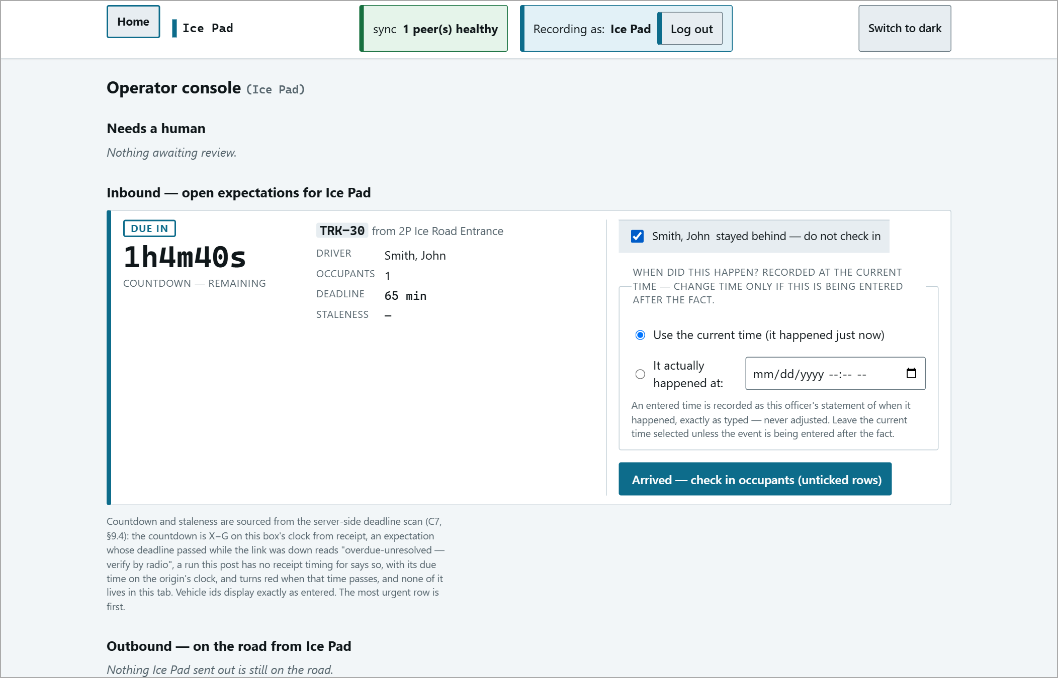
An inbound card with an occupant box ticked - that person will NOT be checked in.
An outbound card at the post it left from only closes once the destination records the arrival and it syncs back.
Overdue Vehicles
If a vehicle passes its deadline without an arrival being recorded, a red OVERDUE bar appears at the top of every page at both posts, naming the vehicle and how many people are aboard.
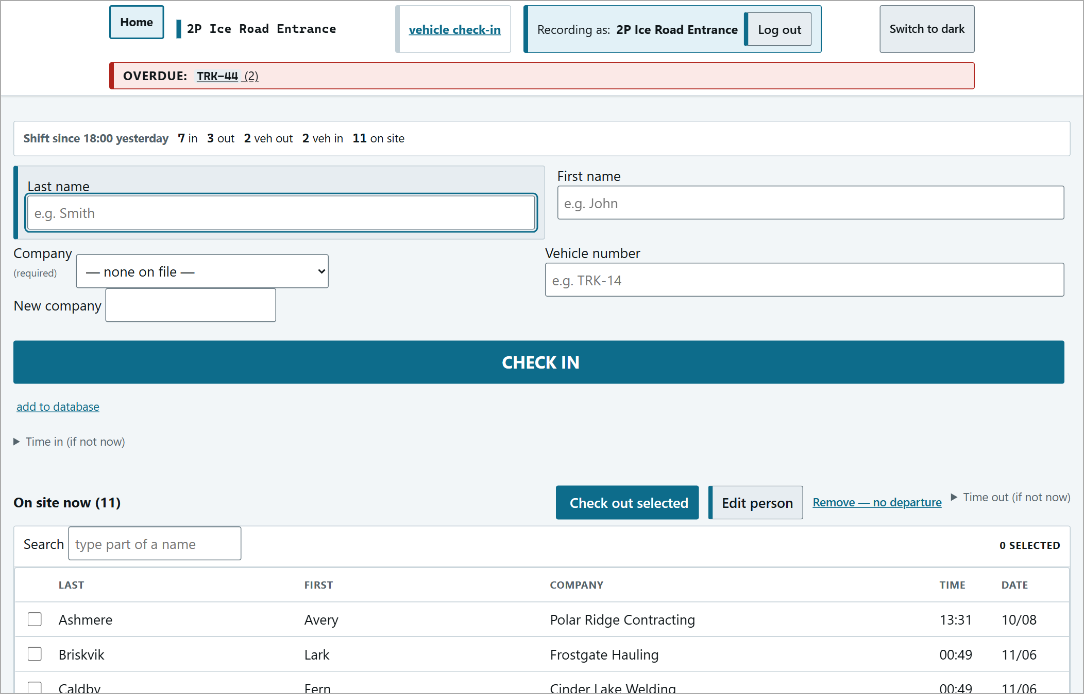
The red OVERDUE bar on the gate screen.
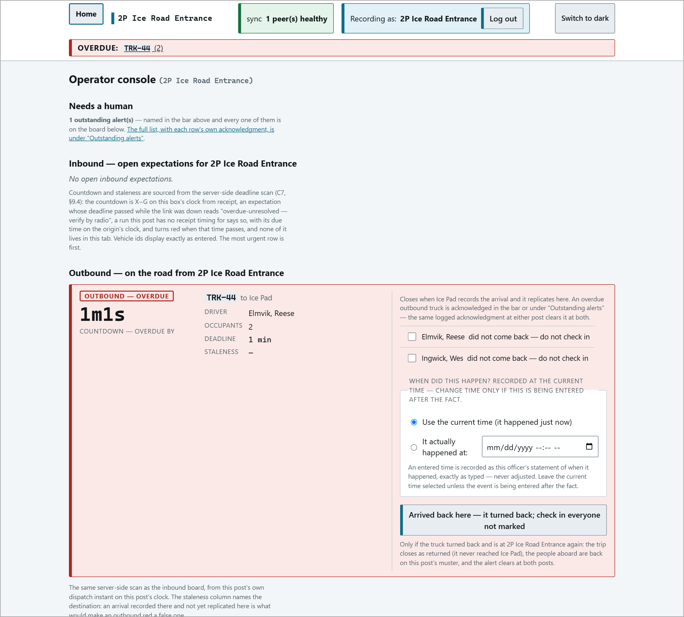
The overdue trip card: OVERDUE, counting up.
Acknowledging an alert
1 | Contact the vehicle / the other post by radio and find out where it is.
2 | On the operator console under Outstanding alerts, press Acknowledge (logged).
3 | The red bar clears at both posts and your acknowledgement is logged. The trip itself stays open (marked ACKNOWLEDGED BY <post>) until the arrival is recorded.

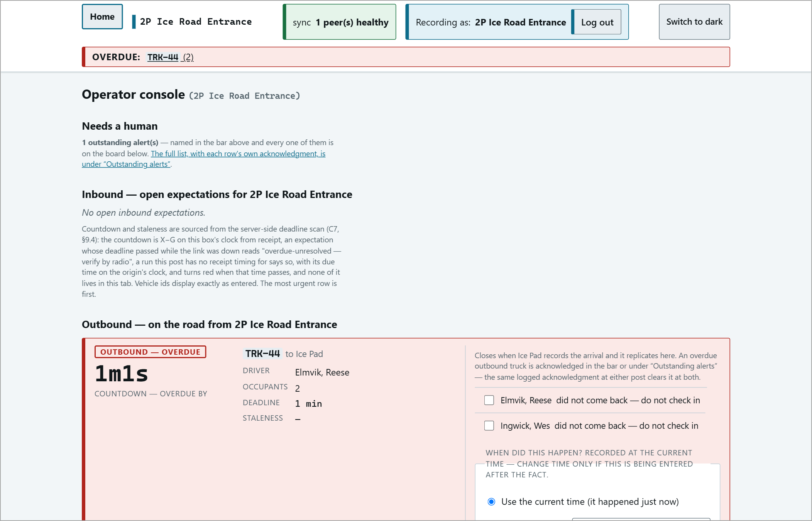
Outstanding alerts with the Acknowledge (logged) button.
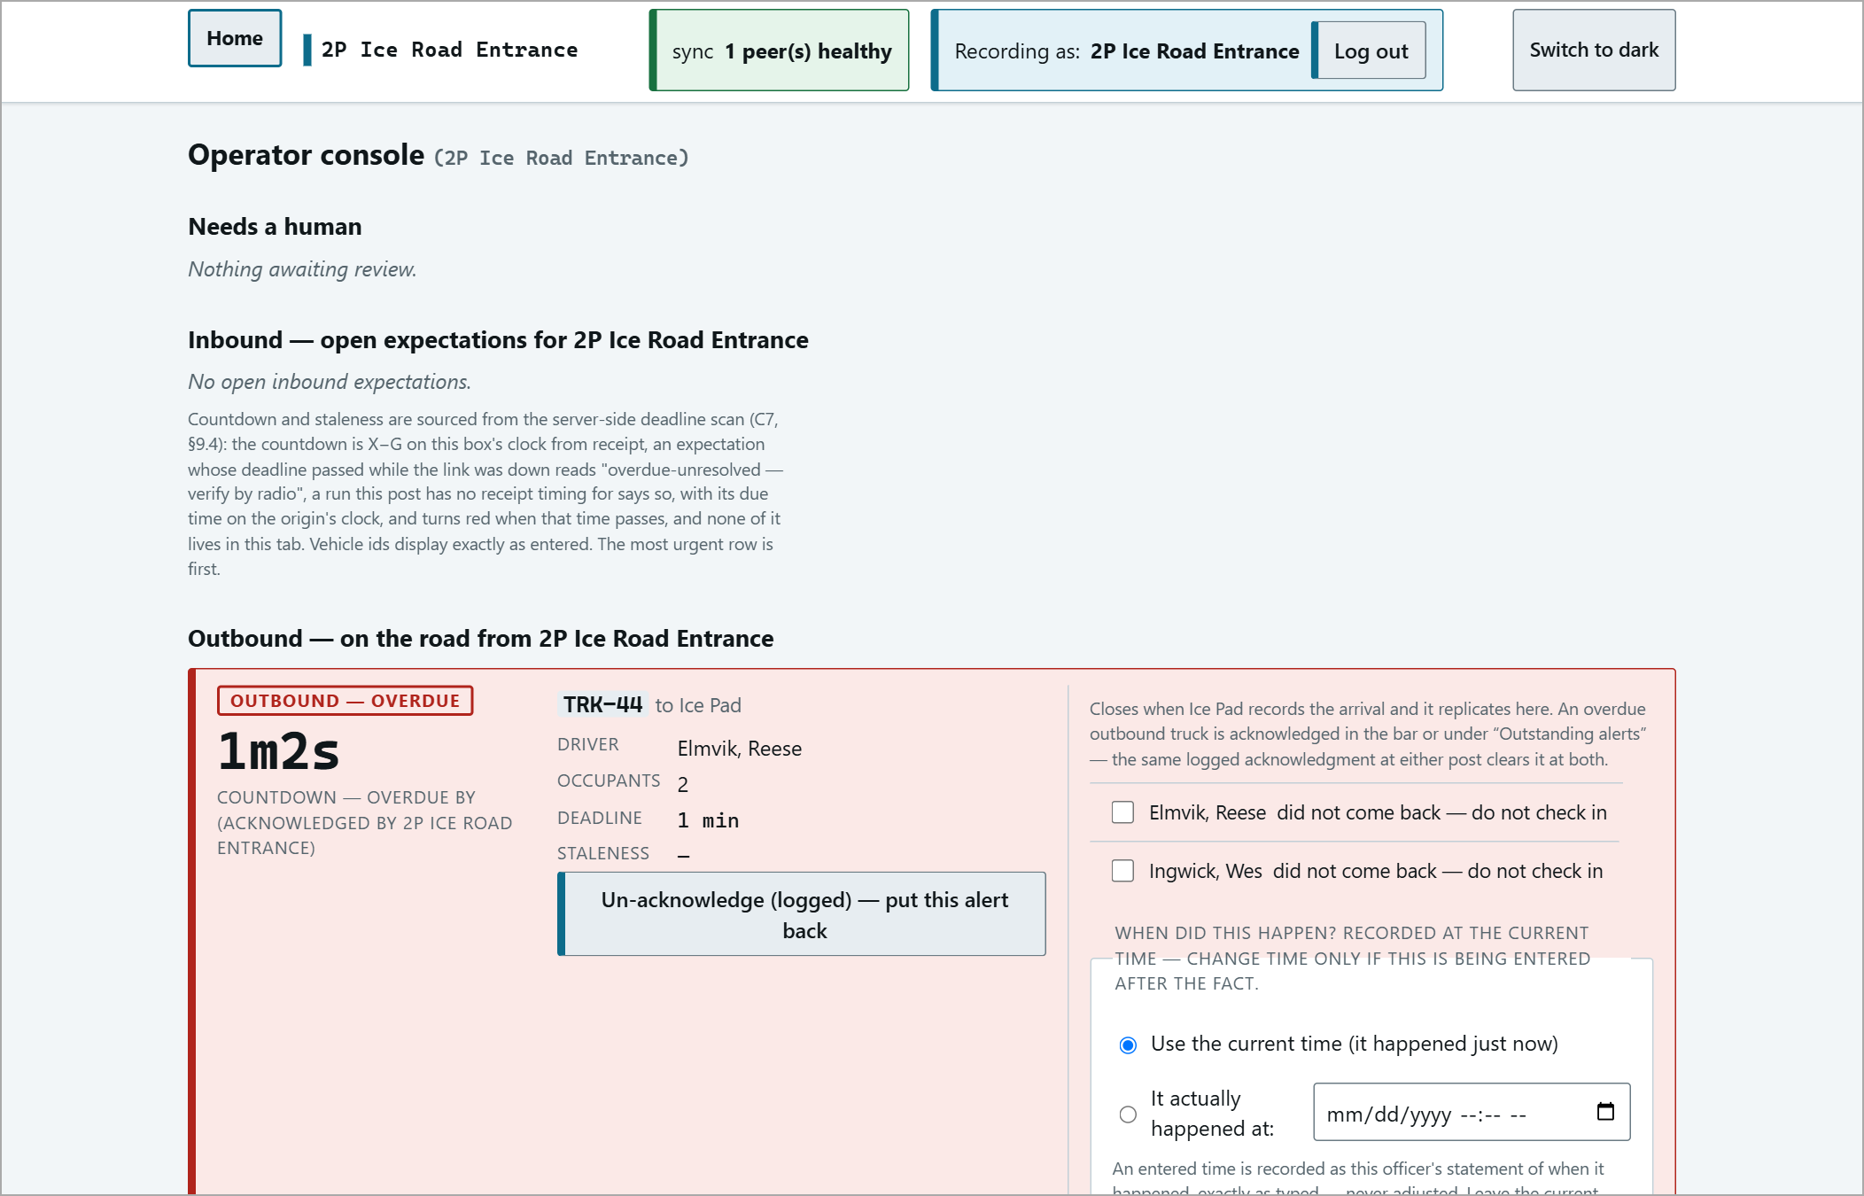
After acknowledging.
Orientation
Some posts (e.g. Ice Pad, NPF, NDB, STP) require their own orientation, once per person, per site. Someone arriving without it is not checked in - there is no override.
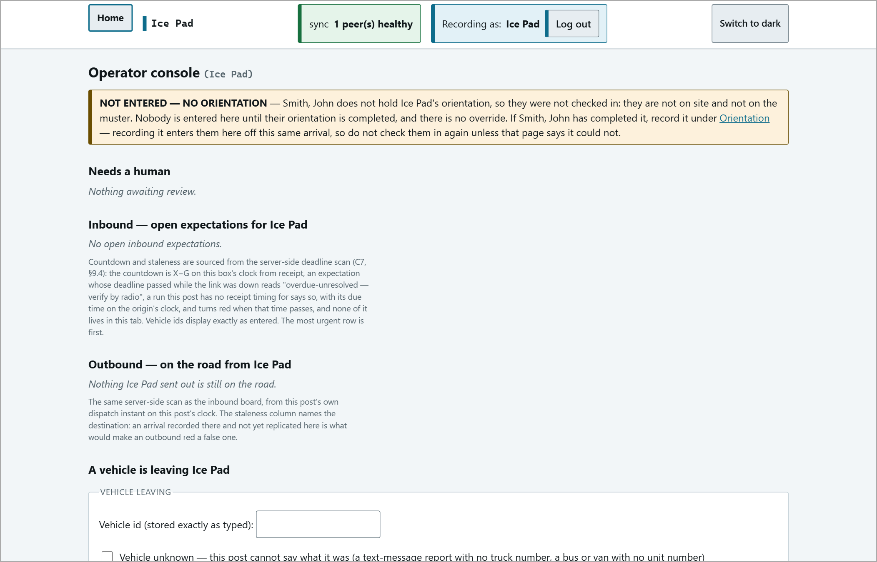
"NOT ENTERED - NO ORIENTATION" on the console: the person is not on site and not on the muster.
Recording an orientation
1 | Open the post's orientation page. People refused at the gate are listed under Held out at the gate - waiting on orientation.
2 | Find the person (Find a name / Filter), tick COMPLETED, and press Record the ticked completions.
3 | If they were held out at the gate, recording the completion checks them in automatically - do not check them in again.

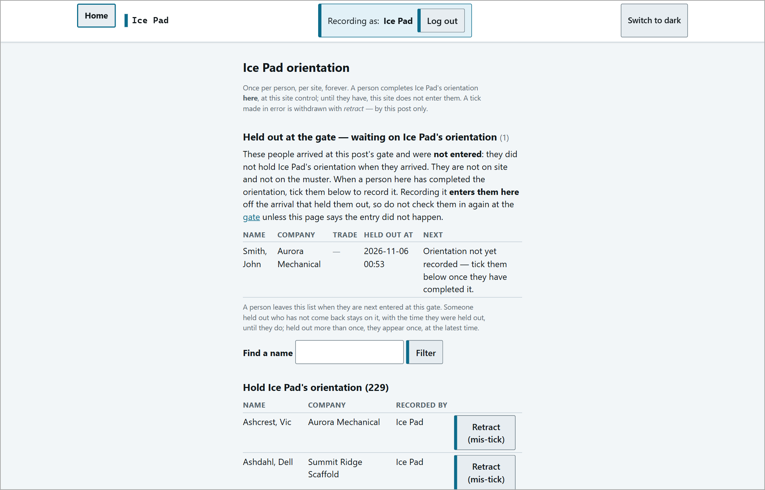
The orientation page.
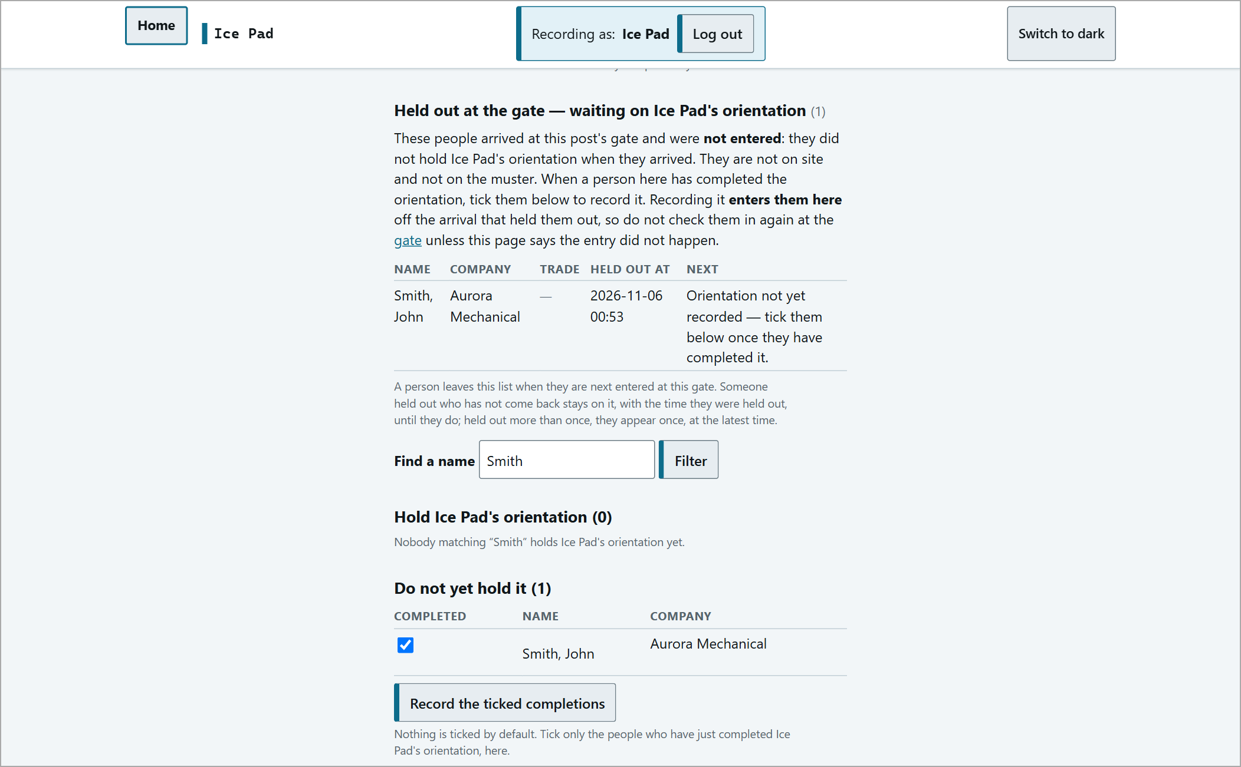  Filtered to one person and ticked. | 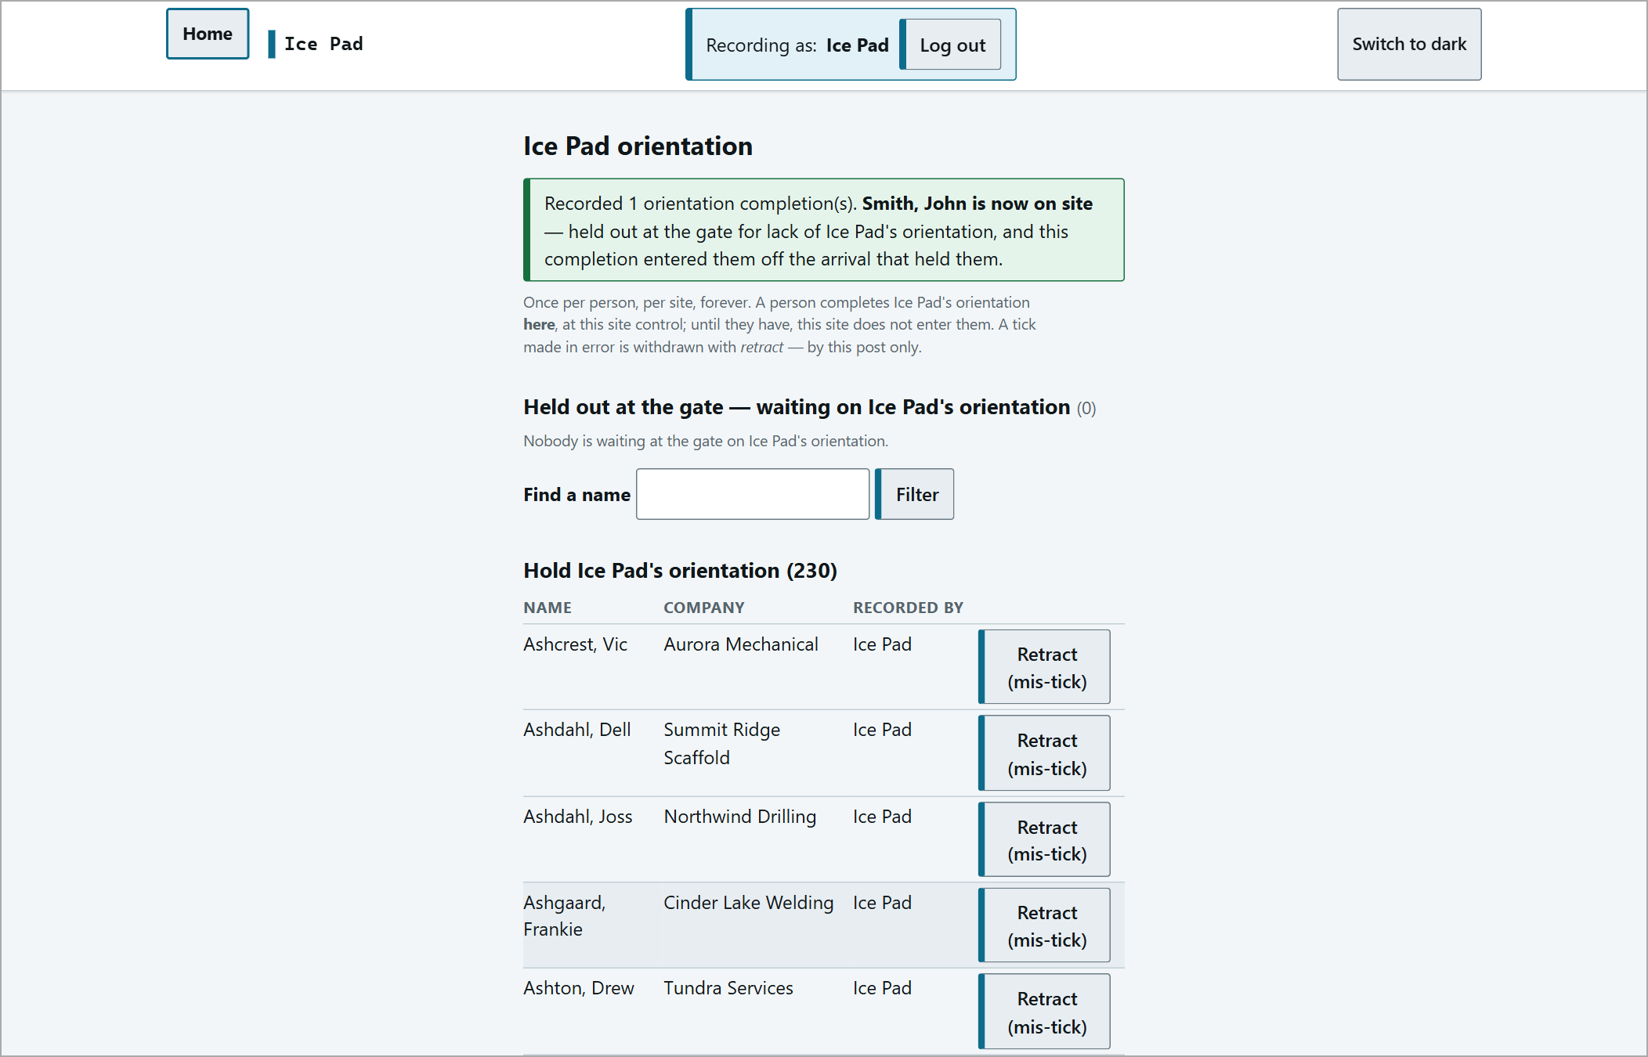  "Recorded 1 orientation completion(s). Smith, John is now on site..."

Ticked the wrong person? Use Retract (mis-tick) on their row.
Muster
Evacuation or drill: open muster (footer link), press Print this muster, then Print (or Ctrl + P).

The live muster shows the time it was taken, the sync state, and separate counts:
ON SITE | Everyone checked in here, listed by company / trade below. Small crews are pooled in a "Summary group".
ON THE ROAD | Dispatched from here and not yet arrived - named, and this post's responsibility. Not in the on-site total.
AWAY AT AN UNCONTROLLED DESTINATION | Gone to a pad with no gate or timer.
NOT TRACKED | The system cannot say where they are - account for them by radio.

The counts may overlap on purpose. If a name appears in two places, treat the person as present AND account for the other location by radio.
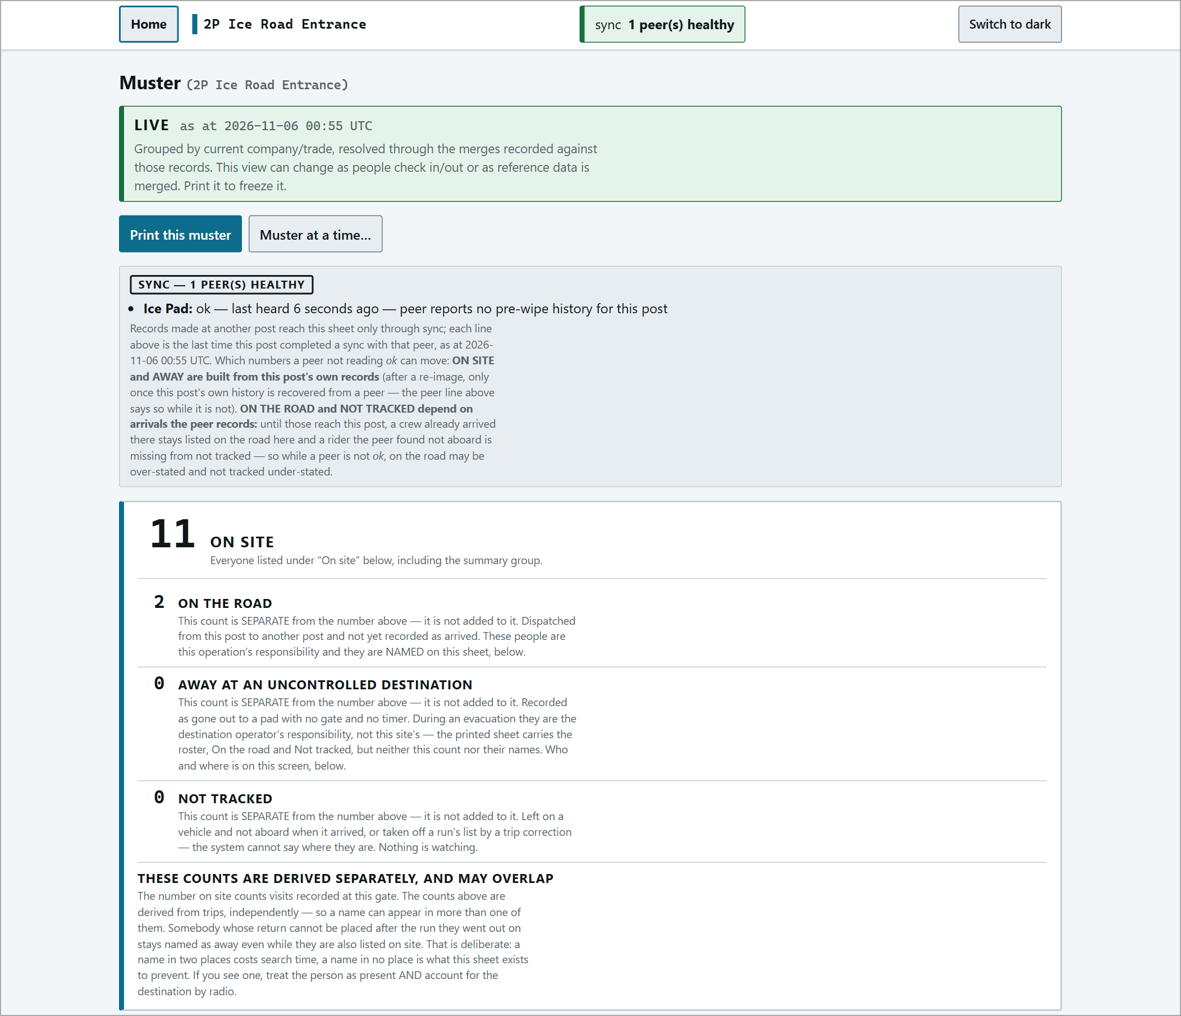
Live muster - top: sync status and the counts.
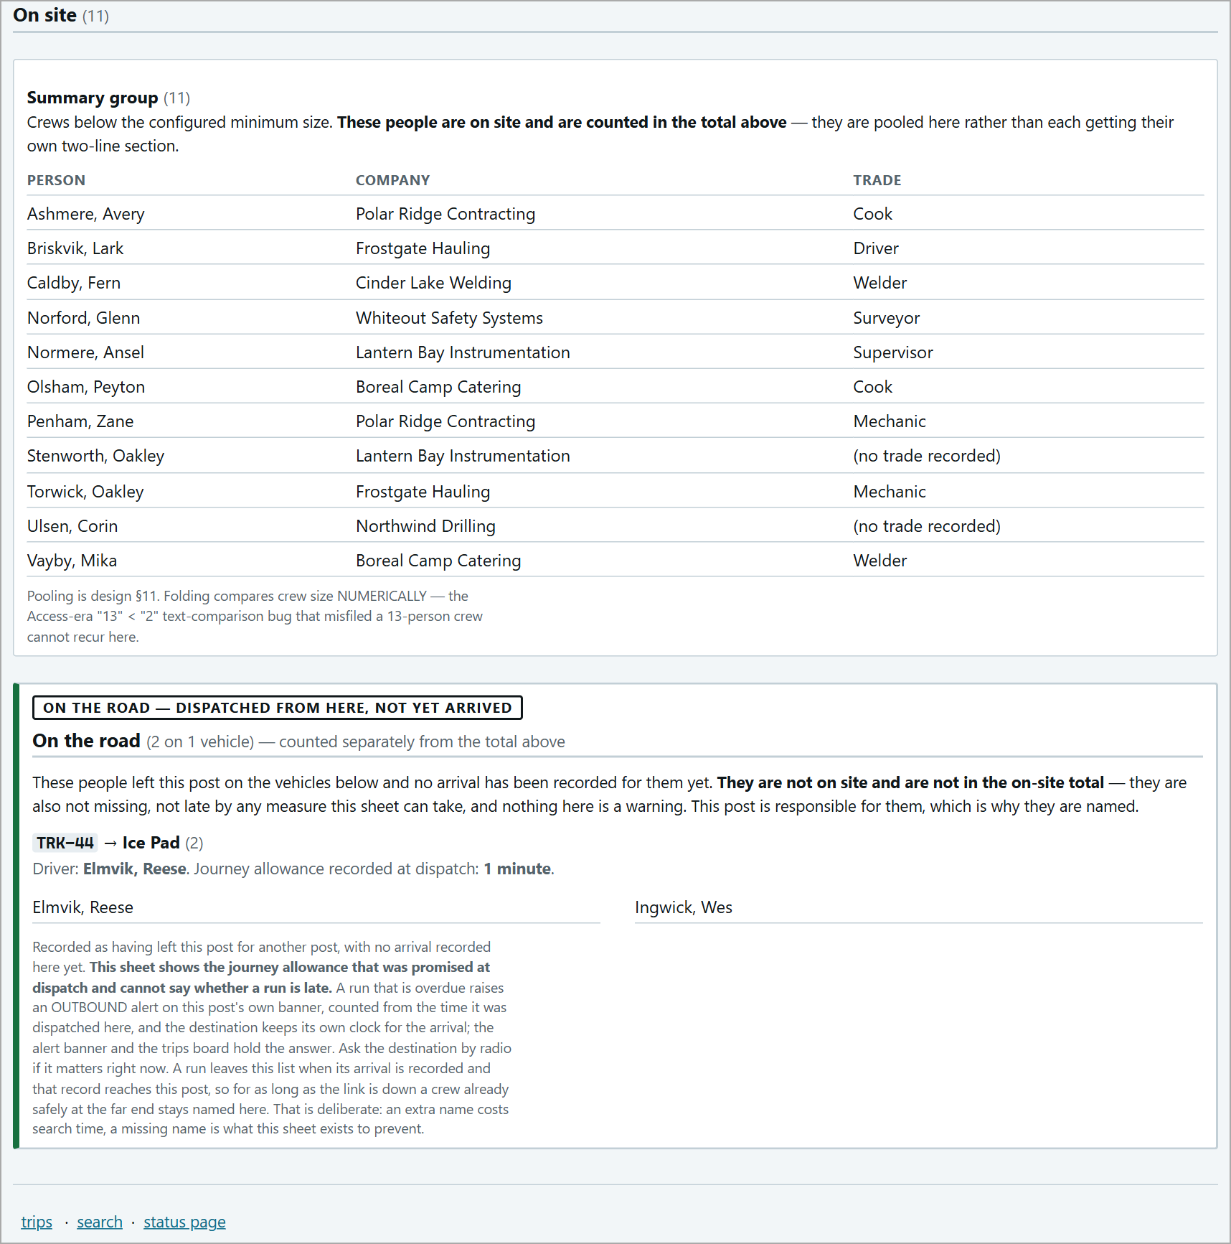
Live muster - bottom: the people on site and on the road, by name.
Printing
Print this muster freezes a snapshot ("PRINTED FROM LIVE snapshot taken <time>"). Press Print or Ctrl + P. The Reprint this exact sheet link reproduces the same sheet later.
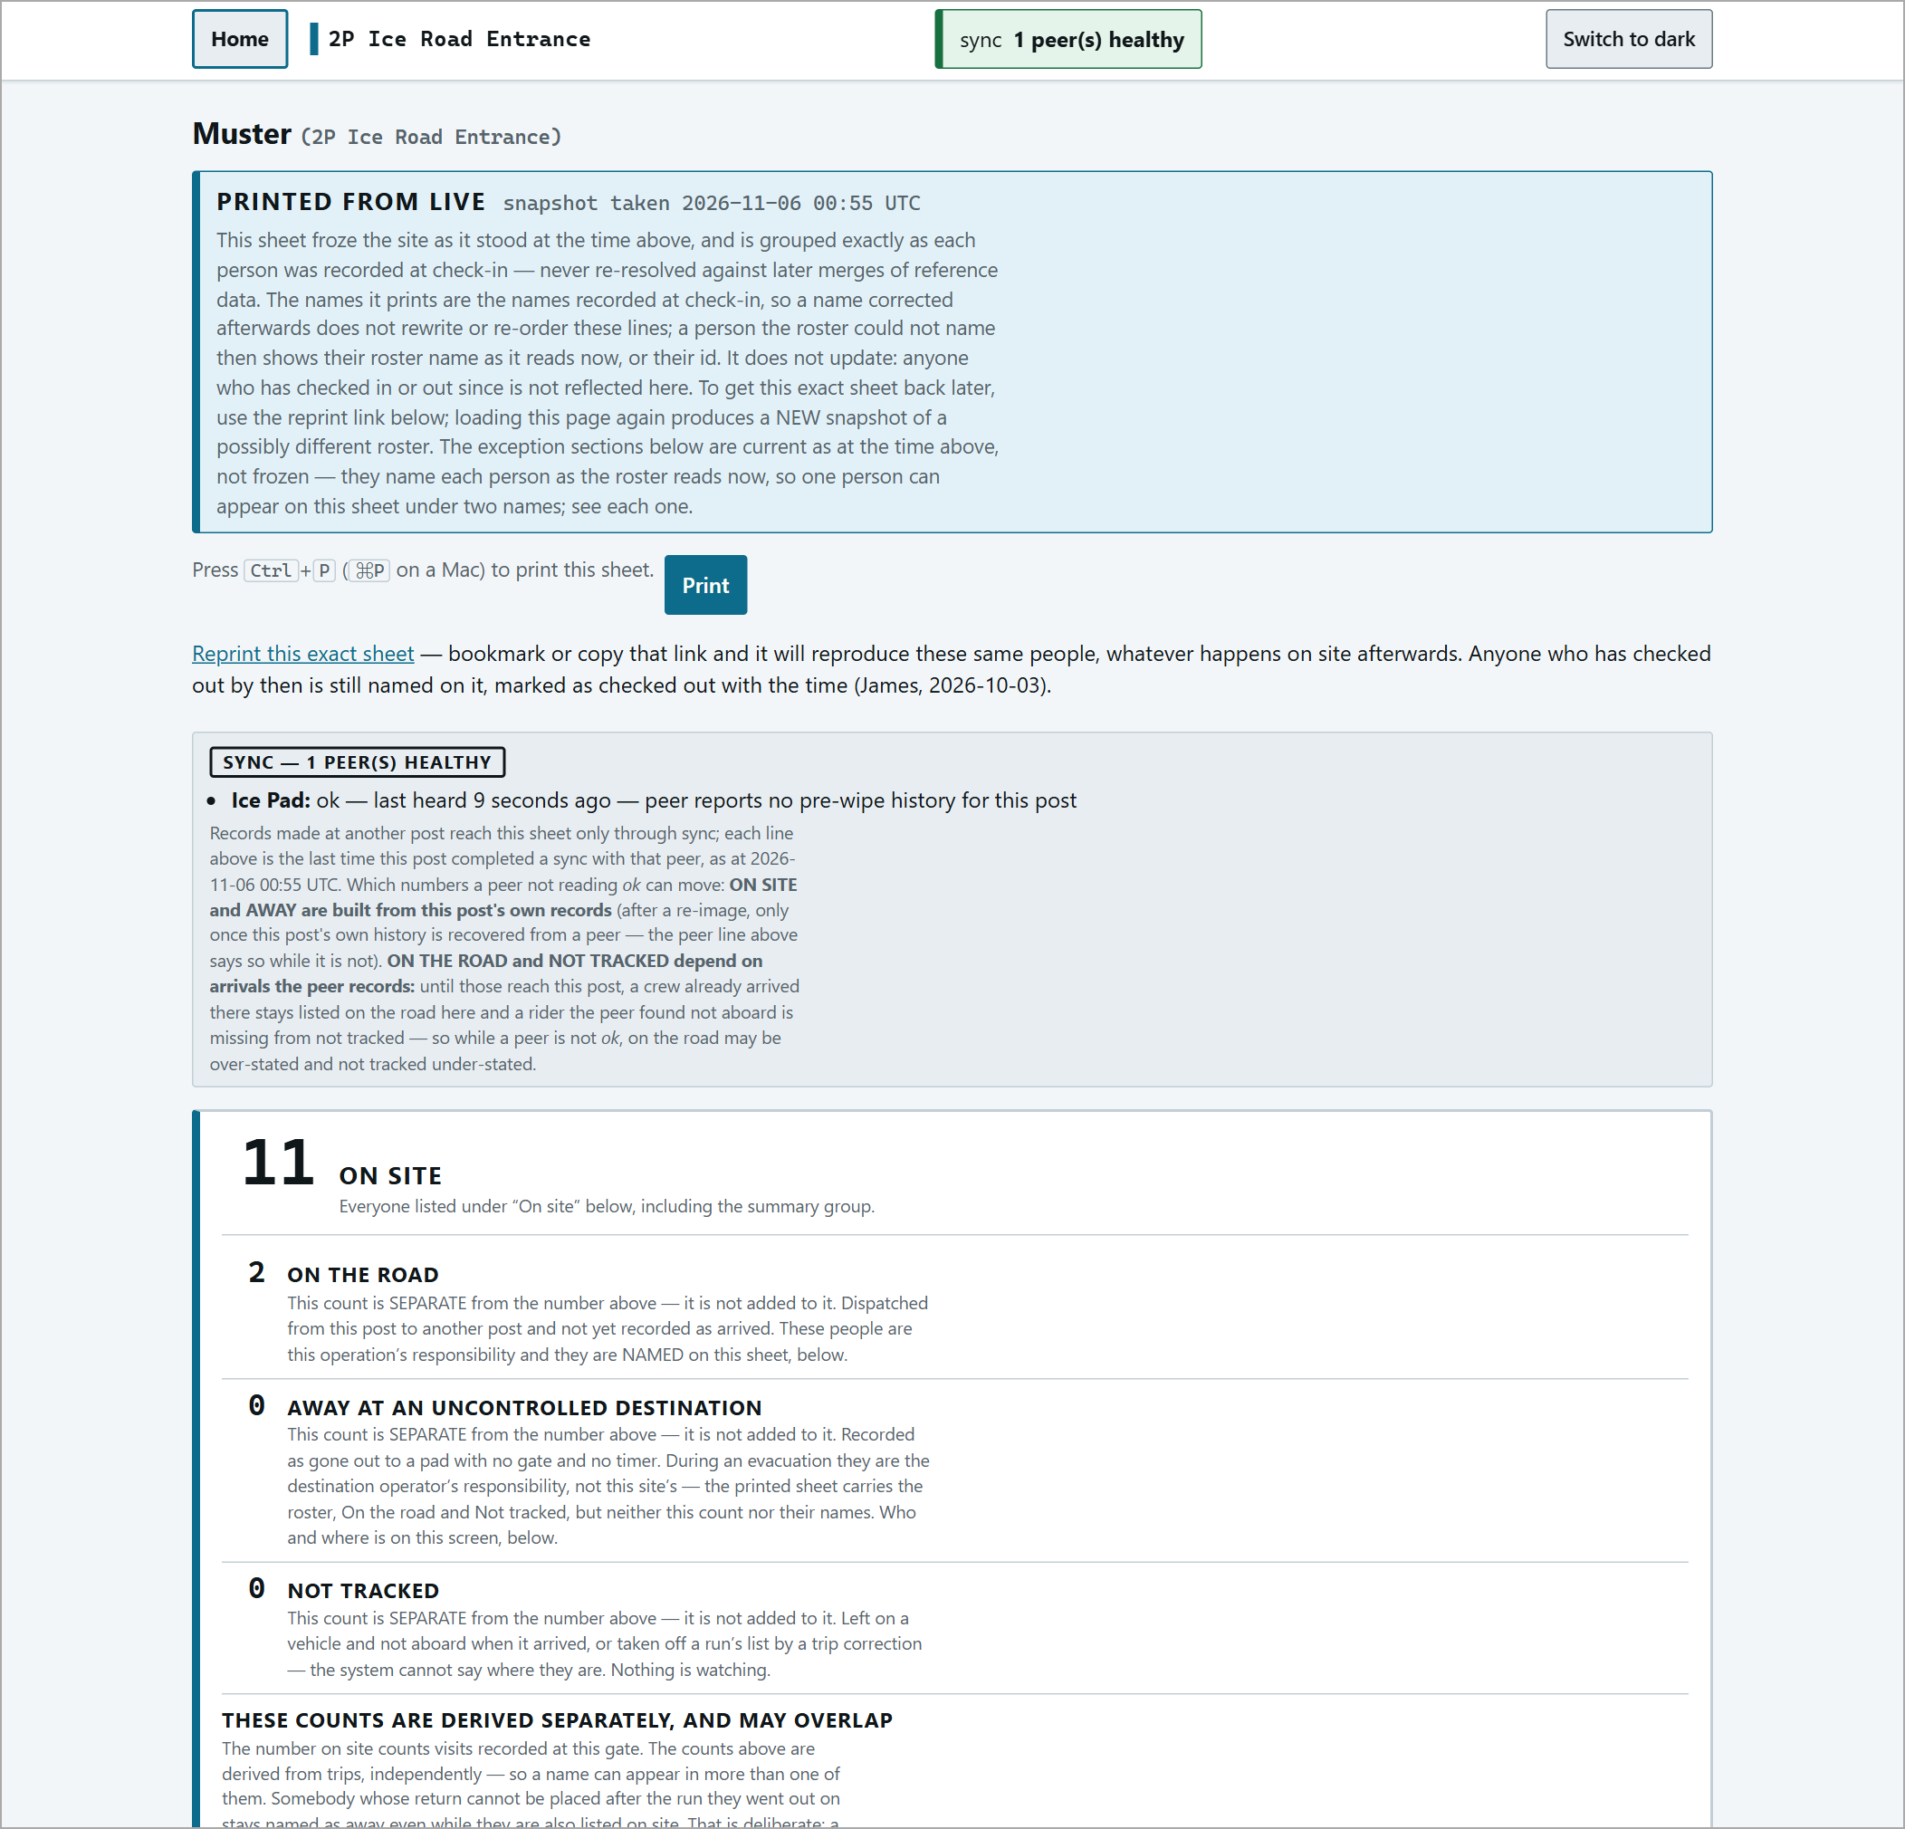
The print sheet.
Muster at a past time
Muster at a time... shows who was on site at any past moment: pick the site, date and time (24-hour) and press Show the muster. Times on the muster are shown in UTC.
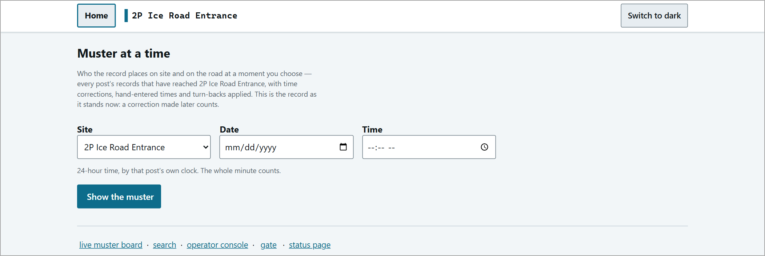
Muster at a time - the form.
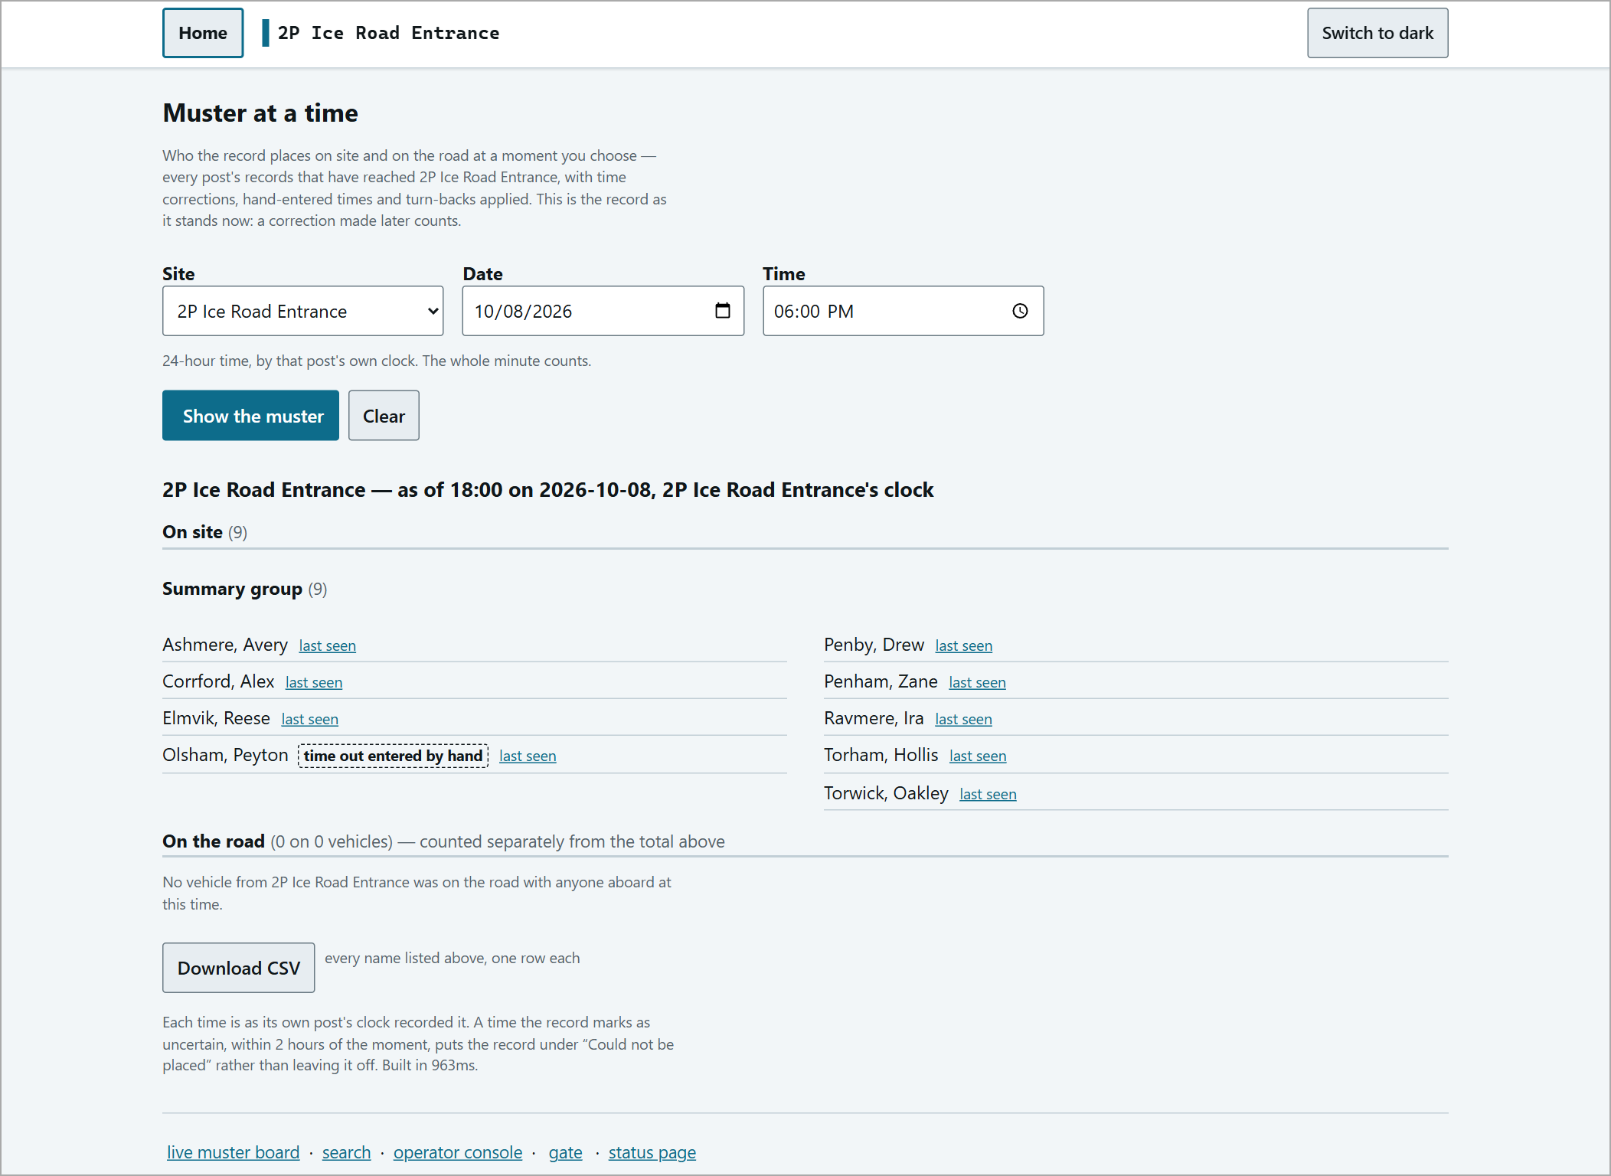
The result.
Search
search (footer link) finds people, visits and trips. Use Search for for free text (any name, company, trade, phone digits, truck number or post - every word must match) or the separate fields. Truck numbers ignore spaces, hyphens and capitals. Narrow by Site and a date / time range.
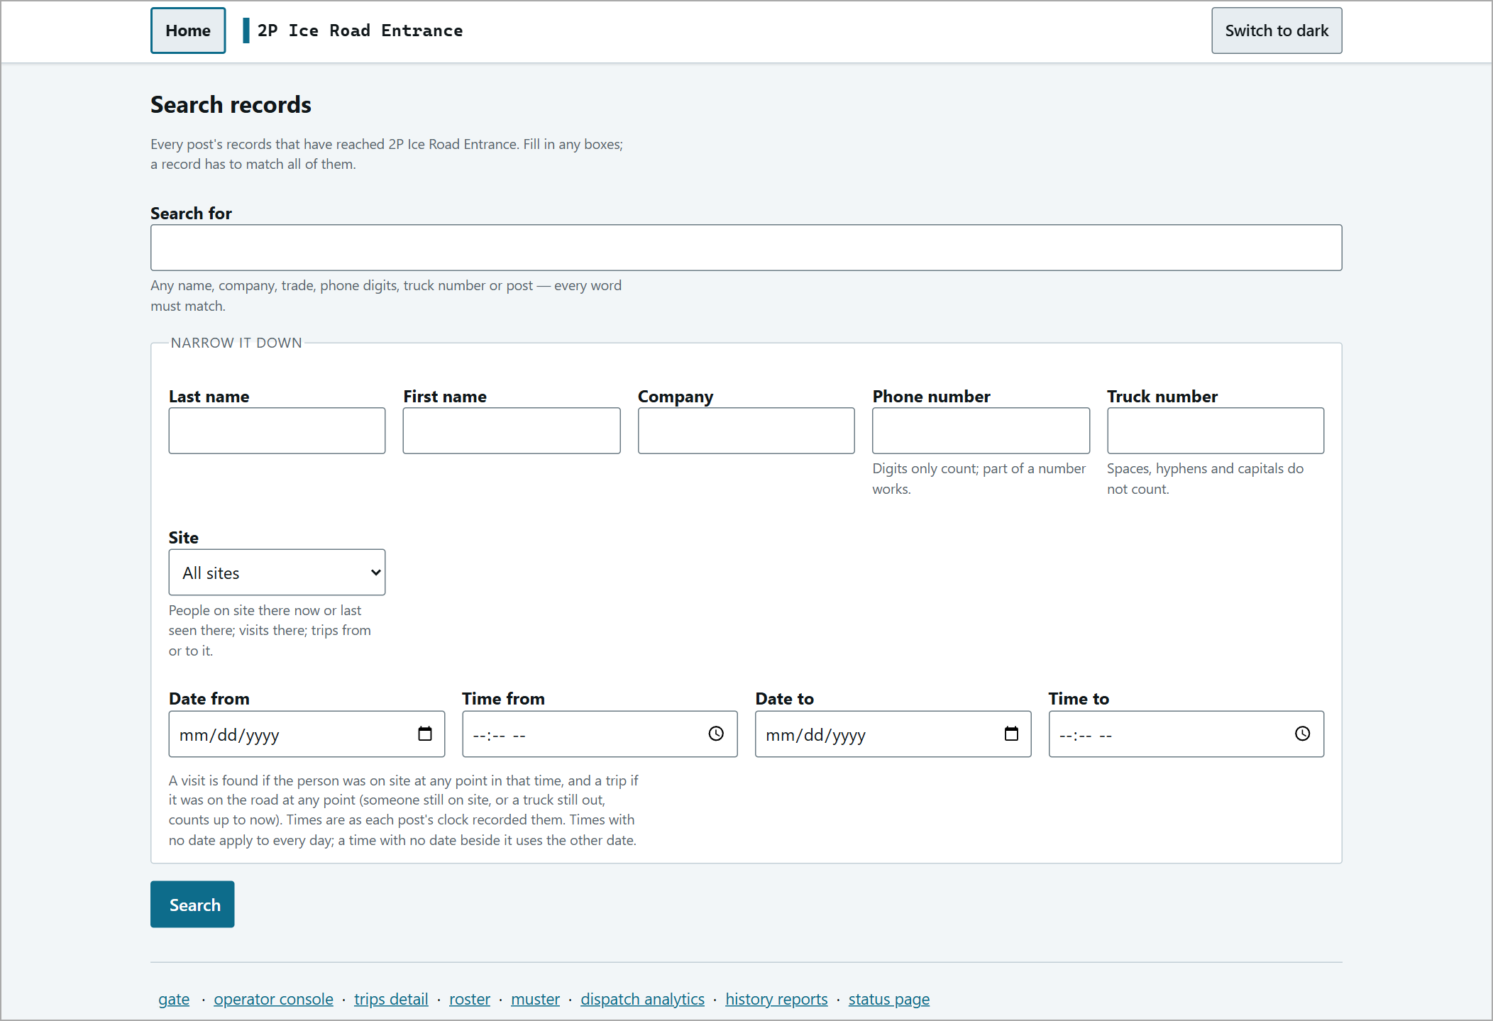
The search form.
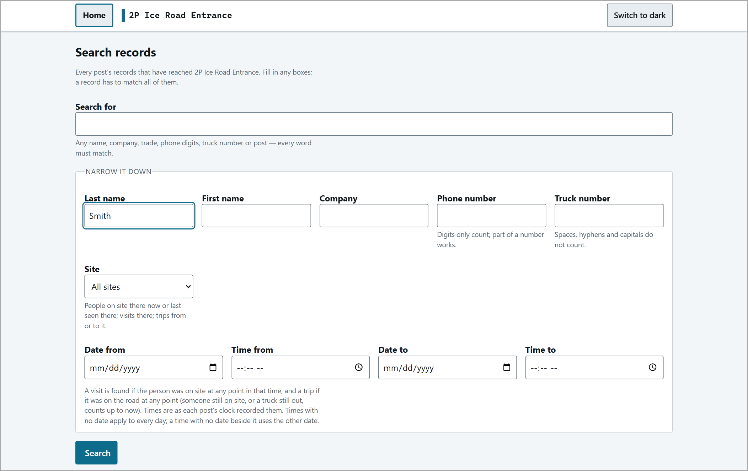
A search filled in.
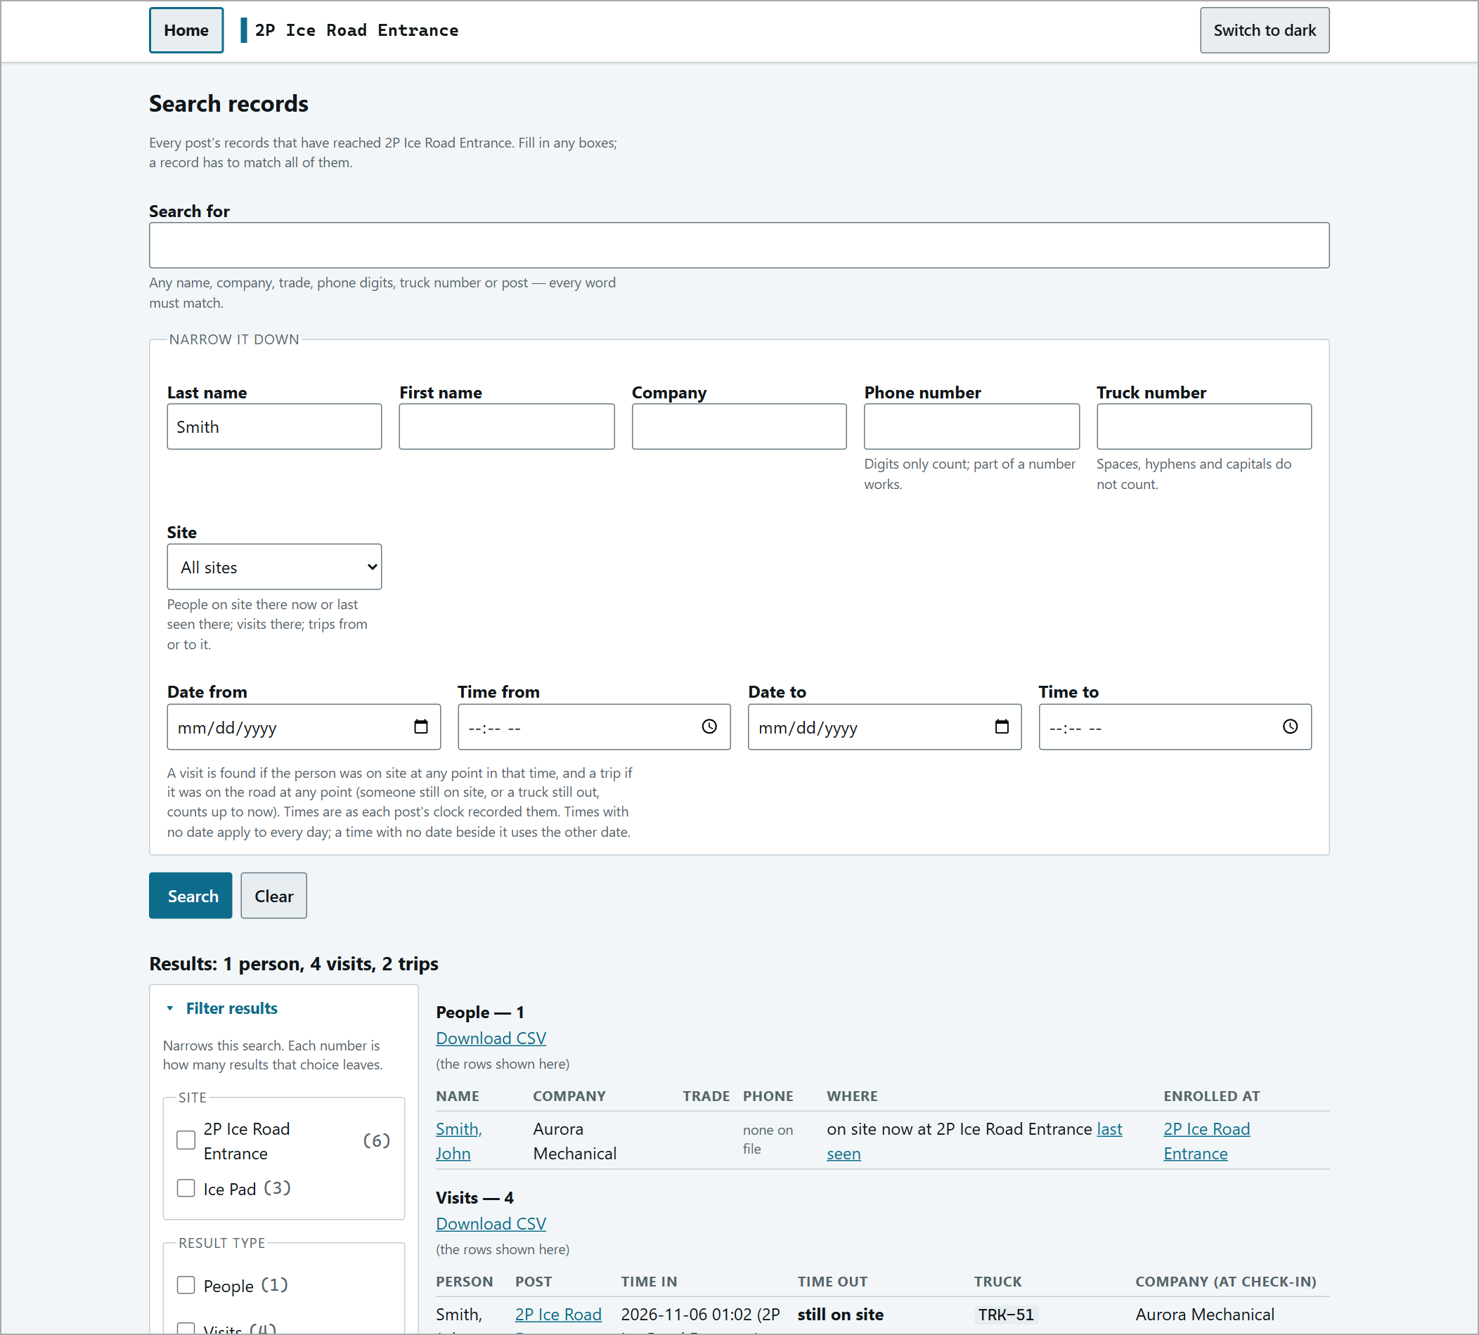
Results: People, Visits and Trips, with filters and Download CSV for each.
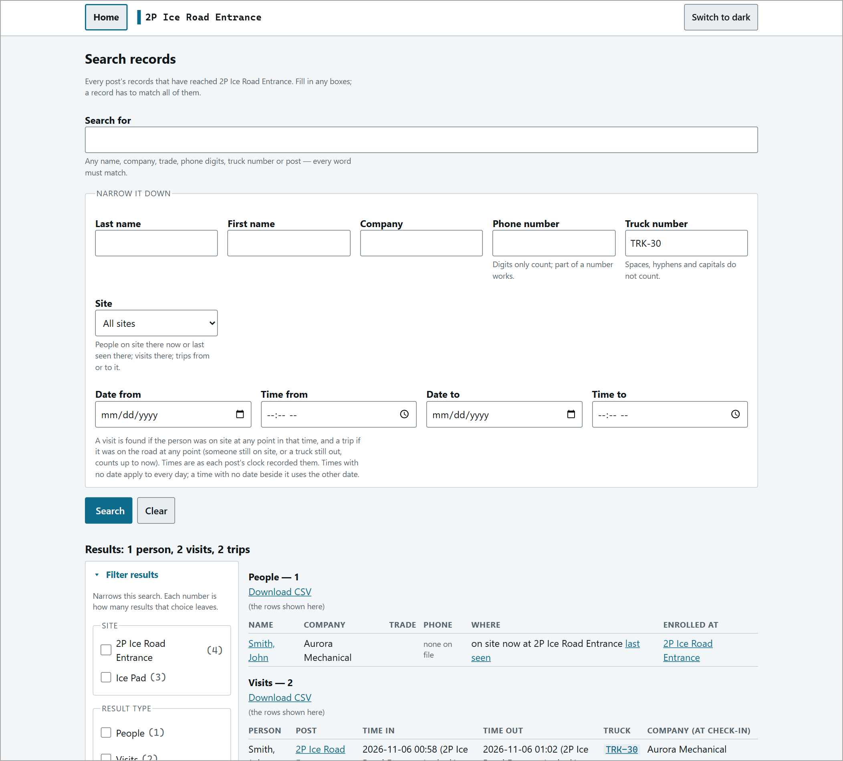
Searching by truck number.
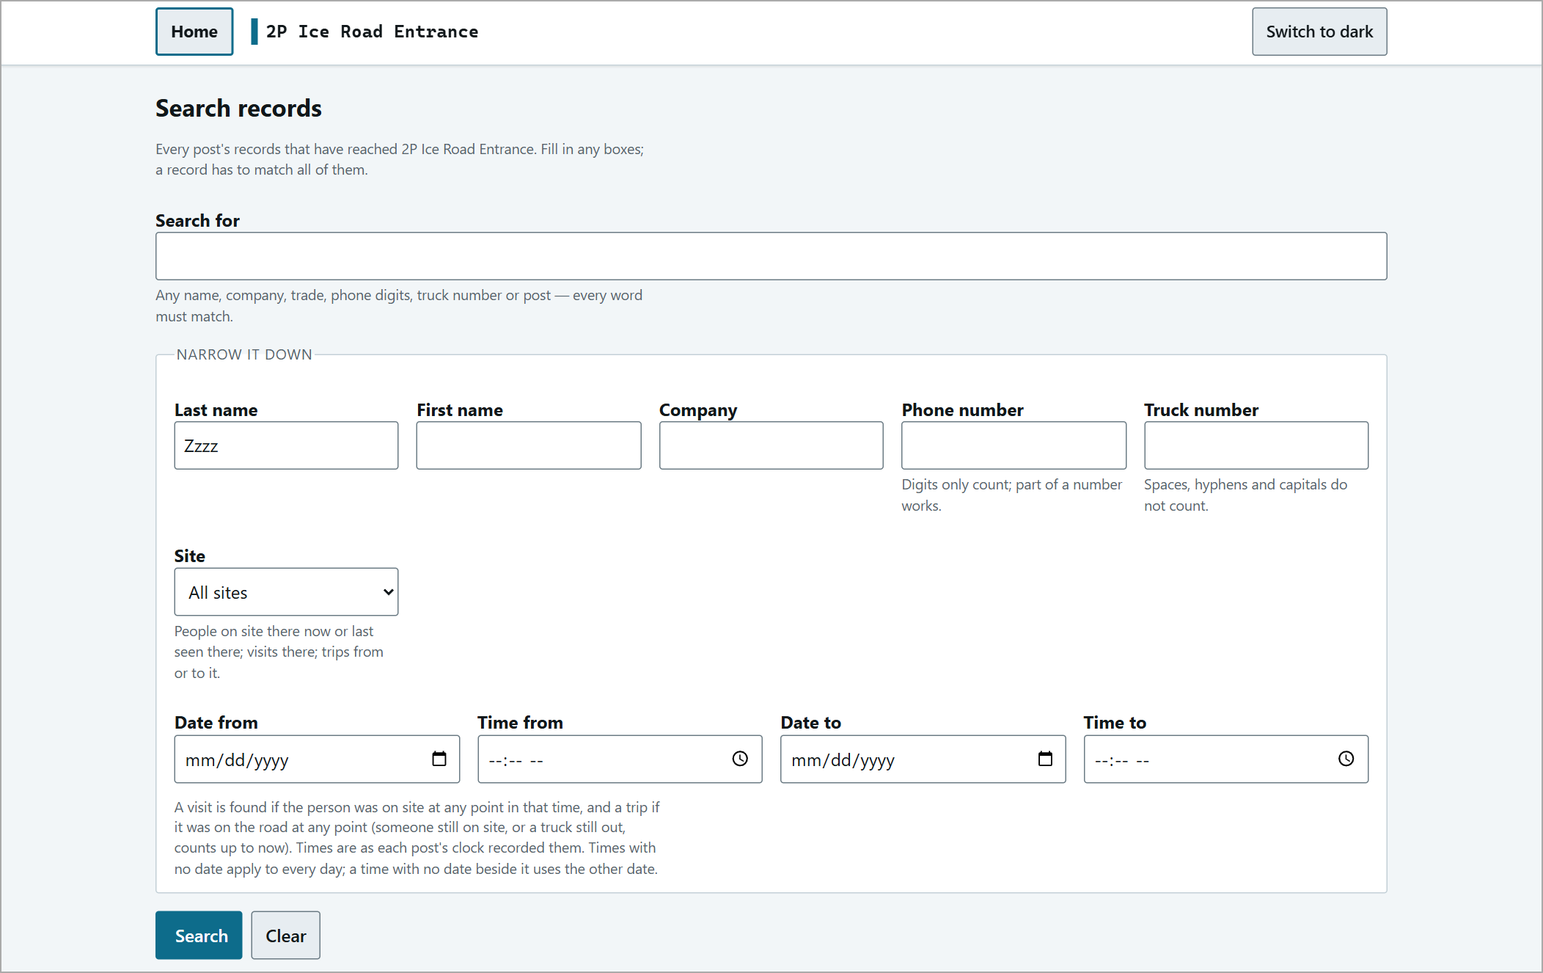
No match - all counts show 0.
Corrections
Nothing is ever erased - every correction is added to the record and earlier values are kept.
Edit a person
Tick the person in On site now and press Edit person (their id is filled in for you). Fill in only the fields to change - a blank field changes nothing - and press Amend this person. Company and trade are entered as ids (listed on the page).
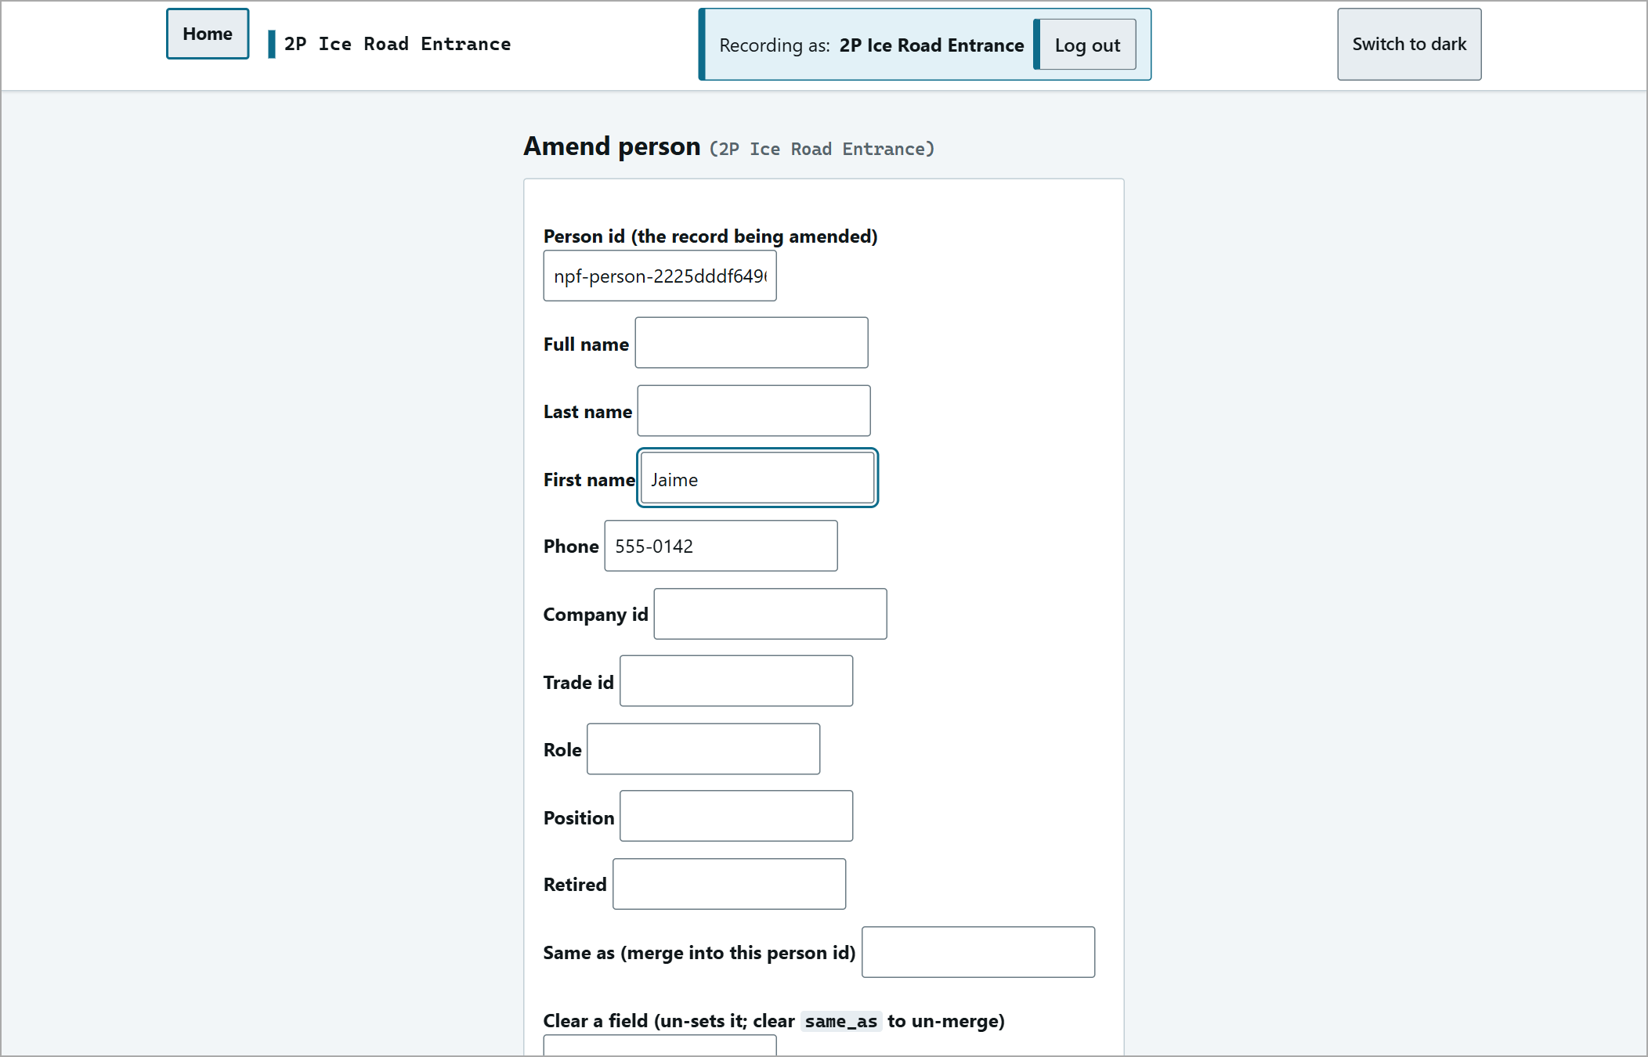
Edit person with one field changed.
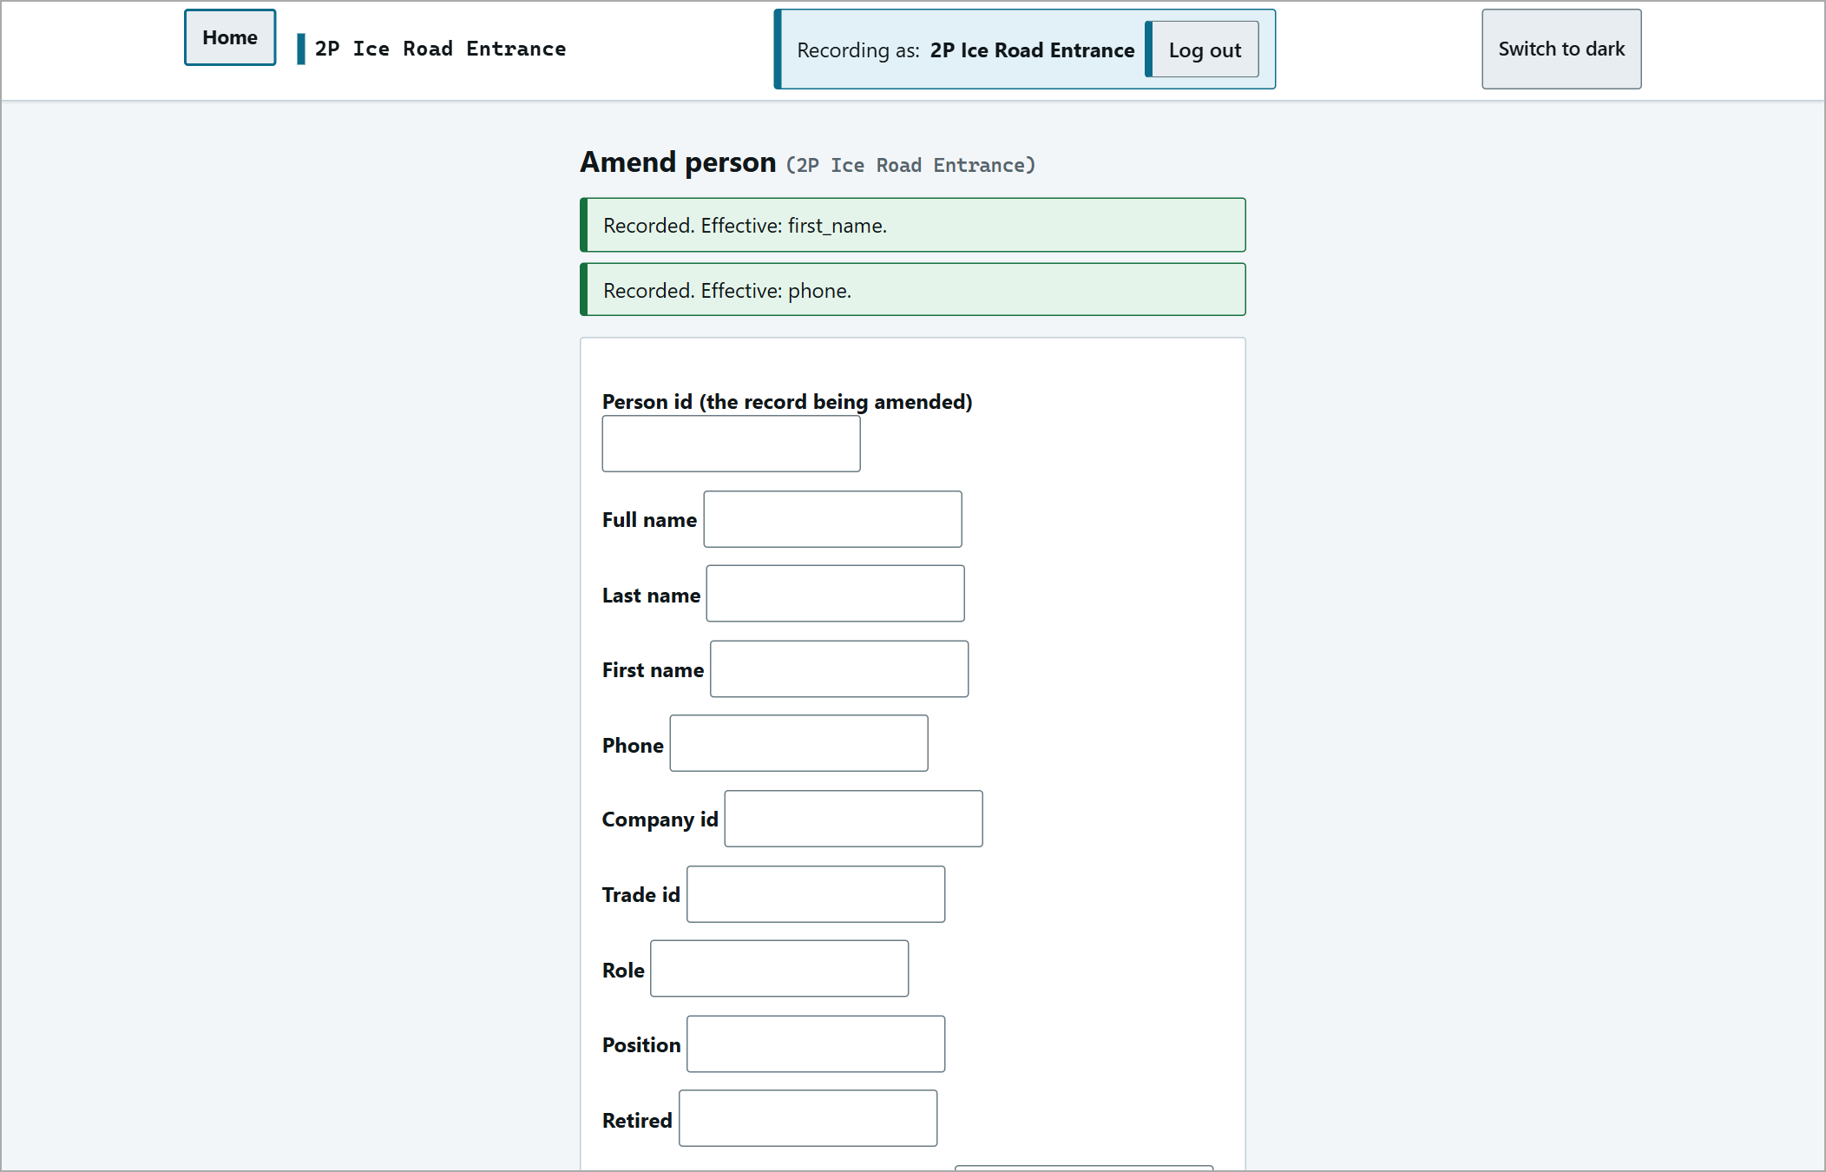
"Recorded. Effective: ..."
Remove - no departure
For someone entered by mistake: tick them and click Remove - no departure. The pop-up lists exactly who will be removed - "Is that everyone, and only them?" No departure or trip is recorded.
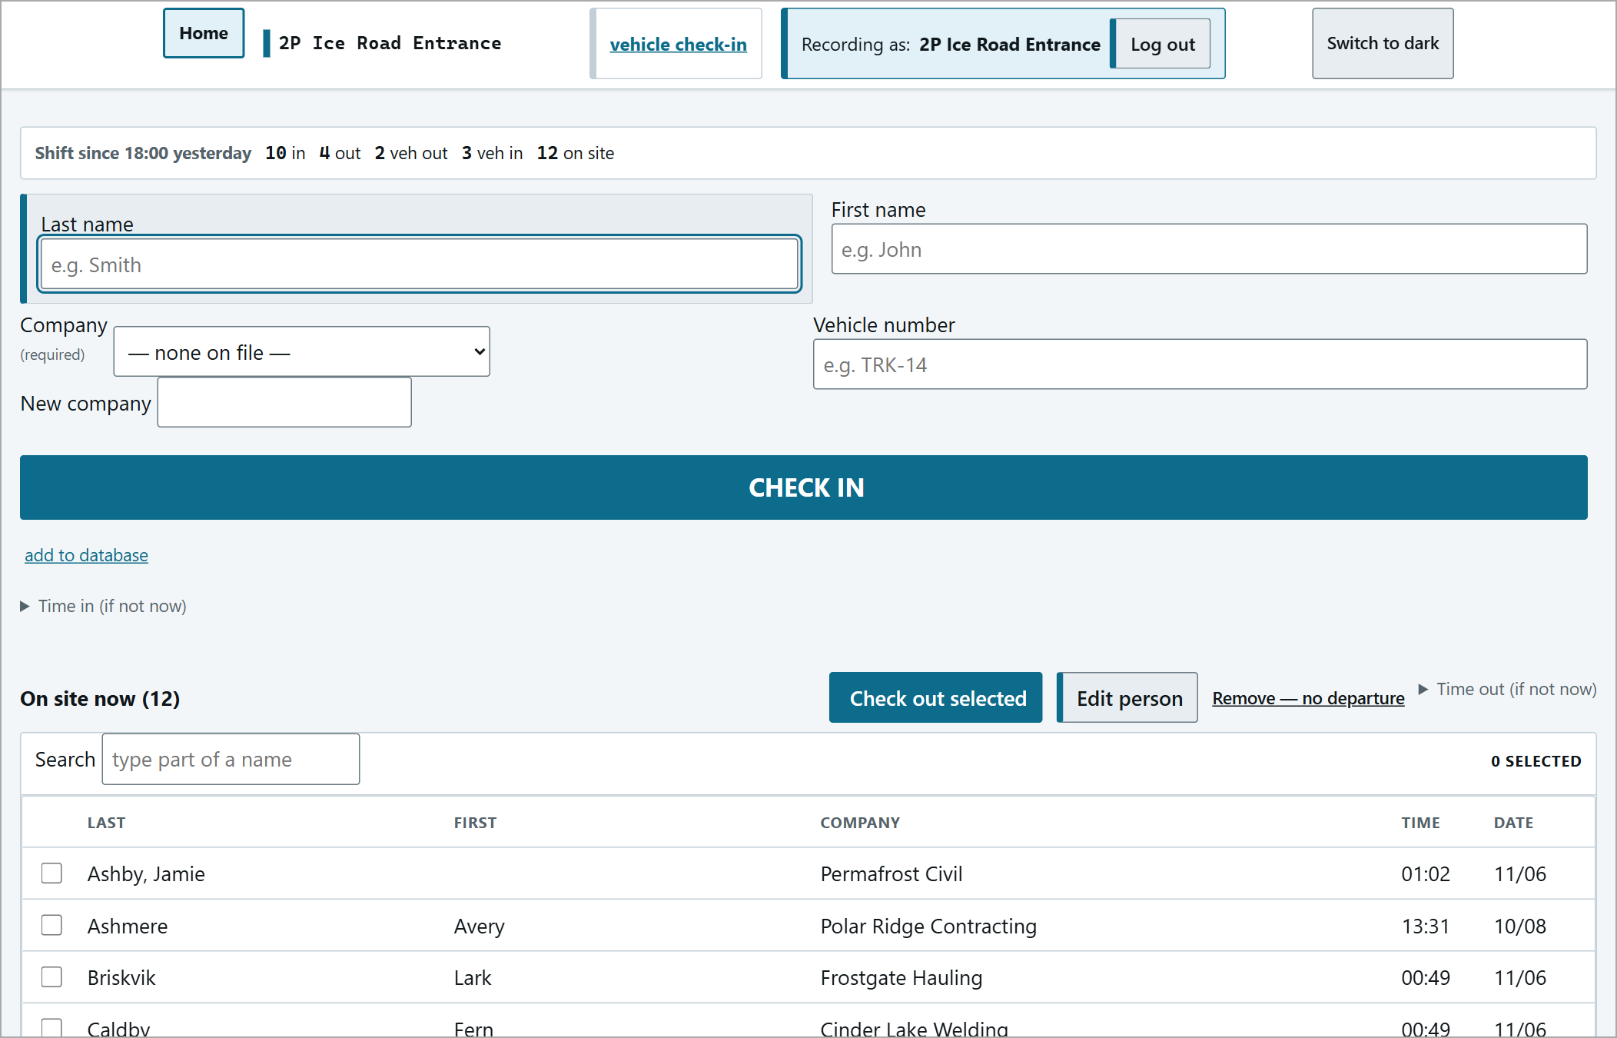
The gate after removing a mistaken entry.
Fix a trip
all trips & drivers lists every trip; click correct this record to amend one (driver, who was aboard, vehicle, destination, allowance). It uses person ids, listed on the page.
Trips are never cancelled: a vehicle that turns back is recorded as Arrived back here - it turned back on the console, and a return journey is a new dispatch.
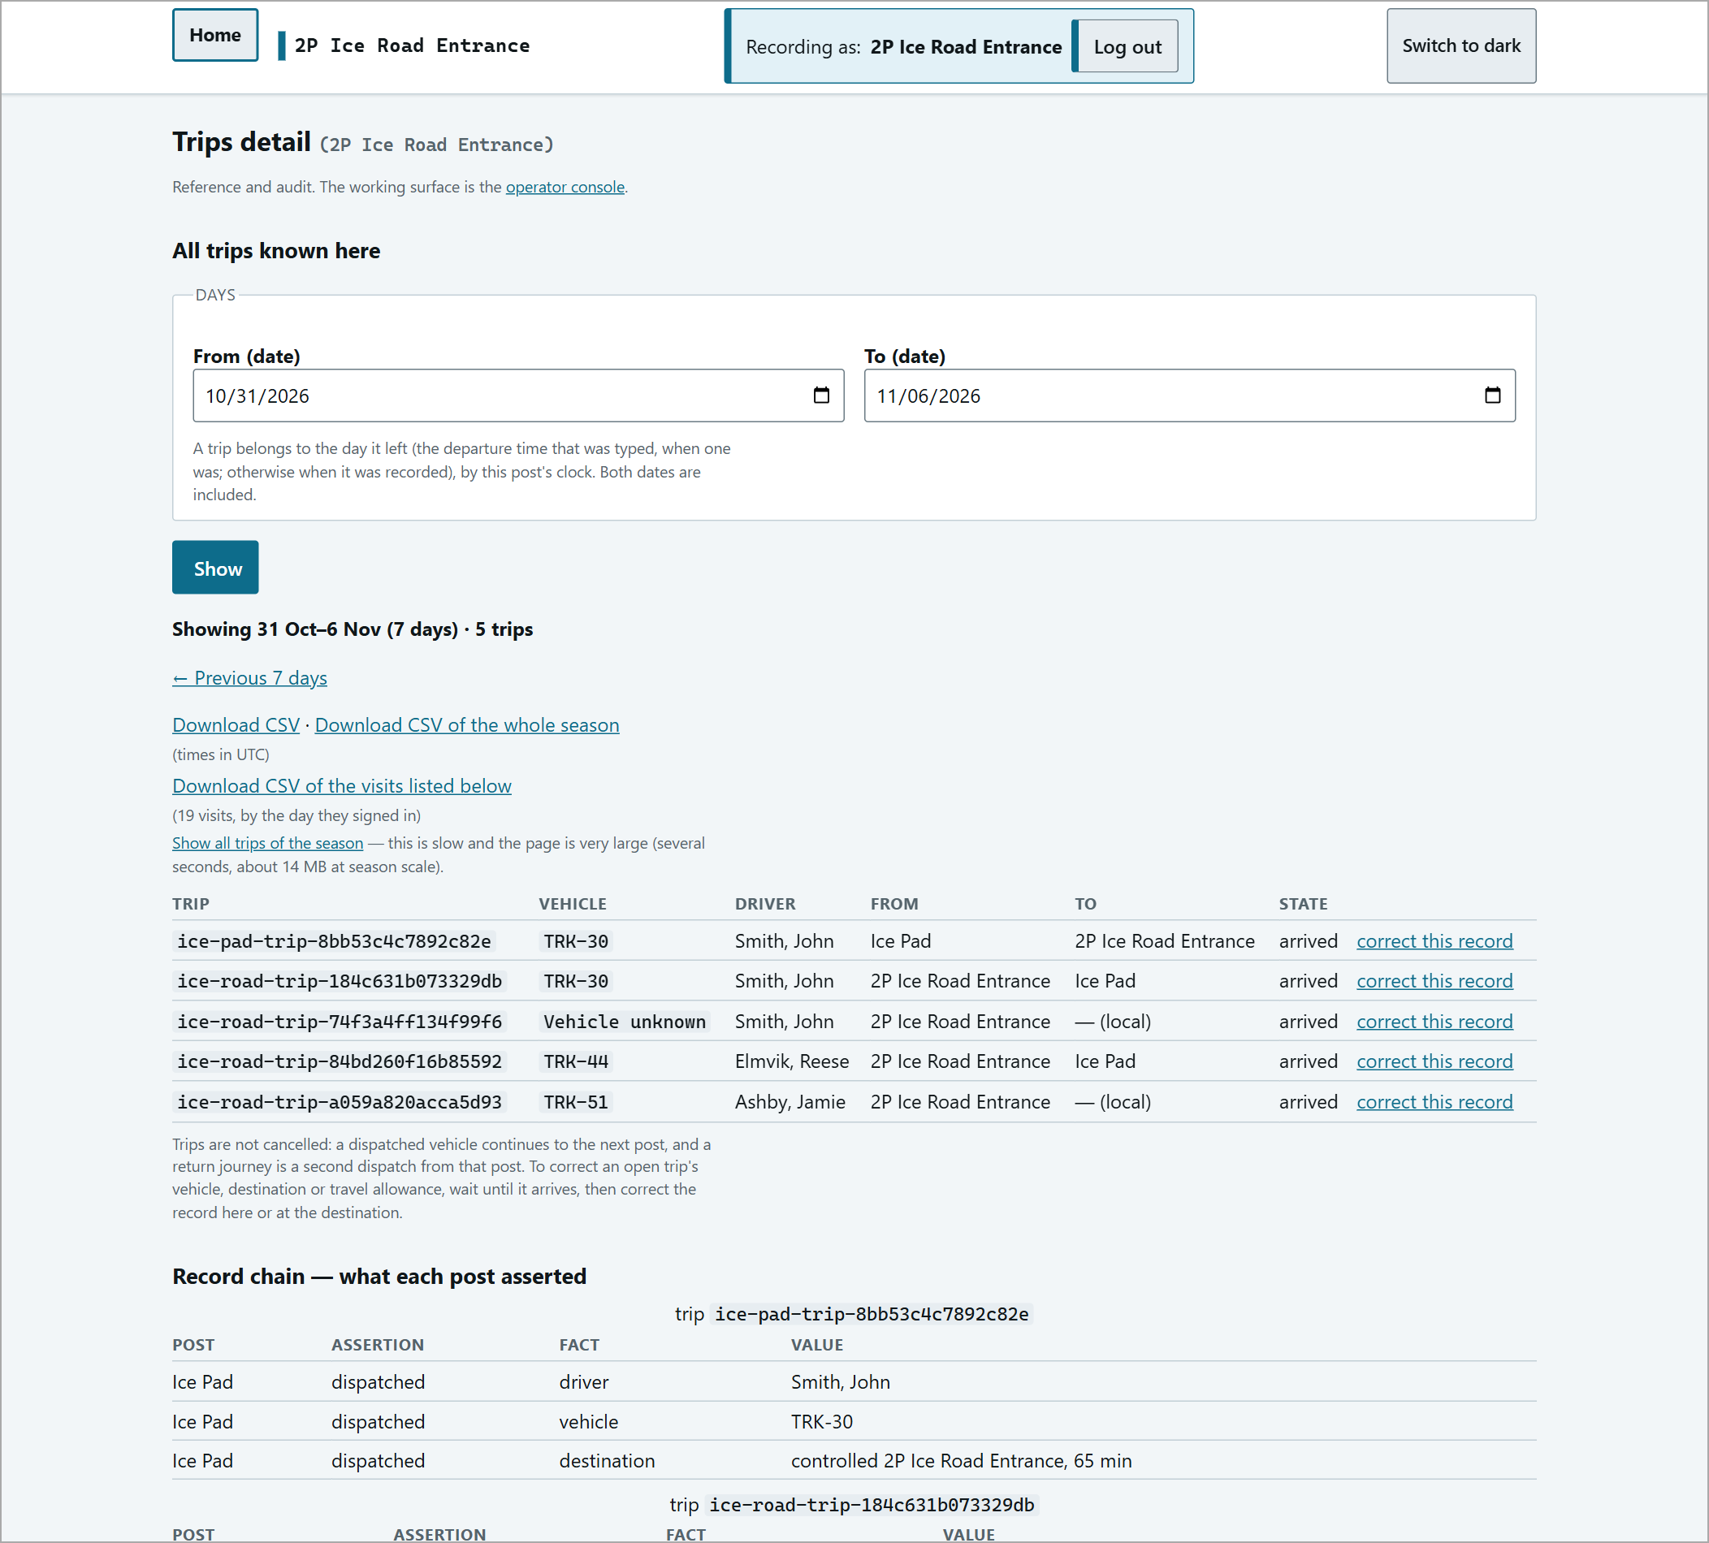
All trips & drivers.
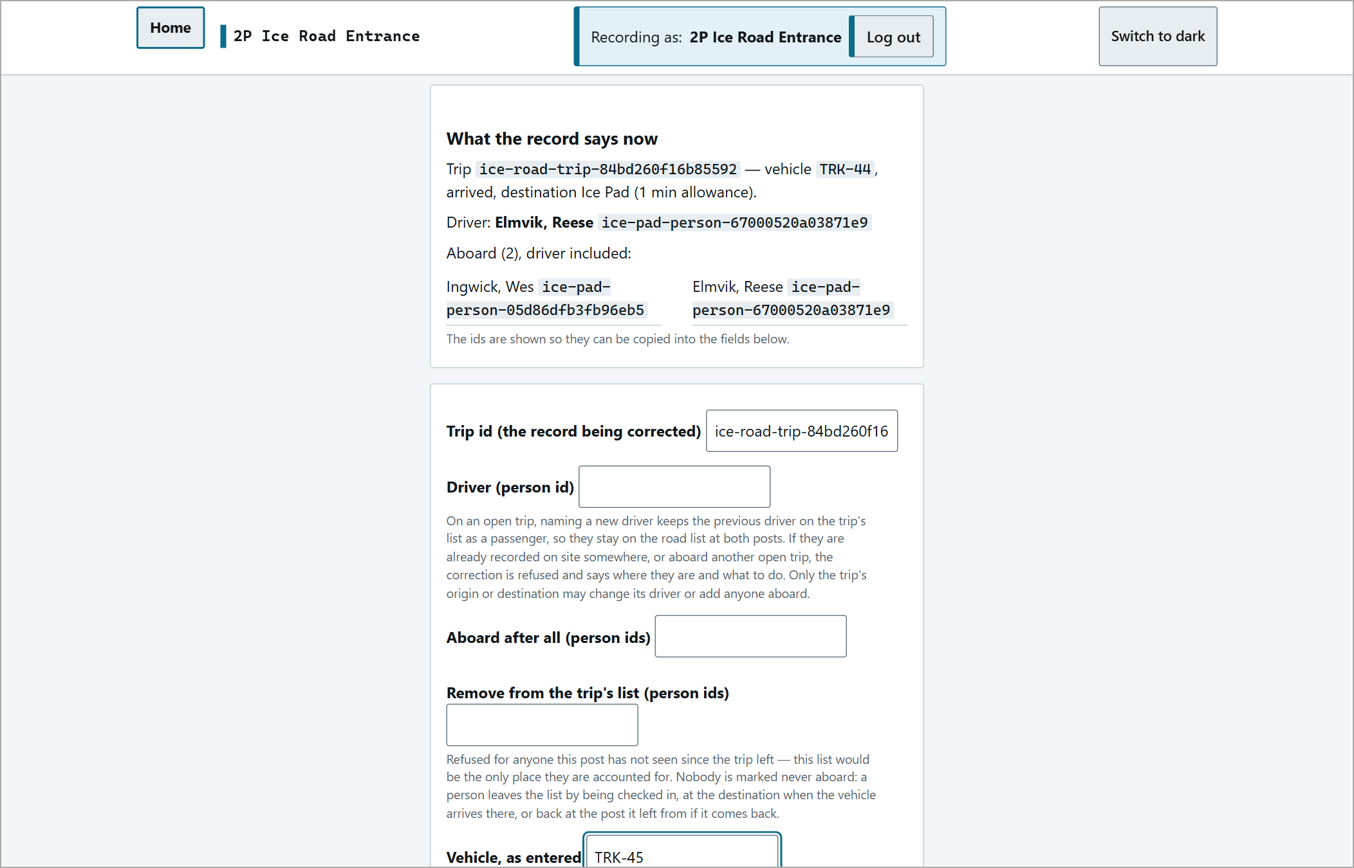  A trip correction filled in. | 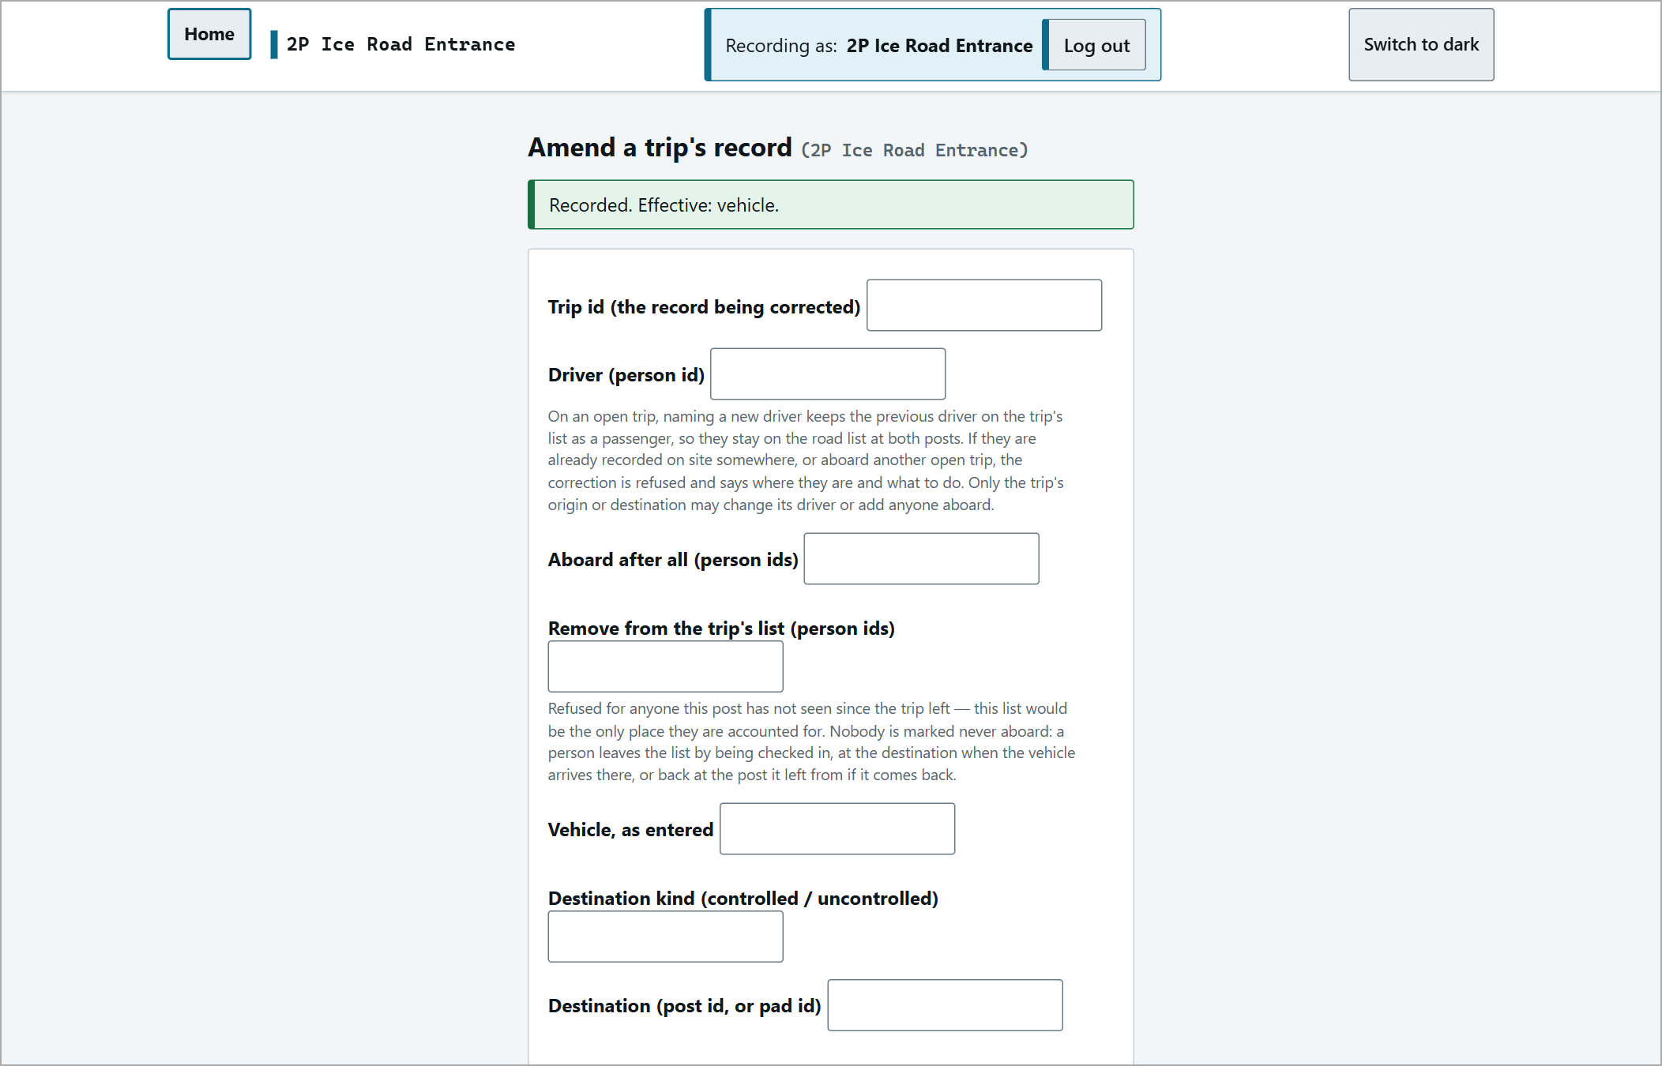  "Recorded. Effective: vehicle."

Roster
At a road post, people are added to the roster automatically the first time they are checked in. A post that gives its own orientation refuses anyone who is not on the roster - orient them, then enrol them here first (see Orientation). To enrol someone, use add to database on the gate (the roster page):
1 | Fill in Last name, First name, Phone (required - not shown on the muster) and Company; Trade is optional.
2 | Press Enrol this person - at a post that gives its own orientation the button reads Enrol this person and record <post>'s orientation, which records it. A green ENROLLED banner confirms.

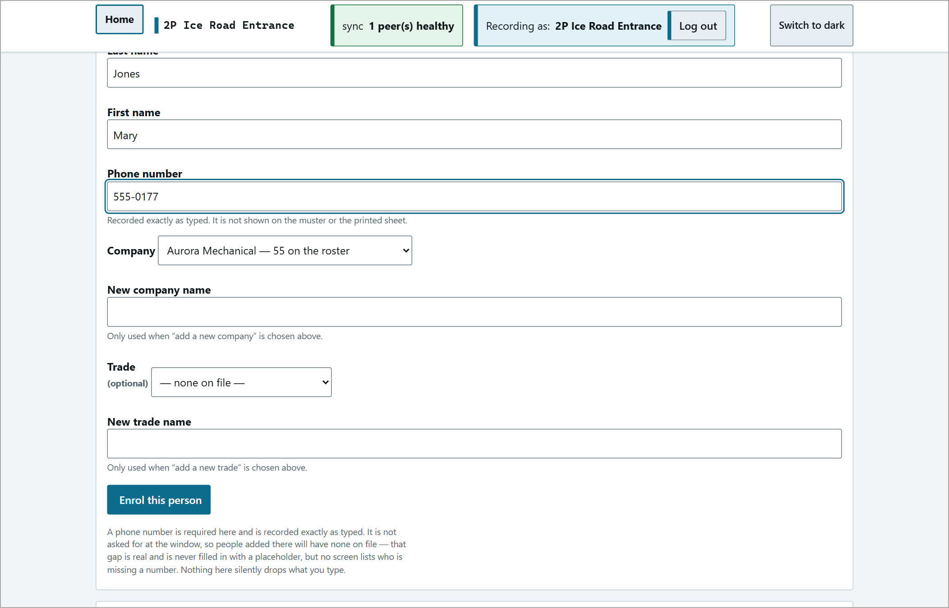  Enrolment form filled in. | 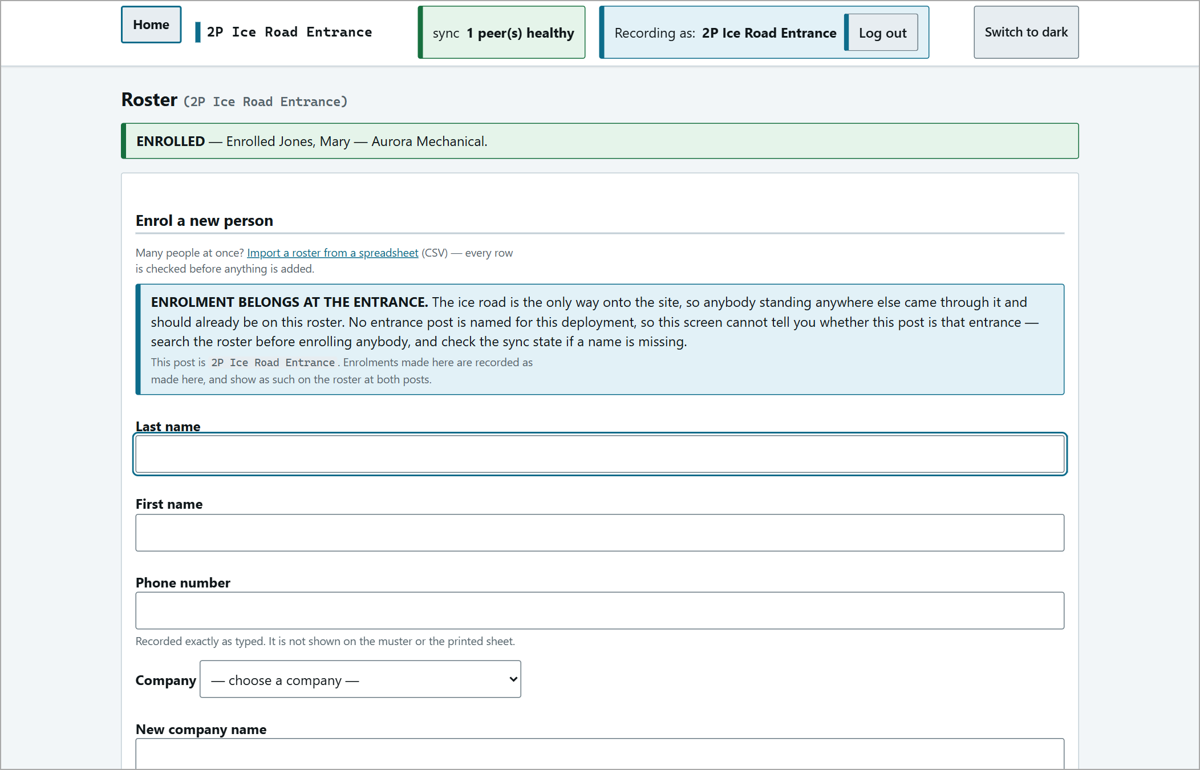  "ENROLLED - Enrolled Jones, Mary - Aurora Mechanical."

A whole list can be loaded with Import a roster from a spreadsheet (CSV) (columns: last name, first name, phone, company, optional trade). Check the file previews it and records nothing until you confirm.
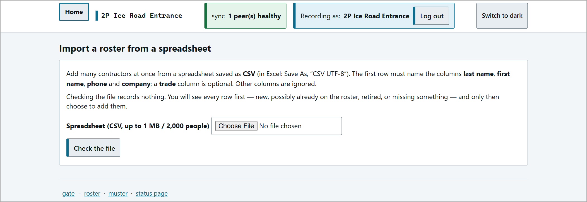
The roster import page.
Lost Signal
Each post keeps working on its own when the link (Starlink) drops. Carry on recording as normal - entries are kept and reach the other posts automatically when the link returns.
When a post has not heard from the others for about 30 seconds, a red LOST SIGNAL banner appears on every page and the sync pill turns red:
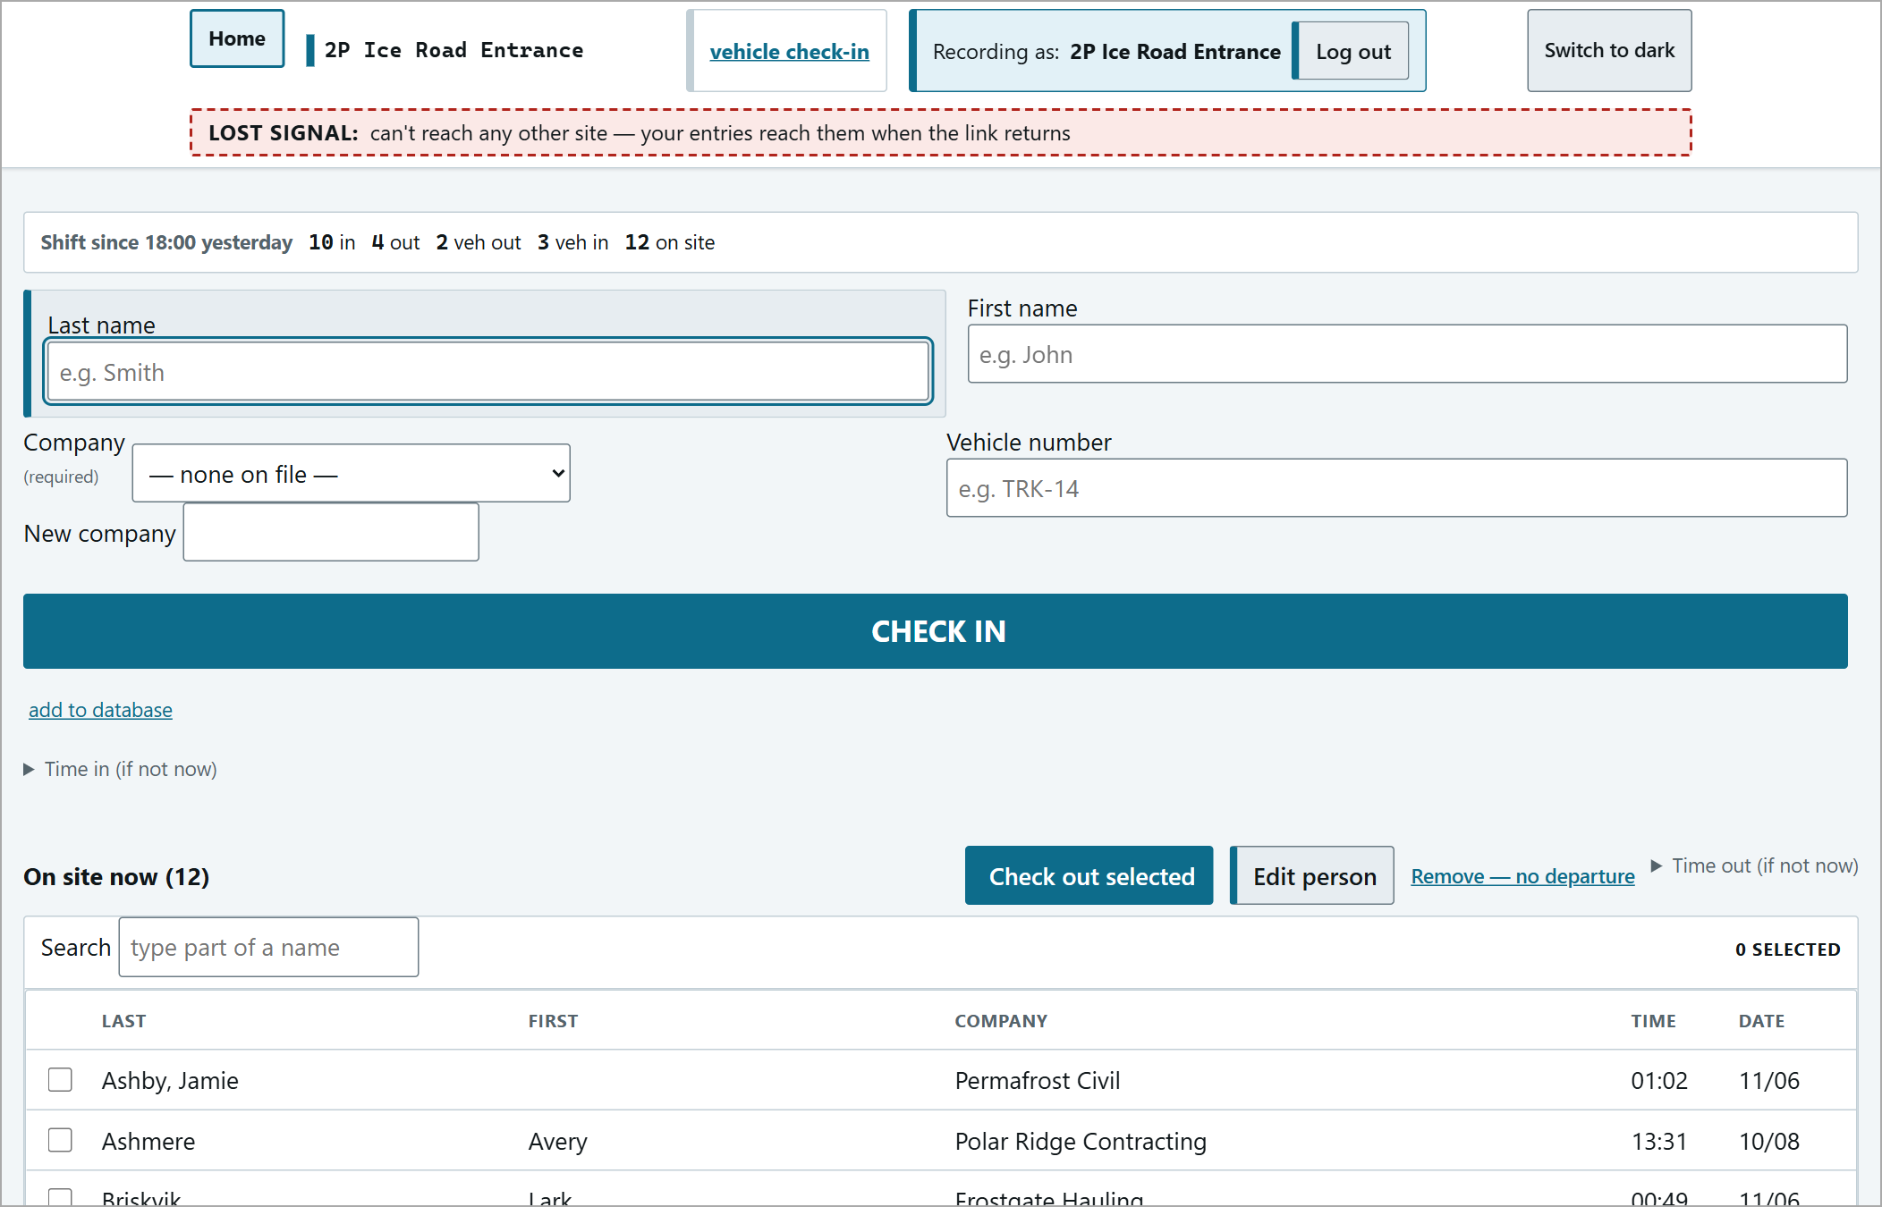
"LOST SIGNAL: can't reach any other site - your entries reach them when the link returns."
While the signal is lost, the muster and analytics mark the other posts STALE - LAST KNOWN and leave them out of the totals - verify those by radio. Vehicles on their way to you may not show up as expected until the link returns.
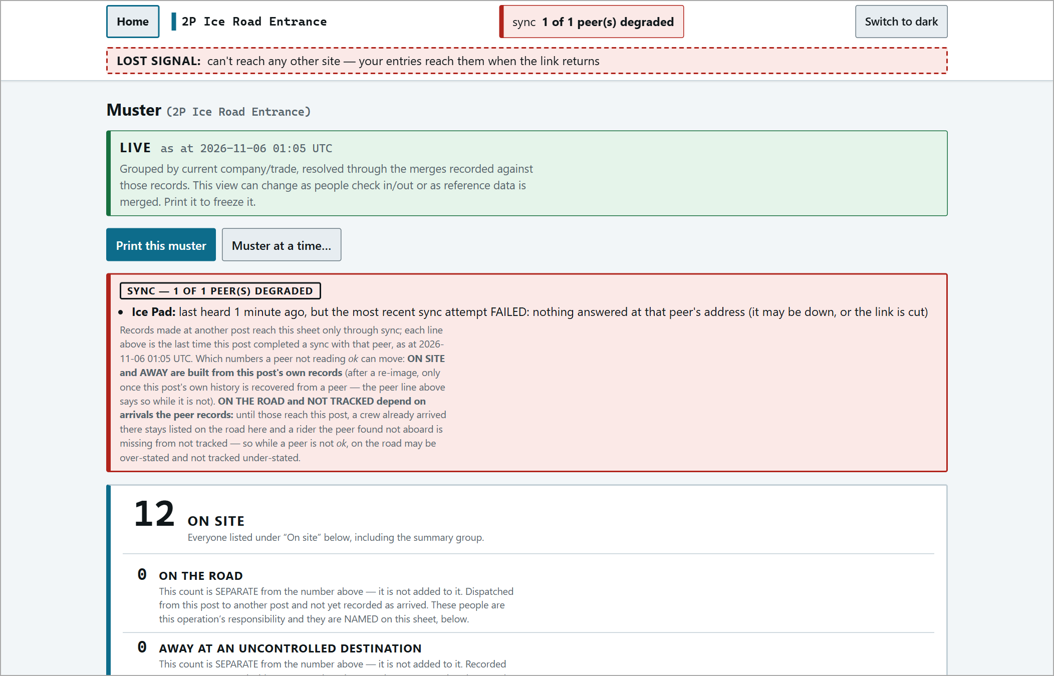
The muster during lost signal.
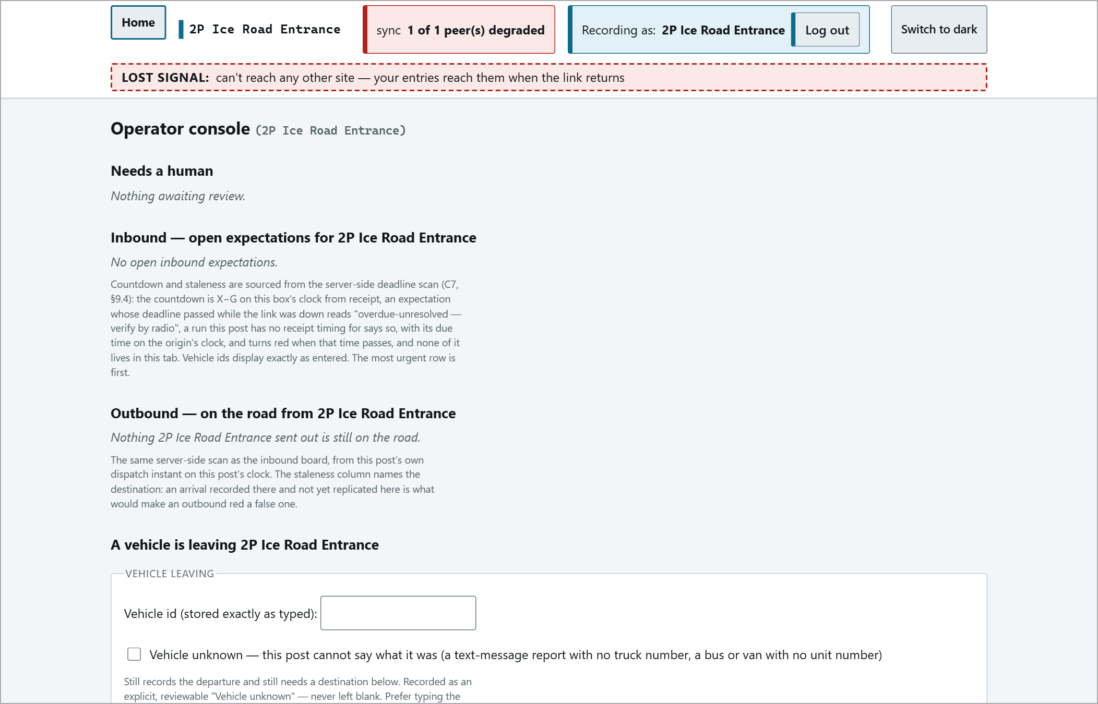
The operator console during lost signal.
Reports and Status
status page | Confirms the program is running, the last backup, and the state of each link to the other posts.
Overdue history | Every trip that ran past its deadline, who acknowledged it and the outcome.
Missed sign-outs | People whose visit was only closed by their next return - with repeat flags by person / company.
Lost-signal history | Every outage, filterable by date and site.
dispatch analytics | All posts at a glance: on site, trips, in transit, overdue, signal. Refreshes every 60 seconds.

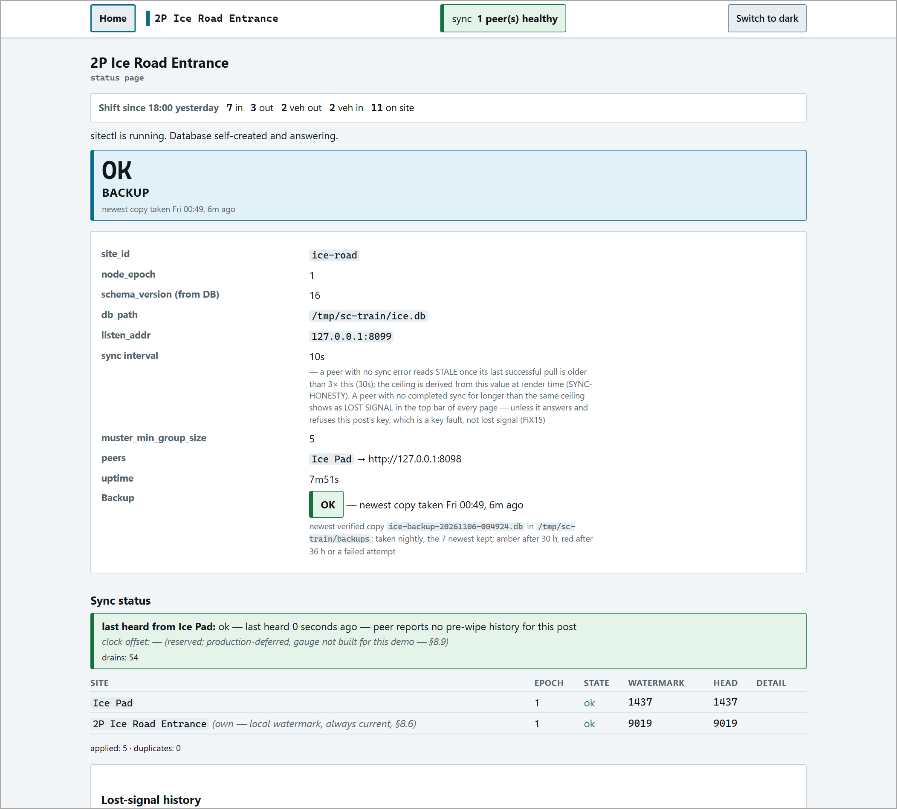
The status page.
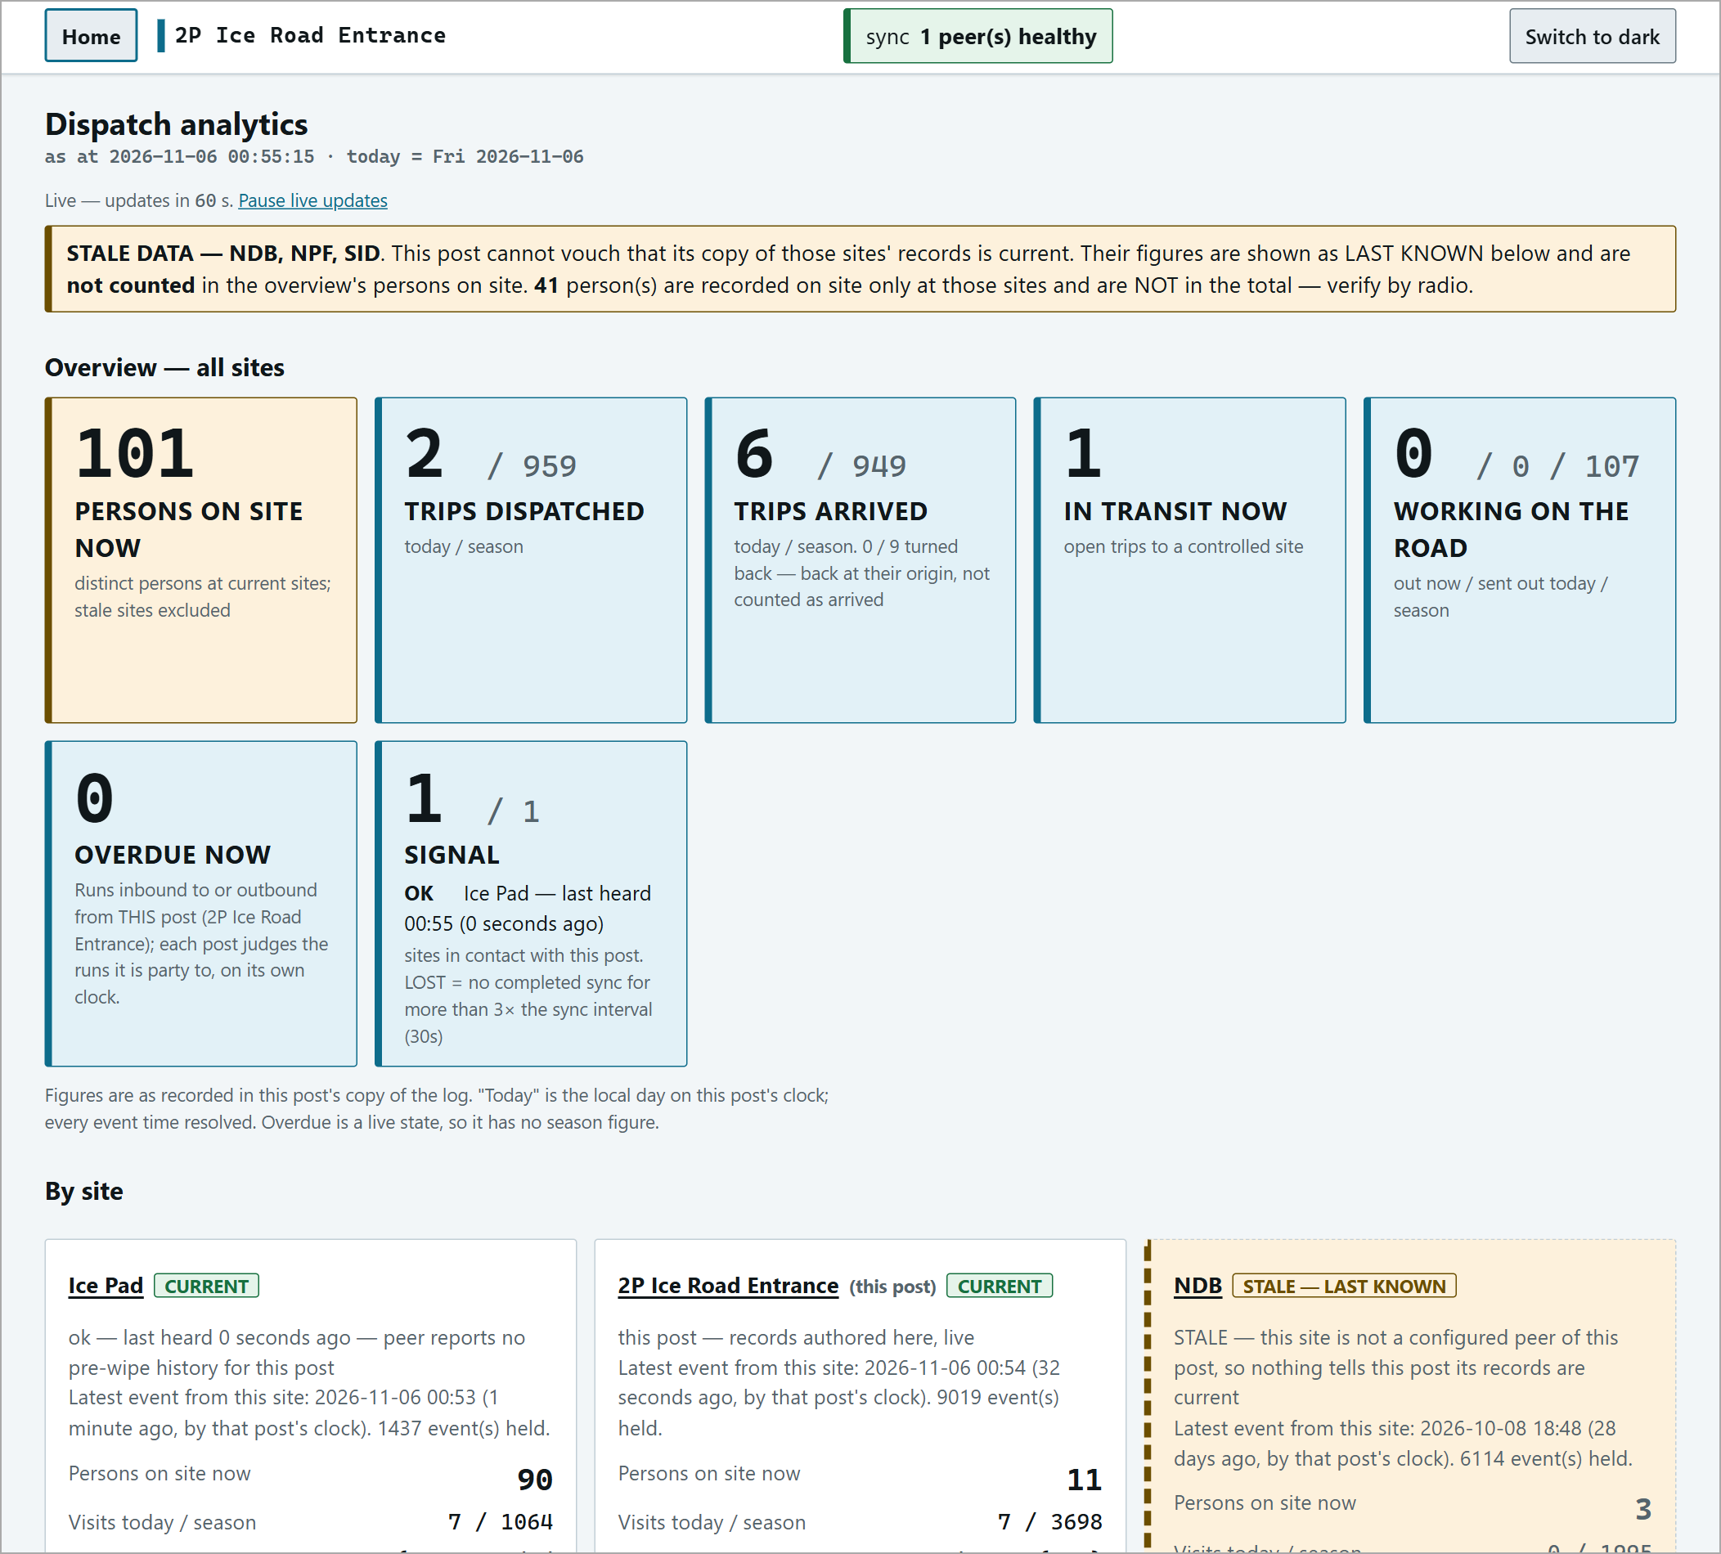
Dispatch analytics.
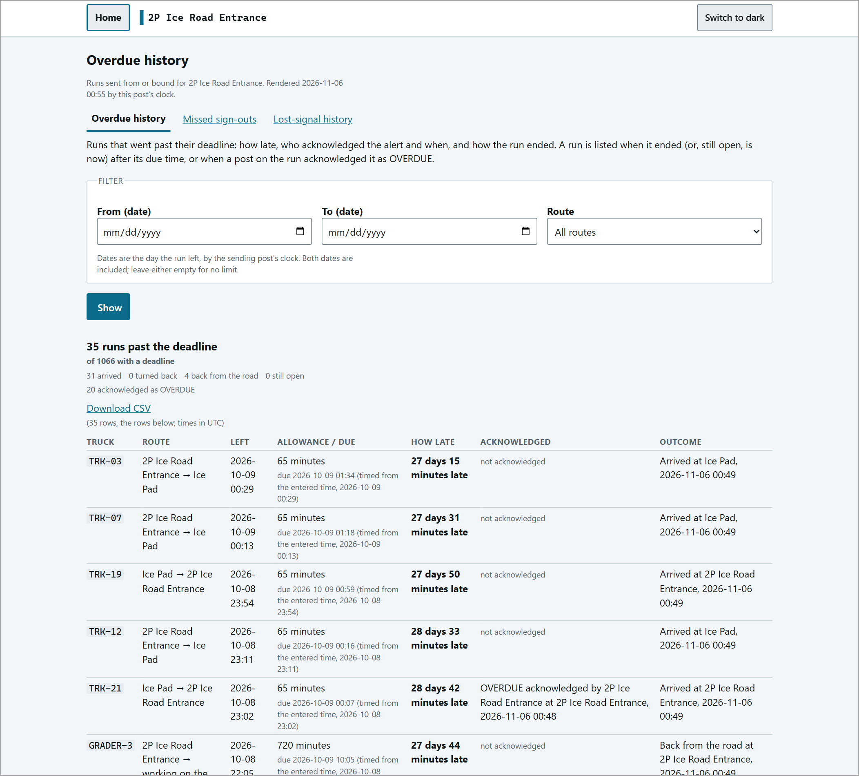  Overdue history. | 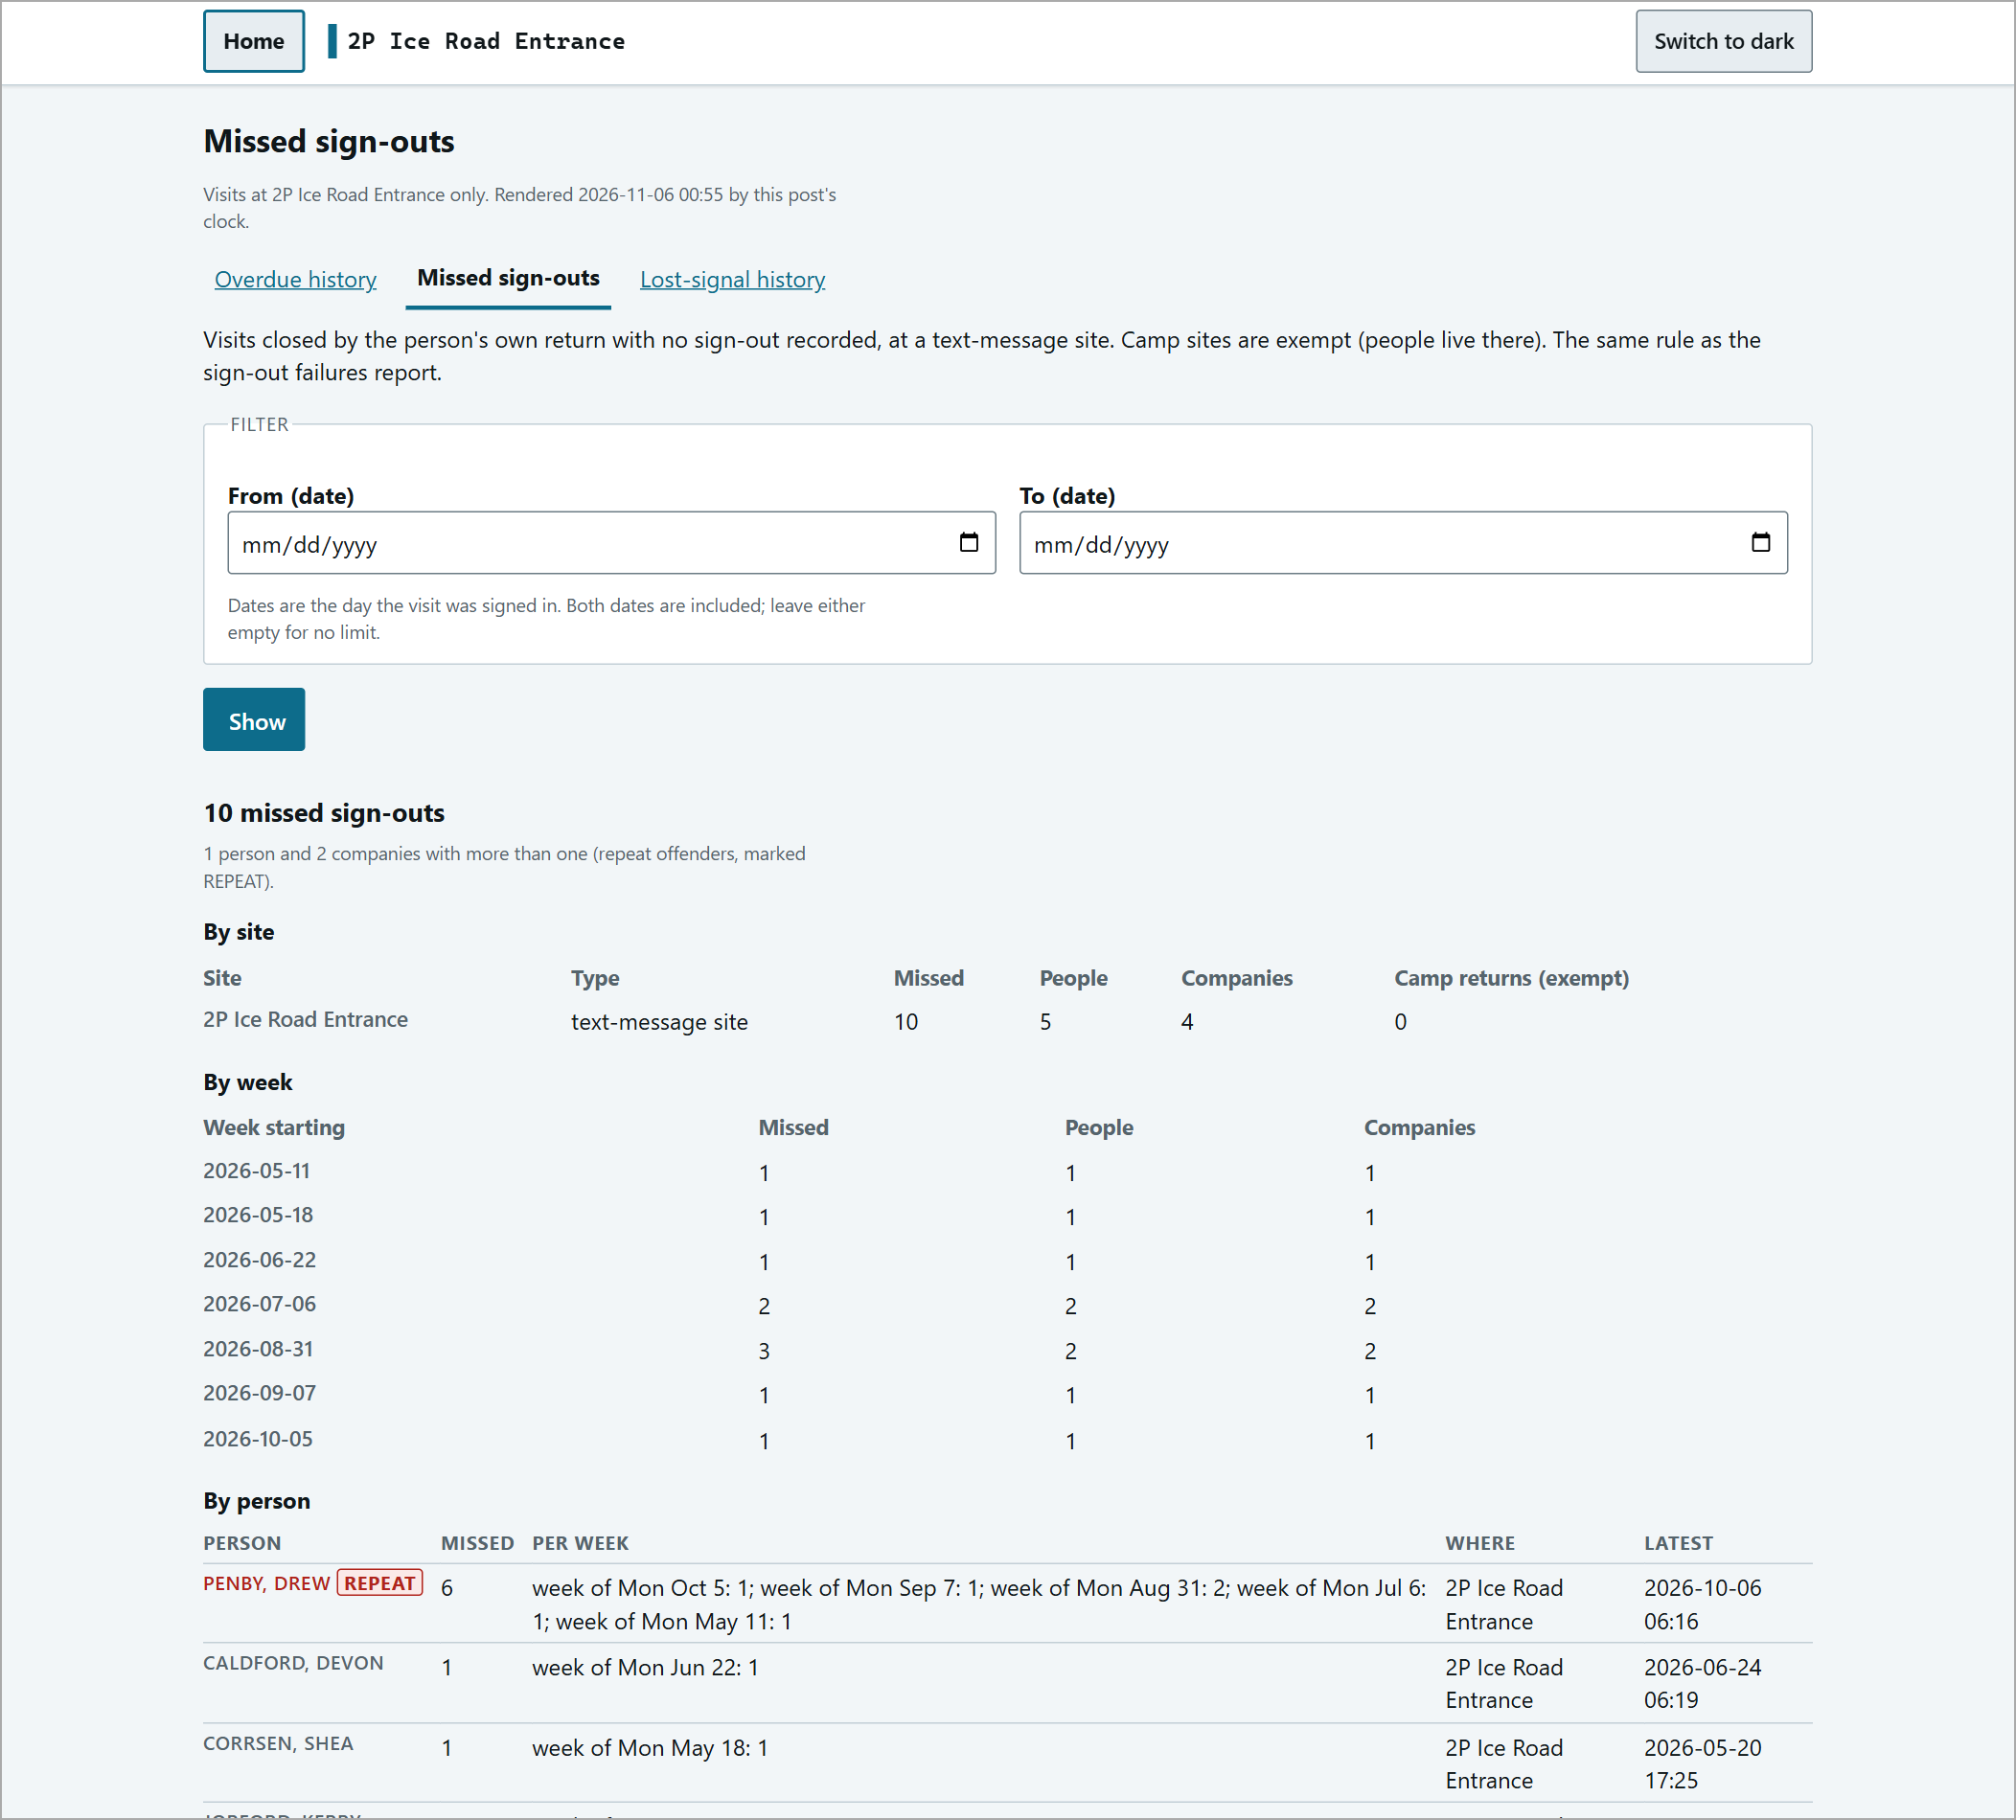  Missed sign-outs.

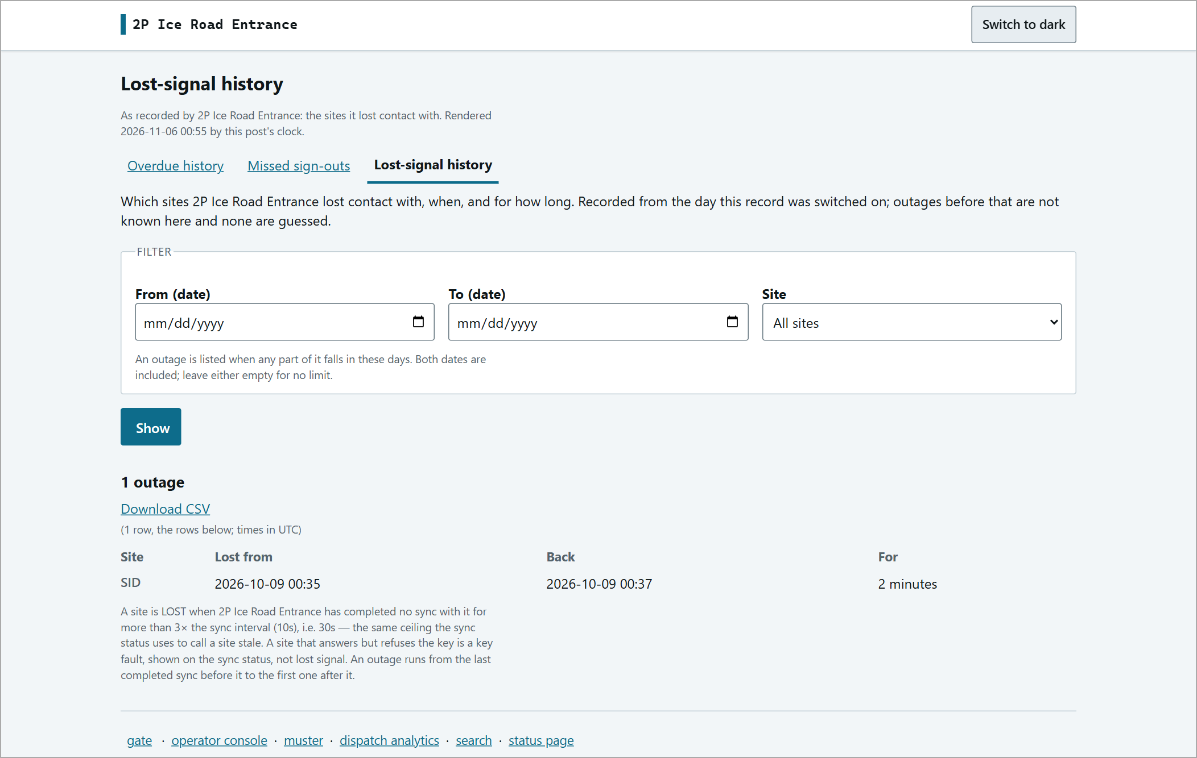
Lost-signal history.
Troubleshooting
Situation | What to do
"a trip with a destination requires a deadline" | Click Deadline: not set (change) and enter the travel minutes. It is never filled in for you.
Pressed CHECK IN / Confirm and nothing seemed to happen | Success is silent. Check the On site now list and the shift counters.
"...a company is required..." (mentions Passenger 1) | Pick a company, or choose "not listed" and type it. "Passenger 1" is normal on the individual screen.
Check in all ... button is greyed out | Choose the Driver first.
Someone who arrived was not checked in | Was their box ticked on the trip card? Ticked = left out. Or they lack this post's orientation - see Orientation.
"NOT ENTERED - NO ORIENTATION" | Record their orientation on the orientation page; that checks them in. No override exists.
Red OVERDUE bar | Radio the vehicle / destination, then Acknowledge (logged). The trip stays open until the arrival is recorded.
Red LOST SIGNAL banner | Keep working. Verify other posts by radio. Entries sync when the link returns.
A name appears twice on the muster | Deliberate. Treat the person as present and account for the other place by radio.
Times look different on the muster | The muster and history show UTC; the gate shows the post's local time.
Entered someone by mistake | Tick them > Remove - no departure.
Wrong details on a person or trip | Edit person or correct this record (uses ids shown on the page).

Quick Reference
Check in | Last name > pick > (company) > CHECK IN > OK > check the list
Check out | Tick > Check out selected > vehicle, driver, destination, deadline minutes > Confirm > OK
Vehicle arrives | Vehicle page: add passengers > driver > Check in all > OK
Expected vehicle | Vehicle page > open the row > Check in (N)
Arrival on console | Leave arrivals unticked > Arrived - check in occupants
Overdue | Radio > Acknowledge (logged)
Orientation | Orientation page > tick COMPLETED > Record the ticked completions
EMERGENCY | muster > Print this muster > Print
Find anything | search > any field > Search
Lost signal | Keep working; verify other posts by radio

Log out at the end of your shift.

Supervisor contact: ________________________________

