SITECONTROL
Administrator Guide

Installing posts, creating and retiring sites, configuration, passwords and keys,
backups, restores, upgrades and health checks.

For IT / administrators - not for gate officers. Written against the deployed sitectl build of 2026-10-08.
Contents
Section | Covers | Page
About This Guide | Who it is for, how to read the TESTED marks | 3
How It Fits Together | Posts, the mesh, the front door | 4
The sitectl Command | Service flags and the admin command set | 5
site.toml Reference | Every setting and what it accepts | 6
Installing a Post | Linux / systemd install, first start | 8
Creating New Sites | A whole new season, or one more post | 10
Retiring a Site | Removing a post from the mesh | 12
Passwords and Keys | Changing the site password, peer keys | 13
Backups and Restore | Nightly copies, manual copies, restoring | 14
Replacing or Upgrading | Laptop swap, new binary | 16
Season End and Start | Shutting down and coming back up | 17
Health Checks | Is it up, is it in sync, what the logs mean | 18
Windows Install | Running a post as a Windows service | 19
Known Gaps | What is not yet documented or tested | 20
Admin Quick Reference | One-page summary | 21

About This Guide
This guide is for whoever installs and looks after SiteControl: setting up the computer at each post, creating a new site, taking an old one out of service, changing passwords, and keeping backups. Gate officers use the Site Operator Guide; dispatch uses the Dispatch Guide.
TESTED marks
Every procedure carries one of these:
TESTED the steps were run end to end on a test copy of SiteControl and worked as written.
NOT YET TESTED the steps come from the program's own help text and the live installation, but have not been run start to finish. Do them carefully the first time and confirm each result.
Secrets. Each post's site.toml holds its login password and every peer key. Never email it, print it, or paste it into a chat. In this guide secrets are shown as placeholders: <SITE_PASSWORD>, <PEER_KEY>, <PROXY_TOKEN>.

To look at a site.toml safely, show the key names only, or mask the secret lines:
grep -o '^ *[A-Za-z_.]*' site.toml
sed -E 's/^( *(peer_key|key|login_password|proxy_auth_token) *=).*/\1 <masked>/' site.toml

How It Fits Together
1 | One program per post. Each gate (post) runs its own copy of sitectl with its own site.toml and its own SQLite database. A post works fully on its own - no internet needed to record anything.
2 | The mesh. Every post lists every other post as a peer and pulls their records every few seconds (sync_interval_seconds, normally 10). Each pair shares a key. When the link drops, posts carry on and catch up later.
3 | Records are never overwritten. Every check-in, departure and correction is an event added to a log. Corrections add to the record; nothing is erased.
4 | The front door (only where posts are reached through a browser from outside): a web proxy (Caddy) per host, then a Cloudflare tunnel and a hostname per post.

The current demo installation
Host | A single Linux container on the demo host
Program | /opt/sitectl/sitectl - older copies kept beside it as sitectl.pre-YYYYMMDD-HHMM
Posts | One folder each under /opt/sitectl/<name>/ - iceroad :8081, pad :8082, npf :8083, ndb :8084, sid :8085 (all 127.0.0.1)
Note | The folder / service name is not always the site_id: folder pad runs site_id ice-pad; iceroad runs ice-road.
Service | systemd template sitectl@.service - one instance per folder (sitectl@pad, ...)
Front door | Caddy on :80 (/etc/caddy/Caddyfile) -> Cloudflare tunnel -> sc-<name>.jnkfacey.com; landing page sc-demo.jnkfacey.com
Helpers | /root/sc-converge.py (wait for all posts to agree), /root/demoseed/ (demo data)

The service unit
[Service]
User=sitectl
WorkingDirectory=/opt/sitectl/%i
ExecStart=/opt/sitectl/sitectl -config /opt/sitectl/%i/site.toml
Restart=on-failure
RestartSec=2
[Unit] After=network-online.target Wants=network-online.target
[Install] WantedBy=multi-user.target

The sitectl Command
TESTED every flag below was run.
Service and maintenance flags
Flag | What it does
-config FILE | The post's site.toml. Required for everything. On its own: run the post (what systemd does).
-backup DIR | Make one verified backup copy into DIR and exit. Safe while running. Keeps the 7 newest in DIR.
-restore FILE | Replace this post's database with a backup and exit. Refuses while the post is running.
-dump | Print the post's full state as JSON - compare two posts to prove they agree.
-report visits | CSV of every visit and time on site (read-only).
-report signout-failures | CSV of missed sign-outs (read-only).
-h | Help. There is no -version flag - identify a build by file size / sha256sum.

Admin commands (run by IT, never by the service)
sitectl admin season -plan site-plan.toml -out DIR # build a whole new mesh
sitectl admin check a/site.toml b/site.toml ... # prove config files agree
sitectl admin site add -config LIVE.toml -self-url URL -new new-post.toml -out DIR
sitectl admin peer apply -config site.toml join-<id>.toml # at each existing post
sitectl admin site retire -config site.toml -out DIR # at the post leaving
sitectl admin peer remove -config site.toml leave-<id>.toml # at each remaining post
sitectl admin swap plan -config site.toml [-old-url URL] [-from-backup FILE]
sitectl admin swap status -config site.toml [-wait 30m] # READY check

Common admin options: -db FILE (the database, if it is not beside site.toml) and -out DIR (must be new or empty). The admin tools never print passwords or keys; keys are named by fingerprint (fp:xxxxxxxx).
Gotcha (tested): the running service finds a relative db_path from its working folder; the admin tools look beside site.toml. They agree under systemd (the working folder is the post's folder). If you ever run the program by hand from elsewhere, pass -db to the admin tools or use an absolute db_path.

site.toml Reference
The loader is strict: an unknown key or a wrong type stops the post from starting, and the error names the key. Top-level settings must come before the first [[table]].
TESTED each rule was produced by running the program against a bad file.
Setting | Meaning / allowed values
site_id | Permanent short name, e.g. "ice-pad". Never reuse a retired id.
display_name | Name shown on every page.
listen_addr | "host:port" - e.g. "127.0.0.1:8082" behind a proxy. A port on its own is refused.
db_path | The SQLite file. Use an absolute path on Windows.
node_epoch | Whole number, 1 or more. Set at provisioning; raised by swap plan after a restore or machine swap. Never lower it.
peer_key | The key this post accepts from peers calling it (64 hex characters).
login_password | The one site password officers type (required). No usernames.
login_hint | Optional text on the login page.
proxy_auth_token | Shared secret the proxy sends in the X-SC-Proxy-Auth header. Only allowed with a loopback listen_addr.
dev_routes | true/false. Must be false on anything reachable from outside.
orientation | true at a work site that gives its own orientation; false at a road post.
site_type | "camp" (people live there; returning without signing out is normal) or "text_message" (per-visit sign in/out).
muster_min_group_size | Crews smaller than this are pooled into the muster's Summary group (generated default 5).
sync_interval_seconds | How often to pull from peers (generated 10). A peer is STALE / LOST SIGNAL after 3x this.
shift_starts | e.g. ["06:00","18:00"] - the gate's shift counters reset at these times. Unset = 06:00 and 18:00.
theme_cookie_domain | Optional, e.g. ".jnkfacey.com", so light/dark mode follows across posts.
backup_dir | Folder for nightly copies. Unset = "backups".
backup_mirror_dir | Optional second folder (another disk / USB) - every nightly copy is written to both.
backup_time | "HH:MM" local time for the nightly copy. Unset = about 03:00 (each post runs a few minutes apart).

Tables
[[peers]] # one per OTHER post
site_id = "ice-road"
display_name = "2P Ice Road Entrance"
long_name = "..." # optional
base_url = "http://127.0.0.1:8081" # how THIS post reaches that post
key = "<PEER_KEY>" # that post's peer_key

[[destinations]] # where this post may dispatch vehicles
id = "ice-road" # a peer's site_id
display_name = "2P Ice Road Entrance"
controlled = true # true = a gate at that end, the run is timed
travel_minutes = 65 # one number, same both ways; prefills the deadline

[[former_peers]] # written by 'admin peer remove' for a retired post
site_id = "gamma"
display_name = "Gamma Gate"

Mesh rule | For every pair A and B: A's [[peers]] entry for B carries B's peer_key, and the other way round; every base_url agrees. admin check proves this.
destinations | With two or more peers the list must be written out explicitly (destinations = [] if none).
Removed | Weather phases are gone: a [[weather.phase]] table or a per-phase travel_minutes table is refused. travel_minutes is one number.
Not yet documented | entrance_site_id, one_way, road_work, road_work_label, limit_minutes, ungated - present in the program, meaning not confirmed. Leave them as generated.

Installing a Post
NOT YET TESTED the program and its config were tested; the systemd and proxy steps follow the live installation.
1 | Once per host - install the program, a service user and the unit:
2 | Get the post's site.toml - from Creating New Sites (a new season or one more post).
3 | Put it in place (owner sitectl, mode 0640 - the file holds secrets):
4 | Start it: systemctl enable --now sitectl@<name>
5 | Check it (next page).

# step 1
useradd --system --home /opt/sitectl sitectl
install -o sitectl -g sitectl -m 0755 sitectl /opt/sitectl/sitectl
cp sitectl@.service /etc/systemd/system/ && systemctl daemon-reload

# step 3
install -d -o sitectl -g sitectl -m 0750 /opt/sitectl/<name>
install -o sitectl -g sitectl -m 0640 site.toml /opt/sitectl/<name>/site.toml

# step 4
systemctl enable --now sitectl@<name>

Front door (only if the post is reached from outside)
http://sc-<name>.jnkfacey.com {
import common
import gate
reverse_proxy 127.0.0.1:<port> {
header_up X-SC-Proxy-Auth "<PROXY_TOKEN>" # must equal the post's proxy_auth_token
}
}
# then:
caddy validate --config /etc/caddy/Caddyfile && systemctl reload caddy

Then add sc-<name>.jnkfacey.com to the Cloudflare tunnel (pointing at the Caddy host on port 80) with its DNS record. The tunnel's hostnames are managed in the Cloudflare dashboard, not in a config file - see Known Gaps.
First start - what you should see
TESTED
Journal | journalctl -u sitectl@<name> -n 20 shows "site=<id> epoch=1 ... listening on <addr> (sync every 10s, N peer(s))" and the next backup time.
Peers not up yet | "REJOIN ... FAILED" and "PEER UNREACHABLE" are normal while posts start one by one; within 10-20 s "PEER REACHABLE AGAIN" / "SYNC RECOVERED".
Database | Created automatically on first start.
/status page | No login needed: "sitectl is running. Database self-created and answering.", backup state, site id, epoch, peers and sync state.
Login | One field, Site password, then Individual / Vehicle check-in. The page then reads "Recording as: <display_name>".
First backup | About 2 minutes after the first start, then nightly.

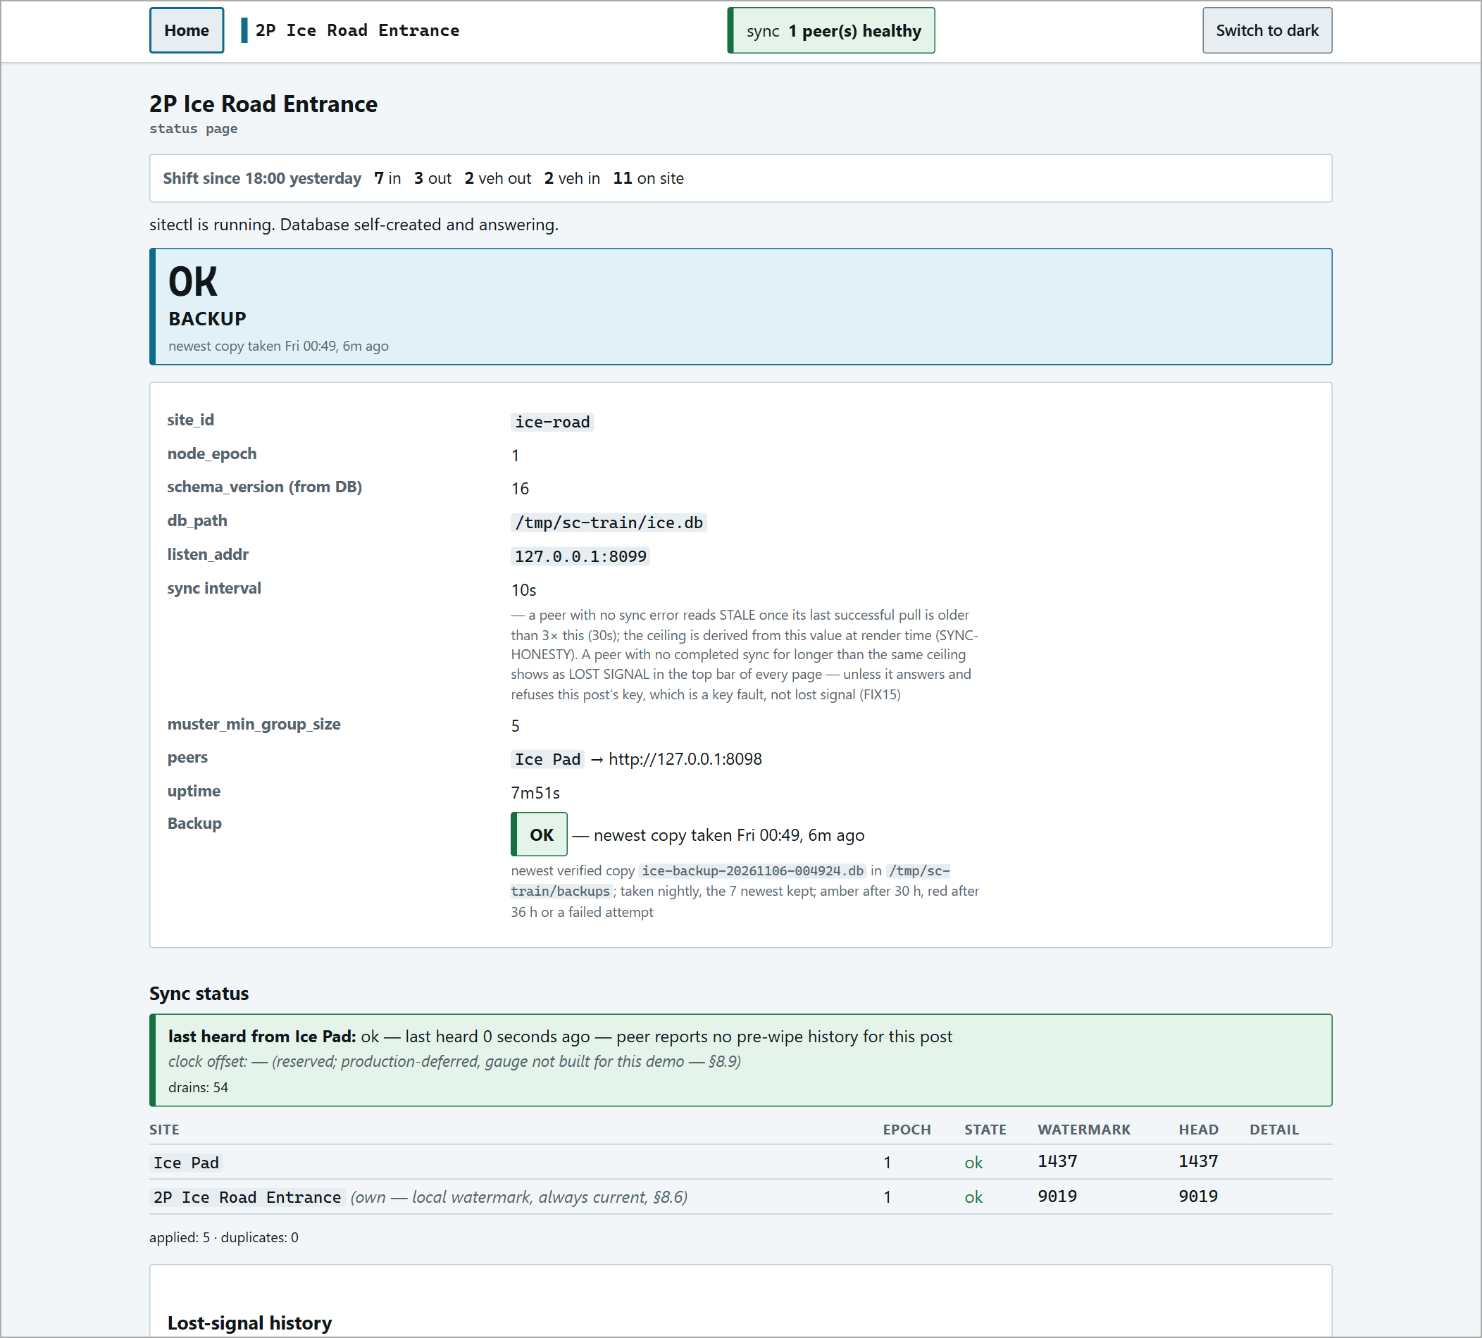
The status page of a running post.
Creating New Sites
A. A whole new set of posts (new season)
TESTED two posts.
1 | Write a plan file listing every post and every road between them:
2 | Run admin season into a new, empty folder.
3 | It writes one <site_id>/site.toml per post, passwords.txt (the officer handover sheet, one password per post) and IT-CHECKLIST.txt (no secrets). If the plan is inconsistent it prints REFUSED - nothing was written and the reasons.
4 | Optionally add backup_dir, backup_time, backup_mirror_dir, proxy_auth_token, theme_cookie_domain or shift_starts to each file (top of the file). Not generated for you.
5 | Install each post (Installing a Post), start them all, then prove the mesh (below). Delete the output folder - it is the only other copy of every key.

# site-plan.toml
[[post]]
site_id = "alpha"
display_name = "Alpha Gate"
listen_addr = "127.0.0.1:8090"
base_url = "http://127.0.0.1:8090"
site_type = "camp" # or "text_message"
orientation = true # required: true at a work site, false at a road post
[[post]]
site_id = "beta"
...
[[route]]
a = "alpha"
b = "beta"
travel_minutes = 60

# run it
sitectl admin season -plan site-plan.toml -out /root/season-out

Expected: one line per post ("accepts fp:..., 1 peer(s), 1 destination(s)"), then "cross-check: every post lists every other, every key held matches the key accepted, every base_url agrees".
Prove the mesh
sitectl admin check alpha/site.toml beta/site.toml ...
# MATCH: every post lists every other, every key held is the key accepted, every address agrees
sitectl admin swap status -config alpha/site.toml
# READY: alpha has its own history back and is in step with every peer (exit code 0)

B. Add one post to a running set
TESTED a third post added to a running pair.
1 | Write new-post.toml with exactly ONE [[post]] (the newcomer) and its [[route]] entries.
2 | On any one existing post (it may stay running), run admin site add. It writes the newcomer's site.toml, one join-<id>.toml (secret - carries the newcomer's key) and passwords-<id>.txt.
3 | At each existing post run admin peer apply with that same join file, then restart that post. The old file is kept as site.toml.bak-<date>.
4 | Install and start the new post. Check: swap status on the new post says READY; /status on every post shows the newcomer in sync.
5 | Add the new post to the proxy and tunnel, and make sure the other posts can reach its base_url (firewall).

sitectl admin site add -config /opt/sitectl/<existing>/site.toml \
-self-url http://<how the other posts reach this existing post> \
-new new-post.toml -out /root/add-out

# at EACH existing post:
sitectl admin peer apply -config /opt/sitectl/<existing>/site.toml join-gamma.toml
systemctl restart sitectl@<existing>

Expected at peer apply: "added peer gamma ...", "added destination gamma (gated, 45 min)" at the post named in the route. Running it twice is refused ("gamma is already a peer here - nothing to do").
Retiring a Site
TESTED on a post with an empty database - the "someone still on site" refusal was not triggered.
1 | Make sure nobody is on site and no vehicle run is open at that post. The tool checks and refuses otherwise.
2 | Stop the retiring post: systemctl stop sitectl@<name>. (While it runs the tool refuses: "service still answers ... stop the service, then run this again".)
3 | With the other posts running, run admin site retire. It proves every other post already holds all of this post's records, then writes leave-<id>.toml (no secrets).
4 | At each remaining post run admin peer remove with that file, then restart it. The retired post becomes a [[former_peers]] entry so its name stays on old records.
5 | Run admin check on the remaining files - MATCH.
6 | Take and keep a final backup of the retired post's database. Remove its proxy block, tunnel hostname, DNS record and firewall entries. Wipe the machine.

sitectl admin site retire -config /opt/sitectl/<name>/site.toml -out /root/leave-out
# ... holds every record of Gamma Gate
# nobody on site, no open run, every peer holds Gamma Gate's records: Gamma Gate may retire

# at EACH remaining post:
sitectl admin peer remove -config /opt/sitectl/<remaining>/site.toml leave-gamma.toml
# removed peer gamma / removed 1 destination(s) to gamma / kept its name: [[former_peers]]
systemctl restart sitectl@<remaining>

A retired site_id can never come back. Its records stay in every remaining post's history. A post that returns later must use a new site_id (added with Creating New Sites, B).

Passwords and Keys
Site login password
NOT YET TESTED
1 | Edit login_password in the post's site.toml (keep a copy of the old file first: cp site.toml site.toml.bak-<date>).
2 | Restart: systemctl restart sitectl@<name>.
3 | Tell the officers at that post. There is no user list and no web page for passwords - one password per post.

To make one in the same style the tools use (xxxx-xxxx-xxxx-xxxx):
openssl rand -hex 8 | sed 's/..../&-/g;s/-$//'

Peer keys
NOT YET TESTED there is no rekey command.
A peer key must be changed at both ends at once: the accepting post's peer_key and the matching key in the other post's [[peers]] entry. Restart both, then run admin check - MATCH. A mismatch shows on /status as a key fault (the peer "refuses this post's key"), which is different from LOST SIGNAL.
Other settings
backup_time, shift_starts, destinations and so on: edit, restart, and read journalctl -u sitectl@<name> - every config error names the setting. Always keep the previous file.
Backups and Restore
Nightly backups - automatic
TESTED
When | Every night at backup_time (about 03:00; posts are a few minutes apart). First copy ~2 minutes after a fresh start.
How | Online SQLite copy, then verified (integrity check and a hash check of every event). Log: "backup: verified copy <path>".
Kept | The 7 newest copies, named <site_id>-backup-YYYYMMDD-HHMMSS.db, in backup_dir (default "backups").
Second copy | Set backup_mirror_dir to another disk or USB - every copy is written to both.
Check | /status shows "Backup OK - newest copy taken ..., N ago". Investigate if older than a day.

A copy in the same folder as the database dies with that disk - use backup_mirror_dir, and keep copies off the machine.
Manual backup (any time, running or not)
sitectl -config /opt/sitectl/<name>/site.toml -backup /root/manual-bak

Restoring a post's database
TESTED mechanics tested on an empty database.
1 | Stop the post: systemctl stop sitectl@<name>.
2 | Pick the copy from backups/. If the post has been used at all, restore with swap plan -from-backup (it raises node_epoch, which a plain -restore requires).
3 | The database being replaced is kept as <db>.pre-restore-<date>.
4 | Start the post. On start it pulls its own newer records back from its peers before serving.
5 | Wait for READY: sitectl admin swap status -config site.toml -wait 30m.

sitectl admin swap plan -config /opt/sitectl/<name>/site.toml -from-backup backups/<copy>.db
# node_epoch 1 -> 2 (old file kept as site.toml.bak-...)
# next: start the SiteControl service, then run sitectl admin swap status ... until it says READY
systemctl start sitectl@<name>
sitectl admin swap status -config /opt/sitectl/<name>/site.toml -wait 30m

# plain restore - only on a post that has never been used in its current epoch:
sitectl -config /opt/sitectl/<name>/site.toml -restore backups/<copy>.db

swap plan asks the other posts for their highest record of this post; if one does not answer it refuses. Only if that post is truly gone: add -epoch N -unreachable-ok with N above any epoch it could hold.
Replacing or Upgrading
Replacing a post's machine (laptop swap)
NOT YET TESTED
1 | Switch the old machine off or unplug it. (swap plan refuses while the old one still answers.)
2 | On the replacement, with the post's site.toml copied over and before the first start, run swap plan (optionally -from-backup with the newest copy).
3 | Start the service and wait for READY with swap status -wait 30m.

sitectl admin swap plan -config site.toml -old-url http://<old machine>:<port> [-from-backup <copy>]

Upgrading the program
NOT YET TESTED follows how the demo has been upgraded.
1 | Back up every post first (manual -backup, or copy the post folders).
2 | Keep the old program: cp -a /opt/sitectl/sitectl /opt/sitectl/sitectl.pre-$(date +%Y%m%d-%H%M)
3 | Copy the new program in as sitectl.new, then mv it over sitectl.
4 | Restart each post: systemctl restart sitectl@<name>. Check /status and the journal.

No going back after a database upgrade. A newer program may upgrade the database; an older program then refuses it ("schema_version N but this binary requires M - refusing to open"). To roll back, restore the pre-upgrade backup with the old program. Run the same build at every post - compare with sha256sum /opt/sitectl/sitectl.

Season End and Start
NOT YET TESTED assembled from the tools; there is no written season-end procedure yet.
Season end
1 | Take a final backup from every post (-backup) and store it off the machines.
2 | Export what the business needs: -report visits and -report signout-failures (CSV); optionally -dump as an audit copy.
3 | Shut the posts down: systemctl stop sitectl@<name>.

Next season - two choices
Keep the data | Power the posts up with their partners running. The journal shows REJOIN then SYNC RECOVERED; swap status says READY. Check the clock is right first - a clock set back is flagged on the records.
Start clean | Run admin season with a new plan (Creating New Sites, A). New databases start at node_epoch 1. Do not mix new posts with old databases of the same site_id.

Machines that sit unpowered for long periods: see the hardware report for battery, storage and condensation advice before powering up in the cold.
Health Checks
Check | Command | Healthy
Running | systemctl is-active sitectl@<name> | active
Answering | curl -s -o /dev/null -w '%{http_code}' http://127.0.0.1:<port>/status | 200
Sync detail | curl -s http://127.0.0.1:<port>/debug/sync-status | every stream state ok; no key refused; nothing pending
Configs agree | sitectl admin check <all site.toml> | MATCH
Caught up | sitectl admin swap status -config site.toml | READY (exit 0)
Posts agree | sitectl -config site.toml -dump (on two posts, compare) | identical
Backup fresh | /status - Backup row | newest copy under 24 h old

Log messages
Message | Meaning
PEER UNREACHABLE | The other post is down, firewalled, or its base_url is wrong.
REJOIN ... FAILED | Normal at start-up while peers come up. If it persists, a peer is unreachable.
PEER REACHABLE AGAIN / SYNC RECOVERED | Good - the link is back.
schema_version N but this binary requires M | Program and database versions do not match - see Upgrading.
sitectl: config FILE: ... | A setting is wrong; the post will not start (systemd retries every 2 s). The message names the setting.
bind: address already in use | Another program holds the port.
backup: SECOND COPY FAILED | backup_mirror_dir is not writable. The main copy is fine.

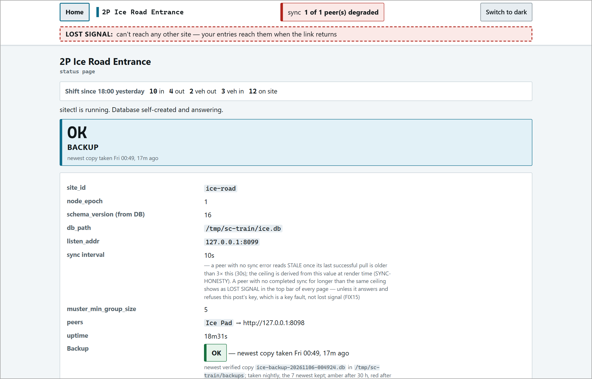
/status while a post has lost contact with its peers.
Windows Install
NOT YET TESTED from the September installer script; the October installer was not available.
1 | Run the installer (deploy\windows\install-service.ps1) from an elevated PowerShell. It copies sitectl.exe to C:\Program Files\SiteControl\, creates C:\ProgramData\SiteControl\ (Administrators + the service only), and registers the SiteControl service (virtual account, automatic start, restart on failure). Re-running it replaces the program or config.
2 | Put the post's config in C:\ProgramData\SiteControl\. Check the file name the service expects: the September script uses config.toml, the newer checklist says site.toml - match the service's -config path.
3 | Set db_path to an absolute path, e.g. C:\ProgramData\SiteControl\site.db (a service has no fixed working folder).
4 | Firewall: allow the post's listen port inbound only from the other posts' addresses (listed in IT-CHECKLIST.txt).

Uninstall with deploy\windows\uninstall-service.ps1.
Known Gaps
Things this guide could not yet confirm. Check them before relying on them in production:
Cloudflare hostnames | How sc-<name>.jnkfacey.com is added to the tunnel - managed in the Cloudflare dashboard, not written up.
Some settings | entrance_site_id, one_way, road_work, road_work_label, limit_minutes, ungated, login_hint: present in the program, meaning not confirmed.
Rekey | No command to change a peer key; manual both-ends edit, untested.
Windows | The current installer and its config file name (config.toml vs site.toml).
Real sites | How posts reach each other across separate Starlink links in production (a private VPN link is expected; not designed yet).
Real data | Retire, restore and swap were tested on empty databases; the refusals for people on site / open runs were not triggered.
Passwords | Whether a minimum password length is enforced.
Source | The program's source repository is not on this laptop; this guide follows the deployed 2026-10-08 build.

Admin Quick Reference
New season | admin season -plan site-plan.toml -out DIR > install each > admin check > swap status
Add a post | admin site add (on one post) > peer apply + restart (each existing post) > install new post
Retire a post | nobody on site > stop it > admin site retire > peer remove + restart (each remaining) > admin check
Change password | edit login_password > restart > tell the officers
Manual backup | sitectl -config site.toml -backup DIR
Restore | stop > admin swap plan -from-backup COPY > start > swap status -wait 30m
Upgrade | backup > keep sitectl.pre-<date> > replace > restart each post
Is it healthy | /status 200 > /debug/sync-status ok > admin check MATCH
Logs | journalctl -u sitectl@<name> -n 50
Never | email or print site.toml; reuse a retired site_id; lower node_epoch

