SITECONTROL
Dispatch Guide

Sending vehicles between posts, following them on the road, recording arrivals,
handling overdue alerts, and the trip records.

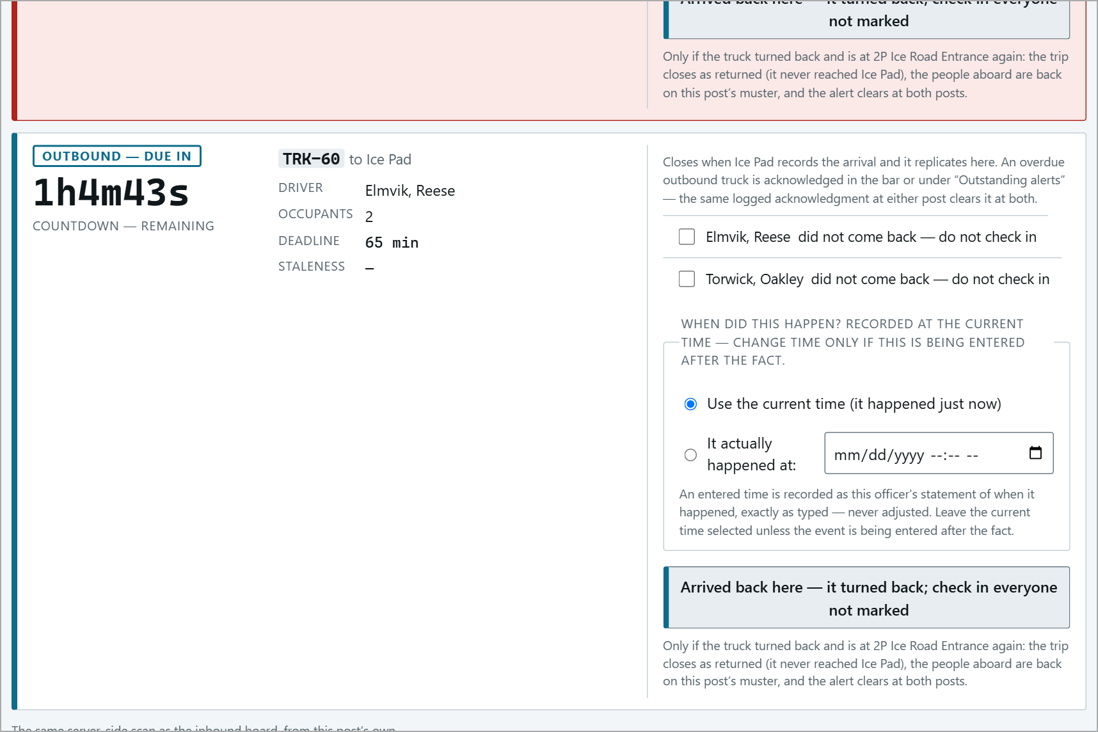

All names in this guide are sample data. Screens are from the 2P Ice Road Entrance and Ice Pad posts; every post uses the same screens. "Winter Camp (no gate)" is an example uncontrolled destination added for the screenshots.
Contents
Section | Covers | Page
How Dispatch Works | Trips, deadlines, the three kinds of destination | 3
The Operator Console | The trip board and its sections | 4
Sending a Vehicle | From the gate, or from the console | 5
Uncontrolled Destinations | Pads with no gate and no timer | 9
Working on the Road | Equipment out on the road itself | 11
Following a Trip | Countdowns, both ends of the trip, staleness | 13
Recording Arrivals | Expected, unlisted, turned back, back from the road | 14
Overdue Vehicles | The red bar, acknowledging, overdue history | 18
When the Signal Is Lost | What changes on the board | 21
The Muster and Dispatch | On the road, working, away - who is responsible | 23
Trip Records and Corrections | All trips & drivers, record chain, fixing a trip | 25
Reports and Analytics | Dispatch analytics, history reports | 28
Troubleshooting | Things that catch people out | 30
Quick Reference | One-page summary | 31

Checking people in and out at the gate is covered in the Site Operator Guide; installing and setting up posts in the Administrator Guide.
How Dispatch Works
Every vehicle that leaves a post with people aboard is a trip. The trip records the vehicle, the driver, everyone aboard, where it is going, and how long it should take (the deadline, in minutes).
1 | A post dispatches the vehicle - its people leave that post's muster and are shown as On the road.
2 | Both posts see the trip with a countdown: the sending post as Outbound, the receiving post as Inbound.
3 | When the vehicle arrives, the receiving post records the arrival - the people go onto its muster and the trip closes at both posts.
4 | If the deadline passes first, both posts get a red OVERDUE alert until someone acts on it.

Three kinds of destination
Controlled (a gated post) | e.g. Ice Pad. Deadline required, countdown runs, overdue alert if late. Closed by the arrival at the other end.
Uncontrolled (a pad with no gate) | e.g. Winter Camp (no gate). No deadline is allowed, no timer, no alarm. Closed when the people return.
Working on the road | Equipment out on the road itself (graders, plows). No destination; overdue after the post's working limit (e.g. 12 h).

Records are never deleted. Trips are not cancelled - a vehicle that turns back is recorded as turned back, and a return journey is a new trip. Corrections are added to the record; the original stays.

The Operator Console
Open operator console from the links at the bottom of any page. From top to bottom:
Needs a human | Anything waiting for review, and how many alerts are outstanding.
Inbound | Vehicles on their way TO this post, most urgent first, with countdowns.
Outbound | Vehicles that left THIS post and have not yet been recorded as arrived.
Working on the road | This post's equipment out working on the road.
Back from a pad | People out at uncontrolled destinations, waiting to return.
Outstanding alerts | Every overdue trip, with the Acknowledge button.
A vehicle is leaving | The dispatch form.
A vehicle has arrived | For a vehicle nobody told this post about.

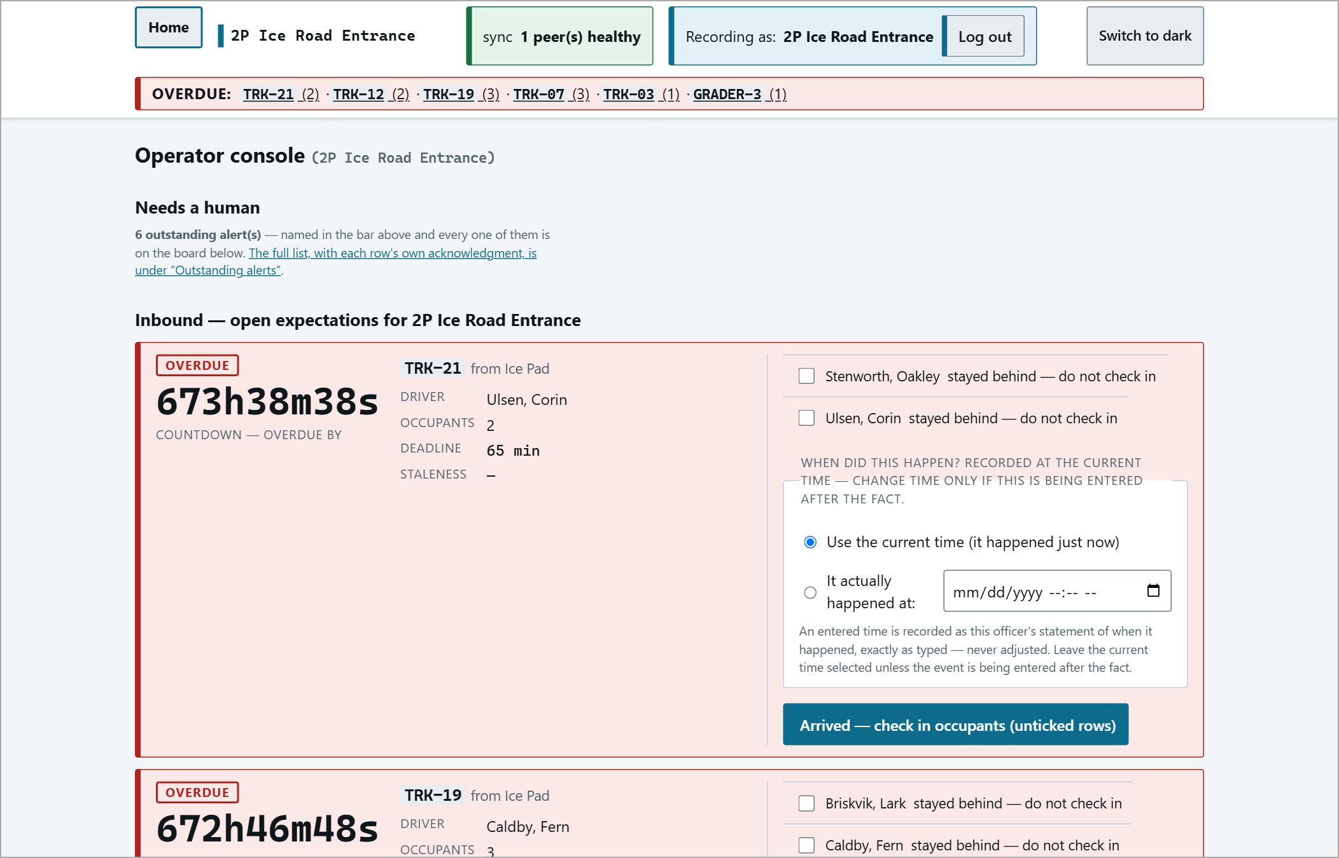
The top of the operator console.
Sending a Vehicle
From the gate (Check out selected)
When the gate checks people out, that is a dispatch: tick the people, Check out selected, then vehicle, driver, Where is it going? and the Deadline in minutes. The gate never fills in the deadline - leaving it blank gives "Nothing was recorded. a trip with a destination requires a deadline...". (Full steps in the Site Operator Guide.)
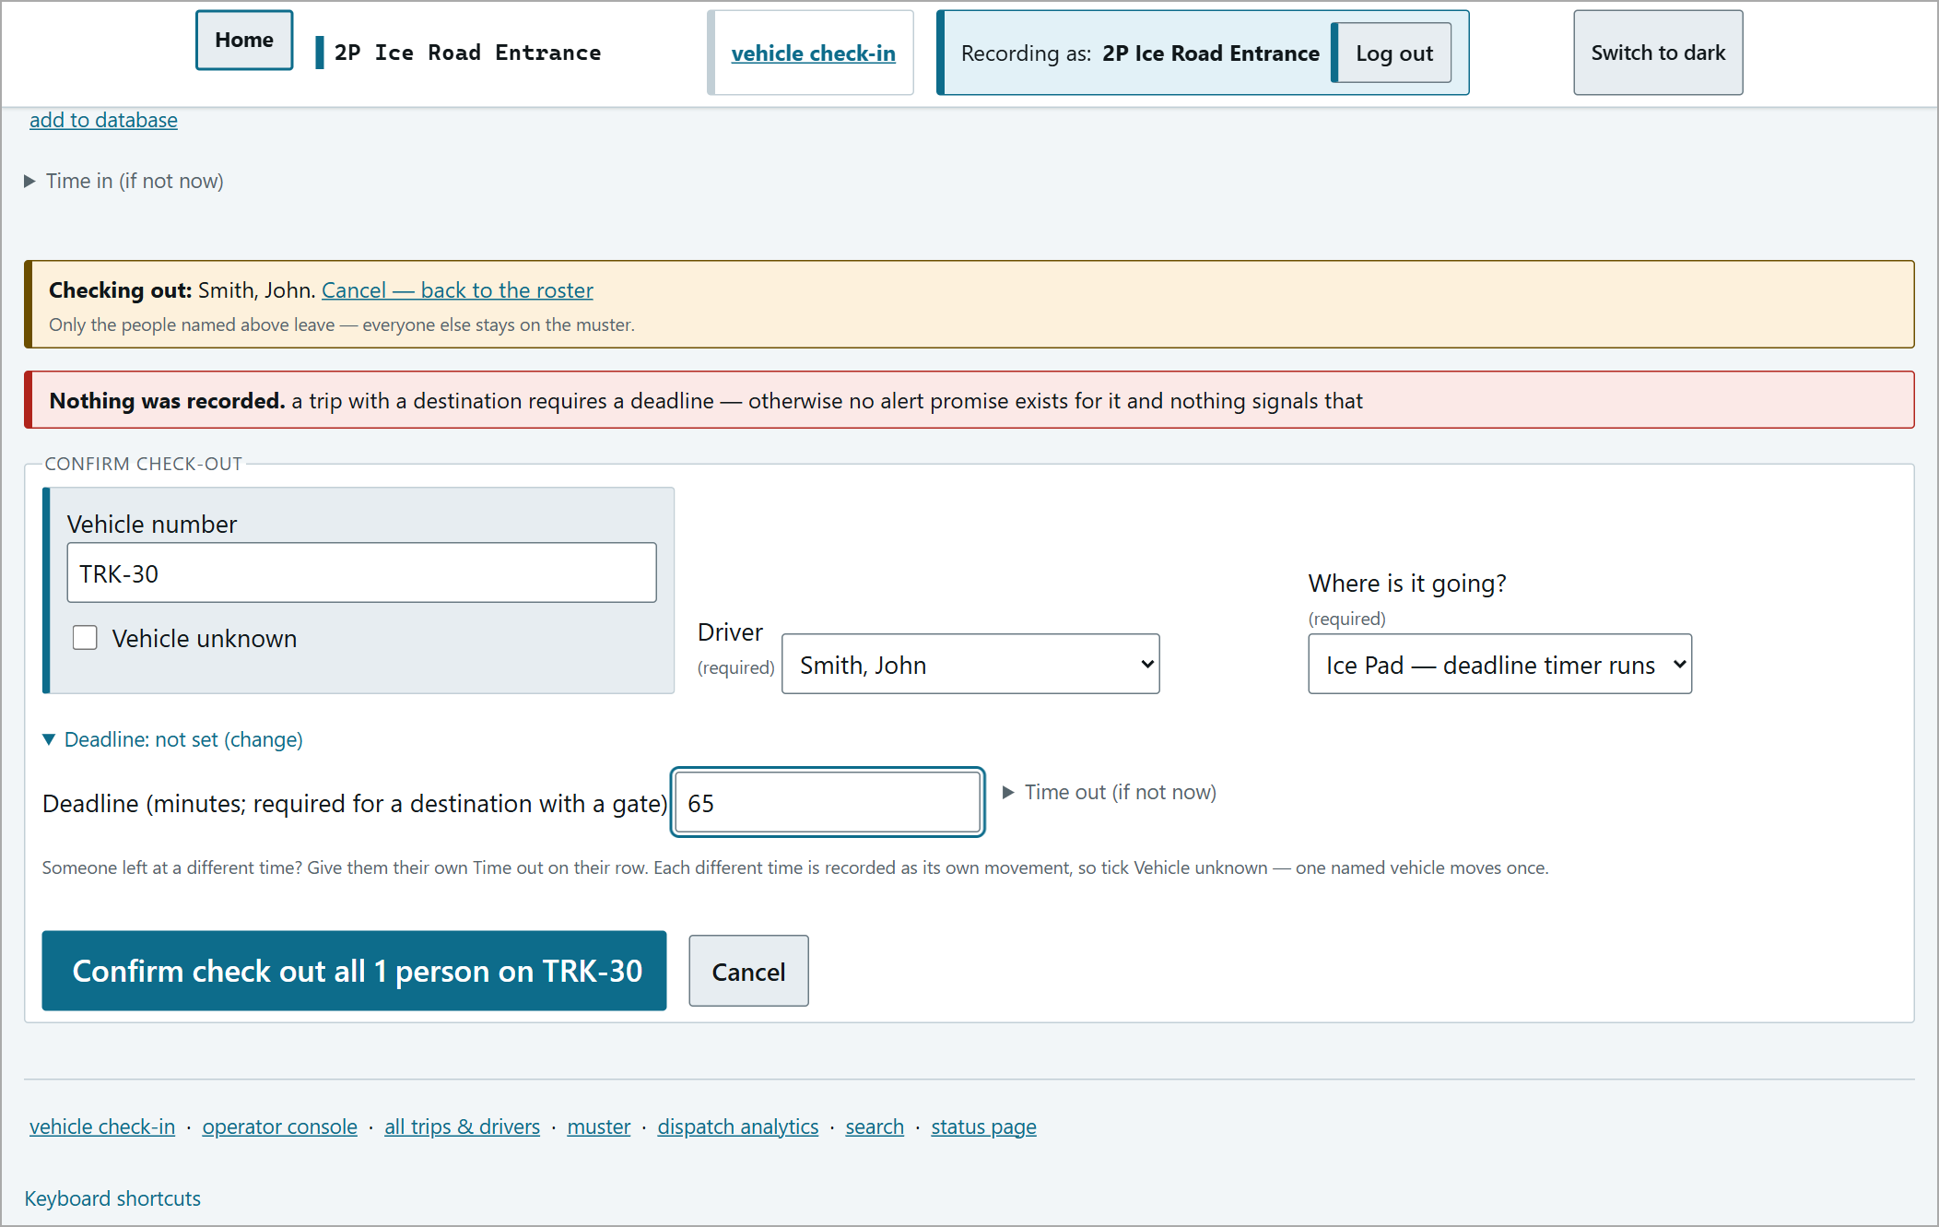
Check-out from the gate with a 65-minute deadline.
From the console (A vehicle is leaving)
The console form does the same job and adds the uncontrolled and working-on-the-road options. Steps on the next page.
1 | Vehicle id - as painted on the vehicle. If you genuinely don't know it, tick Vehicle unknown instead.
2 | Driver - pick exactly one. Nobody is pre-selected, on purpose. Only people recorded on site here are listed - check someone in at the gate first if they are missing.
3 | Other occupants - tick everyone aboard, including the driver again. Anyone left unticked stays on this post's muster.
4 | Deadline (minutes) - for a gated destination. If left empty, the destination's normal time is used (e.g. 65 min to Ice Pad). Leave it EMPTY for an uncontrolled destination.
5 | Press the destination button: "Dispatch to Ice Pad - deadline timer runs (65 min)", "Record run to <pad> - no gate there, no timer", or "Working on the ice road - ... overdue after 12 h".
6 | Check the pop-up - "About to check out of this site - N person(s): <names> - Is that everyone, and only them?" - and press OK.

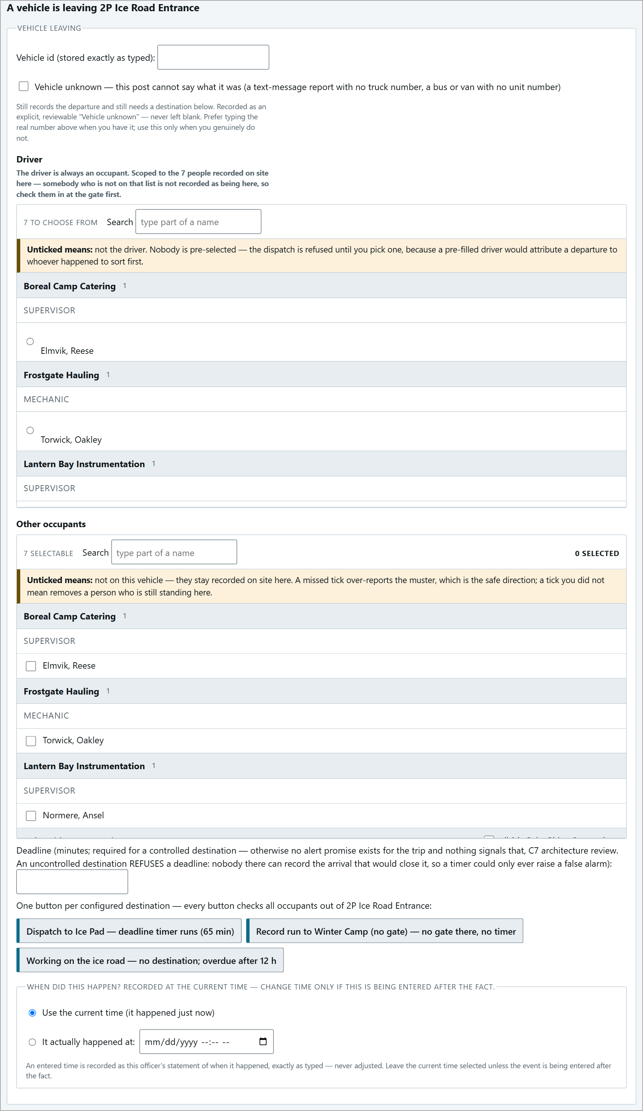  The empty form. | 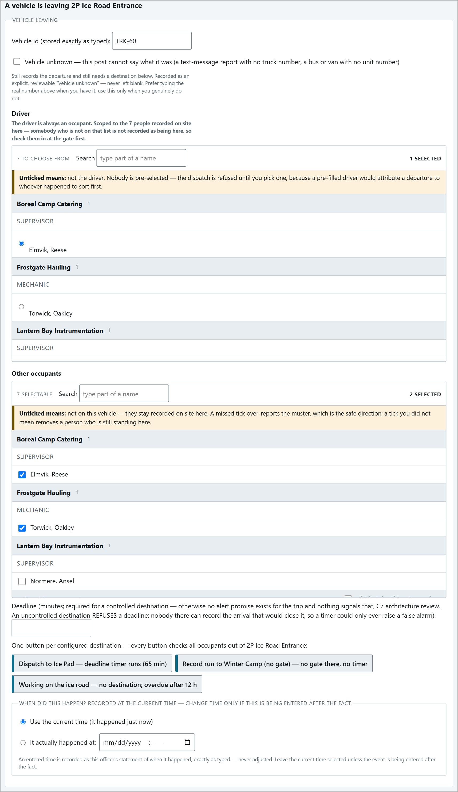  Filled in: TRK-60, driver and occupants ticked.

The result
There is no message. The page reloads and the new trip appears at the bottom of Outbound with its countdown. The people are gone from the on-site list.
OUTBOUND - DUE IN 1h4m43s: TRK-60 to Ice Pad, 2 occupants, 65 min deadline.
Vehicle unknown
Use it only when the vehicle really cannot be identified (e.g. a text-message report with no truck number). The trip shows as "Vehicle unknown" everywhere, and cannot be matched automatically on arrival.
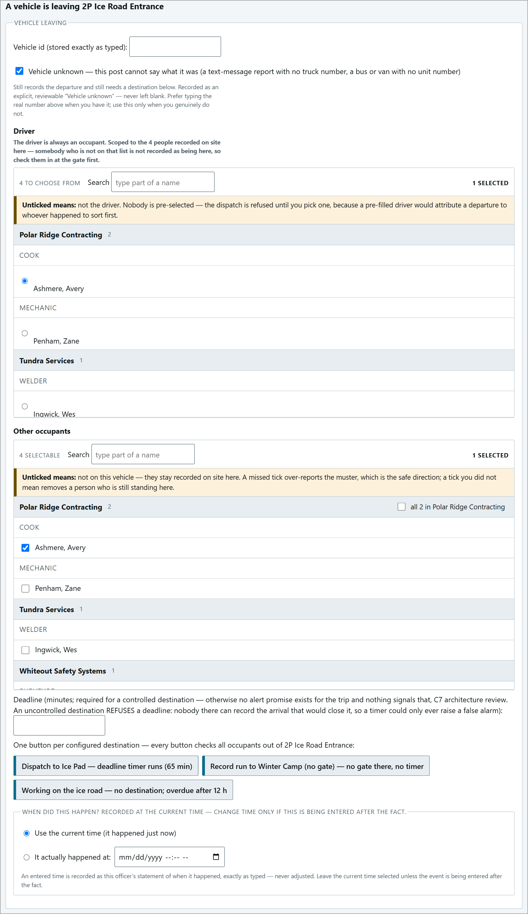  Vehicle unknown ticked. | 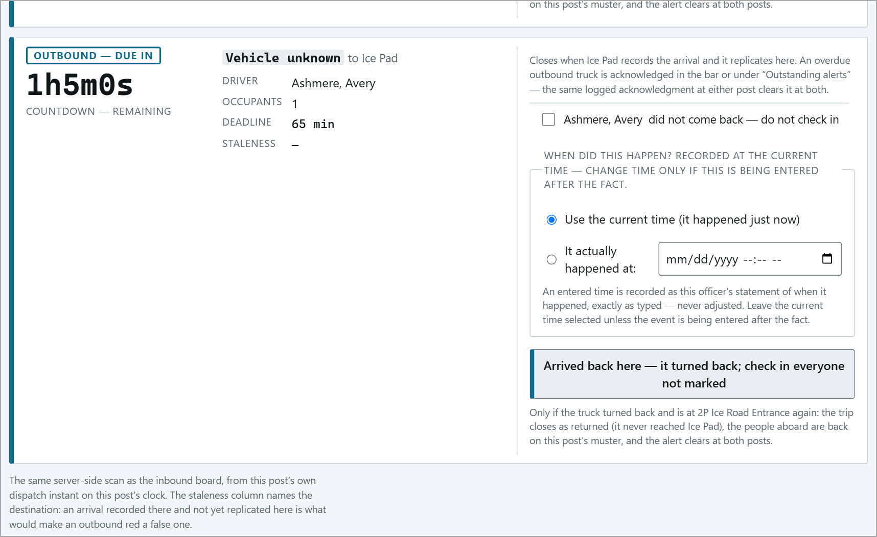  The resulting card.

Uncontrolled Destinations
A pad with no gate: nobody there can record an arrival, so there is no deadline, no countdown and no alarm. Use the button "Record run to <pad> - no gate there, no timer" with the Deadline box empty.
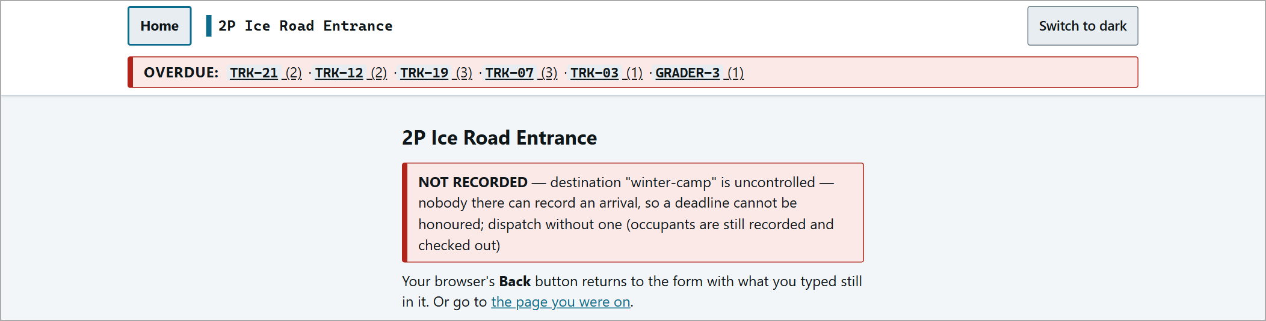
Typing a deadline is refused: "NOT RECORDED - destination ... is uncontrolled ... dispatch without one". Use Back and clear the deadline.
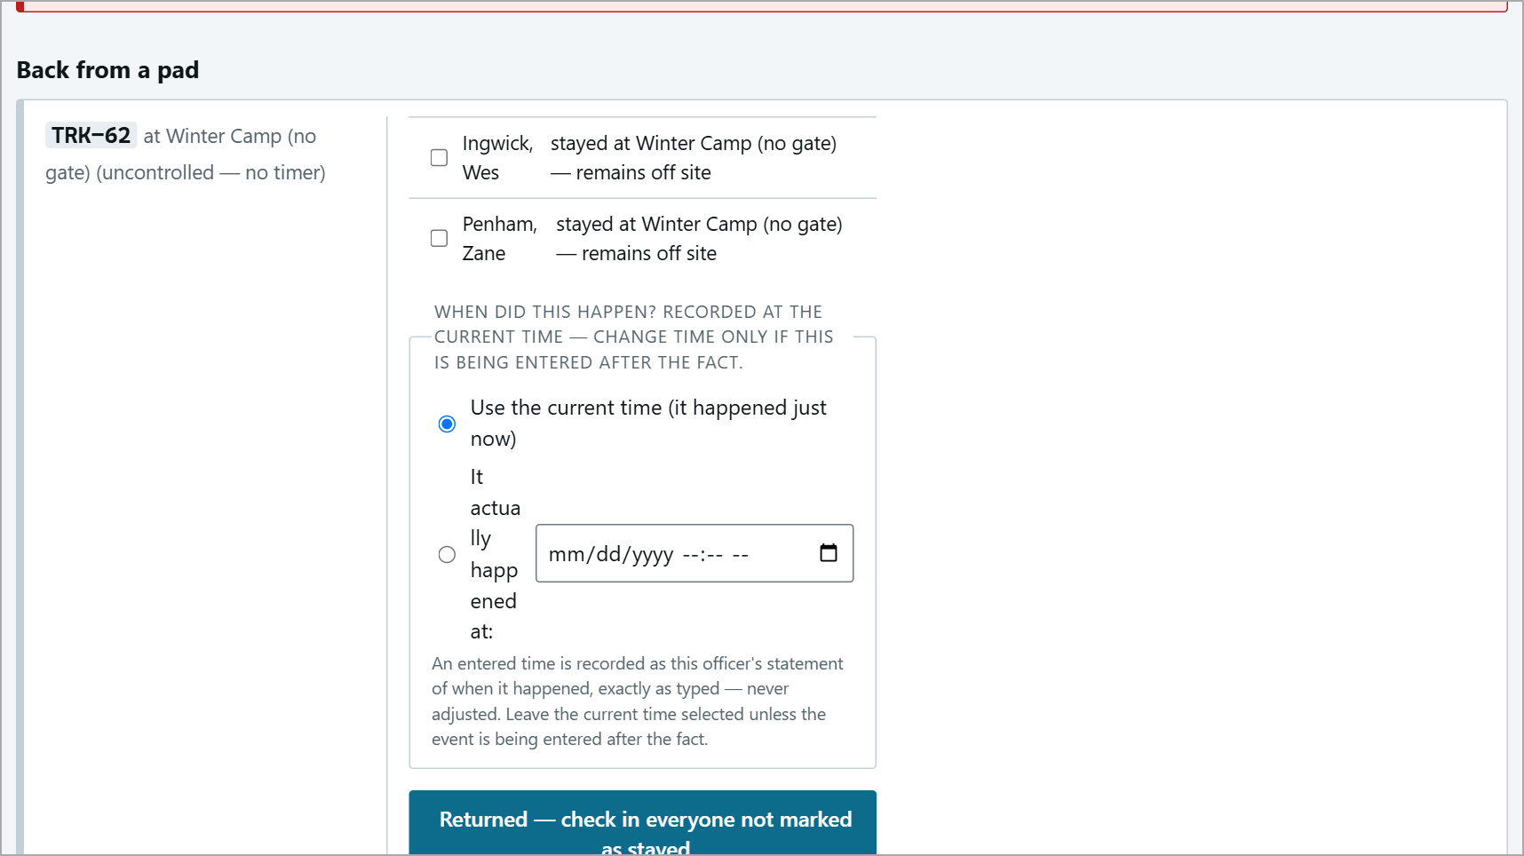
The run waits under "Back from a pad" until the people return.
When they come back
On the card, press Returned - check in everyone not marked as stayed. Tick anyone who stayed at the pad - they remain off site. (People back from a pad can also simply be checked in at the gate on any vehicle.)
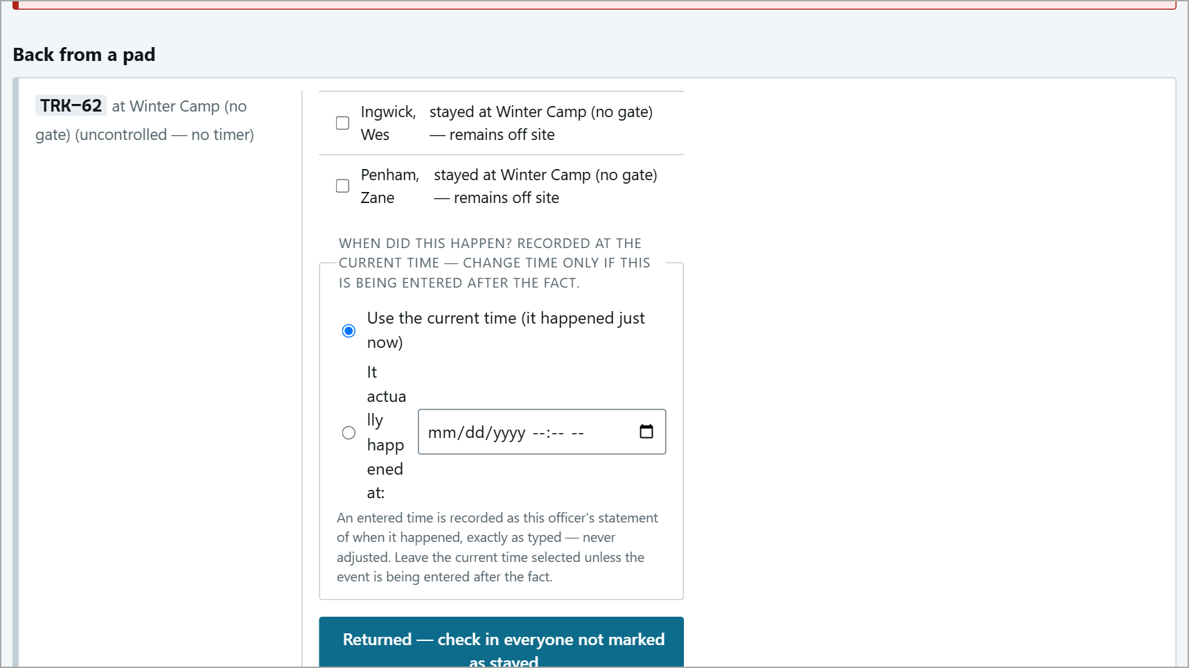  Before: the Back from a pad card. | 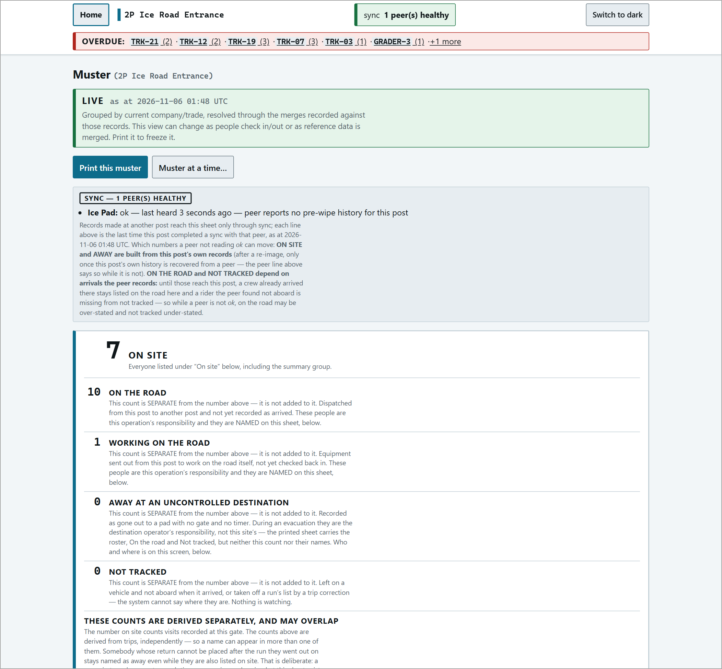  After: back on the muster.

Not on the printed muster. People away at an uncontrolled destination are counted on screen as "AWAY AT AN UNCONTROLLED DESTINATION" but are not named on the printed sheet - during an evacuation they are the destination operator's responsibility. Check them on screen or by radio.

Working on the Road
For equipment working on the road itself (graders, plows, maintenance crews) with no destination post. Use the button "Working on the ice road - no destination; overdue after 12 h". No deadline is entered - the post's working limit (here 12 h) applies.
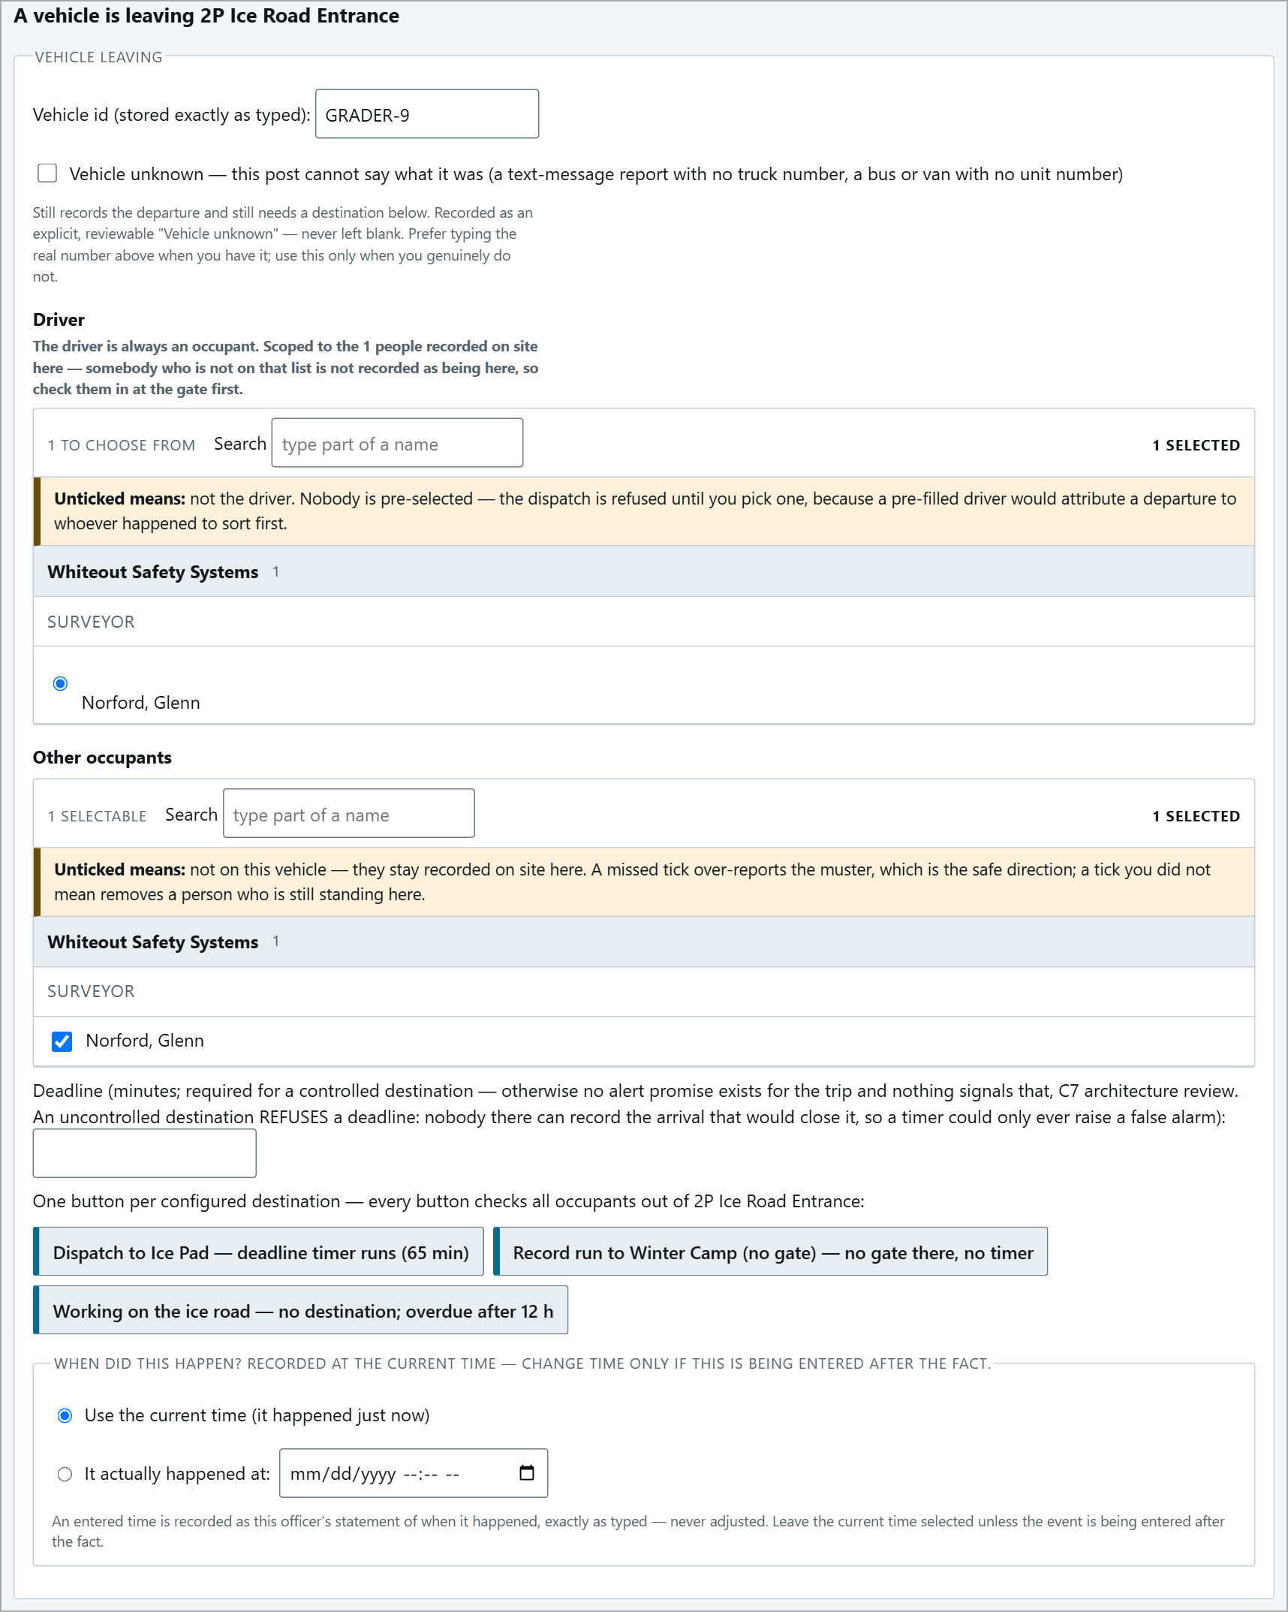  GRADER-9 sent out to work on the road. | 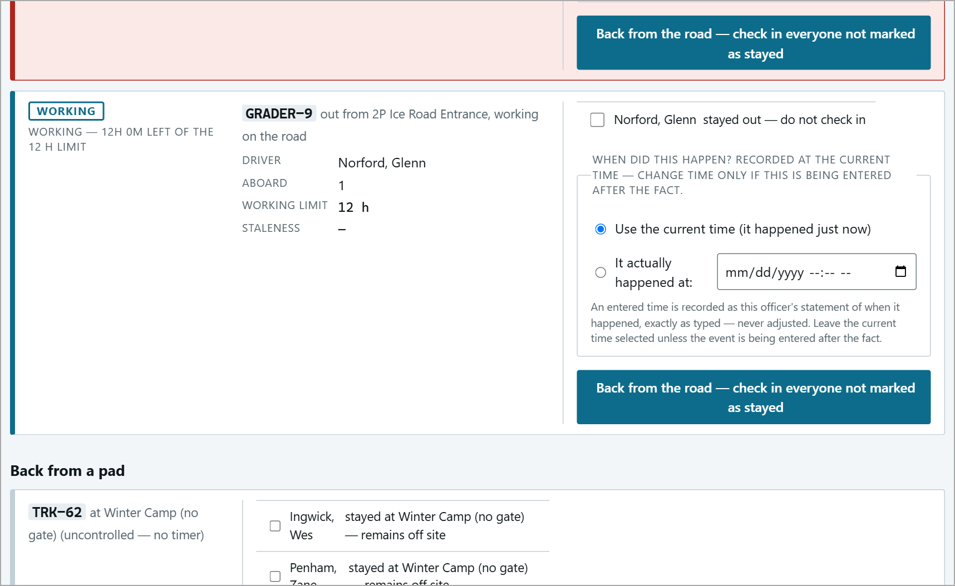  WORKING - 12H 0M LEFT OF THE 12 H LIMIT.

Past the limit the card turns red ("OVERDUE - OUT ... PAST THE 12 H LIMIT"), it appears in the red bar and under Outstanding alerts like any overdue trip.
When it comes back
Press Back from the road - check in everyone not marked as stayed. Tick anyone who stayed out.
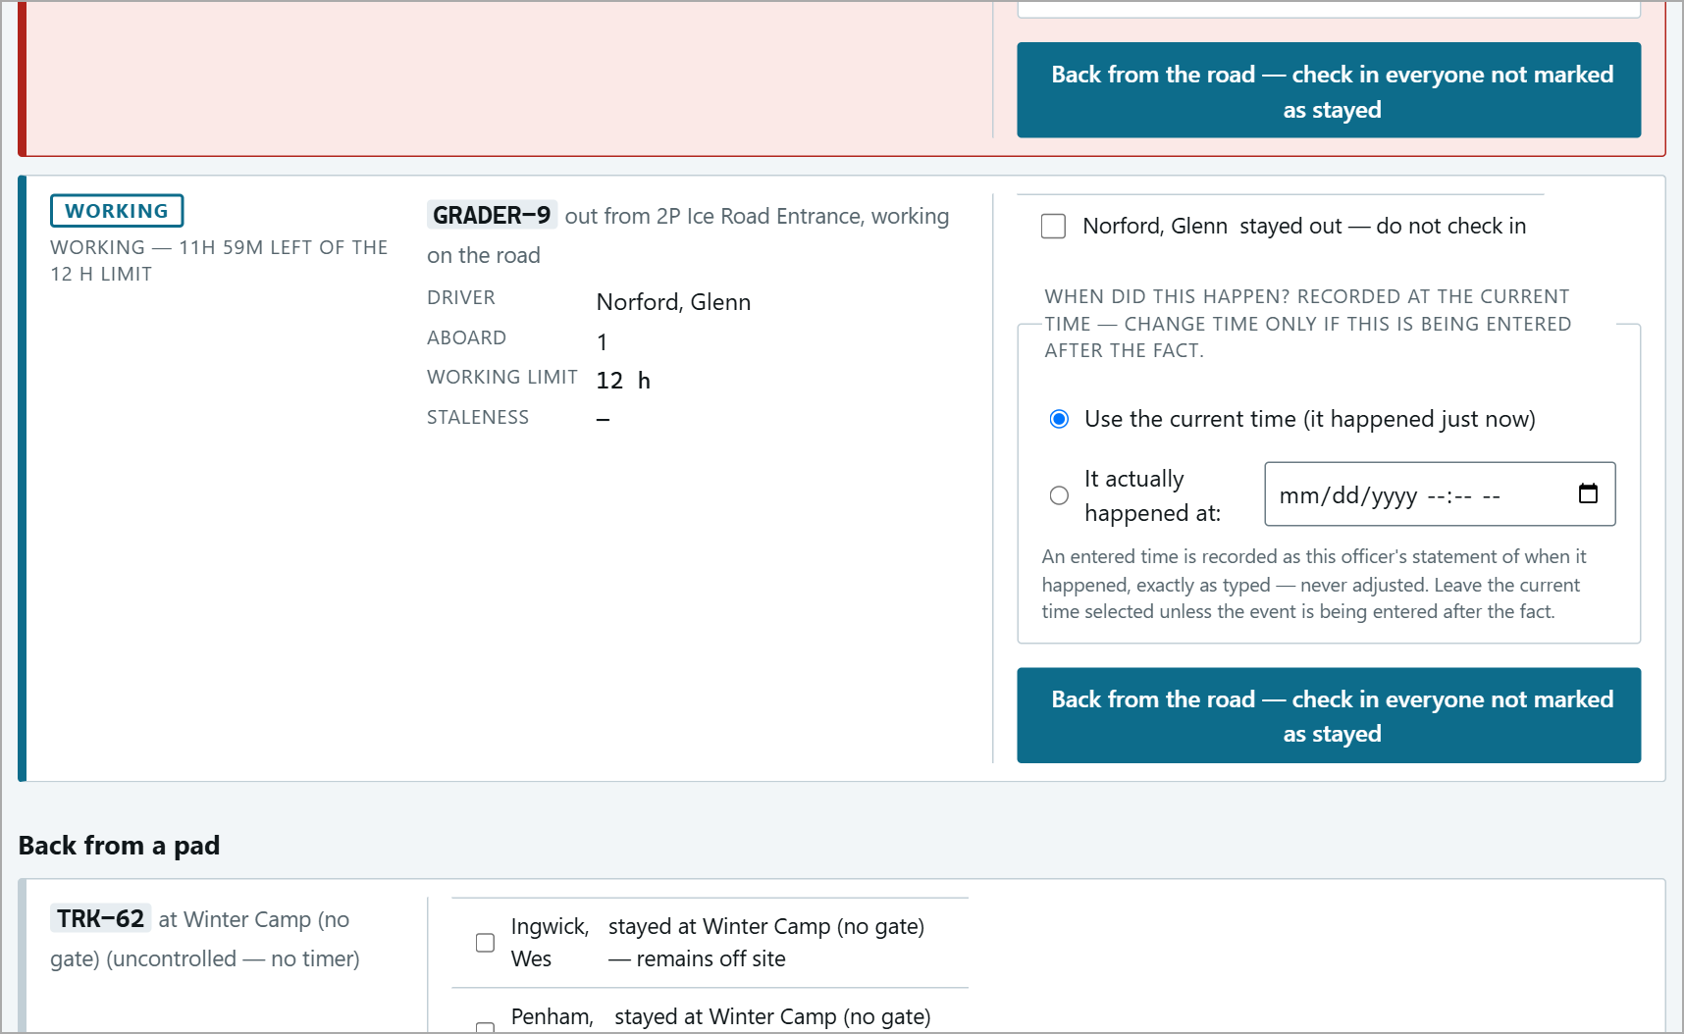  Before: the working card. | 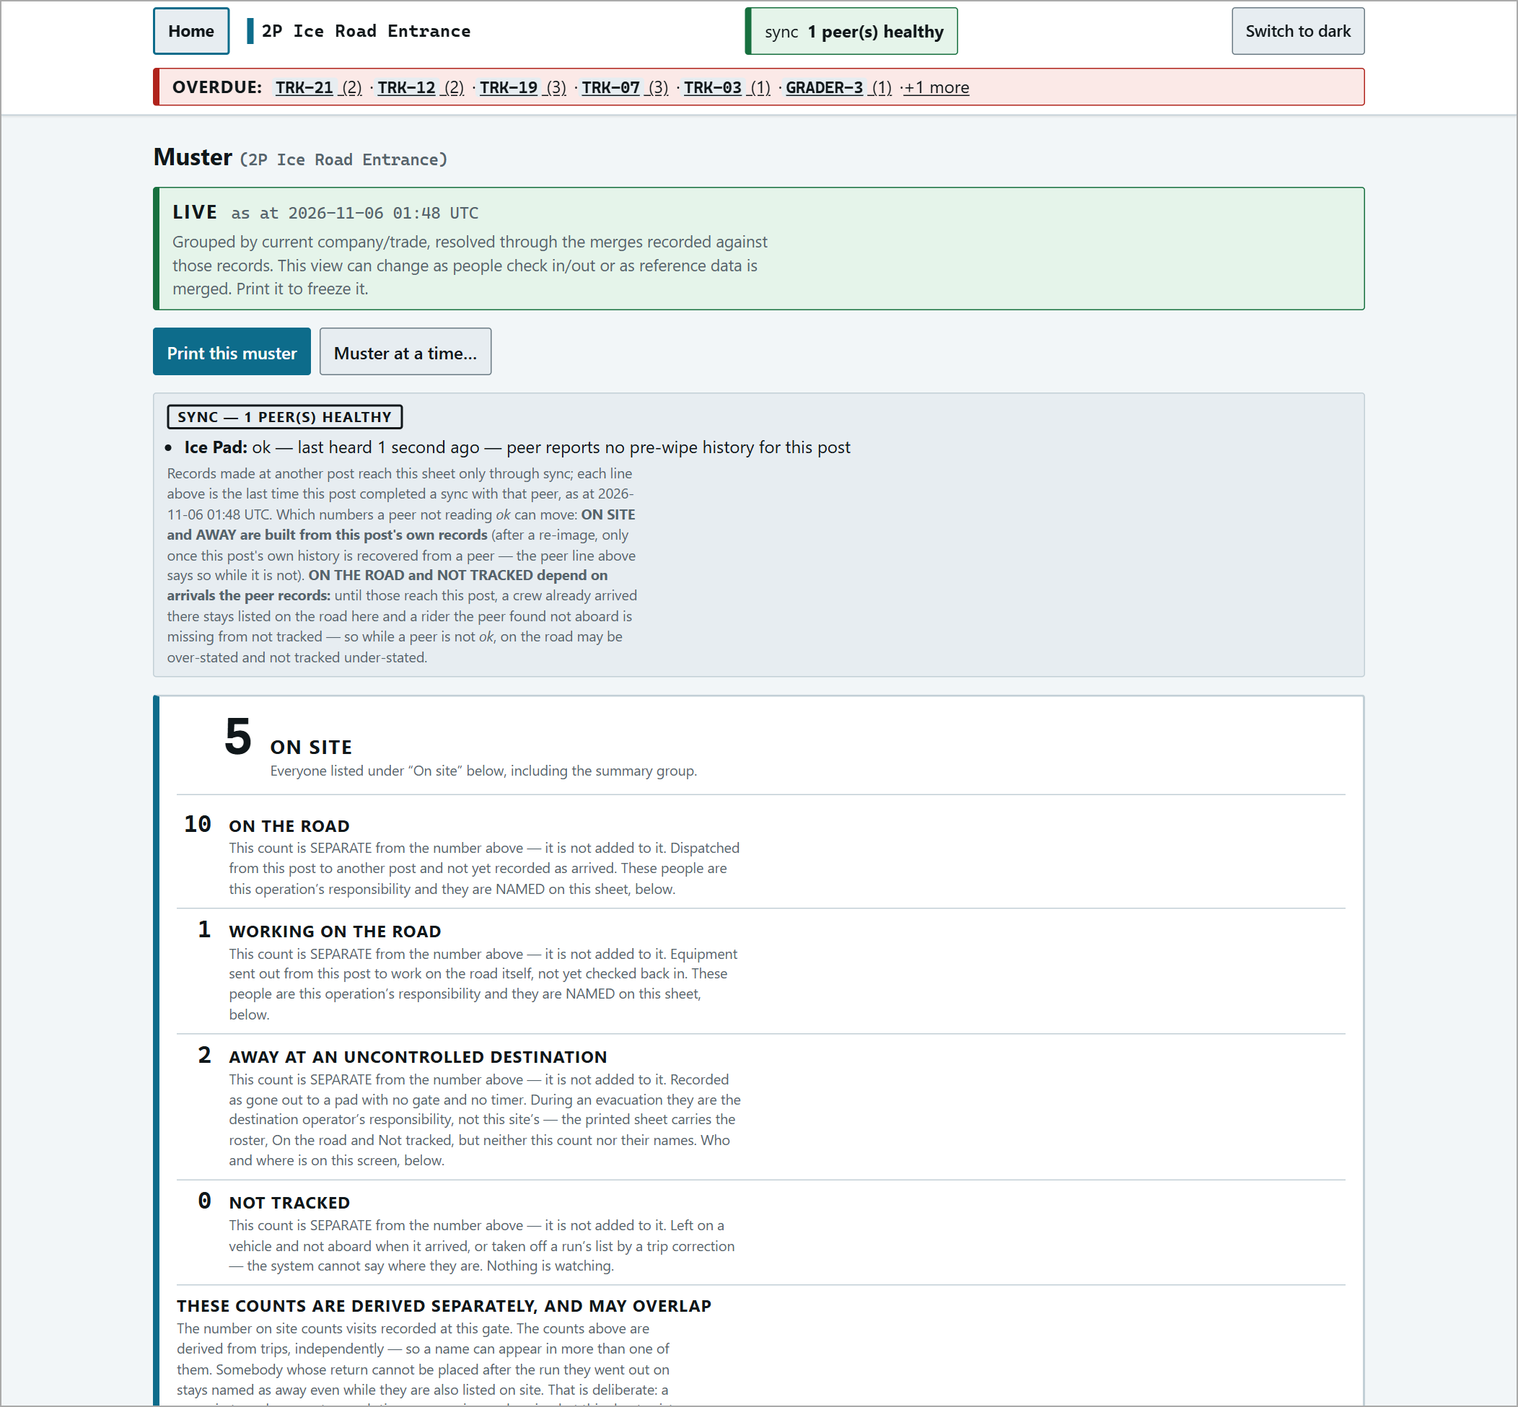  After: the Working count falls on the muster.

Following a Trip
A trip is shown at both posts, each counting down on its own clock:
At the sending post: OUTBOUND. | 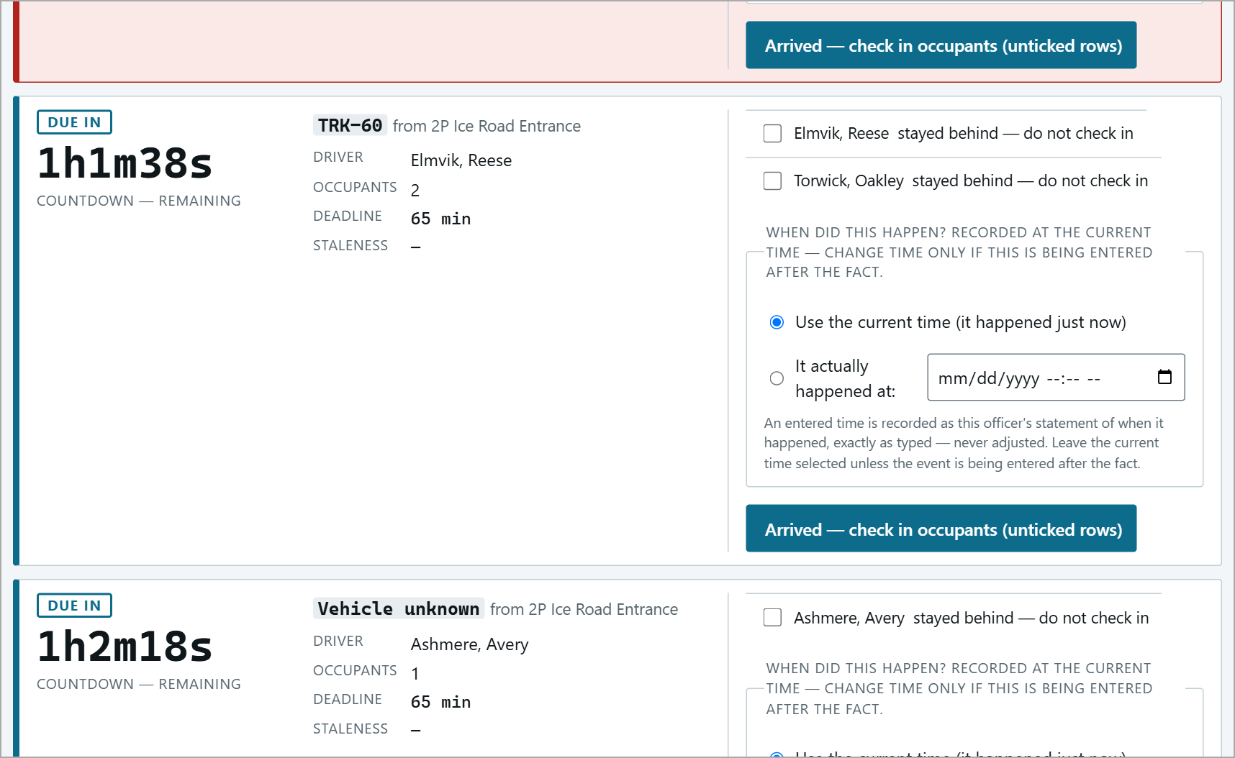  At the receiving post: INBOUND (the same trip).

Countdown | Time left before the deadline (REMAINING), or how late it is (OVERDUE BY) once past it.
DRIVER / OCCUPANTS | Who is aboard.
DEADLINE | The minutes promised at dispatch.
STALENESS | "-" when the two posts are in contact. Otherwise "Last heard from <post>: N minutes ago" - see When the Signal Is Lost.

An outbound card only closes when the receiving post records the arrival and that reaches the sending post. The sending post itself can only close it with Arrived back here - it turned back.
Recording Arrivals
1. An expected vehicle (the usual way)
On the vehicle check-in page, the vehicle is listed under On the road to <post>. Open its row and press Check in (N) - a green banner confirms ("TRK-30 arrived: 1 checked in."). Or, on the console, use the Inbound card's Arrived - check in occupants (unticked rows).
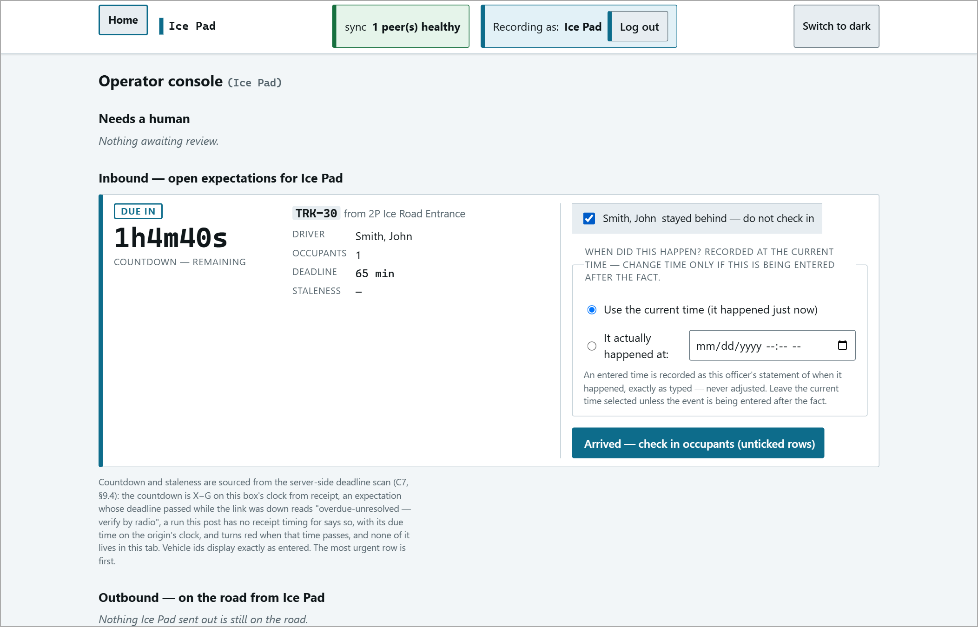
On the Inbound card a TICKED box means "stayed behind - do not check in". Leave everyone who arrived unticked.
Tick boxes mean LEAVE OUT on every trip card: "stayed behind", "did not come back", "stayed out", "stayed at <pad>".

2. An overdue vehicle that arrives without everyone (adjust)
Overdue rows on the vehicle page get an adjust link. It opens the manifest - untick only someone who is NOT here. They are not checked in, stay off the muster, and show as NOT TRACKED until somebody records where they are.
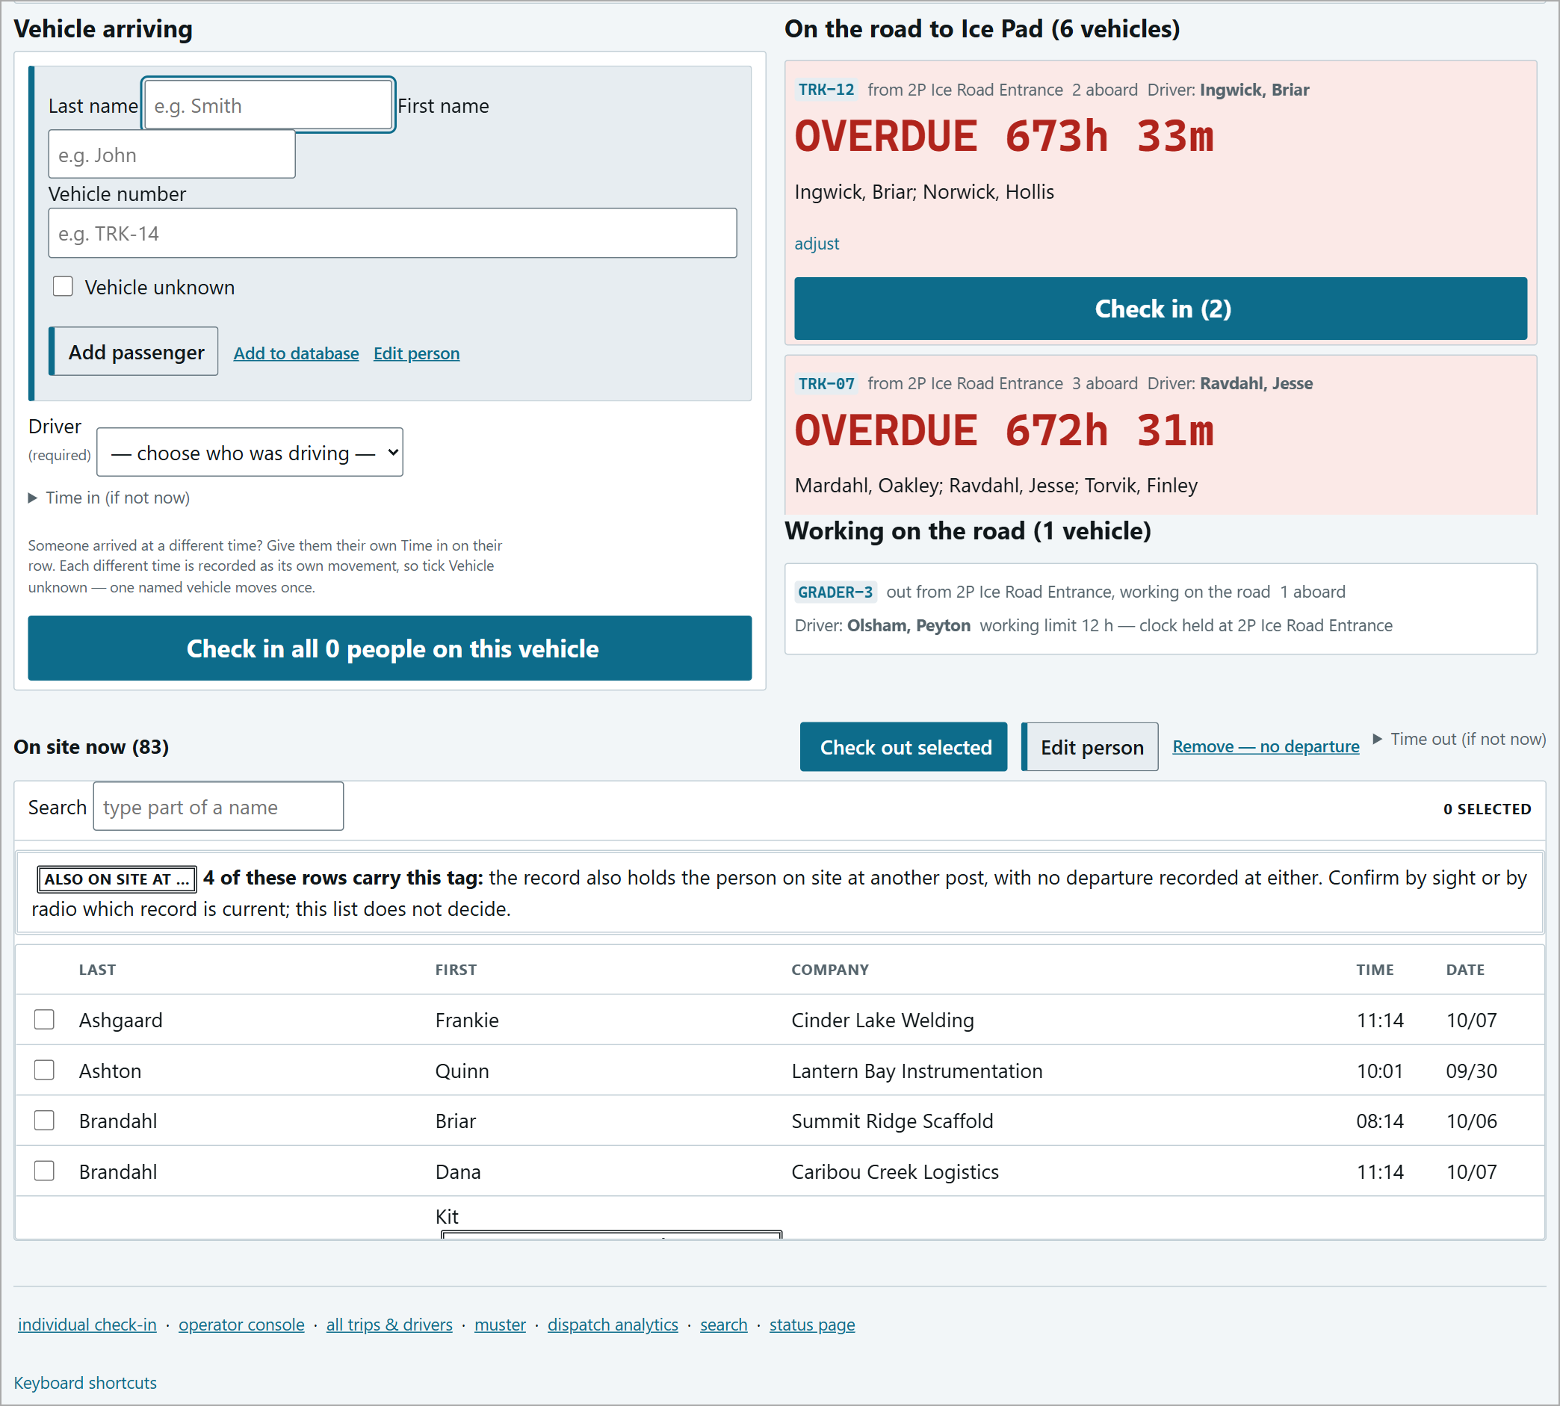
Overdue rows on the vehicle page with the adjust link.
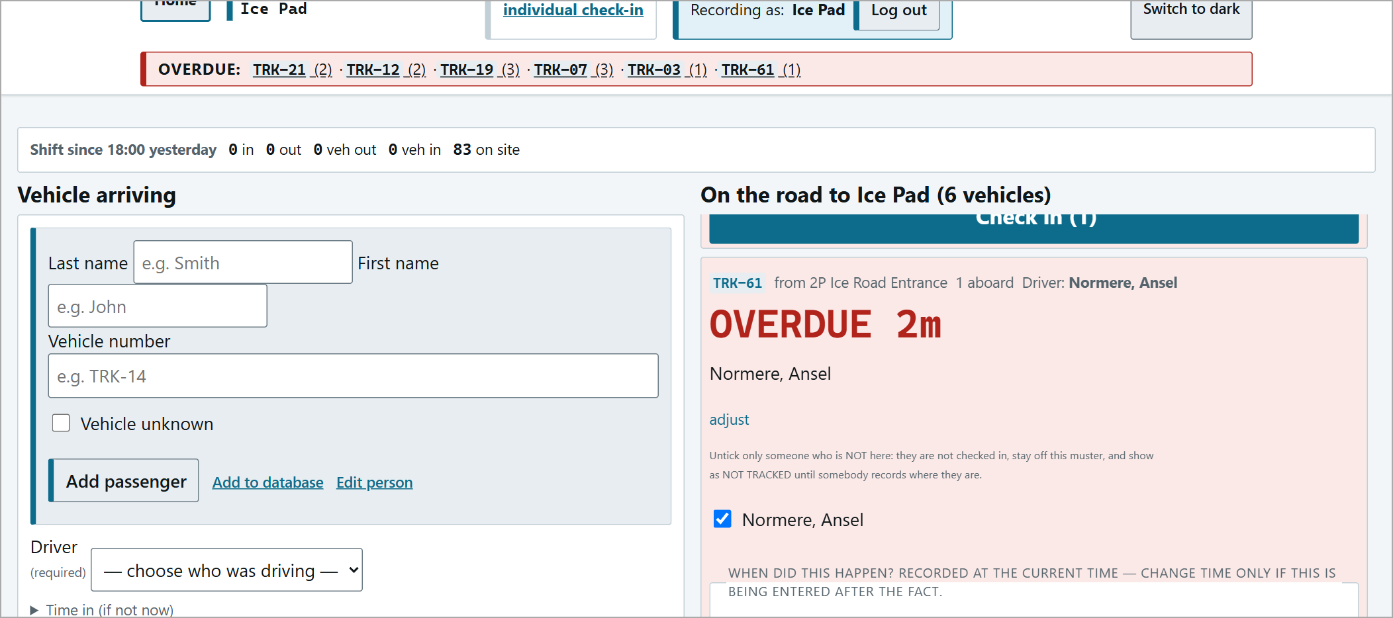
adjust opened for TRK-61.
3. A vehicle nobody told you about (A vehicle has arrived)
For a vehicle that outran the sync, or arrived while the link was down. At the bottom of the console:
1 | Vehicle id (or Vehicle unknown) and Came from.
2 | Tick People aboard. The whole roster is listed; the likeliest crew (people recorded on site at the post it came from) is at the top. Search hides rows but never unticks anyone.
3 | Press Record arrival - creates one visit per person and check the count in the pop-up against the people in front of you.

If it matches exactly one open trip it is linked to it automatically; otherwise it goes to review - the system never guesses.
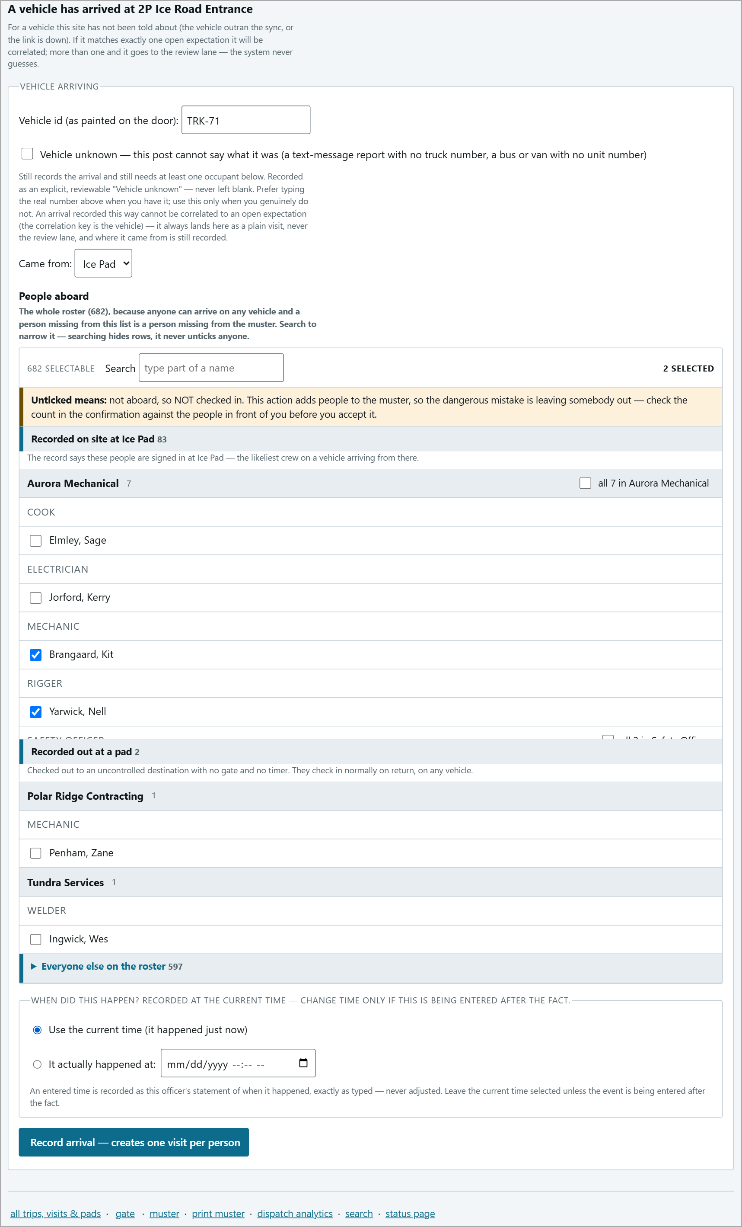  The arrival form filled in. | 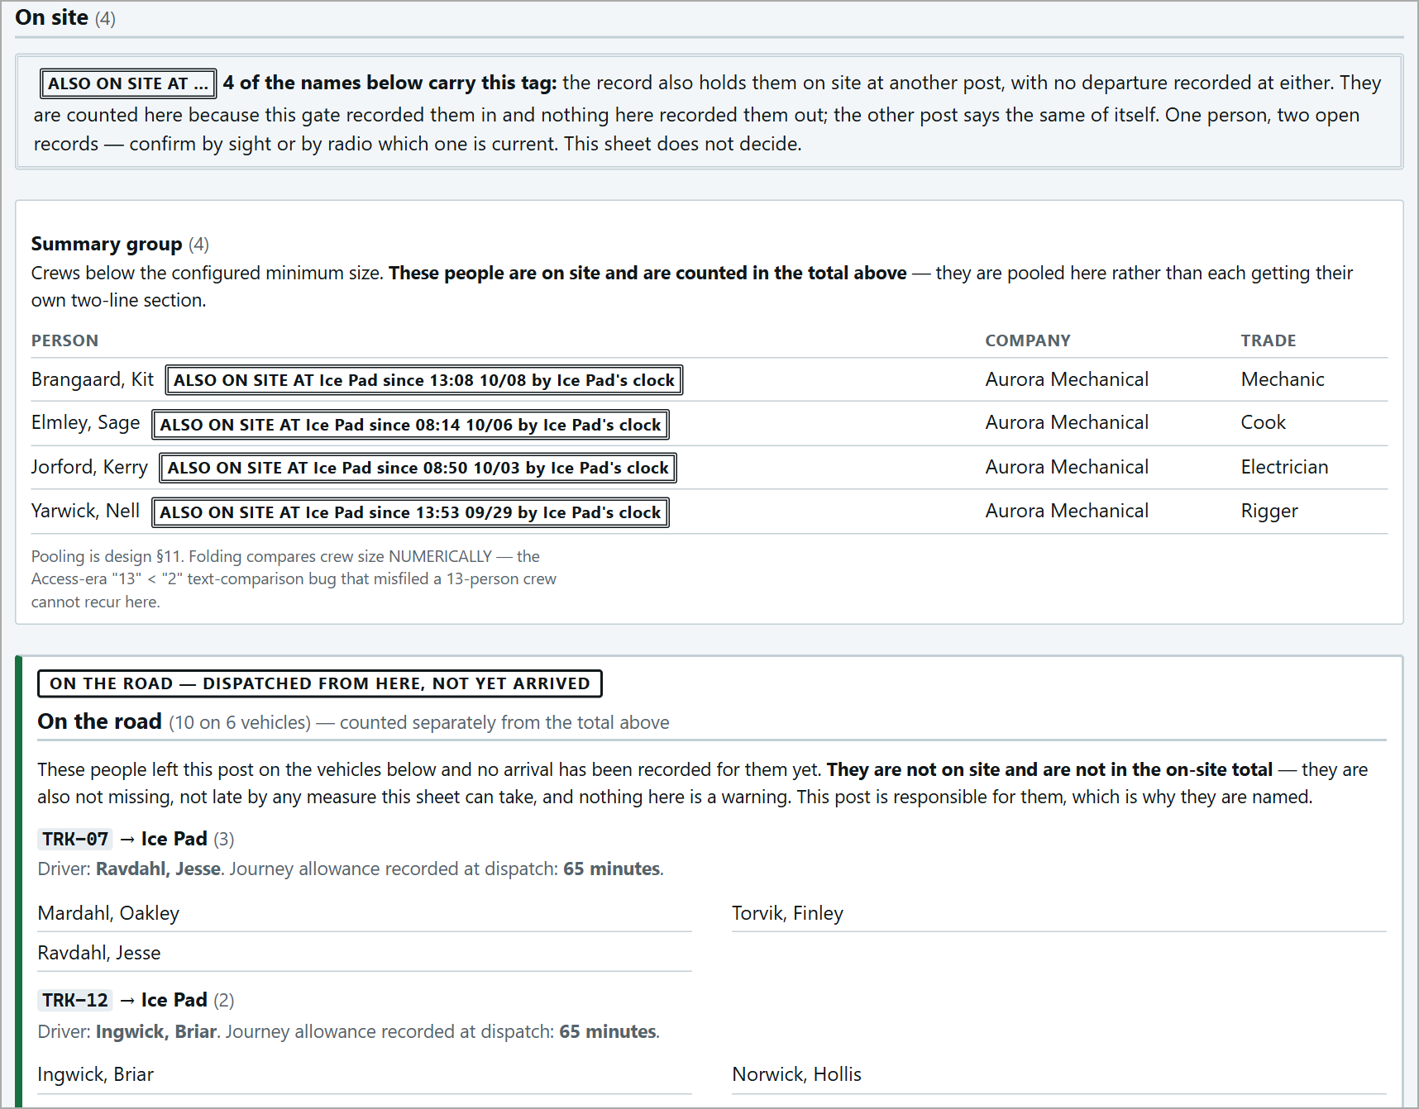  The people now on site.

People who were never signed out at the post they came from will show "ALSO ON SITE AT <post>" at both posts - confirm by sight or radio which is current, then sign them out at the other post.
4. It turned back
If a vehicle returns to the post it left from without reaching its destination, press Arrived back here - it turned back; check in everyone not marked on its Outbound card. The trip closes as RETURNED, the people are back on this post's muster, and any alert clears at both posts.
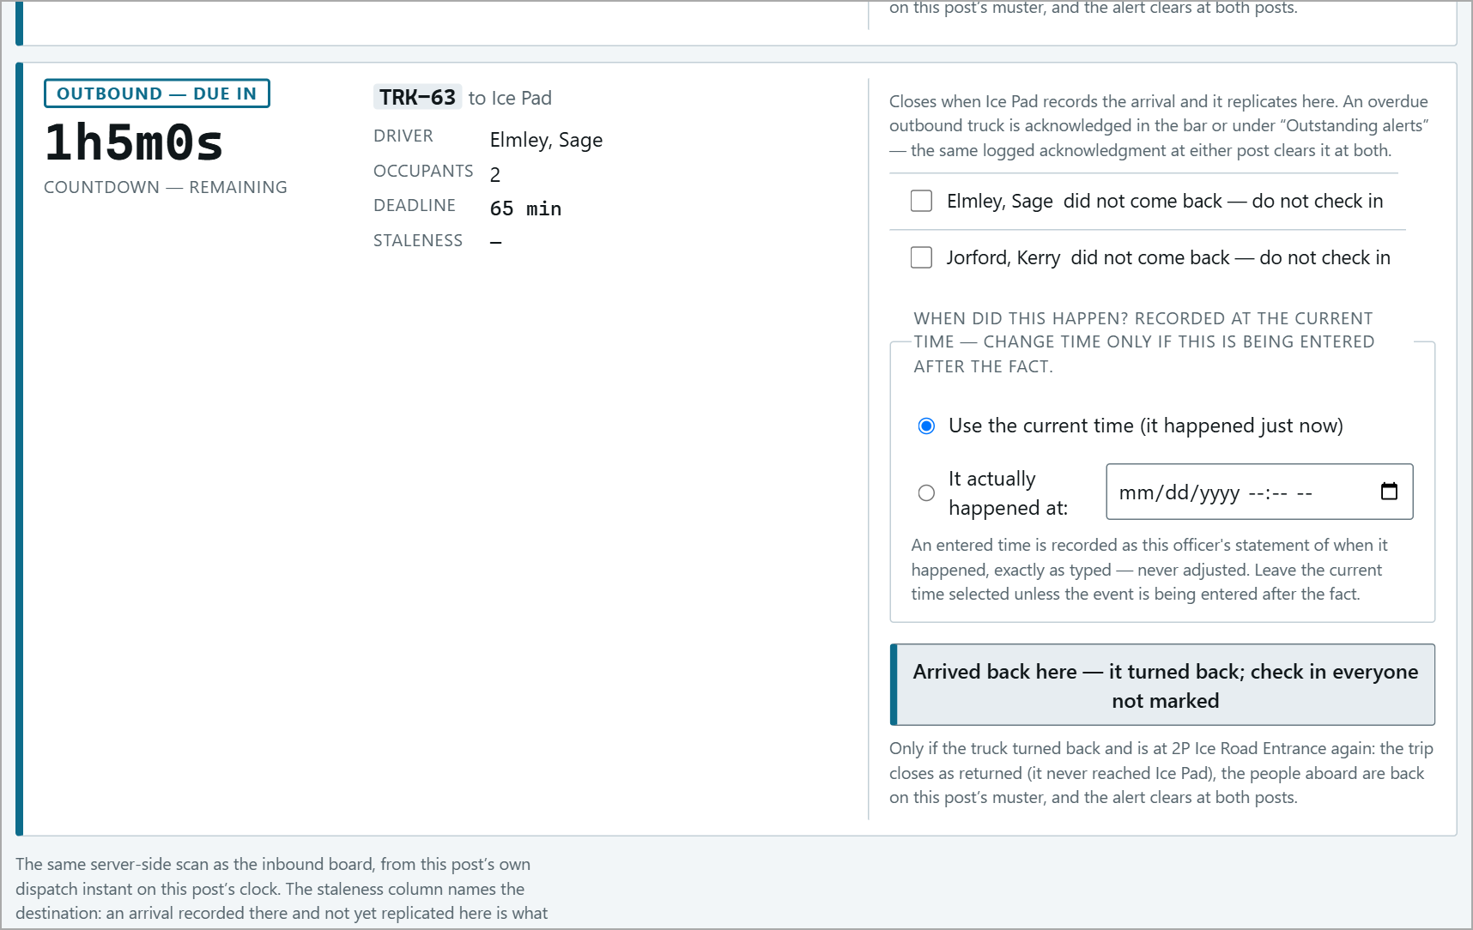
TRK-63 on its way to Ice Pad - before.
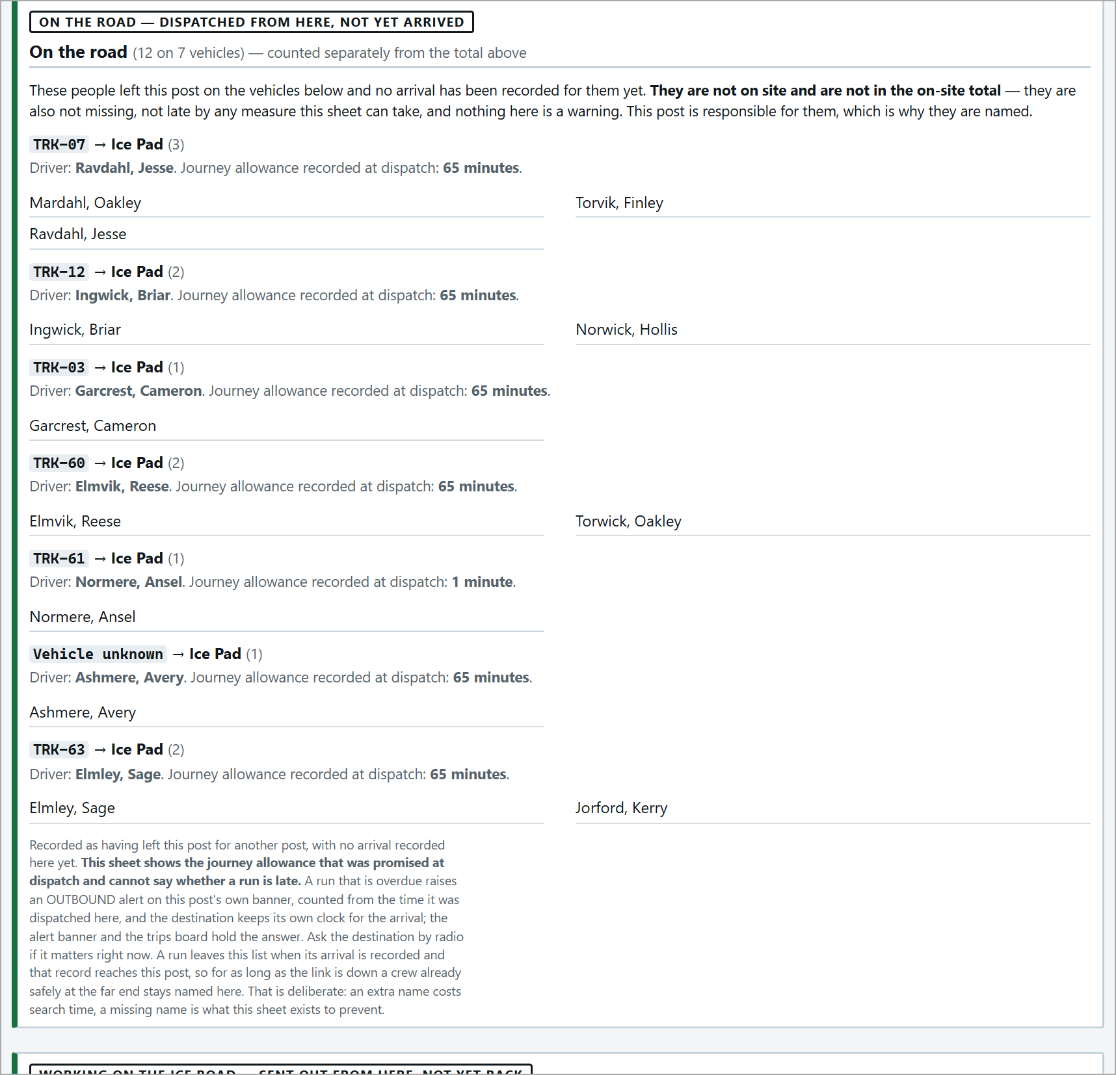  Muster before: TRK-63 On the road. | 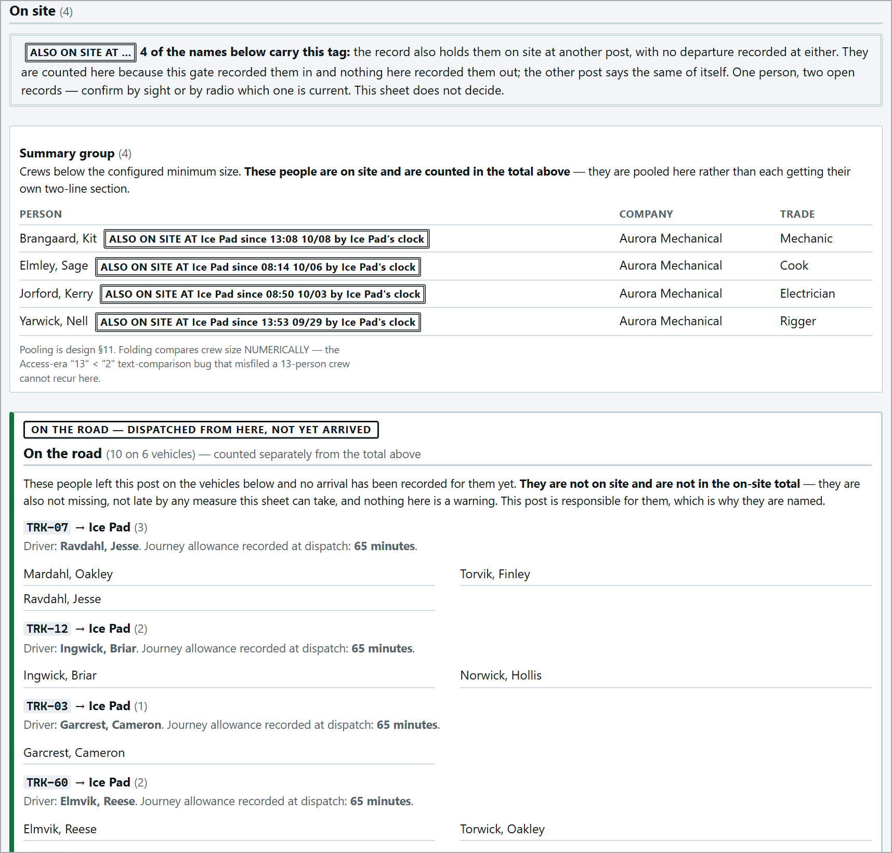  Muster after: both people back on site.

Overdue Vehicles
When a deadline passes with no arrival recorded, a red OVERDUE bar appears on every page at both posts, naming each vehicle and how many are aboard.
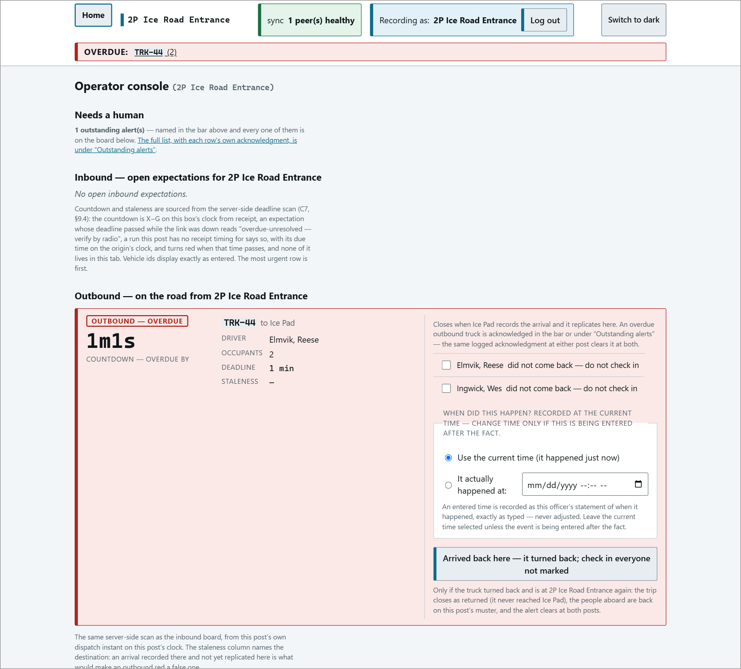
An overdue Outbound card - counting up.
1 | Find the vehicle - radio the driver and the other post.
2 | If it has arrived but was not recorded: the receiving post records the arrival (that closes it everywhere).
3 | If it turned back: the sending post presses Arrived back here - it turned back.
4 | Once you are dealing with it: under Outstanding alerts press Acknowledge (logged).

Acknowledging
Acknowledging takes the vehicle off the red bar at both posts and logs who did it and when. It does not close the trip - the card stays, marked "ACKNOWLEDGED BY <post>", until the arrival is recorded. Pressed by mistake? Un-acknowledge (logged) - put this alert back.
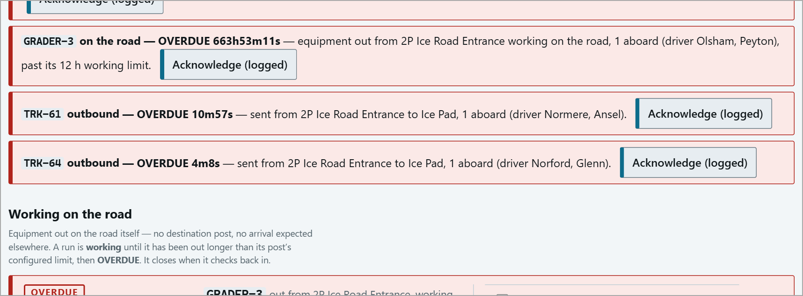
Outstanding alerts: TRK-61 - OVERDUE, with Acknowledge (logged).
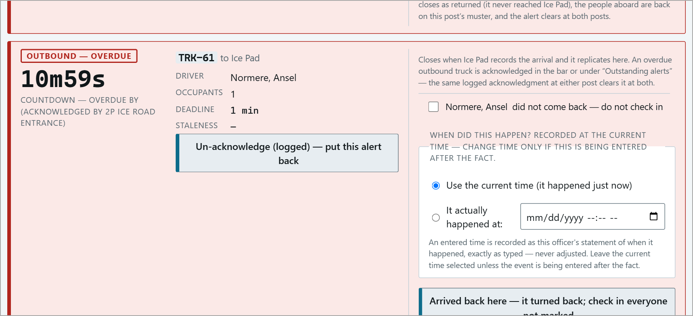
After: COUNTDOWN - OVERDUE BY (ACKNOWLEDGED BY 2P ICE ROAD ENTRANCE).
Overdue history
Reports > Overdue history lists every run that went past its deadline: how late, who acknowledged it and when, and how it ended. Acknowledged runs stay "Still open" until the arrival is recorded. Times are UTC.
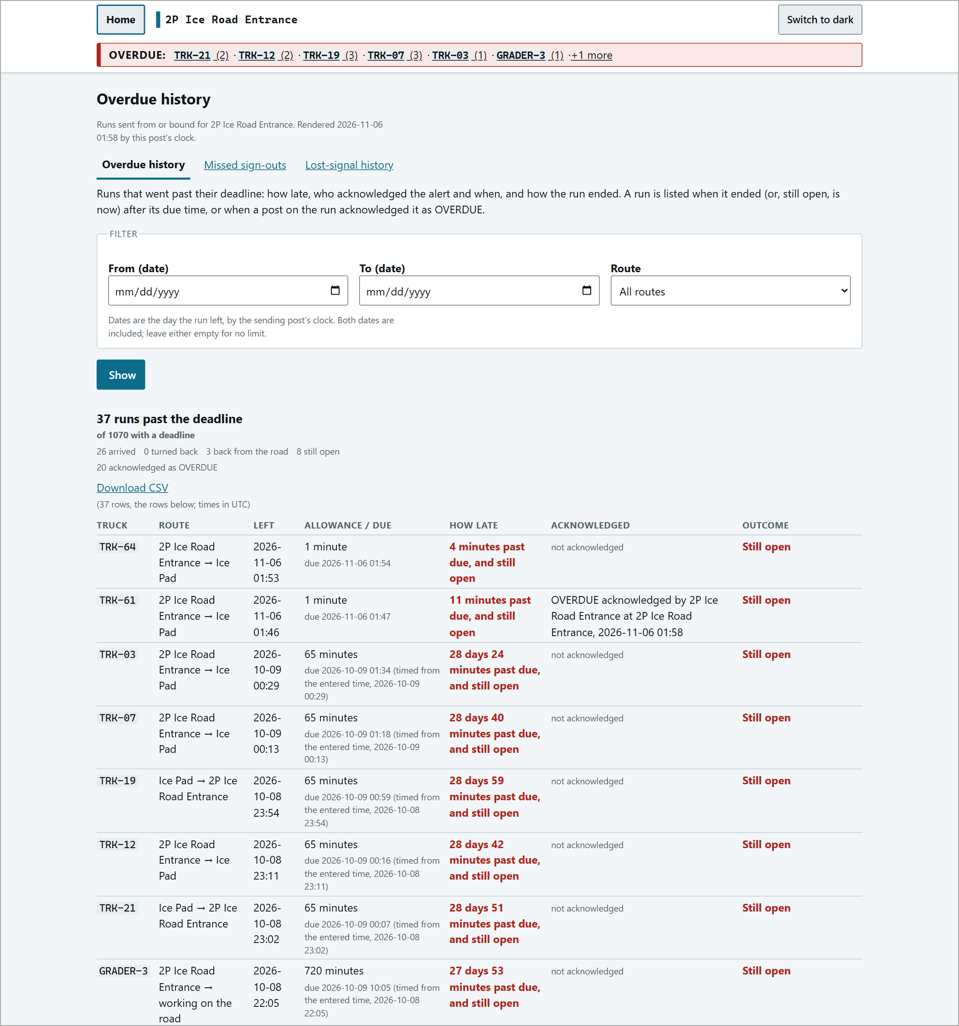
Overdue history, with TRK-61 acknowledged and still open.
When the Signal Is Lost
If a post cannot reach the others, a red LOST SIGNAL banner appears and the sync pill turns red. Each post keeps recording; everything catches up when the link returns. For dispatch this means:
Countdowns | Keep running on each post's own clock. A trip can go OVERDUE while the link is down.
STALENESS | Cards and vehicle-page rows show "Last heard from <post>: N minutes ago".
Arrivals | An arrival recorded at the other post will not reach you until the link returns - the card stays open and may turn red. Verify by radio.
Vehicles not listed | A vehicle may arrive before its trip reaches you - record it with A vehicle has arrived.
Muster | On the road may be over-stated and Not tracked under-stated until the link returns.

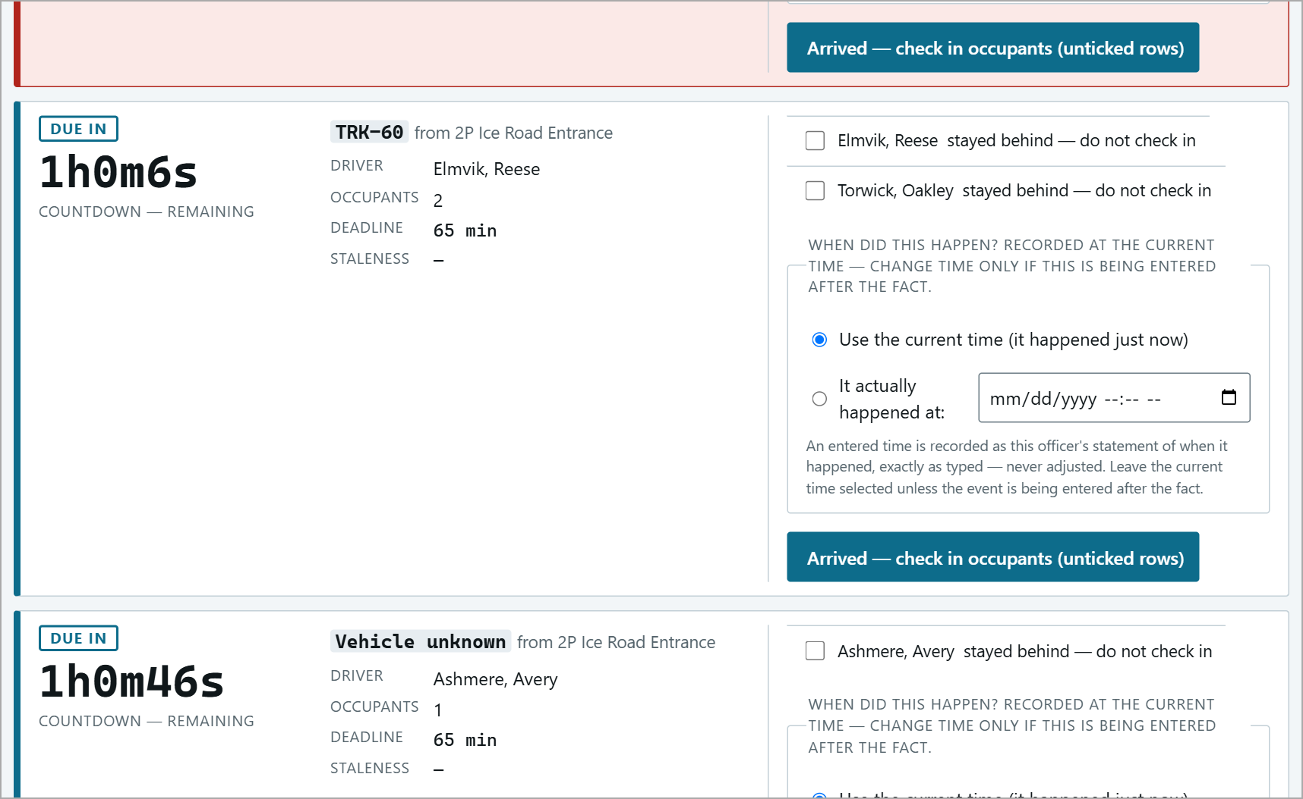  Inbound card: "Last heard from 2P Ice Road Entrance: 1 minute ago". | 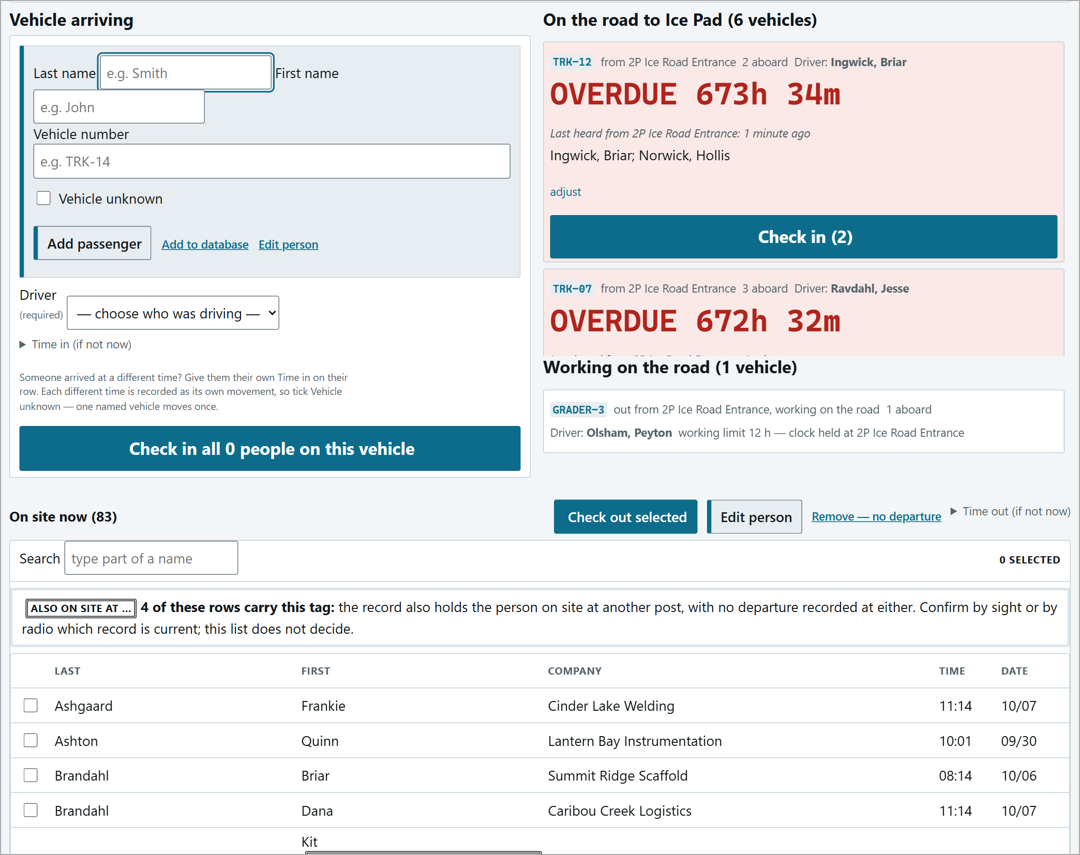  The vehicle page during lost signal.

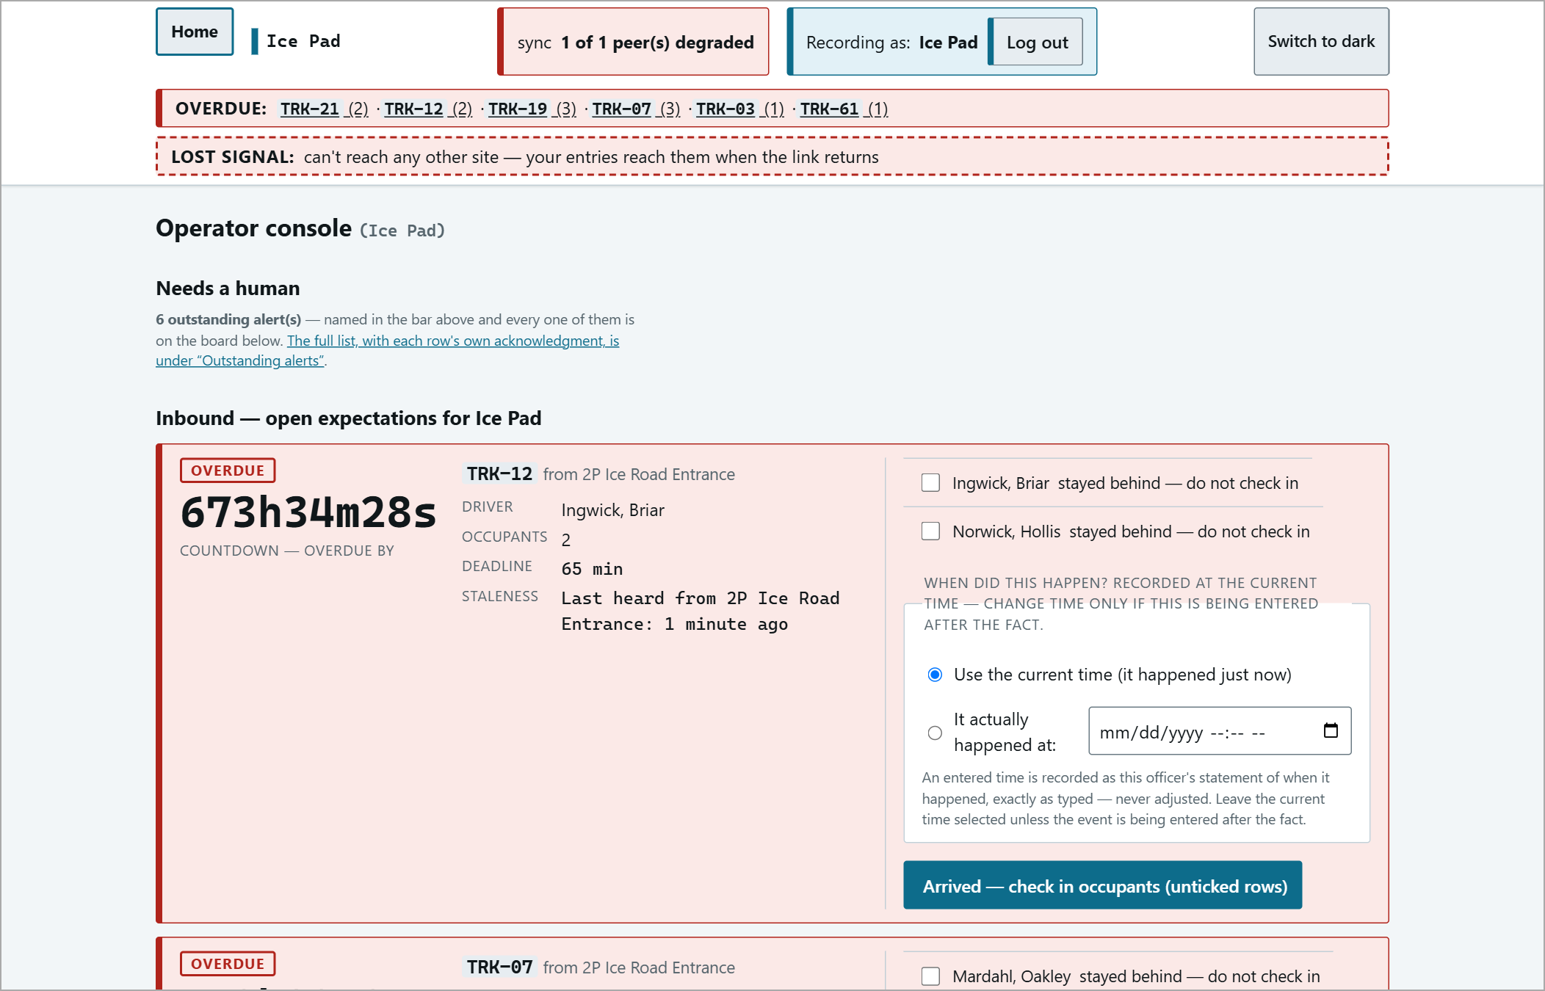
The console with the LOST SIGNAL banner.
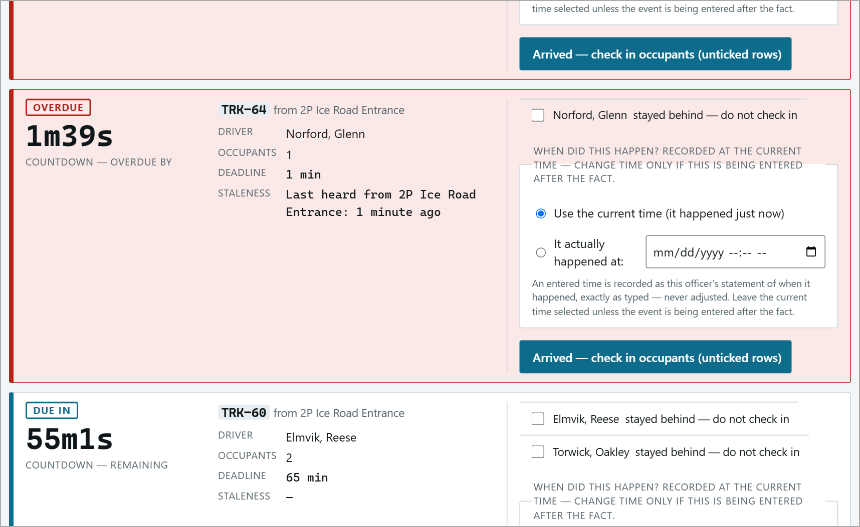
A trip whose deadline passed while the link was down - still shown as OVERDUE. Radio to confirm.
The Muster and Dispatch
The muster keeps the people dispatch is responsible for separate from the on-site total:
ON THE ROAD | Dispatched from here, not yet arrived - named, and this post's responsibility.
WORKING ON THE ROAD | This post's equipment out working - named.
AWAY AT AN UNCONTROLLED DESTINATION | Out at a pad - counted on screen only, not on the printed sheet.
NOT TRACKED | Left off a vehicle on arrival (adjust) or removed by a trip correction - the system cannot say where they are. Find them.

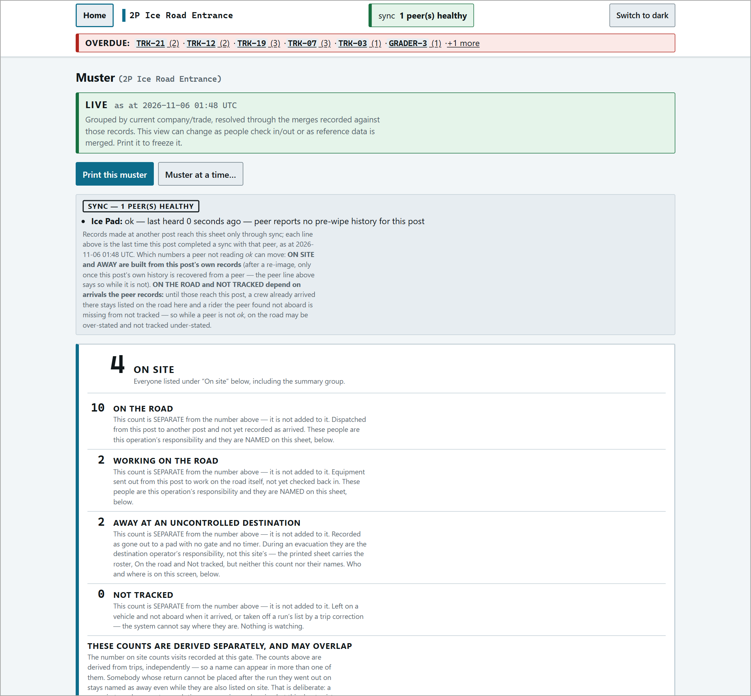
The muster counts at the sending post.
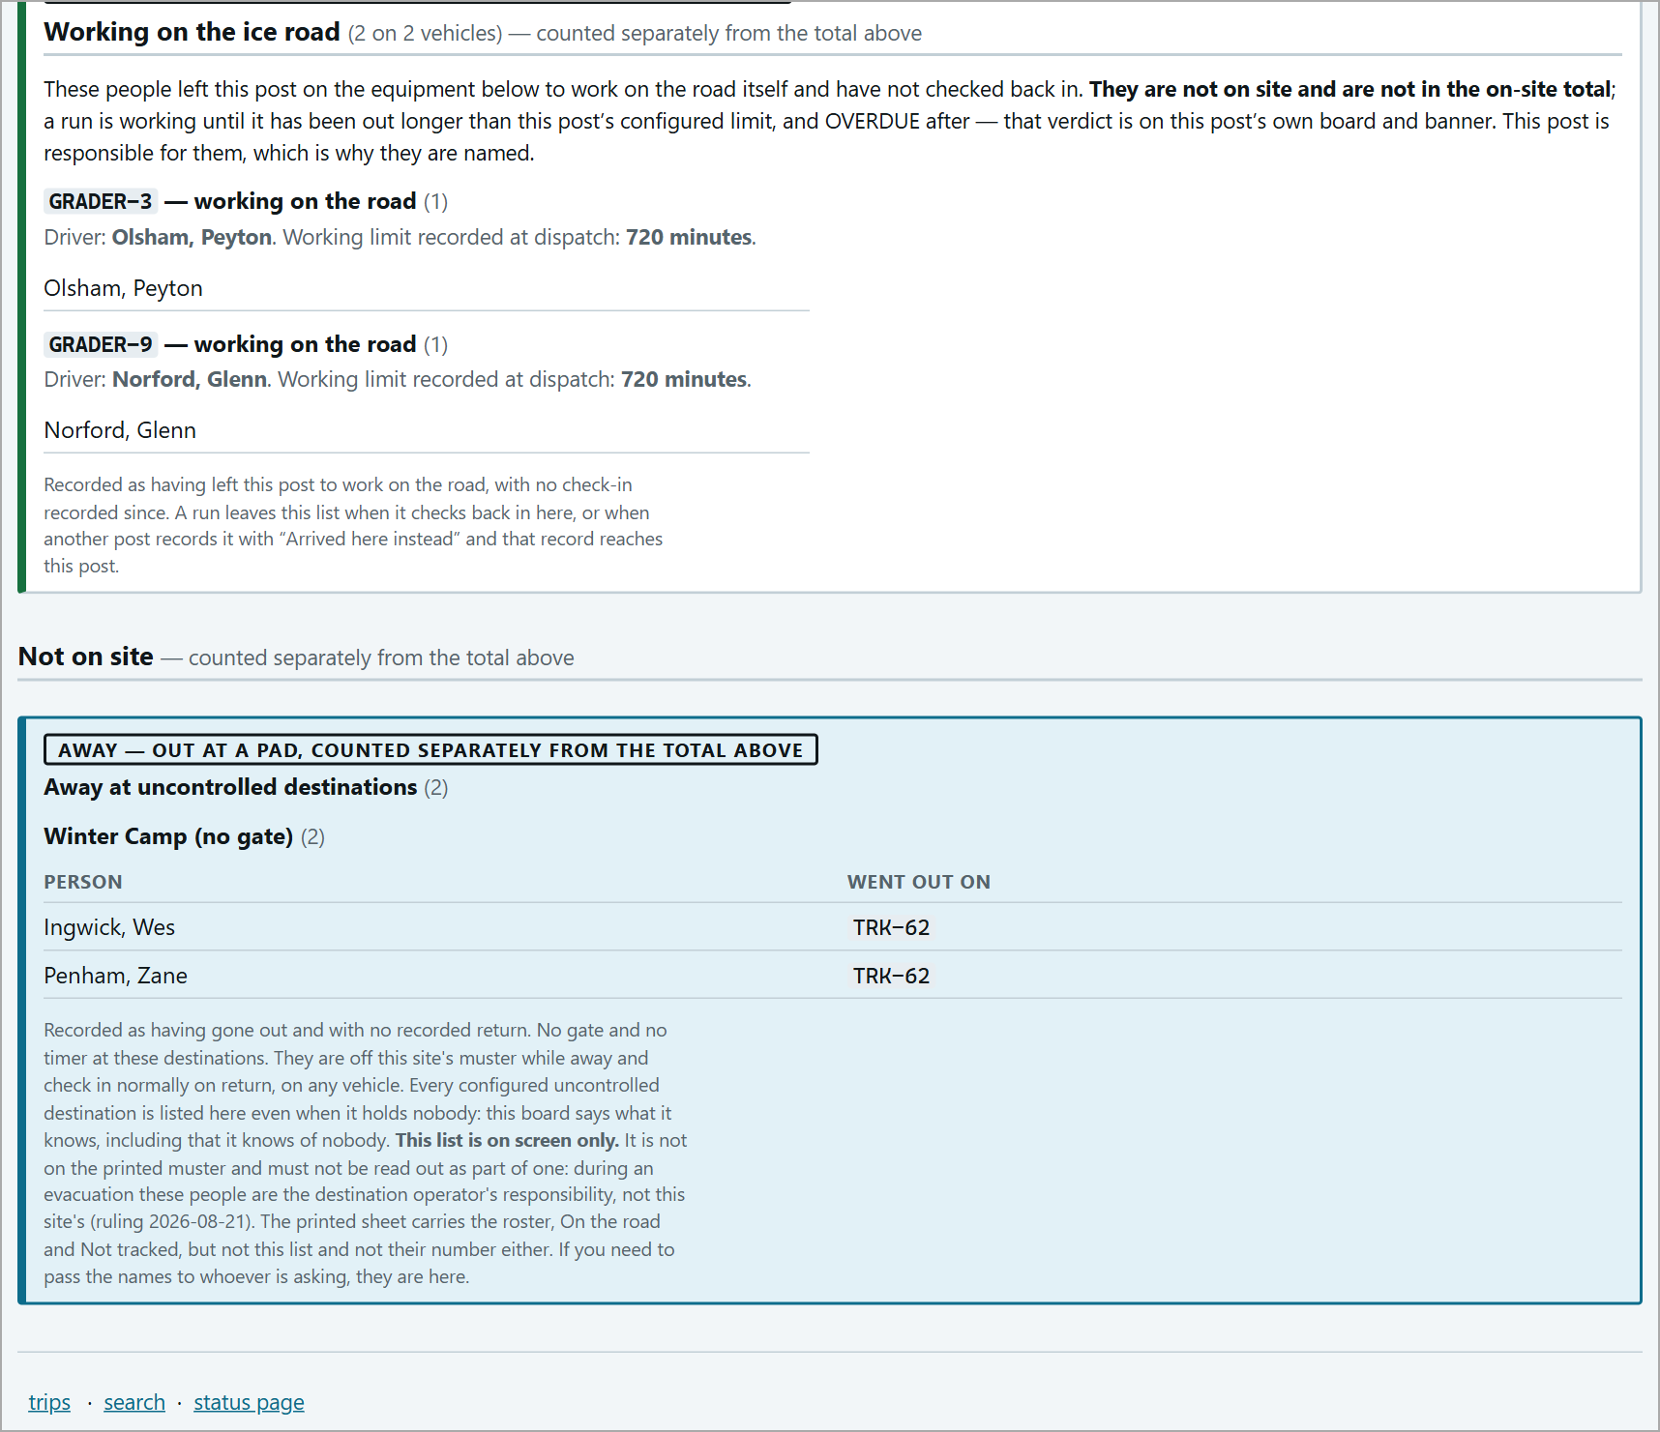
Working on the road and Away at uncontrolled destinations, further down the muster.
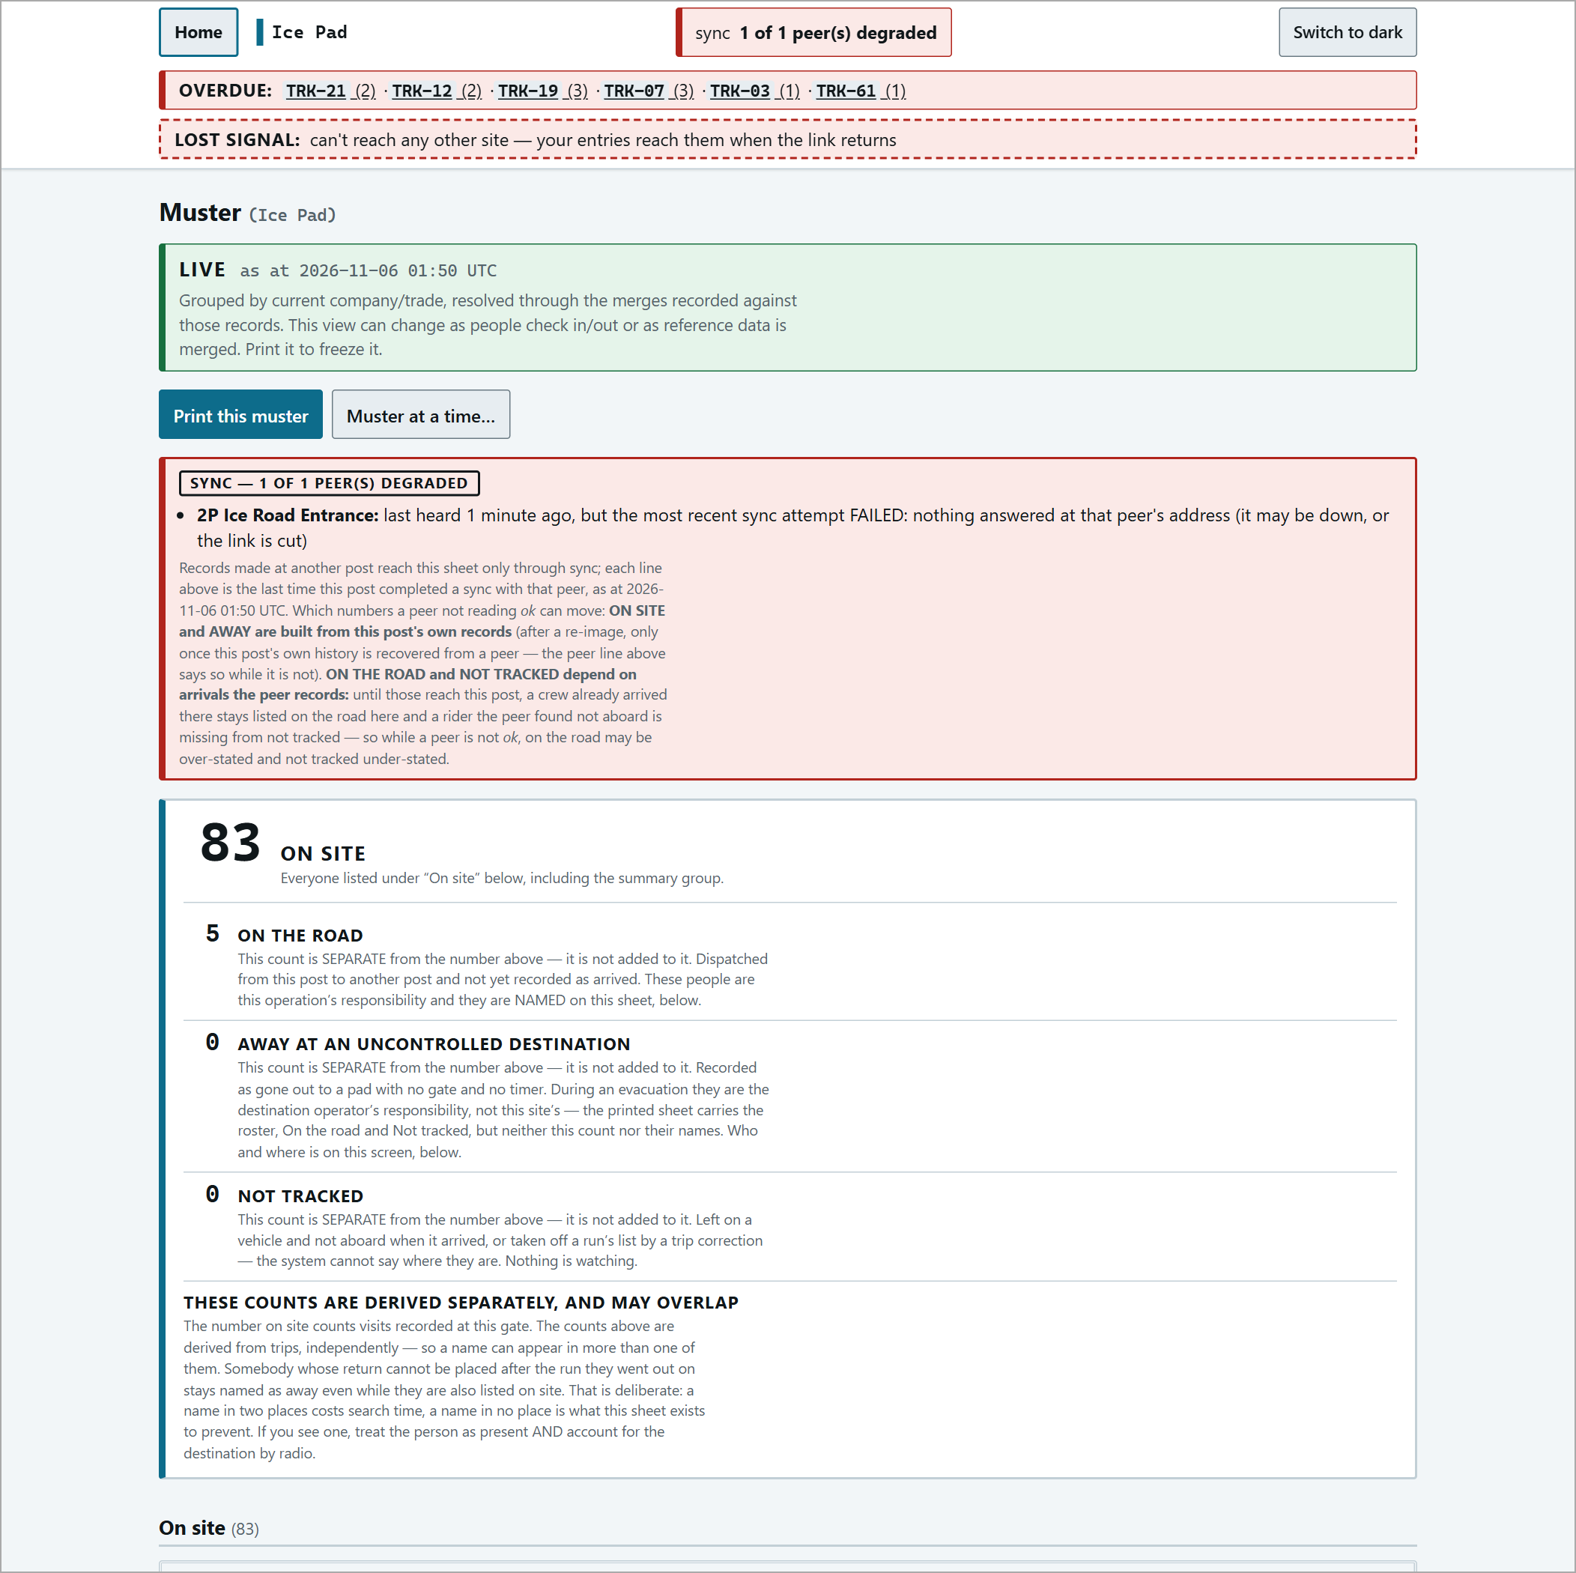
The muster during lost signal: "SYNC - 1 OF 1 PEER(S) DEGRADED".
Trip Records and Corrections
all trips & drivers is the reference and audit view (the console is the working surface). Pick a date range (7 days by default; <- Previous 7 days to page back) and download CSVs of the trips or visits.
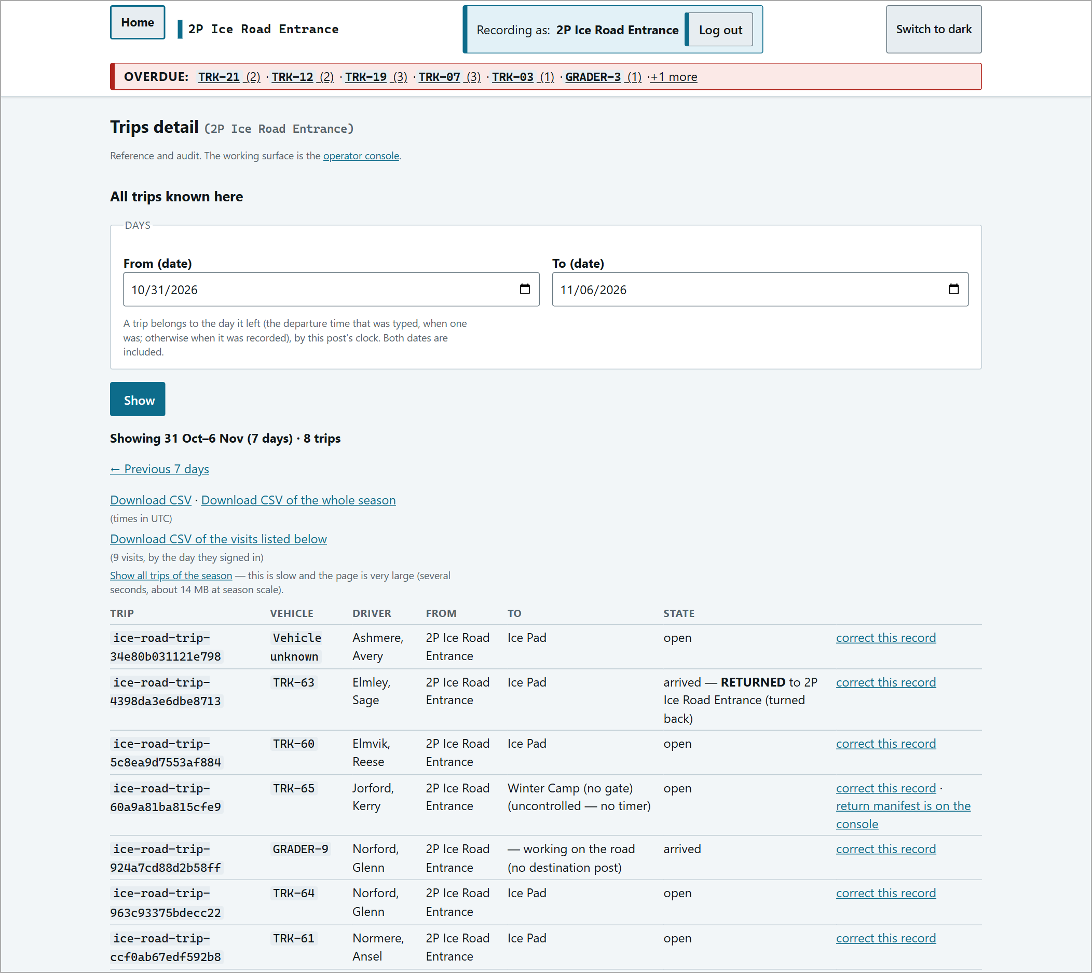
Trips detail: filter, paging and CSV links, and the trip table.
Record chain
For each trip, every fact each post recorded - driver, vehicle, destination, who was aboard. Nothing is ever deleted; corrections appear as extra rows.
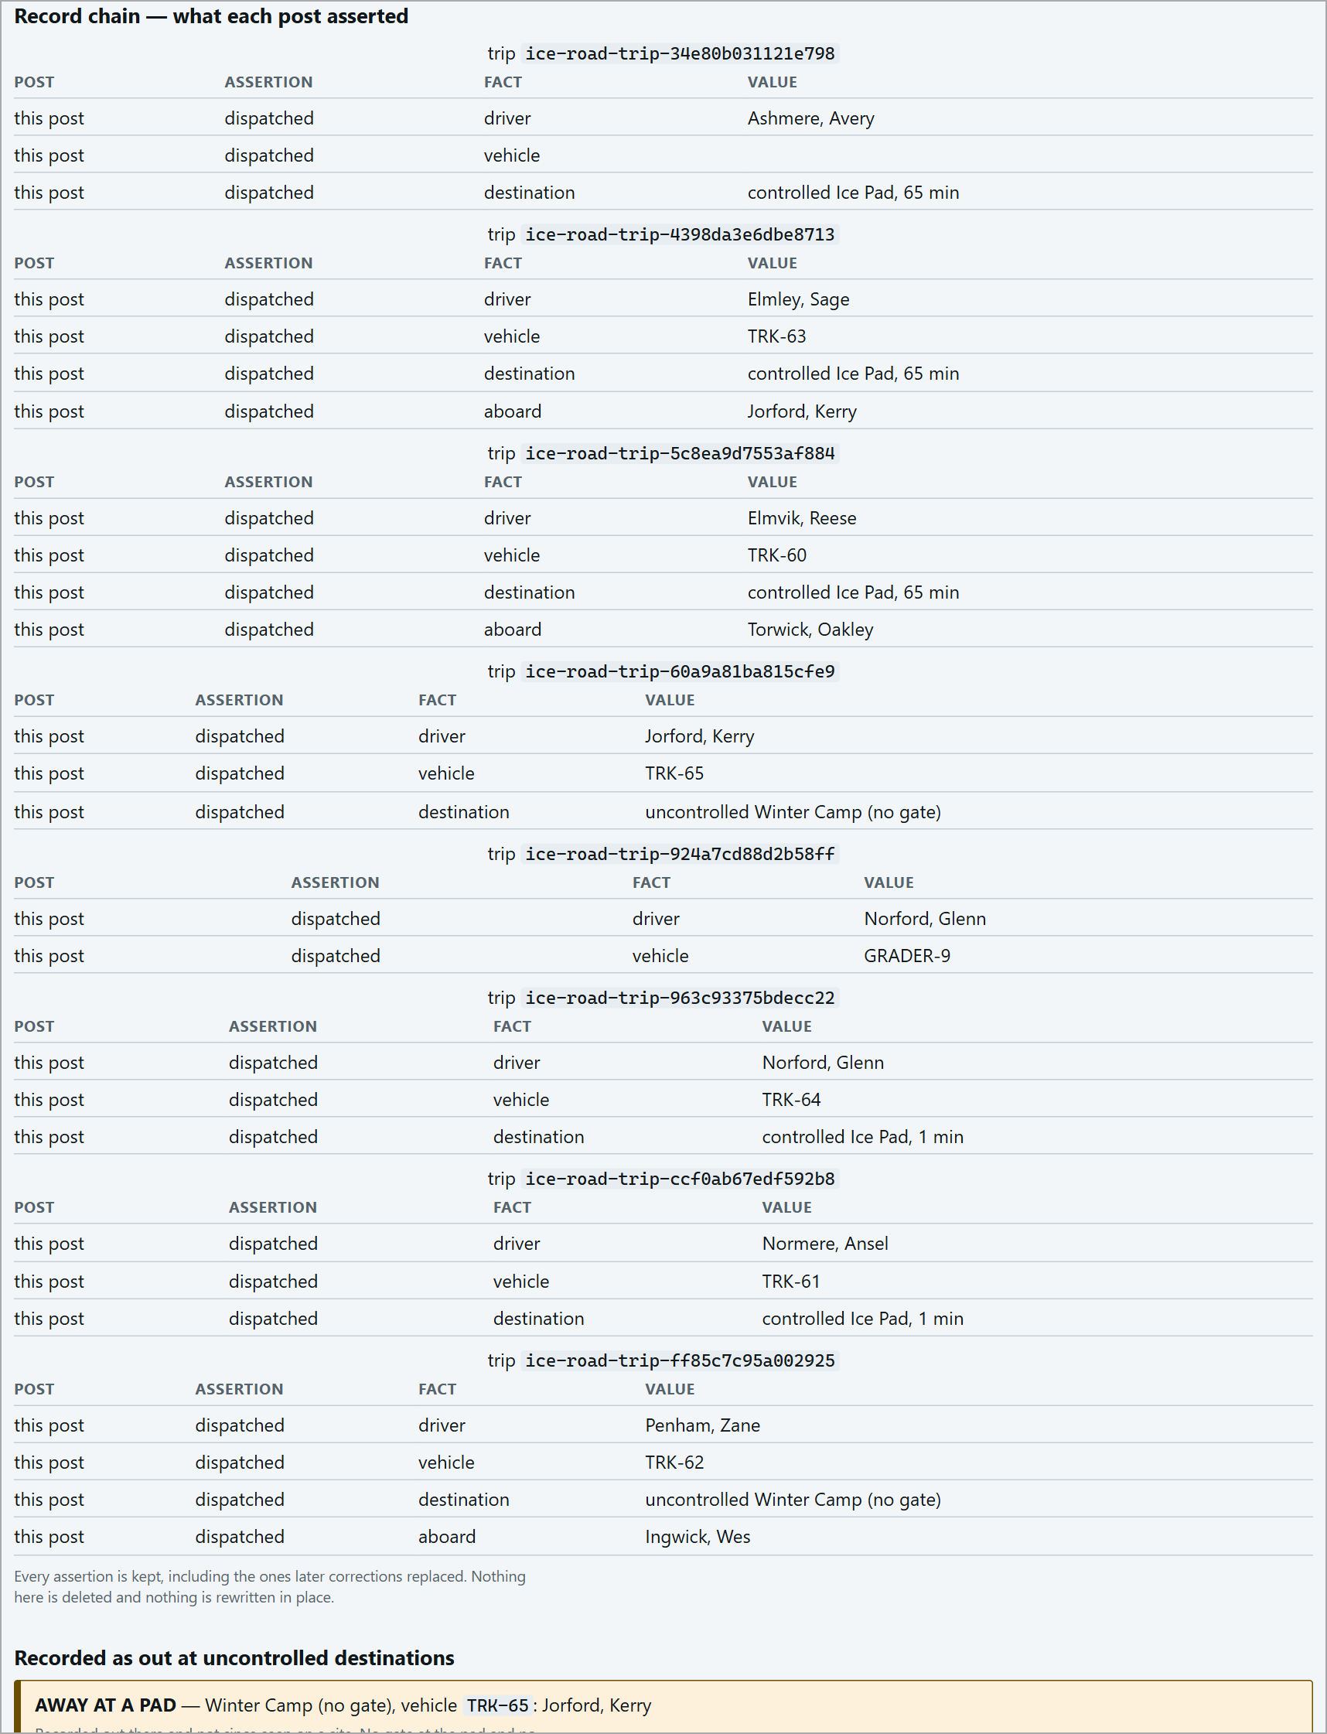
Record chain - what each post asserted.
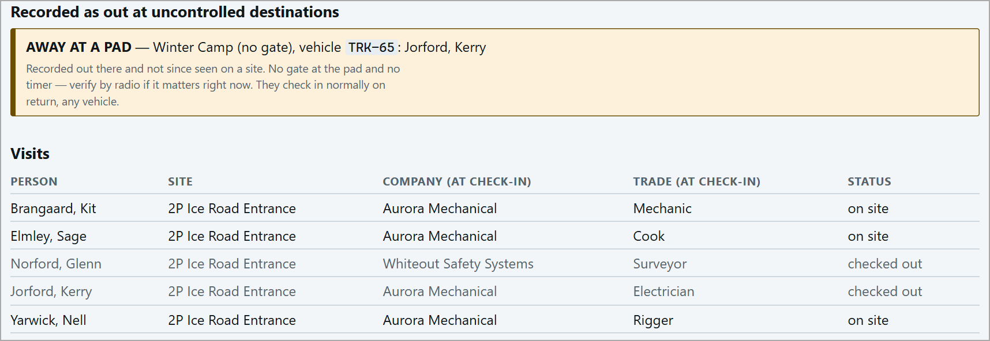
Recorded as out at uncontrolled destinations.
Correcting a trip
Click correct this record on the trip. Fill in only what changes (driver, who was aboard after all, who to remove, vehicle, destination, allowance, cargo note) and press Correct this record. People are entered by person id (listed on the page). Vehicle, destination and allowance can only be corrected after the trip has arrived.
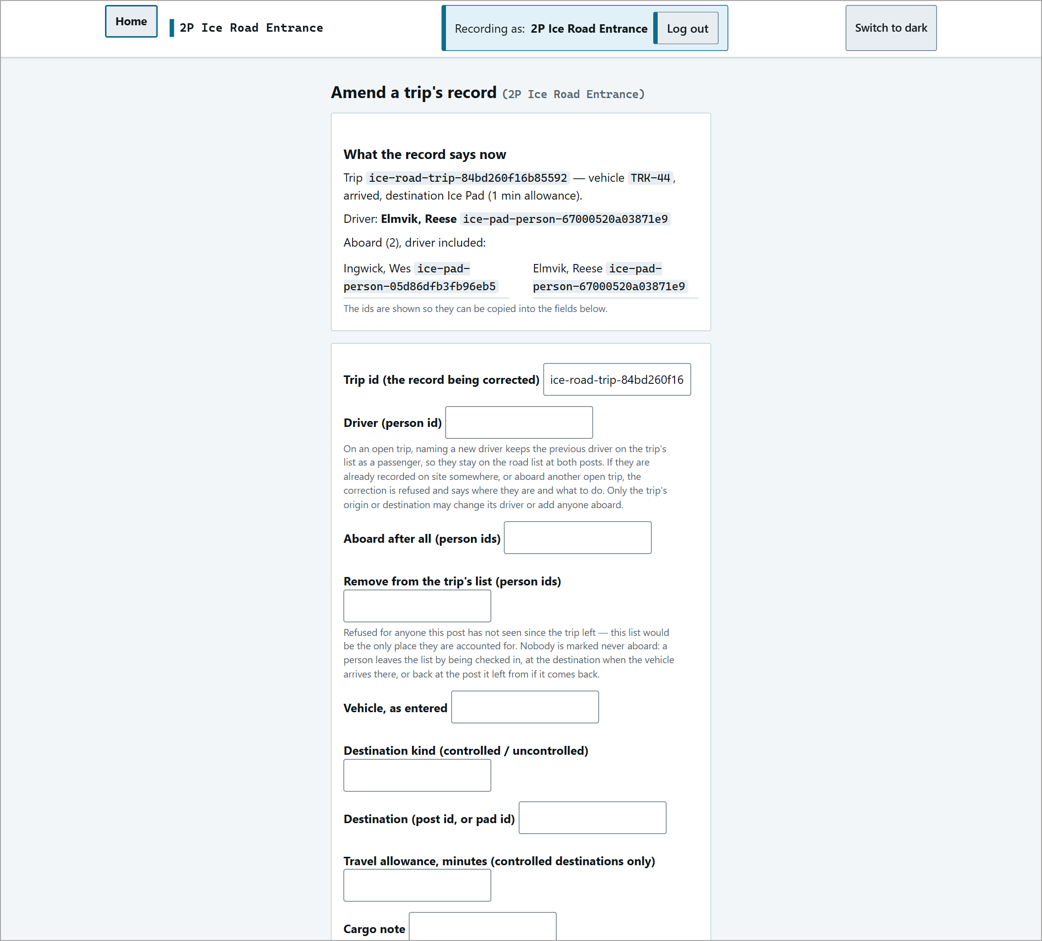
The trip correction form.
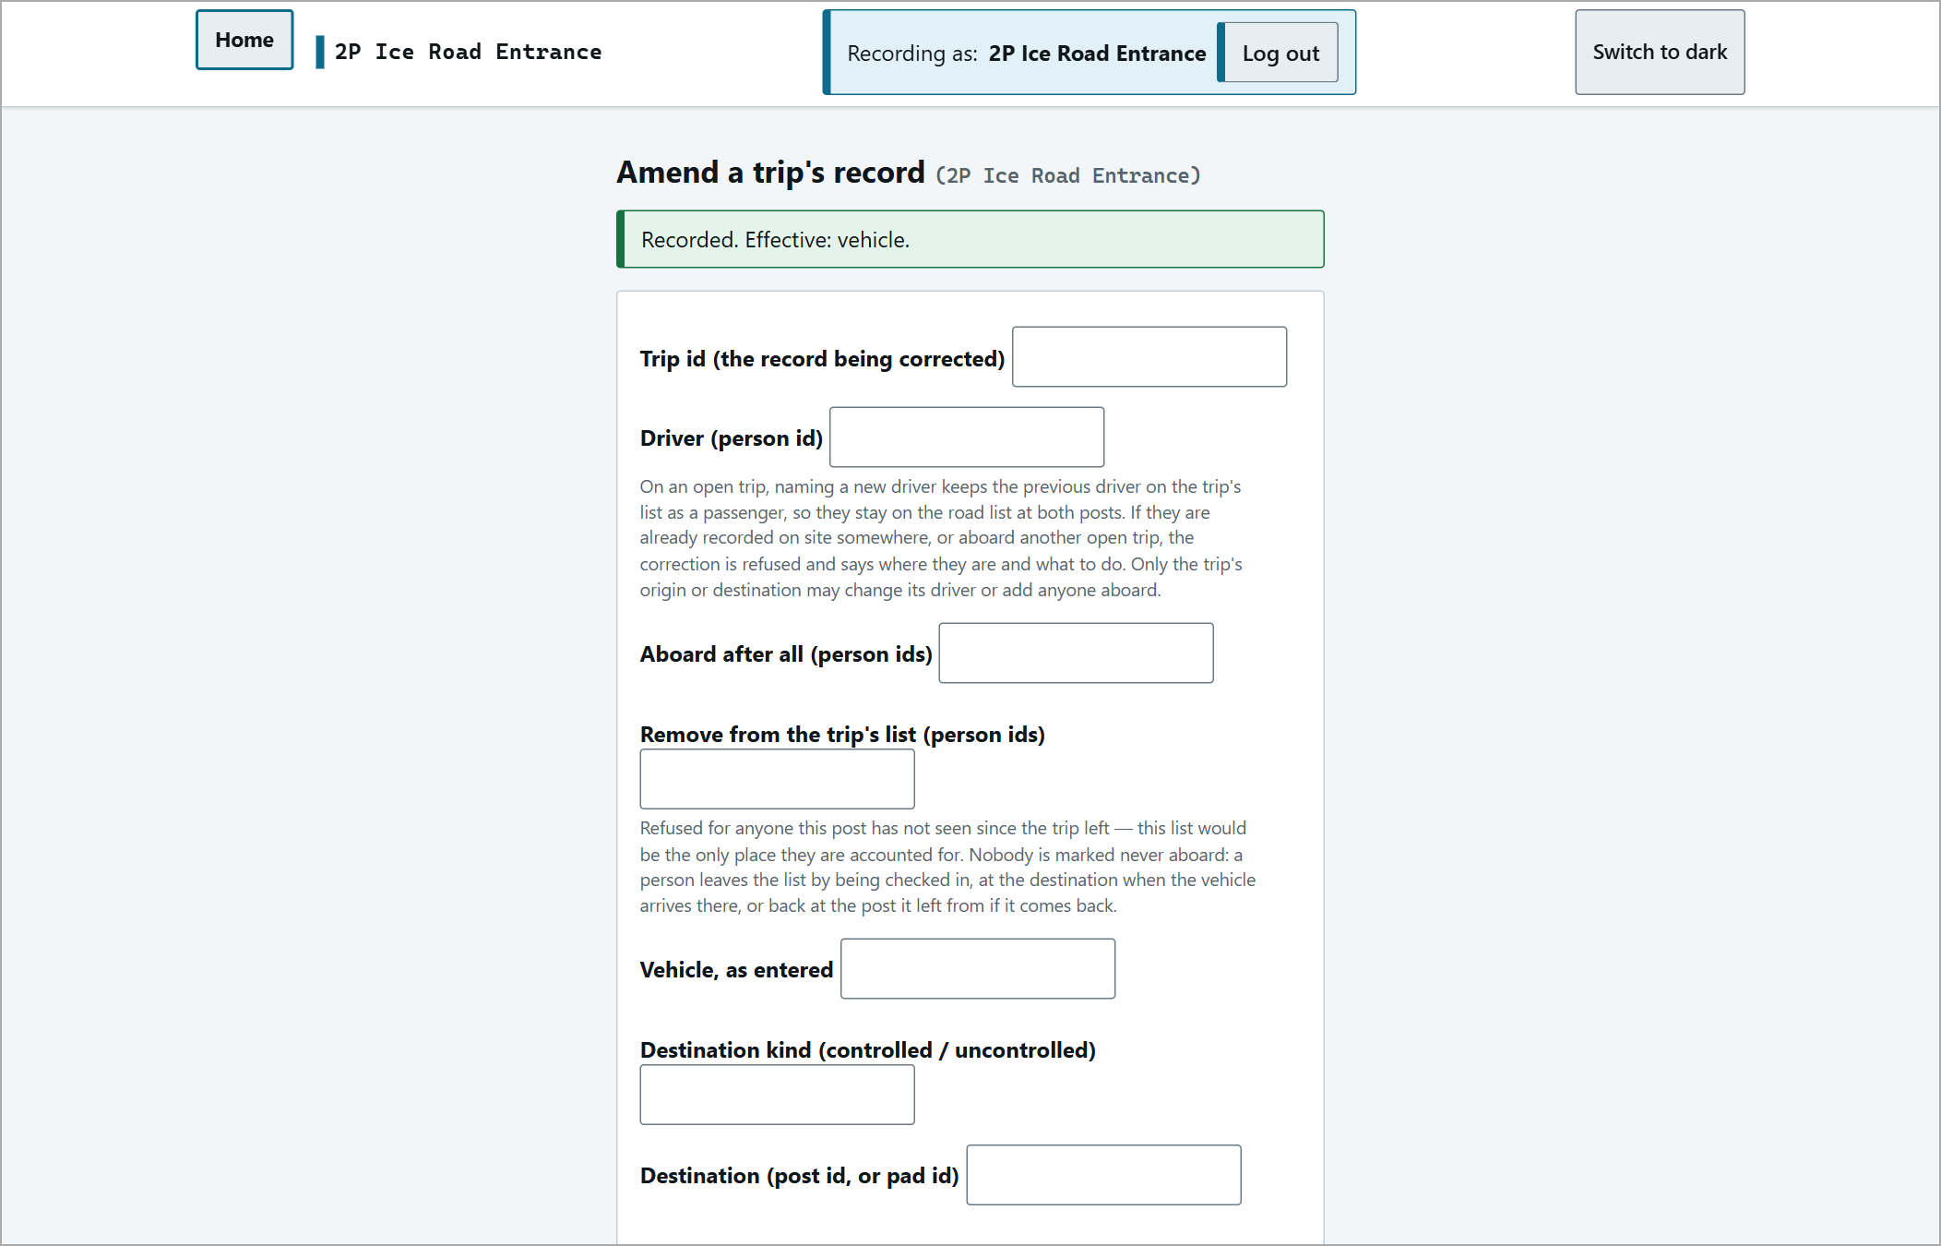
"Recorded. Effective: vehicle."
Reports and Analytics
dispatch analytics shows every post at a glance and refreshes every 60 seconds: persons on site, trips dispatched today / this season, in transit now, overdue now, working on the road, and signal to each post. A red STALE DATA notice names posts this one cannot currently vouch for.
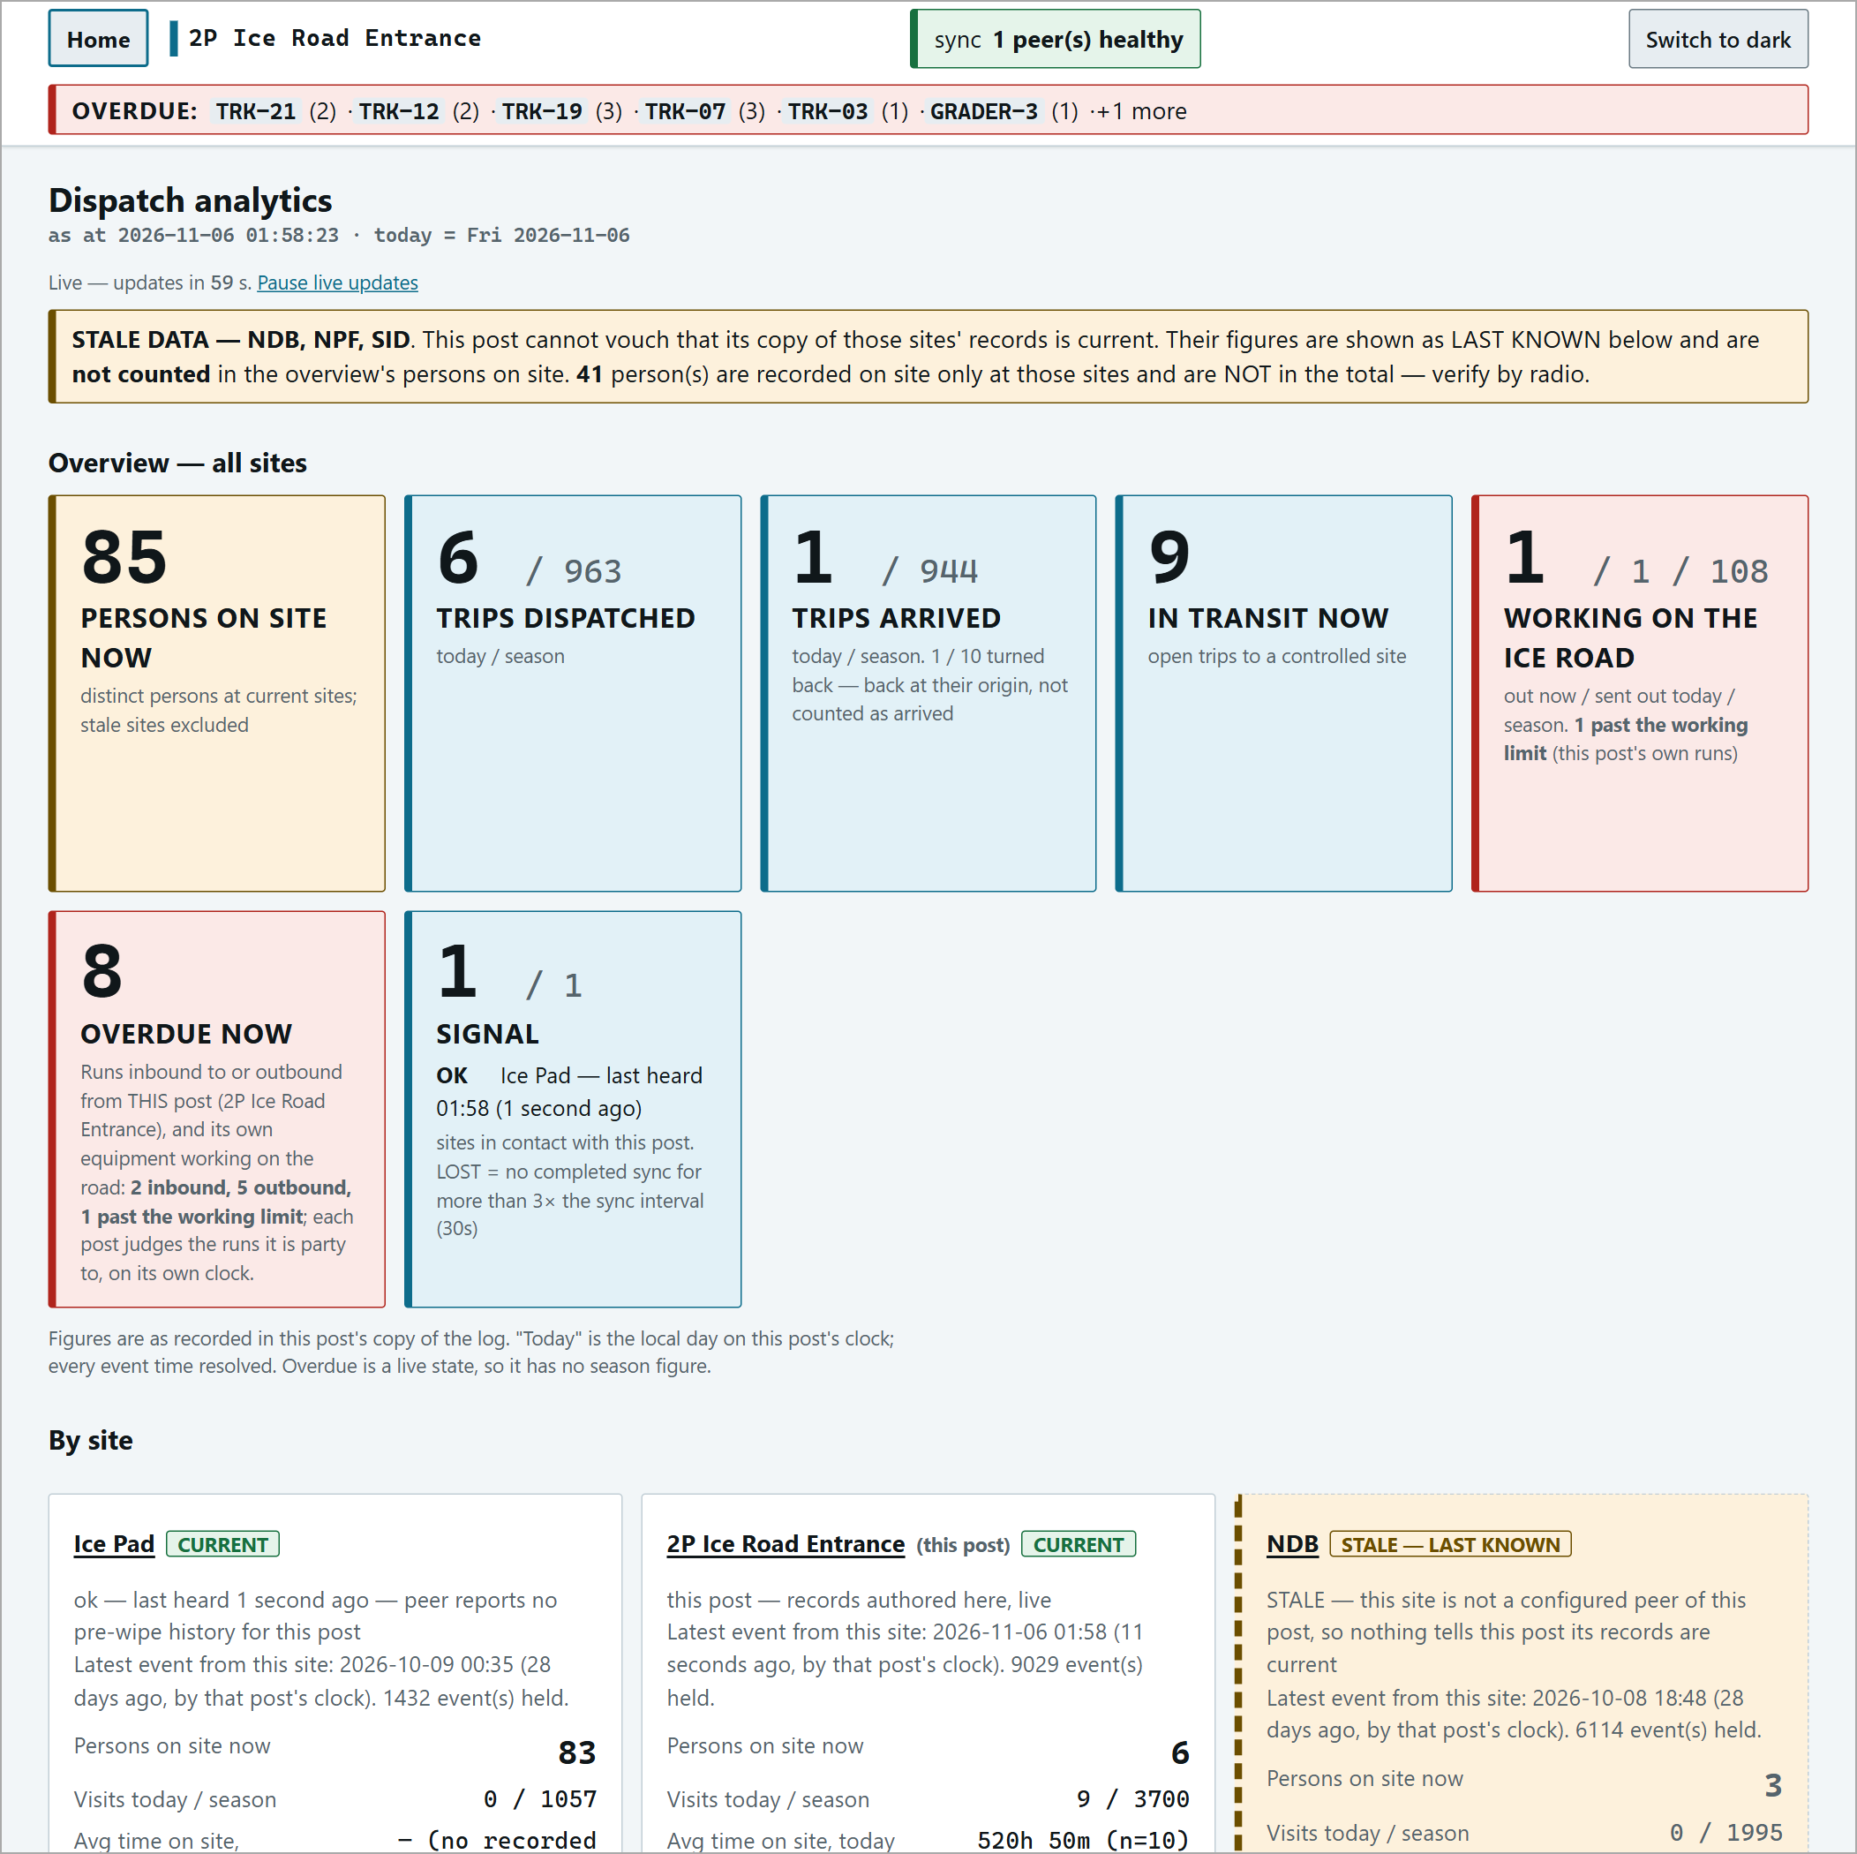
Dispatch analytics with trips in transit and overdue.
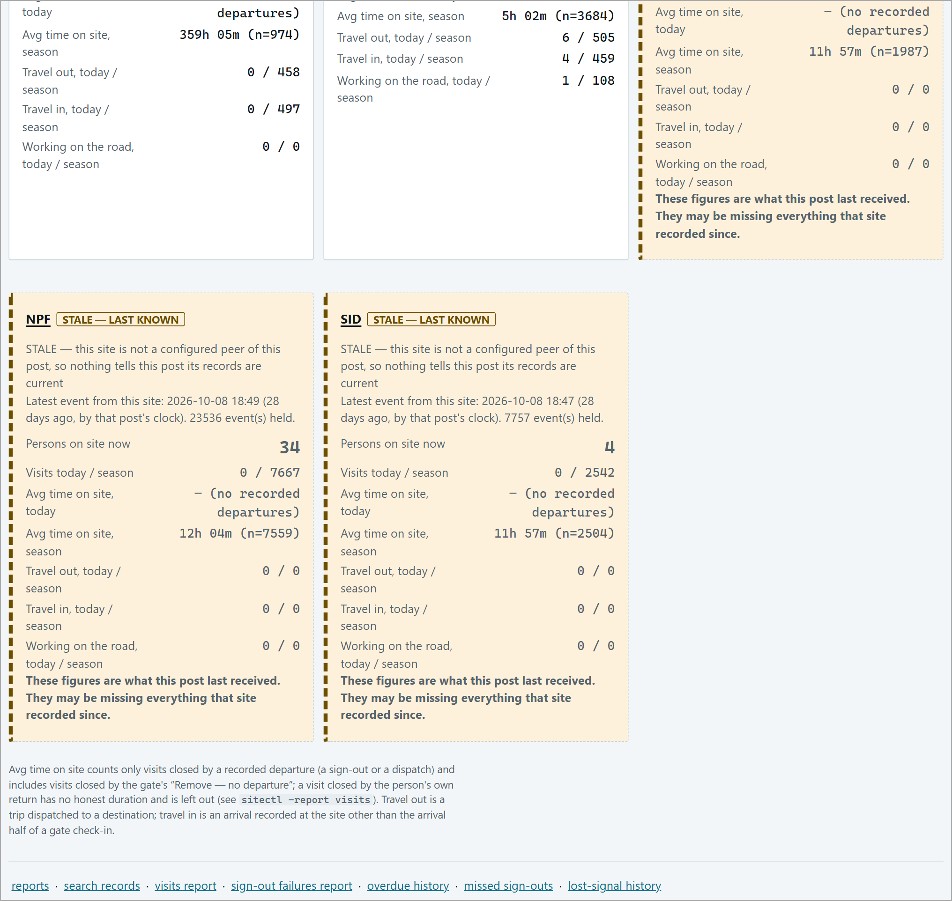
Analytics - per-site cards (CURRENT / STALE - LAST KNOWN).
Overdue history | Every late run, who acknowledged, the outcome. CSV.
Missed sign-outs | People whose visit was only closed by their next return, with repeat flags.
Lost-signal history | Every outage by date and post.

Troubleshooting
Situation | What to do
"a trip with a destination requires a deadline" (gate) | Open Deadline: not set (change) and enter the minutes. The gate never fills it in.
"NOT RECORDED - destination ... is uncontrolled" | Clear the Deadline box - uncontrolled runs take no deadline.
Dispatch refused / nobody as driver | Pick a driver - nobody is pre-selected - and tick them in Other occupants too.
Driver not in the list | They are not recorded on site here. Check them in at the gate first.
Nothing happened after a button | Success is silent. Look for the card to move or appear, or check the muster.
Someone was not checked in on arrival | Their box was ticked (ticked = left out), or they lack the post's orientation (NOT ENTERED - NO ORIENTATION).
Red OVERDUE bar | Radio; record the arrival or turn-back if it happened; Acknowledge (logged).
Acknowledged but the card is still there | Correct - it stays until the arrival is recorded.
Outbound card won't close | The receiving post must record the arrival, and it must sync back. Check the signal.
"ALSO ON SITE AT <post>" | Someone arrived unlisted while still signed in elsewhere. Confirm, then sign them out at the other post.
Names under NOT TRACKED | Someone was left off on arrival. Find them and record where they are.
Times differ between screens | Muster and history are UTC; the gate and console use the post's local clock.

Quick Reference
Send a vehicle | Console > A vehicle is leaving > vehicle, driver, occupants (incl. driver) > destination button > OK
Gated trip | Deadline minutes (blank = normal time on the console; required at the gate)
Pad (no gate) | Deadline EMPTY > Record run to <pad> > returns via Back from a pad
Road work | Working on the ice road > Back from the road when it returns
Expected arrival | Vehicle page > open row > Check in (N)
Some missing | Overdue row > adjust > untick only who is not here
Unlisted arrival | Console > A vehicle has arrived > tick people > Record arrival
Turned back | Outbound card > Arrived back here - it turned back
OVERDUE | Radio > record arrival / turn-back > Acknowledge (logged)
Lost signal | Keep working; verify by radio; it catches up
Fix a trip | all trips & drivers > correct this record (person ids)
Tick boxes | Always mean LEAVE OUT

Supervisor contact: ________________________________

