_{CA169 Assignment 1 Lab Report}

_{Submit these pages onwards.}

Date: | 09/03/2019
STUDENT NAME: | James Fallon
STUDENT NUMBER: | 18394123
PROJECT NUMBER: | 1
MODULE CODE: | CA169
DEGREE:  [CA EC ECSA PSSD] | CA
LECTURER: | Brian Stone

Declaration
In submitting this project, I declare that the project material, which I now submit, is my own work. Any assistance received by way of borrowing from the work of others has been cited and acknowledged within the work. I make this declaration in the knowledge that a breach of the rules pertaining to project submission may carry serious consequences.

Answer Sheets

Ipconfig exercise
IP address of the machine | 136.206.18.49
MAC address | 34-17-EB-B8-98-00

Ping exercise 1
What is displayed?

The ping command returns the usage of ping and all its options. A brief explanation of what each option does is also displayed.

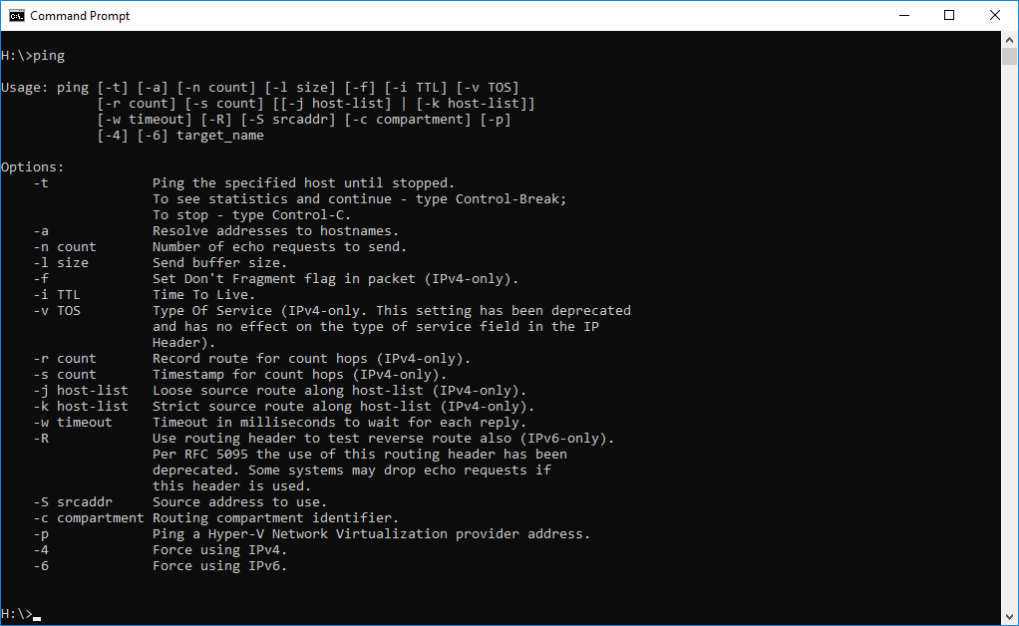

Ping exercise 2

First part exercise 2

Ping localhost
Paste window here.
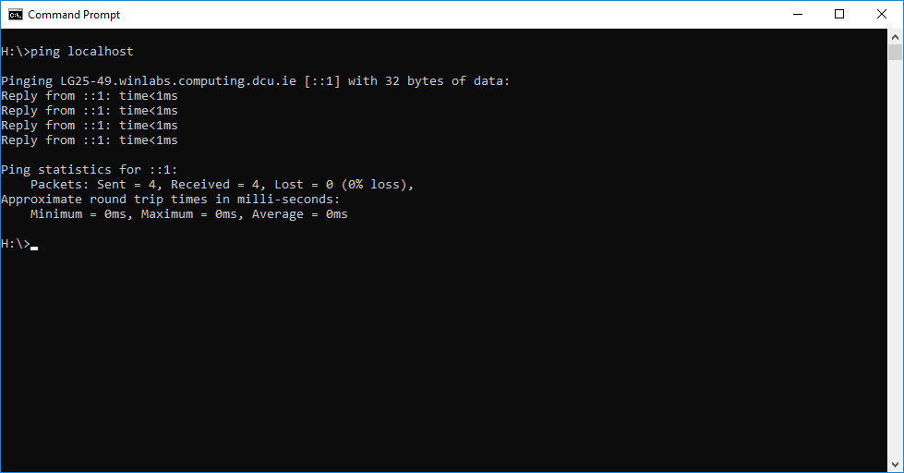

- What information is returned?
- What is the localhost?

Answer 1
Localhost points to your IPv4 and IPv6 loopback which is often ::1. These were pinged with 32 bytes of data. The time the machine takes to reach these and reply is returned. The amount of packets sent and received is recorded as well as how many were lost. The round trip time is displayed. The average trip in this case is 0ms.

Answer 2

The localhost is this computer that I’m using. It’s the name describing the local computer address. Mine is LG25-49.winlabs.computing.dcu.ie.

Second part exercise 2

For higher marks
Rteplayer.tv is also hosted on 104.18.162.29.
Domain: rte.ie
Domain Holder: RTE Commercial Enterprises Limited
IP Location: California – San Francisco – Cloudflare Inc.
Account Name: DIRECT REGISTRANT
Registrar Abuse Contact: reg-abuse@iedr.ie
I found this information by looking up reverse IP lookup. This then redirected me to http://reverseip.domaintools.com
Google.com is hosted on 74.125.193.100.

Ping and/or enter into browser the three addresses.
Paste windows here

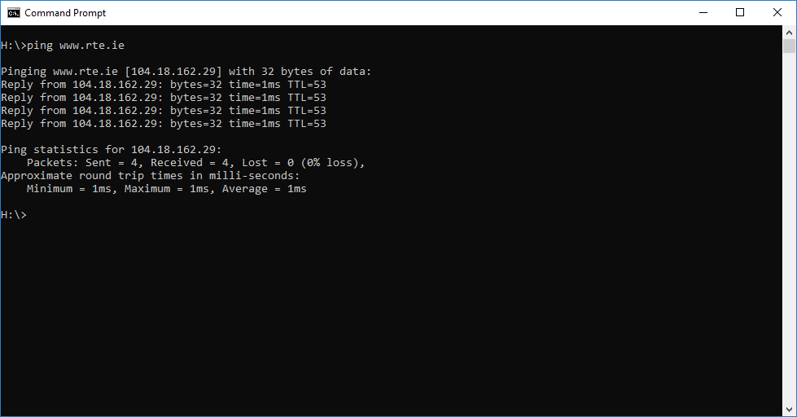

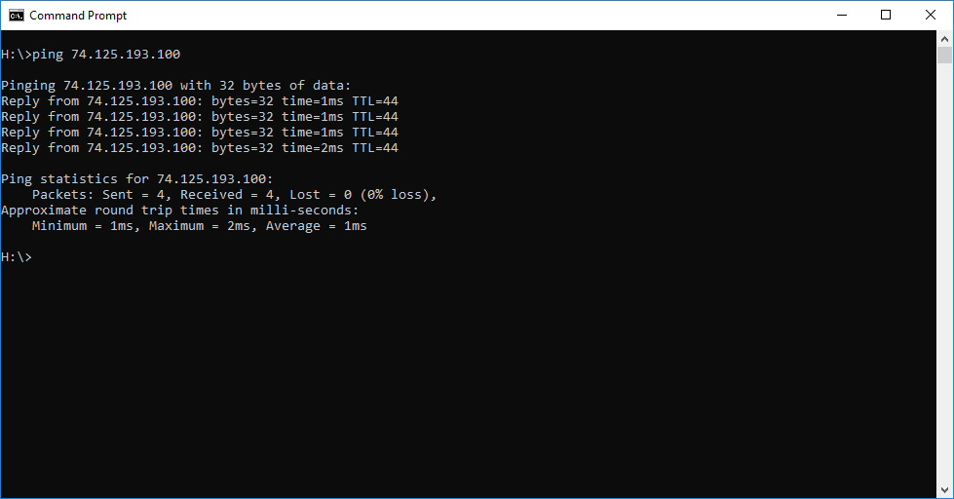

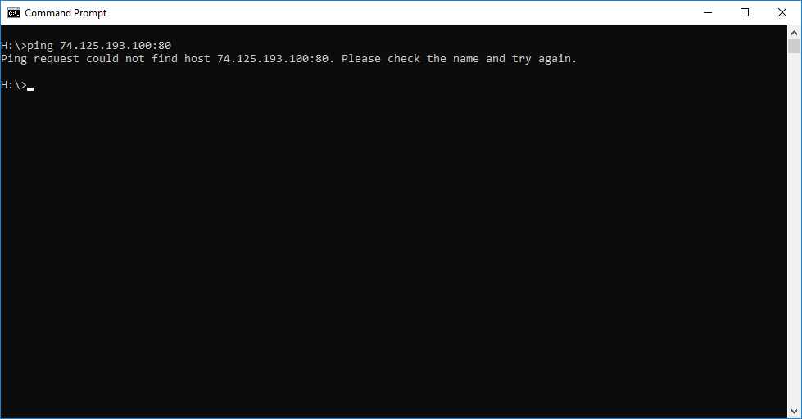

Explain output here, item by item.
“Pinging www.rte.ie” When I asked it to ping “rte.ie”, it looked up the corresponding IP address. It then sends 32 bytes of data to this IP address.
“Reply from 104.18.162.29” This tells you that the remote server at the IP address replied.
“time=1ms” This is the round trip time. The time between sending “are you there?” and receiving “yes I am”. In this case it took 1 millisecond.
“Sent = 4, Received = 4” TCP/IP is designed to deal with packet loss. Every packet you send should get to where it’s going, but that doesn’t always happen. Ping sends multiple packets and reports the success rate so you can see if this connection is prone to packet loss.
“Approximate round trip times” Some packets take longer than others. Ping reports these statistics so you can see if the connection is prone to this type of problem. In this case the average was 1 millisecond.

Exercise 3
Paste window 1

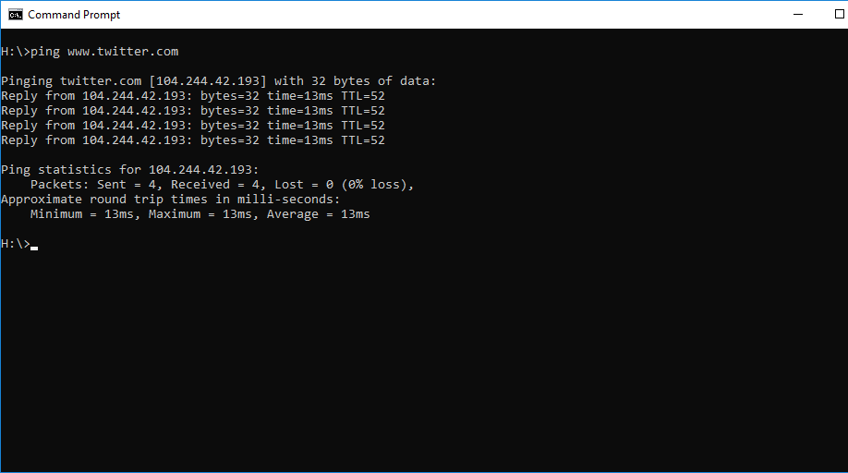

Paste window2

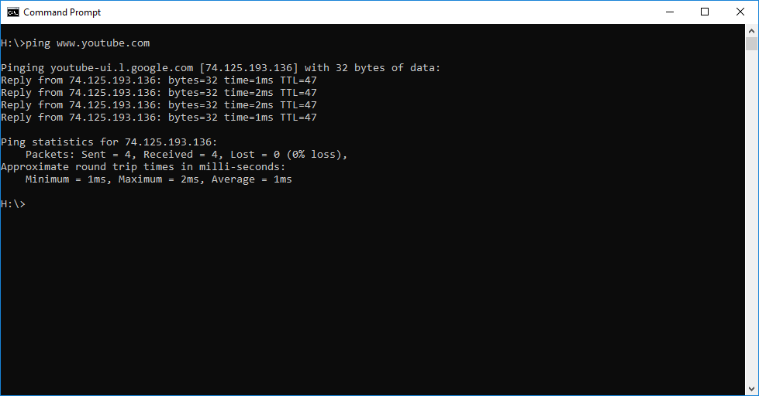

 | Website 1 | Website 2
Name of the website pinged | www.twitter.com | www.youtube.com
What is the IP address returned? | 104.244.42.193 | 74.125.193.91
What is the TTL figure? | 52 | 47
Average round trip time | 13ms | 1ms

13 milliseconds was the largest round trip time I could find. The factors that could have affected this include: Infrastructure components, network traffic, and physical distance along the path between me and the destination.

Your comments on administrative information that you found by searching on the Internet about the websites from experiment 3. Things like, who owns it, phone numbers, email addresses, registered addresses etc, anything at all that tells us about the website and its administration.
Twitter.com
Country Code: US
Country Name: United States
Region: California
City: San Francisco
Domain Name: TWITTER.COM
Registrar: CSC Corporate Domains, Inc
Registry Domain ID: 181959971_DOMAIN_COM-VRSN
Registrar Abuse Contact Email: domainabuse@cscglobal.com
Registrar Abuse Contact Phone: 8887802723

Youtube.com
Country Code: US
Country Name: United States
Region: California
City: Mountain View
Domain Name: YOUTUBE.COM
Registrar: MarkMonitor Inc.
Registry Domain ID: 142504053_DOMAIN_COM-VRSN
Registrar Abuse Contact Email: abusecomplaints@markmonitor.com
Registrar Abuse Contact Phone: +1.2083895740

*Information found on www.whois.net

Exercise 4: Netstat exercise

Number of packets received by workstation:

Number of packets = 20930

Window here.
The netstat -s switch displays per-protocol statistics.

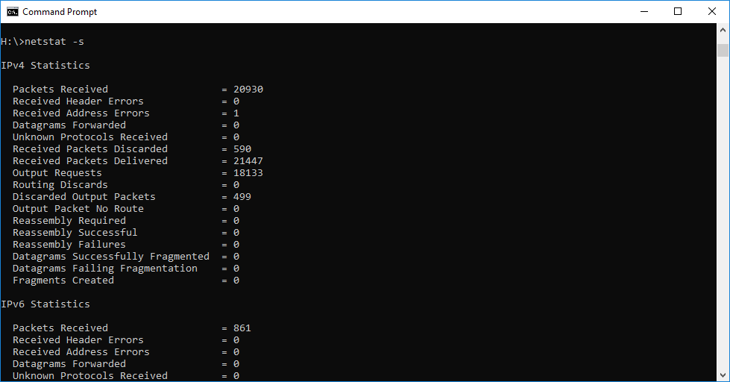

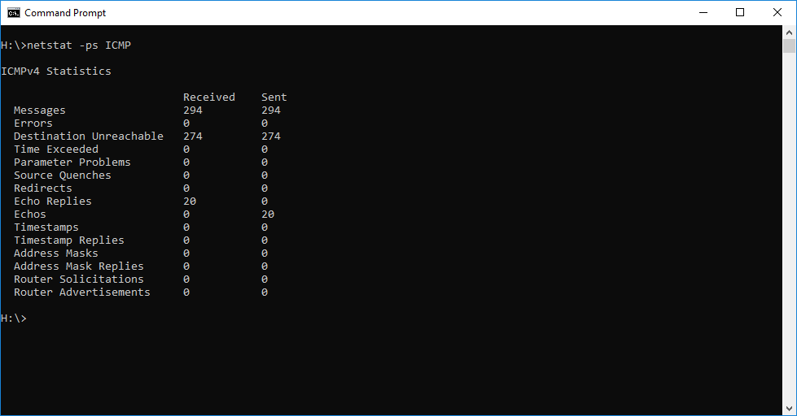

ICMP packets explained:
ICMP Messages:
Echos, Echo Replies
Used to test destination accessibility and status. A host sends an Echo Request and listens for a corresponding Echo Reply.
Destination Unreachable
Sent by a router when it can’t deliver an IP packet.
Source Quenches
Sent by a host or router if it is receiving data too quickly for it to handle.
Redirects
Sent by a router if it receives a packet that should have been sent to a different router.
Router Advertisement, Router Solicitation
Allows hosts to discover the existence of routers. Routers periodically broadcast their IP addresses via Router Advertisement messages. Hosts may also request a router address by broadcasting a Router Solicitation message to which a router replies with a Router Advertisement.
Time Exceeded
Sent by a router if the packet has reached the maximum limit of routers through which it can travel.
Parameter Problem
Sent by a router if a problem occurs during the transmission of a packet such that it can’t complete processing.
Timestamp, Timestamp Reply
Used to synchronize the clocks between hosts and to estimate transit time.
Address Masks, Address Mask Replies
Used to find the mask of the subnet (i.e. what address bits define the network).

ICMP packets are IP packets that have data stored in them. This information can be error messages. The above shows that 294 sent ICMP packets which came from pinging servers. If it reaches the given destination then we receive an ICMP echo reply as shown above.

Discuss the connections opened by visiting the DCU website here.

Using netstat –a shows all active connections. We can see the connections opened by connecting to the DCU website. We know a connection has been made because it is in the established state. We can also see the IP addresses that the computer has connected to.

Also, grab the window, showing connections opened as a result of visiting the DCU website.

Before visiting the DCU website:
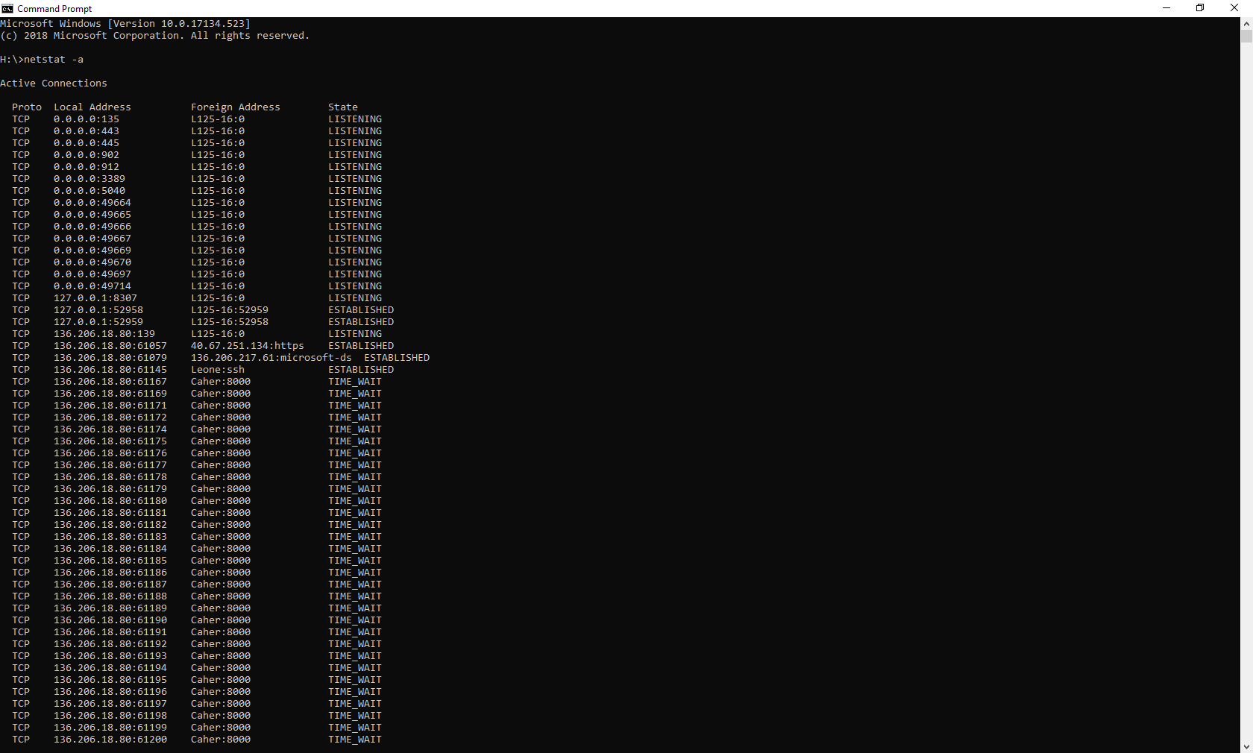

After visiting the DCU website:
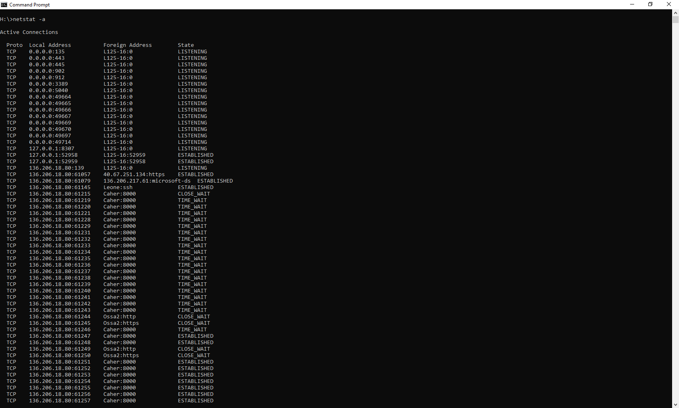

Netstat –r explained
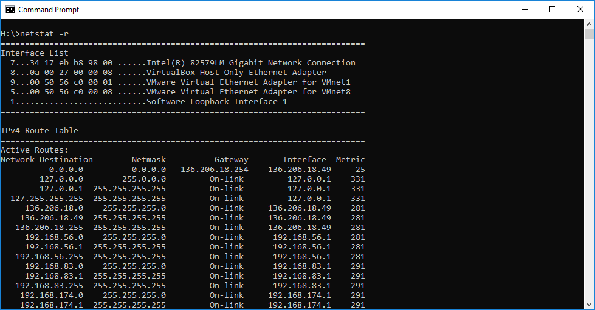
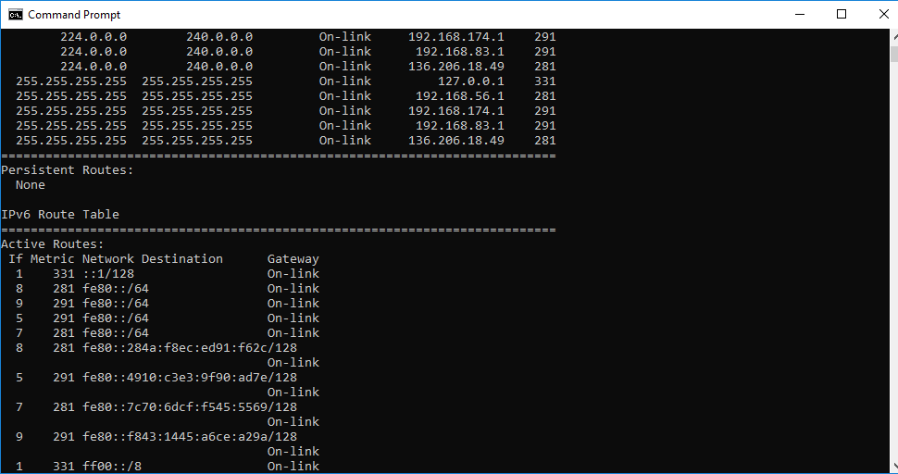
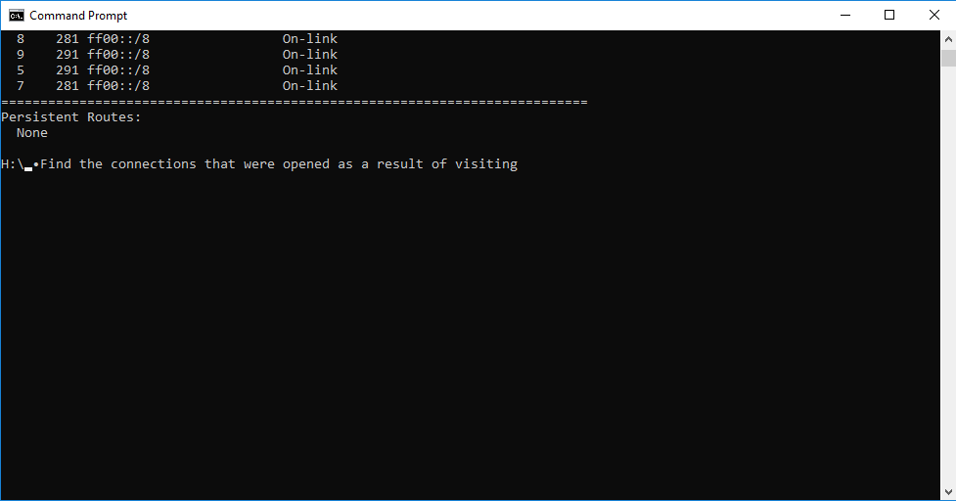

Netstat -r shows the IP routing table. This is the same as using the route command to execute route print. Routing is used to set IP packets first hop according to their destination. Our system route information can be listed with this –r option. There is one table displayed for IPv4 and one for IPv6. This information shows the best route to take when the computer sends data to these networks.

