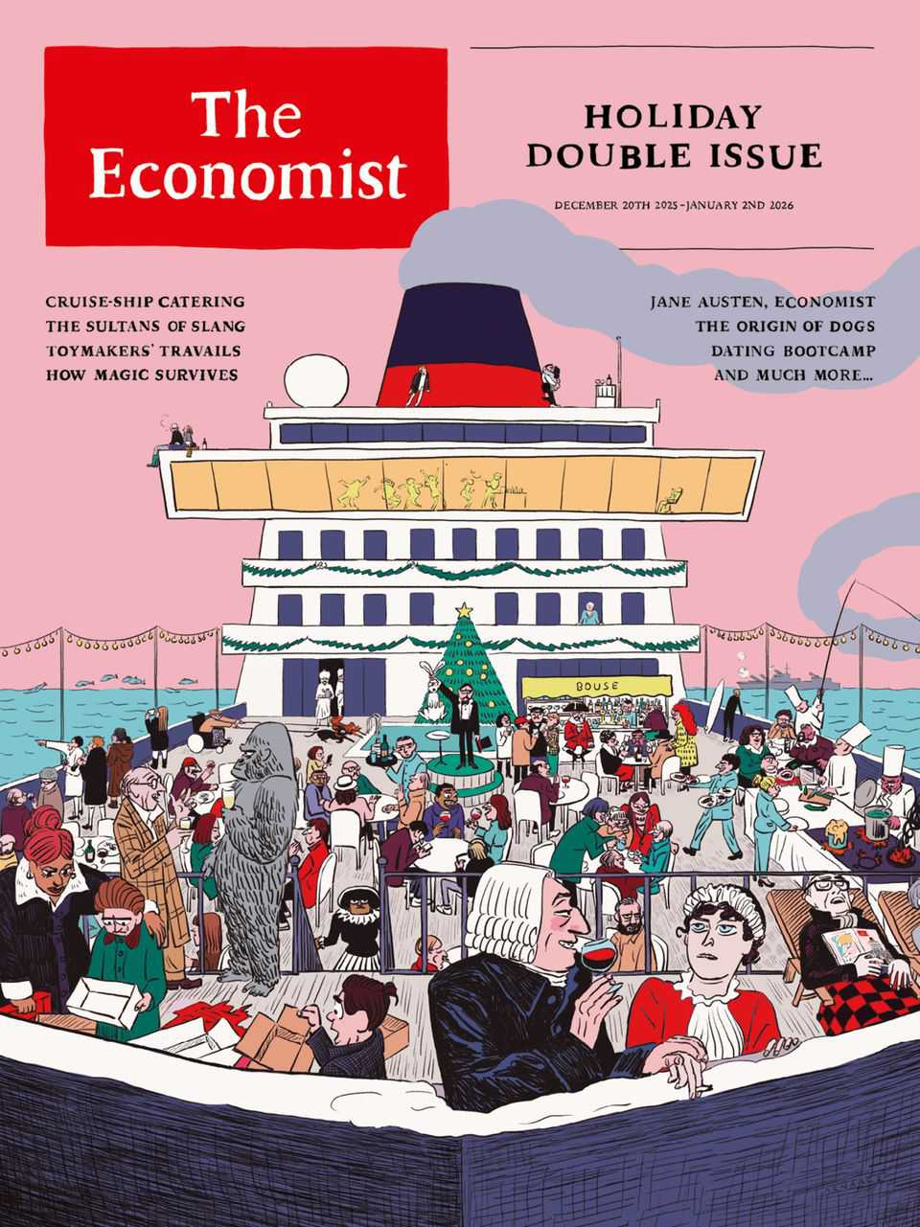

Table of Contents
The world this year 2025
The weekly cartoon
China proved its strengths in 2025—and Donald Trump helped
Two months in, the Gaza ceasefire is floundering
The Economist’s country of the year for 2025
What Novo Nordisk, OpenAI and Pop Mart have in common
Your Well Informed guide to surviving Christmas
Europeans should be worried by America’s new national security strategy
Will California try to block Hollywood’s next megadeal?
Toll roads are spreading in America
More schools in America are adopting a four-day week
The race for an AI Jesus is on
A vote against gerrymandering shows why political courage is rare
An oil boom where the Amazon meets the Atlantic
Javier Milei loosens his grip on the peso
Can Australia defend itself against jihadist murderers?
Why has the border between the Koreas fallen silent?
The botched response to a devastating storm infuriates Indonesians
Jimmy Lai’s judgment day
The Christmas-industrial complex centres on Yiwu
Donald Trump’s peace plan is faltering in the chaos of Gaza
Just 74 intensive-care beds remain in Gaza
Ethiopia wants to build Africa’s biggest airport
Ukraine scrabbles for handholds against Russia’s massive assault
Italy is using the Winter Olympics to appeal to the ultra-wealthy
Why German cities feel like war zones on New Year’s Eve
European nationalism is dead. Long live European gastronationalism
How to heal the trauma from Northern Ireland’s killings
Britons are becoming obsessed with pet photography
A portrait of Britain’s aristocrats
All sides have learned a lot from Extinction Rebellion’s co-founder
A journey into the world’s most mysterious rainforest
What The Economist discovered at dating bootcamp
How humankind’s 10m-year love affair with booze might end
The tariffs that nearly stole Christmas
From honeycomb curry to blood fry: India’s “untouchable” cooking
The battle to stop clever people betting
Adam Smith is misinterpreted and his influence overstated
What street talk reveals about Anglophone civilisation
America’s fight back against China starts in Los Angeles—in flip-flops
The long, strange journey of a temple from profane to sacred
What if the best way to learn about history is by playing with it?
How two explorers, a mother and a baby made America
The titanic task of catering on the world’s biggest cruise ship
How wolves became dogs
A journey along East Asia’s hidden artery
How Jane Austen revealed the economic basis of society
Was Mr Darcy the richest of all Jane Austen’s characters?
The most friendless place on earth
Two centuries ago, Russian revolutionaries tried to change the world
The rise and fall and rebirth of lapsang souchong
How magicians stay relevant in the age of AI
Ditch textbooks and learn how to use a wrench to AI-proof your job?
How to survive abandonment by America
The plan to rescue Novo Nordisk
Retreating from EVs could be hazardous for Western carmakers
Job apocalypse? Not yet. AI is creating brand new occupations
Luxury handbags may be shoddier than you think
How to conduct a job interview
SpaceX, OpenAI, Anthropic and their giga-IPO dreams
Where America’s most prominent short-sellers are placing their bets
Meet the American investors rushing into Congo
This Christmas, raise a glass to concentrated market returns
Crypto’s real threat to banks
Watch who you’re calling childless
A debate is raging over the origins of an elusive cousin to modern humans
Saudi Arabia wants to host the world’s cheapest data centres
How dogs make teens feel less anxious
Are some types of sugar healthier than others?
What goes into raising the turkey on your holiday table
And 2025’s winners are…Timothée Chalamet and Sydney Sweeney
The best podcasts of 2025
Economic data, commodities and markets
Iain Douglas-Hamilton fought to save the beasts he loved


December 20th 2025
- The world this week
- Leaders
- Letters
- United States
- The Americas
- Asia
- China
- Middle East & Africa
- Europe
- Britain
- Christmas Specials
- International
- Business
- Finance & economics
- Science & technology
- Culture
- Economic & financial indicators
- Obituary
优质App推荐
 Duolingo - 快乐、高效学外语, 带你玩转听说读写! 点击下载
 英阅阅读器 - 让您高效阅读英语书, 点击查词、句子翻译、背单词、AI大模型等一应俱全! 点击下载
 Notability - 高效、便捷的PDF笔记App, 随时记录你的想法! 点击下载
 欧路词典 - 英语学习者的必备词典App! Android、iOS、电脑端全平台可用。点击下载

The world this week
- The world this year 2025
- The weekly cartoon
The world this week | The world this year 2025

The world this year 2025

December 18th 2025

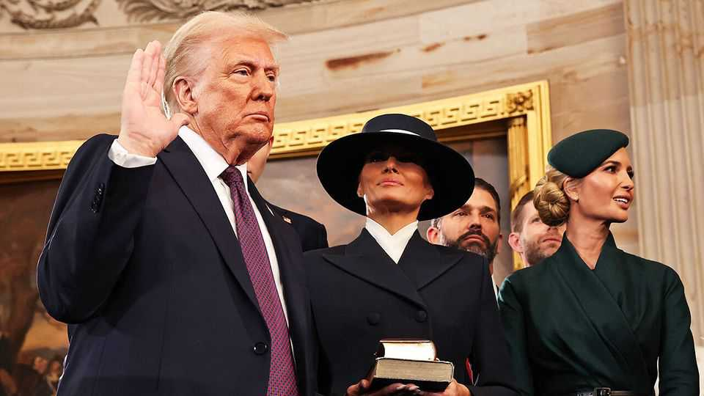
The first year of Donald Trump’s second term turned domestic and international politics on its head. The president withdrew America from the Paris accord on climate change, deployed the armed forces to crack down on migration at the border, ordered the National Guard into cities to help arrest illegal migrants, scrapped all diversity programmes in government, cancelled policies supporting renewable energy, attacked judges he disagreed with and renamed the Defence Department the Department of War. The fractious mood in America worsened with the murder in public of Charlie Kirk at a college in Utah, where students had come to debate his conservative politics.
Mr Trump also instigated tough trade policies, though the world economy remained remarkably resilient and is forecast to grow by around 3% in 2025. His big-bang “Liberation Day” tariffs in April led to the biggest fall in stockmarkets for the year. The S&P 500 tumbled by 4.9% in a day (and a further 6% on the following day) and the NASDAQ by 6%. Many tariffs were eventually lowered or postponed, however, leading stockmarkets to bounce back. Overall, they had another good year.
The bosses of OpenAI, Oracle and SoftBank joined Mr Trump at the White House soon after his inauguration to announce the Stargate project, a $500bn investment in the infrastructure for artificial intelligence. A new AI industrial policy emerged in America, with the government taking a 10% stake in Intel. The pace and size of AI deals were mind-boggling, $50bn here, $300bn there, and stocks in AI-related companies soared. Nvidia became the world’s first $4trn company, and just a few months later the first $5trn one (albeit briefly). Investors have some doubts, however, about whether all that spending on AI will produce profits. Stocks swooned in January when DeepSeek, a Chinese firm, developed an AI model at a fraction of the cost of ChatGPT and the rest.
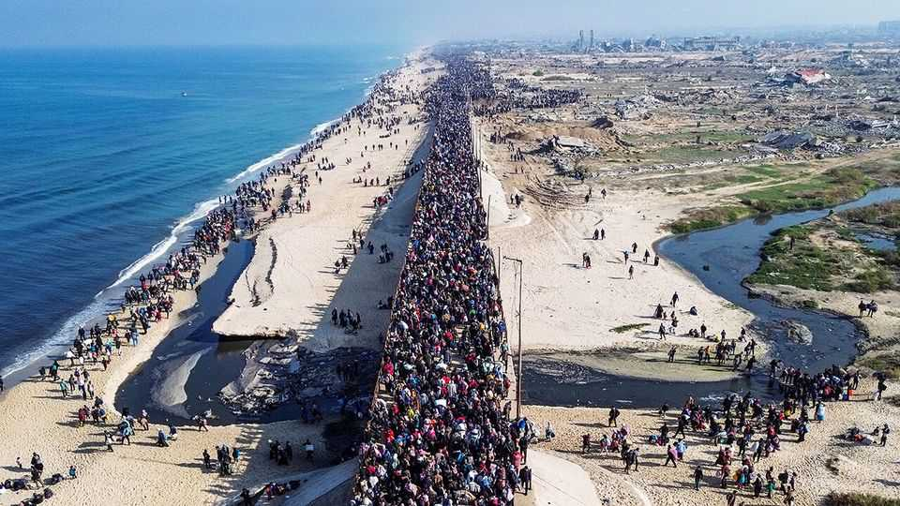
A ceasefire eventually came into force in Gaza, in large part because of the pressure Mr Trump put on Israel and Hamas and some energetic shuttle diplomacy by his envoys. America unveiled an ambitious peace plan for the region that was given a cautious welcome. The remaining Israeli hostages were freed by Hamas and Israel allowed in some aid for Gaza’s hungry and shattered residents. Skirmishes continue and the peace remains fragile. Israel bombed Iran, wiping out a number of senior regime officials, including the chief of staff of the armed forces and the head of the Islamic revolutionary guard, as well as 11 nuclear scientists. During the 12-day campaign America dropped bunker-busting bombs on Iran’s uranium-enrichment facilities. Iran made a symbolic retaliation by firing missiles at America’s military base in Qatar.
In December two gunmen killed at least 15 people at a Jewish event at Sydney’s Bondi Beach. The gunmen were followers of Islamic State and had spent time in the southern Philippines, were IS is active. Earlier in the year a Syrian-born man attacked a synagogue in Manchester. He fatally stabbed one person and the police accidentally killed another. And a Palestinian sympathiser shot dead two Israeli embassy staff outside a Jewish museum in Washington.
America’s new national security strategy proclaimed its dominance in the Western Hemisphere. For the first time America’s armed forces attacked suspected drug-smuggling boats in the Caribbean and eastern Pacific. Mr Trump threatened to bomb or even invade Venezuela to oust Nicolás Maduro as president. Colombia was decertified as a partner in fighting drugs; Mr Trump called its leftist president an “illegal drug leader”. Violence rose in the country. Miguel Uribe Turbay, a conservative presidential candidate, was fatally shot at a rally. Mr Trump also floated using force to take control of the Panama Canal. Not all Latin American countries fell out with him. El Salvador struck a deal to house deported drug criminals from America in its prisons.
Jair Bolsonaro, a former president of Brazil, was found guilty by the country’s Supreme Court of conspiring to launch a coup after he lost an election in 2022 and sentenced to 27 years in prison. At the end of the year the Brazilian Congress passed a bill that could reduce that sentence to as little as two years, though this would have to be approved by the court.
Elon Musk was put in charge of the new Department of Government Efficiency, which recommended the mass firing of federal workers (317,000 left their jobs for one reason or another). But Mr Musk fell out with Mr Trump over the president’s “big beautiful” tax-cutting bill, which increased the deficit. A row in Congress over health care meant that a bill to renew federal spending was delayed, leading to America’s longest-ever government shutdown.
Mr Musk was awarded a remuneration package by Tesla worth up to $1trn (depending on very ambitious performance targets). Tesla had a mixed year, recording steep declines in deliveries. The pace of growth in the demand for pure electric vehicles stalled in America and Europe, but sales of hybrids increased. Recognising the new reality, the EU eased a plan to ban sales of new petrol-engine cars by 2035; now emissions will have to be 90%. Norway was a notable exception to the EV reversal. Nearly 100% of new car sales in the country were electric.
The worst military conflict in decades broke out between India and Pakistan, sparked by a terrorist attack in Jammu and Kashmir that killed 26 people. India blamed Pakistan for giving succour to the attackers and fired missiles at what it said were terrorist bases in Pakistan. Pakistan responded with drone and missile strikes. Tensions remain high; incidents such as a deadly car bomb near the Red Fort in Delhi haven’t helped.
The year’s other big stories from Asia included the removal from office of Yoon Suk Yeol as South Korea’s president, following his imposition of martial law in late 2024. A subsequent election was won by Lee Jae Myung of the Democratic Party. Japan got its first female prime minister. Takaichi Sanae is described as the country’s Margaret Thatcher. She has the same proclivity for controversy, soon starting a full-on diplomatic row with China over Taiwan. In Thailand the Constitutional Court dismissed Paetongtarn Shinawatra as prime minister after an ill-advised phone call she placed with Hun Sen, an influential Cambodian politician, amid border clashes between the two countries.
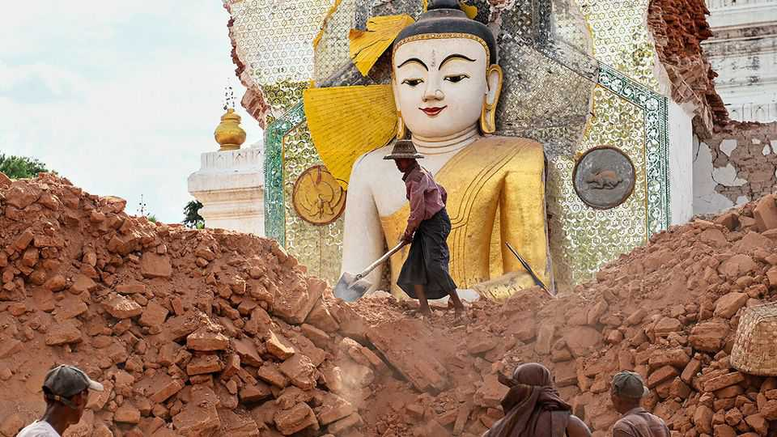
A devastating earthquake and aftershocks struck Myanmar, killing at least 5,500 people. The epicentre was close to Mandalay but the quake also caused damage in Vietnam and Thailand. A skyscraper that was under construction in Bangkok collapsed, killing about 95 people. Afghanistan was also hit by a large earthquake in which some 2,200 people died.
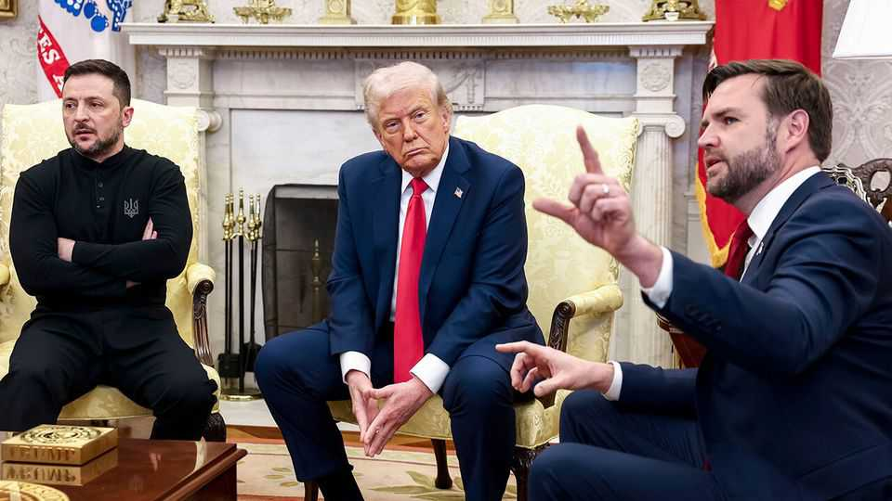
The war in Ukraine raged on, with Russia making (extremely limited) territorial gains. The Trump administration waxed and waned in its support of Ukraine. Volodymyr Zelensky’s visit to the White House in February was a disaster. He was berated by the president and J.D. Vance, the vice-president, in a public confrontation that was unprecedented for any world leader. Later in the year Ukraine rattled Russia by launching drone attacks on air bases and refineries deep inside the country. A much ballyhooed summit in August between Mr Trump and Vladimir Putin in Alaska came to naught. The year ended with America pushing a peace plan.
The Christian Democrats came first in Germany’s snap election, at which the populist-right Alternative for Germany got its best-ever result. Friedrich Merz, the new chancellor, said that Europe could no longer rely on America for its defence and loosened Germany’s constitutional “debt brake” in order to ramp up spending on weapons and infrastructure. France saw François Bayrou resign as prime minister over a budget row in the National Assembly. Sébastien Lecornu also resigned, after less than a month in the job, only to be reappointed by Emmanuel Macron.
The civil war in Sudan took a turn for the worse when el-Fasher, the besieged capital of Darfur, fell to the rebel Rapid Support Forces. The RSF, which is descended from the mostly Arab Janjaweed militias, went on a killing spree in the city. America has accused it of genocide. The office of the prosecutor of the International Criminal Court expressed “profound alarm” over possible war crimes.
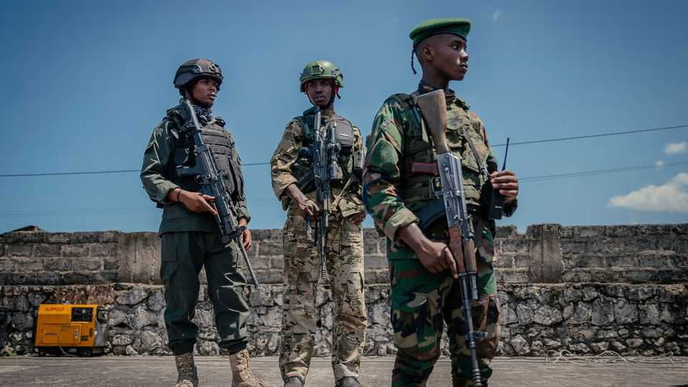
The conflict also intensified in eastern Democratic Republic of Congo, where Goma, the biggest city in the region, fell to M23 rebels backed by Rwanda. The Congolese and Rwandan presidents eventually signed a peace deal in Washington towards the end of the year, though the fighting continued to rage on the ground.
Mark Carney became Canada’s prime minister following the resignation of Justin Trudeau. An election in April returned the Liberals to office leading yet another minority government. Mr Carney promised to “stand up” to America. During a meeting at the White House with Mr Trump Mr Carney said Canada was not for sale.
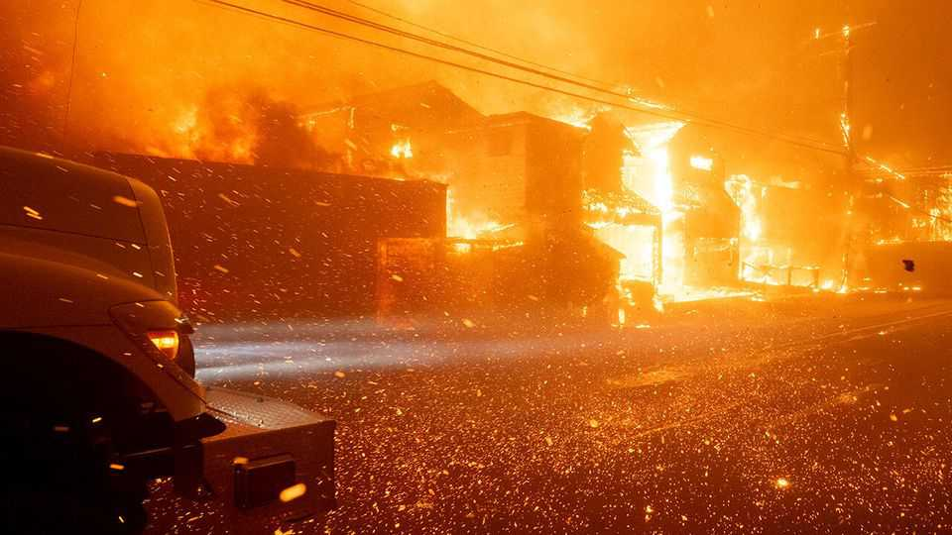
Los Angeles had a tough year. Wildfires destroyed the wealthy Pacific Palisades neighbourhood in January, killing 12 people and razing 6,837 structures to the ground. A man was eventually charged with arson in October. The first house to be rebuilt was finished in November. During the summer riots broke out in the city in response to the crackdown on migrants. On the opposite coast, New York elected Zohran Mamdani, a democratic socialist, as mayor. Mr Mamdani has promised to put affordable housing at the heart of his agenda when he takes office on January 1st.

Following the death of Pope Francis the Vatican conclave elected Cardinal Robert Prevost as pope, the first pontiff to hail from the United States. Pope Leo’s first foreign tour took him to Turkey, and Lebanon, where about 40% of the population is Christian.
Bishop Sarah Mullally was appointed as the first female Archbishop of Canterbury, following the resignation of Justin Welby in 2024. She is due to start the job early in 2026, but like her predecessor she has already become mired in scandal relating to the handling of allegations of sexual abuse by Church of England clergy.
It was a year of political upheaval in Turkey. Protests erupted following the arrest of the mayor of Istanbul, the main opposition figure to President Recep Tayyip Erdogan, on what his supporters claim are politically motivated corruption charges. Turkey’s markets plunged in response. In a historic decision the Kurdish Worker’s Party (PKK), which Turkey, America and the EU describe as a terrorist group, laid down its arms and said it would dissolve itself after four decades of conflict.
The American economy remained strong. Throughout the year Mr Trump put pressure on the Federal Reserve to cut interest rates and sought to remove Lisa Cook from the Fed’s board of governors; the Supreme Court will hold a hearing in January to determine if he has the power to do so. The Fed eventually started to reduce rates in September. Many other central banks, including the European Central Bank and Bank of England, also cut rates.
In Britain polling showed that Sir Keir Starmer is one of the most unpopular prime ministers ever, and Rachel Reeves, his tax-raising, welfare-spending chancellor, the most unpopular person in her job. Angela Rayner quit as deputy prime minister for not paying a property tax (she was also the housing minister). The populist-right Reform UK surged ahead in the polls. Even the Greens are polling as well as Labour. Sir Keir can take some Christmas comfort that the Tories are doing just as bad.
Warren Buffett decided to retire as chief executive of Berkshire Hathaway, a company he has led for six decades. At 95, the Oracle of Omaha will stay on as chairman when he passes the CEO job to Greg Abel in January. Berkshire’s stock has risen by 6,000,000% since 1965, outperforming the S&P 500, which is up by 46,000% over that period.
This article was downloaded by zlibrary from https://www.economist.com//the-world-this-week/2025/12/18/the-world-this-year-2025
The world this week

The weekly cartoon

December 18th 2025

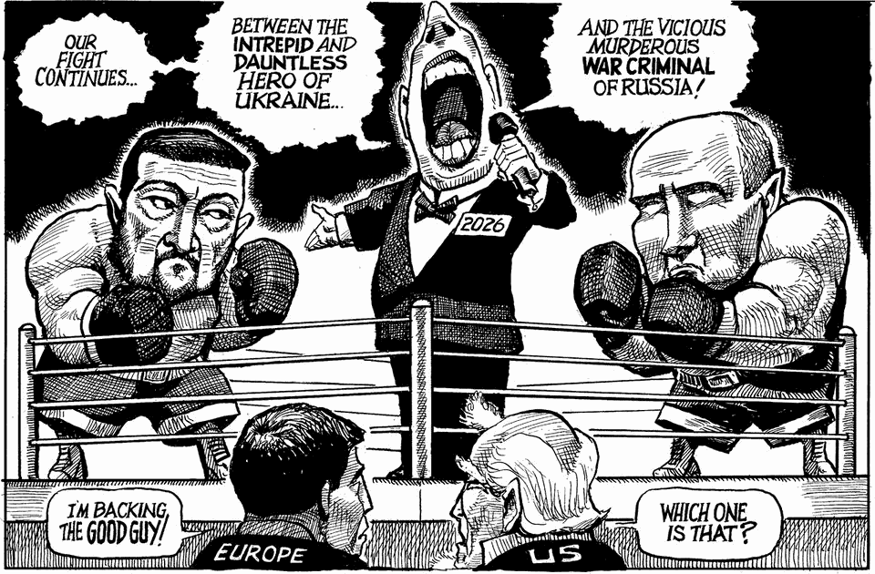
Dig deeper into the subject of this week’s cartoon:
America gives Ukraine reason to hope, justEnough dithering. Europe must pay to save UkraineVladimir Putin has no plan for winning in Ukraine
The editorial cartoon appears weekly in The Economist. You can see last week’s here.
This article was downloaded by zlibrary from https://www.economist.com//the-world-this-week/2025/12/18/the-weekly-cartoon

Leaders
- China proved its strengths in 2025—and Donald Trump helped
- Two months in, the Gaza ceasefire is floundering
- The Economist’s country of the year for 2025
- What Novo Nordisk, OpenAI and Pop Mart have in common
- Your Well Informed guide to surviving Christmas
Leaders | Superpowers

China proved its strengths in 2025—and Donald Trump helped
It was a good year for Xi Jinping

December 18th 2025

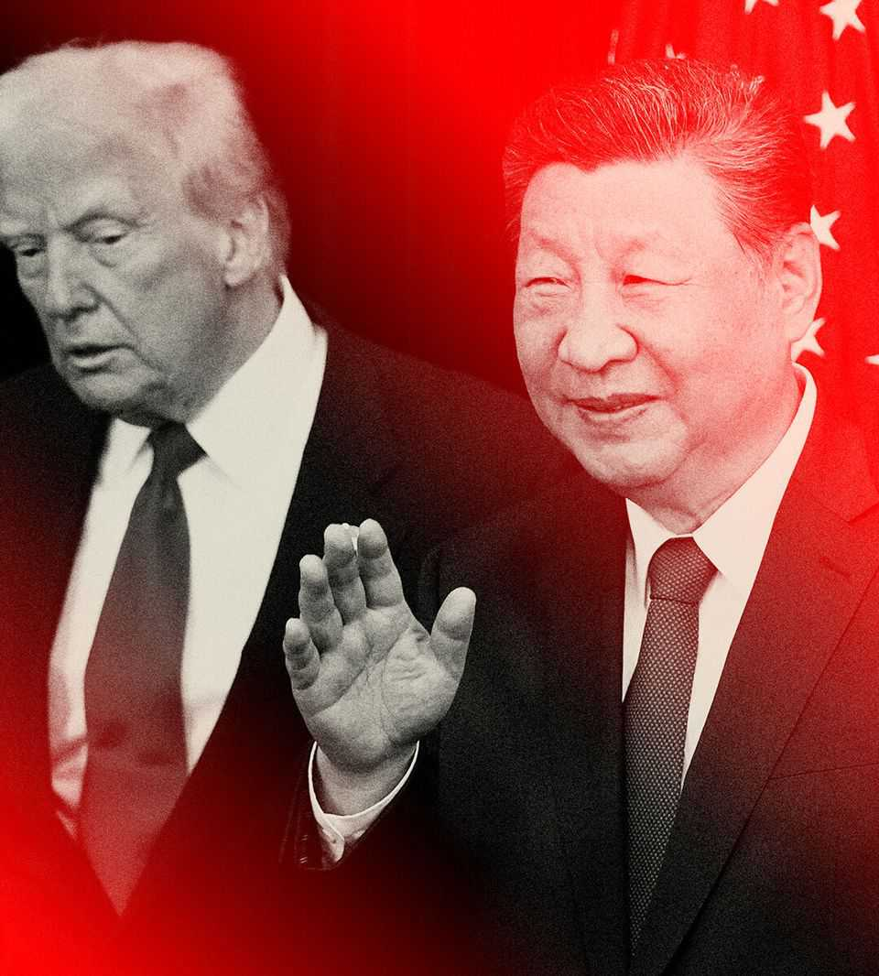
THE BIG noise in 2025 has been President Donald Trump. Launching a barrage of executive orders, he directed his fire at target after target. With the aid of Elon Musk, he attempted to dismantle the federal bureaucracy. On “Liberation Day” he rewrote the rules of trade. Around the world he imposed peace and threatened war.
However, the big beneficiary has been President Xi Jinping. This year China defied Mr Trump’s attempt to use tariffs to force a show of submission. By turning the tables, Mr Xi revealed just how much America actually depends on his policies. In this round of the superpowers’ fight for 21st-century supremacy, it was a victory for China.
This year showed the power of China’s industrial chokeholds. China’s share of the world’s manufacturing value added exceeds one-third, giving it the power to disrupt global supply chains overnight. In green technology, Chinese firms supply the materials, components and finished goods for 60-80% of solar panels, wind turbines and electric vehicles. DeepSeek showed what China can do in artificial intelligence, despite America’s best efforts to hobble it. China’s drug firms now run nearly as many clinical trials as their American peers—and do them faster. Two decades ago Western firms invested in China to take advantage of its cheap producers and huge market. Today they build laboratories there.
In 2025 Mr Xi showed he is willing to use China’s dominance as not just a source of wealth, but of power. His restrictions on rare-earth exports are one example of how China can use other countries’ dependency as a weapon. Findings this month from the Australian Strategic Policy Institute show that China leads in research in 66 of 74 fields, measured by its share of key scientific papers. These include over two dozen areas, such as computer vision and grid integration, where it has a chokehold.
The extraordinary thing is that Mr Trump has played into Mr Xi’s hands, both with his tariffs abroad and his wrecking-ball at home. Choosing bilateral tariffs as a way to inflict pain on China was a mistake. Partly because Chinese firms are used to harsh conditions and partly because China is not a democracy, its economy is better at enduring pain than America’s. Mr Trump could instead have co-ordinated a commercial encirclement of China by integrating more deeply with America’s allies. Foolishly, he preferred to alienate them with tariffs.
Likewise, Mr Trump’s attack on science will impede American innovation. He has targeted researchers, cancelling grants and withholding billions of dollars in funding to institutions that he does not like. Framed as an effort to eliminate inefficiency and woke ideology, his efforts have curbed financing for vital research. His hostility to foreign scientists, especially ethnic Chinese ones, is part of a more general assault on immigration. Talented people will either leave America or choose not to move there. China has already benefited.
The question is where this leaves the superpowers. In the short run, the advantage is surely with China. America and its allies cannot soon deprive it of its chokeholds. Should Mr Xi choose to throttle Taiwan, America and its allies may find that sanctions intended to force China to back off will trigger reprisals that cause more harm than their industries and citizens are willing to bear. That would have grave implications for East Asian security, and for America’s role in the western Pacific.
In the longer run, China’s dynamism could be stifled by its rigid politics. To see why, consider its economy. Factory-gate prices were 2.2% lower in November than a year earlier, and have declined for 38 months in a row. Property prices in the secondary market are more than 20% below their peak and still falling. Although the party has pledged to stimulate domestic demand next year, it will also double down on strategic manufacturing—the very thinking that has mired it in overcapacity.
By the end of 2026 that may seem like hubris. As provinces and cities struggle to pay down debt, stagnation could become even more entrenched, a bit like Japan’s lost decades. Deflation could worsen if countries unwilling to lose their own industries block more of China’s cut-price exports. Yet as Mr Xi prepares to start a fourth term in charge in 2027, his underlings seemingly cannot or will not challenge him.
In China the bigger the mistake, the less willing the party is to change course. By contrast, America has change built in—indeed MAGA’s bent for deregulation and its impatience with the suffocating effects of elite political correctness were examples of that principle in action. Whereas China is an ethno-nationalist state in which people who are not Han Chinese struggle to be accepted, America is founded on universal values that speak to every race and creed. These values have long made America a magnet for talent and enhanced its global influence. In the past they have also bound together its alliances.
In theory, all that should be the basis for renewal. However, Mr Trump scorns universal values as gimmicks exploited by cynical foreigners. Oppression does not shock him: he admires iron-fisted rulers, especially when they are also rich. As his recent National Security Strategy showed, MAGA sees ethnic and religious diversity as a threat, not a source of strength. If America is just one more ethno-nationalist project like Russia or China it will squander its greatest advantage.
Next summer America will mark the 250th anniversary of the Declaration of Independence. That should be the occasion for a debate about the republic’s founding principles. America’s economy remains the envy of the world. Nowhere else can mobilise ideas and capital on such a scale. Its people possess tremendous reserves of skill and enterprise.
Ideally, this would mean that the hopes of renewal will burn bright. The question is how much Mr Trump’s corruption of public life, his administration’s vindictiveness towards those in public service and his diminishment of Congress will dim America’s prospects. Mr Xi will be watching. ■
Subscribers to The Economist can sign up to our Opinion newsletter, which brings together the best of our leaders, columns, guest essays and reader correspondence.
This article was downloaded by zlibrary from https://www.economist.com//leaders/2025/12/18/china-proved-its-strengths-in-2025-and-donald-trump-helped
Leaders | Bored of peace

Two months in, the Gaza ceasefire is floundering
The consequences will ripple beyond the Middle East

December 18th 2025

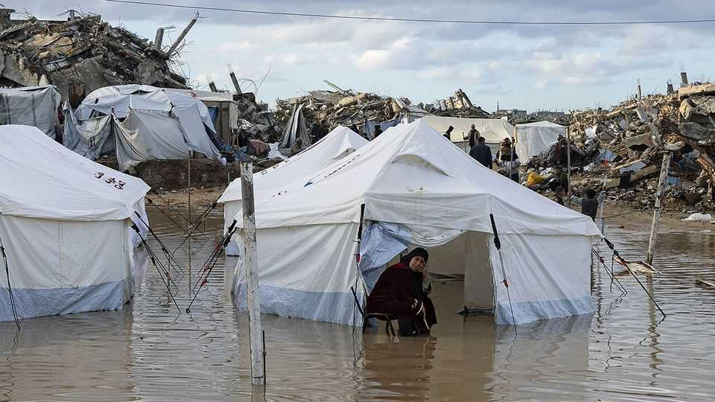
EVEN with a ceasefire in place, Gazans still fear death from the skies—but more from the weather now than Israeli jets. The winter storm that lashed the Palestinian territory in early December flooded thousands of tents, leaving families to endure long nights standing in frigid waters. At least four babies died of hypothermia.
Two months after it was signed, the deal is literally and figuratively sinking into the mud. Everyone knew it would be hard to move from the first phase to the second. The former stopped most of the fighting. The latter is more ambitious: Hamas will disarm, a new government will assume control and the enclave will be rebuilt.
It is unsurprising that these lofty goals have not been achieved. Hamas refuses to hand over its weapons, which precludes reconstruction and further Israeli withdrawal. What is more striking is that the world seems to have lost interest in spurring on peace.
Donald Trump has spent weeks hinting at big announcements about the “board of peace” that will oversee post-war Gaza. The announcements have not yet come, and may not until early 2026. No one has signed up for a planned peacekeeping mission, known as the international stabilisation force (ISF). Some officials in the region complain that they have not heard from the White House about Gaza since the October summit in Sharm el-Sheikh, where a peace plan was signed.
In recent weeks Mr Trump’s allies have instead focused on a scheme to build “planned communities” in the half of Gaza still under Israeli control. Each would house several thousand Palestinians and contain a clinic, a school and other services. The charitable view is that such hamlets would offer a model for how the rest of Gaza will be rebuilt.
A more realistic assessment is that they would become Potemkin villages. Each would shelter around 1% of Gaza’s population. Donor countries could slap their names on these communities and tout them as accomplishments. But they would offer no succour to the larger number of Gazans stuck on the other side of the ceasefire line. Rebuilding only the near-deserted, occupied half of Gaza would be a tacit admission that Mr Trump’s plan has stalled. That would be a tragedy.
Most obviously, a lack of progress towards phase two will prolong the misery of 2m Gazans. Hunger has abated, but there is more to life than food. Delay helps Hamas, which has reasserted control over the half of Gaza not in Israeli hands. With no alternative on offer, it is the only game in town. It will strain Israel’s relationship with Egypt as well. Diplomats in Cairo worry that the miserable conditions in Gaza will drive a growing number of refugees across the border.
America and its allies need to move faster. Mr Trump should appoint both a board and the Palestinian technocrats who will oversee Gaza on the ground. Countries in the region should get off the fence and decide how they will support the ISF, reconstruction or both.
This newspaper has argued that the promise of rebuilding is a powerful tool to convince Hamas to disarm. That remains true. But Gaza deserves far more help than it is getting. Roads must be cleared of rubble to let aid get through. Gazans need caravans, sturdy tents and other shelters, as well as medical care. Mr Trump should insist that Israel allow foreign media into the enclave independently. If the plight of Gazans has slipped down the global agenda, first-hand accounts would push it back up.
Progress on the ceasefire plan will not only help Palestinians and Israelis. It is also a test of Mr Trump’s ability to honour ambitious but ill-defined agreements. If the Gaza deal turns out to be a worthless piece of paper, that will bode poorly for the peace deals he is trying to negotiate elsewhere—not least in Ukraine. America’s credibility is on the line. ■
Subscribers to The Economist can sign up to our Opinion newsletter, which brings together the best of our leaders, columns, guest essays and reader correspondence.
This article was downloaded by zlibrary from https://www.economist.com//leaders/2025/12/18/two-months-in-the-gaza-ceasefire-is-floundering
Leaders | A better life for some

The Economist’s country of the year for 2025
Which country improved the most this year?

December 18th 2025


Each Christmas The Economist names a country of the year. Not the happiest: that would nearly always be Scandinavian, making for a dull, predictable contest. Nor the most influential: that would always be a superpower. Rather, we try to identify the country that has improved the most, whether economically, politically or in any other way that matters.
The year was a turbulent one, with President Donald Trump disrupting global trade and horrific conflicts scarring places such as Gaza and Sudan. But several countries navigated choppy waters well. Canada elected a sober technocrat as prime minister, rather than a populist, and stood up to American bullying. Voters in Moldova rejected a pro-Russian party despite threats and disinformation from Moscow. Mr Trump brokered a shaky truce between Israel and the Palestinians.
South Korea recovered from a serious threat to its democracy. A year ago President Yoon Suk Yeol tried to impose martial law, sending troops to shut down parliament. But lawmakers, protesters and institutions held firm, and this year the disgraced ex-president was put on trial for insurrection.
Another exemplar of how to deal with violent attempts to upend the constitutional order was Brazil. In September a Brazilian court imposed a 27-year jail term on Jair Bolsonaro, a former president who lost an election in 2022, claimed he was cheated and tried to mount a coup to stay in power. Brazil was plagued by coups for much of the 20th century; this is the first time a putschist has been suitably punished. The government also managed in 2025 to slow the pace of deforestation in the Amazon, thus doing its bit to slow climate change. However, its Kremlin-cuddling foreign policy badly blotted its record.
The two strongest contenders this year are very different: Argentina and Syria. Argentina’s improvement has been economic. Its president, Javier Milei, began far-reaching free-market reforms in 2023, hoping to jolt his country out of more than a century of statism and stagnation. Such reforms—abolishing price controls, curbing spending and ditching distorting subsidies—are exceptionally hard because they are exceptionally painful; many previous reformers have failed. Yet Mr Milei stuck to his chainsaw in 2025, and voters stuck with him. So did America, offering a $20bn lifeline to avert a financial crisis. The results have been impressive. Inflation has fallen from 211% in 2023 to around 30% now. The poverty rate is down by 21 percentage points since last year. The budget has been wrestled under control. Mr Milei has moved towards a floating peso, and removed most capital controls.
Argentina could still fail. The Peronists who misruled it for generations are itching to return, should Mr Milei stumble. And the president has many flaws: he is intolerant of critics and beset by corruption scandals. But if his reforms are sustained, they could permanently alter Argentina’s trajectory—and give hope to economic reformers everywhere.
Syria’s improvement, by contrast, has been political. Little more than a year ago it was ruled by Bashar al-Assad, an odious dictator backed by Iran and Russia. His jails were stuffed with political prisoners, and dissent was punished with torture or death. Thirteen years of civil war had claimed more than half a million lives. Mr Assad’s forces had used chemical weapons and barrel bombs indiscriminately on civilians. More than 6m people had fled from the country.
Then, in early December 2024, the tyrant was himself forced to flee as rebels seized power. When we were choosing that year’s country of the year, it was too soon to have an idea of how the new Syria might look. Its ruler, Ahmed al-Sharaa, was a jihadist. Many feared he would impose a grim Islamist theocracy, or that Syria would collapse into chaos. In fact, neither has happened. Women are not obliged to cover up or stay at home. Entertainment and, yes, alcohol are allowed. Mr Sharaa has brought about a series of positive surprises, holding the country together and forging good relations with America and the Gulf states. As Western sanctions are relaxed, the economy is starting to recover, too.
Huge problems remain. Militias carried out two atrocious local massacres of minorities, in which 2,000 people died. Mr Sharaa rules in a clannish way, and in such a fragile country much could still go wrong.
Nonetheless, Syria in 2025 is far happier and more peaceful than it was in 2024. Fear is no longer universal. Life is not easy, but it is more or less normal for most people. Voting with their feet, some 3m Syrians have returned home. Our choice goes to Syria, too. ■
Subscribers to The Economist can sign up to our Opinion newsletter, which brings together the best of our leaders, columns, guest essays and reader correspondence.
This article was downloaded by zlibrary from https://www.economist.com//leaders/2025/12/18/the-economists-country-of-the-year-for-2025
Leaders | Beyond the one-hit wonder

What Novo Nordisk, OpenAI and Pop Mart have in common
All three have suffered the curse of overnight success

December 18th 2025

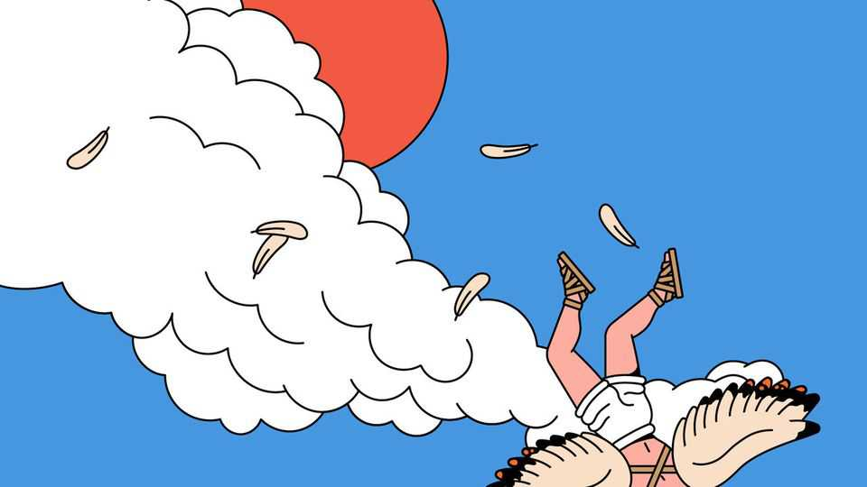
Every chief executive dreams of it: a product so successful that it propels their company from obscurity to superstardom seemingly overnight. Among the lessons from 2025, however, is that runaway success is not all upside. As the experience of whizzy chatbots, weight-loss jabs and wacky dolls illustrates, it brings problems, too.
The first pitfall is that bosses face the vexed task of scaling up their business to satisfy a level of demand that is impossible to predict. Consider OpenAI, maker of ChatGPT, a product so successful it has precipitated an investment frenzy not seen for a generation. According to OpenAI, around a tenth of the world’s population now uses its chatbot. The firm reckons that its yearly revenue will reach roughly $200bn by 2030, ten times its current annualised rate. In response, it has committed to $1.4trn of spending on computing power over the coming years, including through a series of circular deals funded by the recipients of its largesse. Growth of the sort that OpenAI is projecting has not been seen before. If it falls short, the firm will probably go broke, bringing the artificial-intelligence boom to a grinding halt.
Yet underinvestment also brings problems beyond the failure to take full advantage of surging demand. A particular danger is the rise of shadow markets—the second pitfall of overnight success—which can cause lasting trouble for businesses. Take Novo Nordisk, the Danish pioneer of weight-loss jabs. Because it was slow to ramp up its manufacturing capacity to satisfy the voracious appetite for Wegovy, “compounding” pharmacies, which in America are permitted to offer replicas of drugs that are in shortage, were able to muscle in. Although the shortage ended in February, around 1m Americans still take the copycats—which are cheaper but, according to Novo, less safe—as compounders have used loopholes to keep producing them.
Pop Mart, the Chinese firm behind the mischievously grinning, nine-toothed Labubu dolls that shoppers have queued up to buy this year, has faced similar trouble. Although it has increased production, it is battling a scourge of fake eight- or ten-toothed Lafufus that have flooded online marketplaces.
The final pitfall of overnight success is that it attracts legitimate competitors who can learn from both your triumphs and disasters. Call it the first-mover disadvantage. Eli Lilly, which brought its own weight-loss jab, Zepbound, to Americans two years after Novo, has this year pulled ahead of its Danish rival in the market for obesity drugs. That is partly because Zepbound is more effective. But Lilly also learned from Novo that it needed to have ample supply in place and offer its treatment directly to consumers, many of whom would rather not have to visit the doctor for a prescription, and are not covered for one by their insurers.
Similarly, OpenAI’s success inspired competitors that were able to learn from its breakthroughs before it had time to entrench itself with customers. The first shock came in January, when DeepSeek, a Chinese AI lab, launched a cutting-edge model it had developed on a shoestring, which it made freely available. More recently, OpenAI has been threatened by Google, which was mobilised into action by the success of ChatGPT and last month launched a model that is neck and neck with OpenAI’s best. With its vertically integrated business model, deep pockets and established distribution channels—including nearly 4bn Android users worldwide—Google now looks like the AI company to beat.
The wider lesson from all this is that hit products rarely lead to enduring commercial success. Instead, consider two of 2025’s quiet achievers. Walmart, America’s mightiest retailer, has seen its market value soar to nearly $1trn without fanfare. Its enormous scale, which it uses to push down costs and pass the savings on to customers, has won over many stretched shoppers this year. Plenty of them will also have been struck by the retailer’s digital reinvention. Look, too, at CATL, China’s battery colossus, whose secondary listing in Hong Kong in May was the largest share offering worldwide in 2025. Its hefty investment in research and development has given it a commanding lead. It is using that strength to expand into batteries for the grid.
Bosses should take heed. A hit product can bring a company to the attention of millions. But lasting success comes from a business model that is difficult to replicate, and which keeps evolving in a fast-changing world. ■
Subscribers to The Economist can sign up to our Opinion newsletter, which brings together the best of our leaders, columns, guest essays and reader correspondence.
This article was downloaded by zlibrary from https://www.economist.com//leaders/2025/12/18/what-novo-nordisk-openai-and-pop-mart-have-in-common
Leaders | Festive feasting

Your Well Informed guide to surviving Christmas
Drink slowly, eat cake and remember that fun is good for you, too

December 18th 2025


Since the start of 2025 our Well Informed column has brought you evidence-based advice on health and well-being. After reading hundreds of studies on everything from the benefits of red-light masks to whether or not butter is good for you, what have we learned about how to cope with the perils of Yuletide feasting? Here is your guide.
Start with alcohol. Try to be young, since young people tend to be leaner and so can absorb alcohol more efficiently. If, by some oversight, you are not young, make sure that you started strength training several months ago in preparation for Christmas indulgence, to build up muscle mass. Muscle tissue contains a lot of water and, because alcohol is soluble in water, less muscle means uncomfortable jumps in the levels of blood alcohol. It also means worse hangovers.
If age and regular strength training are not on your side, then science still has some tips for you. Choose your drinks wisely—clearer drinks, such as gin or vodka, are preferable to darker ones such as whisky or red wine. The “congeners” that accompany ethanol in darker spirits can make the after-effects of your tipple much worse.
Sip your drinks, rather than gulping, to avoid nauseating jumps in blood-alcohol levels. Alternate booze with water or, if you really want to optimise your session, sports drinks or coconut water. These contain electrolytes that will not only keep your body hydrated and its pH balanced, but also keep your nervous system firing on all cylinders. Remember that some of alcohol’s worst effects are compounded by what it does to your sleep patterns—it disrupts brain chemicals such as GABA and melatonin; it exacerbates snoring by relaxing your throat muscles—so stop drinking well before you fall into bed.
Festive food can be another hazard of the holidays. Perhaps you cannot resist the temptation to stuff yourself with roast turkey and potatoes. But you can ease the damage by dropping in handfuls of almonds, oats or apples. Regularly eating foods like these, containing beneficial plant proteins and lots of viscous fibre, has been shown in clinical trials to block the absorption of cholesterol in the gut by nearly 30% over the course of a month, similar to the effect of taking statins.
And what about sugar? No one type is better than the other. But eating sugar alongside fats, protein and fibre helps prevent glucose spikes in the blood. It is the crashes after these spikes that can lead to sudden hunger and the desire to overeat (dangerous when there are so many tubs of sweets lying around). Avoid fruit juice, which can be full of sugar, and eat the fruit instead, which helpfully has lots of fibre. If you can’t find fruit, fruitcake will do. So ditch the Buck’s fizz and help yourself to Christmas cake.
Mental health matters, too. As we explain in one of our Christmas features, though alcohol is a poison, it can have psychological upsides. By stimulating the brain’s reward and endorphin system, it can make people feel more sociable and less anxious, for a while. Over the past 10m years, booze has strengthened bonds within groups and perhaps shaped human civilisation. In the next couple of weeks, it will make countless parties more convivial. This is not something to say “Bah, humbug!” to. As another feature describes, loneliness is bad for you.
Heavy drinking is of course dangerous. But light quaffing involves trading off a statistically small risk of harm for the tangible benefits of fun, relaxation and social connection. So we recommend drinking and eating to celebrate, commiserate or meet new friends. Most important, take everything in moderation, including moderation itself. ■
Subscribers to The Economist can sign up to our Opinion newsletter, which brings together the best of our leaders, columns, guest essays and reader correspondence.
This article was downloaded by zlibrary from https://www.economist.com//leaders/2025/12/18/your-well-informed-guide-to-surviving-christmas

Letters
- Europeans should be worried by America’s new national security strategy
Letters | A selection of correspondence

Europeans should be worried by America’s new national security strategy
Also this week, Chinese trade, “stonking”, political parties, corrections, Santa and AI, “The Odyssey”, “The Wizard of Oz”

December 18th 2025

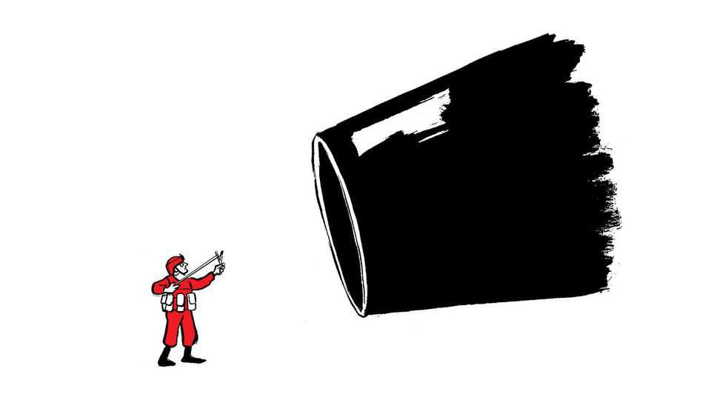
Letters are welcome via email to letters@economist.comFind out more about how we process your letter
You are right to say that Europeans should be worried by America’s new national security strategy (“An unreliable ally”, December 13th). Donald Trump’s personal style may be brash and rude, but the message that America has had enough of European freeloading on defence and posturing on the world stage has been around for a long time.
Barack Obama was furious at Europe’s incapacity and lack of will to sort out Libya in 2011. In the same year he declared America’s strategic pivot to Asia. Vladimir Putin invaded Crimea in 2014, and the European reaction was to cut defence spending and double down on its energy dependence on Russia. Faced with this non-reaction to a drastically changed world, Trump 1.0 was sceptical of NATO and Europe; Trump 2.0 is evidently even more so.
Even now, after nearly four years of unprovoked Russian aggression in Ukraine and widespread grey-zone attacks across Europe, our politicians are still only just beginning to talk the talk, but walking the walk is still for the future. Britain may reach 3.5% of GDP spent on defence, but by 2035. Western fleets continue to carry a third of all Russian oil exports and European Union countries will continue to import Russian gas until late 2027. These are hardly signs of being deadly earnest in fighting a major threat.
Simon DigginsColonel (retired)US Combined Joint Task Force, Horn of Africa, 2011Rickmansworth, Hertfordshire
The national security strategy explicitly states an intent to “cultivate resistance” to European leadership from within our own borders, revealing an insidious and fundamental threat. Regardless of one’s view of the White House, the strategic reality is that Europe is now caught in a pincer movement: squeezed from above by political expediency, and from below by disruptive domestic movements increasingly energised by a superpower.
European decision-makers must stop eroding checks and balances, a tendency denounced by the European Ombudsman and illustrated by the growing appetite to bypass unanimity rules in the EU under the guise of “urgency.” Such expedience merely energises critics and creates tools that illiberal forces will happily inherit and use if, as Washington anticipates, they take power.
Institutions that provide critical services, from universities to banks, have a responsibility too. Many have drifted into becoming active participants in political battles. This must stop. They should return to institutional restraint and focus on their core missions. Inspired by the cybersecurity concept of “attack surface reduction,” they must realise that restraint is the only way to ensure our institutions are not torn apart by the polarisation that Washington seeks to exploit.
Yohan Benizri451 InstituteBrussels
I was struck when reading your article on the fight for MAGA’s foreign policy by how aligned Mr Trump’s vision is with that of Xi Jinping and Vladimir Putin (“Deals and ideals”, December 13th). All three seem to be pushing hard to create the fictional nations of Oceania, Eurasia, and Eastasia from George Orwell’s “1984”. In Orwell’s novel the three powers were in constant conflict, but with no desire to ever actually prevail over the other. Rather, they relied on the threat implied by the other two to keep up a perpetual state of emergency that justified their dictatorial, totalitarian control over their own populations. How prescient Orwell seems now.
Doug ArcherdBrighton, Michigan
The Economist recommended that Europe should not raise trade barriers in response to China’s ballooning exports of cars, machine-tools and other manufactured goods (”From customer to killer”, November 22nd). The EU, including Germany, should instead pivot to services and become more like Britain, you say.
But this is not The Economist’s 19th-century crusade against the Corn Laws in favour of Manchester capitalism. And prescribing a 21st-century British remedy is hardly persuasive for the EU. The British economy has been in the doldrums for years, and the badly managed collapse of manufacturing helped propel Brexit.
China itself would certainly reject such a medicine wholeheartedly. The country continues to double down on costly but successful industrial policies. Combined with weak internal demand, these policies have pushed China’s export volumes up by roughly 40% over the past five years, while China’s imports of manufactured goods as a share of GDP have been falling for two decades. A China that exports nearly everything, imports far less and pours subsidies into advanced manufacturing does not just bend the rules-based trading order, it distorts the manufacturing base of its trading partners and deepens strategic dependencies.
Why would Europe choose to double down on services and deepen its reliance on Chinese manufacturing at the very moment it is rearming to supply Ukraine and deter Russia, China’s ally? Europe will need drones and tanks, not just more consultants.
China’s policies should not be replicated by the EU, but neither should the China shock be allowed to play out without intervention to slow it down. The EU will have to use industrial policies to steer demand towards its own production and consider broader sectoral tariffs on China as the slow product-by-product trade defences are failing, as evidenced by the EU’s landmark duties on electric vehicles.
It is understandable that The Economist, given its free-trading genesis, is reluctant to say so. But clinging to one’s founding creed is risky when the beneficiary is not Manchester capitalism but a mercantilist China.
Sander TordoirChief economistCentre for European ReformBerlin
I always enjoy The Economist’s vocabulary. What were once “scrappy” startups are now “plucky”, and “lofty” firm valuations are “dizzying”. But the word I have enjoyed the most is “stonking”. I had not seen this prized jargon used in some time, so imagine my surprise when it made a recent appearance in Schumpeter (November 29th).
I have thought a lot about the term. Is someone who creates those outsize returns a “stonker”? Does the word work unconjugated, as in “to stonk”? Is “stank” the past tense?
Chris RyanCalgary, Canada
Your Blighty newsletter of November 18th asked for the best comparisons of political parties with well-known brands. My suggestions are John Lewis stores for the Conservatives; once reassuringly boring, now in an identity crisis and trying to sell you things no one asked for. ASOS for Labour; used to be cool, then chaotic, now desperately trying to look sensible again. Promises better returns. IKEA for the Liberal Democrats; everyone likes the idea, but no one commits when it comes to the big purchase.
Sports Direct for Reform UK; shouts a lot, sells simple solutions and somehow always has a sale on. Patagonia for the Green Party; expensive, earnest and loved by people who cycle to meetings. BrewDog beer for the Scottish Nationalists; loud, proud, originally revolutionary, now dealing with some awkward headlines. And Le Creuset for Plaid Cymru; stylish, niche, and owned mostly by people who really care about provenance.
Nick HeathSan Miguel de Allende, Mexico
Both the Labour and Conservative parties feel like British Leyland in the 1970s. Endless infighting between management and workforce, as their market share declines along with the quality of their products. They have forgotten what their core purpose actually is.
Martin SmithAndover, Hampshire
A Free exchange column (December 6th) stated that in the media age before artificial intelligence, true and false information were easy to distinguish. They are not and never were. Even the most diligent newsroom team can publish information that is factually wrong or turns out that way later. Reputable newspapers, your esteemed organ included, publish corrections. An AI slop mill never will. Newspaper corrections are the anti-misinformation signal you are looking for.
Georg BlahaMunich
Ending letter deliveries in Denmark (”Final letter”, November 29th) is yet another casualty of the slow demise of all things paper. But there is hope for paper enthusiasts like me, who find a physical letter ever more comforting in the digital age. My husband and I, Gen Z and young millennial, designed and printed custom Christmas cards for the first time this year to post to friends and family. And it is younger commuters who are more likely to be holding a paperback on the subway, as older folk read on Kindles. If paper, against all odds, becomes cool again, it will be thanks to the smartphone generation.
James Hill-JiangNew York
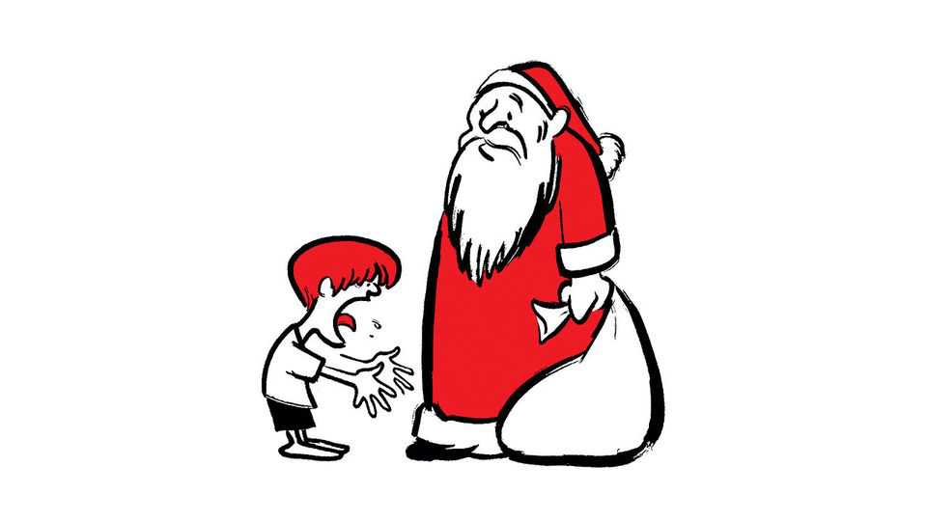
Regarding concerns about AI (The World Ahead 2026), in Canada children who write a letter to Santa Claus at North Pole, H0H 0H0, and pop it in the mail without a stamp receive a personalised letter back from him. Last winter our postal service went on strike and our local flying club stepped up to organise sending the letters to Santa. We initiated a school-wide project and a special “flight to the North Pole”. Seven adults used AI to create, print, sign, stuff and repackage hundreds of personalised response letters within an afternoon, for delivery back to the children the next day.
When inputting the kids’ special requests into the AI prompt, we were either scolded for their selfishness in asking for an X-Box, or given enthusiastic guarantees that an X-Box would be waiting for them on Christmas morning.
As we consider building morality into AI, disciplined parenting and limits on gaslighting children should be on that list.
Meagan BalaneskiVermilion, Canada
I enjoyed your take on the relevance of Homer’s “The Odyssey” for today (The World Ahead 2026). You conclude that Odysseus, the hero, is imperfect but offers hope. Perhaps you could have reinforced this optimistic message by referring to James Joyce’s “Ulysses”, which is based on Homer’s poem. It ends deliberately with the word “Yes”, as Molly remembers accepting her husband’s offer of marriage, aware though she is of his many shortcomings and even though she has had a sexual encounter with her lover during the day.
That “Yes” is a symbol of her husband’s peaceful triumph over his many adversaries and offers hope to all of us.
William MacilwraithWorcester
My one disappointment was that space did not permit a discussion of Penelope as a proto-feminist. She is almost as wily as Odysseus, her husband, contriving to maintain control over her body, at the same time as using her needlework skills to offer a role model for the numerous unsung female contributors to the arts and crafts movement.
Self-help guidance has a long pedigree.
Peter BloxhamLondon
Your review of Salman Rushdie’s new collection of short stories was right to point out how fun his writing can be (“Mightier than the knife”, November 8th). I once stumbled upon his essay about “The Wizard of Oz”. Among many witty observations, Mr Rushdie confessed that he hates Toto, “That little yapping hairpiece of a creature, the meddlesome rug!” The dog playing Toto apparently had a nervous breakdown during filming.
Mia McleanNew York
This article was downloaded by zlibrary from https://www.economist.com//letters/2025/12/18/europeans-should-be-worried-by-americas-new-national-security-strategy

United States
- Will California try to block Hollywood’s next megadeal?
- Toll roads are spreading in America
- More schools in America are adopting a four-day week
- The race for an AI Jesus is on
- A vote against gerrymandering shows why political courage is rare
United States | Lights, camera, legal action!

Will California try to block Hollywood’s next megadeal?
States are beefing up their antitrust enforcement

December 18th 2025


CONSIDER IT a cautionary tale. In 2022 Kroger announced that it would buy Albertsons, a rival grocer, for nearly $25bn. Then things went off the rails. The attorneys-general (AGs) for Washington and Colorado challenged the merger in their respective state courts, on the grounds that the impact on prices and labour would harm their constituents. The Federal Trade Commission (FTC) brought its own suit in federal court soon after, and the avalanche of litigation torpedoed the deal. States may have been aligned with the FTC against the merger, but they didn’t wait for the feds to act before jumping into the fray. “It’s clear we are willing and able to litigate cases on our own,” says Phil Weiser, Colorado’s attorney-general.
Hollywood ought to pay attention. The industry’s latest merger risks becoming a sequel. Netflix and Paramount are in a heated competition to buy Warner Bros Discovery, one of Hollywood’s crown jewels. David Ellison, the nepo-baby boss of Paramount, wants to purchase the studio so badly he is mounting a $108bn hostile takeover bid. On December 17th the board of Warner Bros urged shareholders to reject Paramount’s offer, though Mr Ellison looks unlikely to back down so easily. Paramount hopes to convince Warner Bros shareholders that if Netflix prevails, the resulting mega-movie-and-streaming company would spook federal antitrust enforcers, whereas a Paramount-Warner combination could pass antitrust muster.
Both bidders are focused on getting Donald Trump, the Department of Justice (DoJ) and the FTC on side. It doesn’t hurt that the Ellison family is friendly with Mr Trump, a transactional president with a history of meddling in media mergers. The president has already mused about the deal, suggesting that he will ultimately decide who wins. But Mr Ellison and Ted Sarandos, Netflix’s co-chief executive, ignore state attorneys-general at their peril. Rob Bonta, California’s top prosecutor, is a particular wildcard who could kill any Warner Bros merger even if decision-makers in Washington see a deal they can accept. During the auction, a spokesperson for Mr Bonta’s office said that “further consolidation in markets that are central to American economic life…does not serve the American economy, consumers or competition well.” That does not sound as if he plans to defer to Washington, DC.
States have a long history of antitrust enforcement. Twelve states actually passed their own competition laws before Congress got around to drafting the Sherman Act, the foundation of America’s antitrust regime, in 1890. But consolidation across industries and the growth of anti-monopolist politics among leftists and MAGA economic populists have put the issue centre-stage. States are responding in two ways: by passing laws that beef up their antitrust powers and by bringing their own cases regardless of what the feds do. “There’s more of a concern of potential under-enforcement at the federal level” during Mr Trump’s presidency, explains Prasad Krishnamurthy, a legal scholar at the University of California, Berkeley.
In 2025 eight states introduced bills that would require big firms to notify their attorneys-general before a merger. Colorado and Washington passed their measures. Colorado is leading in other ways, too (perhaps because Mr Weiser is a former antitrust lawyer). In 2023 the state passed a law that increased fines and endowed the state’s attorney-general with more investigatory powers, among other things. Mr Weiser argues that prior to the reform his office had been handicapped in a way that had surrendered state sovereignty. No longer. “Just because the FTC or the DoJ goes one way”, he warns, “doesn’t mean I might not go another way”.
For three years the California Law Review Commission, which recommends bills to lawmakers, has been mulling whether the state should strengthen its antitrust laws. The legislature could take up the issue next year. Big firms, fearful of a balkanised antitrust landscape, will no doubt lobby hard against any reform.
There are other signs that Democratic attorneys-general, in particular, intend to prioritise antitrust enforcement. Rohit Chopra, a former head of the (in-effect defunct) Consumer Financial Protection Bureau, will lead a new consumer-protection working group for the Democratic Attorneys General Association. Taking on big firms also helps ambitious AGs to raise their profiles. Bob Ferguson, the attorney-general who sued Kroger and Albertsons in Washington, is now the state’s governor. Mr Weiser is running for governor in Colorado. Part of his pitch to voters is that he went after “irresponsible companies that ripped off Coloradans”.
Mr Bonta may have something similar in mind. He is mulling a run for governor in 2026. California’s DoJ has already sued the second Trump administration at least 48 times, and he would not pass up an opportunity to suggest that California is standing up to big firms where the president is not. Suing to stop a Warner Bros merger would endear him to Hollywood’s powerful unions, which worry that fewer studios means fewer buyers for their members’ work. The LA chapter of the Writers Guild of America describes the studio’s potential sale as “a disaster”. Whichever firm prevails, the merger will take time to play out. This is just episode one. ■
Stay on top of American politics with The US in brief, our daily newsletter with fast analysis of the most important political news, and Checks and Balance, a weekly note that examines the state of American democracy and the issues that matter to voters.
This article was downloaded by zlibrary from https://www.economist.com//united-states/2025/12/12/will-california-try-to-block-hollywoods-next-megadeal
United States | Turnspike

Toll roads are spreading in America
The decline of petrol taxes is to blame

December 18th 2025


This article was downloaded by zlibrary from https://www.economist.com//united-states/2025/12/18/toll-roads-are-spreading-in-america
United States | Show that 4 > 5

More schools in America are adopting a four-day week
Teachers and parents like it, but results for pupils are middling

December 18th 2025


ELDON, IOWA, rarely bustles. “We’re on top of a hill, in the middle of nowhere, surrounded by corn,” explains James Craig, the superintendent of the area’s school district, which has about 1,000 pupils. But on Mondays, the schools are particularly quiet. Only the teachers are at the primary school, learning a new maths curriculum. Since 2022 the district has worked on a four-day week schedule. “I couldn’t be happier,” Mr Craig says, “everyone is thriving.” Giving students Mondays off has led to better attendance, behaviour and mental health, he thinks.
Across America, more schools are embracing four-day weeks. Over 2,100 schools operate that way and every state west of the Mississippi now allows it. Created in order to either save money or attract teachers, four-day school weeks were previously a rural phenomenon. But they are now reaching into more towns and cities. In November voters in Independence, a suburb of Kansas City, Missouri, opted to keep its 14,000 pupils on a four-day school week. Unsurprisingly, teachers and students love it. Parents, too, have embraced the chance to spend more time at home. But for educational outcomes, the policy gets middling marks.
How much less teaching takes place during a four-day week depends on each district’s policy. Generally, schools extend the four remaining days by just less than an hour, according to a study by RAND, a think-tank. How schools use the spare day also varies: some offer tutoring or child care, while others (such as those run by Mr Craig) do not offer much or anything.
So what is the impact of all of this? Start with test scores. The effect “is not huge”, says Emily Morton of NWEA, an education-research firm. “But it’s not nothing,” akin to students being two to seven weeks behind where they would be otherwise. This is not felt equally—students in rural schools and schools that kept the same amount of teaching do better. Academics worry about compounding negative results as pupils go through school without ever having a full week.
Despite this, educators are effusive about the impact of short-weeks on classroom atmosphere. One teacher told researchers that students were less “burned out”. Karl Janson, a retired superintendent who took two school districts in Missouri four-day, said behaviour improved and severe discipline problems fell by half. Some studies are more equivocal. One looking at Oklahoma’s four-day schools did find that they had less fighting and bullying. But the RAND survey found that though parents and teachers perceived higher morale, surveys showed it was no different from full-time schools. And despite advocates’ hopes, research shows short weeks have not significantly improved attendance.
The policy does not save districts much money, typically no more than 2.5% of their budget. Their motivation has been to address problems in teacher recruitment, explains Gregg Klinginsmith, a superintendent in Warren County, Missouri. He contrasts his area to the nearby St Louis suburbs, which “pay very, very well… Our community very much values low taxes.” He cites data that the transition to the four-day week has led to an increase in teachers sticking around. But broad studies show that four-day weeks do not significantly improve rural teacher retention.
Some worry about children who are falling through the cracks. “We’re not finding and reaching the families that might be struggling,” says Emily Tomayko of Montana State University, pointing to kids in single-parent families.
Losing a day of child care might not work outside rural areas. But so far, parents are among the biggest supporters of four-day weeks. Nine primary-school parents out of ten told RAND they were satisfied and nearly as many would probably or definitely choose to keep it. (Some 95% of high-school pupils felt similarly.) “Our lives are less stressful, ” one parent said. “I feel like my kids are just happier.” ■
Stay on top of American politics with The US in brief, our daily newsletter with fast analysis of the most important political news, and Checks and Balance, a weekly note that examines the state of American democracy and the issues that matter to voters.
This article was downloaded by zlibrary from https://www.economist.com//united-states/2025/12/18/more-schools-in-america-are-adopting-a-four-day-week
United States | God complex

The race for an AI Jesus is on
A chatbot offers personalised counsel on faith

December 18th 2025


A PASTOR’S job is to lead congregants towards a closer relationship with the divine. With Christmas approaching, many are writing sermons they hope will do just that. Yet surveys show that Americans’ trust in clergy has hit a record low. More people now pray in their cars than in churches.
Perhaps inevitably, tech bros in Silicon Valley are taking the wheel. “Text with Jesus”, an app built with OpenAI’s ChatGPT, allows users to pose personal and theological questions. Represented by an avatar with a well-trimmed hipster beard, the virtual Jesus responds with friendly nudges and quotes from scripture. “I hear you sister, honest doubt matters and you’re not alone in it,” he responds to an admission of scepticism about the resurrection. The app suggests selecting a denomination and offers a range of biblical figures and apostles to consult. For gentle advice consider Mary; for a scrappier conversation, perhaps Cain or Judas.
The app has about 150,000 users and is popular in big American cities like New York, but also in Mexico and across South America. It too has doubters. AI Jesus is too concerned “with providing answers palatable to the itching ears of 21st-century users”, wrote James Spencer of the Christian Post, a news website. He reckons the bot barely resembles biblical Jesus—to his horror, he writes, it wouldn’t unequivocally affirm that Jesus is God. Stéphane Peter, the app’s French-born founder, admits that his own mother thinks his innovation is blasphemous.
Pope Leo has cautioned Catholics against reading wisdom into aggregated data. Expect other faith leaders to follow. Elon Musk once warned that “with artificial intelligence we are summoning the demon”. At least for now the Satan feature on Text with Jesus isn’t on by default—it has to be enabled in the settings and is only available to subscribers. ■
Stay on top of American politics with The US in brief, our daily newsletter with fast analysis of the most important political news, and Checks and Balance, a weekly note that examines the state of American democracy and the issues that matter to voters.
This article was downloaded by zlibrary from https://www.economist.com//united-states/2025/12/16/the-race-for-an-ai-jesus-is-on
United States | Lexington

A vote against gerrymandering shows why political courage is rare
Yet it is particularly valuable now

December 18th 2025

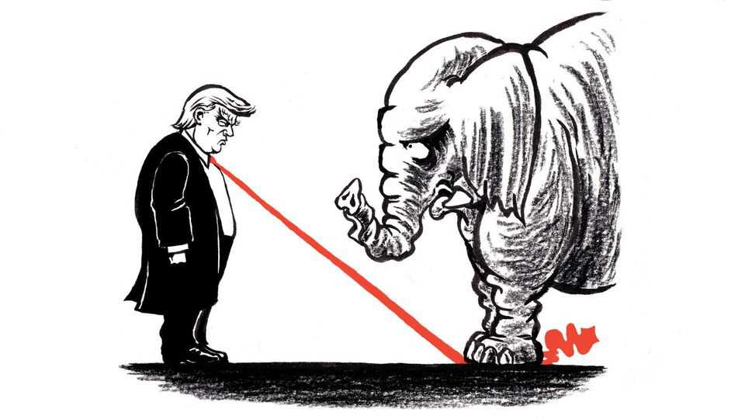
Politicians generally have good reasons, even moral ones, to talk themselves out of acts that history might judge as brave. As a senator in his first term, John F. Kennedy wrestled with this complexity in “Profiles in Courage”, the study of character in the Senate that earned him a Pulitzer prize in 1957. The desire to get along with one’s peers, a willingness to compromise, even the ambition to win re-election—such reasons to soften principles in the moment may help advance them in the long haul, he observed.
And while expediency may eventually serve principle, what is principled may be judged by the public to be sneakily expedient. Politicians who flout the will of their state or local constituents while claiming to act in the national interest could be seen as angling for the presidency. Those who vote against their party while claiming devotion to higher principle lay themselves open to the charge “they accepted office under one banner and yet deserted it in a moment of crisis for another”, Kennedy wrote.
One could argue that Republican state senators in Indiana were just being smart politicians earlier this month when they rejected a bill to redraw their state’s congressional districts to benefit their party. Polls showed more of their constituents opposed the measure than supported it. Yet these state senators set a heartening example of courage in public life for a country in need of one. That they had the people and common sense on their side does not diminish their demonstration of character; instead, it supplies a gauge of just how debased American politics have otherwise become. “Friends, we’re better than this, are we not?” said Greg Goode, a senator who voted against the measure, posing a simple, clarifying question that other Americans might put to themselves as this challenging year draws to a close.
It would be tough to invent a surer means of intensifying polarisation and cynicism. In states dominated by Republicans, the legislatures have been holding special sessions not to confront high prices or any other matter on voters’ minds, but for a brazenly partisan purpose, to help their candidates choose their own voters rather than risk the reverse. In states Democrats dominate they have felt compelled to respond in kind. Thus is the race to the bottom being run under Donald Trump: few politicians but him seem to relish the degrading competition, but everyone winds up running as hard as they can.
In Indiana, the state house passed a redistricting bill. But despite intense lobbying from Mr Trump and others, despite threats that primary challengers would be lavishly funded and that federal money might be withheld, despite even death threats in some cases, 21 of 40 Republican senators joined with all ten Democrats to vote the measure down. “It was an act of principle and a courageous one,” says Mitch Daniels, a former Republican governor of Indiana who was consulted by some of the senators. “We’ve had too few examples of either in our politics in recent times.”
In trying to identify the source of courage in the politicians he admired, Kennedy approvingly cites the realism of one of them, John Adams, in saying, “It is not true, in fact, that any people ever existed who love the public better than themselves.” Kennedy concludes of his heroes that “it was precisely because they did love themselves” and that each needed “to maintain his own respect for himself” that each could withstand public disapproval with the “faith that his course was the best one, and would ultimately be vindicated”. (Though, in some cases, it has not been.)
If self-love is the essential ingredient, that might explain why Mr Trump shows at least as much courage as anyone in public life these days, albeit without demonstrating character commensurate with it. He has shown fortitude in compelling his party to embrace not only his views on matters like redistricting, trade, political prosecution and militarised mass deportation, but even his standards for insult and self-enrichment in office. Republicans with other ideas have lacked the self-love, or self-respect, to dissent. For their part, Democrats have little cause to feel righteous. In recent years, to win primaries, many of the party’s candidates capitulated to its own extreme activists. Few Democratic politicians raised concerns about President Joe Biden’s policies or his age; those who did were vilified within the party.
In his time, Kennedy worried the “tremendous power of mass communications” and the “expensive” and “mechanised” reality of modern politics were making it even more perilous to venture unorthodox or unpopular positions. Yet America needed independent thinking more than ever to confront the Soviet Union: “Only the strength and progress and peaceful change that come from independent judgment and individual ideas—and even from the unorthodox and eccentric—can enable us to surpass that foreign ideology.” Today, the forces for conformity that Kennedy feared are stronger; though the Soviet Union is gone, the case for dissent and argument is at least as strong.
Americans have witnessed principled dissent this year, including by prosecutors who refused orders they considered partisan and university presidents who would not retreat from their vision of academic freedom. In the absence of a clear leader Democrats are starting to usefully bicker again. Some Republican congressmen, notably Thomas Massie of Kentucky, have even had the audacity to disagree with the president while still planning to run again. Mr Daniels notes that in Indiana, courage was contagious: “As a few more people had the temerity to say, ‘I’m just not going to go along with this,’ the numbers grew,” he says. “The pressure never lessened, but the numbers grew.” Mr Trump is likely to face more principled dissent in his party next year—particularly as the deadlines pass for potential opponents to file for primaries. ■
Subscribers to The Economist can sign up to our Opinion newsletter, which brings together the best of our leaders, columns, guest essays and reader correspondence.
This article was downloaded by zlibrary from https://www.economist.com//united-states/2025/12/18/a-vote-against-gerrymandering-shows-why-political-courage-is-rare

The Americas
- An oil boom where the Amazon meets the Atlantic
- Javier Milei loosens his grip on the peso
The Americas | Drill, baby, drill!

An oil boom where the Amazon meets the Atlantic
Despite is green bona fides, Brazil cannot resist a second run at oil riches

December 18th 2025

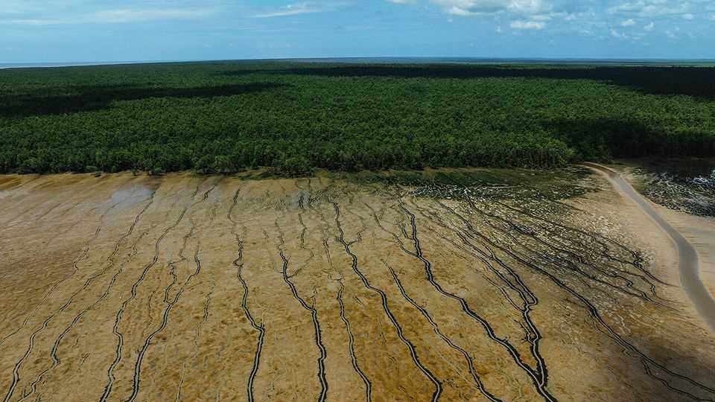
Oiapoque is a sleepy town on the edge of the Amazon basin in Brazil’s northernmost tip. On weekdays fishermen haul their catch to the local market and indigenous people stream in from the rainforest to sell ground manioc and buy fuel. At the weekend, tourists from neighbouring French Guiana cross the border to buy cheap food and flirt with locals. But it is not hard to see that a transformation is afoot. Hotels are popping up along the main drag. One that is set to open next year will boast seven floors, practically a skyscraper in the impoverished region. A tiny airport on the outskirts of town has been recently renovated. The whir of helicopter blades is becoming more common.
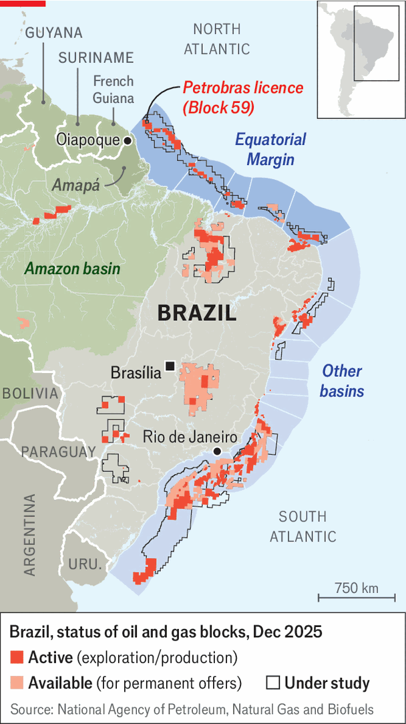
Long a backwater, Oiapoque is preparing to become a boomtown. On October 20th Ibama, Brazil’s environmental regulator, gave Petrobras, the state oil firm, a licence to explore for oil 160km (100 miles) off the town’s coast in a region known as the Equatorial Margin (see map). More than ten years in the making, the decision comes after a mounting campaign by Brazil’s president, Luiz Inácio Lula da Silva, known as Lula. While Ibama dithered, ExxonMobil found 11bn barrels of proven reserves off the coast of neighbouring Guyana, worth over half a trillion dollars. The tiny new petro-state quickly became the world’s fastest-growing economy. More blockbuster discoveries followed for neighbouring Suriname. Lula fumed. “Are we going to get stuck eating bread and water? No! We like bread with mortadella,” he told a crowd in February.
Brazil’s government is betting on oil from the Equatorial Margin to revive the country’s depleting reserves. In 2006, during Lula’s first term, vast reserves were found beneath a thick layer of salt under the seabed off Rio de Janeiro. Lula triumphantly declared that the discoveries were tantamount to Brazil’s second independence. The reserves, which are still being extracted, rocketed the country up the oil-producers’ league table. By 2030 Brazil’s “pre-salt” fields will make it the world’s fourth-largest oil producer. But soon after that the stuff will begin to run out (see chart 1). Without new discoveries to keep exports going, Brazil could once again become an oil importer from 2040. Lula’s government reckons this oil-export decline would mean the state missing out on trillions of reais of revenue (hundreds of billions of dollars).
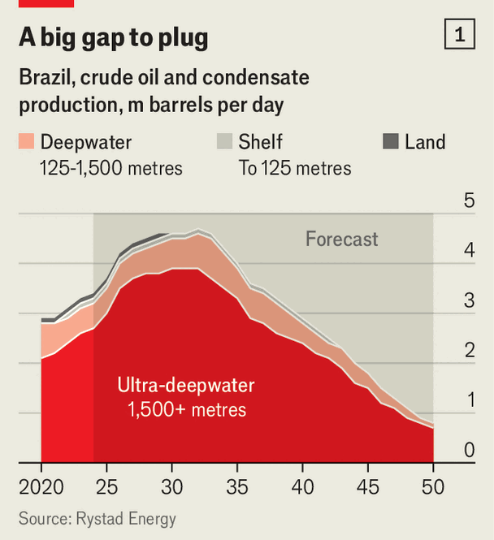
In order to put off this problem, Lula has been willing to disappoint those of his fans who voted him back into power in 2023 on a green platform. The potential gains are simply too juicy. Brazil’s national oil and gas agency reckons that the country’s chunk of the Equatorial Margin holds over 30bn barrels of oil, of which 10bn may be recoverable. Thanks in large measure to this region, South America has become the part of the world in which oil production is growing at the fastest rate. Its output is forecast to increase by a third by 2030, compared with around a quarter in the Middle East and a tenth in North America.
The catch is that South America’s newest oil frontier is near one of the world’s least-studied and most biodiverse regions—the Amazon river estuary. It accounts for a fifth of the fresh water flowing into the world’s oceans each day from rivers. An unknown but vast number of fish species nurse in the slimy soils of the region’s mangrove forests, which are among the world’s largest. Pink river-dolphins, whales and manatees splash about near the coast. In 2016 scientists stumbled upon a 1,000km-long deepwater reef on the seafloor. Nobody knows the full scale of the other biological and geological riches that lie beneath the Amazon’s murky waters.
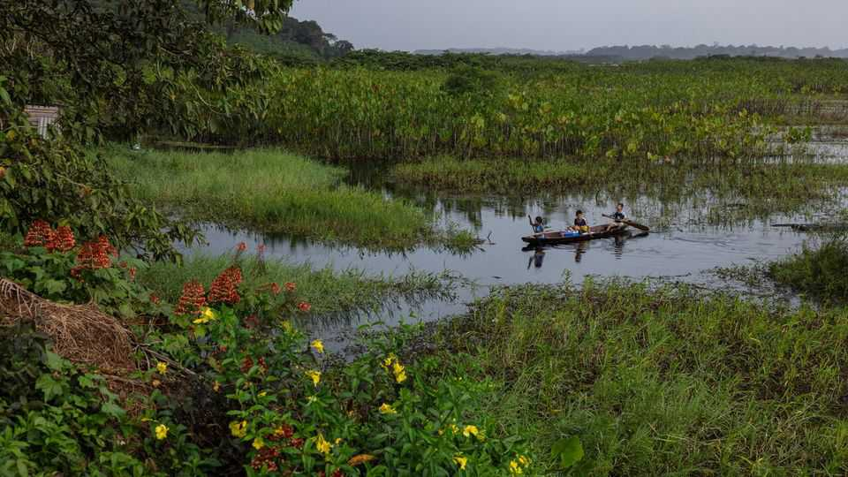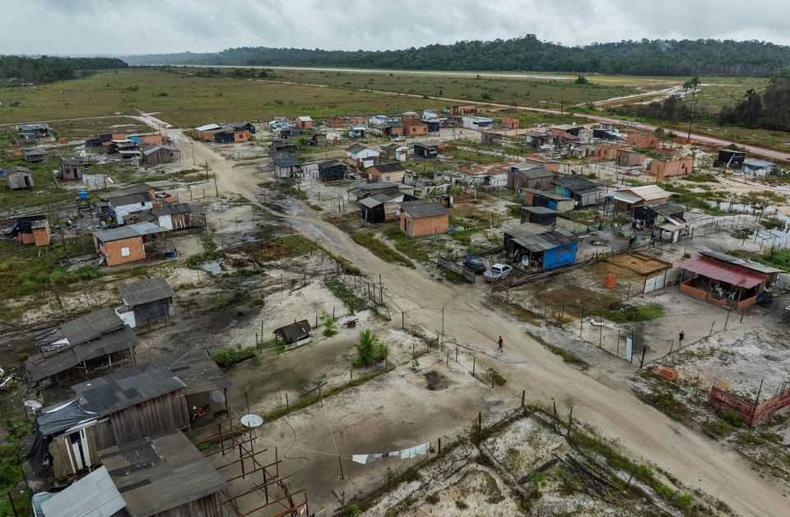
Most inhabitants of Amapá, the state in which Oiapoque is located, are gung-ho about oil. Along the highway connecting the state capital to the town, food shacks and rundown houses are plastered with stickers that read “Yes to development! Yes to petrol!” From her fruit and vegetable stall on the sweltering streets of Oiapoque, Edna da Silva Costa is giddy. “[Oil] is going to generate money for everyone…everyone is in favour, it’s going to bring jobs.” Brazil’s energy ministry reckons that investments in the Equatorial Margin could reach 280bn reais ($52bn) and create 350,000 jobs. Such expectations probably explain why Brazilians increasingly support drilling. In October 26% said they were in favour of prospecting in the Equatorial Margin. Now 42% approve, against 49% who disapprove.
Yet drilling along Brazil’s northern coast is fiendishly difficult. The currents around the mouth of the Amazon are strong and unpredictable, generated by the colossal volume of water the river dumps into the sea. At the surface the currents run towards the Caribbean, but 200 metres down the flow reverses, pushing back towards the land. The main site that Petrobras is eyeing up, known as Block 59, is deep. At a depth of about 3km it is almost twice as far beneath the surface as the Deepwater Horizon well in the Gulf of Mexico; it took three months for BP to contain the flow of oil when that rig exploded in 2010. These complexities haven’t put off the oil majors. In June ExxonMobil, Chevron and the China National Petroleum Corporation won rights to prospect there. Petrobras is a world leader in deep-water drilling, since the pre-salt fields lie at a depth of about 2km.
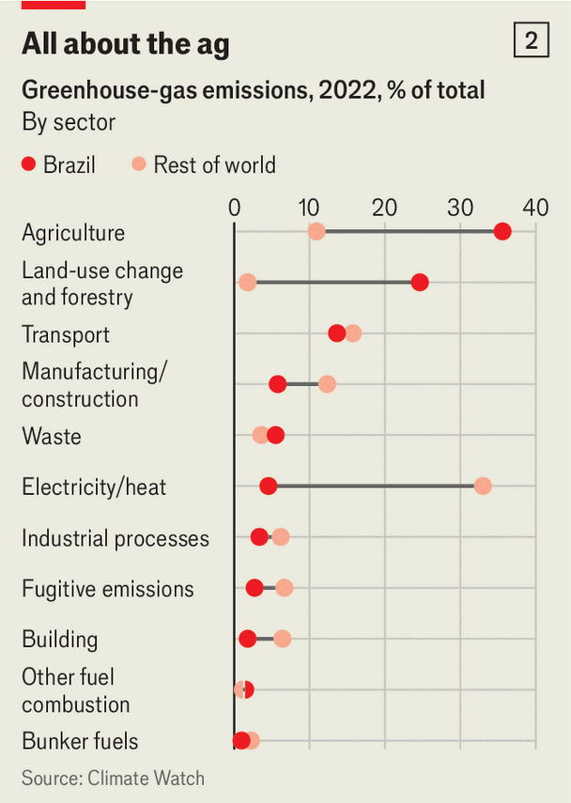
Some locals are less sanguine. Under a mango tree that is hosting a conference of japim, small yellow-rumped birds, Gildo Leoncio, the vice-chief of the Karipuna indigenous group, says Petrobras did consult him and other chiefs. “We told them we were worried, but they said nothing is going to happen, it’s all going to be safe,” he says. “But we’ve seen on television that there have been oil spills elsewhere. Why should we believe that can’t happen here?”
If Petrobras finds oil, it will take years to bring to market. But even the anticipation has a dark side. Much of the rainforest around Oiapoque has been cleared to make way for new development. Migration into the area “is out of control”, says Isaú Macena, a local-government official. Schools and hospitals are overflowing. Corruption is endemic across the Amazon.
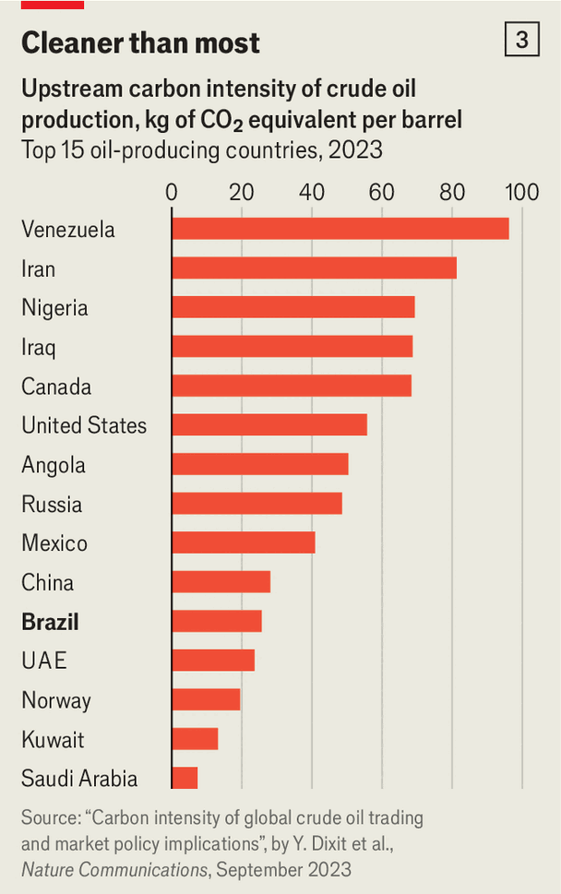
Clécio Luis, the governor of Amapá, acknowledges the difficulties of managing an oil boom. “We can’t let this take us by surprise,” he says. He wants the state to follow Norway’s example and set up a sovereign-wealth fund to invest its new riches.
Lula’s government plans to use the oil money to try to escape the contradictions of promoting a green agenda while expanding oil drilling. On December 5th he ordered his ministers to produce a roadmap for how Brazil will lessen its dependency on fossil fuels. Oil revenues will apparently finance the transition. “Brazil’s strategy is pragmatic,” says Alexandre Silveira, the country’s energy minister: to “ensure energy security and fiscal stability” in the short term, while financing “long-term competitiveness in renewables”. While the world continues to consume oil he thinks it may as well gobble up Brazil’s. The country’s carbon emissions per barrel of oil produced are significantly lower than the global average (see chart 3). Back in Oiapoque schools of catfish, hake and oscars play along the river in blissful ignorance. ■
Sign up to El Boletín, our subscriber-only newsletter on Latin America, to understand the forces shaping a fascinating and complex region.
This article was downloaded by zlibrary from https://www.economist.com//the-americas/2025/12/15/an-oil-boom-where-the-amazon-meets-the-atlantic
The Americas | Argentina’s economy

Javier Milei loosens his grip on the peso
But there is more to do

December 18th 2025

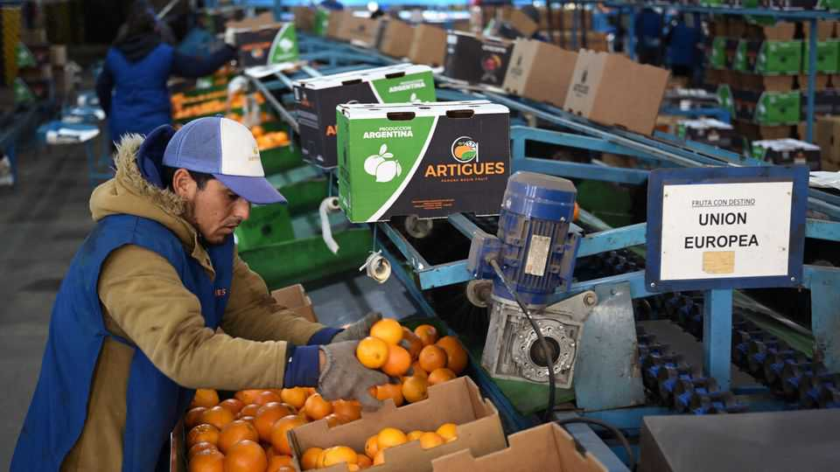
Quietly, in a jargon-filled statement on the Argentine central bank’s website, President Javier Milei has made a crucial change. From January the Argentine peso—bloodied by markets and propped up by Donald Trump last year—will be allowed to float more freely.
Since April it has moved within a band, the limits of which widen by 1% each month. Now they will widen with inflation, currently 2.5% per month. That will allow the peso, which many believe is overvalued, to weaken more rapidly. It will also help with a new plan to buy some $10bn in foreign reserves next year. All this is a welcome, if cautious, step to address the biggest weakness in Mr Milei’s liberalising reform programme.
His government has long sought to keep the peso strong. This has helped to pull inflation down but weighed on exports and made foreign-reserve accumulation very hard. That has worried the IMF and investors, who are owed dollars. As midterm elections approached in October, everyone began selling pesos, forcing the central bank to sell billions of dollars to defend the band’s limit. The peso was in danger of crashing out, potentially tanking Mr Milei’s electoral prospects and wider reform project. Then, extraordinarily, the US Treasury backed the peso. That relieved pressure and helped Mr Milei to win. He still insisted that he would not alter the exchange-rate regime, but investors remained concerned.
The IMF immediately welcomed the latest shift. So did markets: Argentine stocks and dollar-denominated bonds jumped, suggesting that the government could soon borrow in global capital markets again. The peso weakened. Widening the bands risks a modest rise in inflation, but that is less of a problem for the government with midterms out of the way.
Still, this is far from a full float. In real terms the band was in effect forcing the peso to strengthen over time. It will now allow it to weaken, but only marginally. This will still leave the peso overvalued, says Capital Economics, a consultancy in London. Moreover, the central bank says foreign-reserve purchases will be contingent on the rate of economic growth and the size of the foreign-exchange market. It has still not announced a programme to target inflation through interest rates. Mr Milei’s monetary journey is not yet over. ■
Sign up to El Boletín, our subscriber-only newsletter on Latin America, to understand the forces shaping a fascinating and complex region.
This article was downloaded by zlibrary from https://www.economist.com//the-americas/2025/12/17/javier-milei-loosens-his-grip-on-the-peso

Asia
- Can Australia defend itself against jihadist murderers?
- Why has the border between the Koreas fallen silent?
- The botched response to a devastating storm infuriates Indonesians
Asia | Terror on the beach

Can Australia defend itself against jihadist murderers?
The father and son who killed 15 in Sydney may have sought training in the Philippines

December 18th 2025

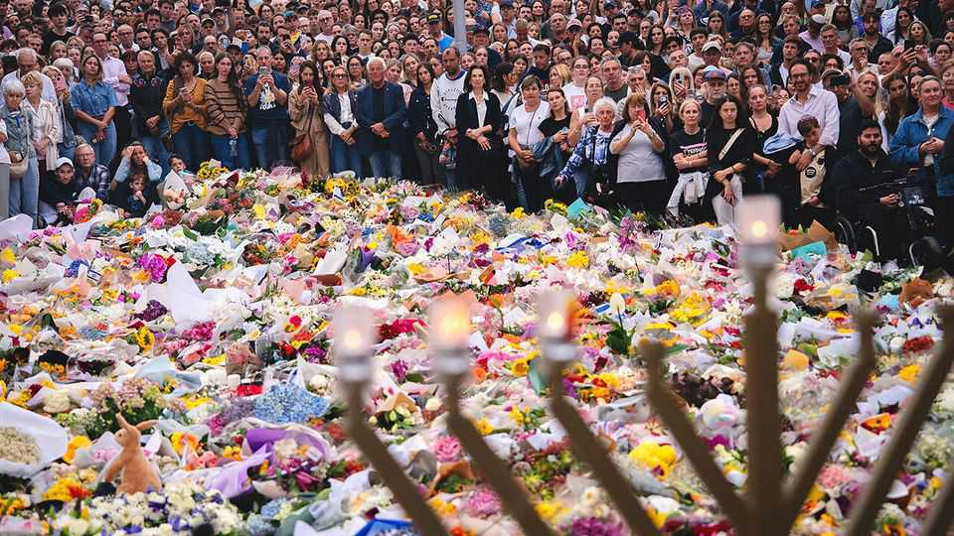
When gunmen opened fire on crowds attending a Hanukkah celebration at Bondi Beach in Sydney, Larisa Kleytman was among those who sought cover on the ground. Her husband of 57 years, Alex Kleytman, also dropped to the floor. Mr Kleytman, a retired civil engineer and a survivor of the Holocaust, died shielding his wife from the bullets. At 87, he is the oldest of 15 people who were murdered on December 14th in the deadliest terrorist attack in Australian history. Matilda, the youngest victim to have been named, was aged only ten.
Days after the attack mourners were still streaming to Bondi—a suburb with a large Jewish community—to lay flowers and light candles. They have sung Hanukkah songs; a few have wrapped themselves in Israeli flags. On December 16th Australia’s most famous beach still seemed frozen in time. Chairs and half-eaten picnics remained strewn across the lawn at an outdoor cinema that sits right next to the sands. Unfinished drinks stood abandoned on beachside tables.
Authorities say the attack was carried out by Sajid Akram, 50, and his son Naveed Akram, 24. The older Mr Akram was killed on the scene by police. His son was gravely wounded, arrested and taken to hospital; he has since been charged with 59 offences. Several explosive devices and two home-made flags bearing the insignia of Islamic State, a jihadist terrorist group, were found in the younger man’s car. Both men were motivated by “Islamic State ideology”, said Anthony Albanese, Australia’s prime minister. “The threat of antisemitism, as we have seen, is very real.”
Australians have responded anxiously to news that the younger Mr Akram was already known to Australia’s domestic intelligence service (ASIO). It admitted it had investigated him in 2019 (when the spies also interviewed his father). The Australian Broadcasting Corporation reports that, back then, the authorities had connected him to Isaac el-Matari—a self-proclaimed commander of Islamic State, based in Sydney, who was arrested that same year and later jailed for plotting a terrorist attack. But at the time ASIO found no evidence that Naveed Akram had himself been radicalised. After this there was clearly a big change in his “risk profile”, said Tony Burke, Australia’s home-affairs minister.
In November this year the father and son spent four weeks in the Philippines, returning about a fortnight before they launched their attack. During their trip they travelled to Davao City in Mindanao, an island in the south of the country. Mindanao has long suffered from Islamist militancy; one theory is that the men were seeking training. The Philippine Bureau of Immigration said that Sajid Akram entered the country on an Indian passport, and his son used an Australian one. Police in India confirmed that Sajid was originally from the southern Indian state of Telangana and that he had moved to Australia in 1998.
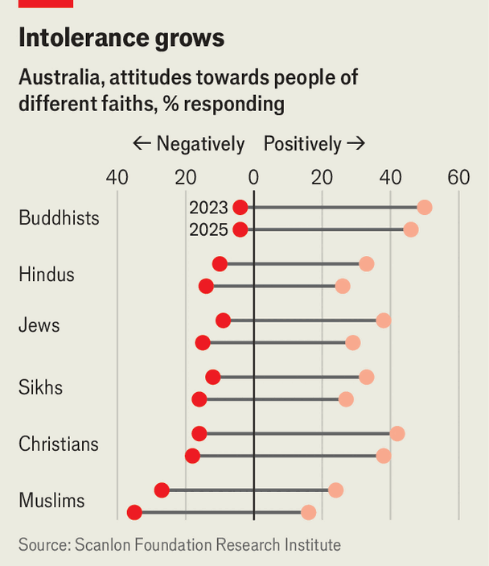
Jewish leaders are demanding that Australia’s government step up action against antisemitism. There have been more antisemitic attacks in Australia in the past two years than in the whole of the preceding decade, according to the Executive Council for Australian Jewry, a community group. These have included arson attacks on synagogues and a Jewish business. Jewish leaders say that antisemitic incidents have risen faster in Australia than in other rich countries. The share of Australians who express a positive attitude towards people of Jewish faith has fallen from 38% in 2023 to 29% this year (see chart), according to a study by the Scanlon Foundation Research Institute, a non-profit.
Mr Albanese has promised to use “every single resource required” to eradicate antisemitism in Australia. On December 18th he announced plans to toughen hate-speech laws. He said there would be stronger penalties for people who spread hate speech that urges violence, and that the government would be gaining new powers to cancel or refuse visas to people who are deemed to be spreading hate. He also announced a task-force that will examine how to prevent and respond to antisemitism in the education system.
These are only some of the government’s new pledges: tougher controls on guns is another. Australia has had relatively tight gun laws since a rampage in 1996, when a gunman killed 35 people in the Tasmanian town of Port Arthur. Automatic and semi-automatic weapons were largely banned as a result, and the government bought hundreds of thousands of firearms back from the public. Only around 12% of killings in Australia involved a firearm in the year to June 2024, according to the government. That compares with about 80% in America in 2023.
Yet gun violence has been making a comeback in Australia, says Roderick Campbell of The Australia Institute, a think-tank. Sajid Akram legally owned six guns. Several of these weapons appear to have been used in the attack in Bondi. Mr Campbell’s organisation calculates that there are now around a million more guns in civilian hands in Australia than there were before the atrocity at Port Arthur. The government may now set up a national firearms register, linking up records currently held separately by states. It may limit the number of guns one person can own. And it may expand the checks carried out before a gun licence is issued.
While they wait for politicians to fulfil their pledges, shocked Australians have been trying to help in any way they can. Cafés in Bondi Beach have been handing out free coffees. Locals have been retrieving and lining up (for easy collection) items that fleeing visitors left behind on the beach. In the days after the massacre, record numbers of Sydneysiders rushed to donate blood.
An online fundraising campaign has collected over A$2.5m ($1.65m) for Ahmed al-Ahmed, a 43-year-old father who runs a shop in southern Sydney. People all around the world have gasped at video footage, published on social media, that shows Mr Ahmed creeping up on the older gunman from behind a car, then wrestling the attacker’s rifle away from him. He was subsequently shot in the shoulder by the younger gunman, and is recovering in hospital.
Mr Albanese called him “the best of Australians”. Donald Trump also praised him. Mr Ahmed was in Bondi having coffee with a friend when he heard gunshots, said his parents, who have been visiting Sydney for a few months from their home in Syria. Their son would have done anything to protect anyone, his parents said—no matter their background or faith. ■
This article was downloaded by zlibrary from https://www.economist.com//asia/2025/12/18/can-australia-defend-itself-against-jihadist-murderers
Asia | Asia’s audiowars

Why has the border between the Koreas fallen silent?
South Korea’s president wants to reduce tensions with the North

December 18th 2025

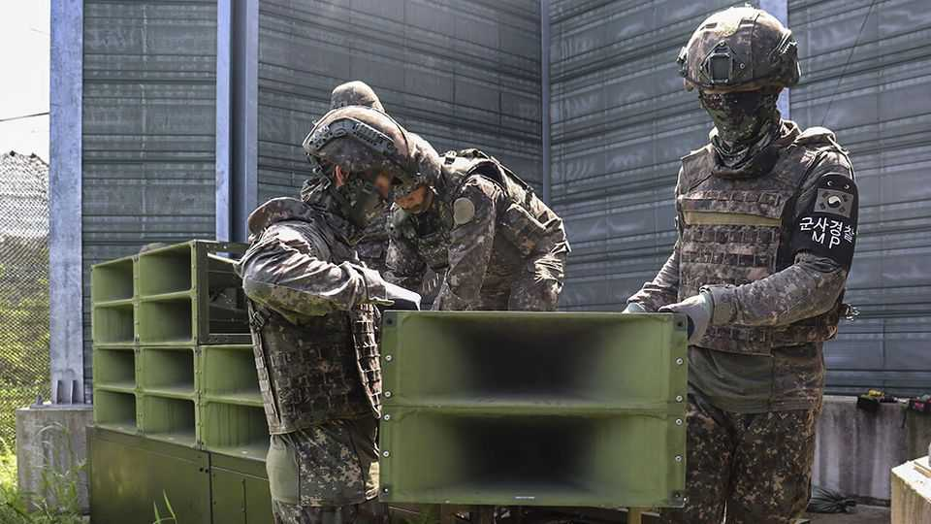
KIM CHANG-HWAN used to need earplugs when he went to bed at his home in Daedong-ri, a South Korean village near the border with North Korea. Eighteen months ago South Korean authorities began blasting K-pop and news reports into North Korea from a network of loudspeakers rigged up along the frontier. North Korea responded in kind, broadcasting animal cries and spooky whistles from its own set of loudspeakers. Then, earlier this year, the border fell silent. Mr Kim rejoiced.
The calm reflects a new approach that Lee Jae Myung, South Korea’s president, has taken towards its menacing neighbour. Tensions between North and South mounted under his predecessor, Yoon Suk Yeol, a conservative who held office between 2022 and 2024. Goings-on at the border reflected those worsening ties. South Korean activists wafted leaflets lambasting the North Korean regime over the frontier; the North sent back balloons filled with rubbish and excrement. Last year Mr Yoon upped the ante: he switched back on loudspeakers which had once been a regular feature at the border but had in fact not been used since 2018.
Mr Lee, a left-winger who became president in June, is trying to be more conciliatory. Silencing the loudspeakers was one of his first acts as president. The leafleting has also mostly stopped. Within a few days of this decision the North turned off its own noisemakers, too.
Not many people will miss the cacophony in the borderlands. Yet this is only one of the ways that Mr Lee has sought to pause activities that rile the North—and some of his other reforms are producing rather more disquiet. For years South Korea’s spy agency has broadcast radio into North Korea in the hope of giving ordinary citizens access to uncensored news.
This year its stations fell silent for the first time since 2010. This switch-off came not long after Donald Trump dismantled America’s state-funded news services, which had also broadcast into North Korea. As a result, the number of hours of programming entering the country from outside has fallen by roughly 80% since May, according to the Stimson Centre, an American think-tank.
The remaining broadcasters, a smattering of activist-run outfits, have transmitted in shortwave from countries including Taiwan, the Philippines and Uzbekistan. Transmitting from South Korea would make it more difficult for censors in the North to jam their signals. But the South Korean government will not allow it, laments one person involved.
So now activists are scratching their heads for new ways of reaching North Koreans. One defector from the North who lives in Seoul recently launched an internet-based radio station targeting North Koreans who reside outside the Korean peninsula, such as overseas students or labourers, in the hope that listeners will relay information they pick up from it to friends and family back home.
All this represents a fairly large concession to North Korea’s leaders, who consider uncensored information a big threat to their rule. The regime has been ramping up punishments for distributing and consuming foreign content. These now include lengthy prison sentences and (sometimes) execution. Just owning a foreign-made radio is illegal, unless the device has been registered with police and fixed so that it can only pick up state signals. But North Koreans nonetheless consider radio broadcasts a safer way of getting outside information than smuggled flash drives, which can be intercepted in transit. Radios are easier to hide from authorities than television sets and they can operate on batteries, which is useful in a country short of power.
Mr Lee has defended his decision to suspend broadcasts by painting radio as antiquated and wasteful. “Everything’s searchable on the internet,” he said last month. But the president doubtless knows that North Koreans cannot freely access the internet. Instead, Mr Lee appears to be hoping that this gesture, among others, can help coax Kim Jong Un, North Korea’s dictator, back to the negotiating table. “He’s looking for little things that can stop the situation from worsening,” says Jun Bong-geun, professor emeritus at the Korea National Diplomatic Academy.
Will that work? Having more or less earned the backing of China and Russia, the North Korean regime hardly looks desperate to sit down with the South. Indeed, its leader seems to believe he may soon be able to extract big concessions from America, perhaps even including acceptance of its nuclear arsenal. There is a growing expectation that Mr Trump may meet North Korea’s dictator in person, for a second time, next year. Much will ride on America’s president approaching that dialogue with caution and forethought. Just as well that South Koreans who live closest to the border are getting a chance to catch up on their sleep. ■
This article was downloaded by zlibrary from https://www.economist.com//asia/2025/12/15/why-has-the-border-between-the-koreas-fallen-silent
Asia | A flood of failures

The botched response to a devastating storm infuriates Indonesians
Nationalism impeded the arrival of help from abroad

December 18th 2025

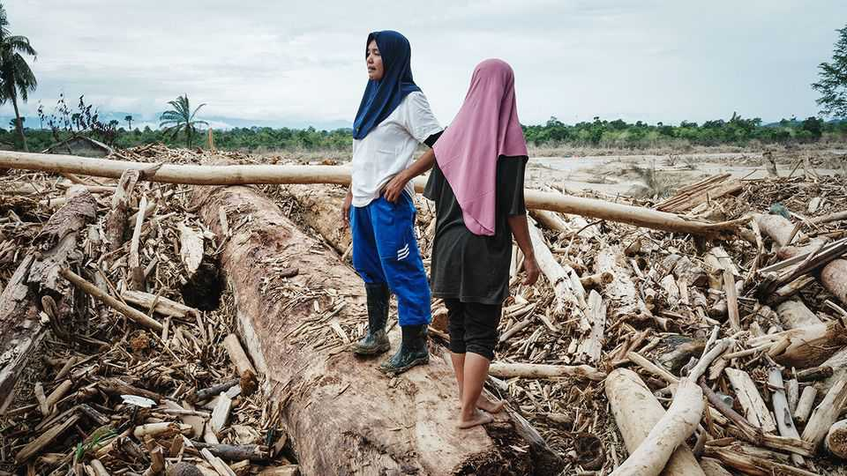
Three weeks have passed since Cyclone Senyar ravaged Sumatra in western Indonesia, bringing enormous floods. But only in mid-December, as the waters have receded, has the scale of the destruction become clear. More than 1,000 people have been killed, around 150,000 homes damaged and nearly 1m people displaced. Scientists have described the storm as a once-in-70-year event.
And yet it is not a national disaster—or at least not by the standards of the government in Jakarta, the capital. Officials have declined to formally designate it as one, even though doing so would hand authorities emergency powers and, importantly, make it much easier for them to accept foreign aid. Politicians including Prabowo Subianto, the president, have insisted that Indonesia does not need outside help.
“The arrogance of this government has cost lives,” says Farwiza Farhan, who heads HAkA, an NGO working in Aceh, a province in Sumatra. When the floods struck, the head of Indonesia’s disaster agency suggested the devastation was not as bad as it looked on social media (he later apologised). Relief efforts have been slow and poorly co-ordinated, says Ms Farhan.
Officials think it will cost 52trn rupiah ($3.1bn) to rebuild damaged homes and infrastructure. For now, several communities remain stranded by collapsed roads and bridges, hundreds of people are still missing and diseases are spreading. Residents in Aceh have started hoisting white flags outside their homes as a symbol of their desperation and their anger at the central government’s response.
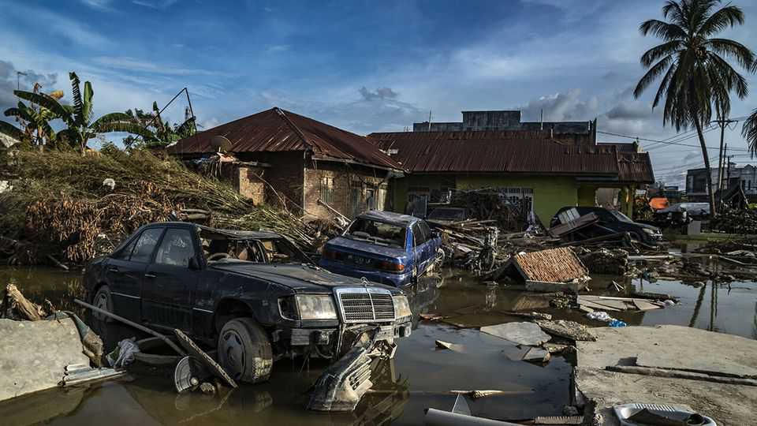
Mr Prabowo has dismissed some of the criticism as lies spread by foreign forces that, he says, have never liked Indonesia. He has apologised for delays in the provision of services and assistance to affected regions, but has also warned Indonesians that he does not have a “staff of Moses” that he can use to fix things straightaway.
Environmentalists say work to prevent the next such disaster needs to start immediately—and that none of it is magic. They say deforestation worsened the floods. Tree canopies collect water; tree roots stop soil sliding away. But since 2001 Sumatra has lost 4.4m hectares of forest, an area roughly the size of Denmark, mostly to palm-oil plantations and illegal logging.
Indonesia’s forests minister has admitted that poor forest management aggravated the floods. The environment ministry has suspended the operations of firms alleged to have cleared forest in areas where they took place. Yet environmentalists question the government’s sincerity. Mr Prabowo raised eyebrows among them when he said, in a speech given during the height of the flooding on December 5th, that Indonesia was lucky to be “blessed” with palm oil.
As climate change makes extreme weather more common, efforts to prevent and withstand disasters are growing more urgent everywhere. But the need in Indonesia is especially pressing. It ranks third globally in its vulnerability to natural disasters, according to an annual report from an alliance of German NGOs. The events in Sumatra suggest that it is badly equipped to handle the storms still to come. ■
This article was downloaded by zlibrary from https://www.economist.com//asia/2025/12/18/the-botched-response-to-a-devastating-storm-infuriates-indonesians

China
- Jimmy Lai’s judgment day
- The Christmas-industrial complex centres on Yiwu
China | The verdict

Jimmy Lai’s judgment day
The tycoon’s conviction speaks to the state of Hong Kong’s civil liberties

December 18th 2025


Editor’s note (December 15th): Jimmy Lai was found guilty of conspiring to commit sedition and foreign collusion on December 15th. He will be sentenced at a later date.
JIMMY LAI did not seem surprised when the verdict was read out. On December 15th three national-security judges found Hong Kong’s most famous media mogul guilty of collusion with foreign forces and of sedition. He spent 156 days on trial—52 of them on the witness stand. He has been behind bars for more than 1,800 days already, serving time for unauthorised assembly and fraud. When sentenced, Mr Lai could face life imprisonment.
Mr Lai has a long history of support for democratic causes in China; his involvement began after the Tiananmen Square protests of 1989. Through his outspoken newspapers the tycoon backed the millions of Hong Kongers who marched for democracy, first in 2014 and again in 2019. Mr Lai himself took to the streets in the more peaceful protests (some other demonstrations became violent). Foremost among his publications was Apple Daily, which critics found sensationalist. It had to close down almost a year after he was arrested in 2020.
Few believed he would be acquitted: national-security trials have a conviction rate of over 95% in Hong Kong (including defendants who plead guilty). Although receiving medical treatment in prison, his family fear that the 78-year-old, who suffers from diabetes, will die behind bars. Despite being a British citizen, he chose to stay put. “I must face the consequences of my actions, just or unjust,” he wrote from prison. “It is also a way to uphold the dignity of Hong Kong people, as one of the leaders for the fight of freedom.”
The judges saw things differently. In their 855-page judgment, they claimed Mr Lai was “obsessed” with “turning China into a lackey of the West”, and had published seditious articles to “undermine the legitimacy or authority” of the governments in both Hong Kong and Beijing. They said he had used his “personal influence” to call for foreign countries to impose sanctions on China. Notably, they suggested he had continued his “international lobbying” by “indirect and subtle means” even after the introduction of a national-security law (NSL) in 2020 made it a crime. The defence had argued that Mr Lai stopped all such activities when they became illegal. (Before the NSL was promulgated he met powerful potential supporters such as Mike Pence, who was America’s vice-president at the time.)
It is a febrile moment. A terrible fire last month in the Tai Po neighbourhood consumed seven apartment blocks, killing at least 160 people. A recent election saw the second-lowest turnout on record, and was taken by some as a tacit rebuke of the pro-government legislature. China’s Communist Party has changed a once defiant city—with barely a whimper from abroad. Mr Lai’s case, which is the first related to foreign collusion, looks likely to establish precedents both legally and socially.
The party’s control centres on the NSL. It was promulgated by the national parliament in Beijing in 2020 in the wake of the unrest in Hong Kong the year before. The NSL created sweeping, ambiguous categories of crime previously unknown in Hong Kong, such as subversion and the collusion of which Mr Lai was accused. Another set of rules passed last year, “Article 23 legislation”, introduced harsher sentences for national-security offences. Trials under both the NSL and Article 23 legislation can be held without juries and involve judges drawn from a special pool.
Hong Kong’s authorities seem on edge. On December 6th representatives of around a dozen international media outlets, including The Economist, were summoned by the national-security police and told not to publish over-critical accounts of the government that they said might sow discord. The warning explicitly concerned coverage of the Tai Po fire, but correspondents drew a broader message. On December 15th the spokesperson of the Commissioner’s Office of the Chinese Foreign Ministry in Hong Kong wrote to some outlets in the city “to draw…attention to some facts”, for example that Mr Lai’s case “has nothing to do with press freedom”.
It is unclear what the reverberations in Hong Kong will be. Supporters of Mr Lai queued overnight to watch the verdict’s delivery. A sense of resignation pervades the city. “A lot of people are just saying: ‘Oh well, [Mr Lai] he is gone,’” says one resident. Except for national-security cases, the territory’s common-law legal system, inherited from Britain, is still generally considered fair. Business leaders have broadly kept quiet about Mr Lai’s case. But aspects of his treatment have caused liberal types to raise their eyebrows.
Although protest has become more difficult at home, Mr Lai’s fortunes have attracted criticism abroad. Britain condemned Mr Lai’s “politically motivated persecution” and called for his release, as did the European Union. Marco Rubio, America’s secretary of state, lambasted “the enforcement of Beijing’s laws to silence those who seek to protect freedom of speech”. But both Sir Keir Starmer, Britain’s prime minister, and Donald Trump, America’s president, are planning to visit Beijing early next year. The leaders may wish to avoid provoking Xi Jinping, their Chinese counterpart, by pressing Mr Lai’s case. Britain is already wrangling with China over a new embassy in London and spying scandals. And Mr Trump is keen for more dealmaking after a truce in Sino-American trade tensions was agreed in October.
Besides, China does not take kindly to others meddling in its domestic matters. After the verdict China’s foreign ministry warned other governments “not to interfere in Hong Kong’s judiciary or China’s internal affairs in any form”, while the central government’s liaison office in Hong Kong described the outcome as a “stern warning” to “anti-China” forces. It also decried “the political manipulation of Hong Kong by a small number of Western politicians and anti-China media under the guise of ‘human rights’ and ‘freedom’”.
Authorities in Hong Kong will hope that the world moves on quickly from the verdict. But for some Mr Lai will remain a symbol of the city’s transformation. He arrived on its shores as a 12-year-old refugee from mainland China, a penniless stowaway in a boat. His fortunes rose alongside those of Hong Kong, making him an emblem of its promise. Now he will be remembered by his supporters as a martyr to his convictions. ■
Subscribers can sign up to Drum Tower, our new weekly newsletter, to understand what the world makes of China—and what China makes of the world.
This article was downloaded by zlibrary from https://www.economist.com//china/2025/12/14/jimmy-lais-judgment-day
China | Snow globalisation

The Christmas-industrial complex centres on Yiwu
How Chinese traders beat out Lapland’s elves

December 18th 2025

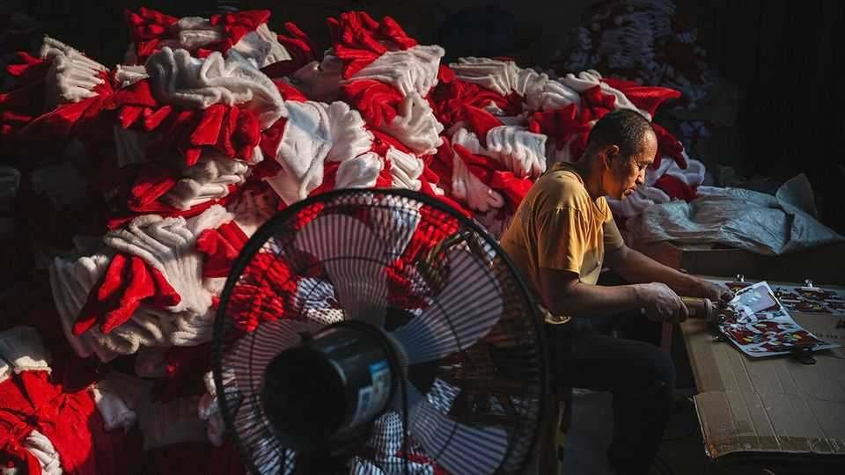
YIWU IN EASTERN China is the world’s Christmas capital. The five main districts which contain its wholesale markets, each home to vast commercial buildings, stretch for miles on end. Masses of stalls are, for much of the year, dedicated to Christmas paraphernalia: trees, ornaments, hats, wreaths and candy canes. It hums in the summer months, when jolly fare is readied for elsewhere. By December each year it lies more quiet. The city’s wares will have contributed to China’s record $1trn trade surplus in the first 11 months of 2025.
China dominates exports of the world’s Christmas decorations by value; in the recent past America has bought more than half of what China produced. But this year in the ten months to October China exported $5.1bn of the trinkets, down from $5.8bn over the same period in 2024. America has been responsible for all of that decline and more, having imported about $940m less in festive fare from China than it did last year. That is thanks to President Donald Trump’s trade war and his introduction of painful tariffs, which though down from their peak still stand at 20% for Chinese goods.
The large number of banners, signs and decorations saying “Feliz Navidad” and “Buon Natale” suggests that many merchants are shifting to other markets in response. Data show exports to Germany and the Netherlands are up by 22% and 16%, respectively. And there are more grinchy ways of getting around the American tariffs, too. Dismembering Father Christmas and then shipping his head, limbs and torso to South-East Asia is one such ruse. Reassembling him, relabelling him and selling him on to America thereafter is more jolly.
Yiwu’s traders are a worldly sort, and not all about Christmas. They converse with visiting buyers from India, the Middle East and Russia. Arabic, Spanish and other tongues can be heard among its stalls. The criticism of Mr Trump in many languages is stinging. “America is crazy these days,” gripes Yang Jie, a local. “We can’t do business with them, it’s just impossible to plan,” she adds. “How can I set prices when I don’t know what the tariff will be when I ship?” asks a vendor in a stall blooming with artificial flowers.
Mr Trump is not the only problem. “The war in Ukraine has really been a headache for us,” says Wu Yunqing, a car-parts seller. Demand has dropped in Russia, and he has lost touch with customers in Ukraine. A woman selling shirts does business across the Middle East. The flare-up between Israel and Iran made her very nervous, she says.
Yet the mood still twinkles. Many have their eyes on the next round of orders. The city’s merchants make decorations for festivals Christian, Muslim and more. Ms Yang has just finished sending the last few shipments of decorations for Ramadan in February. What next? Chinese New Year, of course. ■
Subscribers can sign up to Drum Tower, our new weekly newsletter, to understand what the world makes of China—and what China makes of the world.
This article was downloaded by zlibrary from https://www.economist.com//china/2025/12/18/the-christmas-industrial-complex-centres-on-yiwu

Middle East & Africa
- Donald Trump’s peace plan is faltering in the chaos of Gaza
- Just 74 intensive-care beds remain in Gaza
- Ethiopia wants to build Africa’s biggest airport
Middle East & Africa | What’s next for Gaza?

Donald Trump’s peace plan is faltering in the chaos of Gaza
But American officials insist the strip has a bright future

December 18th 2025

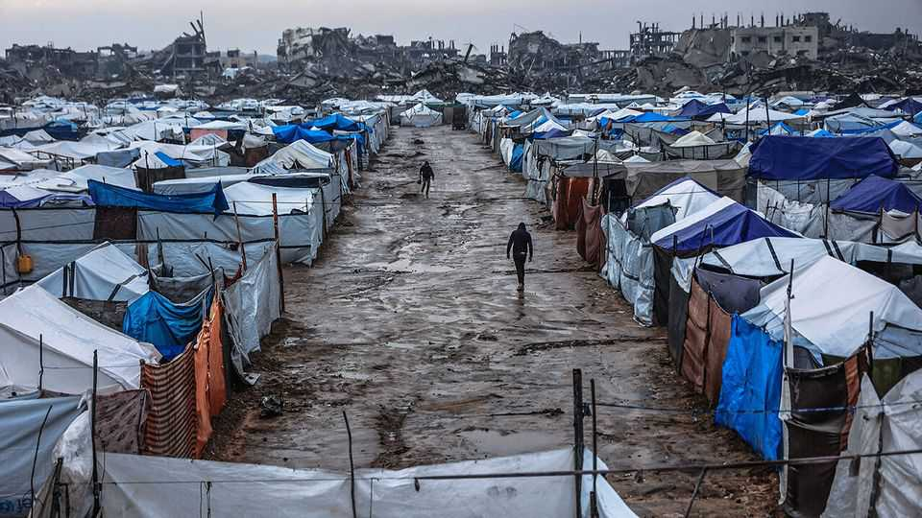
Rafah was once the third-largest city in the Gaza Strip. It was home to around 200,000 people. Today it is a desolate moonscape of rubble and twisted iron. The city and its suburbs were systematically destroyed by the Israel Defence Forces (idf) during the two-year war against Hamas. Rafah’s population was forced to move to tents in squalid refugee camps on the coast which are now being battered and flooded by winter storms.
But to hear American officials talk, Rafah is about to become the bright new future of Gaza. The State Department recently posted a video showing it rising from the ashes. Boosters point to two Israeli engineering projects as evidence. First, the idf’s one to destroy the labyrinthine network of tunnels built by Hamas, the Islamists who still control parts of the territory. Second, a plan, already started, to clear thousands of tonnes of rubble in two parts of what used to be eastern Rafah to make way for what the Americans are calling “planned communities”.

The Economist has recently visited the Yellow Zone—the half of Gaza’s territory still occupied by Israel—twice, both times accompanied by Israeli soldiers. idf officers were sceptical either project would ever be completed. “We’re still surprised at the size and complexity of tunnels we’re uncovering,” said one engineer. “We don’t have the capacity to destroy them all.” Israeli officers were even more dismissive of the new planned communities.
The ceasefire process that began in October as part of a 20-point plan presented by Donald Trump seems stuck in the mud and chaos of Gaza. In the first phase, Israel withdrew from the populated coastal areas. Israeli hostages and Palestinian prisoners were exchanged. Some aid deliveries resumed. But things have now stalled.
The second phase of Mr Trump’s plan was meant to include the deployment of an International Stabilisation Force (isf), the appointment of a technocratic civilian government and the disarmament of Hamas. So far none of this has happened. The names of the technocrats have yet to be released. No country has publicly pledged to send troops for the isf. Hamas has reasserted its grip on the civilian population. It has made vague statements about disarming, but taken no steps to do so.
This was to be the prelude to the reconstruction of the devastated strip, which is expected to take years and cost tens of billions of dollars. But that will not happen without Hamas disarming and a new governing body being in place. Donors will not pay to rebuild things if they fear Israel could destroy it all in another war. And Israel will not allow building materials in.
Meanwhile, there have been multiple infractions of the ceasefire with ambushes of Israeli troops by Hamas along the Yellow Line and regular Israeli attacks there and deeper into Gaza. On December 13th an Israeli strike killed Raad Saed, a senior Hamas commander who Israel claims was working to rebuild the group’s missile-manufacturing capabilities and helped plan the October 7th attacks. Nearly 400 Palestinians are reported to have been killed by the IDF since the ceasefire began.
And yet despite all indications that the ceasefire has merely been a transition to a low-level bitter war of attrition, American officials seem convinced that Mr Trump’s plan is moving forward. The “Board of Peace” he plans to chair will be announced very soon, they promise. The isf and Gaza’s new technocratic government will materialise any day, they insist. American contractors with close ties to the administration have already visited the area, sniffing for opportunities.
Behind the scenes, however, disagreements between Israel and America on how to implement the next stage are deepening. The administration wants to use its planned communities—compounds of prefabricated homes that will include schools and clinics—as a proof of concept. These compounds will take months to build and provide homes for only a fraction of the population. But the administration believes they will show it can fulfil much more ambitious reconstruction plans. They envisage Israel withdrawing from the areas around the new compounds and isf troops securing them while talks continue over Hamas’s disarmament.
Israel sees things differently. It shows no sign of withdrawing. Lieutenant General Eyal Zamir, the idf’s chief of staff, has called the Yellow Line a new border. Binyamin Netanyahu, the prime minister, wants the idf to control access to the compounds and allow in only Gazans who have been screened by Israel. Sources close to Mr Netanyahu claim this is the only way to isolate Hamas and force it to disarm—though another military campaign, they say, may also be needed. Israel’s security types are less convinced. “There’s absolutely no way we’re going to get enough Gazans to move to the Yellow Zone” to allow for this, says one official.
Another major point of contention between the Israelis and the Americans is the inclusion of Turkey in the isf. For Israel, this is a red line. The Turkish government has hosted Hamas leaders and imposed a trade embargo on Israel. Mr Trump, however, has grown closer to Turkey’s president, Recep Tayyip Erdogan, and is eager to take advantage of his aspirations to be a power in Gaza.
Mr Trump has summoned Mr Netanyahu to Mar-a-Lago, his Florida home, on December 29th. The president is expected to press him to accept his version of the second stage of his peace plan. “Netanyahu can’t fold on the Turkish issue,” predicts one Israeli diplomat. “But he will have to concede on other matters.” Mr Trump, who wants some big announcements on Gaza in January, is losing patience. ■
Sign up to the Middle East Dispatch, a weekly newsletter that keeps you in the loop on a fascinating, complex and consequential part of the world.
This article was downloaded by zlibrary from https://www.economist.com//middle-east-and-africa/2025/12/17/donald-trumps-peace-plan-is-faltering-in-the-chaos-of-gaza
Middle East & Africa | On its knees

Just 74 intensive-care beds remain in Gaza
The health-care system is shattered and no one is rebuilding it

December 18th 2025

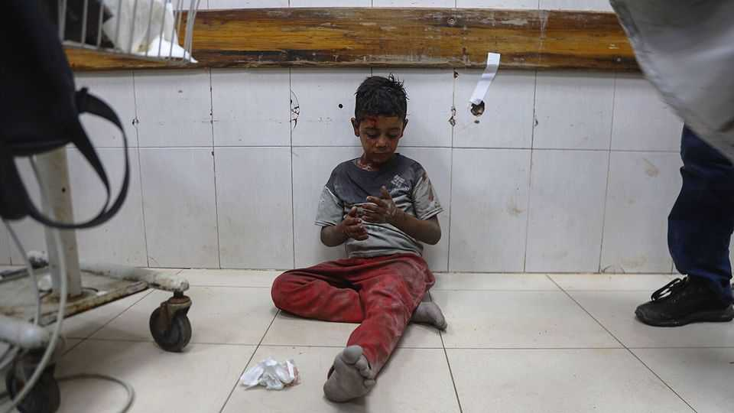
To grasp the magnitude of the task of rebuilding Gaza, look at its health-care system. From buildings to medics, it is shattered. Out of 35 hospitals and clinics in Gaza evaluated by the un, six have been flattened; 11 are out of commission; only parts of 18 can be used. Several hospitals are in the half of the strip controlled by Israel, out of reach for most Palestinians. Of the 18 partially functioning hospitals and clinics, 16 cannot dispose of infectious waste properly, 15 do not have dependable electricity, 13 lack decent toilets and sinks and 11 lack reliable clean water. In Gaza just 74 intensive-care beds and 215 emergency-room beds remain.
Supplies of everything from fuel and drugs to bags of saline, syringe needles and gauze are scarce or non-existent. There are no mri machines in northern Gaza and just one functional ct scanner. Newborns in critical condition have to share incubators. At Nasser hospital in Khan Younis, the largest in the south, the glass on the main autoclave, used to sterilise equipment, was shattered by a bullet during the war and has not been replaced. Medics dealing with amputations, burns and limb or spinal trauma have just five sets of skin-grafting surgical tools in the entire strip. “Normally each hospital would have at least four,” says Dr Victoria Rose, a British surgeon who has been into Gaza three times since October 2023.

Israel still prevents anything it considers “dual use” from entering Gaza. That includes surgical instruments, x-ray equipment and solar-powered refrigerators used to store drugs. The list of dual-use items is unclear and inconsistent. Aid workers say Israeli officials confiscate stethoscopes and operating glasses.
At least 1,722 health-care workers were killed during the war, about 10% of the workforce. About 80 who were arrested are thought to remain in Israeli jails. Many more fled. Those left have been working flat out, enduring the same air strikes, food and water shortages as all Gazans.
Nor can Gazans easily get medical help elsewhere. Before October 2023 between 50 and 100 patients would leave the strip every day for treatments such as radiotherapy in East Jerusalem and elsewhere. Since then 10,600 patients have been evacuated, the equivalent of about 13 a day. More than 18,500, including 4,000 children, are waiting to leave for treatment, says the World Health Organisation (who). Between July 2024 and October 2025 more than 930 died waiting to be evacuated.
Telemedicine could provide some relief. Specialist teams outside Gaza can offer advice remotely on the right course of action for individual patients, an approach that was used before the latest conflict. Diagnostic tools such as the cad4tb software, which uses artificial intelligence to detect tuberculosis in digital chest x-rays, could speed up screening and treatment.
Nor is the damage only physical. Experts assume that every child in Gaza has suffered trauma that will have a severe impact on their behavioural, mental and emotional development. “They have all had to live under acute life threat every single day,” says Katrin Glatz Brubakk, a Norwegian child psychologist who has been to Gaza twice since August 2024. “They have all lost family members or friends. They have all [seen] people dismembered.”
Children with severe trauma form fewer neural connections in their prefrontal cortex, a part of the brain that is essential to everything from decision-making to learning, problem-solving and emotional regulation. To provide care, “you don’t only need psych wards,” says Dr Glatz Brubakk. “You need to rebuild homes and schools—preferably also a football field.” In other words, some kind of normal life.
Putting the health-care system back together will take years. The who puts the cost at $7bn-8bn. The Hamas-run ministry of health has drawn up a 49-page “early recovery plan” which estimates it will take five years to rebuild a “smarter and more sustainable” system. But removing Hamas from power is central to Donald Trump’s peace plan, so the ministry’s proposal may not be implemented any time soon. In the meantime, Gazans will suffer. ■
Sign up to the Middle East Dispatch, a weekly newsletter that keeps you in the loop on a fascinating, complex and consequential part of the world.
This article was downloaded by zlibrary from https://www.economist.com//middle-east-and-africa/2025/12/18/just-74-intensive-care-beds-remain-in-gaza
Middle East & Africa | The next mega-project

Ethiopia wants to build Africa’s biggest airport
But conflict, competition and government meddling are complications

December 18th 2025


Ethiopian airlines (ET) has come a long way since it started flying five small planes at the behest of Emperor Haile Selassie back in 1946. Four major wars, two revolutions and three constitutional overhauls later, it is the largest and most profitable airline in Africa (if not necessarily, judging by recent customer reports, the most comfortable).
Now the airline hopes to cement its dominance in African air travel by building Africa’s largest airport, near Addis Ababa, Ethiopia’s capital. The project is supposed to strengthen Ethiopia’s status as the continent’s air-travel hub and help return the country of around 130m people to a path of stability and development after years of internal strife. Yet competition from other regional players, the fractious state of Ethiopia’s politics and government meddling raise doubts about the project’s viability.
If it is built, the new airport will occupy vast swathes of what are currently fields around Bishoftu, an hour’s drive south of Addis Ababa. According to ET’s plans, it will ultimately be able to handle some 110m passengers a year. That is more than travelled in 2024 through Atlanta, which has been the world’s busiest airport almost every year since 1999. ET, which is owned by the Ethiopian government, says it will stump up a fifth of the expected cost of around $10bn. The African Development Bank (AfDB) has pledged $500m and is soliciting more cash from foreign investors.
The business case for a new airport is compelling. Most state-owned African airlines are badly managed and chronically lossmaking. ET, by contrast, has long been run by able professionals. In 2024 its passenger-carrying capacity was roughly equivalent to that of the second-, third- and fourth-largest African airlines combined. When flying from one African capital to another or onwards to Europe, it is often the cheapest option and sometimes the only one.
Since many of those passengers must transit through Ethiopia, its main airport is already under strain. It boasts a capacity of 22m passengers a year; by 2035 ET aims to be carrying triple that number annually. The airport’s location in central Addis Ababa limits any potential expansion. Moreover, taking off at the capital’s altitude of 2,300 metres requires planes to be lighter. From Bishoftu, which lies around 400 metres lower, ET’s aircraft could carry either more cargo or more fuel, which would make it possible to offer direct flights to North America, for instance.
Some reckon the airline can easily afford the steep price tag. ET has turned a profit every year for nearly two decades, even during the covid-19 pandemic. In the year to July its revenues grew by 8% to $7.6bn; over the previous year they grew by 15%. “Ethiopian Airlines is about as blue-chip as you can get if you’re looking at infrastructure in Africa,” says Sean Mendis, an aviation consultant. In addition to the AfDB, both America and China have expressed interest in financing the airport.
Others remain sceptical. Even with ET’s strong balance-sheet, $8bn is a lot of debt. Civil strife, which continues in much of the country, could cripple the project, as could a new war with neighbouring Eritrea.
More prosaically, ET is also likely to face more competition in the coming years. Airlines from the Gulf have plans to expand in Africa. Emirates recommenced its daily direct flight to Lagos, Nigeria’s commercial capital, in 2024. It also increased the frequency of flights to key hubs like Addis Ababa and Nairobi, in Kenya. Like Qatar Airways, it is adding new destinations by signing codeshare agreements with African carriers. Istanbul airport, an important hub connecting Africa with many European destinations, plans to finish its expansion by the end of 2028, increasing its annual capacity to 200m passengers. Turkish Airlines will significantly expand its network in western and southern Africa next year.
Some investors therefore believe a more prudent approach would be to opt for a smaller airport to start with, which could be expanded in stages. Several sources suspect that the monumental size of the current plan reflects pressure from the government of the prime minister, Abiy Ahmed. Like previous Ethiopian regimes, it has a penchant for mega-projects.
Plans for the airport could conceivably be revised or scaled back should investors refuse to cough up the cash. More troubling is the government’s inclination to interfere with ET’s affairs more generally. ET’s success derives in large part from what one researcher calls its “Chinese wall between political and commercial decision-making”.
For now, interference in the day-to-day running of the company appears to be limited. But there are worrying signs that the Chinese wall is crumbling. In 2022 the airline’s widely respected chief executive resigned after facing what credible sources say was intimidation from the government over his perceived links to opposition politicians. In 2023 General Yilma Merdasa, head of the Ethiopian Air Force, replaced a veteran aviation executive as chairman of ET’s board. (ET and the Ethiopian government did not respond to multiple requests for comment.)
At the site of the new airport, construction is expected to displace some 15,000 people. Some say they have been promised new houses. Others expect to receive nothing at all. Local activists say people who complained to the government have been harassed and arrested by security forces. Whatever the eventual fate of the airport, some Ethiopians are already beginning to notice its impact. ■
Sign up to the Analysing Africa, a weekly newsletter that keeps you in the loop about the world’s youngest—and least understood—continent.
This article was downloaded by zlibrary from https://www.economist.com//middle-east-and-africa/2025/12/16/ethiopia-wants-to-build-africas-biggest-airport

Europe
- Ukraine scrabbles for handholds against Russia’s massive assault
- Italy is using the Winter Olympics to appeal to the ultra-wealthy
- Why German cities feel like war zones on New Year’s Eve
- European nationalism is dead. Long live European gastronationalism
Europe | Bitter struggle

Ukraine scrabbles for handholds against Russia’s massive assault
A counter-attack in Kupiansk is promising, but the overall outlook is not

December 18th 2025

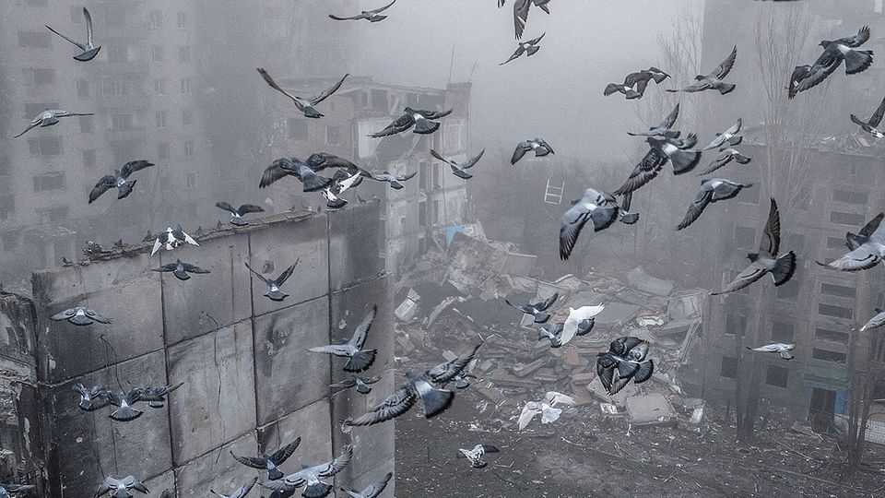
ON DECEMBER 12TH situation maps around the key railway town of Kupiansk in Ukraine’s north-east flipped from red to blue. DeepState, a war monitor, explained the change: a successful Ukrainian counter-attack had liberated most of the town, leaving pockets of Russians encircled. After midday came more drama, with Volodymyr Zelensky posting a selfie video from the town’s edge. Barely 1km from enemy positions, and just weeks after Vladimir Putin had declared the town to be his, the Ukrainian president challenged Kremlin claims to be winning the war. “They talked a lot about Kupiansk. Now we see the truth for ourselves.”
Much about the Kupiansk operation remains secret. Part of the reason is that it is ongoing. Perhaps 200 Russian defenders remain isolated in basements in the town. But part is because Ukraine is keeping secret the methods it hopes will help it regain a winning edge elsewhere. Participants refuse to say how they circumvented the all-seeing eyes and kill-zones of the modern battlefield. “There are war games and different courses of action, but these are things the enemy must not know,” says Ihor Obolensky, commander of the Khartiia corps, who developed the original operational plan. “Above all it’s about creative thinking, a feel for the enemy, a sense of his rhythm.”
The Kupiansk counter-attack was conceived in response to increasing Russian pressure in the late summer. The first stages of an operation to relieve the town began as early as August 24th, Ukraine’s independence day. Yet by mid-September the situation grew critical, with Russian troops breaching the Oskil river that runs through the town, occupying the town centre, and threatening a much larger grouping of Ukrainian forces to the south. On September 21st a task group led by Khartiia, the 92nd brigade and the Code 9.2 regiment, an elite assault unit, began the full counter-charge.
Over October and November, the group slowly pushed the Russians back over the river. They took control of two villages to the north, effectively cutting off supply routes. Russia attempted to reinforce its encircled troops via a disused pipeline, unaware that Ukrainian guns had established control over the exit point. The pipe became a death trap, with Ukraine destroying whatever came out of it. “Every day [they sent] a platoon,” says Ihor Raikov, head of Khartiia’s drone forces. ”A platoon a day is a thousand men a month.”
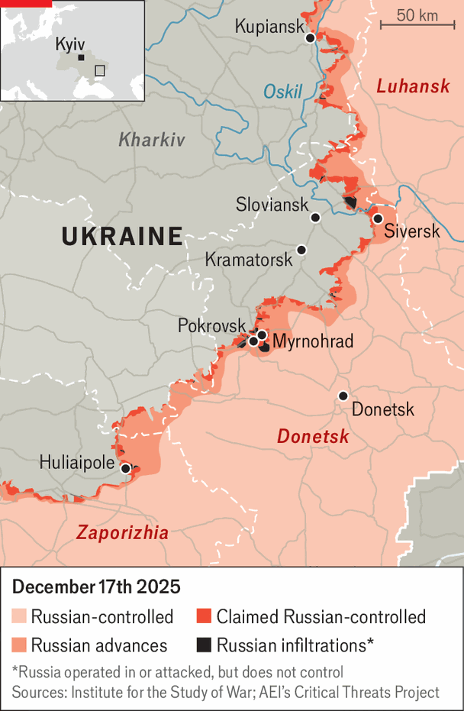
The Kupiansk counter-attack is one of few bright points for Ukraine. Elsewhere, Russia continues to push its advantage in men and materiel. Progress is slow and bloody, and the Russians have not achieved a break-out. Yet Ukrainian defences are retreating faster than at any point since the start of war. A Ukrainian intelligence source said Russia’s fifth army is now “several weeks” ahead of its operational plan, advancing westward near the city of Huliaipole in Zaporizhia province.
The 22-month-long defence of Pokrovsk and its satellite town of Myrnohrad is also reaching a bitter end. Russia has assembled 160,000 troops there and is pressing ahead. The situation in Myrnohrad (prewar population: 50,000) has become particularly acute. As of the most recent rotation of Ukrainian troops in mid-November, Russian forces were already close to surrounding the town. A marine from the 38th Brigade said his unit went in only after two others refused. “Someone had to do the job.” By early December the town was in effect encircled, with no safe routes out and no order to withdraw. Ukrainian military sources say several hundred soldiers remained trapped in mid-December, many sheltering underground under the threat of Russian glide bombs. Some are missing. “There are wounded, and they cannot be evacuated,” said a relative of one of the unaccounted-for. “People are hoping for a miracle.”

A similarly bleak picture is developing in Siversk, a small mining town in Donetsk province. Owing to its location on high ground, Siversk had served as a Ukrainian outpost, blocking a Russian advance towards Sloviansk and Kramatorsk, the largest cities in the province still held by Ukraine. In the second week of December Russian forces surged forward to gain a significant foothold. A senior Ukrainian officer, speaking anonymously and nervously, said that key positions could have been held had reserves been released. They were not. ”If the line now breaks, it won’t be a local setback,” he said. “Siversk is only the first domino. It will create a chain of panic.” By mid-December Russia appeared to control most of the town, with some troops already pushing beyond it.
Ukraine is struggling in Donbas and Zaporizhia for three reasons. The first is its well-documented difficulties with conscription and materiel. Russia, by contrast, is drawing on a far larger pool and has little difficulty finding recruits to feed its costly offensive. A source in Ukraine’s general staff said that during the first half of 2025 Russia’s army grew by an average of 8,000–9,000 soldiers a month, despite heavy losses, while Ukraine struggled to replace its own casualties. The Russian grouping in Ukraine now stands at roughly 710,000 troops, with an operational reserve of about 50,000. “They are still exceeding their recruitment targets by 20-30%,” said a Ukrainian intelligence officer. “They create conditions in the regions such that people choose between starving or signing a big contract with the armed forces.”
A second factor is Russia’s growing competence in drone warfare. New, well-funded drone units, including the grouping known as Rubikon, are striking Ukrainian logistics deep behind the front. In some areas of the front line it has many more drones that can operate at longer distances, meaning it can search for and kill Ukrainian drone operators first. Casualties among drone operators and others in rear areas are now higher than among front-line infantry, a remarkable reversal from earlier in the war.
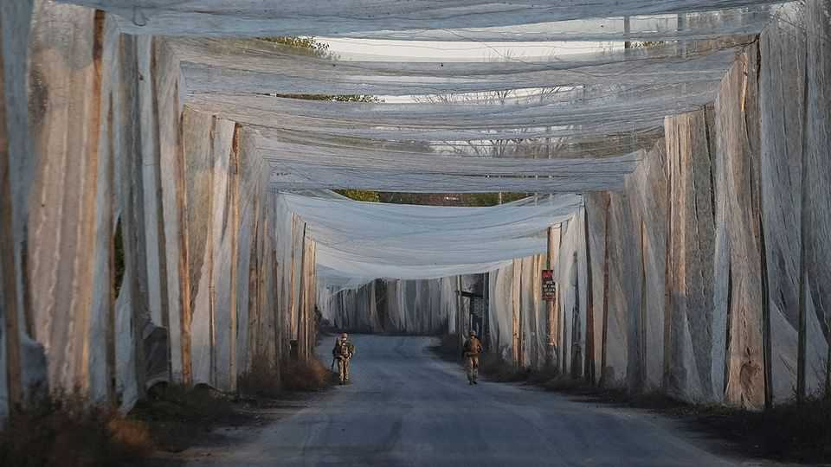
But local conditions are a third factor. Not all commanders are as joined-up as Mr Obolensky. At the Pokrovsk axis, for instance, command has long suffered from co-ordination problems. Where Russian forces encounter a coherent, systematic defence, they grind to a halt, said a commander of an elite Ukrainian drone unit that took part in the Kupiansk attack. “Numbers alone do not decide things in modern warfare.”
The Russian surge is clearly designed to project confidence at a sensitive moment in negotiations. It may be working, but it is not cheap. Ukraine estimates that Russia is suffering more than 1,000 casualties a day, killed and wounded. Even so, a Ukrainian intelligence source says the push can continue for several more months. The Ukrainians think Russia will eventually lose its current level of dominance, but not until February. Until then it plans to squeeze as hard as possible, seize as much territory as it can, and weaken Ukraine while talks continue.
Ukraine’s western allies hope it will be able to hold out until then, denying Russia major gains while demonstrating its ability to fight. Before the maps in Kupiansk flipped from red to blue, many feared that was asking too much. But that tactical success showed that Ukrainian strength is sometimes deeper than it appears. “For the public, everything turned on the map update,” says Khartiia’s Raikov. “We don’t lie. We are under pressure. But we have shown that when we are organised, we can beat them.” ■
To stay on top of the biggest European stories, sign up to Café Europa, our weekly subscriber-only newsletter.
This article was downloaded by zlibrary from https://www.economist.com//europe/2025/12/17/ukraine-scrabbles-for-handholds-against-russias-massive-assault
Europe | Swish as they come

Italy is using the Winter Olympics to appeal to the ultra-wealthy
In Milan, everyone is going for gold

December 18th 2025

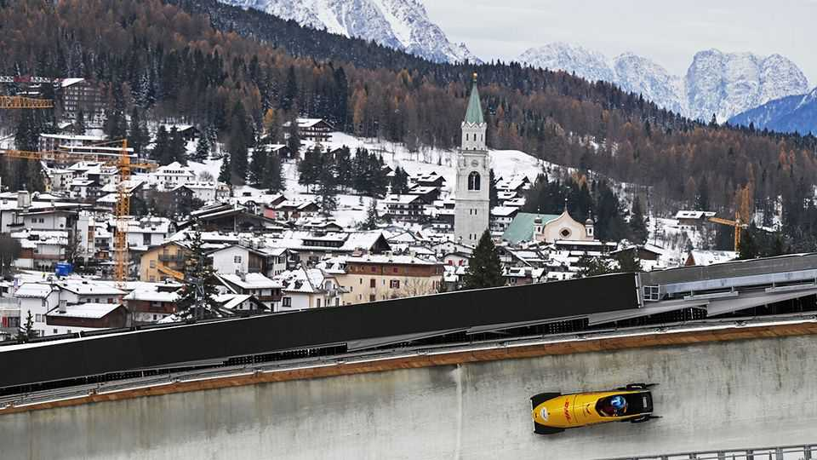
On the outskirts of Milan lorries come and go from a site beside the railway tracks where the final touches are being put to six elegant beige and cream apartment blocks. At the end of January thousands of athletes will arrive and the site will become an Olympic Village. The 2026 Winter Games are due to start here on February 6th.
Milan is scarcely an obvious venue. It sits north of the River Po in the longest, broadest valley in Italy. The highest point in the city is just 122 metres above sea level. So it will host the skating events, including ice hockey at two venues, one of which is running nail-bitingly late. Most of the Olympic and Paralympic competitions will be held at various towns in the Alps.
Yet only one of these resorts, Cortina d’Ampezzo—a five-hour drive away—features in the Games’ official title. The winter playground of Italy’s bankers, industrialists and entertainers, it has been entrusted with the curling, sliding events (bobsleigh, skeleton and luge) and some of the skiing. The women’s downhill and super-G will be on the intimidating Olympia delle Tofane run, where skiers plunge between rocks down a slope with a 64% gradient known as the Schuss.
Why the focus on Cortina? Because, like Milan, it is a byword for ritzy wealth. The winter games here in 1956 were attended by Sophia Loren; George Clooney is a repeat visitor. In the resort’s Cianderies district, with its mesmerising views of the Dolomites, a three-bedroom flat sold two years ago for €6.5m ($7.6m). At five-star accommodation such as the Hotel Ancora a room can go for €1,500-2,000 a night.
This makes Cortina a perfect partner for the Milan that has taken shape since 2017, when a tax break devised by the government of Matteo Renzi, a centre-left prime minister, began luring the very rich to Italy. Anyone content to pay an annual €100,000 on their non-Italian income was welcome. The figure was later upped to €200,000 and the 2026 budget proposes raising it to €300,000. Official records of the number of takers are outdated and incomplete. Filippo Molinari of Withers, a law firm, puts it between 5,000 and 10,000.
Geraldine Semeghini, who runs a property agency, reckons that about 80% of them came to Milan and doubts the proposed tax-rate increase will stem the flow. The arrival of so many ultra-high-net-worth individuals (UHNWIs in the jargon) is having a profound effect. Milan has acquired new clubs, admittance to which depends not on membership of the local aristocratic and financial elites but the ability to pay eye-wateringly costly subscriptions. Several new private schools have opened or are planned.
“I should be excited,” says Nicolas Bellavance-Lecompte, whose business relies on just the sort of high rollers who are making Milan their new home. He founded and manages Nomad, a travelling fair that showcases collectible design and contemporary art. “But I used to be able to go to my favourite restaurant without a reservation and now I need to call days, if not weeks, in advance.”
He is not the only one with reservations. Property prices have soared, pulled up by demand at the top end—and, recently, the effects of a real-estate scandal. In October prosecutors asked for 36 people to be tried in connection with alleged irregularities in granting permission to build a huge residential complex. Investigations into other developments have led to the arrest, and subsequent release, of the head of the firm that built the Olympic Village. He denies wrongdoing. The investigations have caused work to be halted on several projects intended to increase the city’s housing stock and mitigate the rise in prices. Developers complain that other projects are paralysed because city officials, wary of future prosecutions, fear signing additional building permits.
Not that any of this is terribly likely to deter the UHNWIs. “We are getting calls every week for properties in the €5m to €30m range,” says Ms Semeghini. “And most recently we have had inquiries from private offices outside Europe.” In Milan, everyone is going for gold. ■
To stay on top of the biggest European stories, sign up to Café Europa, our weekly subscriber-only newsletter.
This article was downloaded by zlibrary from https://www.economist.com//europe/2025/12/18/italy-is-using-the-winter-olympics-to-appeal-to-the-ultra-wealthy
Europe | Same procedure as every year

Why German cities feel like war zones on New Year’s Eve
A dream for pyromaniacs, a nightmare for everyone else

December 18th 2025

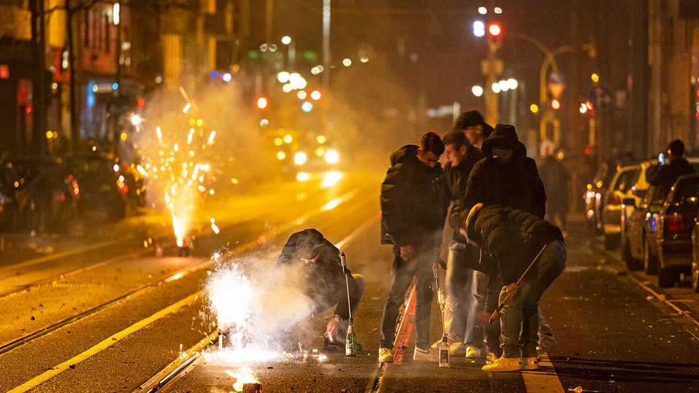
NEW YEAR traditions in Germany are not for the faint-hearted. eu regulations have killed off the old custom of divining one’s future by dripping molten lead into cold water. But the devotion to seeing in the new year with a viewing of “Dinner for One”, a British comedy from 1963 stuffed with the double entendres Germans adore, is undimmed. So is the commitment to waging street battles with fireworks so intense that in the hours around midnight on December 31st, parts of Berlin and other cities can resemble war zones.
In 2024 five Germans were killed in firework-related accidents on New Year’s Eve. In Berlin over 360 people were hurt, hundreds of fires broke out and a block of 36 flats was evacuated after its windows were shattered. A visiting Palestinian influencer was arrested after posting a video of himself firing a rocket into a child’s bedroom. Then there is the less visible damage. Emergency services are overwhelmed, people hesitate to leave home and pets cower in fear (airport hotels with soundproofed rooms make a killing). Germans stepping out to greet the new year find the air thick with particulates and streets littered with debris.
Every year the chaos inspires the same lament: surely Germany should extend the ban on buying fireworks that applies for 362 days of the year to the remaining three? True, much of the damage is done by the dreaded Kugelbomben, which are already illegal for amateurs. These intensely explosive spherical “bombs” are smuggled in from Poland and the Czech Republic, with the names of trusted dealers spread on private networks. Big Firework says existing laws on Kugelbomben simply need to be enforced. But campaigners say it is tricky for overstretched police to distinguish between legal and illegal fireworks while rockets whizz past their heads. Better just to ban the lot, says Vasili Franco, a Green member of Berlin’s parliament.
Polls suggest most Germans agree. But many politicians regard Silvester (new year) fireworks as an inviolable national tradition, and the relevant law is federal, meaning city-states like Berlin cannot impose unilateral prohibitions. Still, Hanna Rhein of Environmental Action Germany, an ngo pushing for a ban, reckons politicians are beginning to feel the pressure. Campaigners take solace from the neighbouring Netherlands, where years of carnage forced mps to outlaw private fireworks earlier this year. Yet even there it will not take effect until 2026/27—so pyrophobes must, one last time, see the year out with a bang. ■
To stay on top of the biggest European stories, sign up to Café Europa, our weekly subscriber-only newsletter.
This article was downloaded by zlibrary from https://www.economist.com//europe/2025/12/18/why-german-cities-feel-like-war-zones-on-new-years-eve
Europe | Charlemagne

European nationalism is dead. Long live European gastronationalism
A continent united by treaties remains divided by recipes

December 18th 2025

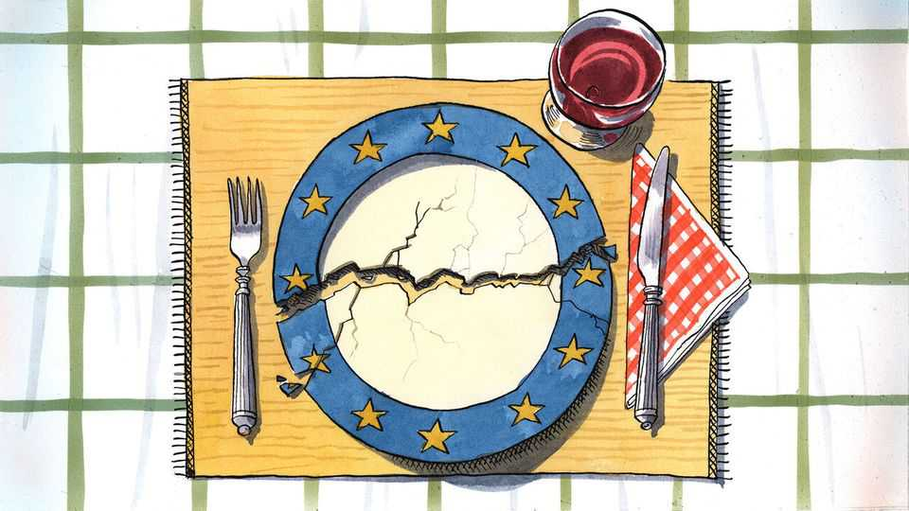
Attacked by Russia, economically submerged by China and forsaken by America, Europe can still be trusted to focus on the things that matter. Like, say, the proper way to cook spaghetti carbonara. Upon discovering last month that a shop in the European Parliament in Brussels was selling jars of ready-made carbonara saus that apparently used the wrong ingredients, Francesco Lollobrigida, Italy’s agriculture minister, reacted with the solemn intensity one might expect for matters of war and peace. How could a carbonara containing cream—crema! Madonna mia!—and the incorrect cut of pork ever be worthy of the name? What next, pineapple on pizza? This was plainly unacceptable, fumed the populist minister, who happens to be a brother-in-law of Giorgia Meloni, the prime minister. An investigation was sternly demanded. Faced with existential threats, the continent has once again shown its talent for prioritising the non-negotiable.
Mr Lollobrigida’s Vesuvian outrage was symptomatic: food can arouse stronger emotions in Europe than almost any other topic. Culinary habits continue to divide its countries even as they have come together in myriad other ways. For decades the European Union has laboriously tamed their residual jingoism. In one interminable summit after another, 27 sets of national laws have been harmonised, border checks eradicated, currencies fused into one. But a continent stitched together by treaties remains torn apart by recipes. From Dublin to Lublin and Malmo to Palermo, European palates have remained unmoved by 70 years of European integration. Americans chow much the same food wherever they are from. Yet serve up Dutch cheese to a Greek or an Irish stew to a Spaniard and the best you can hope for is polite silence. It is considered impolite these days for a European to denigrate a neighbour, surely an ally in some vital EU negotiation. But taking pot-shots at their cuisine remains a sign of patriotic virility. European nationalism is dead. Long live European gastronationalism.
Dietary peculiarities have long been used to poke fun at those just over the border. Germans are unlovingly known as Krauts, the French are Frogs (or “cheese-eating surrender monkeys”), Brits are rosbifs in an allusion to their unrefined ways of cooking beef, and so on. Politicians across Europe know that belittling the cooking abilities of their neighbours will play well at home. French president Jacques Chirac once proclaimed that Britain’s only contribution to European agriculture was mad-cow disease, and that “you cannot trust people who cook that badly”—which, from the EU’s vantage point, turned out to be true. Italy’s late Silvio Berlusconi dismissed food from Finland as consisting largely of marinated reindeer. A Finnish restaurateur’s revenge, a Pizza Berlusconi featuring smoked reindeer meat, went on to beat a host of Italian entries at a pizza-making festival in New York.
In matters of cuisine, as with economics and climate, a horizontal line divides the continent. Those above it, the rich, rained-upon northerners, mostly cook with butter and are the continent’s gastronomical poor relations. Their “cuisine”, their southern neighbours allege, is an efficient means of delivering calories befitting their innate humourlessness; who has ever voluntarily sought out a German, Dutch or Polish restaurant? The southerners, in contrast, are an olive-oil lot. The Italians, Greeks and French (who cleverly straddle the oil-butter line) think of a meal as a sacred occasion, nourishing the soul as well as the body.
Free-trading northerners, with their ho-hum grub, have gained much from globalisation: witness how fast Brits ditched their rosbif in favour of chicken tikka masala, and how Germans flocked to döner kebabs. Southerners like what they have, and want to defend it. In part they resent poor imitations of their nonnas’ recipes. Scandinavians happily serve their pasta with ketchup, while Poles serve up a dish of macaroni and strawberries (best not tell Mr Lollobrigida). The southerners have fought back against this culinary appropriation with gusto. Since 1992 the EU has enforced rules that stipulate some foods can only come from certain areas, ensuring for example that only Greeks can make feta and that Parmesan must hail from northern Italy. Of the over 1,500 foods now protected more than 70% come from five southern countries. On December 10th UNESCO extended its list of humanity’s intangible cultural heritage to include the cuisine of Italy, making it the first country to get such a nod. There are, one assumes, no plans to recognise Dutch fare.
Europe’s gastronationalistic squabbles are delicious because they can be comically small-bore. It is the narcissism of tiny differences. Belgians resent that “French fries” are named after their neighbours, given their evident superiority at cooking them. Greeks lay claim to “Turkish coffee”. All southern European countries distil fruit into some aniseed-flavoured firewater best enjoyed in the sunshine; who can tell the difference between Greek ouzo, Bulgarian mastika and Balkan raki? And yet each country treats its own concoction as nectar from the gods while denigrating its neighbour’s brew as a variant of paint stripper. Ukraine and Russia have long squabbled about the origin of borscht soup, each using the other’s claim as evidence of intransigence.
In a globalised age in which Instagrammable “fusion” food steamrolls over local tradition, is a little culinary chauvinism not sensible? Only up to a point. For to prescribe a “correct” way to prepare a dish, or to tie it down to one place, is to miss how cuisine evolves. Cooks borrow, adapt and improve what they find. Much food tradition is invented anyway. The carbonara so vigorously defended by Italians is no ancestral dish: the first known recipe was printed in 1952—in Chicago. Only in the 1990s did the current “canonical” version take root. You can put that on your plate and eat it. ■
Subscribers to The Economist can sign up to our Opinion newsletter, which brings together the best of our leaders, columns, guest essays and reader correspondence.
This article was downloaded by zlibrary from https://www.economist.com//europe/2025/12/18/european-nationalism-is-dead-long-live-european-gastronationalism

Britain
- How to heal the trauma from Northern Ireland’s killings
- Britons are becoming obsessed with pet photography
- A portrait of Britain’s aristocrats
- All sides have learned a lot from Extinction Rebellion’s co-founder
Britain | The Troubles

How to heal the trauma from Northern Ireland’s killings
The British government hopes new commissions will draw a line under the Troubles. It won’t be easy

December 18th 2025


As a young man Martin McAllister risked his life to kill British soldiers. As an old man he risks the wrath of his former comrades to help find the body of a British soldier. When he joined the Irish Republican Army (IRA) he believed that he was part of a heroic struggle to drive the British out of Northern Ireland. But the IRA’s slaughter of ten young Protestant civilians in the 1976 Kingsmill massacre shook his belief that the IRA was “romantic, chivalric, holy”. After Mr McAllister was shot by British soldiers he was attacking, he had an epiphany when a Royal Marines medic saved his life. It was that man’s actions which he now viewed as chivalric.
In 1977 a Grenadier Guardsman attached to Britain’s special forces, Robert Nairac, was abducted, tortured and murdered by the IRA. His death endures as one of the most infamous atrocities carried out during the 30 years of sectarian violence in Northern Ireland, known as the Troubles, in which more than 3,500 people were killed. Nairac’s body was “disappeared” by the IRA to instil fear. The bones of most other disappeared victims have been returned, but Nairac’s remain hidden somewhere beneath the earth near the Irish border. Mr McAllister has spent decades searching for his former foe’s body.
This lonely private quest involves the sort of reconciliation the British government has spent years trying to engineer, yet it has happened entirely outside official structures. By contrast, government attempts have failed. More than 27 years after the Good Friday Agreement ended the Troubles, the legacy of the conflict festers in Northern Ireland and beyond.
Now Sir Keir Starmer’s government is embarking on a new policy which it hopes will see commissions reinvestigate Troubles deaths, then draw a line beyond which a new future can be written. This has been agreed with the Irish government as part of a wider post-Brexit rapprochement.
Sir Keir’s policy involves ditching that of the previous, Conservative government. It legislated for a de facto amnesty—in effect trading justice for information if those involved would talk. It argued that securing convictions for crimes which may have happened half a century ago is hard, which is true. But that wasn’t the only, or even the main, reason for the legislation.
Though many terrorists had been jailed during the Troubles, few rogue soldiers were. As evidence of atrocities involving soldiers emerged, police were coming to interview veterans under caution. Some were charged and tried. On the right of British politics and media, this became a pet cause out of a belief that former IRA members weren’t being pursued to the same extent. This fury involved an inchoate logic. There is no statute of limitations for the most serious crimes. The oldest Nazi war criminal was jailed aged 101.
The most high-profile trial of a former soldier involved a British paratrooper who admitted to a public inquiry that he killed four people on Bloody Sunday. On that infamous day in 1972 soldiers killed 13 civilians at a civil-rights march in Londonderry. “Soldier F”, granted anonymity due to fears for his life, was ultimately cleared of murder. When judged by the criminal standard, the evidence against him was weak. Even in clearing him, the judge said he was satisfied the soldiers “did not act in lawful self-defence”. By shooting in the back unarmed civilians fleeing from them, the paras had “sullied” the name of the regiment.
Unionists, who want to keep Northern Ireland British, fear that the Troubles are being retrospectively legitimised. This concern is far from irrational.
In 2022 Michelle O’Neill, a Sinn Féin politician who is now the first minister of Northern Ireland, said that there had been “no alternative” to “violent resistance to British rule” during the Troubles. A poll found that 69% of Northern Irish nationalists agreed. Yet when atrocities were happening, support for killing was far harder to find. In 1998, 70% of Catholics and 74% of Protestants said they not only did not support the violence, but had no sympathy for the reasons behind it. In its darkest decades, a shared revulsion united Northern Ireland’s politically divided community.
One of the perverse fruits of peace has been the glamourisation of killers. All three young members of Kneecap, a rap group and Belfast’s most controversial music act, largely grew up in peace. Yet their trademark is the balaclava worn by paramilitaries, they lead chants of “ooh, ahh, up the Ra” (IRA), and one of them shouted at a gig “kill your local MP”, something that the IRA did.
Some ex-paramilitaries are genuinely remorseful for their actions. But others see this as another phase in their struggle: they want to convince succeeding generations that their barbaric acts were heroic. In this lies future danger. Irish history is replete with cycles of violence in which those who launch attacks have no popular mandate or hope of success but who later come to be venerated, perpetuating the hope for others that, though shunned today, they will be lauded tomorrow.
The £200m ($267m) public inquiry into Bloody Sunday shows how getting truth is not always enough (for legal reasons, its findings couldn’t be admitted in the criminal trial). Its outcome led the then prime minister, David Cameron, to apologise in the House of Commons for “unjustified and unjustifiable” killings. But even such clearly indefensible killings remain points of conflict. When Soldier F was cleared on October 23rd Gavin Robinson, leader of Northern Ireland’s main unionist party, the Democratic Unionist Party (DUP), posted on social media an image of the Parachute Regiment’s insignia. That crass act was all the starker because the DUP’s 41-year-old leader is a relative moderate in his party.
Under Labour’s Northern Ireland Troubles Bill, which is making its way through Parliament, the possibility of prosecutions will remain, but no one expects many killers to end up in jail. Any who do will serve only two years, thanks to a provision in the Good Friday Agreement. The focus will be on “information recovery”: telling families, and the public, what happened. But there are significant blocks on information being published. If these are seen to be sanitising what happened, rather than bringing closure, the exercise could amplify the sense that the truth is being hidden.
Mr McAllister says unionism and nationalism each “need to throw up a statesman” who can lead reconciliation. He fears that myths—such as those which accuse Nairac of atrocities without evidence—will become embedded. “What we’re dealing with here is folk memory and the older that folk memory becomes, the more potent it is because there’s no way to refute that,” he says. It took 30 years to end the killing in Northern Ireland. Resolving the trauma those deaths caused will take far longer.■
For more expert analysis of the biggest stories in Britain, sign up to Blighty, our weekly subscriber-only newsletter.
This article was downloaded by zlibrary from https://www.economist.com//britain/2025/12/15/how-to-heal-the-trauma-from-northern-irelands-killings
Britain | Family pawtrait

Britons are becoming obsessed with pet photography
Photos of pets are more popular than those of partners

December 18th 2025


AT A STUDIO in east London, Storm, a Maltipoo in a Christmas collar, nearly topples off a backdrop roll. Luckily the shoot is over, and her owner is thrilled with one image: Storm nose-to-nose with a large rabbit. It will sit neatly on her Instagram profile.
That Britons—western Europe’s top dog-owners—like pet photos is no surprise. What is striking is how many they take. A 2024 survey of 2,000 pet-owners found that Britons post three times as many shots of their pets on Instagram as they do of their partners, or even themselves. Demand for professional pet portraits surges before Christmas.
“Is your dog ready for their closeup?” asks a flyer for a south London pop-up—illustrated with a chihuahua in a Christmas jumper. Purists sniff at the seasonality. Jon Mills, who runs Soul Dog studio in West Sussex, discourages owners from bringing outfits. “I’m all about naked dogs,” he says.
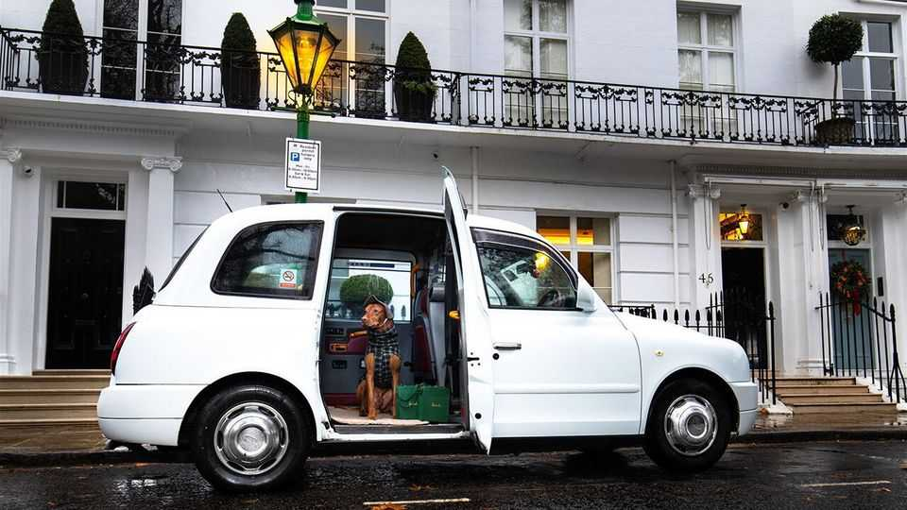
Artsier choices include portraits against London landmarks (one firm will hire a London cab for £949, or $1,270). Pawtiqe promises “an irreverent study of the art of simply being dog”, and testimonials for Paws Célèbre show clients handling their prints with white gloves.
It is no coincidence that “pet parents”, as many insist on calling themselves, are becoming more affluent. In 2025 some 49% of new cat-owners were managers or professionals, despite that group making up only 23% of the population. Though about 16% of pet-owners have set up a social-media profile for their animal, a recent survey says the share is higher in Kensington and Chelsea, London’s poshest borough (30%), than in less well-off Blackpool (8%).
Pet photography is not for the timid. Stoyo Gerov, who runs Pawshot Studios (and offers those cab rides), recalls working with a Czechoslovakian wolfdog called Wulrick. For his signature shot for “food-motivated” animals—throwing treats and capturing the moment—Wulrick missed the kibble and caught Mr Gerov’s head. Fortunately the dog was “intelligent enough not to squeeze”.■
For more expert analysis of the biggest stories in Britain, sign up to Blighty, our weekly subscriber-only newsletter.
This article was downloaded by zlibrary from https://www.economist.com//britain/2025/12/13/britons-are-becoming-obsessed-with-pet-photography
Britain | Declining, not falling

A portrait of Britain’s aristocrats
A thousand years of British history is ending. Does it matter?

December 18th 2025

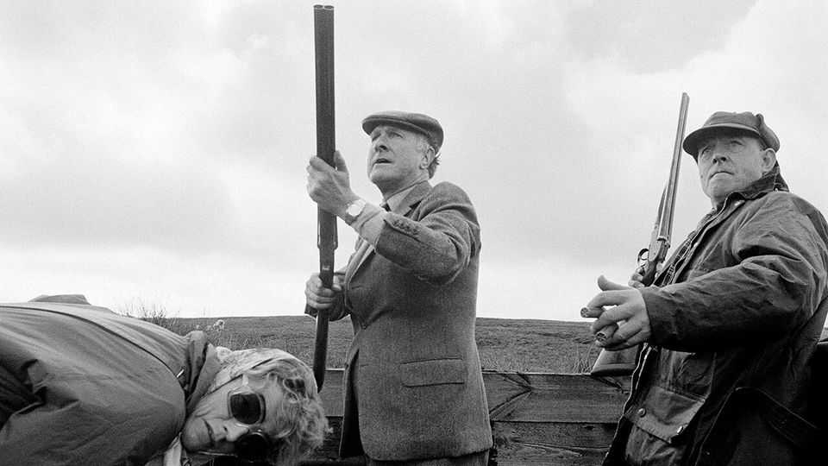
It looks at first sight like a common-or-garden trade fair: there are stalls, free glazed biscuits and glazed-looking people. Peer a little closer and it becomes clear that very little about this trade fair is common—particularly not its gardens. One stall offers statuary for stately piles; another can do the stonework for stately balustrades. The punters are similarly grand. There are ladies with high colour and higher breeding; there are people with names like Araminta. They have come for the annual meeting of Historic Houses, an association that works to keep grand homes independent and in private ownership. Some call this the “AGM for aristocrats”.
Britain has changed. Its aristocrats used to gather for “the season” in the summer months (Ascot in June, Lord’s and Henley in July) and for shooting parties in the duller months (stags in autumn, pheasants in winter, foreigners whenever possible). But now they gather each autumn in a drab hall in Westminster to find ways to prevent their crumbling piles from crumbling further and to attend talks with titles like “How repairs can be made to sash windows”. Historic Houses, says a toff, is the “trade association for aristocrats”.
Britain does not have many aristocrats: just 794 hereditary peerages. As an endangered species they are less numerous than the lesser-spotted woodpecker (under 2,000). But aristocrats are not lesser-spotted. England echoes with aristocratic influence. People walk along Shaftesbury Avenue (named after the 7th Earl of Shaftesbury) and wrap cardigans (the 7th Earl of Cardigan) around them as they eat their sandwiches (the 4th earl). They watch “Downton Abbey” and revisit “Brideshead”. There has been a decline in Britain’s nobility, writes Eleanor Doughty, a journalist, in “Heirs and Graces”. There has “not yet been a fall”.
Britain’s aristocrats still dominate the nation physically (a third of the land is owned by titled toffs) and literarily (the words “country house” appear twice as often in books as “semi-detached”). The English aristocracy, as Nancy Mitford, a novelist, wrote in 1955, “is the only real aristocracy left in the world” because it still “has real political power”.
Or it did. In 2026 the House of Lords will boot out the last of its hereditary peers, all 85 of them. A thousand-odd years of aristocratic influence—which began when William the Conqueror trounced Harold in 1066—will end once The House of Lords (Hereditary Peers) Bill is passed.
Defining quite who aristocrats are is tricky. Most people might reasonably assume that to be a member of the landed gentry one must have land and be gentry. Nothing so simple will suffice. A toff might have land and a title but it is possible to be one without either a title (Winston Churchill had none, but counts as one) or land (the 9th Earl of Buckinghamshire was a street-sweeper). The hierarchy of the squirearchy can, says Hugo Strachwitz of Debrett’s, a directory of those with blue blood, be “confusing”.
Their decline has in some ways been steep. In that same 1950s essay Mitford wrote that a true aristocrat’s “mind is not occupied with money”. Today, after decades of death duties, it is occupied with little else. Consider the current Earl of Sandwich. One of his ancestors was the 4th earl, John Montagu, First Lord of the Admiralty, who had breeches, a wig, a mistress, an imperious air and a wild life.
Now the 12th earl, Luke, wears a mildly apologetic air and a Patagonia fleece. (“I refuse to turn on the heating,” he says. “It would cost such a fortune.”) To pay for his house, Mapperton, he opens it to the public. He has a giftshop, a YouTube channel (“Mapperton Live”), paying guests and hires a butler only when “we want to look posh”. The 4th earl invented the sandwich; the current one serves sandwiches in the Coach House Café and lives “a pretty normal middle-class existence”. Albeit with the title “The Right Honourable The Earl of Sandwich” and 1,900 acres.
Which is not nearly middle-class enough for some. An aristocracy, critics argue, causes snobbery to seep through society. Parliament has a webpage explaining how to address an earl (not, naturally, as “Earl”) and a duke (grovellingly). One must, as Mitford noted, still demonstrate “U” (upper-class) speech and thus know to call a private school “a public school” and (some say) to pronounce the name “Featherstonehaugh” as “Fan-sure”. Which can leave others feeling a little un-stonehaugh. England’s nobility often feels less like a social class than a social shibboleth created to confuse the middle classes.
This makes many people cross. Behind aristocrats’ fancy pilasters, argues a book by a Labour MP, Chris Bryant, lies “theft and unrepentant greed”. Maybe so, but it is equally true that Britons like to look at those pilasters. The National Trust, a charity which offers fresh scones and old stones (and, like Historic Houses, helps preserve architectural gems that might otherwise crumble), has nearly 5.4m members. For biscuit-tin Britain, which takes pride in the national heritage, this matters.
Back in Westminster, England’s aristocracy mill about their AGM peering at stalls on woodworm prevention. Their badges give not only their own names but those of their houses. “Penshurst Place” walks past at one point; “Mapperton House” at another. As if these were not mere people but a bit of England incarnate—which, perhaps, they are. ■
For more expert analysis of the biggest stories in Britain, sign up to Blighty, our weekly subscriber-only newsletter.
This article was downloaded by zlibrary from https://www.economist.com//britain/2025/12/18/a-portrait-of-britains-aristocrats
Britain | Bagehot

All sides have learned a lot from Extinction Rebellion’s co-founder
Call it the Roger Hallam extended universe

December 18th 2025

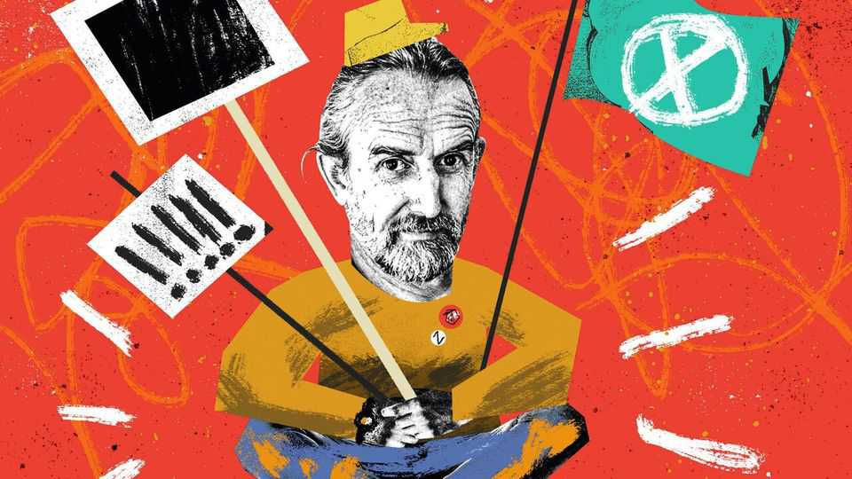
Splat! The first protester smeared a tray of apple crumble onto the case containing the Crown Jewels in the Tower of London. Next came the custard. Slop! Then the earnest slogan, from two nervous activists: “Democracy has crumbled!” Then the demands to camera: introduce a House of the People, with people appointed at random and the promise that Take Back Power, the custard-chucking protest group, will be doing this all again soon.
If it felt familiar, it should. The aims were new but the methods were old. Extinction Rebellion activists caked Shell’s headquarters in graffiti and blocked junctions in central London. Just Stop Oil, another protest group, encouraged its activists to hurl tomato soup on paintings by Vincent van Gogh. Insulate Britain, possibly the first civil-resistance movement dedicated to lobbying for lagging, blocked roads. In some cases, even the phone number supplied to curious journalists is the same.
Call it the Roger Hallam extended universe. A co-founder of the likes of Extinction Rebellion and Just Stop Oil, Mr Hallam has spent much of the past decade helping organise civil disobedience in Britain. Eventually, the law caught up with him. The activist gave a pep talk to people planning to block the M25, London’s orbital motorway, which was recorded and then handed to the police. Mr Hallam gave the court a two-hour lecture; the judge gave him five years. Now, sporting an electronic tag, Mr Hallam is free and cheering on the custard-hurlers if not doing it himself. Why listen to a 59-year-old man fresh out of hmp Wayland?
Plenty of other people have. In Mr Hallam’s telling, the more activists sent to prison the better. What was once a fringe tactic is now a core strategy across the left. Pro-Palestine activists turn up en masse outside Parliament holding signs saying “I oppose genocide. I support Palestine Action”, a pro-Palestine group that vandalised a military base and which the British government places in the same category as al-Qaeda. The protesters knew it would result in arrest. So far, 2,700 people have been arrested. Mass arrest has become the omnistrategy for the omnicause.
After all, a movement needs some martyrs. “People need to go to prison,” says Mr Hallam, who practises what he preaches. Among those jailed for blocking motorways was a Quaker so elderly no tag could fit her slender limbs. At the Palestine protests an 89-year-old was carted away by four police officers perhaps a third her age. Those arrested can become causes célèbres, touring universities and right-on talking shops to extol the virtues of lying down in the road or holding a forbidden sign.
For years the left had a near-monopoly on martyrdom. But if prison works for lefties, it will work for their enemies, too. The right is developing its own martyrs. Tommy Robinson, a football hooligan turned far-right rabble-rouser, has perfected the art of victimhood, rattling a digital collection tin in front of his followers after his release for contempt of court in May. Lucy Connolly, who was jailed for tweeting “set fire to all the fucking hotels full of the bastards for all I care”, is now a celebrity, marching on stage at Reform UK’s annual conference like an “X Factor” contestant. She sees herself as Sir Keir Starmer’s “political prisoner”.
Now the right is on the march. Angry protesters appeared outside a hotel full of asylum-seekers in Epping after one of its residents assaulted a teenage girl. Rather than bald right-wing men, middle-aged women placed themselves at the front, dressed in pink, toting “I’m not a racist, I’m a worried mother” signs. Britain is a land where The Children march against climate change one year and The Mothers march against sex offenders the next. Sentimentality is a weapon that both sides of the political spectrum have learned to use.
Politicians in Westminster pretend that street politics does not exist and, if it becomes impossible to ignore, that it does not work. Mr Hallam and friends provide the counter. Extinction Rebellion helped create an atmosphere that pushed a Conservative government into becoming the first G7 country to pledge to reach net-zero by 2050. Just Stop Oil’s goal of banning new oil-and-gas licences in the North Sea is now government policy. Ideas can affect the body politic only if they are already in the bloodstream. A citizens’ assembly is a mad idea, but then so is an upper chamber consisting of party donors and apparatchiks. And here you are reading about it, thanks to apple crumble and custard.
British politics has taken a millenarian turn. A movement without a pet civilisational threat seems pointless. For parts of the left the looming threat is a climate apocalypse. For the right it is a Britain overrun by “fighting-age males” from abroad. How can stodgy centrists compete with the end of the world and invasion? Catastrophism sells. Mr Hallam and his ilk realised this earlier than most. “Act Now Because It’s Too Late” was an Extinction Rebellion slogan. In focus groups, voters despair that things can hardly get any worse. The radical becomes rational. And so Britain has become a nation where grannies are happy to risk jail and The Mothers will join a mob.
It might seem ridiculous to talk, as Mr Hallam does, of regime collapse. People leap to the 1920s images of “Weimar Britain”, which are absurd. More prosaic but just as sweeping examples exist, such as in early-1990s Italy, when once-hegemonic parties disappeared and Silvio Berlusconi emerged. In Britain in the 2020s each political party is only a few points from non-existence, whether they have barely reached their seventh birthday, like Reform, or are almost 200 years old, like the Conservative Party. Doomerism is now the norm among Britain’s political class. Yet few seem to be actively preparing for it. If the system fractures, whoever is most organised will be able to pick up the pieces. ■
Subscribers to The Economist can sign up to our Opinion newsletter, which brings together the best of our leaders, columns, guest essays and reader correspondence.
This article was downloaded by zlibrary from https://www.economist.com//britain/2025/12/17/all-sides-have-learned-a-lot-from-extinction-rebellions-co-founder

Christmas Specials
- A journey into the world’s most mysterious rainforest
- What The Economist discovered at dating bootcamp
- How humankind’s 10m-year love affair with booze might end
- The tariffs that nearly stole Christmas
- From honeycomb curry to blood fry: India’s “untouchable” cooking
- The battle to stop clever people betting
- Adam Smith is misinterpreted and his influence overstated
- What street talk reveals about Anglophone civilisation
- America’s fight back against China starts in Los Angeles—in flip-flops
- The long, strange journey of a temple from profane to sacred
- What if the best way to learn about history is by playing with it?
- How two explorers, a mother and a baby made America
- The titanic task of catering on the world’s biggest cruise ship
- How wolves became dogs
- A journey along East Asia’s hidden artery
- How Jane Austen revealed the economic basis of society
- Was Mr Darcy the richest of all Jane Austen’s characters?
- The most friendless place on earth
- Two centuries ago, Russian revolutionaries tried to change the world
- The rise and fall and rebirth of lapsang souchong
- How magicians stay relevant in the age of AI
Christmas Specials | Inside Africa’s great green lung

A journey into the world’s most mysterious rainforest
The secrets of the Congo basin are only slowly coming to light

December 18th 2025

“Welcome to my office,” says Juan Thomas, as his plane soars over Odzala-Kokoua National Park in the Republic of Congo. The pilot for African Parks, a conservation NGO, puts on an incongruous playlist of upbeat dance tracks and anthemic rock as he glides above the epic greenery. Only the occasional elephant or scampering antelope interrupts the stillness of the forests that stretch to the horizon.
It is hard to think of another place as important, yet as poorly understood. The tropical rainforest of the Congo basin is the world’s second-largest. (The Amazon is slightly bigger, but far better studied.) Via the Congo river, water drains into the Atlantic largely from six countries: the two Congos plus Cameroon, the Central African Republic, Equatorial Guinea and Gabon. The forest is the world’s largest terrestrial carbon sink, a place of bewildering biodiversity and an archaeological treasure trove. Working there “is exciting because pretty much anything you find is new”, says Andrew Davies of Harvard University, whose research lab studies Odzala. He says that the only part of the world we may know less about is the deep sea. “It is one of the frontiers of scientific discovery.”
In October The Economist took a journey to the frontier, in Odzala, where researchers have made startling discoveries in three areas: climate science, ecology and archaeology. Your correspondent criss-crossed the park, on foot, by road, in the air and, with the help of a chain-smoking skiff captain, via a tributary of the Congo river, where slender-snouted crocodiles yawned on the banks. Wonder comes easily here.
Yet Congo’s tropical forest is under threat. Loggers, miners and oilmen covet its resources. Rising populations are slashing down trees for fuel and farmland. At the COP climate summit in November experts warned that deforestation rates in the Congo basin mean it may soon emit more carbon than it absorbs. The race is on to uncover its secrets before it is too late.
Over the past 10m years the Congo basin has been the site of a slow battle between savannah and rainforest. At the peak of the last ice age, 25,000 years ago, the area was mostly grassland. As temperature and humidity rose conditions became more propitious for tropical forests. Today the vapour they release is vital to rain as far away as Ethiopia and the Sahel.
Over the past decade climate research—the first of three areas where research is breaking new ground—has led to the basin being dubbed “Africa’s great green lung”. It is estimated to absorb 600m more tonnes of carbon dioxide than it emits each year, roughly equivalent to the annual emissions of Germany, the world’s tenth-largest polluter.
One source of its importance is its vast peatlands. Scientists affiliated with the CongoPeat project, led by Simon Lewis of the University of Leeds, have mapped these carbon-rich bogs made of decomposed plant matter, using on-the-ground surveys and satellite data. The peatlands span almost 17m hectares, a larger area than England and Wales combined. Collectively they store carbon equivalent to roughly three years of global emissions from the burning of fossil fuels.
Now scientists are surveying the forests themselves using “light detection and ranging” (lidar) instruments. These can be attached to a drone, an aircraft like Mr Thomas’s or even the International Space Station. They emit pulses of light that, when they rebound, are used to build a three-dimensional model of the basin. “We can measure 10m trees within a few hours, down to an accuracy of 2cm,” says Mr Davies. “We know which trees are most carbon-rich and [so] which forest types are most in need of protection.”
Next year Odzala should get what is known as an “eddy covariance flux tower”, a big stick that measures how greenhouse gases are emitted and absorbed—a pulmonologist for the great green lung. Though there are more than 1,000 towers globally, the tower in Odzala will be the first in the Republic of Congo and only the second in the basin (the other is in the much larger Democratic Republic of Congo).
Lidar is also being used to reveal the mysterious gaps in the forest known as bais. From above, these clearings look like randomly plonked sports fields. In 2024 a team led by Evan Hockridge, a researcher at Mr Davies’s lab, used lidar to map more than 2,000 bais in Odzala, many times more than were previously assumed to exist. Recent research has uncovered how forest elephants, which are smaller than the savannah elephants of east Africa (and children’s books), act as “ecosystem engineers”. One study estimates that, by trampling smaller trees and spreading the seeds of larger ones, forest elephants indirectly influence the climate. The study reckons that without them, carbon capture in Congo’s forests would be 7% lower.

Bais are like sociable pubs for pachyderms. At night in Odzala their bellows get louder as they approach one. There is the sound of sloshing as a herd enters the clearing, then gurgling on an industrial scale, as the elephants “mine” the bai for its mineral-rich nutrients. They blow air out of their trunks to churn up the soil, before sucking up the water.
Forest elephants travel in smaller groups than their savannah cousins, as their food sources are more dispersed. Bais let them meet occasionally. By attaching tracking collars, and using new techniques that extract DNA from dung, researchers have mapped elephants’ journeys. Herds return to the same bais over many decades, passing the information down generations.
One morning The Economist walks through the forests with Gwili Gibbon, the conservation manager for African Parks, and Plaisance Mbounga, who grew up in the area and also works for the NGO. We weave through the trees as rain cascades off laminated-looking leaves. Snakes slither underneath. Termite mounds resemble miniature Sagrada Familias. To quench our thirst Mr Mbounga scythes open a branch with his machete, before pouring the tannic water into the mouth of your grateful correspondent.

When the bai opens up before us Mr Gibbon explains that these areas are, in effect, ecological entrepots: their mineral-rich soil attracts a plethora of animals from all across the forest. They are the meeting places for many of the 1,200 bird, 700 fish, 450 mammal and 280 reptile species that dwell in the basin.
The particular salt and water content of this clearing means it is a “gorilla bai”, he says. (Mr Gibbon, who became fascinated with primates on an expedition to Ethiopia, politely deadpans that “I have never heard that idea before,” when queried about nominative determinism.) Soon enough a silverback meanders through the bai. It stops every few metres to peruse the vegetation, occasionally scratching its head as if it has forgotten something.
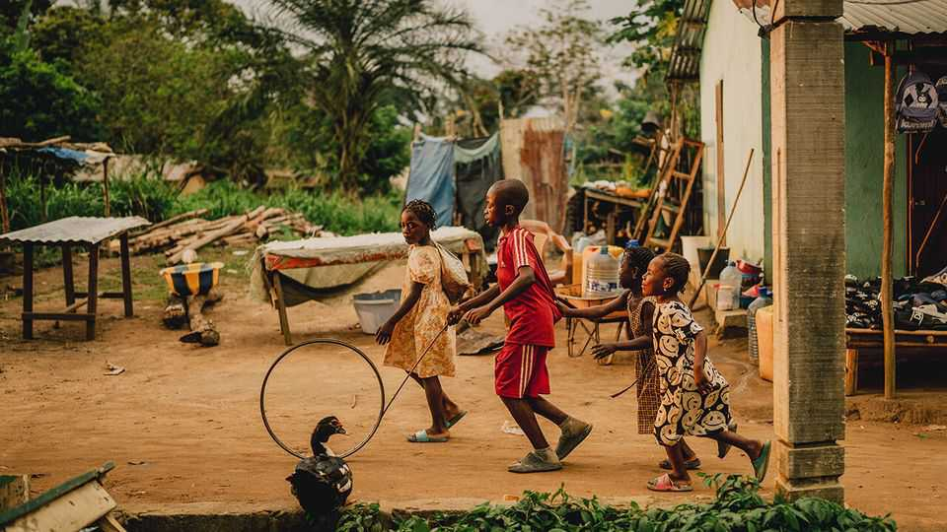
The male is one of a few hundred thousand western lowland gorillas found across central Africa. It was long assumed that they were basically the same as their larger, more endangered cousins, the mountain gorillas of the Great Lakes (and of “Gorillas in the Mist”). But ecological research—the second field that is uncovering vast secrets of the basin—has upended that assumption. The lowlanders groom less, socialise less and enjoy a more varied diet.
Much research into lowland gorillas was done by Magda Bermejo, a Spanish primatologist who worked in Ngaga, on the outskirts of Odzala. Today tourists can visit gorilla troops she and her associates habituated through Kamba, an outfit founded by Sabine Plattner, a German philanthropist. In Ngaga, The Economist watches as half a dozen lowland gorillas scamper up the trunk of a strangler fig tree in search of fruit. Their mother follows, more slowly, a tiny infant clasped to her thigh, wet and black like an oil slick.
Above us the mother utters a series of grunts and growls. The sounds are complemented by hand gestures, some of which primatologists have deciphered. They think some gestures are specific to a given area, akin to the accents of human speech.

Research in the basin is also uncovering new insights into that other primate: humans. At Lango, another camp run by Kamba, your correspondent waits for elephants to leave before sloshing his way through a swampy bai. After a short walk, conical stones appear on the ground, small enough to hold in one’s hand. These are the remnants of salt pans used by people known as the Mboko and Kota, around 150-200 years ago. They loaded the devices with salty sludge, heated them, and after water evaporated the conical end was broken off, leaving a salt ball. The elephants have quite literally helped unearth history.
Archaeologists are salivating. An initial dig by a Franco-Congolese team found axes from the Neolithic period (2,500-4,000 years ago) and tools cut with quartz that could date back to the late stone age, some 10,000 years ago. The site could help illuminate the Bantu expansion: the migration of black Africans from west-central Africa to the rest of the continent, a process that began 4,000-6,000 years ago. The items found in Lango may give a better grasp of who those early movers were, when they migrated—and why.
What, though, of the future of the Congo basin? A study earlier this year found that from 1990 to 2020 it lost 8.5% of its total forest area and warned of further loss over the next 30 years, as more roads are built and more chainsaws wielded. This is folly. The value of its carbon, flora and fauna is far greater than its wood, oil, bushmeat or gold. The World Bank estimates that the forest supplies $1.15trn a year in global benefits, largely climate-related; roughly six times the GDP of the countries that contain it. In a vast tragedy of the tropical commons, what makes sense for each individual logger or farmer is disastrous for humankind.
At the COP Brazil launched a Tropical Forest Forever Facility, which promises to raise capital to protect forests globally, including the Congo basin. It is the latest of several initiatives that involve outsiders trying to pay for conservation. They offer some promise, but the money on offer remains meagre and donors remain wary. Rewarding people for not chopping down trees is especially hard in the Congo basin, since the governments there are dysfunctional and corrupt, and it is seldom clear who owns the land.
Mack Zola Kanda, a Congolese gorilla researcher, recalls how his college friends said he should get a “suit-and-tie” job that paid better. But, he says, “the rainforest is a treasure we have to protect.” The more scientists reveal the wonders of the basin, the better we will understand what is at stake if it is lost. ■
This article was downloaded by zlibrary from https://www.economist.com//interactive/christmas-specials/2025/12/18/a-journey-into-the-world-s-most-mysterious-rainforest
Christmas Specials | Dating advice

What The Economist discovered at dating bootcamp
For some men, women are baffling creatures, apparently

December 18th 2025

Blame Ovid. Two thousand years ago the Roman poet wrote a manual that promised to explain to his readers the “art of loving”. Its advice ranged from the sensible (pluck your nose-hair), to the slightly more subtle (brush your teeth, but not in front of each other), to the borderline criminal. When you like a woman, advised Ovid, sit close to her, pretend there is dust on her breast, then brush it off. Which might lead to love but might, today, lead to a lawsuit.
European literature has been imitating Ovid—or recovering from him—ever since. This has led to a paradox. Love has given English literature some of its finest works, from Shakespeare’s sonnets to the novels of Jane Austen. It has also inspired some of the worst: a class into which most dating guides fall. It has given us chapter titles like “THE LOVE OF NUNS” (a medieval hit); and book titles like “THE GAME” (a modern one) and far too many things in capitals. It has given us a volume titled: “How to Flirt with Women: The Art of Flirting Without Being Creepy That Turns Her On!”. (For little speaks more eloquently of not being creepy than reading a manual about not being creepy.)
Dating manuals are an odd genre. They offer all those capitals—but speak of a lack of social capital. They promise triumph (hot girls) but hint at tragedy (for what man who gets hot girls actually reads them?). They slip, often unwittingly, into comedy. One modern manual advises that, to attract women, one should try “freely sprinkling your conversation with words of sex”. A breezy but opaque piece of advice (Which words? “Sprinkled” how?) that feels like it might lead to some awkwardness in the office. And possibly another lawsuit. Their advice is sometimes illiterate; often immoral; at times borderline illegal. Naturally, they sell in their millions.
For millions feel they need them. With good reason. In America, over a quarter of households contain only one person. In Britain, it is about the same. Singlehood is rising in most of the rich world. Some of these singletons are happy to be so; many are not. This matters: lonely people feel sadder, die younger and suffer poorer health than those in relationships. If singletons are young and male they are also likely to experience “the manosphere”—an online aggregation of aggrieved men who talk lovingly about protein shakes and bitterly about women.
Singleness falls on men and women evenly. But read 2,000 years of dating advice and it seems that most of it is aimed at men. Partly this is cultural: for centuries men were more literate, so they wrote for other men. Partly, it is sensible. Women “are just more emotionally intelligent than men”, says Dave Barry, an American humourist and the author of a “Complete Guide to Guys”. They do sophisticated things like washing and listening, he observes. Many men, by contrast, need “pretty primitive” advice.
Some of this disparity is biological. A frequent bleat of the manosphere is that dating obeys an “80/20 rule”: 20% of the men get 80% of the women. That is nonsense. But women are sexually far pickier than men. In 1978 researchers at an American university decided to test this empirically. Young volunteers thus approached total strangers of the opposite sex and asked them, “Would you go to bed with me?” Their paper would go on to become famous. Partly because those lines were made into a catchy British pop song.
But mainly because its results were so stark. The vast majority of men said “Yes”; some asked, “Why do we have to wait until tonight?”; the few who refused did so regretfully. “I cannot tonight,” was a typical refusal, “but tomorrow would be fine.” By contrast, every single woman said “No”. Most were appalled. “What is wrong with you?” was a typical response. As was: “Leave me alone.” The conclusions are clear: pop lyrics can come from unlikely places. And men and women approach sex very differently.
Manuals have thus, from the Bible on (often seen as the first self-help guide) stepped in, offering advice on everything from grooming (wash, says Ovid); to table manners (men should not, says one timeless 18th-century guide, “blow their Noses on their Napkins”); to their choice of paramour (do not, Leviticus warns, have “sexual relations with your mother. She is your mother”). Which is all very sensible. If not, perhaps, things you need to tell a daughter.
Despite the plethora of advice, many men feel they need more. To understand how deep the need, consider the market value of the solution. In a bright, modern flat in Miami, 12 men sit on sofas. They have notebooks, and an eager air. All have come on a four-day dating “Bootcamp” given by a dating guru who has written a book subtitled “HOW TO GET BEAUTIFUL WOMEN INTO BED”. (Subtlety, and the sparing use of the capslock key, is not this movement’s strong suit.) Charging a lot is: the full course costs around $10,000.
At 12 o’clock, it begins. For men who have paid such an abnormal amount of money, the punters look fairly normal. Aged between around 20 and 60, they wear normal clothes (jeans, shirts, T-shirts), have normal-looking bodies and normal professions too: scientists, tech bros, men in finance. And though one or two describe themselves as “lucky” (Silicon-Valley speak for “stinking rich”), most seem normally paid, too.
The course is being run by a man who calls himself “the world’s most famous dating guru & pickup artist”, which may be true, and gives his name as “Mystery”, which definitely isn’t. His real name is Erik Von Markovik and he rose to fame in the 2000s, when he featured in a dating book called “The Game”, by Neil Strauss, a journalist.
It had chapter titles like “STEP 5—ISOLATE THE TARGET” and “STEP 10—BLAST LAST-MINUTE RESISTANCE”. Its glossary included terms like “SHB—noun” —“Super-hot babe” and “LSE—adjective”— “low self-esteem”; something desirable in a SHB as it makes her more likely to give in when you “CAVEMAN” (don’t ask). It was not exactly Austen. It was a bestseller.
Men heard about “The Game”, thought “me too” and bought it. Women heard about it, thought “#MeToo”, and lambasted it. Pick-up is now a (slightly) chastened industry. Though not, as this course shows, wholly so. As the men take notes, Mystery expands on his technique to pick up “women of beauty”. Courting, in Mystery’s telling, is less an intimate interaction than a one-man show whose tone lies somewhere between sales and comedy.
A pick-up begins with A1-3, which includes “THE ATTRACTION PHASE”. A good pick-up artist, explains Mystery, must have “openers” to start conversation and lengthier “gambits” to keep it going. In this phase you must show off, or as he puts it in the inevitable acronym, “DHV”—“Demonstrate higher value”, by bragging about your achievements. Like a comedian, your chat should be funny: “You’re going to be laughing all the way to the bedroom.” Also like a comedian, you should discourage hecklers and even audience interaction. He is not “interested in them”—by which he means women—“talking”.
After you have hooked the woman of your dreams by bragging at her, then not allowing her to speak, you must pretend to cool off: “negging”. The Game’s glossary defines a neg as a “seemingly accidental insult delivered to a beautiful woman” to show “a lack of interest in her”. Mystery has published a book of negs. They include—women, still your hearts—“You talk a lot” and “Ew, your palms are sweaty.”

After you’ve bored your potential paramour, then insulted her, you can bounce through stages C1-3: which takes in the “COMFORT PHASE” (don’t leap on her instantly) before reaching the “S” levels: “THE SEDUCTION PHASE”. By this point your SHB with LSE will be so turned on that you won’t need to seduce her: she will seduce you. “I’m not a seducer,” says Mystery, who practises what he preaches, peppering his conversation with DHVs. “I’m an attractor.”
The whole process is intensely formulaic. Pick-up teachers call themselves “artists” but these numbered steps feel less like artistry than the assembly manual you might get with a child’s toy: Lego for legovers. It is also, for many men, arguably necessary. A constant in dating advice is men’s terror of talking to women. As that 12th-century manual noted, there are men who “in the presence of ladies” are so flustered that they “lose their power of speech”.
They still do, says James Bloodworth, the author of “Lost Boys”, a book on the manosphere. He worked on a similar pick-up course and said that you couldn’t tell merely by looking why the men had come; it was more “when they opened their mouth”. He saw 30-year-old virgins for whom even talking to women was “terrifying”, like “climbing Everest”.
This awkwardness, judging by the men on the Miami course, seems typical. Several talk of feeling fearful around women. Several of those your correspondent spoke to talked too much; listened too little; walked through doors first and didn’t offer women seats. Most lacked that elusive elixir: charm.
It is not clear whether this course will help them. In a break, Mystery’s assistants demonstrate some of their best lines on your correspondent. She does not fall in love but is tempted to laugh, as they are terrible. Such a reaction is, says the glossary, a “BITCH SHIELD—noun: a woman’s defensive response to deter unknown men who approach her.” Or as women call it: “A WHOLLY REASONABLE REACTION—adv-adj-noun”.
Pick-up pays little respect to feminism. “Misogyny is baked into it,” says Mr Bloodworth. But then pick-up is not pretending to be a moral guide; it is a service. And though its prose may not be Austenian, its principles are: few knew better than Austen and her £10,000-a-year heroes the importance of DHV-ing; few have ever negged better than Mr Darcy when he muttered that Elizabeth was “tolerable, but not handsome enough to tempt me”.
A better question is not: is it morally good; it is: does it work? And here, both detractors and supporters would agree: yes. Partly, says Mr Bloodworth, because dating is “a numbers game”. Just as Mrs Bennet forced her daughters out to attend balls, so pick-up forces men to stop “festering at home”. Each night the men on the course must dress up, go out and speak to six to 12 groups of women. Inevitably, says Mr Bloodworth, “Your social skills will improve.” And, he adds, if you have halitosis “Someone is going to tell you.”
Going on a pick-up course may well, then, result in better breath. Whether it will result in good relationships is less clear. But dating advice is changing. People are turning from pick-up artists to another type of expert in the mysteries of what women might want: these experts are called “women”.
Pick-up offers a one-size fits all approach, but as Minnie Lane, a dating and attraction coach in London, points out, women are not a category, “a singular thing”, but individuals. Men should thus listen to the woman in front of them as she “is telling them constantly” what she wants—not just with words, but with her body. Ms Lane leans closer to your correspondent to prove the point and there is, indeed, an immediate charge in the air.
So for readers wanting some good dating advice, it is simple: do leave your house and your screen. Do put on a shirt. Don’t spew out pre-prepared pick-up lines. Do react to the woman’s responses. As indeed Ovid said, all those years ago. Look intently at the woman before you, he wrote, for “silent features often have both words and expression.” Although, being Ovid, he then tells his reader to kiss her anyway, whether she wants it or not. So maybe don’t listen to that one. ■
This article was downloaded by zlibrary from https://www.economist.com//christmas-specials/2025/12/18/what-the-economist-discovered-at-dating-bootcamp
Christmas Specials | Drunken monkey, dry future

How humankind’s 10m-year love affair with booze might end
Civilisation was built on alcohol. Technology may sober us up

December 18th 2025

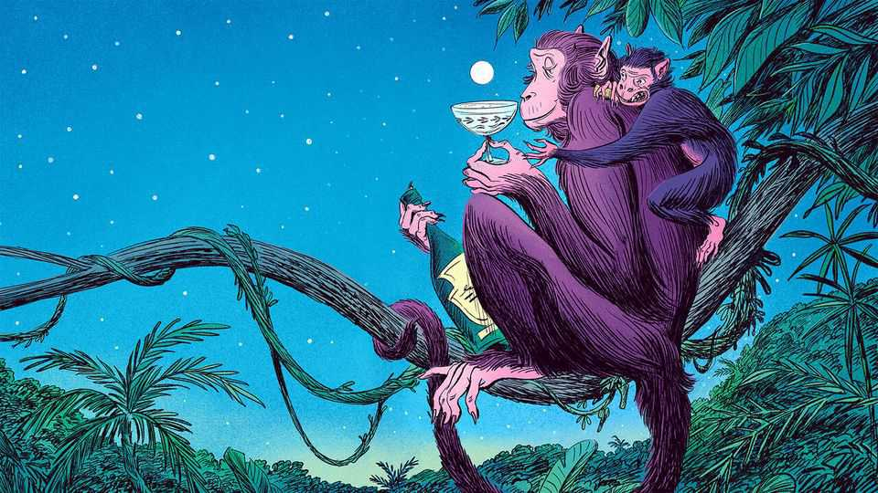
Whether it is champagne fizzing on the tongue, a hoppy beer coating the palate, or a plummy wine staining the lips, alcohol announces itself instantly. First there is a faint burning sensation, a little chemical spark, as the thin mouth membranes absorb a drop. If the stomach is empty, the booze starts to pass into the bloodstream within minutes—and then reaches almost every cell and tissue in the body.
The secret to its rapid transit is in its chemistry. Ethanol, to give booze its proper name, is a tiny, agile molecule. It has a backbone of two carbon atoms and is soluble in water. It can hop over the blood-brain barrier like a ninja. And then the fun begins.
By gatecrashing our brains, alcohol has shaped human history, from our ancestors’ descent from the trees to the formation of modern cities. Yet because it brings misery and sickness as well as joy and conviviality, our species’ love affair with it is on the rocks. Sales are sliding in rich countries; some think global consumption has peaked. Is the greatest party of all time coming to an end? To answer this question one needs to understand a relationship whose molecular fingerprints are first visible millions of years ago.
A good place to start is with biochemistry. Ethanol is so toxic that most animals that consume it either quickly get drunk or poison themselves. Humans, unusually, have a pair of enzymes that turf it out like night-club bouncers. Our ability to process alcohol has deep evolutionary roots.
Ten million years ago a common ancestor of humans, chimpanzees and gorillas acquired a mutation that let them remove ethanol from the body more efficiently. This adaptation coincided with a change of habitat. Tropical forests were collapsing, notes Robin Dunbar of Oxford University. Some 90% of apes went extinct. One lineage survived by leaving the trees and foraging on the ground.
Whereas apes in trees gobbled fresh fruit, those on the ground found fallen fruit, which ferments. Thus, our ancestors may have acquired a taste for alcohol–which allowed them to use these scarce calories. This “drunken monkey” hypothesis suggests that a love of the smell and taste of alcohol, the sign of an energy-rich fruit, gave our ancestors an edge. Their chosen poison would have been fairly weak. A study of overripe wild Panamanian palm fruits found none stronger than 5% alcohol—about the same as a Heineken.
At some unknown point, people discovered how to make booze intentionally. The first solid evidence is from nearly 10,000 years ago. At a Neolithic site in Jiahu in China, residues in jars suggest they contained an early form of mead blended with rice and fruit wine. Alcohol was probably brewed long before this, perhaps in gourds or animal skins.
Booze helped human settlements grow without falling apart. If a group has more than, say, 100 members, direct personal relationships are hard to sustain. New social mechanisms are needed to build trust among those who may not know each other well. Dr Dunbar argues that rituals involving mild intoxication may have kept large social groups cohesive.
There is plenty of evidence of shared feasting in early societies. Alcohol amplifies other tools that foster group cohesion: laughing together (which evolutionary biologists see as a form of chorusing), singing, dancing, storytelling and worshipping. All these activities trigger endorphins (as does booze). Known as the brain’s natural opioids, endorphins create feelings of pleasure, reward and stress release. At low concentrations this eases anxiety and strips away inhibitions.
The endorphin system can lift one’s pain threshold, says Dr Dunbar, and inculcate a sense of belonging. Thus, social drinking reinforces social bonds, helping early societies to co-operate, manage conflict and form alliances. Just the ticket for helping groups of angry neighbours to get along, should a dispute arise over, say, whether someone has eaten an overly generous portion of the communal grain supply.
Booze also boosts two neurotransmitters, serotonin and dopamine. This rewires us for sociability. We become more talkative; other people’s jokes seem funnier. Potential mates seem sexier (hence: “beer goggles”). A drink or two even makes the drinker look more attractive to someone who is sober. It is not clear why. One theory is that moderate alcohol consumption makes the face look slightly more vibrant, which signals good health. Another is that a drop or two puts the drinker in a positive mood.
Booze also dampens the activity of the pre-frontal cortex, the part of the brain responsible for self-monitoring and judgment. This makes us less critical and more spontaneous. Around the world alcohol spurs young people to have earlier, riskier sex.
Modern experiments support the idea that drinking strengthens social bonds. Dr Dunbar’s work shows that regulars at a local pub have larger and closer support networks, which are associated with greater life satisfaction and even well-being. Strong relationships can act as a buffer against mental and physical illness.
Thus, human civilisation has marched forward to the sound of clinking goblets. In ancient Mesopotamia, Egypt, Greece, China, the Mayan empire and many more, people have offered libations to the gods, held tipsy festivities to cement political hierarchy and paid pyramid-builders partly in grog.
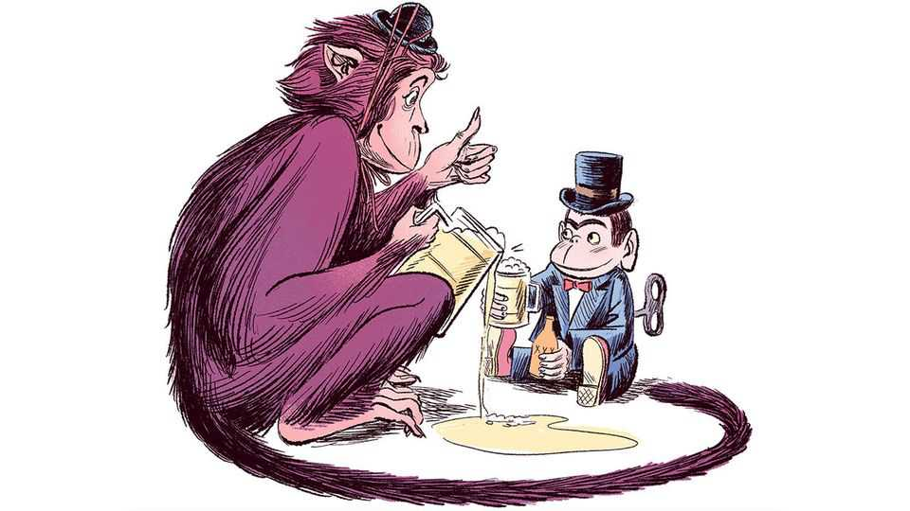
Edward Slingerland of the University of British Columbia argues that alcohol was not merely a companion of progress but a precondition. His “drunk hypothesis”, proposed in 2021, is that alcohol’s effects on the human pre-frontal cortex drove the emergence of large-scale, stratified societies by allowing “fiercely tribal primates to co-operate with strangers”. Human societies are so complex, and depend so much on creativity and the cultural transmission of knowledge, that humans could not have built civilisation without first getting drunk enough to intermingle and co-operate to a degree that is unusual for other species.
How large the influence of being under the influence was remains open to question. A study in the journal of Humanities & Social Sciences Communications in July 2025 looked at 186 non-industrial societies and found a modest positive relationship between the presence of fermented drinks such as mead, wine and beer and higher levels of political complexity. However, this effect is small when one removes the confounding effect of agriculture—a common driver both of higher political integration and of brewing. Were early humans plastered because they were planters? Or civilised because they were sozzled? The debate will continue, over many a glass of scholarly sherry.
Fast forward to the present day, and alcohol is far easier to obtain than it was when our forebears had to forage for rotten berries. Enough gin to kill a grown man can be made for pennies in a factory. Most countries apply heavy taxes to curb consumption, but if they are too high people turn to moonshine.
Winston Churchill was fond of boasting: “I have taken more out of alcohol than alcohol has taken out of me.” But what may (or may not) have been true of Britain’s bibulous wartime prime minister is untrue for many. Worldwide, alcohol abuse results in nearly 1.8m deaths each year. It can ruin livers, marriages and careers. For a long time it was thought that moderate drinking was healthy. But in recent years officials have advised that even small amounts are harmful.
Studies fifty years ago suggested that one or two drinks a day were beneficial for cardiovascular health. Alcohol seemed to boost good cholesterol and reduce blood clotting.
Alas, these benefits were probably overstated. Scientists had compared the health of moderate drinkers with non-drinkers, but failed to distinguish between non-drinkers and never-drinkers. Since some people stop drinking because it is making them unwell, this omission disguises some of the harm alcohol causes. Dr Tim Stockwell of the Canadian Institute for Substance Use Research says those who continue to drink may simply be those who have not yet become unwell.
In January 2023, as New Year revellers were regretting their excesses, killjoys at the World Health Organisation declared that no amount of alcohol was safe. It is, they said, “a toxic, psychoactive and dependence-producing substance” and “a Group 1 carcinogen”. They cited growing evidence that alcohol raises the risk of cancers of the mouth, throat, liver and colon.
Such risks are much higher for people who are genetically less able to metabolise alcohol (one of their molecular “bouncers” is less adept at removing it from the body). Some 540m people, largely of East Asian ancestry, struggle to break down acetaldehyde, a toxic metabolite of alcohol. Many visibly redden after drinking, an effect known colloquially as “Asian flush”.
For those who can metabolise alcohol normally, the risks are less severe. David Spiegelhalter, a statistician, argues that if you don’t drink much, the danger is trivial. One study found that if 25,000 people had one drink a day for a year it would give rise to one extra serious health event, such as cancer, diabetes or stroke. Knute Rockne, an American football coach, was onto something when he (reputedly) said: “Drink the first. Sip the second slowly. Skip the third.”
Yet stopping is hard. As the joke goes, “I only drink a little, but when I do I turn into someone who drinks a lot.” Humans can metabolise roughly eight grams of alcohol an hour—not enough to eliminate half a pint of beer. Drink more and blood alcohol and harmful byproducts like acetaldehyde start to accumulate.
A new wariness of booze is spreading, especially among the young. Adolescent drinking has declined since the turn of the millennium in almost all rich countries. During the school week young people are more likely to use social media than slip out of the house to meet friends. Teenagers kill boredom by meeting online and gaming. Many see booze as an expensive way to fog your brain and wreck your sleep.
Sales of alcohol have been slowly declining in rich countries. Each person in the OECD drank on average the equivalent of 8.9 litres of pure alcohol in 2011. By 2021 that had fallen to 8.6. Volumes in the world’s top 20 markets have continued to fall, by 2% between the pandemic and 2024. Headlines speculate that the world has reached “peak booze”.
The past few years have seen a dramatic rise in the use of weight-loss drugs such as Ozempic. Such drugs may also help people drink less. They seem to influence the brain’s reward pathways, making booze less appealing. They also heighten the nausea one feels after drinking too much.
The drinks industry is paying attention to all these trends. It is furiously concocting no- or low-alcohol alternatives to booze (NoLo, in the jargon). Non-alcoholic beer, which used to be revolting, is now quite palatable. Sales of non-alcoholic beers, wines and mocktails, which replicate familiar flavours without the side-effects, are still only 1.4% of the alcoholic sort. But the global market is growing fast. It was worth $26bn in 2024 and is projected to reach $47bn by 2034.
Another approach is to create new drinks that deliver some of alcohol’s pleasurable effects with different ingredients. Pepped up with plant extracts such as ginseng, l-theanine, ashwagandha, lion’s mane or CBD, such “functional” drinks promise to be calming, enlivening or socially lubricating. The plant kingdom offers a cornucopia of unexplored possibilities. Mineral additives such as magnesium, which promises a calming effect, are also increasingly popular.
Yet it is tricky to mix a herbal tipple as delicious or effective as the real thing. Brands such as Impossibrew, Gabyr, Three Spirit and Collider have tried. Your correspondent sampled five brands of functional beer and wine. Her favourite was a hoppy creation from On Beer, a British firm, with a floral note that comes from rhodiola—a medical plant that is supposed to reduce stress. All the herbal beers she tried offered a noticeable unwinding effect and even a slight buzzy sensation. Her friends and family offered reviews ranging from distaste (husband) to mild enjoyment (friends). The functional wine, alas, was undrinkable.

For a boozeless booze that packs a stronger punch, some firms are making “functional spirits”. These are typically concentrated herbal extracts. With mixers and creativity, they can yield a passable and mildly mood-altering mocktail. They are not subtle, though. They can have “a challenging flavour profile” admits Dash Lilley of Three Spirit, a firm that employs herbalists, phytochemists and bartenders in a quest to create something as lovely as a gin and tonic.
No single functional drink can replicate alcohol’s broad effects. Three Spirit offers three basic functions: drinks that boost energy, those that help people socialise and those that help them relax. Ingredients such as caffeine, ginseng, tryptophan, 5-HTP, lemon balm and ashwagandha can all tinker with dopamine, serotonin, GABA and other neurotransmitters. Nothing triggers the release of endorphins like alcohol, though.
GABA, which is part of the brain’s natural calming system, is strongly affected by alcohol. Scientists think this is the mechanism by which drinking can reduce stress and anxiety. GABA Labs, a firm based near London, is trying to develop a flavourless substance called Alcarelle that has a similar effect. Trials to show that it is safe could take years. But if they are successful, the firm will be able to market Alcarelle to drinks makers as a way to create soft drinks that mimic the buzzy feeling of booze, with none of the downside.
PepsiCo and other firms are trying to make encapsulated, and thus flavourless, versions of functional ingredients. This could allow drinks makers to add any of their functions to any drink, without spoiling the taste. Bartenders of the future may be serving cola that calms or lemonade that gives you a lift.
“Why do billions of people drink caffeine every day, or smoke tobacco, or drink alcohol?” asks Mr Lilley. “It’s because of the human condition. We all require some kind of relief or state-changing mechanism to [stop] us from going insane.” Humans have found many ways to tinker with their minds: meditation, psychedelics, speaking in tongues, dancing, drumming, chanting. All shift the brain state directly, or focus the mind on the here and now, ignoring our chattering brains. For the past 10m years, though, nothing has matched the versatility, portability and fun of alcohol.
Such an old habit will not vanish overnight. Societies accustomed to toasting success with bubbly, venerating Jesus with wine or ramping up a party with tequila slammers will not easily switch to ginseng soda.
But over time, drinks cabinets may change. As no-alcohol beer grows tastier, more people will use it to help them socialise and drive home safely. As functional drinks improve, more people will seek that booze-free buzz. If GLP-1 drugs can reduce the craving for ethanol, perhaps one day a wonder-pill will help people stop after one glass.
The future will throw up more choices for precise neurological tinkering. Humans could rediscover moderation, imbibing no more than our primate livers can metabolise. Churchill would find such a future dispiriting. Others may celebrate it, popping corks from bottles of sparkling fruit juice laced with some as-yet-undiscovered plant extract. ■
This article was downloaded by zlibrary from https://www.economist.com//christmas-specials/2025/12/18/how-humankinds-10m-year-love-affair-with-booze-might-end
Christmas Specials | A wonderful, awful idea

The tariffs that nearly stole Christmas
The Economist spent a year talking to toymakers battling President Grinch

December 18th 2025


For toymakers, Christmas starts early. As the world is grouching through dry January, toy firms are finalising festive designs and signing deals with factories. By the start of summer, containers packed with play-sets and dolls must be crossing the ocean, so that shelves in America can be stocked by autumn. Co-ordinating the global supply chain of childish delight is a delicate, intricate feat, like building a Death Star out of Lego. In 2025 it was disrupted by President Donald Trump’s tariffs. Throughout the year, The Economist asked toymakers how they were coping.
April. “At 145% there’s not going to be Christmas this year.” Isaac Larian’s mood is midwinter bleak. His firm, MGA Entertainment, sells Bratz dolls. Like four out of five toys sold in America, they are made in China. The “Liberation Day” tariffs have just been unveiled, including a rate of 145% on imports from China. Most toys cost between $1.99 and $19.99. Margins are Barbie-thin. “President Grinch” is our headline.
Production for Christmas is already under way. Duties will have to be paid on anything set to arrive in America, long before the cost can be recouped. “Nobody’s shipping; they may be making things, but nobody's shipping,” says Jay Foreman, head of Basic Fun!, which sells Care Bears. Firms that have already placed orders are in a bind. Some owners must decide: “Do I mortgage my house to get the merch out?”
Mr Trump insists that foreigners will pay the tariffs, not Americans. Then he contradicts himself: “Maybe the children will have two dolls instead of 30.”
May. The chairman of Mattel, a dollmaker, complains. Mr Trump threatens 100% tariffs specifically on his firm, so “he won’t sell one toy in the United States.” Then, a few days later, a reprieve. After stockmarkets swoon, Team Trump agree to a 90-day pause on most tariffs with China. “We live to fight another day,” Mr Foreman quips darkly. Instead of going out of business, it’s a case of “just maybe losing our profit this year”. He has taken a gamble to keep Christmas production going, while other firms waited. It has paid off.
July. Not everyone has been so lucky. An estimated 60% of American toymakers have laid off staff. Joann Cartiglia has run The Queen’s Treasures, which specialises in traditional-style dolls, for two decades. She tells The Economist she is living in a camper and renting out her home to keep her business afloat. She can’t afford to import her dolls at the current tariff rate. Most items on her website are marked “SOLD OUT-ETA SUBJECT TO TARIFFS”.
April to December. Is any of this legal? Rick Woldenberg, the boss of Learning Resources, an educational-toy firm, doubts it. Mr Trump claims that America’s trade deficit, which has been there since the 1970s, is an emergency, and that the International Emergency Economic Powers Act (IEEPA) of 1977 gives him the power to raise tariffs in an emergency. Snag: IEEPA doesn’t mention tariffs. On April 22nd Learning Resources sues to have the IEEPA tariffs struck down.
“What else could I do?” Mr Woldenberg asks. A former lawyer, he joined the family business decades ago, for a calmer life. Before “Liberation Day”, his firm was ready to absorb a 30-40% tariff. Now it faces bankruptcy—most educational toys used to be tariff-free.
If any industry illustrates how global trade has changed in ways Mr Trump dislikes, it is toys. America used to make nearly all of its own. Mr Foreman remembers it well; he cut and sewed stuffed animals on an assembly line in 1980s Brooklyn. “79 Bogart Street”, he laughs. “Today that’s the hottest neighbourhood.”
Even in the 1980s, toymaking in America was precarious. Half his co-workers were illegal immigrants, Mr Foreman recalls. Then “China got more competitive, and everything in America got more expensive.” The toy firm he worked for went under. Mr Foreman moved to Mexico, then South Korea, before going all-in on China with his own toy business in the 1990s. The old Brooklyn factory building he remembers is set to be replaced by a block of luxury offices, complete with a wine bar and video-game room.
Could toy manufacturing (as opposed to design, marketing and other high-value-added activities) return to America? Stitching bears and painting faces on dolls is skilled work, but dull. Paying Americans to do it, when they have so many other opportunities, is therefore expensive. Even small “Made in USA” teddies can cost $100 or more. At that price, even two dolls would be a stretch for many families.
One winner from the tariffs is Build-A-Bear Workshop, a firm that lets kids stuff their own bears. It reported record revenues for the first three quarters of 2025. It helps that “about 25% of our ‘manufacturing’, if you want to call it that, is onshore as part of the experience,” jokes Sharon Price John, Build-A-Bear’s boss.
September. Lego is doing what Mr Trump wants: building its first-ever American factory. Though plans for a plant in Virginia were first unveiled in 2022, and the firm has long made bricks close to customers, the new protectionism surely swayed its decision.
Your correspondent visits a Lego factory in Vietnam, a near-copy of what will be in Virginia. The factory, which churns out bricks for Asia, is more Duplo than Lego: giant grey blocks sprawl over 44 hectares. Inside is both cavernous and sweet. It takes ten minutes of walking to reach the production line. Lego sculptures decorate the way.
Keeping production local has paid off, says Carsten Rasmussen, Lego’s head of operations. But smaller toymakers may struggle to copy it. Lego makes the world’s most popular toy, so it has the demand (and margins) to split production across the world. Its factories are high-tech: plastic-injection moulding machines handle most of the work. Humans fix the machines and move containers of bricks. So few are needed that Lego’s Danish factory sometimes runs with the lights off. If Mr Trump thinks tariffs will bring lots of factory jobs back to America, he may be disappointed.
Not least because no one trusts American policy to be consistent. During Mr Trump’s first term, toy firms thought they could satisfy him by shifting out of China (but not necessarily back to America). Mr Woldenberg moved production of 160 of his toys out of China to Vietnam and India. On “Liberation Day”, those countries were tariffed sharply, too.
October. “This has been the year from hell for us,” says Ms Cartiglia. She has just opened a gourmet-food business and a shop in her warehouse, hoping to generate cashflow until Christmas sales begin. (“We have space in the warehouse now, sadly.”) Her only goal is to stay afloat until then. She is expecting a grand-daughter on December 21st. “I worry about all the things I’m not going to be able to do for her that I planned all my life to do for her.” Her voice breaks. “My desire to make a sweet toy-line has turned into [a] nightmare.”
November. Ms Cartiglia is surviving, but only just. Her shop has turned out to be popular with locals.
On November 5th Mr Woldenburg hears his case, Learning Resources v Trump, argued before the Supreme Court. The president has called plaintiffs like him “enemies of the country”. Mr Woldenberg is not perturbed. “We’re going to win,” he says.
The justices sound sceptical of the president’s case. As this article went to press, they were expected to rule soon. If Mr Woldenberg triumphs, Uncle Sam might owe him, and everyone else who paid tariffs under IEEPA, some $140bn in refunds. Mr Trump would lose his most powerful (but not only) tool to impose tariffs as and when he pleases. If the toymakers’ bid to save Christmas ends up curbing a president’s power, that would be a nice gift to America—and the world.
But they have more immediate concerns. Mr Foreman has returned from the Shanghai toy fair. He almost cancelled his trip, but is now glad he went. It has been a hard year, he says, but there were silver linings. Shops might need to restock sooner if they didn’t order enough during the spring panic. The Labubu fad has given him all sorts of ideas for new toys.
His thoughts are already on next Christmas. ■
This article was downloaded by zlibrary from https://www.economist.com//christmas-specials/2025/12/18/the-tariffs-that-nearly-stole-christmas
Christmas Specials | Caste and cuisine

From honeycomb curry to blood fry: India’s “untouchable” cooking
The hidden joys of a cuisine shaped by cruelty

December 18th 2025


Smoke a hive of wild kagadi bees. They flee, leaving behind a honeycomb packed with eggs and larvae. Chopped, spiced and simmered, it makes a dish with a sweet and spicy kick.
For many foreigners “Indian food” means safe, reliable treats such as butter chicken, onion bhaji and naan. Even to many Indians, curried bee larvae sound alarmingly exotic. They belong to another India: to a cuisine that is one of the world’s richest, yet practically invisible. Its recipes are shaped by cruelty, scarcity and shame. This is the food of Dalits, once called “untouchables”. It is widely shunned—yet fabulous.
In millions of Indian kitchens pork, beef and offal, horrifying to upper-caste Hindus, take centre stage. Generations of cooks have turned wild greens, foraged roots and thousands of overlooked ingredients into culinary masterpieces. A handful of historians and Dalit activists are now trying to bring these foods from the margins to the mainstream.
Dalits, who are between a fifth and a quarter of India’s 1.4bn people, occupy the bottom rung of its ancient hierarchy. For thousands of years the caste system has divided people into hereditary groups. At the top were Brahmins, or priests; below them came kings and warriors; then traders and farmers. Beneath all were the Dalits, born to do jobs deemed degrading, such as cleaning latrines or disposing of carcasses. Hindu texts explained these divisions through divine anatomy: Brahmins emerged from the head of God, warriors from the arms, traders from the thighs—and Dalits from the feet.
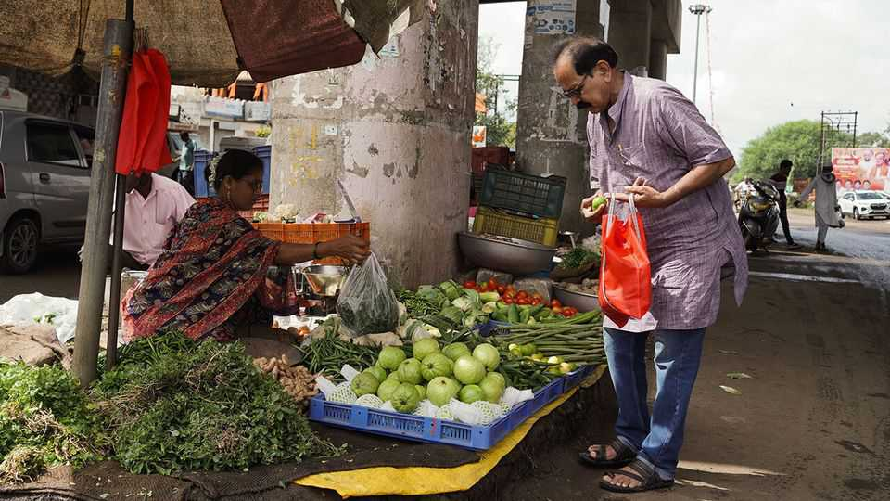
Dalits were shut out from much of society; even their touch was considered polluting. Their homes were pushed to the edge of villages. They could not use the well from which higher castes drew water. Caste discrimination was outlawed in 1950, but remains rife. Many higher-caste Hindus would never eat with Dalits, let alone treat them as equals.
In Hindu scripture food has a hierarchy, too. At the top is sattvic (“pure”) fare—rice, fruit and fresh vegetables meant to calm the mind. Below is rajasik (“fit for kings”) food—meat, fish and heavily spiced dishes thought to excite body and spirit. At the bottom lies tamasic (“sinful”) food—beef, offal and other “impure” meats said to dull the senses and sap energy.
Dalits are less picky than their compatriots. And though caste taboos blight their lives, there is a culinary upside. Food that others shun is likely to be cheaper. So skin, intestines, tongues, feet and ears all find their way into Dalit pots. Leftovers from upper-caste homes where Dalits skivvy are seldom wasted. When cows die naturally, no Brahmin would touch their flesh, but for Dalits it is affordable protein.
In other ways, their diet is dictated by scarcity, notes Shahu Patole, a Dalit historian. Ingredients taken for granted in upper-caste kitchens, such as ghee (clarified butter) and asafoetida (a pungent spice), are often out of reach. Dalit women, who are likelier than other Indian women to work outside the home, have little time to cook. So they have devised recipes that are often quick, simple and ferociously flavourful. One of many listed in Mr Patole’s book Dalit Kitchens of Marathwada is blood fry, a spicy mix of onions, garam masala and tender cubes of congealed goat’s blood.
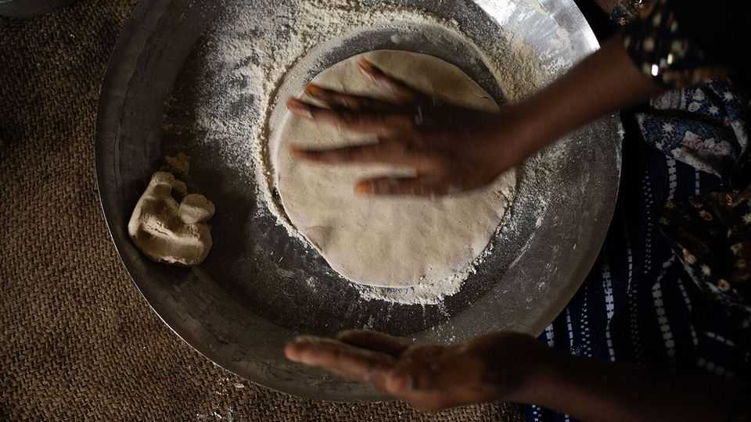
It should not be surprising that a group more populous than France and Japan combined has invented some tasty dishes. What is remarkable, though, is the obstacles Dalit cooks face. Such as violent mobs who object to their ingredients.
Pious Hindus revere cows. Any task relating to bovine butchery therefore falls to Muslims or Dalits. This can be hazardous. Cow-killing is banned in most Indian states. Disposing of cows that have died naturally is not, but cow vigilantes sometimes fail to make that distinction. One July day in 2016 four young Dalit workers were flogged and paraded through Una, a village in the state of Gujarat. They had been caught skinning a cow. Their attackers, members of a “cow protection” group, accused them of having slaughtered it. Their pleas of innocence were ignored.
Such incidents of “cow vigilantism” have grown more common since the Bharatiya Janata Party (BJP), a strident Hindu outfit, won national power in 2014. Some politicians exaggerate the threat minorities pose to cows, hoping to fire up their supporters and intimidate their opponents. Cow-related violence is more likely to erupt in states run by the BJP, notes the Armed Conflict Location and Event Data Project, an NGO.
In 2015 Maharashtra banned not only the slaughter of cows, but also their transport out of the state for slaughter elsewhere. Buffalo meat was exempt. However, because it is hard to tell whether meat has come from a buffalo or a cow, the law gave cow vigilantes a pretext to harass anyone dealing in bovine products.
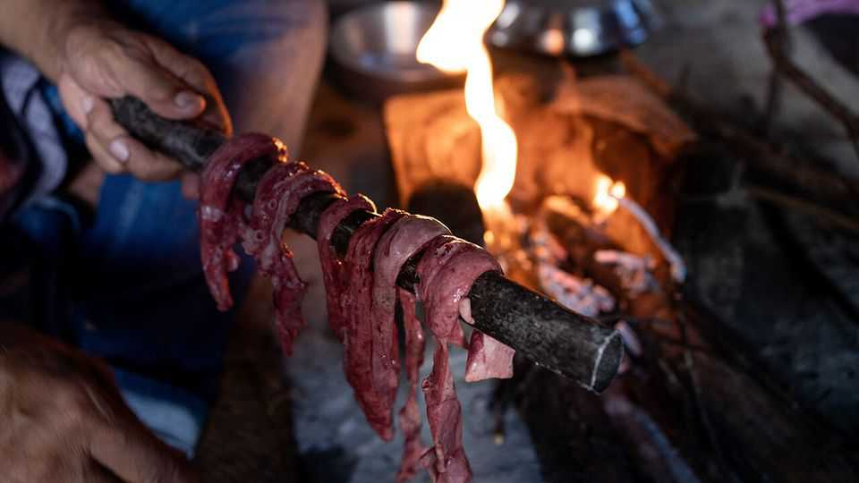
Farmers in Maharashtra have lost out. Previously, when their dairy cows were too old to yield much milk or their buffaloes were too frail to pull a plough, owners could sell them to a slaughterhouse and use the proceeds to buy new stock. Now they are left with unproductive animals or forced to buy expensive tractors. Once-bustling cattle markets have shrunk.
Meat is far more widely consumed in India than Hindu nationalists pretend. Hindus are four-fifths of the population; surveys suggest that about three-quarters eat some form of meat. Among members of “backward” castes, nearly nine in ten do. Yet the image of a vegetarian nation endures, both at home and abroad.
Sri Vamsi Matta is an artist whose performances explore the history of Dalit food. In a solo show, “Come Eat With Me”, he weaves personal stories with traditional ones, and then invites the audience to share a meal he has prepared. He finds the rhetoric of “purity” baffling. Of cows, he says: “How can something so pure when alive become impure the moment it dies?”
Over time, he says, upper-caste notions of what counts as “pure” food have seeped into the mainstream, setting the standard to which others are expected to aspire. This can have nasty consequences. Landlords often refuse to rent to Dalits or Muslims, insisting that their tenants be “pure vegetarian”.
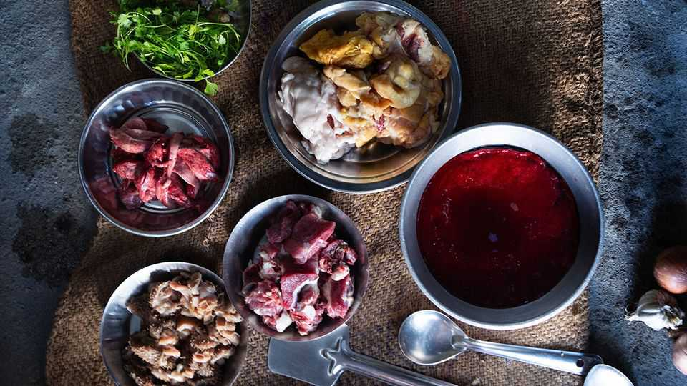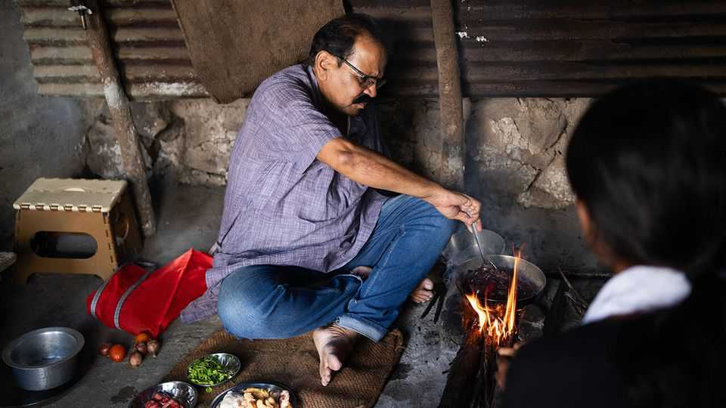
In March 2024 Zomato, a food-delivery app, launched a “Pure Veg Mode” that allowed customers to order only from vegetarian restaurants. Couriers assigned to these orders were given green uniforms. This caused uproar; critics warned that drivers without green uniforms might be harassed. The service was withdrawn the same day.
Yet the sentiment lingers. Many cities routinely ban the sale of meat on Hindu religious days. Zealots demand purity even on film sets. Ranbir Kapoor, a Bollywood star, has been cast as Lord Ram, one of the most important deities, in a new adaptation of the Ramayana, a Hindu epic. Hindu nationalists were furious to discover that Mr Kapoor had once cheerfully described himself as a “big beef guy”—and demanded that he be sacked. His handlers rushed to limit the damage, stressing that Mr Kapoor had given up meat and alcohol for the duration of filming.
Not all Dalit food is meaty. For many poor families, even cheap cuts are a rare delicacy. For daily fare, most rely on grains and vegetables. Dalits who labour on other people’s farms are sometimes paid with a share of the harvest. During the monsoon, when farm work is scarce, many resort to foraging, says Dr Patole. Wild plants cost nothing but time and sweat.
City-dwellers forage, too. Vinay Kumar, a professor at Azim Premji University in Bangalore, recalls that until the early 2000s his relatives would go out to the lake to wash clothes. On the way back they would pluck “various leaves” from the water’s edge, or gather mushrooms and greens from nearby fields in the monsoon. Such greens were cheap, seasonally abundant and nutritious—but also stigmatised.
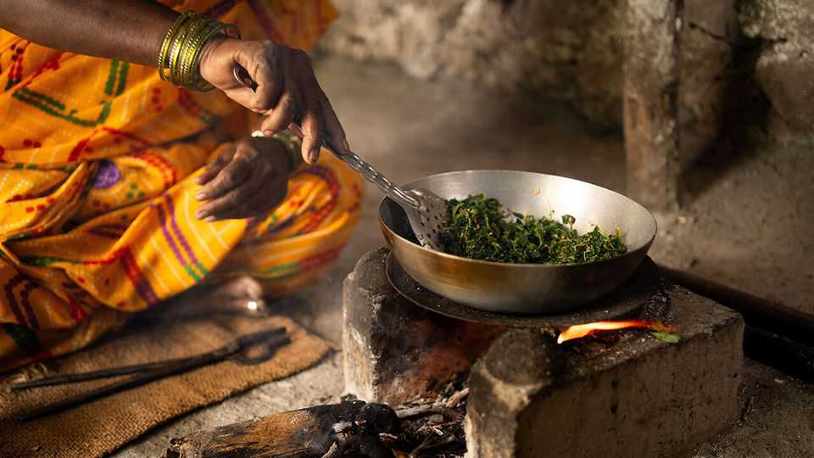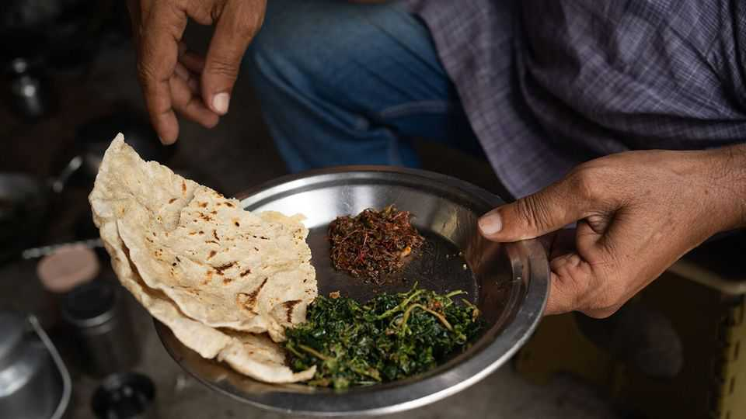
Dalit cuisine is seldom listed on restaurant menus. A few places serve it, but only if you know what to ask for. Ordering it is “a marker” that the eater is a Dalit, says Mr Kumar; few people wish to do so in public. It will be a while before it is widely available, he predicts.
Yet you can buy it if you know where to look. At busy intersections in Bangalore, vendors set up makeshift stalls with giant pots of home-cooked blood fry, beef curry and goat-trotter soup. The blood fry is soft and yielding, almost like tofu, but with a far deeper flavour sharpened by a mix of spices. After a few bites it feels like tucking into paneer (Indian cheese), only hotter, darker and more intense. It pairs well with rice.
Next year India will conduct its first caste census in more than 90 years. It will record how many Brahmins, Dalits and other groups live there, what jobs they do and whether they have indoor toilets. It will not measure the persistence of prejudice.
Caste clings. “Culture, literature, even food flows from the top down,” says Mr Patole. Yet there are hints of change. Dalits today are only half as likely to live below India’s (very low) poverty line as they were a generation ago. And whereas only around a tenth of Dalits could read in 1961, that had risen to two-thirds by 2011, the time of the most recent national census.
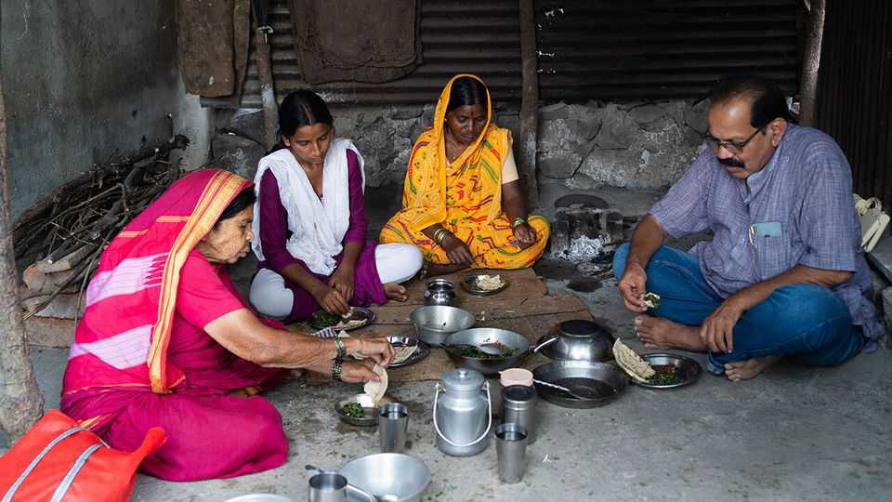
Other countries have embraced the cuisine of the oppressed. Brazil’s national dish, feijoada, is said to have been created when slaves were given black beans and the parts of pigs their owners didn’t want to eat, and turned these humble ingredients into a mighty stew. Might Indians one day learn to love Dalit food?
When Mr Patole first published his recipe book in Marathi in 2015, other Dalits rebuked him for drawing attention to food habits they feared would be ridiculed. However, he noticed curiosity among younger ones eager to learn about their heritage. An English translation in 2024 drew interest from food writers and sparked discussion on social media. For many upper-caste Hindus, it was their first encounter with Dalit cuisine. With luck, it won’t be their last. ■
This article was downloaded by zlibrary from https://www.economist.com//christmas-specials/2025/12/18/from-honeycomb-curry-to-blood-fry-indias-untouchable-cooking
Christmas Specials | Geeks, mules and whales

The battle to stop clever people betting
The tools bookmakers use to block data-savvy gamblers, and how to get round them

December 18th 2025

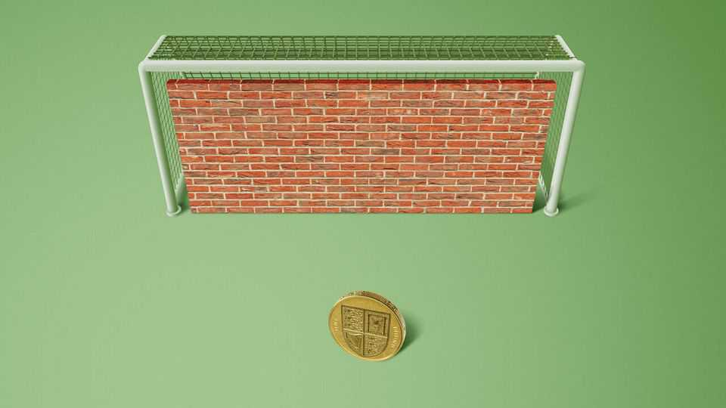
Everyone loves a winner, goes the saying. Sports-betting firms don’t. Indeed, they dislike winners so much that they deploy complex tools to stop them from wagering more than a pittance—as your correspondent discovered in 2018, when Ladbrokes, a British bookmaker, told him he couldn’t bet more than £5 ($6.50) on the winner of the National Basketball Association’s Most Valuable Player award. For skilled players, or “sharps”, such “stake restrictions” are common.
Your correspondent, a data journalist for The Economist, is a sharp in his spare time. He builds statistical models to work out the probabilities that various teams or players will win, and looks for instances where bookmakers are offering better-than-justified odds. This geeky approach got him restricted at every betting shop in Britain. Stymied, he was inspired to investigate how sharps who gamble for a living evade the bookies’ efforts to exclude them.
Most punters are unaware that betting firms, whose adverts promise glittering riches, are at pains to shut out winners. If pressed, the firms stress that very few players are restricted. A report by Britain’s Gambling Commission found that 4.3% of accounts active in the past year have “stake factors”—the proportion of the maximum bet offered to a new customer—below 100%. American books give a longer leash: only 0.64% of accounts in Massachusetts are limited, for instance. But restrictions are rare only because most customers are “square”—that is to say, losers.
No one knows how many people make a living betting. However, they range from stealthy lone wolves to “syndicates” as big as a hedge fund. Contrary to popular perception, advantageous wagers are everywhere if you know how to look for them. The profit margins sportsbooks build into their odds are as low as 4.5%, and they accept bets on far more events than their algorithms can price accurately. So their business model works best if they strive to identify and restrict sharps. “Betting is easy,” says Antonino de Rosa, whose syndicate has 17 employees and wagers an average of $12m a week. “Betting a lot of money is hard.”
A good “player-profiling” strategy can boost a betting firm’s margins by 10-20%. It is not simply a case of shutting out people who win large sums. Such folks may be lucky rather than skilled. If so, bookies want to give them a chance to lose it all again.
At the same time, they want to hook big losers, or “whales”. When betting firms spot punters who appear deep-pocketed and reckless, they raise their limits and offer them VIP treatment to keep them playing. Such inducements are especially lavish in America, where rules to protect problem gamblers are comparatively lax. However, some “whales” are sharps in disguise.
In 2023 DraftKings identified a man called Felix Baum as a rash high roller and pampered him, inviting him to travel on the Indiana Pacers basketball club’s team plane, stay at the Four Seasons and sit in courtside seats for a game. He turned out to be a sharp, and his VIP limits were soon cut nearly to zero.
Nonetheless, the expected profits from bagging a whale typically dwarf the cost of letting a sharp linger too long. In March 2024 PointsBet, another betting firm, raised its share of online sports-gambling revenue in New Jersey from 11% to 24% after wooing a single cash-spouting customer away from DraftKings.
The profiling process starts before you place a bet. Are you using a phone, like most punters? Good. Or a computer, which makes it easier to compare odds? Not so good. Did you deposit by debit card, or via the e-wallets preferred by syndicates? Are you a woman? That is suspicious. Far fewer women bet than men, and many sharps get women to place bets for them.
The first wager you place speaks volumes. Normal punters bet on the most popular spectacles, such as English Premier League football or America’s National Football League (NFL), starting around half an hour before kickoff. They generally bet on who will win, what the scoring margin will be and which statistical milestone a star player will achieve, paying little attention to the odds. Square players love to combine multiple bets into a “parlay” or “accumulator”, which delivers a big payout only if all of them win.
Sharps have the opposite tendencies. They target less popular leagues and bet as soon as odds are published, when they are most likely to be mispriced. They shop around. They like obscure “derivative” markets, such as how many points will be scored in the third quarter, and bets on lesser-known players to perform poorly. They rarely use parlays. They make big deposits, and seldom withdraw winnings. “By the time a customer places his first bet, [sportsbooks] are 80-90% certain they know the lifetime value of the account,” says Ed Birkin of H2, a gambling consultancy.
If that bet happens to snipe an outdated or off-market price, says Phillip Gray, a former head trader at Sports Interaction, a betting firm in Canada, the player will usually be limited on the spot. Otherwise, it takes only a few more wagers to identify a sharp. Sportsbooks look at a player’s “closing-line value”—a measure that compares the odds at which he bets with those available right before a match begins. If it is consistently ahead of the market over his first ten wagers, he is highly likely to beat the book in the long run.
Surveillance never lets up. An internal document summarising the “scorecard” system used a few years ago by GVC, a big firm now called Entain, tells traders to monitor mathematically modelled “risk scores”—an estimate of the probability that customers will wind up unprofitable—every six to eight hours. It highlights e-wallet users, women and bets over €100 ($115) for scrutiny. Suspected sharps are allowed a 30% stake factor; confirmed undesirables are restricted to 1%.
Even after learning all this, your correspondent still couldn’t work out how so many betting sites caught on to him so quickly. So he went to Dublin to find out.
On the ground floor of a grand red-brick building is the single-room office of ak Bets, a sportsbook with roughly 50,000 accounts whose website launched in 2023. Anthony Kaminskas, the site’s owner, said that in the previous week it had kicked out 13 users. One had identified a football league for which data feeds tend to be slow. As soon as a goal was scored, the customer tried to bet £400 before ak’s odds caught up. Other accounts were banned for consistently targeting obscure events, like the number of perfect scores in darts tournaments, at odds far superior to the closing price. In contrast, a golf bettor with £23,000 in profits on £25,000 of wagers remains in good standing. “He’s betting into prices we’re comfortable with,” Mr Kaminskas says. “If he wins, he wins.”
Your correspondent’s first wager with ak was, apparently, too clever by half. “I recall the bet straight away,” says Mr Kaminskas. It was a £25 basketball bet whose result would take five months to determine. With normal customers focused on that day’s football, such a wager is “an incredibly rare sight on a bet monitor”. He factored yours truly down to 30% on the spot, appending a note saying that this punter had found a price where he had an edge over the house. The next account note was more than a year later, when your correspondent wanted £165 on the Los Angeles Rams, and ak’s odds were the best in the market. Suspicions confirmed, the firm slashed his stake factor to 1%.
“Rrrrrrotate!” It’s a sweltering day in Las Vegas, and hundreds of bleary-eyed men scramble to get up from their chairs and find their next appointment. BetBash, a conference for sports bettors, features a “speed-networking” session in a windowless ballroom. Sharps with the maths skills to spot good bets are seeking partners with the social skills to get the money down.
Once you have been limited at every betting outlet, all other options have drawbacks. Betting shops and casinos accept modest cash wagers anonymously. But it is a hassle to keep mixing up hats, sunglasses and other disguises to avoid detection. Furthermore, gambling firms sometimes refuse to pay players who buy small tickets in bulk. Last year Caesars voided $800,000 in winnings by Thomas McPeek, a shaggy-maned 24-year-old punter, for placing repeated bets on the same parlay at its wagering machines.
A handful of “sharp books” offer the same limits to all customers. However, these sites are not available in Britain or most American states, and because they draw a lot of well-informed wagers, their odds are hard to beat. Similarly, peer-to-peer betting exchanges often charge high fees. And anyone offering a large wager on an exchange probably knows more than you do.
The remaining venues are offshore. Websites in lightly regulated jurisdictions such as Costa Rica welcome cryptocurrency deposits and are not obliged to vet users for problem gambling or the source of their funds. But the easier it is to get your money in, the harder it can be to get it out. SingBet, a huge Asian bookmaker, routinely cancels wagers after matches finish, citing unspecified “abnormal” betting patterns. Less reputable sites may spuriously accuse you of cheating and take your money.
An alternative is to get someone else, known as a “beard” or “mule”, to bet on your behalf. Such “proxy betting” is a violation of every sportsbook’s terms, and if they catch you doing it, they will void any winnings. Moreover, according to Elihu Feustel, a gambling lawyer, if the punter executes bets in a mule account himself, it is arguably fraud. Nonetheless, it is widespread.
The safest beards are close friends and relatives, who can be trusted to pay out winnings. With appropriate operational security—never logging into different accounts from the same device or wireless network; never having multiple users place the same bet; and maintaining a distinct set of physical locations for each user—such artisanal bearding is almost impossible to detect. One BetBash attendee says he owns around 20 iPads, each with its own data plan, and routinely drives around his state so that each wager comes from an appropriate address.
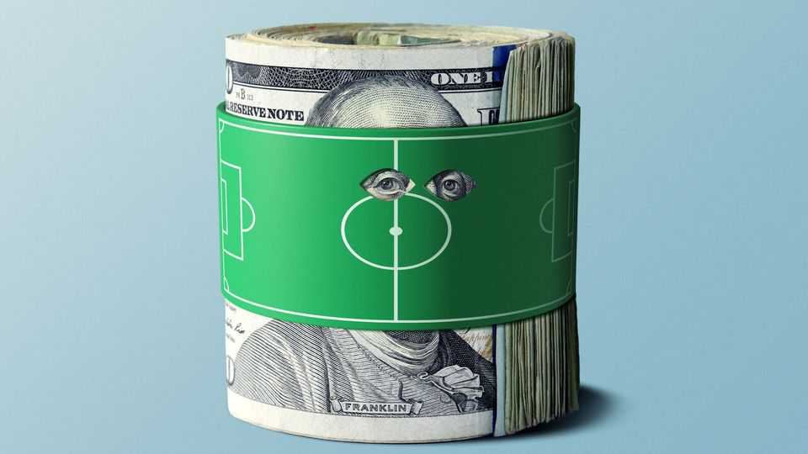
To get the most out of beards, sharps engage in “priming”, a digital version of the old pool-hall hustle. This involves intentionally making large losing bets to get an account’s limits raised, and then earning the losses back and more before the books realise they’ve been had. “They want to prey on degenerates and irresponsible gamblers,” says Chris Dierkes, a veteran sharp. “So you want to dress yourself as the most degenerate, irresponsible gambler out there.”
Good primers make the type of bad bets that VIP managers love, such as multi-leg parlays on major sports. To reinforce the image of a gambling addict, they can get a bot to log in at 3am whenever a wager is pending on an overnight sporting event, says Isaac Rose-Berman, another priming guru.
The best strategy of all is “whale-flipping”. Sharps befriend big losers and get them to place bets on their behalf, thus hiding their shrewd punts in a big bucket of dumb ones. Billy Walters, perhaps the most successful American sports bettor of modern times, wrote that Phil Mickelson, a squillionaire golf star and avid gambler, routinely placed wagers for him at vastly higher limits than he could get for himself.
Whale-flipping works best if the sharp is not too hasty or greedy. “You can come in like Dracula,” says Gadoon “Spanky” Kyrollos, the founder of BetBash and one of America’s largest bettors. “But we prefer the mosquito way, taking a little bit of blood at a time.”
Most sharps eventually run out of friends and relatives they can use as beards. Then they call in the professionals. Middlemen known as “movers” sell access to networks of paid mules, and remain on the hook even if mules run off with the cash. (Stiffing is a cost of business, generally estimated at 3-5%. Happily, no one gets their kneecaps broken any more.) Lower-end movers pocket 10-20% of any winnings and eat none of the losses. The top tier work with data-driven gamblers, move larger sums and typically split profits or losses down the middle.
Moving requires marketing, discretion and occasional moral gymnastics. One Kentucky-based mover at BetBash, with 35 active beards, has mined his church for recruits. “Greed is a sin,” he concedes. “You’re lying to the sportsbooks, but these are evil companies. Jesus had a beard, and Jesus would have been a beard.” Still, even in a business built on subterfuge, there’s one authority no mover dares deceive: the taxman. God may forgive, but the IRS shows no mercy.
A few jurisdictions have tried to place limits on betting limits. Every Australian state has set minimum amounts that punters must be allowed to win for wagers on horse and greyhound races, usually A$2,000 ($1,300). In Spain, thousands of bettors have won lawsuits grounded in consumer-protection law requiring operators to reset their stake factors or reopen their accounts. On September 26th Alex Bores, a state legislator in New York, submitted a bill banning account limits altogether. Regulators in both Britain and Massachusetts are reviewing the practice, but sound sceptical. “Being a successful bettor is not a protected characteristic in discrimination law,” noted Britain’s Gambling Commission in July.
Perhaps surprisingly, sharps have not lobbied against the rules designed to keep them down. One reason is that, paradoxically, they don’t mind them. If there were a limit on limits, bookmakers might worsen the odds, lower maximum bets for everyone or stop offering bet types that pros can exploit. “Limits are the best thing that’s happened to me,” says Mr Dierkes. “I do not want them to be gone. It keeps the people that can’t scale where they are, and makes me money.” ■
This article was downloaded by zlibrary from https://www.economist.com//christmas-specials/2025/12/18/the-battle-to-stop-clever-people-betting
Christmas Specials | The “Wealth of Nations” at 250

Adam Smith is misinterpreted and his influence overstated
The most famous book in economics is less revolutionary than you think

December 18th 2025

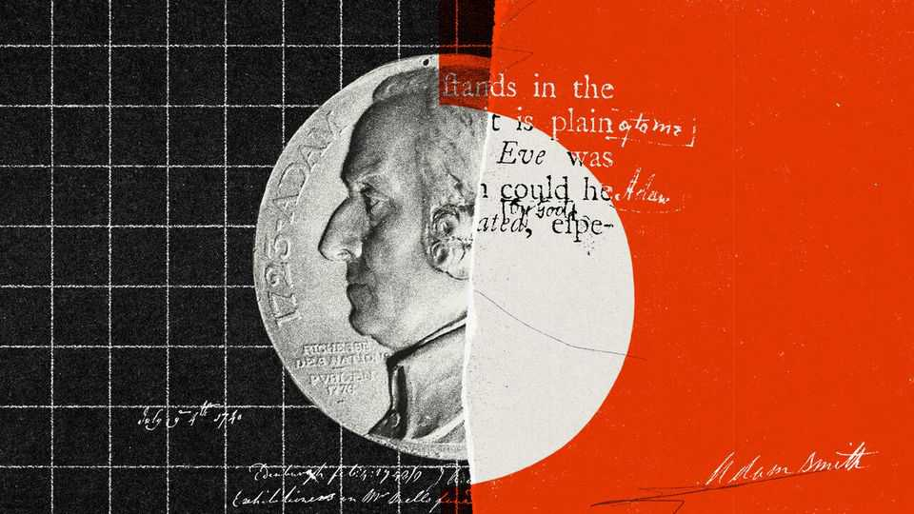
BEHIND ONLY Karl Marx, he is the best-known economist in history. As with Darwin or Newton in their fields, Adam Smith’s ideas seem so foundational that attribution is often unnecessary. Marx inspired socialist revolutions across the world; Smith inspired liberal ones, including the turn to free-market economics in America and Britain in the 1980s. Javier Milei, Argentina’s libertarian president, is a Smith devotee. Margaret Thatcher supposedly carried a copy of his most famous book in her equally famous handbag.
In 2026 that book, “An Inquiry into the Nature and Causes of the Wealth of Nations”, will turn 250. People will sagely nod at the mention of the anniversary; they will claim to have read it. Yet its reputation exceeds its contents. The book contains fewer genuinely novel ideas than many assume, and more weaknesses than its modern admirers acknowledge.
Kirkcaldy, a small town on Scotland’s east coast, is a nice place. But aside from a small alleyway, Adam Smith Close, the town has largely forgotten that Adam Smith lived there. The Adam Smith Heritage Centre is rarely open. The house in which he wrote the “Wealth of Nations” no longer exists.
Kirkcaldy’s lack of boastfulness about Smith is in keeping with the man’s character. Smith was shy, though he enjoyed drinking claret with friends. He never married. He had little time for pomp, quitting a scholarship at Oxford in 1746 because he thought the teaching was poor. He was also fantastically absent-minded. Lost in thought, he once wandered out of town in his dressing gown. He brewed a beverage of bread and butter and pronounced it the worst tea he had ever tasted.
He was nonetheless brilliant. By his early thirties he was the professor of moral philosophy at Glasgow University. Before long he decided that becoming an independent scholar would allow him to make a bigger impact. Following his great work’s publication in 1776, the reading public wanted more. But Smith never felt that he had completed a worthy successor. On his deathbed in 1790, he ordered his papers to be burned.
The popular view of Smith is that he celebrated self-interest. John Ruskin, a Victorian art critic, called him a “half-bred and half-witted Scotchman” who advised his readers to “hate the Lord thy God, damn His laws, and covet thy neighbour’s goods”. Many people today associate Smith with “Greed is good”, a line from the film “Wall Street”, released in 1987. How else to understand Smith’s second-most famous quotation?
“It is not from the benevolence of the butcher, the brewer, or the baker, that we expect our dinner, but from their regard to their own interest.”
Many people also believe that Smith was a libertarian on consequentialist grounds. To simplify: when governments step back, the “invisible hand” of the market delivers something near a socially optimal outcome—even if people act selfishly. This is an idea that Mr Milei, Ronald Reagan and Thatcher came to espouse. According to Smith’s most famous quotation:
“He intends only his own gain, and he is in this, as in many other cases, led by an invisible hand to promote an end which was no part of his intention.”
A cottage industry of academics, led by Amartya Sen, a Nobel prizewinning economist, has encouraged people to read Smith’s work more closely, however. Do so, and the caricature melts away. His first big work, the “Theory of Moral Sentiments” (1759), opened with a clear statement opposing greed-is-good:
“How selfish soever man may be supposed, there are evidently some principles in his nature, which interest him in the fortune of others...though he derives nothing from it except the pleasure of seeing it.”
In this book Smith introduced the “impartial spectator”, a model of human decision-making. A human, he insisted, does not make decisions purely from selfish impulses. Instead he or she consults others—sometimes family and friends, but sometimes himself or herself. The “impartial spectator” is a sort of inner monologue, a third party who judges our actions.
The impartial spectator reveals the true meaning of the “butcher, baker” quotation. Trade works because each party frames his offer in terms the other can accept: wouldn’t you enjoy my bread, says the baker, and wouldn’t you enjoy my mutton, says the butcher. To get what you want, says Smith, you need to imagine what the person on the other side would like. Good dealmakers will “never talk to [others] of our own necessities but of their advantages”. By contrast, two perfectly selfish actors would struggle to strike a bargain:
“Nobody ever saw a dog make a fair and deliberate exchange of one bone for another with another dog. Nobody ever saw one animal by its gestures and natural cries signify to another...I am willing to give this for that.”
Smith was wrong about animals, but then again Kirkcaldy does not have chimpanzees. More importantly, his argument is almost the opposite of the popular understanding. Selfishness did not create markets in meat, beer and bread. Rather, those markets encouraged people to think both of themselves and others at the same time. Smith was tapping into the contemporary idea of doux commerce, found in the works of Montesquieu and others. Montesquieu argued that markets civilised people and softened manners, making societies peaceable. Under capitalism, the argument went, humans no longer fought like dogs.
The popular understanding of the “invisible hand” is even further off the mark. Smith borrows the phrase from Macbeth, who talks about a “bloody and invisible hand” shortly before murdering Banquo. In all his works, the economist mentions the phrase just three times, in three different contexts—and never in reference to the price mechanism. “Smith did not particularly esteem the invisible hand,” writes Emma Rothschild of Harvard University.
In fact, he often favoured the visible hand of government. He urged the state to provide education. He favoured legal caps on interest rates. Today, almost all free-market economists despise America’s Jones Act, which requires that shipping between American ports be conducted on vessels that are built, owned and largely crewed domestically. Smith, by contrast, favoured the Navigation Acts, a similar British law.
Smith acknowledged the benefits of markets, but also their costs. Consider his famous pin factory. The division of labour within it allowed workers to produce thousands more pins than if they were working alone. Countries that perfected the art of dividing labour, Smith argued, would grow rich. Yet he also worried that a life spent on a few simple operations would make a labourer “as stupid and ignorant as it is possible for a human...to become”. Did Smith think the costs outweighed the benefits? It is hard to be sure.
When the “Wealth of Nations” came out, everyone agreed it was a Very Important Book. But does it warrant calling Smith the “father of economics”? That may be going too far, for three reasons. Smith was a flowery writer; he made strange errors; and he is credited for ideas that were not his.
Take the book itself first. Full of long, winding sentences, it is not nearly as readable as Milton Friedman’s “Free to Choose” or Marx’s “Communist Manifesto”. Even in the 1770s people found it hard to digest, with a contemporary review noting that the work “may be sometimes thought diffuse”. Small wonder that even Smith scholars admit that they have not read the whole thing in one go.
Second, Smith sometimes got economics wrong—not just in his support for the Navigation Acts. In the “Wealth of Nations” he argued for the “labour theory of value” (the idea that the amount of work that goes into a product determines its price, rather than how useful that product is). This theory distracted economists for decades and laid the groundwork for Marxism. Exploitation, in Marx’s view, arose from the difference between how much workers had laboured to create a good and what they were paid for producing it. Without Smith, there could have been no Marx.
Third, Smith introduced fewer core ideas of economics than you might think. He did not invent GDP (William Petty, in the 1660s, probably gets that accolade). He was not the first to recommend free trade. François Quesnay, a French economist, got there earlier. Nor was Smith the first to recognise the benefits of the division of labour. Plato beat him by 2,000 years.
Some argue that what makes the “Wealth of Nations” revolutionary is not individual ideas, but its method. Often using his favourite claret as an example, Smith treats the “economy” as a system with regularities. He did not use the term “equilibrium”, yet he clearly understood the interaction of supply and demand. When governments meddle, they distort the process. All interesting; yet these ideas were common in late 18th-century Europe.
Finally, what of his intellectual honesty? The rules about plagiarism were vague in Smith’s day. People often cited others obliquely, or assumed that the reader would already know who originated an idea. Smith, as it happens, was fiercely jealous of his insights, calling out rivals who he believed had stolen them, including Adam Ferguson, another Scottish philosopher, in 1767.
Which makes it funny, then, that the “Wealth of Nations” contains what Salim Rashid of the University of Illinois, Urbana-Champaign, delicately calls “unacknowledged borrowings”. Smith does not mention Ferguson’s analysis of the alienation of the worker under the division of labour. Or consider the pin factory. Did Smith personally observe it? Perhaps—he travelled a fair bit. Yet there is circumstantial evidence, including from the details of how the pins were made, that he “borrowed” the idea from the “Encyclopaedia”, a French work. Discussing the charge of plagiarism, John Maynard Keynes shrugged: “It seems unlikely that the question can ever be answered for certain.” So in 2026 raise a glass to the “Wealth of Nations”. But there is no need for the best bottle in your cellar. ■
This article was downloaded by zlibrary from https://www.economist.com//christmas-specials/2025/12/18/adam-smith-is-misinterpreted-and-his-influence-overstated
Christmas Specials | The sultans of slang

What street talk reveals about Anglophone civilisation
From “strangle-goose” to “skibidi”, colloquial dictionaries struggle to keep up

December 18th 2025

In the beginning was the word. But what was it? For Christians, it was the divine logos through which God created the world. For the world’s leading expert on English slang, Jonathon Green, the first word is arse, or perhaps bollocks.
These are the oldest words for which there are citations in “Green’s Dictionary of Slang”. A thousand years ago, an Anglo-Saxon monk translated the Latin word nates as ears-lyre: the first written appearance of “arse” in English. Another Anglo-Saxon glossary-maker noted that the Latin testiculi was, in the local parlance, beallucas. The English have been talking bollocks for at least a millennium.
In many languages, the most common slang words concern body parts, sex, money and intoxicating substances. Yet Mr Green does not think slang is trivial. In 2010 his dictionary came out in a door-stopping three-volume hardback edition. Since then it has lived online (and free). It has expanded with new words, new meanings and new earliest-known citations. Mr Green says he finds a new one at least every couple of weeks.
One purpose of slang has always been to baffle outsiders. The best-known example may be Cockney rhyming slang, which was devised in the 19th century to confuse the police. But there are plenty of others. The first books on slang were “beggar books”. In the middle ages the destitute relied on Christian charity. That led some chancers to try various wheezes to seem needier than they were—and chroniclers like Robert Copland to decode their insider cant. His book of the 1530s, “Highway to the Spital-House”, reveals that a clewner is a high-ranking villain, and the dance is a hanging. Bouse makes an appearance—another of the oldest slang words that is still in robust use today, says Mr Green, though it is now spelled booze.
The first true attempt to make a slang dictionary came shortly after Samuel Johnson’s great dictionary of standard English. In 1785 Francis Grose, a former militia captain so fat it was said he had to be tied to his bed to stop him rolling off, published the “Classical Dictionary of the Vulgar Tongue”, compiled by prowling London’s seedy neighbourhoods and jotting down gems such as strangle-goose for a poulterer.
Vulgar meant “common”, not “rude”, but slang allowed people to get round taboos. In Grose’s era the old names for the body parts had become unmentionable, with comically prudish results. In his slang dictionary bottomless pit is defined only as “the monosyllable”; look under venerable monosyllable and you find pudendum muliebre. This is Latin for a “woman’s shameful thing”, an astonishingly prissy circumlocution. Chaucer, writing four centuries earlier, would just have said “queynte”.
A common slang can bind groups together, as Eric Partridge showed by collecting soldiers’ vocabulary from the first world war. His intent was not to portray the men “as supermen or as whiners”, but as they were. Bored then suddenly terrified, soldiers used ironic detachment to deal with constant peril. Pip squeak and whizz bang were different kinds of shells for the sounds they made; a toothpick was a bayonet. As Blighty was England, a Blighty one was a wound serious enough to send the soldier home. To be a loaf of bread, a poignant example of rhyming slang, was to be dead.
Partridge, whose most ambitious work was a “Dictionary of Slang and Unconventional English” in 1937, was inspired by the Oxford English Dictionary (OED). This mighty tome did not just say what a word meant, but also where it came from and what it had meant at every stage of its past, backed by written evidence.
The OED was made by a team of scholars; Partridge had to rely on volunteer helpers, sending in proposed etymologies from their own areas of expertise (the Boer war, the merchant marine, and so on). He could not possibly verify everything he was told. He could not decide between several origin stories for OK, and so listed them all. (It comes from oll korrekt, a jocular American misspelling of “all correct”.) For johnson used to mean “penis”, he gives the preposterous explanation that perhaps it came from Doctor Johnson, because “There was no one that Dr Johnson was not prepared to stand up to.”
For a young Mr Green, Partridge was a challenge to do better: “He can’t do sex, he can’t do drugs, and he can’t do rock ’n’ roll.” Partridge apologises for including sexual terms. Not so Mr Green, who came up through the 1960s counterculture. After Oxford he worked in underground magazines, even for a short time in “top-shelf” (that is, pornographic) ones.
In the late 1990s an inheritance and a publisher’s commission allowed Mr Green to dedicate himself completely to his magnum opus. When it was published in 2010, a reviewer called it “the best historical dictionary of English slang there is, ever has been or (in print at least) is ever likely to be".
Today many publishers see the dictionary’s ideal format not as a bound volume, out of date by the time it hits the shelves, but as a database that is constantly updated. That is what Mr Green has continued to do from his home office in Marseille. Like Partridge, he is a one-man band with occasional collaborators, volunteers who send him citations from their own reading.
During The Economist’s visit this year, he was taking into his dictionary new words and citations. One volunteer sends in slang culled from the papers of a 19th-century politician, such as rum touch for an eccentric, or Cyprian for a prostitute. Mr Green expands his lexis of gay terms by drawing on the work of Gary Simes, an Australian scholar who died before completing a dictionary of sexuality and slang. This includes a first citation for bone queen, a fellator. He works with James Lambert, another Australian academic, “who will take over when I pop my clogs”, Mr Green says.
It is not clear what the job of slang lexicographer will look like in the future. Technology allows a quicker, more accurate search for citations; but it also makes language harder to pin down. Social-media diffusion means that the half-life of a new term is shorter than ever before. Words race from the avant-garde, to a broader set of cool kids, to mainstream society and finally death when mum and dad start using them, all in a matter of months.
And there is more slang on display than ever before. Countless subcultures generate their own patois. Tony Thorne of King’s College London has collected the slang of gangs and of drill-music lyrics (such as matic for a gun, or nank for “to stab”). His sources are people who know each subculture well. But developing such sources is hard. They may mislead, unintentionally or intentionally, since slang is supposed to be unclear to the outsider. He recalls the time he told a radio audience that smh stood for “same here”. It doesn’t—it means “shaking my head”—but he had been duped by mischievous students.
Social-media influencers are keen to propagate their own new words, such as skibidi, a near-meaningless, briefly ubiquitous term that emerged from a series of videos about talking toilets. Such coinages are “designed to be transient”; by the time lexicographers catch them they could be gone.
Everyone with an internet connection now has access to all the world’s slang. The English-speaking nations have different styles. Mr Green gives the Australians top marks for creativity. Coinages introduced to Britain by Barry Humphries, a comedian, include technicolour yawn (vomit) and siphon the python (to urinate). Mr Thorne by contrast describes the particularly English native style: constantly teasing, terrified of self-seriousness, addicted to playful nonsense-sounds (rumpy-pumpy, naff, cream-crackered). Plenty of Britishisms have caught on in America, where locals sometimes underestimate how rude they are (shag, wanker). Slang—quintessentially insider language—is more global now than it ever was.
For all its richness, many equate slang with language thoughtlessly spoken by those who haven’t mastered the standard language. But Michael Adams of the University of Indiana insists that slang is not a bad copy of the standard language; rather “People have got other stuff to say, and the language they’re given doesn’t meet their expressive needs.” He’s a fan of the word delulu, which may have the same literal meaning as delusional but carries a humorous shrug that delusional doesn’t.
Slang is not only not less than “real” language. Arguably it is more. Many words in a standard dictionary have only specific, referential meanings; “lanthanum” points to a chemical element but doesn’t say much else. Slang words may refer to a much smaller range of things. But they also carry other channels of meaning: who the speaker is (a Gen-Z TikToker, a Cockney), how they see the thing they are describing (with affection, fear, desire or contempt), and even how they want to be seen themselves. Says Mr Adams: “It’s when the fountain of language overflows with meaning.”■
This article was downloaded by zlibrary from https://www.economist.com//interactive/christmas-specials/2025/12/18/what-street-talk-reveals-about-anglophone-civilisation
Christmas Specials | Muscle beachhead

America’s fight back against China starts in Los Angeles—in flip-flops
“Gundo” is the Silicon Valley of hard-headed patriotism

December 18th 2025

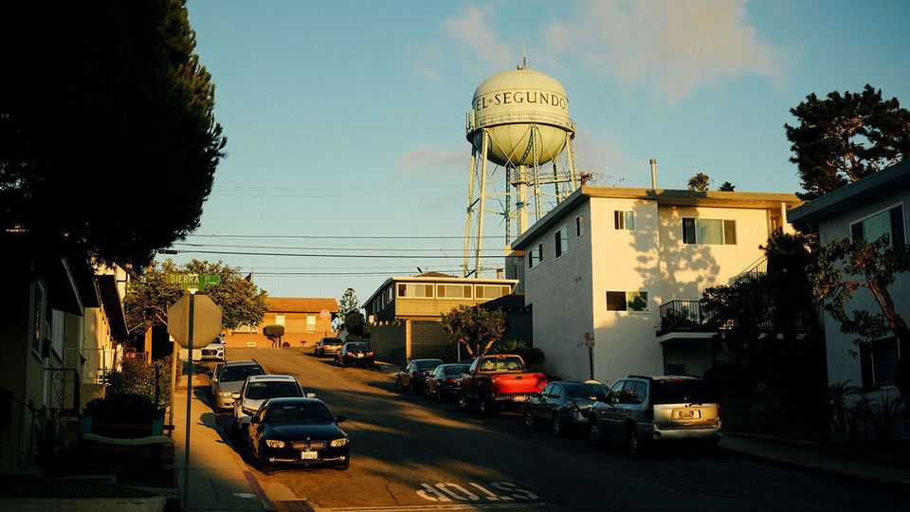
Brandon chrisman is using a rag to polish his 1956 f100 Ford truck, even though the paintwork—“Ferrari blue”— could hardly shine brighter. The fifties resonate with Mr Chrisman. When he throws open the doors to his nearby factory, the patina of history is even more dazzling than the car. Inside are squat machines with cranks, gearsticks, shafts and handles that date back to 1958 when his grandfather started the firm. With his buzz-cut, rust-coloured hair and square jaw, Mr Chrisman looks like he was forged there.
His firm, HydraWedge, is in El Segundo, a beachside city near Los Angeles International Airport (lax), known by industrial metal-heads as “Gundo”. From before the second world war until the 1990s, it bristled with machine shops that cast, milled and ground metal for the defence and aerospace industries—once the lifeblood of la’s blue-collar workforce. Then China drew away some of the metalworking and the machining industry hollowed out. Once Mr Chrisman had about 20 employees. Now he works alone.
And yet he is remarkably chipper. In fact he is more hopeful for the future of American manufacturing than ever. That is thanks to a bevy of startups springing up around him that share an animating principle: they want to wrench industrial supremacy back from China. They are surfing on a rising tide of venture capital. “They spend money like it is going out of style,” Mr Chrisman chuckles.
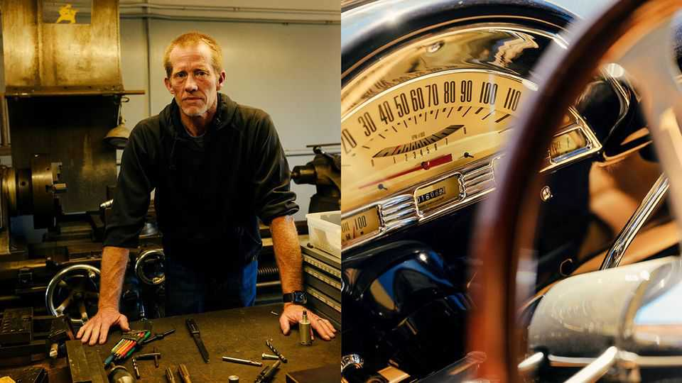
la’s palm-fringed coastline is one of the last places you might expect to find an enclave of pro-American, Bible-thumping, tobacco-loving space nerds whose main aim in life is to make stuff—as long as it’s not movies. Yet El Segundo, which looks like a Hollywood set for small-town America, with only 17,000 residents, diners galore and a theatre that still boasts a Wurlitzer, is a perfect hiding-place for engineers building an anti-China beachhead. Adding to the disguise, many surf in their spare time and come to work in flip-flops.
From afar, the city has nothing going for it. It is not just its proximity to the din of LAX. Situated next to a sewage-treatment plant that leaks so regularly into the ocean that locals call a nearby surfing spot “shitpipe”, and the second oil refinery ever built by Chevron (hence El Segundo, Spanish for “the second”), few beach towns sound less alluring. Yet Gundo is an increasingly important part of America’s attempt to win a high-tech arms race against China.
Visit the startups and they look like throwbacks to the 1950s. Firms drape their walls with vast American flags. They deck their offices with the parts of customised cars. They adopt prosaic company names, such as General Matter, Varda Space Industries and Metal Cross, that echo the General Electrics and General Motors of America’s industrial heritage more than the twee nomenclature of Silicon Valley. Young, buff entrepreneurs, almost all men, bench press and brandish wrenches; they do anything to distinguish themselves from what they see as software dilettantes farther north. Silicon Valley may be the cradle of modern life, from artificial intelligence (ai) to burrito deliveries. Gundo is its equivalent in hardware innovation—and the harder it is to build, the better. If ai is to be the brains of America’s tech supremacy, Gundo hopes to provide the muscle, the energy and the firepower.
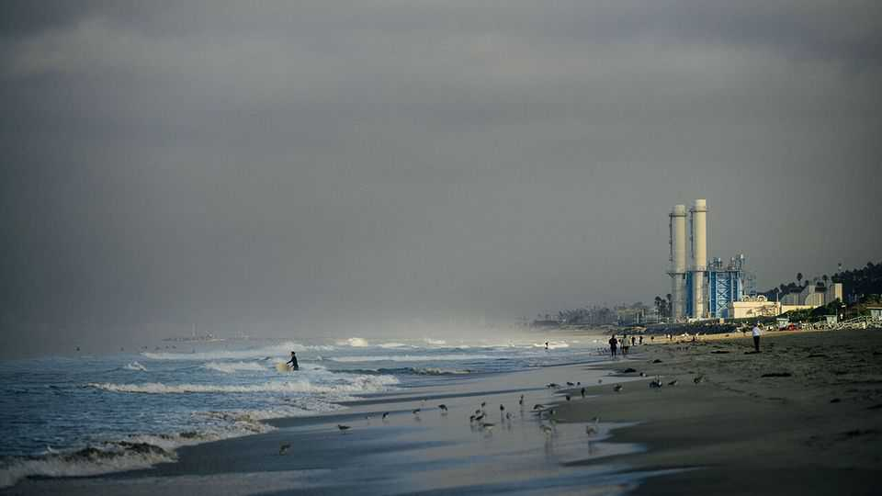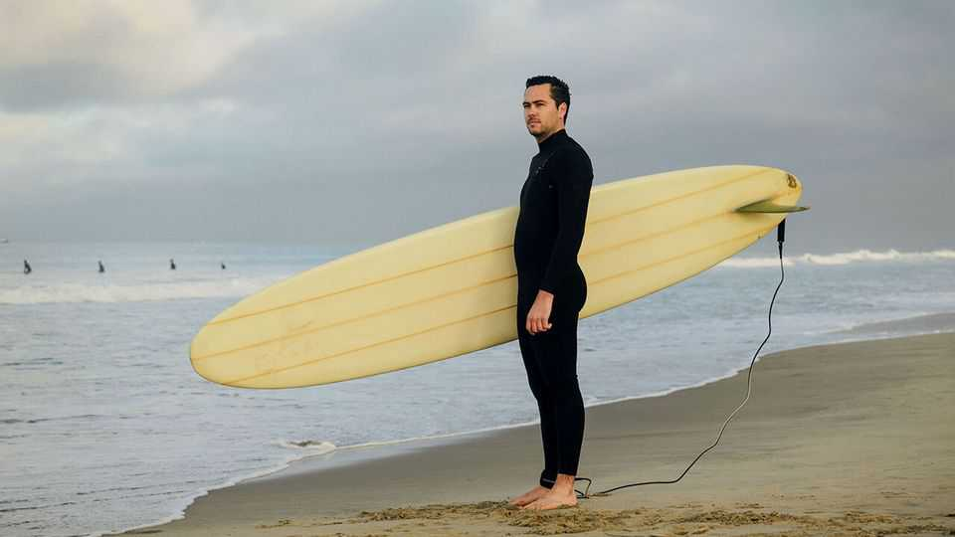
Take some of the firms in Smoky Hollow, a red-brick district of El Segundo where Mr Chrisman works. One is a startup established by one of the first employees of SpaceX, Elon Musk’s rocket firm, which is working on enriching uranium for the nuclear reactors emerging to power ai. It has a cia aura of secrecy about it; ex-spooks are on the payroll and the building is unmarked. The only clue to what is going on inside another company called Rangeview is the word BUILD on the number plate of an Audi parked outside, adorned with the Stars and Stripes and an exhortation to “Support Our Troops”.
Rangeview’s founder, Cameron Schiller, who has the looks of a film star and the zeal of a Mormon missionary, is building a foundry to do high-precision casting of metals and superalloys for components such as turbine blades. He will not let it be photographed because the technology is proprietary.
As a teenager, Mr Schiller won a robotics world championship and flew back and forth between America and China. In China, he says with an eyeroll, he discovered “the American dream”—which he wants to steal back. “We need to take Chinese jobs and put them back in America,” he says. It’s a Quixotic-sounding endeavour, especially in one of the world’s priciest metropolitan areas. On one of Rangeview’s walls is a photo of a recent visitor, Aaron Paul, who plays Jesse Pinkman in “Breaking Bad”. Safe to say, casting metal in la is a lot harder these days than cooking meth.
El Segundo has patriotic capitalism in its foundations. From 1932 until 1962 the “aerospace capital of the world” hosted a factory of the Douglas Aircraft Company that produced navy planes flown in three different wars. The Hughes Aircraft Co, based in El Segundo, built the first American unmanned vehicle to land on the moon. The city still has towering offices for the likes of Boeing, Northrop Grumman and Lockheed Martin (Mattel’s Barbie is a Gundo girl, too).
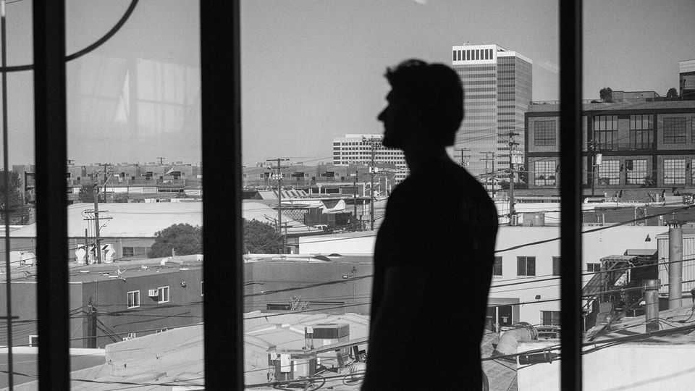
The mom-and-pop machine shops were integral to its culture. The machinists who worked there tinkered with classic cars and raced hotrods at night. Even today, El Segundo has a classic car show in August that brings the cold-war era back to life. But in the 1990s consolidation, bean-counting and the lure of Pentagon cash drove the defence industry closer to Washington, killing the industrial heft of la and wiping the west-coast Republicanism it once fostered off the political map. As the machinists shut up shop, the city took an “artsy fartsy” turn, say locals. The high school shut its metalworking shop. Manual labour was discouraged. That was until 2002, when a young Mr Musk founded SpaceX and moved into a nondescript building in El Segundo. It marked the start of the city’s rebirth as a Mecca for engineers with ambition.
SpaceX’s original headquarters are hard to spot. There are no blue plaques. The premises are now occupied by a seafood wholesaler called “Lee Fish USA”. The Economist was driven there (in a Tesla) by Scott Nolan, one of Mr Musk’s first employees. He scrolled on his phone to find a cover story of Aviation Week, a magazine, from 2004, showing the first 60-foot Falcon One rocket laid out on the building’s floor. “Can tiny SpaceX rock Boeing?” the story asked.
It did. Estimates of the value of SpaceX, one of the world’s biggest private firms, are in the hundreds of billions of dollars, and far more than that of Boeing (Mr Nolan says he still owns shares). But its place in El Segundo is more than a historical footnote. Its diaspora of ex-employees is the basis of Gundo’s startup culture; Mr Nolan, for instance, is founder of General Matter, the company trying to enrich uranium.
SpaceX’s success in sending reusable rockets and satellites into orbit also opened the way for a flurry of startups hoping to piggyback on the new space infrastructure. Delian Asparouhov, co-founder of Varda, a Gundo-based firm building pharmaceutical labs to operate in space, likens SpaceX to Andrew Carnegie’s railways in the 19th century. “The point of the railroads was so Rockefeller could ship oil on them, right? Elon and SpaceX have built the railroad. Now someone has to figure out what the equivalent of oil is.”
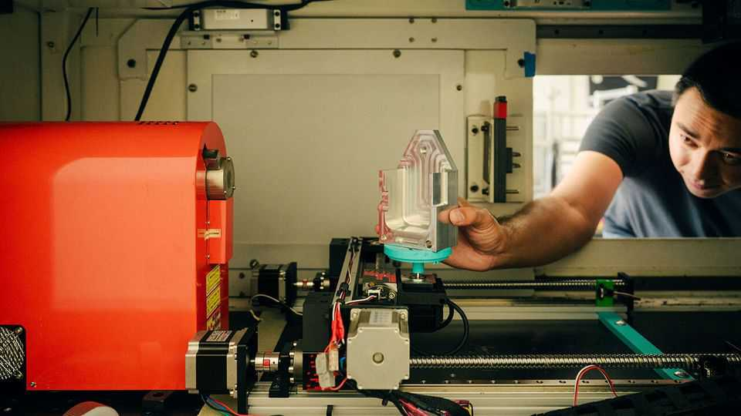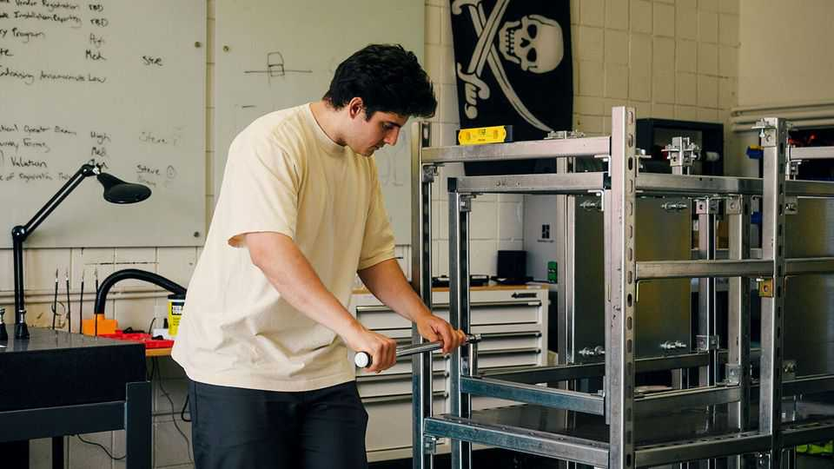
Mr Nolan and Mr Asparouhov are both partners at Founders Fund, a venture-capital firm led by Peter Thiel, a shrewd la-based billionaire who was one of SpaceX’s earliest investors. It is tempting to see Mr Thiel’s Svengali-like hand at work over Gundo’s startups scene; he is a strong advocate of America-first capitalism. Yet his influence is probably clearest in the contrast many of Gundo’s engineers draw between their quest and that of Silicon Valley. They are crusaders for what Mr Thiel calls “atoms” versus “bits”.
Steve Cohen and William Carroll, two aspiring entrepreneurs whose startup, Metal Cross, aims to make x-ray testing equipment to support precision manufacturing, have seen the contrast first hand. Mr Cohen grew up in Silicon Valley. Mr Carroll worked for Google there during the pandemic. There he slept in his Prius, ate from the Google canteen and enjoyed a weekly massage at the firm’s expense, in order to save money to help him start a business.
Compared with Silicon Valley, their startup is spartan; there are no colourful slides, dog treats or kombucha fountains. You spot its premises down a narrow alley because the roll-up doors are open and a star-spangled banner hangs prominently on an inside wall. The open-door approach means anyone can drop in. The co-founders talk of fellow entrepreneurs stopping by to borrow tools. They visit their neighbours for advice, too, such as how to unjam a stubborn bolt (“take a flame thrower to it”). Such startups begin small. The premises in Smoky Hollow are little more than garage-sized. But if their businesses prosper and funding increases, they “hermit crab” into bigger premises in neighbouring cities along la’s South Bay. SpaceX’s la facility now sits in a factory the size of an airfield in Hawthorne, a short drive from El Segundo.

Mr Carroll, who used to surf before work and remains sandal-clad in the workshop, calls himself a renegade from the Silicon Valley culture. He calls tech workers he met there “anti-American”. Gundo’s lack of perks appeals: “Could you imagine a masseuse in a molten-metal foundry?” he asks. The business model is different, too. Whereas software is a scale business, with zero marginal costs and a winner-takes-all mindset, hardware is more like craftsmanship; products are bespoke and so high-tech that somewhere, a market for them exists, even if it is only in space.
Venture capitalists have started to pay attention to Gundo. vc giants like Andreessen Horowitz have diversified from software to promote a pro-American hardware culture. But some Gundoites are wary of being mythologised into world-changers in the way their Silicon Valley counterparts have been. They have an engineer’s mindset: to shoot for the moon you have to crack one problem at a time. You don’t talk big. You think in minute detail.
All this makes Gundo a bottom-up example of something that countries around the world try in vain to replicate: a genuine entrepreneurial cluster. It starts with that diaspora. Locals say many of the startups are built by former employees not just of SpaceX, but of Palantir, a data platform used by spy agencies and law enforcement, and Anduril, a defence-tech pioneer. Their early employees, cashing in multi-million-dollar stock options, became founders in their own right. This trend has grown big enough to become self-reinforcing. Many startups fail. But when they do, there are enough opportunities nearby to give employees the confidence that they will find other jobs.
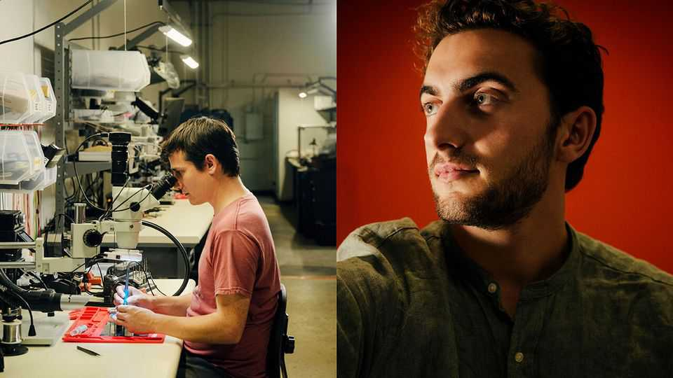
Gundo also has that indefinable lure that clusters require. Some say it is the beach; Zane Mountcastle, co-founder of Picogrid, which provides platforms for linking up military systems, finds the early-morning peace as he waits for a wave on his longboard vital ahead of a day negotiating with defence contractors. Other say it is the countercultural aversion to Tinseltown that adds to the glue. There’s a bar-room culture. There are cigarettes. There is church on Sunday. Whatever it is, some industrialists now list Gundo, along with Silicon Valley and Tel Aviv, within a triumvirate of the West’s most important innovation hubs.
No government master plan lies behind the success. Yet there is little disguising the excitement about President Donald Trump’s ambitions to revive American manufacturing, especially when it comes to defence, space and energy technologies. Mr Nolan stood by the president’s side in May, speaking on behalf of Mr Trump’s executive orders aimed at restoring America’s nuclear industry. Mr Schiller, a keen student of Chinese manufacturing, says the Trump administration “seems to get the importance” of what is happening in El Segundo. The president’s belief that a manufacturing renaissance will revive blue-collar America does not appear to be borne out. Only a few machinists like Mr Chrisman remain employed there. But if the entrepreneurs build the bare bones of a manufacturing base that can be scaled up multiple times in the event of war, it might make more sense.
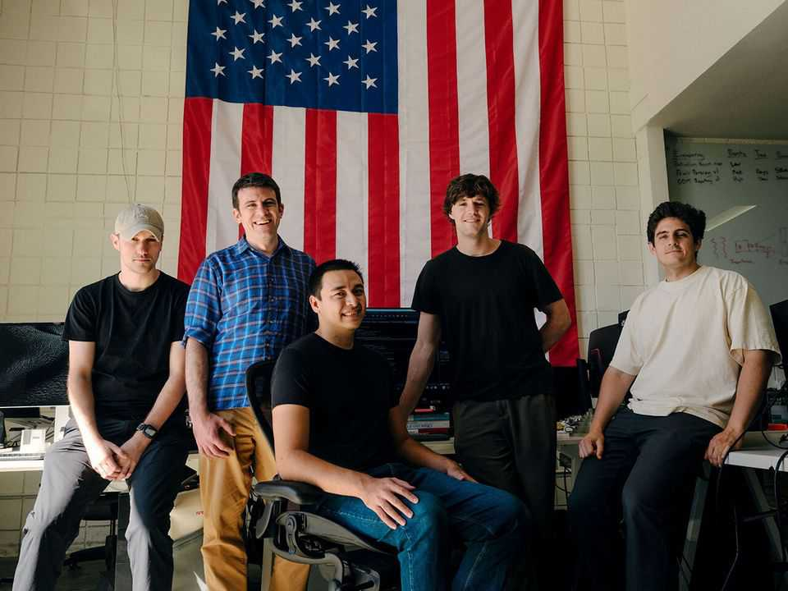
The sense that Gundo’s founders are quietly working on a Plan b for America as tensions rise with China is palpable at Neros, a manufacturer of lethal drones that Soren Monroe-Anderson, its co-founder, says has the highest production rate of drones in America, mostly for sale for use in Ukraine. He shows how Neros has sought to strip all traces of Chinese technology from the products, including their circuit boards.
Each drone is hand-assembled along a small production line, and tested behind the warehouse. The output is about 2,000 drones a day, up from 100 a month at the start of the year. That is “truly nothing” compared with China, Mr Monroe-Anderson says; the biggest Chinese drone manufacturer produces about one per second, he reckons. “We’re trying to make the American drone industrial base competitive on a global scale,” he adds. “That’s a really hard mission; we’re set up to fail. But we think it’s essential to try.”
Asked why Neros does this in California, rather than in a more pro-business, pro-Pentagon state like Texas, he smiles mockingly. “The best engineers in the world don’t want to live in Texas,” he snorts. Mr Schiller, his close friend, walks with your correspondent out into the building’s car park, and points scornfully at a Boeing aerospace complex across the road. “Neros is just taking Boeing’s business from under their nose—literally in their back yard—and they don’t even know it,” he says. Yet even if most Americans are clueless about the disruptive beachhead emerging a stone’s throw from the Pacific coastline, China surely isn’t. ■
This article was downloaded by zlibrary from https://www.economist.com//christmas-specials/2025/12/18/americas-fight-back-against-china-starts-in-los-angeles-in-flip-flops
Christmas Specials | Jainism in the world

The long, strange journey of a temple from profane to sacred
How an object made to sell tea, then used to promote gambling, finally became holy

December 18th 2025


On the outskirts of Los Angeles, on a four-lane suburban street adorned with palm trees, laundrettes, Korean dentists and car-repair shops, stands the tan marble and limestone facade of the Jain Centre of Southern California. Step inside, and you encounter a magnificent wooden structure with a sanctum, sculptures of gods, and a shikhara, or spire, reaching to the heavens. It is an intricately carved replica of a Jain temple in India, and to Americans of the Jain faith in the here and now, it has profound significance.
But the structure’s origins are more crass and commercial, and its significance has changed dramatically depending on where it has gone and who has come into contact with it. This is the story of the wandering temple, of its century-long journey from what was then Calcutta to a World’s Fair in St Louis, Missouri, onward to a casino in Las Vegas and finally to Buena Park, California. It is also a journey in the meaning of an object, from the profane to the sacred.
The tale begins in the early 20th century, with British colonialists in India keen to boost tea sales in America. By 1901 America had become the world’s biggest industrial economy and its population of nearly 80m made it a giant consumer market. It was undeniably attractive. But foisting tea on Americans was a tall order at the time. British colonialists and tea had something of a checkered history in America, dating back to a certain party in Boston. Tea-drinking was a pursuit of ladies who were upper-class or aspiring to be so; Americans drank far more coffee (nearly 5kg a person in 1901, compared to half a kilogram of tea).
Enter the 1904 world’s fair in St Louis, held to commemorate the centennial of the Louisiana Purchase. Sixty-two countries and 43 of 45 American states would participate, and nearly 20m people would visit over its seven-month span. The Indian Tea Association, a trade body of British planters based in Calcutta, under the leadership of Richard Blechynden, a prominent planter, saw an opportunity to make a marketing splash.
At a time when few in the middle-class could afford far-flung travel, fairs brought the world to the middle-class, albeit in highly exoticised form. One teahouse in Japan’s pavilion was modelled on a temple in Kyoto, where “40 genuine Geisha girls performed their graceful dances, and sang”. Ceylon, now known as Sri Lanka, took as its inspiration the Temple of the Tooth in Kandy, and included “handsome specimens of the mild and gentle Singhalese race, dressed in their native costume”. China sent a replica of an entire palace, complete with Prince Pu Lun, the heir to the imperial throne. For local visitors, a ticket to a World’s Fair was the Ryanair flight of its time.
World’s Fairs were also where new ideas and inventions were unveiled or popularised. Among the innovations the St Louis fair is remembered for is iced tea. The legend goes that Blechynden, despairing that the muggy weather was deterring Americans from trying his steaming drink, started serving tea over ice instead. It was a massive hit. The story is probably made up; iced tea was known before the fair. But Blechynden did serve iced tea and indeed took credit for inventing it, and the fair exposed millions of visitors to the concept. It is still a popular American refreshment.
The literal centrepiece of Blechynden’s efforts to push tea in America was the wandering temple, designed to draw gawpers to the Indian pavilion at the fair. The planters in Calcutta commissioned an ornate replica of a shrine from a Jain temple complex on the other side of India, near Palitana, a remote pilgrim town in the state of Gujarat. Exactly why they settled on a structure of the Jain faith thousands of miles away remains a mystery, says John Cort, America’s leading Jain-studies scholar.
Perhaps it eluded them that the temple was from a small, little-understood faith (then, as now, Jainism was often considered a branch of Hinduism). Or they simply did not care about the particulars. In St Louis the fake shrine would be placed at the heart of another replica, of a 17th-century Mughal mausoleum in Agra, making the Indian pavilion an odd synthesis of Islamic and Jain sites (along with a smattering of Hindu iconography among the carvings). A more cynical concoction it could hardly be. As long as it looked the part to hayseed Americans, it would do the trick.
And look the part it did. A photograph from the fair shows three moustachioed Indian waiters in cummerbunds and magnificent turbans in front of a teakwood structure some 35 feet high and 20 feet wide. The entire thing is covered in sculptures and detailed carvings. Two small spiral staircases lead to chattris, or canopied pavilions, on the roof, which is topped with the shikhara. One contemporary report gushed that it was “a wonderful piece of carving which represented the labour of 65 skilled carvers for two years”.
The planters counted the exhibit a success. Their tea proceeded to flow. According to the Civil and Military Gazette, published from Lahore, exports of tea from India and Ceylon to America grew from 7m lb in 1898 to 16.5m lb in 1907 under Blechynden’s direction.
After the fair the organisers sold the buildings, machinery and other things on the site to the Chicago House Wrecking Company for $450,000 (roughly $16m today). Its catalogue lists for resale everything from windows and lightbulbs to “10,000 carloads of lumber”. The Jain temple joined the scrapheap, forgotten for almost 60 years.
Until September 1st 1963, when the Castaways hotel and casino opened its doors for the first time. It was “a magical South Sea island resort in the heart of Las Vegas”, reported the Las Vegas Review Journal. The theme was Hawaiian or thereabouts, with “Chinese modern, Polynesian and South Seas decor”. The decorative highlight, “glistening in the Las Vegas sunlight”, was something the paper called “The Jewel of Palitana”.
The temple-teastall had been reborn as what the casino called the “Gateway to Luck”, installed in a well-trafficked site near the pool. Gamblers could seek fortune from the temple-totem and throw coins in a nearby wishing well. Over time, it became part of the brand (and fell into the possession of Howard Hughes, the reclusive billionaire, who purchased Castaways in 1967). The temple was a selling point on the casino’s postcards and brochures. Performers such as Jan Sutton, a blonde showgirl who featured nightly in a cabaret called “Bottoms Up”, were among those pictured posing on its steps.
Ben Jaffe, the hotel’s owner, told a local newspaper that the dismantled and crated-up temple had been purchased by a private art collector who never bothered to reassemble it. When the collector died, the temple was passed to a dealer, and eventually was acquired by Jaffe. It took four men three months to reconstruct it piece by piece.
Of all the places the temple could have turned up, Las Vegas is in some ways the most fitting. Like the St Louis fair, it attracts millions of transients who come to be amazed and enthralled. Its sparkliest attractions are replicas of famous sights—among them the canals of Venice, the pyramids of Giza and the Eiffel Tower—which are, as their analogs in St Louis were, mostly cynical confections designed to lure in visitors for profit. In the case of the wandering temple, the same structure had now evolved from one crass purpose, selling Americans tea, to another, selling gamblers a quasi-spiritual promise of good luck.
But also like the world’s fair, much of Las Vegas is ephemeral. Castaways, which replaced an earlier casino called Sans Souci, shut in 1987, to be replaced by the Mirage. The temple was about to disappear again—though as fate would have it, not for ever. By the late 1970s the temple was drawing more than curious looks from a small subset of Las Vegas visitors: recently arrived Jain migrants from India.
Congress had in 1965 passed the Immigration and Nationality Act, which in effect abolished race-based quotas. The first wave of Indian migrants started trickling in soon after. Many were doctors and pharmacists, who qualified for instant green cards. But few states allowed foreign-degree holders to practice without retraining.
California was one of them. The new rules also prioritised family reunification, so many new arrivals soon invited other family members. By the late 1970s Los Angeles area was home to a tightknit but growing Jain community of 65 or so families (today there are maybe 1,500). In 1979 they formed the Jain Centre of Southern California to serve as a locus for worship and communal events.
In time Jain migrants were among the many southern Californians drawn to the bright lights of nearby Las Vegas. Visiting Castaways, they stopped in their tracks. “Whoever visited in the early ’80s, they easily identified that as a Jain temple,” says Hasendra Shah, who moved to Los Angeles as a pharmacist in 1981. “And the Jains’ feeling was this is our place, our object of worship.” It did not belong, they felt, among slot machines and scantily clad cocktail waitresses: “We believe the display of the temple in this way is an insult,” Lalit Shah, the Jain Centre’s then vice-president, told the Las Vegas Review Journal.
The casino, for its part, said that the temple had “nothing to do with their religion”. Until the Jains had come along, that was true. The temple had been an instrument of commerce. But that was changing.
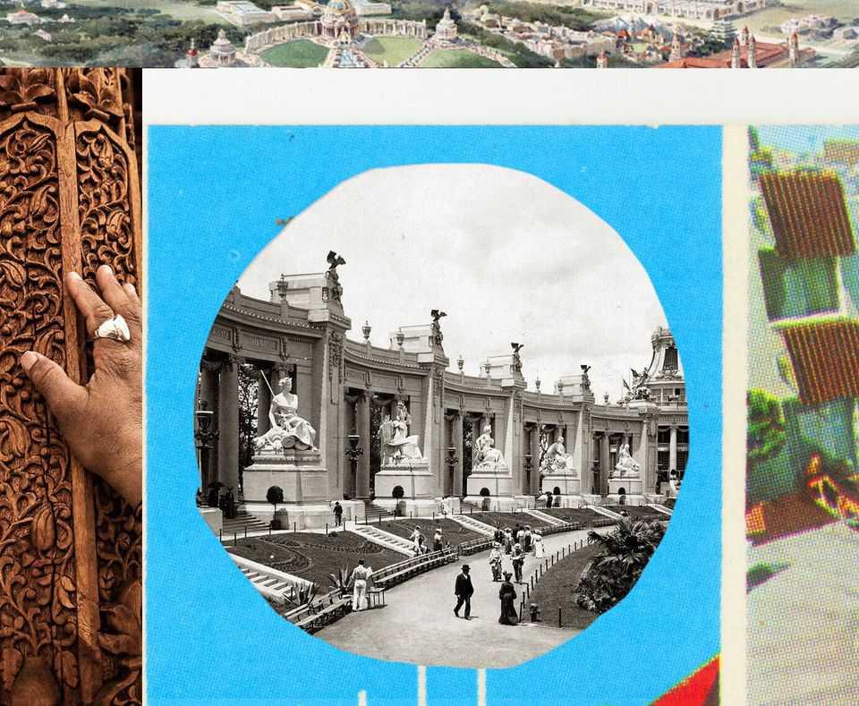
Eventually the casino was sold to a new buyer who wanted to tear down the entire property. In its last four weeks, Castaways held daily raffles in which it gave away everything from ashtrays to the 90-foot marquee outside. The one thing that was not raffled was the temple: that it donated to the Jain centre.
The Jains had a modest plot of land in Buena Park about 20 miles from downtown Los Angeles. But their community hall was too small to fit the wooden temple. It took until 2008 for the centre to become what it is today: an $18m, 75,000-sq-ft complex encompassing a cavernous marble temple, study rooms and event spaces.
Its focal point is the wooden temple, which the centre describes as “priceless”. The structure utterly dominates the space, its soaring shikhara terminating just underneath a skylight. A hundred years after it was commissioned in Calcutta and hand-carved in Gujarat, the wandering temple was finally home, among the followers of the faith it represented.
Yet the temple is still not a temple. The open flames involved in Jain worship would run afoul of fire-safety regulations given all that wood. It is also a bad idea to assemble groups of people in a rickety structure in an earthquake zone. And in any case the temple is too delicate to accommodate the several-times daily rituals that Jains must perform. Besides, the centre already had a consecrated place of worship.
The Jains knew all this before acquiring it. Why, then, did they make all the effort, pursue the casino, and spend money storing and restoring it and building a virtually hallowed space for it?
One reason is that, even though it was merely a replica of a holy site, the Jains believed it deserved reverence. However it was initially conceived by its makers, then reconceived by casino bosses, to Jains the temple’s very shape signifies holiness.
But there is a deeper reason. Jainism has always been a minority religion. There are between 5m and 8m Jains in the world, mostly in India. In America they are a rounding error. Yashwant Malaiya, a computer-science professor in Colorado, has calculated that there were around 160,000 Jains in America in 2019, or less than 0.05% of the population. As the American Jain community enters its third generation, it is assimilating, both into the 4.8m-strong Indian-American diaspora and the mainstream of 330m Americans. Its distinctive identity is at risk of vanishing altogether someday.
The wooden temple reinforces that identity both within and without. Young Jain couples pose for their wedding photographs in front of it. Feasts are held in its shadow. When local or Indian officials visit the centre, it is the first thing they are shown. And it has been a fundraising draw for the faith. Members of the centre have donated millions of dollars to erect the temple and the structure that houses it. They also endow chairs in Jain studies at universities across the west, including a dozen in California alone. “We want them to learn about Jainism, the Jain way of life,” says Jasvant Modi, a philanthropist.
Like the Hinduism with which it is often confused, Jainism is a religion of karma and reincarnation. The temple may have started life as a crass promotional device, deployed by British colonials who had no comprehension of the culture and faith they were appropriating. But it makes sense that eventually the wandering temple would find new life and meaning among wandering Jains, half a world away from their homeland. “In India to have a temple, it is not uncommon. Here it is a special thing to have a temple,” says Hasendra Shah. “We live in the west of the West. We live in the world of Hollywood.” That fits, too. Hollywood: the land where people, and the occasional temple, fake it until they make it. ■
This article was downloaded by zlibrary from https://www.economist.com//christmas-specials/2025/12/18/the-long-strange-journey-of-a-temple-from-profane-to-sacred
Christmas Specials | The Great Games

What if the best way to learn about history is by playing with it?
Video games are changing the way people understand the past

December 18th 2025

When it comes to education, there is no substitute for learning by doing. To teach children Spanish, have them speak it. To teach them art, give them paper and paints. Plenty of tech titans got their start by playing around on a computer in their youth.
But some subjects are less suited to such learning, notably history. The past is fixed, and—until one of those tech titans invents a time machine—inaccessible. You can read about it in books, or watch re-enactments. But even the most eager student cannot get any hands-on experience. They cannot tinker and experiment as they can with a car or a foreign language.
Or can they? On November 4th Paradox Interactive, a Swedish video-game developer and publisher, released Europa Universalis 5 (eu5), the latest in a series of best-selling historical video games. eu5 lets players take control of any one of hundreds of early-modern historical states in the year 1337, on the brink of the Hundred Years War, and guide it through the centuries as they see fit.
Paradox specialises in these high-concept historical games and sells millions of them. The medievally inclined can try Crusader Kings, set in the Middle Ages. The Victoria series covers the Industrial Revolution, while Hearts of Iron focuses on the second world war. Imperator: Rome does what it says on the tin.
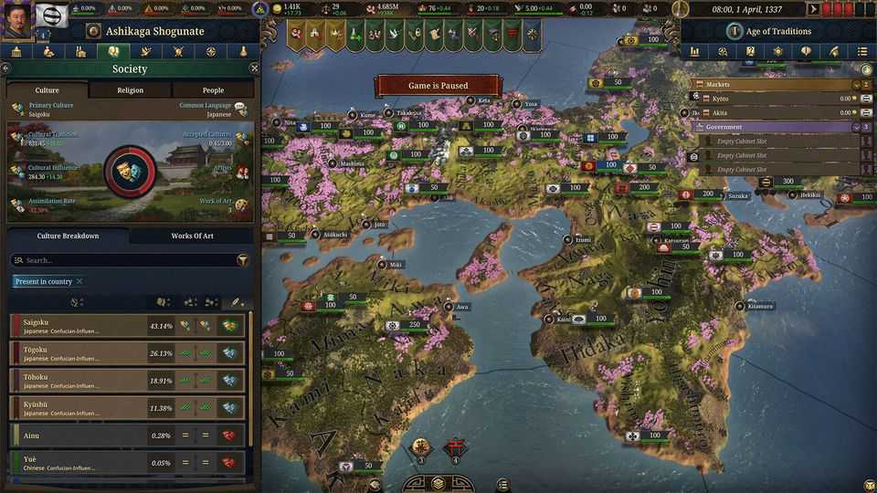
Other game-makers offer similar experiences. The Civilization games let players guide everyone from the Assyrians to the Prussians or the Vietnamese through six millennia of history, from the Stone Age to the space age. It has sold more than 70m copies since the first version in 1991. The more militarily focused Total War series invites players to take command of intricately simulated armies in historical periods from feudal Japan to Napoleonic Europe or Republican Rome.
The influence of such games goes beyond entertainment. In 2021 Nicholas Mulder, a historian at Cornell University, noted on Twitter that a new kind of student was turning up in his class on early-modern Europe; one whose interest had been explicitly sparked by Europa Universalis 4. “You’ll get at least a few in every class,” agrees Bret Devereaux, a historian at North Carolina State University. As he put it on his blog: teachers now encounter self-taught history buffs for whom “Paradox [games are] the historical mother tongue, and actual history is only a second language.”
The idea of simulating history in games is not new. Perhaps the best way to think of a game like Europa Universalis is as a fever-dream remix of Risk, a board game first published in 1957. But whereas board games have to have fairly simple rules, in a video game a machine keeps track of everything. That means those rules and systems can become very complex indeed.
Risk divides the world into a few dozen territories, and allows for up to six players. The map in eu5 features thousands of territories and hundreds of different polities, from tiddlers such as the Free Imperial City of Bremen to historical big cheeses such as the Byzantine Empire. The player chooses one; the computer controls the rest, but all are active participants in the game. The game keeps an eye on everything from armies and navies to a state’s administrative capacity, its diplomatic relations and its trade.
Playing for the first time can be bewildering. Players must conduct diplomacy with vassals and rivals, manage their economies, pacify peasant revolts and balance fractious interest groups. eu4, the previous game in the series, starts in 1444. Play as England and the decisions come thick and fast. Should the royals accept a marriage proposal from Leinster? Should you honour the Treaty of Tours (signed just before the game starts) and hand over Maine, a chunk of English territory in what is now France? Or will you go back on your word and risk reigniting the Hundred Years War? Will you grant a monopoly on the wool trade? And what to do about Scotland, your northern rival?
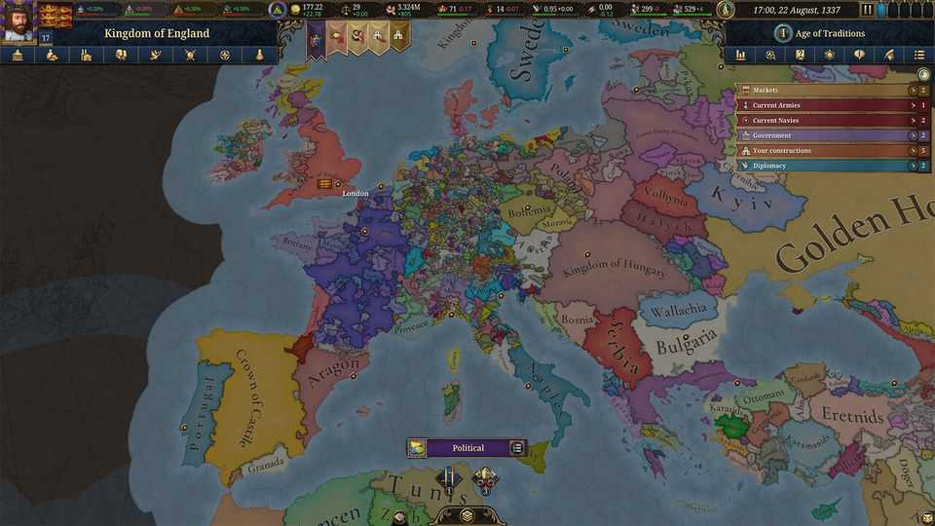
That means the games are practically certain to generate “alternate histories”, in which the world develops along a different path from the one it actually took. If England does manage to hang on to Maine in eu4, for instance, the country can be played as a land power rather than the maritime one it actually became. But doing so may also spark another war with France—albeit one that England can sometimes win. An ambitious Dai Viet player can turn the historical tables and conquer China. Academic historians are often sniffy about alternate history. But it can be a good way to get students thinking about the subject as more than a tedious list of events, says Jeremiah McCall, who teaches history at Cincinnati Country Day School and has written on the educational uses of games.
It is this freewheeling agency, adds Dr McCall, that makes games—especially those that lean towards simulation rather than linear narratives—a unique form of media. Reading about history is a passive experience. Play a game, and you have to get your hands dirty.
People will learn things while they are having fun, too, via something that Ian Bogost, a video-game critic, dubs “procedural rhetoric”—the ideas and assumptions that the rules and systems of a game smuggle, often unnoticed, into the player’s mind. An obvious one is a better knowledge of what the past looked like; that the Grand Duchy of Lithuania was a behemoth in its day, or that an unwise royal marriage risks giving foreign rulers a claim to your throne.
Another idea, more profound, is that history did not have to happen the way it did. Some of Paradox’s earlier games try to keep things trundling roughly along their historical tracks by forcing certain big events—the Manchu conquest of China, say, or the Reformation in Northern Europe—to happen mostly on schedule. But that “railroading”, as players call it, has diminished in later releases in favour of letting the simulation play out as it will.
Some of the lessons can be surprisingly sophisticated. Dr Devereaux has written about how Paradox’s games can teach players about a concept known in international relations as the “security dilemma”, without ever mentioning the phrase. The idea is that though economic growth is not a zero-sum game, security is. A state may beef up its own army because it is feeling insecure next to powerful neighbours. But that makes that country seem more threatening, prodding those next door to build bigger armies, too.
Dr Devereaux uses Burgundy in eu4 to illustrate the baleful consequences. It begins the game next to an expansionist France, with its territory dangerously split in two. To play Burgundy is to fret constantly about France’s intentions and your own precarious position. To safeguard your country, you need to become more powerful. Before the Industrial Revolution, when almost the entire economy is built on agriculture, the easiest way to do that is to acquire more land. That draws the player’s eye inexorably to the small statelets of the Holy Roman Empire to the east. “To avoid becoming a victim of France,” writes Dr Devereaux, “Burgundy effectively must victimise its own smaller neighbours.” But those neighbours face the same incentives, as you will discover if you play as them. It is one thing to read about the security dilemma in a textbook. It is another to experience it for yourself.
The strength of games like Europa Universalis—that they are simulations, with consistent rules—can also be a weakness. Savvy players can exploit the systems, and the unimaginative play of their computer opponents. And if a decision proves catastrophic, the player can always reload and avoid making it again, an option unavailable to real historical decision-makers.
But all forms of media are imperfect. Dissecting a game’s assumptions and flaws is good practice for doing the same to academic articles or historical sources. History is not in fashion today: science and engineering degrees are in the ascendancy. Something that makes history—or at least a gamified version of it—so alluring that students will voluntarily sink hundreds of hours into “is a huge positive” for the field, says Dr Devereaux. “No question about it.” ■
This article was downloaded by zlibrary from https://www.economist.com//christmas-specials/2025/12/18/what-if-the-best-way-to-learn-about-history-is-by-playing-with-it
Christmas Specials | Lewis, Clark and Pompey, too

How two explorers, a mother and a baby made America
The “great man” and “tiny infant” views of history

December 18th 2025

The urge to make America bigger is back. President Donald Trump wants to buy Greenland, 2m sq km of sparsely populated Danish territory. He wants it because it is rich in minerals, strategically located as the polar ice melts, and might fall into hostile hands (Russia’s or China’s, say) if not better defended.
So it is worth studying the last time America took over 2m sparsely populated, richly endowed, strategically located square kilometres. In 1803 President Thomas Jefferson pulled off the Louisiana Purchase, snapping up all the French territory in the middle of the continent, nearly doubling the size of the United States for a mere $7 ($150 in today’s money) per sq km.
Jefferson’s reasoning was similar to Mr Trump’s: that this vast, valuable tract would fall to a rival power if not absorbed by the United States. Russia was probing south from Alaska; Britain was doing the same from Canada. Spain ruled most of what is now the south-western US (see map).
But asserting control over French Louisiana was not simple. France had hardly governed any of it. The inhabitants were unaware that their hunting grounds now belonged to a state run by men in red waistcoats. And Jefferson, though a polymath with the largest personal library in America, knew almost nothing about the new territory. He imagined it home to mastodons, mountains of salt and a lost tribe of Israel.
Yearning to know more, he ordered his bright, resourceful secretary, Meriwether Lewis, to trek across it, mapping the land, scaling the mountains, befriending the natives and finding out whether a navigable waterway linked the Mississippi river to the Pacific.
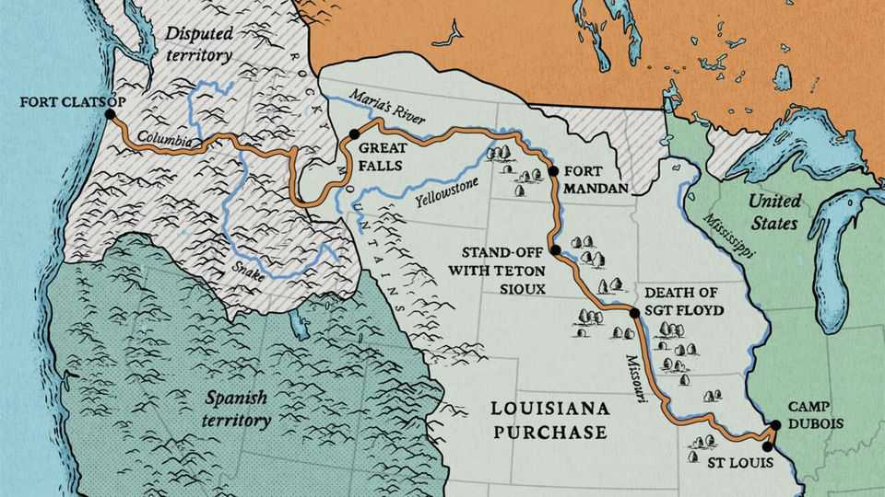
Lewis brought in his former comrade-in-arms, William Clark, as co-commander. The Lewis and Clark expedition yielded a cornucopia of discoveries that accelerated the westward expansion of the United States. It offers support for the “great man” view of history—and also for the less-known “small baby” view of history: had the expedition not included an infant, it might have ended in disaster. To find out why, read on.
The Economist retraced some of their steps, starting at Camp Dubois, near St Louis, where the Missouri river meets the Mississippi. Jefferson had given Lewis an unlimited letter of credit—surely the most generous travel expenses ever. Lewis recruited more than 40 men, mostly soldiers. Clark brought his slave, York.
Supplies included a compass, a theodolite and writing paper; beads and tobacco for gifts to Native Americans; opium for pain and “pewter penis syringes” for venereal diseases; and a hefty arsenal: swords, pikes, rifles and a swivel cannon mounted on a keelboat. A replica of that 55ft boat is now on display at Camp Dubois. Children are urged to think how to pack it.
On May 14th 1804 the Corps of Discovery set off. They knew the precise location of only three points along their route: the start, the destination at the mouth of the Columbia, and some villages of the Mandan tribe, near what is now Bismarck in North Dakota. The rest of the map, they would have to fill in.
Paddling upstream was famishing work. The men ate some four kilos of meat a day: deer and beaver in the woods, buffalo on the great plains. Discipline was maintained with military severity. Whisky was rationed, and all the men knew it would run out after 100 days or so. One night a sentry and his mate got furtively pickled. One was sentenced to 100 lashes; the other to 50. “We have always found [the men] verry ready to punish Such Crimes,” wrote Clark in his journal.
On August 20th Sergeant Charles Floyd died, probably of a burst appendix. He was the first American soldier to die west of the Mississippi. A towering obelisk in Sioux City, Iowa marks his grave.
The expedition met Native Americans for the first time near what is now Council Bluffs, Iowa. Lewis tried to impress the Oto tribe with a display of soldiers drilling and firing their rifles in unison. He then gave a long speech, addressing them as “children” and advising them that Jefferson was now their “great father”.
How much they understood is unclear. But one chief, Big Horse, who arrived naked to highlight his tribe’s poverty, complained that if they made peace with the other tribes, the young men would have no opportunities to loot. Several were unimpressed with gifts of beads, tobacco and certificates declaring the bearer a “friend and ally” of the United States. They would rather have whisky, said Big Horse.
“It never occurred to [Lewis] that his actions might be characterised as patronising, dictatorial, ridiculous, and highly dangerous,” writes Stephen Ambrose in “Undaunted Courage”, a magnificent history of the expedition. “[H]is idea of how to make them into allies was to give them worthless medals and wardrobe trappings rather than the guns and powder they needed… In general, it would be impossible to say which side was more ignorant of the other.” For many, though, “The desire for friendship overrode ignorance.”
An encounter in September 1804 with the Teton Sioux nearly turned calamitous. The interpreter was no good. Lewis’s “great white father” speech fell on uncomprehending ears. An offering of whisky made a chief belligerent. A tussle began. Lewis ordered his men to fall back and prepare to defend the boats. Sioux warriors pulled arrows from their quivers.
“Had Lewis cried ‘fire!’, and touched his lighted taper to the fuse of the swivel gun, the whole history of North America might have changed,” argues Ambrose. Volleys of musket balls would have mown down many Sioux. But there were hundreds of them, and they could reload fast. Lewis and Clark might have been killed on the spot. The expedition might have been aborted. The Sioux might have turned foe to America and ally to the British in the war of 1812, “perhaps strong enough to wrest Upper Louisiana away from the Americans and make it part of Canada”.
Fortunately for all, another Sioux leader, Black Buffalo, ordered his men to back down. After a tense couple of days of talks, the expedition was able to press on. “I am Verry unwelle for want of sleep,” Clark wrote.
They wintered in Fort Mandan, in what is now North Dakota. It was, in Ambrose’s memorable phrase, “sometimes so cold a man’s penis would freeze if he wasn’t quick about it”. They became friendly with the Mandan tribe. Very friendly, in fact. Not only did the Mandan supply them with corn, without which they might have starved; they also offered their wives.
The Mandan believed a man could gain another’s power if both had sex with the same woman. And they thought the whites very powerful. Most caught syphilis during the journey, though Lewis and Clark seem to have abstained. The afflicted were treated with mercury, which may later have hastened their deaths.
At Fort Mandan they hired a 17-year-old Shoshone woman, Sacagawea, as an interpreter, along with her French husband. In February 1805 Sacagawea gave birth to a boy, Jean Baptiste (nicknamed “Pompey”). Perhaps it was rash to take a baby on such a perilous journey, but they needed Sacagawea, so the baby came, too. This turned out to be a blessing. His presence reassured the tribes they met later that the heavily armed expedition was peaceful. For who, they reasoned, takes an infant on a war party? Without Pompey, the Corps might have been wiped out.
On April 15th they passed the farthest point upriver that any white man was known to have reached. Lewis ecstatically likened himself to Christopher Columbus. In June they had to carry their canoes arduously around the five Great Falls in what is now Montana. They thought that when they reached the continental divide—the edge of the Mississippi watershed—it would be a gentle paddle down to the Pacific. Far from it. At Lemhi Pass, on what is now the border between Montana and Idaho, Lewis saw “immence ranges” of snow-capped mountains stretching far into the West.
Then they met Sacagawea’s tribe. And—a stroke of luck—Sacagawea recognised the Shoshone chief as her long-lost brother. (She had been kidnapped at 12 by the Hidatsa.) The Shoshone promised to help, selling the Corps horses and suggesting a route.
Next came the hardest part of the entire journey—a 260km slog over the rugged Rockies, shuffling through snow and carrying a baby. Clark complained of the “rockey hill Sides where our horses were in [constant] danger of Slipping to Ther certain destruction”. By the time they reached a Nez Percé village on September 22nd, they were shivering, starving and dysentery-racked. Ambrose calls it “one of the great forced marches in American history”.
It would have been easy for the Nez Percé to kill their sickly guests and steal their arsenal, but they resisted this powerful temptation. When the Corps had recovered, they made dugout canoes and paddled downstream. On November 7th, as the fog lifted over the Columbus river, a great cheer went up. “Ocian in view! O! the joy,” wrote Clark. They had travelled 6,666km from the mouth of the Missouri.
They had to decide where to spend the winter. On the north side of the river, in what is now Washington state, where the local Chinook kept stealing their things? Or on the south side, in what is now Oregon, where the friendlier Clatsop tribe told them elk were plentiful? They put it to a vote. Sacagawea and York joined in, making it the first time that a woman or a black slave had voted in America.
They chose the south side, and built Fort Clatsop. A reconstruction now gives visitors a feel for their cramped, Spartan quarters—and for the majesty of the surrounding forest. A long hike leads to the beach where they found a dead whale, which “resembled the beaver or the dog in flavour”. Lewis ventured a rare joke about it, contrasting his good fortune in swallowing it with that of Jonah being swallowed.
Lewis and Clark’s journals and maps caused a sensation. Jefferson devoured them and ordered them published. They gave priceless, detailed guidance to the vast numbers of Americans who followed them westwards, on everything from farming to defence. The soil of the great plains was “fertile in the extreem”, Lewis wrote, though there was not enough timber. He noted rapids that might make water-works, and good spots to place garrisons to keep out the British.
It is hard to exaggerate their contribution to science, too. They identified 122 species of animal, from coyotes to prairie dogs, and at least 178 plants. On one day they recorded two new species, the pronghorn and the white-tailed jackrabbit. At first they discounted Native American descriptions of the size and ferocity of grizzly bears. Then they met some. Of one specimen, Lewis noted that it was “extreemly hard to kill notwithstanding he had five balls through his lungs”.
They also described native customs in unprecedented detail (and with some priggishness). Lewis tut-tutted that the Chinook and Clatsop went naked from the waist down. Yet he conceded this made sense, since they were in and out of canoes all day. He frowned that they would “prostitute their wives...for a fishing hook”; yet noticed that they paid more heed to women’s opinions than other nations did. Though he was naively optimistic about prospects for the natives’ peaceful absorption into the United States, he faithfully reported facts that undercut his narrative, such as that many tribes selected chiefs for their courage. As one young brave put it to him, if they made peace, what would they do for chiefs?
The Corps of Discovery are remembered as an exceptional crew. Yet the towering figure in the story is Jefferson. He had the inspiration to buy Louisiana from a France that couldn’t defend it. He understood the value of trade, and the strategic importance of rivers in binding together a country without trains or trucks. He pressed a reluctant Congress to fund research that helped turn America into a transcontinental power. He personally taught Lewis essential skills in botany, astronomy and navigation. He was, as Ambrose puts it, a “man of facts”. Unlike his most recent successor, he yearned to learn about the lands he sought to rule. He had grave faults, such as owning more than 600 slaves. But he was a visionary.
He was badly mistaken in thinking that the march of settlers could be controlled, and war with the Native Americans avoided. In fact, “No force on earth could stop the flow of American pioneers westward,” writes Ambrose. “Good cheap land was a magnet that reached all the way back to Europe.” Jefferson ensured that the pioneers remained, or became, American.
For some of the Corps, the story ended tragically. Lewis, an alcoholic, may have killed himself. York, having contributed heroically to the mission, asked for his freedom. Clark, disgracefully, said no. Pompey grew up to be a successful explorer.
Today, hordes of Americans visit landmarks on the Lewis and Clark trail, which crosses 16 states. Some dress up as members of the Corps and re-enact their adventures, albeit with the safety-net of credit cards and antibiotics. Larry Boschen, a retired boilermaker who played the doomed Sergeant Floyd during a re-enactment, points out the crucial difference. “We knew where we were going. They didn’t.” ■
This article was downloaded by zlibrary from https://www.economist.com//interactive/christmas-specials/2025/12/18/how-two-explorers-a-mother-and-a-baby-made-america
Christmas Specials | The feeding of the 7,600

The titanic task of catering on the world’s biggest cruise ship
How to spend $1.5m on ingredients

December 18th 2025

As you sweat over your Christmas dinner for a mere 12 or even 20 guests, spare a thought for Gary Thomas. When he stands in the dining room of his restaurant at 1pm, all is quiet. Come 7pm it will be heaving. Around him are tables laid for 500. Those tables will be turned three times over the course of the evening. And the restaurant has two more floors. Chef Gary says almost 6,000 people will dine in under two and a half hours. This is not his only concern; he has 25 other restaurants under his command. By the final wipedown, his 344 chefs and 1,700 front-of-house staff and pot-washers will have prepared, served and cleared up 100,000 meals over the course of the day. And they will have done it all while floating over the azure waters of the Caribbean, aboard the Star of the Seas, the largest cruise ship in history.
Chef Gary has been working on cruise ships for nearly 17 years. He is now in charge of catering for Royal Caribbean, one of the largest cruise companies in the world. He oversees thousands of culinary professionals over a fleet of 29 ships and two private resorts. Those vessels have been getting bigger and bigger. Chef Gary has commanded catering operations on vessels that were each, at the time, the largest cruise ship in the world. The Star of the Seas is his 16th. At full capacity it can carry around 7,600 guests and 2,350 crew. It is longer than the Eiffel Tower is tall. It boasts more than 20 decks, seven swimming pools, an ice rink and the world’s largest water park at sea. It weighs 250,000 tonnes (almost five Titanics). Officially, it is powered by liquid nitrogen gas. In reality what keeps the ship going, and the passengers satisfied, are the vast quantities of food produced by Chef Gary and his battalions of catering staff.
A cruise ship is not an aeroplane; there are no reheated ready meals. The meat is butchered, the fish filleted, the bread baked, the potatoes chipped, the meringues beaten, the eggs fried, all aboard a ship pitching over the waves. “The only thing we don’t have is a live cattle farm,” grins Chef Gary. “But never say never.” It requires a dizzying degree of preparation, the keenest eye for detail and military discipline.
To understand Chef Gary’s operations, start not in the main dining room, or even one of the gargantuan walk-in fridges, but rather in 19th-century France, with the godfather of the modern restaurant kitchen: Auguste Escoffier. Born in 1846 to a poor family in Villeneuve-Loubet, in the south of France, Escoffier was sent to work in a professional kitchen at the age of 13. It was a world away from the gleaming calm of the kitchens on the Star of the Seas. The kitchens of the 19th century were full of noise, chaos and drunks. Fights broke out regularly. Escoffier was bullied mercilessly, shoved aside by other chefs to get to the stoves they needed to cook on.
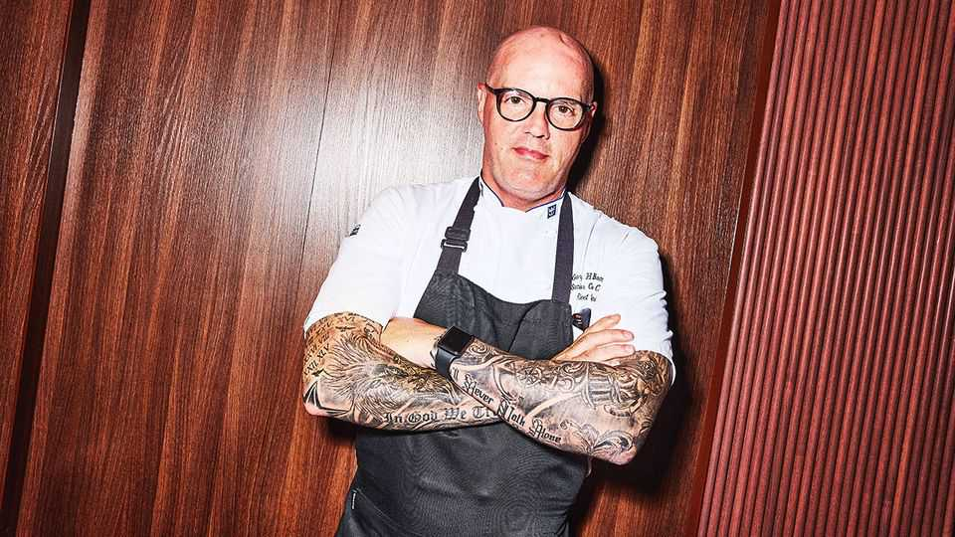
Then he joined the army. The experience was transformational, for Escoffier and the world of professional cooking. Inspired by the army’s discipline and hierarchy, he remade the restaurant kitchen. He forbade chefs from drinking and instructed them to keep quiet. Chef Gary is cut from the same cloth. Signs banning talking abound in his kitchens.
Until Escoffier, chefs had been responsible for entire meals, cooking everything served on a plate. Instead Escoffier put chefs in charge of individual components of a dish. A senior chef would then assemble the plate of food. In this Escoffier anticipated two other principles embraced by industrialists in the 19th century—specialisation and the division of labour.
All of Escoffier’s principles go into making a day’s meals on the Star of the Seas. Preparation starts long before the thousands of diners sit down to eat. At 6am the main deck is eerily empty. The restaurants here have yet to open and the only people out are staff polishing surfaces (and the odd travel influencer trying to capture a selfie for TikTok).
The sun is rising over the Caribbean, with clouds the colour and texture of candy floss. Take a lift down several floors and you reach the crew-only decks. Randy Nicolas, the ship’s inventory manager, stands waiting. His hair is neatly parted and he sports a pressed white uniform that is only slightly whiter than his teeth when he beams his kind smile, which is often. Everything starts here, with Randy.
The lift opens on to a corridor affectionately known as the i-95, an American highway that stretches for over 1,900 miles (3,100km) from Maine to Florida. It runs the full length of the ship, over 300 metres. Randy’s job is to ensure that at no point do the chefs on board run out of anything needed for those 100,000 meals a day (there may be only 10,000-odd people on board but passengers eat many more “meals” than humans usually consume in 24 hours. A running joke in the cruise-ship industry is that passengers gain a pound a day). He is in charge of 25,000 line items including 15,000 lobster tails and 400 tonnes of bottled water. Unsurprisingly, Randy loves a spreadsheet. The ingredients for a weeklong cruise cost $1.5m, and some sailings are twice that long.
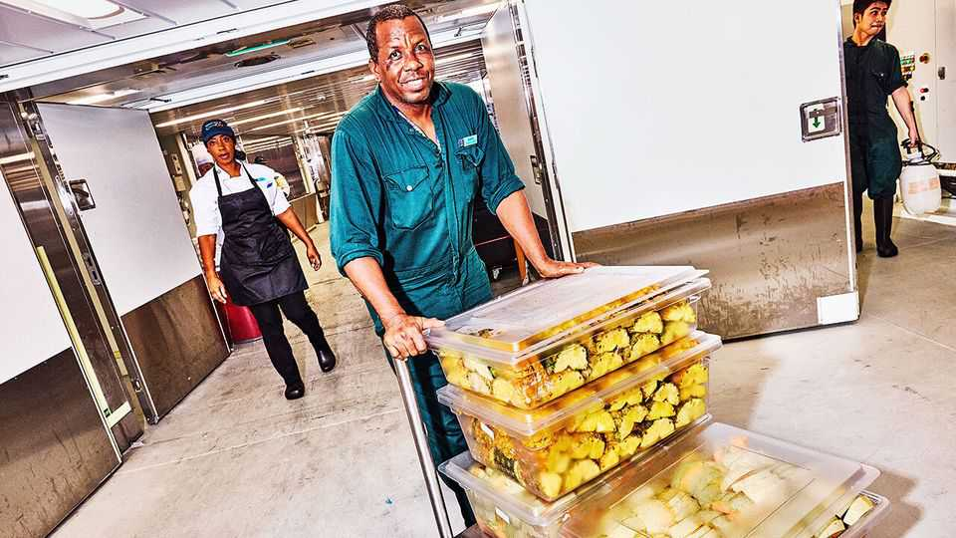
On any given day, the chefs serve 6,800kg (15,000lbs) of protein; there are chickens to debone, spatchcock and grill; lamb to french-trim, roast or braise; salmon to pin-bone; sea bass to fillet; tuna to skin; prawns to devein and pop out of their shells. This cornucopia is stored in numerous walk-in fridges and freezers that branch off i-95. The largest, the fish freezer, is 210 square metres, or about five times the size of the average London flat. The dry store holds two tonnes of sugar in 20kg-sacks stacked nearly two metres (six feet) high, and almost four tonnes of rice. Multiple chiller rooms are devoted to milk in various stages of churn: single cream, double cream, whipping cream, butter, ice-cream.
All are spotlessly clean. Chef Gary frets not just about running out of food but even more anxiously about the safety of everything he serves. A norovirus outbreak can destroy a cruise. This spring the Queen Mary 2, another luxury cruise ship, saw 266 passengers fall ill on a four-week cruise around the Caribbean. The worst case for Royal Caribbean was back in 2014, on the Explorer of the Seas, when 630 passengers fell ill, as well as 54 crew. That’s why the kitchens are immaculate—as clean as any hospital, boasts Chef Gary.
Randy knows exactly what is in each one of them. “I always say that the captain is the brain of the ship. The chief engineer is the heart of the ship. We are the blood,” he grins. Chefs order from Randy like home cooks do from supermarkets. They use software called Crunchtime to monitor how much of each ingredient is being used at any one time by the various restaurants on board. Randy then can use the program to tweak his orders for future sailings.
For a Caribbean cruise he has to put his orders in three weeks in advance; ships travelling to Europe require ten weeks’ notice. Randy is an ingredients oracle, parsing previous orders and the demographic make-up of passengers to determine what is needed. “Americans want burgers and fries; Europeans want pasta and a wider variety of vegetables.” More children means even more burgers and fries: pity the poor chef peeling potatoes if a lot of American children are due on board. He keeps abreast of the ever more detailed dietary requirements that guests are asked to log when they book their cruise; is there an unexpected glut of gluten-free buffet-warriors? A surfeit of vegans? Randy adjusts accordingly.
Crunchtime takes another of Escoffier’s innovations, mise-en-place, and turbocharges it. Mise-en-place literally means “putting in place”. In a kitchen, at its most basic, it involves a careful calculation of what chefs work out they need to have ready for service and charting the most efficient course to get it all in place. When Chef Gary was rising through the ranks he prepared his mise-en-place intuitively. Now Crunchtime makes those predictions, using artificial intelligence, historical data and information that the staff enter daily: “It can tell us, for example, for tonight, we need 1,422 portions of calamari,” Randy explains.
This kind of precision matters not only because keeping hungry cruise-goers happy is essential, but also because, overwhelmingly, what sinks restaurants is their razor-thin margins. This is even more challenging when considered at cruise-ship scale; in 2023 the top three cruise lines spent $2.5bn on ingredients alone. Consistently over-ordering is a recipe for a stomach-churning level of waste.
Wastage nonetheless remains a problem on board. The nature of seafaring buffets makes it inevitable. All-you-can-eat seafarers are rarely content with just one dessert; but if someone loads up on two or three puddings, they are unlikely to finish them all. And food served as part of the buffets can be exposed for only three hours before it has to be disposed of for reasons of health and safety. The excess food is ground to a pulp. Some is thrown into the ocean; some is incinerated. Enough waste is torched to help generate the power for the water-park on the top deck, which features slides that skim passengers over the side of the ship and back up again.
There are three loading bays along the i-95; the ship docks parallel to piers so more off-ramps means quicker loading and unloading. At 6.30am the Star of the Seas has just made landfall at Royal Caribbean’s private island for its customers, “Perfect Day at CocoCay”. The island’s white sandy beaches and garish water-park stand out against the sky, washed the colour of a candy beetroot as the sun peeks over the horizon.
Work must start immediately. “What they say is, early is on time. On time is late. And late is unacceptable,” Randy stresses. Today he and his team are unloading food. But this is also where Randy picks up ingredients for on-board consumption. On loading days the pressure is even greater. If the ship is not stocked on time, its departure could be delayed. That either means burning through more fuel to make up time reaching the next destination, or it means thousands of passengers missing the activities they have booked at specific times at their next stop.
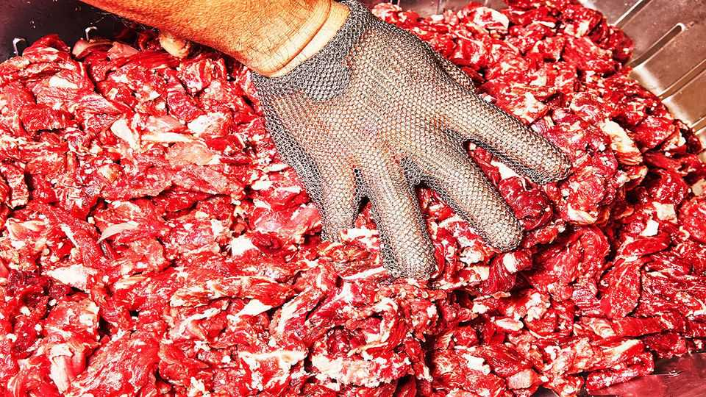
That is why scores of pallets of food have already been prepped, labelled and divided into sealed containers, ready to be taken by forklifts onto the island to stock the restaurants there. The working conditions for chefs and crew throughout a voyage are strenuous at the best of times.
They work seven days a week for the entire length of their contracts, which sometimes last as long as eight months. The chefs are usually from emerging markets such as the Philippines, Indonesia, India and South Africa. They are paid far less than the American minimum wage, and have no access to the luxury amenities enjoyed by paying passengers. Stops at the private island can be especially taxing for them. Almost all of the food served there is prepared on the ship the night before, so the chefs and crew have been working through the night for this moment.
As passengers are disgorged onto the island throughout the day, a new shift of chefs is busily preparing for their return that evening. Chef Gary is doing the rounds, checking that each of his kitchens is up to scratch. Later that evening your correspondent will stand in the middle of the buffet, admiring the watermelons intricately carved into lotus flowers, the grill chef expertly cooking 30 steaks at a time, and the sunburnt revellers crowding around the serving platters, stacking their plates ever higher. They have no idea how much work went into making all this food. Your correspondent appreciates their toil; but even more so, he appreciates how good the meal is. He makes sure none of it is left to waste. ■
This article was downloaded by zlibrary from https://www.economist.com//interactive/christmas-specials/2025/12/18/the-titanic-task-of-catering-on-cruise-ships
Christmas Specials | Your flexible friend

How wolves became dogs
The strange symbiosis between two hyper-predators: humans and hounds

December 18th 2025

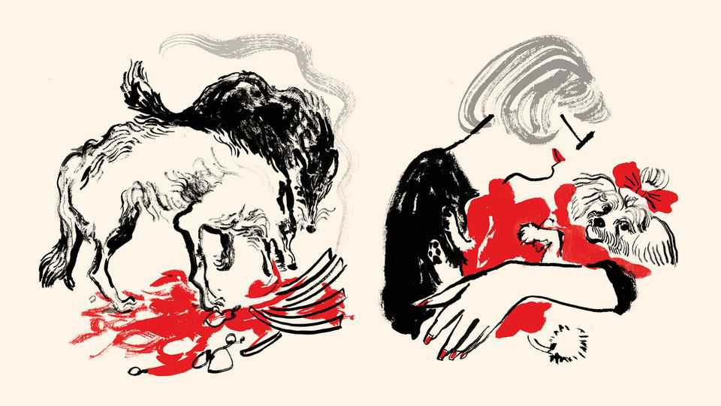
Who said it first, no one knows. But Frederick the Great, warrior ruler and enlightened despot of 18th-century Prussia, said it well. “The only, absolute and best friend a man has, in this selfish world, the only one that will not betray or deny him, is his dog.”
Relations between dogs and people are so normal and pervasive as to pass almost unregarded. Yet viewed objectively, this affiliation is among the most peculiar in the animal kingdom. Somehow, the descendants of a large and dangerous predator, the grey wolf, have integrated themselves into human society in a manner unmatched by any other species.
Domesticated animals abound, but most exist only to serve. Cattle, sheep, goats, buffalo, yaks, horses, asses, pigs, ducks, geese and chickens yield food, transport or materials. Cats, it is true, have inveigled their way into people’s dwellings, where they provide a certain level of companionship beyond their working role as mousers. But dogs are different. They are true and trusted friends, even those that are also servants.
Moreover, such servants—sled dogs, sheep dogs, hunting dogs, guide dogs—are skilled operatives, not mere drudges. They collaborate in a sophisticated and willing manner with their masters and mistresses in ways no other domesticated animals can manage. How this strange symbiosis came about is now being pieced together. Clues come from disciplines ranging from genetics and psychology to archaeology and anatomy, and places as far apart as China, Germany, Alaska and Australia. One of the most telling facts, however, is just how far back the relationship between dogs and people goes.
Sheep, goats, cattle and pigs were all domesticated between 11,000 and 9,000 years ago, during the transition to agriculture—and cats, according to recent research, a mere 4,000 years ago. Dogs stretch back much further. A burial at Bonn-Oberkassel in Germany, of a young dog alongside two humans, is more than 14,000 years old—a time when Homo sapiens was still a hunter and a gatherer. Genetic evidence suggests pre-Columbian American dogs shared an ancestor that lived 23,000 years ago. And a few ambiguous fossils, which some interpret as dogs and others as wolves, are older still than this.
Much of the evidence, both modern and fossil, points to the eastern end of the Eurasian land mass—either China or Siberia—as the place where the switch from wild wolf to domestic dog occurred. It is also possible that another domestication happened farther west, with its descendants subsequently subsumed into the wider canine population which flooded out of its Asian homeland alongside its human companions. For, once dogs had teamed up with humans, they spread rapidly throughout the rest of the world.
They arrived in North America about 15,000 years ago, crossing from Siberia to Alaska, and spreading thence as far as Patagonia. A South-East Asian clade gave rise to distinctive groups such as the singing dogs of New Guinea, which yodel rather than bark, and the dingoes of Australia. And in Europe and the Middle East, the close relations between dogs and humans are reflected in joint burials like that in Bonn-Oberkassel.
None of that, however, answers the question of what prompted the strange symbiosis between canines and humans in the first place. In fact, that is two questions. One is ecological and behavioural: how did wolf and human societies mesh together so that dogs were the outcome? The other is genetic: what changes happened to wolves to turn them into dogs?
Wolves are, in many ways, ideally suited to get along with people. They are sociable, collaborative and respect authority. They also live in small groups, rather like humans in their hunting-and-gathering days. But by themselves, these “pre-adaptations” are not enough. To stimulate the evolution of the behavioural toolkit which allows dogs to thrive in proximity to people would have required something else. That something was probably food.
One explanation for how wolves became dogs, proposed in 2001 by Raymond and Lorna Coppinger, two American biologists, is thus the scavenger hypothesis. The Coppingers studied feral dogs around the world, realised that most of them make their livings by scavenging from refuse tips near human settlements, suggested that this way of life is, in fact, the one to which dogs have been tailored by evolution (a point backed up by estimates that half or more of the 700m dogs on the planet live this way, rather than sharing dwellings and social relations with humans), and proposed that such behaviour was thus the driving force behind canids and people getting together.
It is an attractive idea, with dogs cast, from the human point of view, as useful four-legged garbage-disposal units. The problem is that settlements of the sort which accumulate refuse dumps are manifestations of agriculture. Hunter-gatherer camps tend not to develop middens. But the idea that edible matter surplus to human needs was the force behind dog domestication has not gone away. Maria Lahtinen of the University of Helsinki has devised a different version of it. She thinks hunter-gatherers in ice-age Eurasia might, indeed, have accumulated surplus food from which wolves could have benefited.
Dr Lahtinen’s crucial observation is that, unlike carnivorous wolves, omnivorous humans cannot live on protein alone. Their bodies cannot cope with the quantities of nitrogenous waste products, such as urea and ammonia, that would be generated if they extracted all the calories they need from the chemicals of which proteins are made. They therefore require carbohydrates or fats as well. But both of these would be scarce in ice-age winters, since plants would have died in the cold and animals’ fat reserves would be depleted. To get enough fat, in particular, would involve killing more game than would otherwise be required. The discarded lean meat might then be consumed by wolves tame enough to exploit it.
The main alternative to the food-driven route to domestication is the idea that people simply kidnapped wolf pups and adopted them, perhaps as playthings for children or to act, when they had grown to adulthood, as hunting companions. This cannot be discounted, but it seems less plausible. Wolf cubs taken immediately after birth can be tamed, but it requires weeks of hard work and constant attention. And for the genetic changes involved in domestication to occur, such animals would then have to be bred, with the tamest retained and the others disposed of.
It seems simpler, and thus more plausible, that good-old Darwinian natural selection did the job, with one particular population of wolves gradually developing the nous needed to get along with their new human friends—a process dubbed “survival of the friendliest” by Brian Hare of Duke University, in North Carolina. And dogs do, indeed, seem to display a whole suite of psychological adaptations best explained by the idea that the niche they are adapting to is human approval. Dr Hare, founder of the Duke Canine Cognition Centre, calls this skill-set “dognition”.
Some dognition-promoting differences between wolves and their domesticated descendants manifest early on. Experiments by Kathryn Lord of the Broad Institute in Cambridge, Massachusetts, show that, in contrast to the weeks involved in taming a wolf, a dog pup requires only about 90 minutes of human attention to learn the knack of getting on with people.
Dr Lord is now looking, with the assistance of some wolf-dog hybrids, for the genetic changes which underlie this ability. And other work has already identified one plausible candidate—a pair of neighbouring genes lost in the transition from wolf to dog which, if missing in humans, cause a disorder called Williams-Beuren syndrome. This results in characteristic anatomical changes and mild-to-moderate cognitive disability, but it also promotes extreme friendliness.
Besides being friendly, dogs have evolved as well to be good at reading human minds. Work by the Clever Dog Lab in Vienna suggests they can correctly ascribe motive and knowledge to humans in experiments involving the presence and location of food. They will approach crying strangers (or, at least, strangers pretending to cry for the purposes of the experiment), and their levels of cortisol, a stress hormone, rise when they hear a recording of a baby crying. Experiments which compare dogs’ reactions with those of miniature pigs kept as household pets suggest these sorts of responses are dog-specific, rather than a result of exposure to people making a non-human animal familiar with human ways.
Perhaps most intriguingly of all, that ultimate behavioural hack of human emotion, the puppy-dog-eye look, is a feature specific to dogs. To pull it off, they have evolved a special face muscle, which wolves lack. This lets them raise their eyebrows to make their eyes appear larger and more infant-like, and also more similar to a human expression of sadness.
Understanding how all these changes came about is a work in progress. A much-cited Russian experiment to breed tameness into foxes on a fur farm caused excitement some years ago by suggesting selective breeding could do this in ten generations, and also that a side-effect was physical changes in the animals reminiscent of those (including short muzzles, mottled coats and curly tails) which often distinguish dogs from wolves. However the relevance of this experiment to how rapidly these changes happen has been called into question by Greger Larson of Oxford University, who discovered that the animals used traced their ancestry back to a Canadian fur farm which had tried something similar in the 19th century, and presumably thus carried the genetic consequences of this earlier attempt when the experiment began.
However domestication originally came about, though, a deliberate hand on the tiller of dog evolution is soon detectable, as humans sought to benefit from their new companions. Zhokhov island, off the coast of Siberia, for example, has yielded 9,500-year-old dog remains which are genetically akin to modern Greenland sled dogs and are buried alongside what look like dog sleds. Hunting dogs are similarly ancient. Carvings on cliffs in Saudi Arabia, thought to be between 8,000 and 9,000 years old, depict them.
This corresponds with the time when, according to a paper published in November by Dr Larson and his colleagues, dogs’ skull sizes were shrinking compared with those of their lupine ancestors, and the shapes of their skulls were becoming more variable, paving the way for the diversity of modern breeds.
Time brought more specialisation to the working dog. Terriers controlled rats and flushed rabbits from their burrows. Mastiffs guarded property and were let slip as dogs of war. Gun dogs returned game after the invention of firearms. And, more disturbing to modern sensibilities, bulldogs baited bulls for the entertainment of punters.
Keeping dogs as pets, rather than as working animals, was, however, largely an aristocratic indulgence. As befits a warrior king Frederick the Great’s penchant was for Italian greyhounds, thoroughbred versions of a hunting lineage which evidence from Egypt suggests go back at least 4,000 years. A century earlier, Charles II of England had a thing for toy spaniels, the modern versions of which bear his name. And a century before that Mary, Queen of Scots, was accompanied to her execution by her Skye terrier. Chinese royalty, meanwhile, favoured the small dogs known in English-speaking countries as Pekinese.
It was the rise of the middle classes which changed this. More people could afford the indulgence of an animal that was a non-working companion. And boy, did they indulge. The first British dog show happened in 1859, as animal breeders stirred the planet’s canine gene pool to come up with new versions of old models. The result, so far, is the 225 breeds now recognised by the Royal Kennel Club, Britain’s (and the world’s) oldest association for dog owners.
Sometimes, the results have been grotesque. Dalmatians owe their spots to genes associated with a urinary disease. Dachshunds, corgis and other short-legged breeds are achondroplasic—meaning that they have bred into them a mutation which, in humans, causes a form of dwarfism. And several breeds, such as boxers and modern bulldogs, have had flat faces and other cranial distortions imposed which can affect their breathing and teeth, and also (because their facial skin is often folded) cause skin infections.
But working dogs, too, have continued to proliferate—most notably with the introduction, in 1916, of guide dogs for blind people, and in the 1970s of hearing dogs for the deaf. These assistance dogs have also now been joined by therapy dogs, trained to provide comfort to people in places such as hospitals and hospices, and thus make use of the mutual psychological understanding that makes dogs.
Pet dogs are proliferating, too. Half of American households (65m of them) include a dog, and dog food is a multi-billion-dollar industry. The best friendship in zoology shows little sign of coming to an end. ■
This article was downloaded by zlibrary from https://www.economist.com//christmas-specials/2025/12/18/how-wolves-became-dogs
Christmas Specials | The Black Stream

A journey along East Asia’s hidden artery
How a mighty ocean current shapes societies

December 18th 2025

THE TOWN of Kuroshio in Japan is named after the swift ocean current that flows nearby. The Kuroshio (Black Stream) stretches as wide as a megacity and carries more water than the Amazon river. Kobayashi Eiji moved to the town three years ago to fish for skipjack tuna, which locals grill over piles of burning straw. “When I first entered the Kuroshio, it was like a rapid river, my boat was immediately carried away,” he says. “And it’s truly black.”
A hidden artery running through East Asia, the Kuroshio has shaped life along its path for millennia. It gathers strength east of the Philippines, courses northward past Taiwan, swerves along the Ryukyu islands and bifurcates around Japan. It transports nutrients, sustains fisheries and transforms societies. Like its Atlantic cousin, the Gulf Stream, it carries tropical heat northward, helping to keep the region habitable.
The Black Stream is a metaphor, too. It encourages people to see the region as an interconnected system, rather than as a patchwork of countries, argues Jonas Rüegg, a historian at the University of Zurich. People, goods and ideas flow, like the current, back and forth.
On most maps, oceans appear static. They are anything but. The winds that howl across them, the “Coriolis effect” from the Earth’s rotation and the pressure gradients formed by the subtle slope of the water’s surface combine to create currents like the Black Stream. Engineers hope one day to harness their awesome power with underwater turbines.
Currents, like rivers, follow regular paths, but can meander, shift and spin off into smaller eddies, like “cream in coffee”, says Nagai Takeyoshi of the Tokyo University of Marine Science and Technology. Currents also move vertically, as if along an invisible undersea spiral staircase. The underwater landscape of sea floors and continental shelves pushes swells of water up and down. If static, the ocean’s heavier, more nutrient-rich layers would sink and separate “like miso soup”, Mr Nagai continues. When stirred, the layers mix, bringing nutrients to the surface.
To trace the Kuroshio’s circulation, begin in Manila, circa 1565. Spanish sailors realised they could catch a ride along the current from their colonies in the Philippines to those in Mexico. Evading typhoons and pirates, they ferried silks and spices, silver and gold, gemstones and slaves. An early example of globalisation, this underpinned the expansion of the Spanish empire, says Danilo Gerona of Partido State University in the Philippines. It also taught early lessons in microeconomics: one shipment of 1,000 white cotton shirts from the Philippines in 1792 found no buyers in Acapulco, as they were too small for people there.
The Black Stream gathers strength as it flows between the Philippines and Taiwan. American forces sank dozens of Japanese ships there during the second world war; the current carried the bodies to Taiwanese beaches. Control of these waters might be crucial in a future conflict over the self-governing island. Knowledge of currents helps submarines move undetected. China’s armed forces have studied the Kuroshio; Japan’s have named a submarine after it.
The Black Stream’s darkness comes, paradoxically, from its clarity. A dearth of plankton and sediment at the surface means the water absorbs most light, rather than scattering it. Another paradox, says Saito Hiroaki of the University of Tokyo, is that such seemingly impoverished waters sustain rich fisheries. The prevailing hypothesis holds that regular upwelling from deeper, nutrient-rich layers plays a big role, but the process is not yet fully understood.
On Orchid Island, off the south-east coast of Taiwan, the indigenous Tao people have a deeper knowledge of the ocean than most. “The Kuroshio, the ocean, the typhoon, the flying fish—they shaped my tribe,” says Syaman Rapongan, the modern-day bard of the Tao. Their culture revolves around flying fish and the elaborate wooden boats used to catch them. The Tao divide the year into three seasons: rayon (the flying fish season), teyteyka (the end of the flying fish season), and amiyan (the waiting for flying fish season). The native language has no cardinal directions, only out to sea and returning to shore.
One day early this amiyan, Sinan Matopos prepared for a ceremony to celebrate her family’s new boat. Her husband, Syaman Matopos, had harvested and carved the wood himself, whispering to the trees to ask them to start new lives as part of his vessel. As always, he painted a set of eyes on the front of the boat, to help find the way home.
Si Matopos, the eldest son, had returned for the ceremony from Taipei, where he is studying at university. His friends from the mainland see the ocean differently, he reflects: it “is strange and dangerous for them”. But for the Tao, “the ocean is just like a human: it can be happy or sad, it can get upset with you, it can give you gifts and it can give you warnings.”
Under Taiwan’s dictatorship in the 1970s and 80s, the government dumped nuclear waste on Orchid Island. These days Taiwan’s current ruling party, the independence-minded Democratic Progressive Party, is keen to promote indigenous culture. Waves of migration from China to Taiwan have helped shape the dominant narrative of Taiwanese culture as an extension of Han Chinese culture—a story that China uses to buttress its claims to its democratic neighbour. Indigenous history offers an alternative tale.
In Taitung, a ferry ride from Orchid Island, scholars at the National Museum of Prehistory position Taiwan as a central maritime hub, rather than an appendage of the mainland. In this telling, the currents emerge as crucial byways for exchange and migration, stretching back tens of thousands of years. Taiwan’s indigenous groups are believed to have fanned out into the south Pacific, forming an arc of Austronesian peoples through the Philippines and Indonesia. “From an island perspective, the ocean is the pathway,” says Fang Chun-wei, a museum official.
Ancient humans from the coast near Taitung may have been the first to settle the Ryukyu islands, which stretch along the Black Stream for 1,100km between Taiwan and Kyushu, the southernmost of Japan’s main islands. Yanagita Kunio, a folklorist, suspected as much after coming across a coconut shell on a central Japanese beach and wondering about the currents that carried it there. In “The Maritime Path”, a book published in 1952, he traced Japan’s cultural roots back along the waters of the Kuroshio.
Such theories have found scientific backing. The earliest traces of Homo sapiens on the Ryukyu islands date to the Palaeolithic era, some 30,000 years ago, more recent than the oldest specimens on Taiwan itself. Without a land bridge, the first settlers must have come by sea, across the Kuroshio. Kaifu Yousuke, an archaeologist at the University of Tokyo, assembled an interdisciplinary group of researchers and boat-builders to investigate this ancient migration. Computer simulations helped determine that the settlers could not have drifted over accidentally. Using only the stone tools that would have been available at the time, the team built a dug-out canoe to test the waters themselves. Four men and one woman set off from Taiwan’s east coast one hot day in the summer of 2019. After more than 45 hours of paddling, they reached Yonaguni, Japan’s westernmost territory. (Unlike their ancestors, they had to have their passports stamped.)
Having determined that the perilous crossing was possible, another question arose: why undertake it? If the voyagers needed to escape a conflict, they could have hidden in forests. Mr Kaifu argues the trip was instead an early instance of the “innovation mindset”. Yonaguni, like the moon, could be seen on the horizon, and people wanted to explore it. “This was their Apollo project,” says Mr Kaifu. “They sought new frontiers.”
Tens of thousands of years later, modern Japanese looked over the Black Stream with similar zeal. As Mr Rüegg describes in “The Kuroshio Frontier”, Japan’s empire ran through the current, with the search for resources at sea driving its expansion. The Pacific basin where the Kuroshio empties became the world’s most prolific whaling region in the 19th century, the “Japan Ground” of Moby Dick fame. In the early 20th century one baron built Japan’s first industrial tuna fishery on the remote outposts now known as the Senkaku, the source of a present-day territorial dispute with China. By the 1940s the imperial Navy sang of conquering the current: “We once stood in awe of the vast Pacific’s Kuroshio, the day has come on which, our blood boiling with ambition, we celebrate its crossing.”
Shared cultural touchstones extend along the Ryukyu chain and into the strait between Japan and the Korean peninsula, where the Kuroshio branches into the Tsushima current. On Jeju, a Korean island, a recent art show focused on the current. Exhibits explored migrating fauna and floating rubbish, common religious sensibilities and recurrent basket-weaving techniques. The islands of the Kuroshio region are home to “cultures that use the current as their medium”, explains Lee Jong-hoo, the show’s director.
These islands also “share a lot of wounds from the colonial past”, as the sites of ideological and great-power competition, Mr Lee continues. One project imagined the Kuroshio as an invisible thread connecting Jeju and Taiwan’s Green Island. On Jeju the South Korean government massacred thousands of supposed communist sympathisers in the late 1940s, with the current carrying some of the victims’ bodies across the strait to Japan. Green Island, which sits near Orchid Island, became the site of a notorious prison camp during the White Terror, a decades-long anti-communist crackdown that also began in the late 1940s; at a facility called “Oasis Villa” prisoners could hear the ocean from their cells but never see it.
The Black Stream played an unsung role in America’s entry into the region. In early 1841 a Japanese boat got caught in it and ended up on Torishima, a small island 550km south of Tokyo. An American whaling crew came upon the castaways. One of them, 14-year-old Nakahama Manjiro, returned to Massachusetts with the whalers, where he adopted the name “John Mung”. When he eventually returned home, his rare knowledge of the West made him invaluable to Japan’s rulers. After proving he was not a Christian by stepping on a bronze plate depicting the Madonna and Child, Nakahama was given samurai status. When Commodore Matthew Perry arrived with his Black Ships in 1853 to force Japan to open to trade, he was summoned to help navigate the situation.
Having shaped human history, the Black Stream is now being shaped by human activity. Onishi Katsuya, the mayor of Kuroshio, grew up diving for shellfish and playing on the beach. Now he frets about the trash washing up on shore and the microplastics polluting the waters, about the depletion of fish stocks, the mining of the seabed and the intensification of storms.
Scientists can see those changes clearly. In 1893 Wada Yuji, a Japanese oceanographer, began releasing bottles with letters to map the currents. Now researchers use many tools to study them, including unmanned vehicles, satellites and a network of surface moorings. Finer data and greater computing power have yielded a sharper picture. “It’s like putting on glasses,” says Meghan Cronin of America’s National Oceanic and Atmospheric Administration.
Global ocean temperatures have risen 0.6ºC over the past century; the Kuroshio zone has risen 1.3º. The oceans’ warming alters the circulation of nutrients within them. Higher surface temperatures mean more stratification, with the nutrient-dense lower layers settling deeper down, like the miso of an unstirred soup.
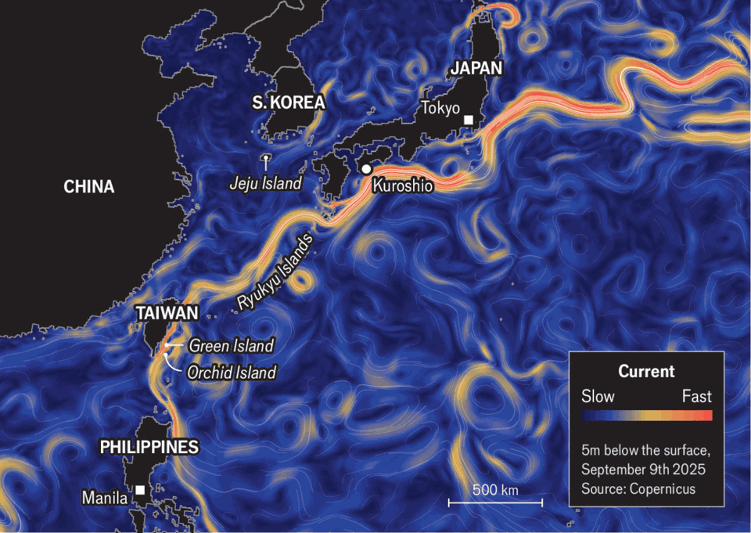
The currents themselves are also shifting. The Black Stream has moved 0.5º north in the past century. “The tropics are expanding and the poles are retreating,” notes Miyama Toru of the Japan Agency for Marine-Earth Science and Technology. “If someone showed me this Kuroshio state a few years ago, I would have said, ‘You must be kidding, it’s a badly behaving simulator, run it again.’ But this is the reality.”
Undersea ecosystems are wobbling. Coral reefs can now be found in Tokyo bay. The Ise ebi, a spiny lobster traditionally found in central Japan, is showing up ever farther north. In the region near Kuroshio town the wild harvest of ulva prolifera, a delicious seaweed, has fallen from 10-20 tonnes annually to zero.
The shifting currents are contributing to more chaotic weather on land. As the Kuroshio gets warmer and moves north, it is helping fuel record temperatures across the north Pacific; it also releases more moisture, causing heavier winter storms and more humid summers. “People are not prepared,” says Mr Miyama.
In February a massive snowstorm struck the town of Obihiro, in Hokkaido, Japan’s northernmost big island. In a single day 124cm of powder fell, the deepest drift since local records began in 1953. Roads closed; trains stopped; many people could not leave their homes, as snow blocked their doors. At a cattle farm in the flat, open plains of Obihiro, Hirose Mayumi shakes her head as she recalls the day: “It wasn’t so bad for the cows, they’re northern cows, so the heat is worse for them. It was much, much harder for us.”
At first, meteorologists puzzled over the cause of the storm. But in July a paper by a team of Japanese scholars pointed to a marine heat wave. The culprit, the authors argued, was none other than the drifting, swelling, surging, whirling, warming Kuroshio. ■
This article was downloaded by zlibrary from https://www.economist.com//interactive/christmas-specials/2025/12/18/a-journey-along-east-asias-hidden-artery
Christmas Specials | Austenomics

How Jane Austen revealed the economic basis of society
Some unacknowledged truths about money

December 18th 2025


The gemstone is a cool turquoise, not a ruby or emerald. The band in which it is set is only nine carats, the lowest concentration that can advertise itself as gold. The small ring nonetheless fetched £152,450 at auction in 2012. A fine result.
But not everyone was happy. The ring once belonged to Jane Austen, author of “Pride and Prejudice” and other literary classics, born 250 years ago this month. The auction was won by Kelly Clarkson, singer of “My Life Would Suck Without You” and other pop hits, who triumphed in an American talent show 23 years ago. Rather than let the ring leave the country, Britain declared it a national treasure and delayed its export until Jane Austen’s House, a museum in Chawton, Hampshire, could raise the money to buy it. When told this story, one museum-goer remarked: “Isn’t it lovely that money doesn’t always talk.”
Money does not have the last word in Austen’s novels. When Mr Darcy, with his country mansion, makes a peremptory marriage proposal to Elizabeth Bennet in “Pride and Prejudice”, she first turns him down. Fanny Price does the same to rich but libidinous Henry Crawford in “Mansfield Park”. Austen herself refused an offer of marriage in 1802 from Harris Bigg-Wither, young heir to Manydown, a large Hampshire estate.
In Austen’s novels and her life, a good fortune is not sufficient for happiness. But it is necessary. Austen insists on that necessity with a consistency and quantitative precision that sets her novels apart from most literary works. She reveals “so frankly and with such sobriety / The economic basis of society”, notes W.H. Auden in shocked admiration. But what discomfited the poet makes her a satisfying read for economists. To many, her novels are about beaux and balls. But she had just as keen an eye for “brass” and budgets. The woman who now appears on Britain’s ten-pound note, knew, without illusion, what money was worth.
In both her first published novel (“Sense and Sensibility”) and her last (“Persuasion”), the story begins with an economic setback, an inward lurch of the family’s budget constraint. Mrs Dashwood and her daughters must leave their beloved home shortly after the death of her husband. The prideful Elliots must rent theirs out to honour their debts: “They must retrench.”
Similarly “Mansfield Park” is set up like a natural economic experiment. Three sisters marry into different stations in life: high, middling and low. As well as the cross-sectional contrast between the siblings, Austen also provides a comparison over time. Fanny Price, daughter of the poorest sister, is taken in by her rich uncle, then cast out eight years later. She migrates between ranks, in both ascending and descending order.
The value of money is debated as well as dramatised in Austen’s novels. “What have wealth or grandeur to do with happiness?” asks Marianne Dashwood, the naive romantic. “Wealth has much to do with it,” replies her elder, worldlier sister, Elinor. Because this is an Austen novel, the debate becomes quantitative. The two sisters each put a number on what they consider an adequate, respectable income. It turns out Marianne’s figure (£2,000 a year) is twice Elinor’s. It’s easy to rise above wealth if you expect so much of it.
Austen rarely introduces a major character without also enumerating their finances. “Before the mid-1780s, the sums doled out to heroines… had been large, vague, and all encompassing,” writes Edward Copeland of Pomona College in California. Austen is more particular. Elinor and Edward Ferrars were “neither of them quite enough in love” to think that £350 a year “would supply them with the comforts of life”. But the £850 they eventually secure does the trick.
These numbers would all have meant something to Austen’s original readers, argues Mr Copeland, serving as a useful “shorthand” for rank and station. £100 a year was required to afford a single maidservant—“a stout girl of all works”. At £400, a household could employ a cook, housemaid and perhaps a boy servant.
Roughly £700-£1,000 a year was required to keep a carriage. With the help of Highbury’s hypochondriacs, this prize falls within the sights of Dr Perry in “Emma”. The higher income target of £2,000 is eventually met by Marianne in “Sense and Sensibility” when she marries Colonel Brandon. That amount will cover a “proper establishment of servants, a carriage, perhaps two”, and horses for hunting. To satisfy the greater demands of a Mary Crawford, eager for a second home in London, would take at least £4,000 a year.
Good fortunes were rare: there were not so many rich men as there were pretty women to deserve them, Austen notes. In 1806 Patrick Colquhoun, a social reformer, estimated how the nation’s income flowed to its different ranks and occupations, from peers to paupers. Building on this, Robert Allen of New York University has calculated the average household income of each of these groups in 1798, a few years after the probable setting of “Pride and Prejudice”. With some tweaks to reflect the evolution of earnings over those years, Austen’s characters can be slotted into the economic hierarchy of the time (see chart).
Such an exercise shows that even Austen’s less fortunate characters are clustered near the top of the pile. After the death of their father, the Dashwoods are forced to live on £500 a year. They retreat to a cottage with “dark narrow stairs and a kitchen that smokes”. But they still had more to live on than the average income of over 95% of families. The garrulous Miss Bates, whom Emma Woodhouse insults in a pivotal scene in “Emma”, is deemed poor by Mr Knightley. “She has sunk from the comforts she was born to.” But if, as some scholars suggest, she lives with her mother on about £100 a year, she has more than the average income of perhaps 70% of families.
Austen’s grasp of these fine gradations of income was the product of experience, not just imagination. She could never afford to be complacent about cash. Her father, a clergyman, upheld the values of the landed gentry without ever holding down the assets. The third of her six brothers, Edward, was adopted by rich relatives, the owners of Godmersham Park. On visits to those lavish surroundings, Austen would “drink French wine & be above Vulgar Economy”. But she could not afford to tip the servants properly and paid half-price for her haircuts. She was only, but always, one step removed from wealth.
Her nephew claimed that she wrote for her own amusement. “Money, though acceptable, was not necessary for the moderate expenses of her quiet home,” he wrote. In reality, money was more than acceptable to Austen; she would have liked to accept rather more of it. She lamented that people were quicker to borrow and laud her work than to buy it. “Tho’ I like praise as well as anybody, I like…Pewter too,” she wrote.
Over her lifetime, she earned about £631 of pewter from her work, according to Jan Fergus, a biographer. It could have been better: Maria Edgeworth, a novelist admired by Austen, reckoned she earned £11,062.44 over her longer career. Fanny Burney, another of her inspirations, made about £4,280 from her four novels.
Austen’s dealings with her publishers provided a harsh education in risk and reward. She published “Sense and Sensibility” at her own expense in 1811. She then sold the copyright of “Pride and Prejudice” for £110. She thus missed out on the rewards from its surprise success. But neither she nor her publisher knew it would be a hit when they struck the deal. Selling copyright spared authors the upfront cost (and hassle) of shepherding a book into print and relieved them of the risk of disappointing sales.
Those risks were real. In 1815 Austen turned down £450 for the copyright to “Emma”, “Mansfield Park” and “Sense and Sensibility”. But that too turned out to be a mistake in hindsight. The second edition of Mansfield Park sold poorly. And her publisher had little incentive to hurry her books into being.
Austen died in July 1817. Her 41 years spanned wild economic times. The first income tax arrived in 1799. Trading in slaves was outlawed in 1807. The Luddites broke knitting frames in 1811. The corn laws, imposing tariffs on grain, entered the statute books in 1815.
Her lifetime was also a seminal time for economics. Adam Smith’s “The Wealth of Nations” was published in the year following her birth. David Ricardo’s “On the Principles of Political Economy and Taxation” appeared in the year she died. In between was “An Essay on the Principle of Population” by Thomas Malthus.
Malthus argued that a country’s population tends to grow faster than the means to feed it. Poverty and distress were thus an inevitable, necessary check on the growth of the masses, discouraging early marriage and frequent childbirth. Labourers who could just about support themselves on their wage would hesitate to divide their daily pittance among four or five.
The same hesitation, Malthus pointed out, can intrude further up the social ladder. A man whose income only just admits him to “the rank of gentlemen” will also delay marriage, Malthus argued. Otherwise, he risked the “essential evil” of losing rank, sinking to the level of “moderate farmers” and “the lower class of tradesmen.” Worse, he would place his wife in the same predicament, “so discordant…to her tastes”. Malthus theorised what Austen dramatised.
Malthus argued that giving money to the needy was often self-defeating. England’s Poor Laws, which tithed the landed gentry to provide relief to penniless parishioners, discouraged abstinence and bid up the price of food. The laws “create the poor which they maintain”, he argued.
Austen had little patience with this line of thinking, according to Sheryl Craig, author of “Jane Austen and the State of the Nation”. As early as her teenage writing, she seems to spoof social reformers like Malthus who documented the misery of the poor only to argue against relieving it. “Many are unfortunate in their progress through the world,” notes one fragment. “To seek them out to study their wants, and to leave them unsupplied is the duty, and ought to be the Business of Man.” She was an ironist, even about economists.
Austen’s most ingenious economic villain is Fanny Dashwood. The reasoning she displays was not just of its time but ahead of it. She persuades her husband that his needy stepmother and half-sisters would benefit more from an occasional gift than a yearly allowance. “If they felt sure of a larger income,” he concedes, “they would only enlarge their style of living …and would not be sixpence the richer for it.” Followers of Milton Friedman, a Nobel prizewinning Chicago economist, will recognise the intuition behind his permanent income hypothesis of 1957: after unexpected windfalls, people increase their saving, but in response to a durable increase in their lifetime income, they “enlarge” their consumption.
Fanny Dashwood is even more wary of annuities, which make regular payments for the remainder of a person’s life, but no longer. “People always live for ever when there is an annuity to be paid them,” she complains. She thus anticipates by over 180 years the argument of two other Chicago economists, Tomas Philipson and Gary Becker, who theorised in 1998 that mandatory annuities can lead to “excessive longevity”.
In her work, Austen criticises people who cannot live within their means, like “expensive” John Willoughby, “extravagant” Tom Bertram, or vain Sir Walter Elliot. But profligacy is not the greatest economic sin in her novels: a spendthrift is better than a tightwad. She is far more forgiving of the Willoughbys and Bertrams of the world than she is of Mrs Norris, the eldest of the three sisters in “Mansfield Park”, with her relentless search for efficiency and economy.
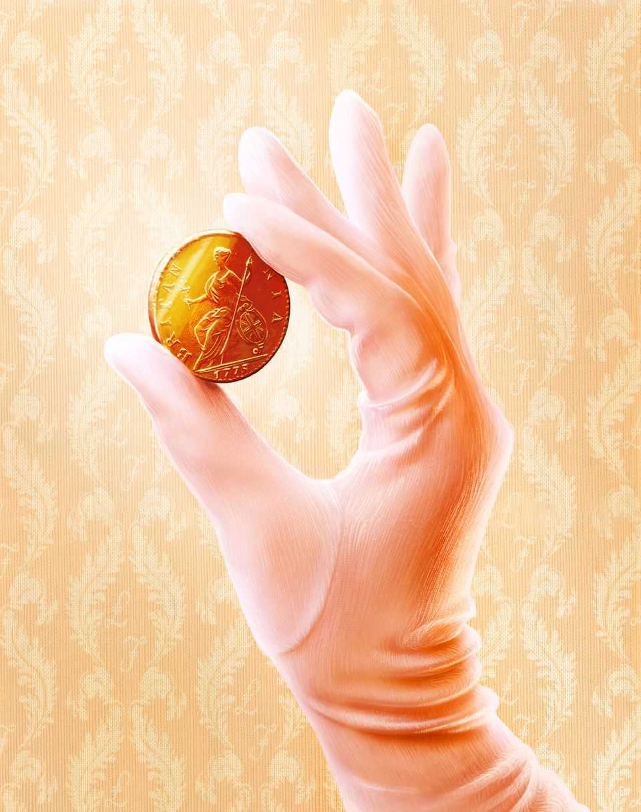
Her tight-fistedness starts as a response to financial setbacks in life. On marrying a clergyman, she must accustom herself to a “narrower income” than expected. When he dies, she has to tighten her belt again. This is the same test faced by several of Austen’s more sympathetic characters—the Dashwoods, for example, or even the novelist’s own mother. But Mrs Norris makes the mistake of turning thrift into an end in itself. Laying aside money becomes her “infatuating principle”. For this, and her gratuitous unkindness to her niece, Fanny, she is exiled from the country, the same fate as a scandalous adulteress.
By disdaining the miser more than the profligate, Austen was echoing a rebel strand of early economic thinking. Overspending might hurt the person guilty of it, but at least it stimulated the economy around him. “Prodigality is a Vice that is prejudicial to the Man, but not to Trade,” noted Nicholas Barbon, an early free-trader in the 17th century. Malthus in his later years argued that “saving too much, may be really prejudicial to a country”, because it impairs the motive to produce. “If every person were satisfied with the simplest food, the poorest clothing and the meanest houses, it is certain that no other sort of food, clothing, and lodging would be in existence.”
The prudence that Austen champions (with some equivocation) in “Sense and Sensibility” is cast in a less flattering light in “Persuasion”. Anne Elliot wishes she had accepted the young sailor, Frederick Wentworth, when he first proposed. She should have trusted in a “cheerful confidence in futurity”, rather than siding with “that over-anxious caution which seems to insult exertion and distrust Providence!”
This debate between confidence and caution is continued in “Sanditon”, Austen’s unfinished, final work. The novel again pits a romantic against a realist. But in this story, the heart-throb is not a person but a project: a spa resort promoted by Mr Parker in the fictional coastal town of Sanditon. Mr Parker is an “Enthusiast” for the scheme, which blinds him to its potential flaws and drawbacks. But he is described as kind-hearted and good-natured. He is that rare character in literature, a sympathetic capitalist.
By contrast, Lady Denham, the voice of financial restraint, is described as thoroughly mean. “Her Love of Money is carried greatly too far,” says Mr Parker, “a Littleness will appear.” She worries that wealthy newcomers from the West Indies will do “mischief” by scattering their money too freely, thereby raising the price of meat and other goods. In response Mr Parker offers an unexpected lesson in the circular flow of income. Prices will go up only if demand is “extraordinary”, he explains, and if that is the case, the “diffusion of money” will do property owners like themselves more good than harm. “Our Butchers & Bakers & Traders…cannot get rich without bringing prosperity to us…[through] the increased value of our houses.”
Mr Parker is already thrilled by the town’s early signs of progress. The library shop is full of “pretty Temptations”, such as new parasols, new gloves, and many “useless things…that could not be done without”. And in the shoemaker’s window, he spots “Blue Shoes, & nankin Boots!” It is, of course, funny when he equates the arrival of this footwear (named for the origins of the cloth in Nanjing, China) with “Civilization, Civilization indeed!” But the truth is no prosperous civilisation was ever built on the covetousness exhibited by Lady Denham.
No one knows how Austen would have resolved the contest between Mr Parker’s animal spirits and Lady Denham’s lust for liquidity. But it now seems fitting that Austen’s last novel was about the combination of tourism and enthusiasm. In the 250 years since her birth, her work has attracted many visitors to her past homes and haunts. Just as Sanditon is like a second wife and kids to Mr Parker, Austen’s characters are like a second family to many of her fans, “hardly less dear …certainly more engrossing.” At her old house in Chawton visitors can try on a replica of her ring, or buy silk ribbons, topaz necklaces and other pretty temptations at the gift shop. As Austen understood, confident spending is not sufficient for a prosperous society, but it is necessary. The economy needs its Enthusiasts. ■
This article was downloaded by zlibrary from https://www.economist.com//christmas-specials/2025/12/12/how-jane-austen-revealed-the-economic-basis-of-society
Christmas Specials | Single men in possession of good fortunes

Was Mr Darcy the richest of all Jane Austen’s characters?
It depends how you count their wealth

December 18th 2025


Mr Darcy is handsome, smouldering and rich. According to the 1995 television adaptation of “Pride and Prejudice”, he is also an excellent swimmer. But in Austen’s next novel, “Mansfield Park”, she introduces a man in possession of even more money: Mr Rushworth. He is a clod, a “king” who appears “best in the background”. But he is blessed with an estate spanning 700 acres (not counting the water meadows), one of the best houses on London’s Wimpole Street and £12,000 a year to Darcy’s mere £10,000.
It is fun to compare characters’ fortunes across novels. Doing so reveals “fiscal twins”, as Marilyn Francus of West Virginia University calls them. For example, Mr Bennet’s income in “Pride and Prejudice” (£2,000) is as large as Colonel Brandon’s in “Sense and Sensibility”. Strange, then, that Mr Bennet has done so little to secure his daughters’ futures. In “Northanger Abbey” James Morland can offer Isabella Thorpe only £400 a year. If she had settled for that, she would have become the fiscal twin of Mrs Price, the poorest sister in “Mansfield Park”, who lived a life of clatter and chaos on what is reckoned to be a similar amount.
The problem with these comparisons, however, is that the pound’s purchasing power was not steady in the years between Austen novels. Harvest failures and recurring wars with France contributed to rapid inflation. Conversely, the demobilisation of soldiers in brief interludes of peace caused unemployment and deflation.
Austen was aware of the problem. While revising “Sense and Sensibility” in 1811, she noted that “the Incomes remain as they were, but I will get them altered if I can.” It can make a big difference whether her numbers reflect the characters’ times or the year of publication. Some scholars, for example, argue that “Pride and Prejudice” is set around 1793-4 when militias were mobilised to protect Britain from possible invasion by France (“a whole campful of soldiers” thrills Lydia, the youngest and most feckless Bennet sister).
“Mansfield Park”, on the other hand, is believed to start in 1808 or 1812. Between 1793 and 1808, the cost of living rose by over half, according to Charles Feinstein, an economic historian. That means the £12,000 flowing to Mr Rushworth in “Mansfield Park” did not stretch as far as the pounds accruing to Mr Darcy roughly 15 years earlier. Indeed, Mr Rushworth’s fortune was worth less than £7,900 at the prices prevailing in 1793. By that logic, he is not in fact the richest of Austen’s characters. Mr Darcy is a better catch.■
This article was downloaded by zlibrary from https://www.economist.com//christmas-specials/2025/12/12/was-mr-darcy-the-richest-of-all-jane-austens-characters
Christmas Specials | Unmoored in Madagascar

The most friendless place on earth
If you think rich, individualistic societies are the loneliest, think again

December 18th 2025


PRICKLY PEAR line the perimeters of brick-red fields. In a few there are crops, but in many the cactus is the only hint of green. Small children, who should be in school, herd Zebu cattle along dusty tracks. Women sell bags of charcoal outside flimsy wooden huts by the main road. It is the tail end of the dry season in southern Madagascar; locals are yearning for rain. They are short of cash and often hungry. They are also lonely.
Many people think loneliness is a first-world problem: that rich societies become atomised as people chase wealth rather than social connections. But surveys suggest this is wrong. Western, individualistic societies, where more people live alone and religion is marginal, tend to be less lonely. People in poor countries are much likelier to be lonely. And the loneliest region of all, surprisingly, is Africa, the home of ubuntu, the sociable notion that “people are people through other people.” In 2024 over a quarter of Africans surveyed said they had felt lonely the previous day.
For those who like definitions, loneliness is the painful mismatch between expectations of social connection and what happens in reality. Satisfying relationships generally include several ingredients, says Samia Akhter-Khan of Brandenburg Medical School. These include proximity, support, intimacy, fun, respect and a sense of contributing or being needed.
Loneliness is hazardous. Researchers have linked it to heart attacks and strokes. A study in 2010 estimated that social isolation shortened lives as much as smoking 15 cigarettes a day. More recent meta-analyses, examining data from millions of people, find that loneliness increases a person's risk of death at a given time by around 14%. Lonely people often have unhealthy habits, but the effect persists even when those are taken into account.
And being lonely is miserable. It raises the risk of anxiety and depression, and creates a vicious circle. “You have loneliness causing mental disorders, and you have mental disorders aggravating or causing isolation,” says Palmira Fortunato dos Santos, a clinical psychologist at Mozambique’s Ministry of Health.
The most rigorous studies of loneliness have largely been in Europe and America. Yet these regions are home only to a small fraction of the world’s lonely (see map). In June the World Health Organisation (WHO) published an analysis of 23 data sets, including the Gallup World Poll, which covers 150,000 people from roughly 150 countries. It found that the poorer a country is, the lonelier it tends to be. The Economist’s own analysis, using Gallup’s raw data, finds that this relationship holds within countries, too: the richest people in the richest places are the least lonely; the poorest in the poorest are the most (see chart).
And the loneliest place of all is Madagascar. The Economist flew there to find out why.
Most outsiders know very little about this giant island in the Indian Ocean. They probably assume, correctly, that the singing, dancing lemurs of the popular cartoon franchise are fictional. They may have heard that millions of years of isolation have allowed an astonishing array of unique wildlife to evolve in Madagascar’s jungles, from the tomato frog to the fearsome cougar-like fossa. They may even have heard that Madagascar suffered a coup in 2025. But they know next to nothing about the people who live there.
There are only 33m of them, in a country more than twice the size of Britain. The largest ethnic group, the Malagasy, descend from settlers from East Africa, South-East Asia and Oceania. Most of the population live in the countryside and are very poor. Roughly 70% subsist on less than $3 a day.
In Ambovombe, a town in the arid, cyclone-ravaged south, the red-dirt streets do not look lonely. Wooden stalls lure shoppers; ox-drawn carts trundle by; labourers linger in groups, chatting as they wait for offers of work. Everyone seems to have some kind of social connection. Yet for many, it is not enough. An astonishing 60% of people in southern Madagascar told Gallup they felt lonely the previous day.
Robinette, a middle-aged seller of household goods, says she spends plenty of time with people. But most are customers, not friends. She lives in a rented room with her children, but no husband—polygamy is common in this region and many women are left to raise kids on their own. There are few people to help her, she complains. She often feels lonely.
Poverty does not cause loneliness, but money affects how and how often people socialise. In richer countries, people report spending far more time with friends, family and colleagues. In poorer places, residents see neighbours more often, but less of everyone else. Finding time to socialise is easier if you can pay for things that save time, from washing machines to grocery deliveries.
Money also seems to influence the quality of connections. Even when controlling for contact with friends and family, a higher income predicts less loneliness. This makes sense. It is easier to bond over dinner if you can pay the bill, easier to make friends with fellow football fans if you can afford tickets, and easier to relax with friends if you are not constantly fretting about money.
The truly poor lose countless hours to drudgery. In Ambovombe, for example, most people have no running water at home, so they have to fetch it from wells or buy it from sellers. Dieu Donné, a middle-aged man with scoliosis, is too disabled to carry water himself, so he relies on others to help him. When it doesn’t rain, wells dry up, water gets more expensive and Dieu Donné’s friends and family have to spend longer hustling for cash. So they have no time for him; and he feels isolated as well as thirsty. When his nearest and dearest are “looking for money”, “they don’t care about [me],” he says. He has contemplated suicide.
Poverty can strain relationships. Studies link it to mistrust and conflict. Stigma can compound the problem. Brigitta, a young woman in Ambovombe, says people avoid her because she doesn’t have a job.
To ease their poverty, many people migrate in search of work. This can aggravate their loneliness, says Lana Razafimanantsoa of the African Women’s Development Fund, an NGO. Since Madagascar is huge, rugged and has few paved roads, migrant labourers are often separated from their loved ones for long stretches. Brigitta’s mother left Ambovombe to look for a job. “I miss her every day,” she says.
Migration affects both movers and stayers, argues Chido Rwafa-Madzvamutse, who advises the WHO on mental health in Africa. Although good longitudinal studies are lacking, there is evidence that periods of mass migration are associated with a drop in social connection. Mentions of loneliness in English fiction rose in the 1800s and early 1900s, as many Britons left the countryside for cities. A review of 25 studies of older adults in China found that loneliness rose sharply between 1995 and 2011, as the young abandoned their villages and found factory jobs. Those left behind were often older, poorer, unhealthier—and lonely.
Culture plays a role. In more collectivist societies, strict expectations—for example, that children must care for ageing parents—can trap people in dutiful but unsatisfying relationships. When obligations are unmet, people can feel shame, says Dr Akhter-Khan. In individualistic cultures, people have more freedom to cut ties with people who make them unhappy.
Anything that reduces poverty would probably make the world less lonely. But attacking loneliness directly can work, too. Some 10,000km away from Madagascar, an experiment is under way to improve social connections. It is in Frome, an English market town, ordinary by rich-world standards but vastly more prosperous than Ambovombe. The surrounding countryside is lush and green. The high street is lined with independent cafés, bookshops and art galleries. Posters advertise jazz concerts and dance classes.

Yet plenty of locals are lonely. Helen Kingston, a doctor, noticed that isolation not only made her patients sicker; it also made them more likely to book an appointment with her, partly to have someone to talk to. In 2013 Dr Kingston and a colleague, Jenny Hartnoll, redesigned their practice. They set up a new service where they began prescribing social contact, and trained thousands of residents as “community connectors”—people who point neighbours towards sources of help and sociable activities.
The results were striking. Between 2013 and 2017 unplanned hospital admissions in Frome fell by 14%, even as they rose by nearly 30% in Somerset, the surrounding county. Researchers estimate that the scheme has saved the local health service more than £1m ($1.3m). Hundreds of other towns and cities have been in touch, hoping to replicate the model.
Similar ideas can work in poorer countries. In Zimbabwe, hundreds of “friendship benches” have been set up outside clinics. Older women, known as “grandmothers”, are trained to sit, listen, offer advice and encourage people to seek support. As well as helping others, the grandmothers themselves often find a new sense of purpose, says Dr Rwafa-Madzvamutse.
Back in Ambovombe, people with disabilities gather every Saturday in a space provided by a Christian charity. They socialise, and go out to visit others who are disabled and lonely. A cyclone this year blew off the roof, which had not yet been fixed when your correspondent visited. Exposure to the elements has curbed attendance a bit, but those who show up talk of the lift they get from bonding, and from helping others. “We connect well,” says one woman. “And we look forward to the future.” ■
This article was downloaded by zlibrary from https://www.economist.com//christmas-specials/2025/12/18/the-most-friendless-place-on-earth
Christmas Specials | An uprising in St Petersburg

Two centuries ago, Russian revolutionaries tried to change the world
Bloodied and exiled, the Decembrists failed. But they made a start

December 18th 2025


IT WAS A wintry night in St Petersburg and revolution was in the air. A piercing wind whipped off the frozen Neva river as, before dawn, the conspirators hurried to Senate Square, close to the Winter Palace. They drew up their troops beneath the stern stare of Peter the Great’s bronze statue; the gilded spire of the Admiralty pierced the inky sky. Before long the imperial cavalry would arrive, and the cannons, and the tsar. “We are going to die, brothers!” exulted one of the rebels. “Oh, how gloriously we are going to die!”
Though barely remembered in the West, that fateful day 200 years ago—December 26th 1825 in the modern calendar—was a hinge in time. Had the conspirators prevailed, their country’s history, and the world’s, might have been drastically different. As it was these men, known as the Decembrists, were transmuted into myth. As with many myths, interpretations of theirs vary. To Russia’s authorities, then and now, they were traitors. To admirers, they are champions of the flickering hope that another Russia is possible.
Revolutions are typically fomented by the uppity middle classes. This plot went right to the top. The Decembrists were the flower of Russia’s aristocracy: young men inspired by the American and French revolutions, the Enlightenment and Romantic nationalism. They were immersed in literature, modelling themselves on Roman heroes. Kondraty Ryleyev, a ringleader, railed in verse against “despotism’s heavy yoke”. Alexander Pushkin, the era’s bard, was a sympathiser. “Here is Caesar,” wrote Pushkin. “Where is Brutus?”
Crucially, they were military officers, mostly in the imperial guards, who had fought in the Napoleonic wars. As Sergei Muravyov-Apostol, another leader, put it: “We were the children of 1812.” That was when Napoleon invaded Russia; two years later Russian forces entered Paris. They returned flushed with the pride of liberators—and with visions of bringing citizenship and rights to a vast land blighted by arbitrary rule, in which a third of the population were serfs. Their revolt was, in part, an example of the blowback of war.
As Yuri Lotman, a historian, observed, the Decembrists represented a new psychological type. They were the first generation of Russian aristocrats to distinguish between service to the monarch and to society and the nation. They had earned their honour and dignity, they believed, not been granted them from above. Still, at first they hoped the tsar, Alexander I, would oversee reform of his downtrodden empire. But though he espoused liberal plans, even enacting a few on the empire’s fringes, he backtracked.
The Decembrists formed secret societies, based in St Petersburg, the imperial capital, and what is now Ukraine. Initially neither subversive nor altogether secret, they hardened into a conspiracy for a coup d’état.
Russian history was littered with coups, but the Decembrists’ aims were unique—even if they did not entirely agree on them. The most radical advocated a republic, others a constitutional monarchy. Still, they shared common goals. Having fought alongside conscripted serfs, all demanded their emancipation. They also wanted representative government, the rule of law and an end to caste-based privileges, including their own. Passionate patriots, they envisaged their country as a modern nation state. “All the nations of Europe are attaining laws and liberty,” declared a manifesto. “The Russian people deserve both.”
Autocracies are most vulnerable at moments of succession. Russia’s came sooner than the Decembrists expected—maybe too soon—when Alexander died suddenly. Since he was childless, his ostensible heir was his brother Constantine. But he had secretly renounced the throne, meaning another brother, Nicholas, would succeed. Because of the secrecy, however, imperial troops began swearing oaths to Constantine. So did Nicholas, lest he look like a usurper. Briefly, reported the Times of London, Russia had “two self-denying emperors, and no active ruler”.
This was an opening for the Decembrists, who set about agitating against Nicholas. Tipped off about the revolt, he instructed that a new oath of allegiance—to him—be sworn on December 26th. And so, on a frigid morning, the Decembrists led the troops who embraced their cause to Senate Square. Their plan was to seize the Winter Palace, arrest the tsar, install an interim government and convene an assembly. For a while they had the quiet, snow-covered square to themselves. Then forces loyal to Nicholas moved in.
In hindsight, the ensuing drama is doubly poignant. First, because many Decembrists didn’t expect to succeed. Rather they thought it was their duty to Russia—and each other—to make a stand. “There may be little prospect of success,” conceded Ryleyev, but “a beginning must be made.” They saw themselves as tragic actors on the stage of history, hoping for vindication by posterity rather than immediate victory.
Yet in a narrow sense, they might have won. The best chance for revolutionaries is often at the very start, when regimes are caught in confusion, and so it proved. Thousands of largely supportive civilians crowded around the square. The rebels could have seized the cannons that trundled across the cobbles. Above all, they might easily have killed Nicholas, who rode around imperiously, shooing away onlookers. Alexander Bulatov, a hero of 1812, stood nearby with two pistols, but found he couldn’t pull the trigger.
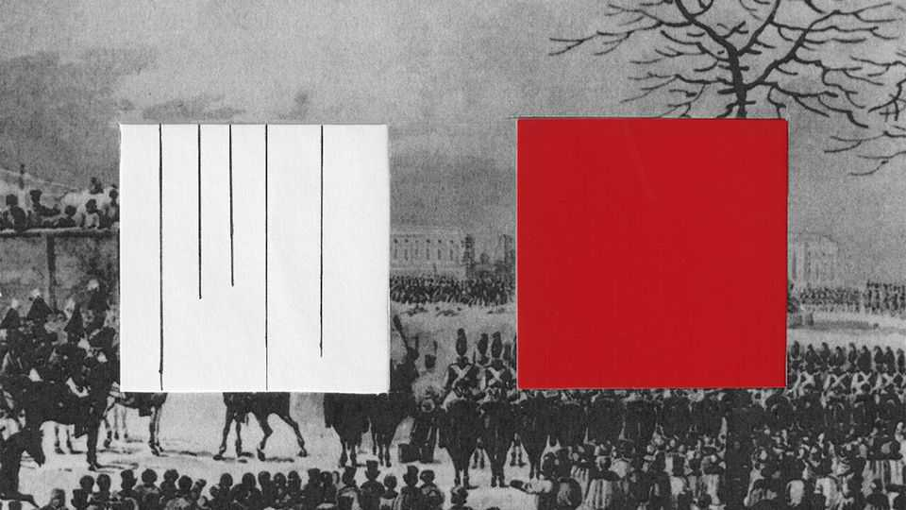
What if the Decembrists had won the day? The rebellion might have been swiftly quashed. Russia could have devolved into civil war, then slid back into despotism. Or, just conceivably, reform would have eased the discontent that led to the Bolshevik revolution of 1917. Communism might not have overrun Russia—in which case Nazism might not have risen in Germany…
So much for hypotheticals. In reality, the Decembrists were undone by haste and disorganisation. Their leader, Sergei Trubetskoy, didn’t show up. His courage is unlikely to have failed (he was a hero of the battle of Borodino); perhaps he foresaw that the amateurish plot would lead to a bloodbath and crackdown. Without orders, the mutineers shivered in their ranks in ten degrees of frost. Overall they numbered around 3,000. Nicholas’s much larger force encircled them.
It was one of those bleak winter days in St Petersburg when it never truly gets light. Both sides were loth to kill their compatriots; soldiers crossed themselves in the icy air. At length Nicholas ordered cavalry charges in a bid to disperse the rebels. The horses were repulsed, partly by stones and firewood hurled from the crowd. Several officials who interceded with the conspirators were shot. Bishops vainly beseeched them to retreat. “Our last minutes are close,” exhorted Ryleyev, “but these are the minutes of our freedom!”
“Give orders that this place should be swept by cannons,” Nicholas was advised, “or resign the throne!” Four artillery pieces were duly brought forward. No one moved. First came warning shots, at which the rebels shouted “hurrah!” Then grapeshot was loaded; it is said that the gunner refused to fire, so an officer did instead. As blood oozed across the snow, dazed insurgents tried to flee across the Neva. Some drowned when cannons smashed the ice. At least 1,271 people were killed, including many civilians.
By six o’clock it was over. The bullet-ridden Senate building was hastily replastered. Bloodstains were covered with fresh snow. Corpses were shoved into frozen canals. And the conspirators were rounded up.
Furious, Nicholas personally interviewed the leaders at the Winter Palace. He was surprised to see Bulatov among them; Bulatov said he was astonished to see Nicholas—because he had very recently meant to kill him. Offered a pardon, another Decembrist replied that it was precisely the tsar’s ability to override the law that provoked the revolt. The men were held in squalor, chained or isolated on Nicholas’s whim.
Interrogated at night, they were pressed to implicate themselves and each other in attempted regicide. In June 1826 scores were sentenced to decades of hard labour and exile in Siberia. Swords were broken over their heads in symbolic executions. Though capital punishment had been suspended in Russia for 50 years, five leaders were condemned to die.
It is never completely dark during the “white nights” of a St Petersburg summer. In the milky light of a July morning, the five were led to the gallows. Three of the ropes snapped. “Oh Lord, they can’t even hang people properly in Russia,” deadpanned Muravyov-Apostol after his tumble. New ropes were fetched.
The rest were clapped in irons and packed off to Siberia. The tsar instructed their wives to divorce them, but 11 women followed the men into exile, leaving behind their titles, fortunes and children. Arduous journeys led to dismal prisons and labour in mines. Kept in chains for over two years, the men told a jailer they had but one request: “not to insult or humiliate them”.
The Decembrist families suffered and survived together. When their penal servitude ended, some settled in Irkutsk, near beautiful Lake Baikal. You can—or could—visit two of their houses, the blue timberwork decorated with ornate window frames in the 19th-century Siberian style. They painted, made music, studied, taught and farmed. By the time Nicholas’s successor pardoned them in 1856, many had died.
Their story, however, does not end with their demise on a malfunctioning gallows or in the Siberian taiga. The struggle over their memory has been as fierce as the carnage on the square.
After the uprising, newspapers obediently described it as a riot by a handful of “madmen”. An official report of 1826 portrayed the Decembrists as traitors, bent on anarchy and the empire’s collapse.
But for generations of Russian writers they have been emblems of honour and self-sacrifice; the gallows became a martyr’s cross. Alexander Herzen, a liberal thinker, first formulated this version of their myth, seeing them as Roman heroes willing to die “to awaken a new life”. Leo Tolstoy planned to write a novel called “The Decembrists” (his protagonist was to be “an enthusiast, a mystic, a Christian”). As he plunged into their back story, it became “War and Peace”.
After 1917 the Decembrist myth was appropriated by both Bolsheviks and dissidents. Lenin inducted them into the pantheon of Soviet heroes, presenting his own rise to power as the climax of a revolutionary saga that began in 1825. Statues and streets were dedicated to them. This veneration gave cover to those who instead saw them as epitomes of selflessness.
In 1967 a play about them by Leonid Zorin was staged in Moscow. At its heart was the moral dilemma of revolution: can it be right to shed blood for a higher goal? The Decembrists’ ideas resonated with the audience of Soviet intelligentsia (which included Alexander Solzhenitsyn). “We travelled half the world, liberating it from a tyrant,” the Trubetskoy character said, evoking the mood of Russian soldiers after the second world war as much as 1825. “And what have we found when we came back? Tyranny at home!”
After Soviet tanks extinguished the Prague Spring in 1968—and with it hopes for reform in Moscow—Alexander Galich dedicated a poem to the Decembrists. Distributed through samizdat, it asked: “Do you dare to come to the square?” Soon, in a landmark of the dissident movement, eight protesters walked onto Red Square bearing signs with slogans such as “For your freedom and ours!” Just as the Decembrists looked to Rome for models, the dissidents looked to the Decembrists, whose Romantic brilliance contrasted with the grey, unheroic Soviet world.
On the uprising’s 150th anniversary, the fight over their legacy spilled back onto St Petersburg’s streets. Artists and poets gathered on Senate Square. “For a moment of freedom,” one of their placards read, “I’m ready to give my life!” They were detained, the placard tossed, like the rebels’ corpses, into the frozen Neva. A KGB officer later recalled that, when dissidents planned commemorations for the Decembrists, the kgb put on rival events in the same place. “We’d show up with a brass band. We would lay our wreaths.” Foreign observers would “yawn a couple of times and go home”. The officer’s name was Vladimir Putin.
Even in Mr Putin’s nightmarish presidency, the Decembrists remain an inspiration for some and a moral threat to others. Mikhail Khodorkovsky, a one-time oligarch who spent a decade in a Siberian camp, invoked them at his show trial in 2005. Alexei Navalny inherited their civic nationalism and sense of mission, and finally their martyrdom. Conversely, in May 2025 the Decembrists’ case was relitigated at a Kremlin-sponsored conference in St Petersburg. The justice minister decried their “lack of honour”, arguing that their punishment was too lenient. The main lesson was that “the Russian state cannot afford to be weak.”
Were the Decembrists anything more than glorious failures? In the short term the regime they loathed grew more draconian. As often in Russia’s past, reckons Andrei Zorin, a historian (and the playwright’s son), the actions of “the purest and most noble people” inadvertently set back reform. Anti-Putin protests have likewise led to crackdowns and war.
From one point of view the men of 1825 were hopeless dreamers, too aloof or naive to see that Russia’s size and history mean it is doomed to eternal misrule. Or perhaps it is still too early to say. The Decembrists’ rebellion lasted only a few hours, but 200 years on, they remain a beacon of individual dignity in undignified times. A beginning must be made, and it was. ■
This article was downloaded by zlibrary from https://www.economist.com//christmas-specials/2025/12/18/two-centuries-ago-russian-revolutionaries-tried-to-change-the-world
Christmas Specials | China’s tea industry

The rise and fall and rebirth of lapsang souchong
A smoky tea is fading in the West; in China, a better version survives

December 18th 2025

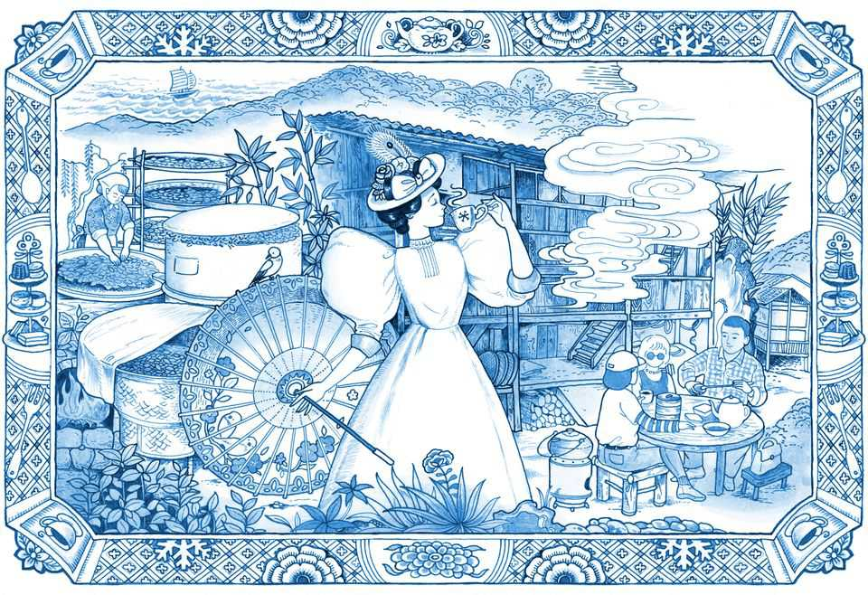
Visiting the birthplace of black tea can be a challenge. China no longer guards the secrets of its production, as it did in imperial days. But the pine- and bamboo-covered Wuyi hills of northern Fujian are a UNESCO “world heritage site”, requiring protection of its cultural relics and flora- and fauna-rich forests. Visitors must be on an authorised trip. Officials get twitchy when a foreigner in a car approaches villages famed for their tea. Anxious minutes pass as they check whether permission has been secured, before waving the vehicle on up the winding road.
Deep in the hills is Tongmu, a village and collection of subordinate hamlets scattered across the steep slopes of a valley. It is here that a kind of black tea was born more than 400 years ago—the grand progenitor of all of them, lapsang souchong. Your correspondent’s journey, inspired by the smoky aroma of this tea for grown-ups that permeated his childhood in Britain, was a quest for answers to a mystery in three parts. How did this particular tea, of all teas, become a sensation abroad? Why is its popularity now fading into irrelevance in the West? And what has become of lapsang souchong in the country that created it?
What becomes clear in these verdant hills is that lapsang souchong, as it is known in the West, does not exist in China. Even the words lapsang souchong may be a Western concoction. Souchong is based on the local dialect for “small type” (of leaf). The meaning of lapsang is unclear. Here at its birthplace the tea is usually known in (genuine) Chinese as zhengshan xiaozhong. But this too is misleading. Zhengshan xiaozhong can have a trace of the smokiness of lapsang souchong, but it is far superior in taste.
The Victorians knew no better. Long before chop suey and chow mein entered common usage, evoking cheap bland fare, British tea-drinkers were venerating lapsang souchong. In London’s 19th-century tea-rooms, it hinted at something posh. Victorian advertising called the tea an enhancer of cognitive ability for “men of brain power”, much in the way faddish supplements are hawked on podcasts today. In 1885, one ad quoted Queen Victoria as urging women to try it, too.
As it became fused with Western culture, tea—a Chinese invention—lost much of its original character. Milk and sugar were added, corrupting the subtleties and varieties of flavour that Chinese consumers relish. But lapsang souchong remained a favourite of more refined types, often without milk. Britain’s wartime leader, Winston Churchill, is said to have been a fan (though evidence is lacking). So, too, it is told, was JP Morgan, the American banker.
As with Marmite, a yeast-extract condiment that Britons love or hate, lapsang souchong has created sharp dividing lines. In a novel by Zoe Barnes, a pen-name of the late British novelist Susan Morgan, a protagonist likens the tea’s flavour to that of “roadmenders’ trousers”. A colleague of your correspondent compares it to “drinking a basketball”. But that, oddly, is part of the point. Legend has it that, in the 16th or 17th century, soldiers passed through Tongmu and bedded down on piles of freshly picked tea leaves, crushing them. Despondent farmers tried disguising the stench of their body odour by curing the leaves in smoke. This novel production method (minus the sweat) took hold with the encouragement of Dutch traders, who found that tea treated this way would survive long sea journeys better than raw green types. The new tea gained pride of place in Western tea-drinkers’ hearts.
Imagine, then, the horror that rippled through polite society when Twinings, one of Britain’s most popular tea brands, announced in 2023 that it would no longer sell lapsang souchong. The product had once been integral to the brand: “An invalid feeble and pining,/Was ordered to drink tea from Twining:/He’s since grown so strong/On our Lapsang Souchong/That he’s taken to dancing and dining,” went an advertising ditty in the 1930s. Columnists wrung their hands. In London the Evening Standard called it “one of those terrible misjudgments that business schools may well be brooding over in decades to come”.
Twinings offered a substitute, called “Distinctively Smoky”. But it received scathing reviews. On Amazon, an online seller, one customer opined: “It doesn’t conjure up misty blue smoke wafting gently through Taoist mountains, nor the campfires of the trader transporting their tea along the Silk Road. Think more, the industrial Midlands; Smokestacks, collieries, creosote.” In 2025 Twinings gave up on its tea-equivalent of New Coke, declaring “It hasn’t been as popular with consumers as we had hoped.”
Lapsang souchong is still offered by specialist dealers. But Sainsbury’s and Morrisons, two British supermarkets, have discontinued selling their brands of it. “Fans should drink up, while they still can,” a newspaper in Shanghai intoned ominously in 2024. Lapsang souchong was fading into obsolescence.
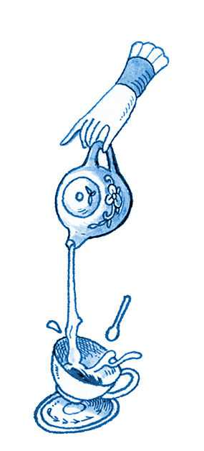
The problem is not with the tea farmers in the Wuyi hills. They are still harvesting the leaves from small bushes on rugged slopes, as generations before them have been doing. It is not a job for machines: humans are needed to identify the right leaves to be picked (four or five down from the tip of the branch). Your correspondent’s clumsy attempts were no match for those of a dexterous group of caichanu, as female tea-pickers are known, who gamely let him try. They are in their 60s—younger folk prefer work in the cities.
The painstaking efforts of the caichanu are matched by those of the men who treat the leaves. Jiang Junfan, who is in his mid-60s, belongs to a family that has been doing this for 24 generations (he says he is training the 25th). He shows off the qinglou where he works: a traditional three-storey wooden building where the leaves are pressed and smoked. There are only two like it in Tongmu. Tea traders say that these days, the lapsang souchong that most foreigners drink is sourced from elsewhere in China, and perhaps from other countries. Instead of wood, some use chemical substitutes to produce the smoky flavour. Wuyi’s meticulously produced tea is far more expensive.
The expense of authenticity may be speeding the fall of lapsang souchong in the West. China has begun using its economic muscle to tighten control over the naming of food and drink sold abroad with Chinese names. In 2020 it reached a “geographic indication” agreement with the European Union, like the kind that restricts where champagne can be made. Under this pact, no tea can be sold in the eu with the name lapsang souchong unless it comes from specified towns and villages (including Tongmu) in Wuyi; what is more, the smoking must involve pinewood.
And Western palates are changing. Henrietta Lovell of the Rare Tea Company in London sells lapsang of the subtle, zhengshan xiaozhong, type, sourced from Wuyi, at nearly £25 ($33) per 50g. Ms Lovell calls the cheaper types a tea “associated with your granny”. She says popular demand has slumped so much that were she to try to pitch lapsang souchong to a supermarket in Britain, they would “laugh me out of the store”.
In China, meanwhile, zhengshan xiaozhong thrives. China’s decades-long economic boom has created a sizeable market of wealthy customers who are willing to pay exorbitant prices for the genuine, pinewood-smoked article. And villagers in Tongmu have responded to market forces with zeal. In 2005 they invented a new form of black tea called Jin Jun Mei (Golden Eyebrow), which uses the tender unopened buds of leaves from the same bushes that produce standard zhengshan xiaozhong a little later in spring. They are not smoked. A pot of this exquisite-tasting tea can sell for about one-quarter of the price of gold.
There is a snag for zhengshan xiaozhong producers in Tongmu. To protect Wuyi’s forests, the authorities have imposed tight controls on the use of pinewood. But so tied up is the local economy in the production of zhengshan xiaozhong that local manufacturers say they expect the government to offer a workaround. The real lapsang souchong will live on as a status symbol for the upper classes. Ordinary Westerners will never know what they were missing. ■
This article was downloaded by zlibrary from https://www.economist.com//christmas-specials/2025/12/18/the-rise-and-fall-and-rebirth-of-lapsang-souchong
Christmas Specials | From Harry Houdini to Harry Potter

How magicians stay relevant in the age of AI
As TikTok dulls the world’s sense of wonder, conjurors are adapting

December 18th 2025

He was the most famous magician of the 20th century. Yet Harry Houdini’s peers were often scathing about him. His tricks were “awful stuff” and “a bunch of junk”, they sniffed. “Watching him play the part of an elegant conjurer was a bit like watching a wrestler play the violin,” writes Jim Steinmeyer in “Hiding the Elephant”, a history of magic.
Despite this Houdini (whose real name was Ehrich Weiss, and who died in 1926) earned more than any magician of his time: as much as $200,000 a week in today’s money. It was not just that audiences loved his death-defying escapes. It was that he had a knack for selling the business of wonder. He used local-newspaper offices and police stations as stages for his escapes, ensuring press coverage. He invited audiences to share a sense of peril by trying to hold their breath while he struggled, handcuffed, to escape from a sealed milk can full of water. (Fortunately, he could hold it far longer than they could.)
He ferociously defended his act against critics. In 1899 a newspaper claimed that his handcuff escape involved a hidden key. He invited detectives to watch him perform the same trick naked, thus debunking the debunker and generating buzz at the same time.
He battled imitators, too, threatening to sue them for copying acts he claimed to have patented. (This was nonsense; you cannot patent an idea while also keeping it secret. But magicians are not lawyers.) One time he copyrighted a performance of one of his most popular tricks—being lowered upside-down into a “Chinese water torture” tank—as a play. This allowed him to sue a copycat in Germany and win. For good measure, while the case was pending, he taught the trick to a rival of the German conjuror, and even lent her the apparatus, recounts Kenneth Silverman in “Houdini!!! The Career of Ehrich Weiss”, a biography.
A century after Houdini’s death, magicians face many of the same challenges—monetising mystery, guarding secrets—and a hatful of new ones. Attention spans are shrinking. Competition is proliferating: anyone can film an act and publish it on social media. More worryingly for those who depend on hocus-pocus for their groceries, TikTok makes it easy to show the whole world how a trick is done. And technology has jaded people to marvels, making them harder to wow. Conjurors today must attempt the trickiest trick of all—staying relevant in the age of AI. The Economist went to Las Vegas to ask them how they do it.
At “MAGIC Live!”, an annual convention, magicians gather in a smoky hotel near the strip to swap tips, snap up hardwood wands for $250 and listen to lectures on “crafting your stage persona through costuming”. In one corner, a fake elephant trunk swings next to the “Jaws of Death”, an $8,000 contraption used by escape artists. The inventor, Mike Michaels, says the weirdest prop he has made is a sex doll named Sindy Suckalnite (“long story short, the card comes out of her mouth”). He dreams up new ideas while drinking a beer, preferably in a casino, he says.
Dozens of wannabe wizards and polished prestidigitators cluster at the bar for “jam sessions”—like the musical kind, but with magic. Your correspondent was taught beginners’ card tricks and watched as one attendee claimed he would make a human appear between his hands (he managed a single shoe).
Mingling with the crowd is Justin Flom, a controversial Minnesotan who may represent the future of magic. He calls himself “one of the most visible humans on the planet”. His deftly publicised illusions are a huge hit on social media.
In Houdini’s day, when the trick of sawing a woman in half was new, magicians would whip up delicious fear by parking ambulances outside theatres and having assistants pour buckets of red liquid into nearby gutters. Today similar publicity can be generated with a shocking headline. In 2017 Mr Flom uploaded a video entitled, “SAWING A BABY IN HALF!!”. It shows his four-month-old daughter gurgling peacefully at the camera while he appears to slot two Dr Seuss books into her stomach and slide her legs away. It has been watched nearly 200m times.
This year Mr Flom released a sequel even more shocking to his fellow magicians: “Sawing a Baby in Half and I Show the Secret”. “Magicians can make things disappear”, Mr Flom says in the video, “using smoke and mirrors.” The secret, he reveals alongside his now eight-year-old daughter, involves the careful arrangement of a doll’s legs that are equipped with springs to make them move, a “magic table” with a hole large enough to hide a small person inside it—and a strategically placed mirror which faces the audience and conceals what is going on underneath.
Showing how it’s done is the cardinal sin for conjurors. Mr Flom does it regularly, calling it “an artistic choice”. Often “the secret is more entertaining than the trick,” he says. “In those cases, give them the secret.” Some of his videos reveal it in the first few seconds. The “game”, Mr Flom explains, is to hook viewers with the opening shot “and then just make them watch as long as possible”. He says he pulls in millions of dollars a year from this sort of thing.
He is not the only one to have turned illusion-shattering into gold. A TikTok video showing a woman making her phone case vanish has 83m views. Her 17-second “tutorial” on how she did it—dropping the case at just the right second and angle for it to be obscured from the camera—has been watched 46m times.
Another video, filmed from the perspective of a magician, reveals some of the secrets of street magic. More than 39m people have watched it. In one frame a pen that presses through an unscathed dollar bill is revealed to be a magnetic contraption; in another a flute of champagne changes colour thanks to a cloth that conceals quick switches of cardboard triangles from inside the glass. “My world just became a little less magical,” laments a commenter.
Does exposing the mechanics make magic less thrilling? Some magicians fear so. But it is not exactly new. In the 1990s a television show called “Breaking the Magicians’ Code: Magic’s Biggest Secrets Finally Revealed” ran for three seasons. The host wore a mask, supposedly to avoid being blackballed by other magicians, before dramatically revealing his identity at the end of the series. (His name was Val Valentino, and he insisted that he only divulged old tricks.)
The key to keeping modern audiences mystified is to stay one step ahead. Sometimes this means subverting the act of exposure itself. In an episode of “Fool Us”, a talent show hosted by Penn & Teller, two industry giants, Asi Wind asks a man in the audience to pick a card; he chooses the king of clubs. Mr Wind takes a deck of red cards from a wooden box on a circular table. Before the show, he says, he removed one card from the deck and reversed it. He reminds the man that they both could have picked anything—and then reveals the reversed king of clubs. Mr Wind was so sure of that choice, he adds, that he shows he took the card from a different deck of blue cards. Even more sure, he turns all of the red cards around, revealing them to have been blanks all along.
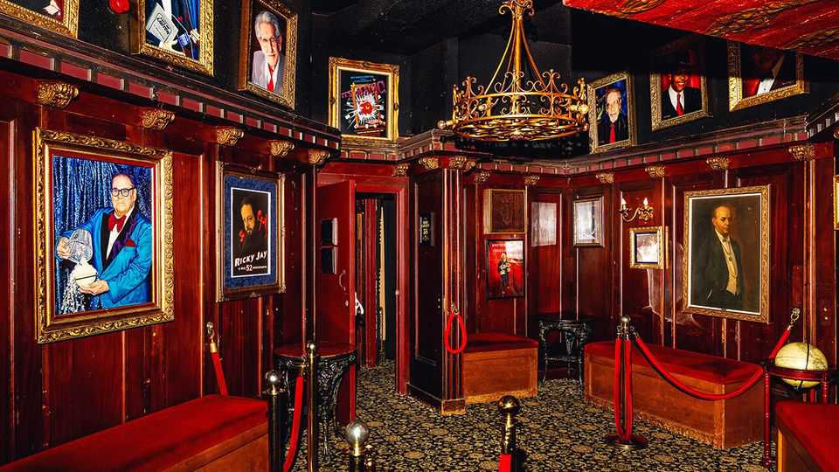
Mr Wind then asks his audience if they would like to know how the trick is done. As the camera pans to the crowd, most cheer. (One dismayed woman shakes her head and covers her ears.) He replaces the wooden box with a plastic box, explaining that it contains a hidden hole as well as magnets to activate a “trap door” in the table. Underneath the table, he shows from above, is a wheel of 52 decks of cards, each containing 51 blanks and a different reversed card. Using a mug rigged with magnets, he demonstrates how he can spin the wheel and guide the correct deck towards the trap door. He jokes: “Do you see how this could help you with the trick?”
In a sudden finale he peels away the table skirt. Where the audience expect to see the contraption, they can see nothing at all. The “wheel” of cards is revealed to be a flat photo. The secret has been preserved. “Nothing is as it seems,” he says, ripping up the piece of paper to rapturous applause.
Despite his talent, Mr Wind frets about the future. “Sometimes I look at the kids and I can tell I’m losing them,” he says. Younger audience members want a “more immediate” pay-off, “more eye candy”. Criss Angel, whose television show “Mindfreak” lasted for six seasons from 2005-2010, says that nowadays “people won’t sit there for three and a half minutes watching one thing.” His live show in Las Vegas mimics the overstimulation of a TikTok scroll: within minutes he is suspended from the ceiling in a straitjacket, escaping while debris is blown towards the audience.
Technology may have cursed audiences’ brains, but it has also expanded the tools at magicians’ disposal. At the convention’s marketplace, one stall refuses to talk to a journalist, but a discreet browse through its catalogue reveals that it sells microchips that can be secretly embedded in cards to help a performer “guess” which one a spectator has chosen. Better tech allows magicians to put on shows more cheaply. Motion-sensitive tags can be used to cue sound. Cameras and screens let card-trick artists command big stages once reserved for grand illusions.
As veterans age and are replaced by digitally native youngsters, some fear there will be a shortage of magicians who can give long, immersive shows. YouTube conjurors “think performing on the internet is how you perform”, sighs one venue owner. Simone Marron of the International Brotherhood of Magicians, an industry group, says that half of them “are performing magic down at their crotch instead of up in their face”.
However, several magicians told The Economist that the complexities of the modern world have heightened the demand for live magic. At the Magic Castle, a club in Los Angeles, the use of phones is restricted. A young, glamorous crowd wanders through a maze to meet a variety of magicians. In the basement, a bartender turns a deck of cards to glass. Entrance requires you to say “open sesame” to an owl on a bookshelf, which then slides away to reveal a secret passage. It is an experience impossible to replicate online.
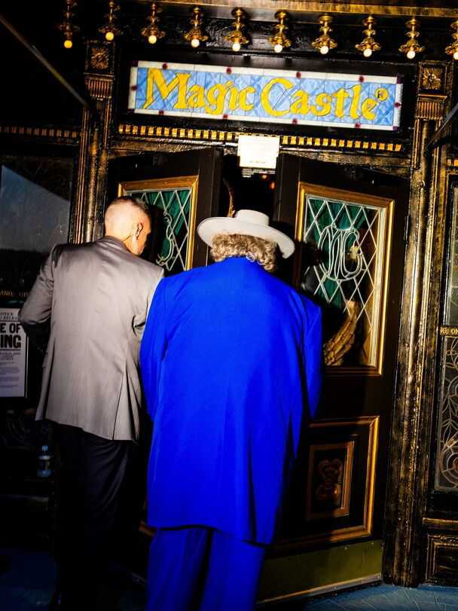
David Blaine, a magician known for spectacular stunts, invites The Economist into his office in New York. He owns an original poster advertising a Houdini escape: burying himself alive. Inspired by the great man, in 1999 Mr Blaine buried himself alive, in a clear coffin in Manhattan, for a week. An estimated 75,000 people stopped by to look. Some, annoyingly, “thought...it was a hologram”.
Mr Blaine realises that the entertainment landscape has shifted. In 2023 Mr Beast, a popular YouTuber, copied his burial stunt and filmed it. The resulting video has been watched more than 285m times. “His magic is studying algorithms,” Mr Blaine shrugs.
The best live performances can be simple. “I’ve done a crate escape at 100 feet in the air, and I’ve got louder applause for doing, like, sponge balls in somebody’s hands,” says Gabriella Lester, a magician based in Los Angeles. Even the cliché of pulling a rabbit out of a hat can still amaze people in the right setting. An effective performance creates “a kind of hiccup in the texture of everyday life”, reckons Jason Leddington, a philosophy professor at Bucknell University. People still crave that. As Houdini once put it, without wonder, “we should find life scarcely worth living.”
Phones will not kill magic. Good magicians incorporate them into their acts. Mr Blaine shuffles cards and fans them out in a pattern of one facing up, one facing down. He takes a photo of your correspondent holding this up, which he sends over to be inspected. It looks the same. Next, an instruction to pick one of the facing-up cards from the physical pile. “Would you be impressed if every single card turns face down, except for your card?” he asks. Indeed. “When I said every card is going to turn face down except for your card, I didn’t mean here.” He gestures to your correspondent’s phone, and the photo is pulled up once more.
This time—hey, presto!—only the queen of hearts faces the camera. ■
This article was downloaded by zlibrary from https://www.economist.com//interactive/christmas-specials/2025/12/18/how-magicians-stay-relevant-in-the-age-of-ai

International
- Ditch textbooks and learn how to use a wrench to AI-proof your job?
- How to survive abandonment by America
International | Toolbox versus textbook

Ditch textbooks and learn how to use a wrench to AI-proof your job?
Generation Z is becoming less invested in university and more interested in skilled trades

December 18th 2025

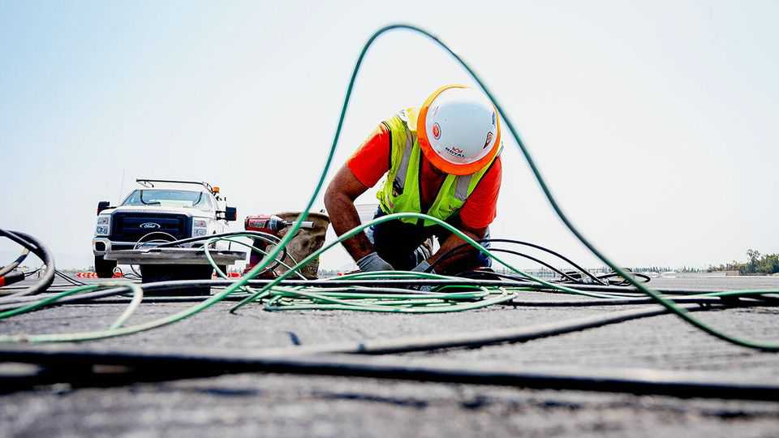
JACOB PALMER knew little about skilled manual jobs growing up, save that they were “dirty, sweaty” and “definitely seemed like lowbrow”. But it took only a year of remote learning during the covid pandemic for Mr Palmer, who grew up in North Carolina, to realise that university wasn’t for him. He dropped out after his freshman year, spent the next two years training as an apprentice electrician, and started his own business in 2024. Though just 23 years old he now has a warehouse, a pickup truck and a YouTube channel with more than 33,000 subscribers who watch him fix devices ranging from smoke detectors to Tesla chargers. He expects to generate $155,000 in revenue this year, of which 10% will come from YouTube. Mr Palmer lists the advantages of becoming an electrician: “You get paid pretty well to do it. You get paid to learn to do it.” And it creates “massive job security” at a time when many young university graduates are anxious about artificial intelligence (AI) replacing entry-level white-collar workers. Mr Palmer doesn’t worry about that: “I’ll be wiring those data centres, right?”
Mr Palmer is not the only member of Generation Z (those born between 1997 and 2012) who is rethinking the merits of getting a university education. Only about one-third of American adults today think that university education is “very important”, according to recent polling by Gallup, a pollster, down from three-quarters in 2010. Around a quarter of Americans say they have “very little” or no confidence in higher education. Dig deeper and many of those with little confidence say that universities do not teach relevant skills and that they are too expensive. Indeed, the average tuition fees charged for a four-year degree at public universities in America have more than doubled in the past 30 years after adjusting for inflation.
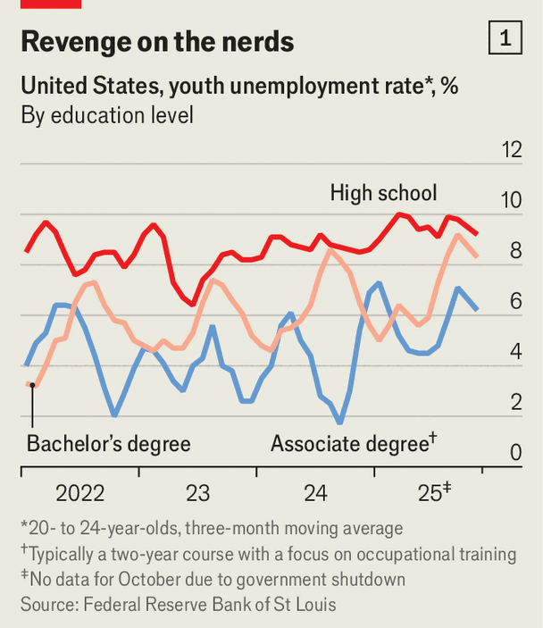
Although AI is creating new sorts of jobs, such as software engineers who help deploy it in companies, it is also making life more difficult for some graduates to land their first jobs. Recent studies from Stanford, Harvard and King’s College London have found that firms that adopt generative AI in America and Britain tend to hire fewer junior white-collar workers. In November 6.8% of 20- to 24-year-olds with a bachelor’s degree in America were unemployed, compared with 8.6% of those with only a high-school diploma (see chart 1). Of those university graduates who have found jobs, more than half are underemployed (working in jobs that did not require a four-year degree) a year after graduation, and 73% of those who start out underemployed remain so a decade later.
At the same time, interest in skilled manual jobs is growing. A recent advertisement on the London Tube shows a typed query: “Hey AI, bend this copper pipe” and an LLM’s response: “Sorry, I can’t do that.” The ad then invites viewers to “learn a trade and future-proof your career.” On social-media platforms such as Instagram and TikTok young plumbers and electricians post videos of their daily work that garner tens of thousands of views and admiring comments.
A survey published in June by the American Staffing Association found that a third of adults would advise youngsters graduating from secondary school to attend vocational or trade school, a slightly higher share than would encourage them to attend university. Some are taking that advice: enrolment in two-year vocational and trade programmes at American community colleges has grown by almost 20% since 2020. The number of active apprentices in America has more than doubled from 2014 to 2024, according to America’s labour department.
University graduates over the age of 25 still enjoy lower unemployment rates and almost double the median annual wage of high-school graduates. But look closer at individual degrees and the results become more varied. People with bachelor’s degrees in science, technology, engineering or mathematics earned a median annual salary of $98,000 in 2024, according to a study at Georgetown University (see chart 2). Arts and humanities graduates had a median income of $69,000. By contrast, a lift technician’s median annual salary in America is $106,580.
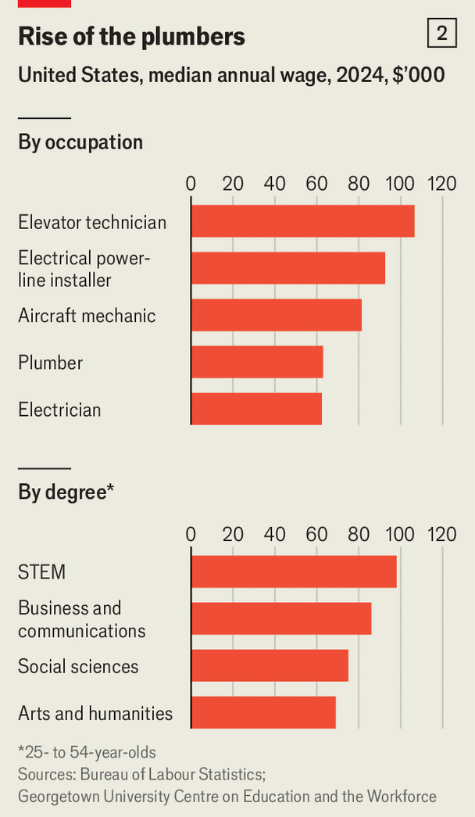
The spread within trades is wide, too. Median annual earnings of electricians in America are $62,000 a year, but the top 10% of them make more than $100,000 each. So do the top plumbers, boiler operators, aircraft mechanics and electrical power-line installers. None of these jobs requires a bachelor’s degree, though they do require specialised training.
Blue-collar workers are also sorely needed for industries like advanced manufacturing and defence. Almost 60% of new chip-manufacturing and design jobs that will be created in America between 2023 and 2030 are projected to remain unfilled because of a lack of skilled workers, according to a study by the Semiconductor Industry Association and Oxford Economics. Of those unfilled jobs, 40% are technician roles requiring only a two-year degree. Jensen Huang, the CEO of Nvidia, a chipmaker, has said that data centres for AI will require hundreds of thousands of electricians, plumbers and carpenters.
In Britain, industry reports estimate there is a shortage of 35,000 skilled welders, who are needed to build offshore wind farms, nuclear power plants and submarines, among others. Many with those skills are ageing: half of Britain’s welding workforce is expected to retire by 2027.
One solution to the skills shortage is to encourage more young people to learn vocational skills. But there is still a stigma attached to blue-collar jobs. Many parents see them as “dirty, dark and dangerous” and “a dead end”, says Sujai Shivakumar of the Centre for Strategic and International Studies, a think-tank in Washington. A lack of co-ordination between schools, industry and the government is also a problem, says Mr Shivakumar. Community colleges often offer courses that will increase enrolment but not ones that industries need, he says, which leaves vocational graduates with poor job choices even though there is a skills shortage.
A better solution would be to learn from countries like Switzerland, where about two-thirds of young people go into vocational training after 11 years of compulsory schooling. The system succeeds because it has “permeability”, meaning students can transfer easily back and forth between vocational and academic paths, says Ursula Renold, an expert in vocational education at ETH Zurich, a Swiss university. Many other countries promote apprenticeships where trainees get certified to work in a certain industry but cannot use that credential in the education system. “They are in silos,” says Ms Renold, which is “very dangerous”. An ideal system should avoid bifurcating students and trainees on different tracks, she says. It should also let companies take the lead in shaping curriculums and training students in the workplace.
Systems like Switzerland’s can take decades to build. In the meantime the best option may be degree apprenticeships, where students are paid by an employer to pursue a university degree and get on-the-job training at the same time. BAE Systems, a British arms manufacturer, has an apprentice programme that takes in more than 5,000 trainees a year, of which one-third are degree apprentices. Laché, a 20-year-old aerospace-engineering degree apprentice (whose last name is withheld for security reasons), spends four days a week working on cockpit technologies for the Tempest, a new fighter jet, and the fifth day attending classes. “It’s very, very, very, very cool,” she says. Demand for such apprenticeships is high: BAE got more than 31,000 applications for 1,100 spots in its most recent cycle, says Richard Hamer, the firm’s education director. It “definitely pays off” for both the trainees and the company, which had been struggling to find graduates with the right skills, he says.
Similar programmes are popping up in America as well. TSMC, a Taiwanese chipmaker, recently started an apprenticeship programme in Arizona, where it plans to build six semiconductor factories. Nolan Cunningham, a 23-year-old process-technician apprentice, was working at a fast-food chain before he joined the TSMC programme in April. He had decided to forgo university to avoid debt. “I don’t want to be spending the money that I’m making on paying student loans for the next 25 years,” he says. “It just cripples you.”
But he is now taking community-college courses in nanotechnology, paid for by TSMC, and is on his way to getting an associate’s degree. His factory job mostly involves data analysis and monitoring manufacturing systems from a computer. It was a “huge leap” to go from flipping burgers to making semiconductors, says Mr Cunningham, but an easy choice. ■
This article was downloaded by zlibrary from https://www.economist.com//international/2025/12/18/ditch-textbooks-and-learn-how-to-use-a-wrench-to-ai-proof-your-job
International | The Telegram

How to survive abandonment by America
Allies are planning for a lonelier, harsher world: a report from South Korea

December 18th 2025


SEEN FROM East Asia, America is a partner with a commitment problem, demanding ever more of Asian allies while promising ever less. That leaves governments in the region wondering how to hedge against their worst fear: Trumpian abandonment. Alas, today’s America is both fickle and jealous. The Telegram was recently in Seoul and heard about the one-sided demands being made by America of its decades-old ally, South Korea.
President Donald Trump’s envoys have told Asian governments to take more responsibility for their own security, because American troops, warplanes and naval ships will not stay and guard them for ever. In the next breath, those envoys warn partners against forging deeper ties with America’s rival, China. Some demands are commercial. To avoid Mr Trump’s wrath (and punitive tariffs), Asian allies must declare America their trade and technology partner of choice, and back that with investments designed to generate jobs and profits for Americans. Earlier this year Japan pledged to invest $550bn in America over several years. South Korea has agreed to invest $350bn in all, a sum equivalent to nearly 19% of the country’s entire gross domestic product in 2024. Other American demands involve blood as well as treasure. South Korean officials have been informed that, if American and Chinese forces ever clash over economically important places, from the island of Taiwan to shipping lanes in the South China Sea, they will not be allowed to sit out the fight.
South Korea is a horribly divided country. It is still recovering from a failed coup attempt a year ago by the country’s then president, Yoon Suk Yeol, a conservative now facing trial on insurrection charges. For all that, there are glimpses of an emerging consensus among moderates of the right and left, including about the relative riskiness of different hedging gambits.
When it comes to China there is agreement that South Korea cannot afford to alienate its giant neighbour. At the same time, greater closeness to China is seen as increasingly high-risk and low-reward. In polls, South Koreans have strongly negative views of China. That follows commercial boycotts imposed by leaders in Beijing to punish South Korea for hosting American missile-defence systems that China’s armed forces call a threat. Continuing Chinese bullying over disputed fishing grounds near the Koreas has stoked more anger. Public opinion helps to explain why the centre-left president, Lee Jae Myung, has toned down his pro-China rhetoric. Instead, Mr Lee has surprised observers with his pragmatism, striking trade deals with Mr Trump and agreeing to spend more on defence. The enthusiasm of South Korean big business for the China market has been tempered by fierce competition from cheaper, often highly advanced Chinese rivals. Whenever Mr Trump’s tariff wars have this year obliged South Korean carmakers and other giant firms to choose between Chinese and American markets, they chose America. For all that, a former diplomat and adviser to the conservative Yoon administration says that if the Trump administration declares South Korea to be outside America’s “defence perimeter” in Asia, then “we will have no choice but to get closer to China.” A prominent progressive scholar agrees, asking: “Why the hell would you antagonise China?”
A foreign diplomat frets about South Korean progressives who naively want to hug Russia, in hopes of loosening the ties between that country and North Korea that were forged when the north sent troops and arms to help Russia in its war with Ukraine. In reality, the diplomat argues, Russia is a wrecker with no intention of making the Korean peninsula safer. Meanwhile, North Korea is in its best strategic position for 35 years. Almost friendless a few years ago, today it plays China and Russia against one another.
South Korea’s centre-left and centre-right are remarkably united in enthusiasm for a project to build nuclear-powered attack submarines with America that was agreed upon by Mr Lee and Mr Trump at a summit in October (though important details remain fuzzy). A long-running debate about acquiring nuclear weapons has moved from the political fringes to the mainstream in South Korea. Officials and foreign diplomats in Seoul report that Trumpworld is surprisingly receptive to “friendly nuclear proliferation” by allies, if it would make those same partners less annoyingly needy. That marks a big break with America’s long-held stance of opposing the emergence of new nuclear powers.
The prominent progressive scholar believes that the Trump administration is miscalculating America’s interests. Why does America imagine that a nuclear-armed South Korea would meekly take orders from Washington, he asks? Worse, a South Korean bomb could trigger an unstoppable Asian arms race, with Japan and perhaps Taiwan feeling the need to follow suit. Meanwhile, China, North Korea and Russia would enlarge their own arsenals.
In Seoul, ghastly scenarios are described in which America withdraws its forces and removes its nuclear umbrella from South Korea; Mr Trump signs a “peace deal” that allows North Korea’s despot, Kim Jong Un, to keep and expand his nuclear arsenal; and an emboldened China tests South Korea’s sovereignty. Even if worst-case scenarios are avoided, South Korea has to reckon for the first time in its history with an America that is not there to pick up the phone when needed, says a former South Korean ambassador. He urges his country to seek closer ties with like-minded partners, starting with Japan. In his telling, if Japan and South Korea can overcome bitter memories of Japanese invasion and colonial rule, they share a long list of common problems, from ageing populations to brittle supply chains, fear of China and disappointment at America. That is shrewd and constructive advice for bleak times. If South Korea must go alone, better to do it in good company. ■
Subscribers to The Economist can sign up to our Opinion newsletter, which brings together the best of our leaders, columns, guest essays and reader correspondence.
This article was downloaded by zlibrary from https://www.economist.com//international/2025/12/16/how-to-survive-abandonment-by-america

Business
- The plan to rescue Novo Nordisk
- Retreating from EVs could be hazardous for Western carmakers
- Job apocalypse? Not yet. AI is creating brand new occupations
- Luxury handbags may be shoddier than you think
- How to conduct a job interview
- SpaceX, OpenAI, Anthropic and their giga-IPO dreams
Business | Slim shaky

The plan to rescue Novo Nordisk
To recover its lead in obesity drugs, the Danish giant is transforming itself

December 18th 2025


When Novo Nordisk launched Wegovy, its pioneering weight-loss jab, in America in June 2021, it felt like it was “running into a dark tunnel”, recalls Maziar Mike Doustdar, who took over as the Danish drugmaker’s chief executive in August. Although it knew the opportunity was vast, the company had little way of telling how much demand there would be, or where it would come from. Novo, he says, suffered from the “curse of leadership”.
For more than two years it had the market for weight-loss drugs to itself. By 2023 sales of Wegovy had reached $4.3bn in America. That year, however, Eli Lilly, a rival that had closely watched Novo’s mis-steps, launched its own weight-loss injection, called Zepbound. In 2024 it brought in sales of $4.9bn, three-quarters as much as Wegovy. This year it will pull ahead. By 2030 Lilly will control more than half of the global market for obesity drugs, compared with just a third for Novo, according to forecasts from Bloomberg Intelligence, a research group (see chart 1).

Investors in the Danish drugmaker are rattled. Its market value, at around DKr 1.4trn ($220bn), is down by two-thirds from its peak in June 2024, when it was Europe’s most valuable company (see chart 2). Lilly’s is up by more than a quarter since then. Even so, in an interview with The Economist, Mr Doustdar sounded confident that Novo can recover. His prescription is to push a new generation of obesity treatments while making sweeping changes to how the company operates.
Novo was well placed to lead the weight-loss revolution. Founded more than a century ago to make insulin, a hormone that regulates blood sugar, it is a specialist in metabolic diseases. The company’s headquarters in Bagsvaerd, just outside Copenhagen, centre on a spiral staircase modelled on the insulin molecule. Around a decade ago Novo’s scientists noticed that semaglutide, a promising diabetes drug, also suppressed appetite, setting off the effort to create a new class of weight-loss treatments. (Semaglutide, which mimics the GLP-1 hormone, is the active ingredient in both Wegovy and Ozempic, a drug approved in America in 2017 for diabetes.)
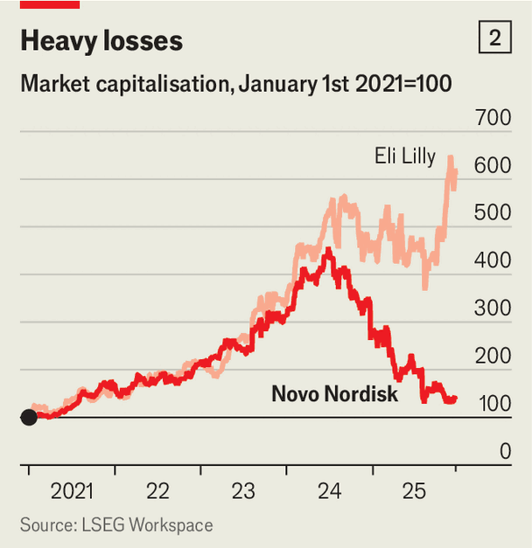
Novo, however, vastly underestimated the appetite for its new weight-loss jab. Mr Doustdar says it planned for demand to be three times that of Saxenda, an older and less-effective obesity drug. But five weeks after its launch in America, Wegovy had notched up the equivalent of four years’ worth of Saxenda prescriptions. Production could not keep pace. As a result, Wegovy was placed on America’s official shortage list, exposing it to “compounding” pharmacies, which are allowed to make copies of brand-name drugs when supply is insufficient and sell them at steep discounts. Although Wegovy was removed from the shortage list in February, loopholes mean that compound copycats are still available. Novo estimates that approximately 1m Americans use them.
Just as Novo’s supply was coming up short, Lilly launched Zepbound. In its own head-to-head trial, patients on the drug lost 20% of their body weight, compared with 14% on Wegovy. What is more, Lilly, which had observed the growth of Wegovy, began ramping up production well before it had gained approval for Zepbound. As a result, the drug has been readily available since October last year.
Lilly also realised early on that selling weight-loss drugs is unlike peddling most other medicines. Demand has been propelled not by doctors and insurers, but by patients themselves, many of whom pay for the treatment directly. From early 2024 Lilly began bypassing intermediaries and going straight to patients. It offered low-dose Zepbound vials online for $399, well below the wholesale list price of about $1,100 (and cheaper even after the discounts insurers receive). Lilly also teamed up with various telehealth providers to broaden its reach. Novo was late to adapt, launching its own direct offering a year after Lilly. In April it set up a partnership with Hims & Hers, a telehealth company, but this quickly collapsed, partly because the provider kept selling Wegovy copycats.
Novo was shaken out of its complacency in May, when the board booted out its chief executive since 2017, Lars Fruergaard Jorgensen. The changes to its leadership continued as the Novo Nordisk Foundation, which owns more than a quarter of the drugmaker’s shares, reasserted itself. Its chairman, Lars Rebien Sorensen, who ran Novo before Mr Jorgensen, rebuked the board for being “too slow” to grasp the shifts in the market for weight-loss drugs. After a purge in October in which seven board members resigned, Mr Sorensen took over as the drugmaker’s chairman.
A person close to both Mr Sorensen and Mr Doustdar says they will be “ruthless” in doing “what it takes” to recover. Change is already under way. In September Novo announced it would cut 9,000 jobs, more than a tenth of its workforce, including about 5,000 in Denmark, the biggest lay-off ever in the country. It has also halted the development of any drug not tied to diabetes or obesity.
That narrower focus is meant to clear the way for two new product launches next year. One is an oral version of Wegovy that, in trials, produced more weight loss than Lilly’s competing pill. Analysts worry that patients may balk at the requirement to take it on an empty stomach and wait half an hour before eating (Lilly’s pill carries no such strictures). But Martin Lange, Novo’s chief scientist, dismisses the concern, noting that diabetics are already taking oral semaglutide without fuss. The second launch is a higher-dose Wegovy injection that achieved weight loss comparable with Zepbound in trials. Novo hopes it will counter the perception that its treatment is less potent. This time around, it will have ample capacity in place for the drugs.
Novo is also making wider changes to how it does business. It wants to expand its direct channels, which currently account for a tenth of Wegovy prescriptions in America. To that end, it has struck deals with retailers including Costco and Walmart to sell its drugs. Partnerships alone, however, will not be enough. Mr Doustdar says Novo must build a “consumer mindset”; he wants it to think “more like Amazon”, offering customers the speed and flexibility they now expect.
Novo is revising its pricing, too. It recently began offering Wegovy to customers directly for $199 for the first two months, rising to $349 thereafter. (Lilly retaliated by cutting prices for Zepbound sold directly.) In November both firms also struck deals with the Trump administration to provide Medicare, the public insurer for the elderly, with discounted access to their obesity drugs, at roughly a third less than the price charged to commercial insurers. In return, Medicare agreed to cover the treatments for the first time.
The final shift in Novo’s strategy relates to how it will build its pipeline. Novo has traditionally relied on its own labs rather than acquisitions, but that is changing. In November it entered a bidding war with Pfizer, an American drugmaker, for Metsera, a biotech firm with a promising obesity drug under development. Pfizer won, but Mr Doustdar is unbothered. Treating hundreds of millions of patients requires openness to outside ideas, he says. He wants Novo to build a broad portfolio of obesity drugs so that it can offer each patient the treatment best suited to their needs.
Novo may well need outside help. Lilly has a formidable pipeline of its own and has experience across a wider range of diseases, which may be an advantage as obesity drugs are increasingly used to treat adjacent conditions such as kidney and liver problems. Other competitors are also eyeing the weight-loss business. Over 160 new obesity drugs are currently in development. Moreover, semaglutide will lose patent protection in several big emerging markets in 2026—including Brazil, China and India—exposing Novo to competition from generic drugs in those places, which are home to a large share of the world’s obese people.
Still, Novo’s biggest battle may be internal, as it seeks to transform itself from a cautious drugmaker into a nimble consumer brand. Mr Doustdar is not out of that tunnel yet. ■
To track the trends shaping commerce, industry and technology, sign up to “The Bottom Line”, our weekly subscriber-only newsletter on global business.
This article was downloaded by zlibrary from https://www.economist.com//business/2025/12/15/the-plan-to-rescue-novo-nordisk
Business | Cruising for a bruising

Retreating from EVs could be hazardous for Western carmakers
Governments are tempting a shift back to petrol

December 18th 2025

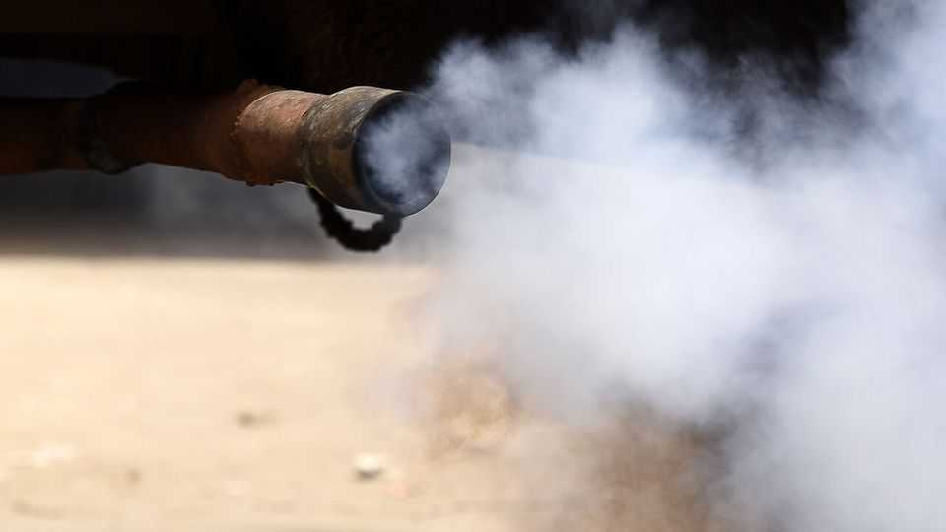
Safe motoring requires adjusting your speed to suit road conditions. Western carmakers know this well. Their customers are not embracing electric vehicles (EVs) as fast as once anticipated, and governments in America and Europe are pulling back on efforts to speed up the transition. On December 16th the EU dropped an earlier ban on the sale of petrol cars from 2035. The day before, Ford announced it would write down the value of its assets by $19.5bn, as it rethinks its EV strategy. But hitting the brakes on the transition away from petrol engines could also be dangerous for Western carmakers.
The EU’s commitment to speedily end petrol’s dominance of the road was always ambitious. But when unveiled in 2022, it did not seem far-fetched. One reason is that legacy carmakers, bewitched by the frothy valuation of all-electric Tesla, made big promises to investors in the hope that some of that magic might rub off on them. Volkswagen said that 70% of its European sales would be electric by 2030, and later increased this to 80%; for Stellantis (whose biggest shareholder, Exor, part-owns The Economist’s parent company) the figure was to be 100%. America’s General Motors looked conservative with its 2035 deadline for a complete transition to battery power.
But the route to electrification has been bumpy. This year only around one in five cars sold in Europe will be purely battery-powered. Growth is far from the trajectory needed to eliminate petrol cars by 2035. High upfront costs, a lack of smaller models, fears over insufficient charging infrastructure and toing-and-froing by governments over purchase subsidies have all weighed on demand for EVs.
Under pressure from carmakers and the governments of Germany and Italy, the EU is cutting the industry some slack. Rather than a U-turn, which some expected, the EU has opted for what UBS, a bank, describes as “moderate adjustments”. Instead of an outright ban, the estimated emissions from the new cars each company sells will have to be cut by 90% from 2021 levels by 2035. The remainder will have to be compensated for by measures including the greater use of European “green” steel.
Although the EU insists its new strategy “maintains a strong market signal for zero-emission vehicles”, sales of petrol and hybrid cars will continue as a result; according to Transport & Environment, a think-tank in Brussels, a quarter of the cars sold in 2035 could include some form of fossil-fuel power following the changes. The new measures, which still have to be ratified by the EU’s parliament and member states, also include changes to interim targets and the rules for commercial vehicles.
Over in America, where pure electrics account for fewer than a tenth of car sales, the transition has now stalled altogether. President Donald Trump’s preference for gas-guzzlers has led to a rolling back of incentives and other measures that supported EVs. Ford has realigned its plans in response. Most notably, it is ending sales of the all-electric version of its F-150 pickup, replacing it with a model with a small petrol engine that recharges the battery when needed, though it is pressing ahead on a lighter electric pickup set to hit the road in 2027 and recently signed a deal with Renault to develop small and cheap evs for the European market.
Reversing on EVs could be risky for Western carmakers. According to Schmidt Automotive Research, a consultancy, Chinese brands controlled 10.7% of the market for all-electric cars in western Europe in the first ten months of the year, a percentage point higher than a year before, despite the EU’s imposition of additional tariffs on EVs imported from the country in October 2024. Sales of Chinese hybrids, which are not subject to the new tariffs, have surged. Western carmakers are also coming up against fast-growing Chinese EV brands elsewhere in the world.
Eventually evs will become the cheaper option for customers, as production expands and costs fall. Western carmakers must therefore perform a tricky balancing act, profiting now from petrol cars while investing enough to stay competitive in EVs. Those that slow down risk giving their competitors an unassailable lead. ■
To track the trends shaping commerce, industry and technology, sign up to “The Bottom Line”, our weekly subscriber-only newsletter on global business.
This article was downloaded by zlibrary from https://www.economist.com//business/2025/12/17/retreating-from-evs-could-be-hazardous-for-western-carmakers
Business | The future of work

Job apocalypse? Not yet. AI is creating brand new occupations
Most needed: human skills

December 18th 2025

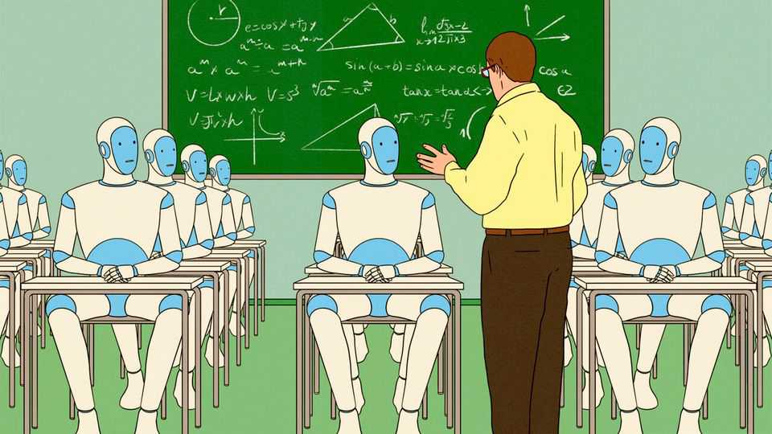
A mock job advertisement that has done the rounds recently calls for a “killswitch engineer” for OpenAI, maker of ChatGPT. The description requires the successful applicant to stand by servers all day and unplug them “if this thing turns on us”. Useful skills include the ability to “throw a bucket of water on the servers, too. Just in case.”
Despite widespread fears of job losses owing to the rise of artificial-intelligence (AI) agents, it is not all gallows humour. The technology is already creating new roles—to train agents, embed them in organisations and ensure that they behave. Many of these new jobs, moreover, require uniquely human skills.
Start with data annotators. No longer are they merely low-paid gig workers tediously tagging images. As AI models have become more advanced, experts in subjects such as finance, law and medicine have increasingly been enlisted to help train them. Mercor, a startup that has built a platform to hire boffins to help build bots, was recently valued at $10bn. Brendan Foody, its chief executive, says they earn $90 an hour on average.
Once bots are trained, teams of so-called forward-deployed engineers (FDEs) are needed to embed them into organisations. Palantir, a software giant that pioneered the concept, imbues them with derring-do. “In the beginning, it was just us. Two engineers dropped into a military base near Kandahar, handed minimal-but-clear marching orders from Palo Alto: ‘Go there and win,’” starts a typical blogpost by a former Palantir FDE.
In practice, their jobs are a blend of developer, consultant and salesman. They work on-site to customise AI tools for a client and get them up and running. FDEs are proliferating, albeit from a low base. Garry Tan, the boss of YCombinator, a startup factory, said recently that its young companies had 63 job postings for FDEs, up from four last year. As AI agents spread, their makers need to understand the human-facing domains in which their tools operate. A programmer who builds a customer-service agent, for instance, needs to have a feel for why a frustrated customer dials zero just to yell at a human.
Himanshu Palsule, chief executive of Cornerstone OnDemand, a skills-development company, uses Waymo, a fast-growing robotaxi firm, as an example of how the job of a developer is evolving. Waymo’s cars drive themselves from start to finish. But what if they break down, locking their passengers inside? Then comes the need for what he calls “the guy—or gal—in the sky”, a remote human troubleshooter who needs to understand not just the technology, but also how to handle frazzled passengers. Software engineers, Mr Palsule says, used to be sought after for their coding abilities, not their bedside manner. No longer. Writing code can now be done by an algorithm. “Your personality is where your premium is.”
Then there is the task of setting rules to ensure that AI agents do not bring chaos. The AI Workforce Consortium, a research group led by Cisco, a maker of networking gear, recently examined 50 IT jobs across rich countries. The fastest growing, even more so than AI programmers, was AI risk-and-governance specialists, who are typically involved in ensuring that bots do not leak data or cause a company’s operations to crash, among other things.
Responsible for bringing all these roles together is the chief AI officer, an increasingly popular addition to the c-suite as chief executives look to assure their boards that they are taking the technology very seriously indeed. Chief AI officers usually combine technical expertise with deep knowledge of a particular industry and a record of overhauling corporate processes. It is not a job for the faint-hearted. The typical large enterprise uses as many as 11 generative-AI models, according to IBM, an IT company, and is constantly being bombarded by vendors trying to sell agents for every conceivable function. Those in charge may already feel like reaching for that killswitch. ■
To track the trends shaping commerce, industry and technology, sign up to “The Bottom Line”, our weekly subscriber-only newsletter on global business.
This article was downloaded by zlibrary from https://www.economist.com//business/2025/12/14/job-apocalypse-not-yet-ai-is-creating-brand-new-occupations
Business | Bags not it

Luxury handbags may be shoddier than you think
Complaints about quality are a growing worry for brands from Chanel to Prada

December 18th 2025

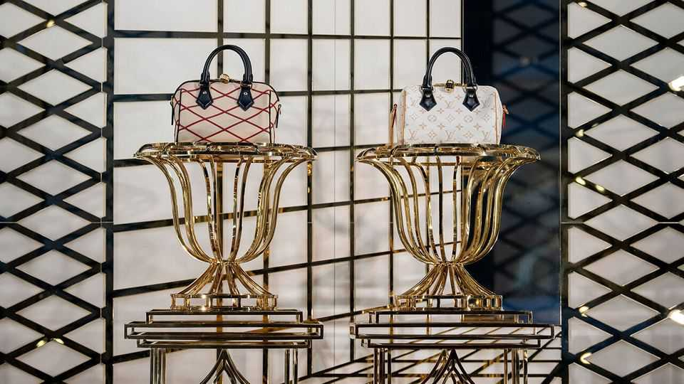
Those lucky enough to find designer wares under the Christmas tree this year will, for the most part, try hard to keep them in pristine condition. Yet an increasingly popular genre of online videos is dedicated to ripping them apart. Creators such as “Tanner Leatherstein” and “Fabricateurialist” show their audiences that even the priciest tier of clothes and accessories is rife with loose heel caps and shoddy stitching.
The most popular critiques by far—and the ones that worry luxury brands the most—are of their extravagantly priced handbags. A video of dye melting off a $2,000 tote from Goyard, a maker of posh leather goods, was watched 3.2m times this year. In a widely viewed sub-genre on TikTok, a short-video app, Chinese manufacturers claim (usually incorrectly) that various luxury bags are made in their country for pennies on the dollar.
Complaints about handbags are particularly concerning for luxury companies because they have been so central to their success. Often they are a brand’s best-known—and priciest—product. According to Bain, a consultancy, such leather goods accounted for 25-30% of the expansion in the global market for luxury items between 2019 and 2023, a period of roaring growth during which the industry’s total sales rose from €284bn to €369bn ($434bn).
Lately, however, the handbag business has taken a beating. Partly that is a consequence of the strain on middle-class wallets. It also reflects shifts in consumer preferences. Some well-heeled shoppers are prioritising splashy experiences over the designer wares that have become increasingly ubiquitous in recent years. LVMH, the industry’s colossus, now offers big-spending clients the chance to sleep in Christian Dior’s original studio.
Yet the slump in spending on luxury handbags has been especially pronounced, even as categories such as beauty and jewellery have continued to grow. Bain reckons that declining sales of leather goods accounted for three-fifths of the reduction in overall spending on luxury items since 2023, to an estimated €358bn this year.
Luxury brands, which ratcheted up prices for their handbags during the post-pandemic spending boom, have invited greater scrutiny of their quality. Shoppers eyeing Louis Vuitton’s Speedy 30 canvas tote will need to pay more than twice what they would have in 2019. The typical price of a luxury handbag has risen from between eight and 12 times the production cost to roughly 15 times, says Luca Solca of Bernstein, a broker. A series of investigations by the Italian government into sweatshop-like conditions in the country’s supply chain for luxury fashion have also not helped the industry’s reputation.
Meanwhile, those coveting a fancy handbag now have more alternatives. Online marketplaces for secondhand luxury goods are growing quickly. Vestiaire Collective, one such platform, says that handbags are its best-selling category, accounting for more than two-fifths of the value of purchases. Decent quality knock-offs known as “superfakes” have also lured some one-time luxury clients.
The luxury industry will not readily abandon the cash cow that is the cowhide bag. Nearly every major European label appointed a new designer this year, and will be hoping that the handbags that appear in stores in 2026 will rekindle interest from jaded shoppers. Brands such as Chanel and Prada have been working to fix quality issues by taking stakes in leather manufacturers and tightening oversight of production. Hermès has avoided quality concerns by having a single artisan produce its priciest handbags, including the Birkin, from start to finish. Its sales of leather goods rose by 13% year on year in the quarter from July to September. Craftsmanship, it seems, still pays. ■
To track the trends shaping commerce, industry and technology, sign up to “The Bottom Line”, our weekly subscriber-only newsletter on global business.
This article was downloaded by zlibrary from https://www.economist.com//business/2025/12/18/luxury-handbags-may-be-shoddier-than-you-think
Business | Bartleby

How to conduct a job interview
The worst way to select people, except for all the others

December 18th 2025


If you had to construct a really bad way to make an important decision, you might come up with something like the stereotypical job interview. You must intuit a complete stranger’s ability and character in a small window of time, before making a commitment that could last decades. Some candidates will be so tense that asking them how their journey was will cause them to have a nervous breakdown. Everyone will be pretending to be someone they are not.
Most of your questions will be entirely predictable; most of the answers will have been rehearsed. To jolt candidates out of their comfort zones, you will ask one or two questions that bear no relevance to anything. If you were a cat trapped in a washing machine, how would you escape? If Jesus were asked who he would most like to have at a dinner party, why should he pick you?
Even with these oddball questions, the spread of AI tools means you cannot be totally sure that a human is the one answering. Jonathan Black, who runs the careers service at Oxford University, tells the story of a student asking an employer to repeat something “because the computer didn’t hear it”. To cap it all, you will be aware that you haven’t had lunch and still have another five interviews to do that day.
If this sounds like an irretrievably broken process, then the truth is more complex. Interviews have a reasonable claim to be the most useful part of the selection process. But they have to be conducted in the right way. And their flaws must be compensated for.
Researchers try to assess the validity of selection processes by correlating the scores that successful candidates get during an application with their subsequent performance in their new jobs. A meta-analysis of such research, published in 2022 by Paul Sackett of the University of Minnesota and his co-authors, found that structured job interviews have the most predictive value of any recruitment method, ahead of things like assessment centres or psychometric tests.
There are two big caveats to this endorsement of interviews, however. The first is the importance of the word “structured”. According to Winfred Arthur of Texas A&M University, that usually means a standardised set of job-related questions which are put to every candidate and each of which is scored according to an agreed system. (You could still ask that question about the cat in the washing machine, in other words, but you had better have a clear idea of what counts as a good answer and why.) An unstructured interview, in which hiring managers make things up on the fly and reach decisions based on gut instincts, has less than half the predictive validity of a structured one.
People have been preaching the gospel of structured interviews for so long that the mystery is why they are not more common. Perhaps interviewers worry that predictable questions are likely to tell them less, even though successful firms like Amazon go out of their way to offer advice on what candidates can expect in an interview. Perhaps managers balk at the time and thought required to construct a truly rigorous process, even though few decisions are regretted as much as a bad hire.
Mr Arthur’s best explanation is that structured interviews remove a sense of agency from interviewers. “You’re saying you can’t ask the questions you want…and they’re going to say to you: ‘What the heck? What am I a manager for?’ ”
The second caveat is that even textbook interviews are not that good at predicting how candidates will do. According to Chris Hartwell of Utah State University, the research suggests that less than 20% of a person’s actual job performance can be attributed to scores in a structured interview. So it makes sense to layer lots of other assessments on top: specific personality tests, work samples and the like. Mr Hartwell says that a battery of measures might together be able to predict as much as 30-40% of a candidate’s eventual performance, an outcome he describes as “not great, but not bad”.
That’s because there is no foolproof way to judge an unfamiliar job candidate. Firms can tip the scales towards success once someone has joined, by offering proper onboarding and training. They can ensure that known quantities are in the running for jobs, by investing in internship programmes and encouraging existing employees to apply for open positions. But if you are interviewing a stranger for a job, it is best done with a script, a scoring system and a hefty dose of realism. No question. ■
Subscribers to The Economist can sign up to our Opinion newsletter, which brings together the best of our leaders, columns, guest essays and reader correspondence.
This article was downloaded by zlibrary from https://www.economist.com//business/2025/12/18/how-to-conduct-a-job-interview
Business | Schumpeter

SpaceX, OpenAI, Anthropic and their giga-IPO dreams
Will more capital trump more scrutiny?

December 18th 2025


A DECADE OR so ago, before venture capitalists and buy-out barons began whipping out their chequebooks, going public was the obvious choice for ambitious businesses. A stockmarket listing offered startups both cash, courtesy of deep pools of capital, and cachet, conferred by a willingness to subject themselves to the scrutiny of millions of investors. It was possible to attain a $100bn-plus valuation while staying out of the stockmarket spotlight: Lidl may have pulled it off with cheap groceries, Mars with confectionery, Cargill peddling the sort of stuff that goes into Mars bars, Gulf and Chinese natural-resource firms extracting less digestible commodities, Vitol and Trafigura trading these. But if it was explosive growth you were after, the real rocket fuel was to be found in public markets.
Maybe it still is. Reports have recently surfaced that SpaceX, a rocketry and satellite firm founded by Elon Musk, was sounding out investment bankers about an initial public offering (IPO) as soon as next year at a valuation as high as $1.5trn. In early December Anthropic, an artificial-intelligence darling valued at roughly $180bn in a recent funding round, was also said to be exploring a listing. It may want to pip OpenAI, the $500bn byword for the AI boom, which is likewise rumoured to be increasingly IPO-curious.
Any of these deals could be the biggest in America since Alibaba, a Chinese e-commerce titan, sold $25bn of shares on the New York Stock Exchange in 2014. It could be the largest anywhere since Saudi Aramco, the world’s oil colossus, raised nearly $30bn in 2019 at a valuation of nearly $2trn in Riyadh.
This sudden interest in public markets seems out of character for the trio. None has struggled to entice private backers. They have so far secured a total of nearly $120bn in funding. Anthropic, which turns five in January, and even ten-year-old OpenAI look youthful by contemporary IPO standards; the typical American company now goes public at 16, four years later than a decade ago. SpaceX, which has shunned the stockmarket for 23 years, looks ancient. In each case a listing also presents thorny dilemmas.
The obvious reason for all three to pursue an IPO is access to ever more capital. SpaceX is developing Starship, a reusable launch system with which it hopes to lift 150 tonnes to orbit on every flight, roughly double the payload of any rocket currently in operation. OpenAI has said it plans to invest perhaps $1.4trn in computing power over the coming years. If the younger and smaller Anthropic wants to keep up, it too must splurge on data centres.
Even as the trio’s capital needs grow, the private market may stop expanding. After swelling at a compound rate of 10% a year between 2012 and 2021, global private assets under management have since plateaued at just over $20trn. Limited partners are demanding that venture-capital and private-equity funds disburse some proceeds before asking for fresh cash.
Moreover, as the unlisted giants’ successive funding rounds balloon in size—OpenAI’s latest came in at $40bn, larger than any IPO ever—so do the typical contributions from what is by public-market standards a puny number of participants. At some point that may become an unacceptable concentration of risk for all but the most fearless, or reckless, financiers out there. The public- equity market, with a global market capitalisation of some $130trn, is far larger and its investor base far less concentrated.
In its aggregated wisdom, however, it is also far more discerning. This discernment is what SpaceX, OpenAI and Anthropic would be trading off for cash. In none of their cases is the trade-off comfortable.
For SpaceX the main headache would relate to corporate governance—or rather, if you treat Tesla as a listed proxy for Mr Musk’s assorted ventures, a troubling lack of it. At Tesla he has had run-ins with regulators (who fined him and Tesla $20m apiece in 2018 for his remark on Twitter that he had “funding secured” to take the carmaker private) and judges (last year one in Delaware voided a supersize pay deal after concluding that Tesla’s board was “beholden” to him). His growing fortune, which soared from $470bn to $638bn on December 15th after SpaceX was valued at $800bn in a secondary share sale, seems likely if anything to make him feel more emboldened.
At least SpaceX makes money. It is thought to be generating cash and turned a profit for the first time in 2023. For their part, OpenAI and Anthropic are burning enough to make a Starship launch pale by comparison. OpenAI is likely to make a net loss of around $12bn this year on revenue of a comparable size. It reportedly expects to torch another $115bn in cash before becoming profitable in 2030. Anthropic thinks it may break even a couple of years earlier, but will still bleed billions beforehand.
It will be a while before OpenAI, Anthropic and even SpaceX generate net profits comparable to those of Alibaba, which was $4bn in the black in the 12 months before its IPO, let alone Saudi Aramco, which booked $111bn, then the blackest ever for any company. The last time large profitless tech darlings went public, in the IPO wave of 2019, Uber needed four years and positive cashflow for its shares to rise reliably above their IPO price. You would be better off today having invested in the S&P 500 index.
The star trio may think they have no choice but to list before big profits arrive. SpaceX will look less exceptional once rival space companies like Blue Origin have narrowed the technological gap. OpenAI and Anthropic face fierce competition already. They could remain private and risk running out of the capital needed to stay ahead. Or they go public and risk markets’ impatience over profits. Either way, their lofty valuations will soon be put to the test. ■
Subscribers to The Economist can sign up to our Opinion newsletter, which brings together the best of our leaders, columns, guest essays and reader correspondence.
This article was downloaded by zlibrary from https://www.economist.com//business/2025/12/16/spacex-openai-anthropic-and-their-giga-ipo-dreams

Finance & economics
- Where America’s most prominent short-sellers are placing their bets
- Meet the American investors rushing into Congo
- This Christmas, raise a glass to concentrated market returns
- Crypto’s real threat to banks
- Watch who you’re calling childless
Finance & economics | The short view

Where America’s most prominent short-sellers are placing their bets
We interview three financial sleuths

December 18th 2025


“I have to giggle,” says Jim Chanos, asked if investors have become overly optimistic about artificial intelligence. “We’ve got to the ‘data-centres-in-space’ stage of the cycle.” Firms from SpaceX and Blue Origin to Alphabet plan to shrug off earthly constraints on the computing clusters that power AI, and launch them into orbit. To Mr Chanos, who is perhaps Wall Street’s most experienced short-seller, such pharaonic ambitions immediately ring alarm bells. Yet even he hesitates to say definitively that share prices are in a bubble: “That’s something we’ll only be able to tell with hindsight.”
You might think that short-sellers like Mr Chanos, who bet on prices falling rather than rising, are looking forward to a bonanza. With plenty of stockmarkets near all-time highs, there is surely no end of juicy targets. Conventional ways of valuing shares (which compare prices to fundamentals such as underlying earnings, sales or assets) show American stocks to be nearly as expensive as during the dotcom bubble, or even more so (see chart 1). And investors convinced of the profitmaking potential of AI are backing companies to fire data centres into space. With hopes so high, betting on disappointment has rarely seemed so tempting.
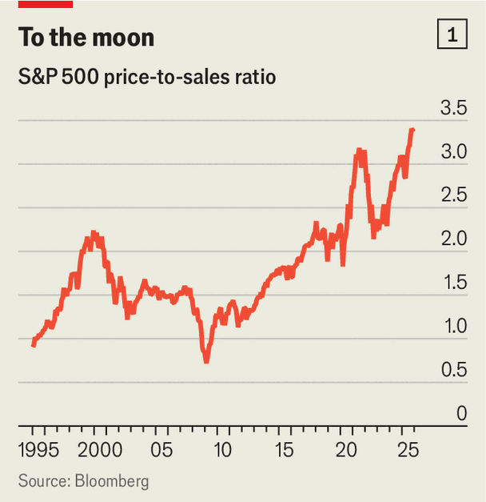
To test this idea, The Economist spoke to three of America’s most prominent shorts. Mr Chanos is best known for having predicted the downfall of Enron, a fraudulent energy-trading giant that collapsed in 2001. Carson Block rose to fame in 2011 after shorting Sino-Forest, a forestry firm that was felled amid a fraud scandal. One of Andrew Left’s biggest hits was Valeant, a drugmaker that in 2015 was Canada’s most valuable firm. Though their bets on fraud get the most attention, all three also hunt for shares that simply seem unjustifiably expensive.
Despite their bearish bias, our group’s views neatly spanned the range of those held by other professional money managers. Mr Chanos worries about “exuberance similar to 2021, or to 25 years ago”, noting that retail traders are even more exposed to the stockmarket than they were in the dotcom era. Mr Block is more sanguine. “I don’t think there’s this big bubble here,” he says, since the firms with the highest valuations have shown solid earnings growth. Mr Left reckons “the market’s too thick and the technology’s too exciting” for there to be a crash. “But a deflation could happen,” he says, when “the cycle turns”.
All agree, however, that predicting this turn is impossible. “To go pick the point where Wall Street has its come-to-Jesus moment? I just don’t think you can do that,” says Mr Left. Mr Chanos draws a comparison with the boom in internet stocks that ended in March 2000. “The market just started going down—there was no narrative about why.” In fact, sales at telecoms firms kept increasing for several quarters. But when every marginal buyer at a certain price found a seller, and the price stopped rising, “that was when people started worrying about risks.”
Mr Chanos suspects the top of this market cycle will look similar. Share prices will peak, then “we’ll begin to see weakness in the AI story after the fact,” whether from cancelled orders or failure to convert technology into profits. Will short-sellers be able to spot the reversal in time to turn a profit? Yes, says Mr Left, “but only after missing the first 15-20%.” Then, the main sign that a prolonged bear market has begun would be firms cutting spending, or “saying they’ve experimented with AI and it’s not been transformational”.
For Mr Block, meanwhile, the key indicator that the cycle has turned would be a sharp rise in unemployment. He thinks a crucial driver of the bull market has been the monthly flow of retirement savings into passive index funds, which buy shares in the biggest firms regardless of their price. An abrupt rise in joblessness would reduce that flow, and with it support for share prices to keep rallying.
Whenever the next bear market begins, there are reasons to worry about its impact. Mr Left points to uncertainty over how AI will develop, and which companies will exploit it most profitably, as a source of potential losses for shareholders. Then there is the question of who will pay for firms’ vast AI-related capital expenditures. Big tech firms, for instance, are set to invest $5trn between now and 2030; JPMorgan Chase, a bank, estimates they will need additional revenues of some $600bn a year to make these worthwhile. “It could [come from] businesses or consumers,” says Mr Left, “so which one is it? Do you really want to be the person trying to guess?”
The second reason to fear a bear market is that American households have more to lose from one than ever before. Stock ownership now accounts for over 30% of their total assets, the highest since the Federal Reserve started collecting such data in 1945 (see chart 2). At the peak of the dotcom bubble the equivalent figure was 27%.
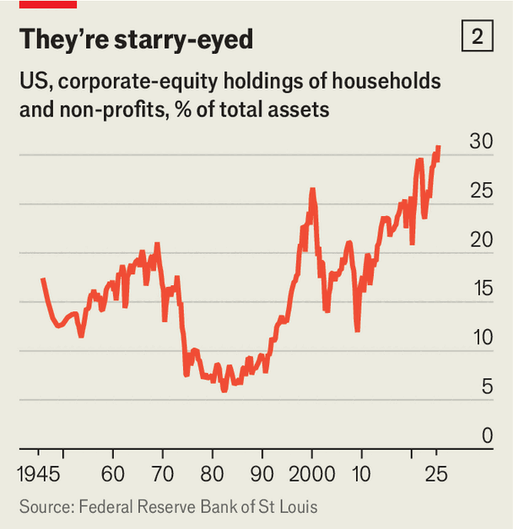
Moreover, Mr Chanos believes that retail traders have concentrated their bets on the riskiest assets. He notes that the average account on Robinhood, a popular trading app, holds around $12,000. Mr Chanos estimates that account values dropped by 7% in October and November, when the the stockmarket wobbled, but ultimately recovered. That balances nevertheless fell suggests they were “way out there on the risk spectrum”, invested in stocks that dropped more and recovered less than the wider market.
The final big risk is that unscrupulous firms have used the boom to conceal wrongdoing. “The fraud cycle follows the financial cycle,” says Mr Chanos, “and the longer the financial cycle goes on, the more egregious the fraud.” It does not help that many short-sellers who once ferreted out such misdeeds have been defanged. Mr Chanos’s firm, once the world’s biggest short-selling specialist, is now a family office, having closed to external investors in 2023 as a result of client withdrawals.
Elsewhere, law-enforcement agencies have taken aim at the shorts themselves, rather than the companies they suspect of fraud. America’s Department of Justice conducted a wide-ranging criminal investigation on short-selling in 2021. This included serving Mr Block’s firm with search warrants and subpoenas—a “really large, cold glass of water in the face” that forced him to consider other business lines. He still places short bets, but now also runs quantitative and long-only funds. Mr Left spoke to your correspondent between court hearings: the same probe left him facing charges including 17 counts of securities fraud.
When today’s optimism finally fades, in other words, markets will have fewer veteran sleuths working to uncover any corruption it has masked. That risks setting a dangerous precedent for the next boom. For all the obvious dangers of a stockmarket crash, the worst may remain hidden. ■
For more expert analysis of the biggest stories in economics, finance and markets, sign up to Money Talks, our weekly subscriber-only newsletter.
This article was downloaded by zlibrary from https://www.economist.com//finance-and-economics/2025/12/16/where-americas-most-prominent-short-sellers-are-placing-their-bets
Finance & economics | Minefield

Meet the American investors rushing into Congo
They are taking on war, corruption and China

December 18th 2025

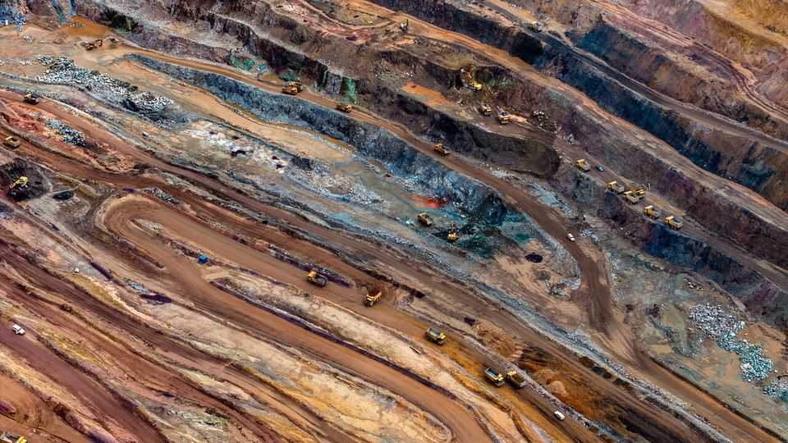
NEAR ZAMBIA’S border with the Democratic Republic of Congo, Josh Goldman, the boss of an American mining firm, is discussing his next venture. KoBold Metals is gearing up to do business in Congo, where one of the world’s biggest known lithium deposits is folded between layers of granite. The country is also home to myriad conflicts. But KoBold has been unable to resist. “It’s the most mineral-rich place on earth,” says Mr Goldman.
American firms have generally avoided Congo on account of its conflicts, corruption and distance. Meanwhile, Chinese rivals appear to operate with ease. Donald Trump wants to change that. On December 4th, the president inked deals with Congo and Rwanda—which is backing the M23 rebel group against the Congolese government. Under the so-called “Washington Accords” America will help oversee a peace deal in the region. In return, Congo will “facilitate investments” by American firms, such as KoBold, coveting access to some of the world’s most sought-after minerals, such as lithium, cobalt and copper.
The American government maintains a list of 60 such “critical minerals” used in cutting-edge tech including weapons, wind turbines and semiconductors. Uncomfortably for America, most of these materials are supplied by China. Mr Trump wants to diversify that supply, leading him to float annexing Greenland and sign a minerals deal with Ukraine in April. In that deal America agreed that any future military aid given to Ukraine would be paid for with a share of the country’s future resource revenues. The Congo deal has a similar rationale. And, as in Ukraine, the agreement has not stopped the fighting.
But, though American firms have made little progress in Ukraine, Congo is abuzz with Western activity. In August KoBold became the first American firm in a decade to hold a Congolese exploration licence. Earlier in December Mercuria, a Swiss firm, announced a $1bn partnership with Gecamines, a state-owned firm. Other enterprising types, often claiming close connections to Trumpworld, are trying to get in on the action, too. Manono, the deposit KoBold is preparing to drill, could on its own produce more lithium than America imports each year.
But these treasure hunters will have their work cut out in the east of the country, especially parts where M23, and thus Rwanda, is in de facto control. Mining in such a dangerous place is difficult. Whether American firms can muscle in will be a test of Mr Trump’s deal diplomacy.
One nationwide challenge is corruption. Between 2007 and 2018, Glencore, a Swiss-British miner and the biggest Western investor in Congo, admitted to paying bribes to open a copper mine in Kamoto, near the border with Zambia, costing it at least $1.1bn in fines. One previous owner of Manono has been accused of paying middlemen for permits, and another is facing corruption charges from the Australian government. Many investors believe it is impossible to get permits without bribes.
But KoBold insists that operating in the country need not require bungs. The firm, backed by Bill Gates, has the slick efficiency of a Silicon Valley startup. What accounts for its optimism? Mr Goldman says that getting things done in Congo has become easier since America showed interest. “Now we know the US government wants to see us succeed,” he says, “and tells the [Congolese] government that they want to see us succeed.”
On the Zambian border, every KoBold employee wears an American flag on their arm, “to show that we have the weight of America behind us”, one explains. According to other investors, Congolese officials want to please Mr Trump, in the hope that he will press Rwanda to stop supporting M23. Mr Trump’s backing, say several investors, has knocked down the sort of conditions that led firms to turn to bribery.
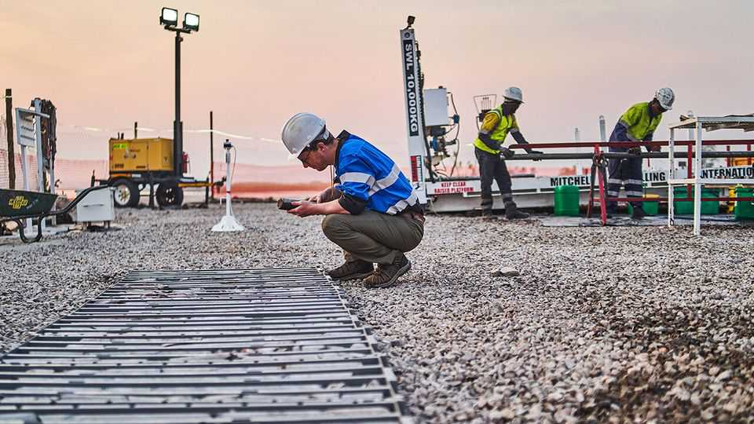
Even so, dealing lawfully with the Congolese government is a headache. Officials grant and withdraw permits with little notice. No single authority collects tax, so foreign mining firms have paid 45 different state organs. Firms struggle to distinguish a genuine revenue collector from pretenders. Royalties are negotiated on an ad hoc basis, exposing firms to dodgy dealings.
The Trump deal settles some of these issues, such as with an upfront agreement on tax. But much informality remains, exposing foreigners to the litigious excesses of Congolese officials. The country has been in court with over half the foreign firms in its mines since 2002. For explorers such as KoBold, which often take over a site after others have attempted to find minerals, disputes can create lingering problems. One Chinese firm that previously invested in Manono claims to still own 15% of a project in the area.
The hope is that a wave of American investment will break China’s grip on the country. In 2007 Congo handed a tax break to Chinese miners until 2040, in return for investments worth $9bn (only $6bn materialised). Back then Western governments showed scant interest in stopping their firms from selling to Chinese buyers. When Mr Trump returned to office in January 2025, China owned 80% of Congo’s mining output, including Tenke Fungurume, a mine once owned by an American firm, and now the second-biggest source of cobalt in the world.
Under the deal, Congo must keep its most promising mineral finds, a so-called “strategic asset reserve” (sar), for American investors. Firms from allied countries can also bid for rights, but America has the final say. The SAR reportedly includes the Rubaya mine, which supplies 15% of the world’s coltan, a metal used in smartphones. The goal is to block China from buying sites explored by Western firms and deplete its pipeline of projects.
Few would have expected Mr Trump’s deal to enjoy such early success. Congo has become more investible for American firms. But can this streak continue, and China’s mining dominance in the country be challenged? Officials will need to sustain their enthusiasm. Eventually exploration must give way to mining, which will test the risk appetites of more conservative resource majors. KoBold, for its part, is planning its own mine, but Mr Trump, or other investors, could well lose patience before then.
Peace will matter, too. Both Mr Trump and Congo’s government may be promising each other something that neither can deliver. Several assets eyed by America, including the Rubaya mine, are controlled by M23. Mr Trump’s half-hearted efforts at enforcing a truce mean that the prospect of tapping such deposits remains remote. In Congo, as elsewhere, Mr Trump has prioritised profit-making above all else. That may not be enough. ■
For more expert analysis of the biggest stories in economics, finance and markets, sign up to Money Talks, our weekly subscriber-only newsletter.
This article was downloaded by zlibrary from https://www.economist.com//finance-and-economics/2025/12/18/meet-the-american-investors-rushing-into-congo
Finance & economics | Former glory

This Christmas, raise a glass to concentrated market returns
A surprisingly large share of companies lag far behind their former greatness

December 18th 2025


Nineteen years is a long time to wait for almost anything. When it comes to a share-price recovery, it can feel like an eternity. Bank of America’s stock touched a new record on December 12th (and again on December 15th). That has at long last taken the world’s second-largest bank by market capitalisation back above its share-price peak in 2006, before the ravages of the global financial crisis.
Some companies have waited even longer before climbing back to old highs. On December 10th shares in Cisco, a networking tech firm, finally surpassed levels reached in 2000, during the dotcom boom. In Japan, a deep slump that began in 1989 long burned through the stockmarket. The Topix index of stocks climbed to a new all-time high only last year.
Overall, indices around the world are far above their pre-financial-crisis highs: global share prices have risen by 135% since their peak in October 2007. But beneath the surface, the phenomenon of laggardly stocks is surprisingly common. Of the roughly 10,000 listed companies currently worth more than $100m and which existed before November 2007, around 36% remain below the share price they reached on the eve of the crisis. If anything, the measure is an underestimate, because it does not count companies that have collapsed entirely, or whose market value has fallen below the cut-off.
Even in America, one in four stocks is down after the best part of two decades. Some are heavyweights: Verizon, a telecoms giant worth $172bn, is still below its 2007 peak. Recovery will be longer in the making for another bank, Citigroup, which is still down about 80% from its high. Even in America’s technology sector, the jewel in the crown of a long and profitable bull market, 22% of firms trade for less than their pre-crisis levels.
The share of long-term losers is higher in other markets. About 42% of German stocks, 53% of British stocks and 70% of those of firms in Hong Kong sit below their 2007 levels in dollar terms today.
If the figures are shocking at first glance, raise a glass to the powerful force of concentrated returns this Christmas. For all the worry about the weight of a few large firms in equity markets, a small number of stocks usually account for the bulk of returns. The share prices of Apple, Nvidia and Netflix are respectively up by 4,043%, 19,920% and 24,807% since 2007.
The trend is not just a curiosity of today’s bull market, either. Hendrik Bessembinder of Arizona State University notes that among listed American firms from 1925 to 2023, most have negative returns. Less than 3% of stocks account for all the increase in shareholder wealth in that time.
Bank of America will cheer its return to old glory. But for most investors, the fact that a large share of firms live in the shadows of their former greatness is not a problem. The many are not so important. It’s the few that count. ■
For more expert analysis of the biggest stories in economics, finance and markets, sign up to Money Talks, our weekly subscriber-only newsletter.
This article was downloaded by zlibrary from https://www.economist.com//finance-and-economics/2025/12/17/this-christmas-raise-a-glass-to-concentrated-market-returns
Finance & economics | Buttonwood

Crypto’s real threat to banks
The industry is supplanting Wall Street’s privileged position on the American right

December 18th 2025

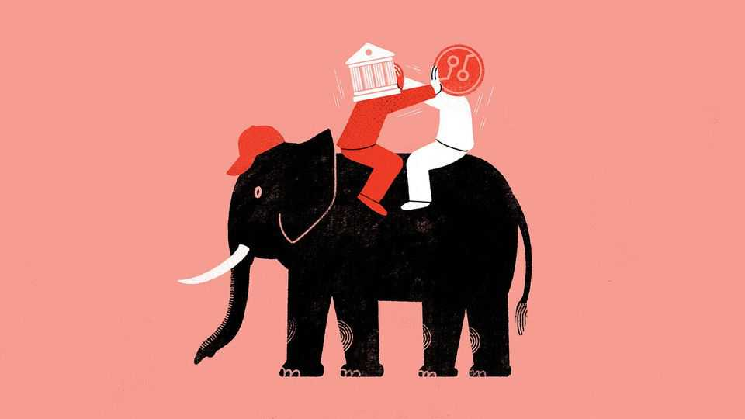
“First they ignore you, then they laugh at you, then they fight you, then you win.” That quote is often attributed to Mahatma Gandhi, though the Indian independence leader never said it. To the crypto industry, the apocryphal phrase is a popular mantra. Digital pioneers have endured snootiness, mockery and derision from Wall Street’s elites. Now, they are mightier than ever.
Bankers and digital-asset purveyors alike have had a bountiful year. The crypto industry has gained ground, largely owing to the legal certainty given to stablecoins by the GENIUS Act passed in July. Bank stocks have climbed by 34% since Donald Trump’s election victory, on expectations of friendlier regulation. Even among bankers who find Mr Trump objectionable for other reasons, vanishingly few prefer the regulatory approach taken under Joe Biden.
Nonetheless, tension between the old and new is growing, and the threat from crypto is bigger than many bankers once believed. Even though lenders stand to benefit from deregulation, their once privileged position as the financial aristocracy of the Republican Party looks shakier than ever before. Sharing that role with crypto-industry upstarts poses a long-term threat.
The immediate concern for bankers is stablecoin regulation. The Genius Act prohibits stablecoins from offering yields to their buyers, a concession that was intended to keep the coins from sapping demand for bank deposits, and thereby reducing lending. But a workaround means stablecoin issuers such as Circle (which issues the popular USDC coin) can share their revenue with exchanges like Coinbase, which in turn pay “rewards” to the users buying stablecoins. Banks want this loophole closed.
But yields are not the only issue. Elsewhere, crypto is threatening to dip below the velvet rope. In October Christopher Waller, a Federal Reserve governor and candidate for chair, alarmed bankers when he suggested more firms might gain access to the central bank’s payment rails. Mr Waller later walked back the statement, saying holders of such Fed accounts would still need bank charters.
At last, on December 12th, crypto jammed its foot in the door of the federal banking system. An American banking regulator approved new national bank-trust charters for five digital-finance firms, including Circle and Ripple. Although the designation does not qualify the institutions to take deposits or lend money, it does let them provide custody for assets nationally, rather than relying on a patchwork of state-level approvals. Banks had pressed regulators not to approve charters for the crypto intruders.
On its own, each development—a speech, a banking charter, some regulatory workarounds by stablecoin issuers—could be written off as small beer. Taken together, though, they are a serious threat to traditional banks. Lenders have already had their central roles in making loans and brokering trades chewed away by private credit and whizzy marketmakers outside the banking system. They are loth to lose out again.
Crypto firms believe banks’ preferential treatment creates an unequal playing-field and hurts competition. The general argument may be reasonable, but offering “rewards” in the place of yields on stablecoins is a brazen side-stepping of the rules. That legislators who banned yields on assets only months ago are not stepping in to end the practice reveals the real problem for banks: their sharp loss of political clout.
Banks are no longer the foremost financial constituency of the Republican Party. Instead, crypto has found a home among the countercultural, anti-elite politics of the new American right. The industry’s largest political action committees boast hundreds of millions of dollars in cash ready to be deployed in the 2026 midterm elections, which always helps. Where the interests of banks clash with those of the newcomers, the outcome is no longer certain, or perhaps even likely to fall in their favour.
Bankers may have bristled at the Biden administration’s regulatory squeeze. But in a considerable irony, they now find themselves relying on a group of Democratic Party senators who are more worried about the camouflaged payment of stablecoin yields, as well as risks related to money-laundering. In their opposition to crypto firms getting banking licences, America’s biggest lenders find themselves in bed with trade unions and centre-left think-tanks. As Gandhi also did not say, “The enemy of my enemy is my friend.”■
Subscribers to The Economist can sign up to our Opinion newsletter, which brings together the best of our leaders, columns, guest essays and reader correspondence.
This article was downloaded by zlibrary from https://www.economist.com//finance-and-economics/2025/12/15/cryptos-real-threat-to-banks
Finance & economics | Free exchange

Watch who you’re calling childless
Women in America are having as many babies over their lifetimes as they did two decades ago

December 18th 2025


IMAGINE a colony of sentient lizards, living on a distant planet. It comprises 100 females and 100 males. Each lives for 100 years. There is only one male and one female of any age (eg, one 15-year-old female, one 74-year-old male). The planet is safe and peaceful: no lizards die from disease or violence. But every year the two 100-year-olds pass away. And every year two babies are born, the fruits of an unusual reproductive cycle. At age 24 every female produces a male baby; at 26, a female. She will never have any more. The population of Planet Lizard is thus fixed at 200.
Now imagine an asteroid hits Planet Lizard, altering its atmosphere and climate. At first little seems to have changed. All the lizards miraculously survive, and they rejoice at their good fortune. But it soon becomes clear something is wrong: the two females, aged 24 and 26, who are due to produce baby lizards do not. The population shrinks to 198. The next year, the same thing happens. The colony dwindles to 196. Concern turns to panic. Prophecies of extinction are splashed across the front pages of lizard newspapers. Councils of senior lizards are convened to devise plans to revive fertility. Nothing works. Ten years after the asteroid struck, the remaining 180 lizards are resigned to their fate: ageing, death and extinction, two by two.
And then: a miracle. The two females who failed to have babies at 24 and 26 are suddenly fertile, at 34 and 36. Soon, two infants are born, to general ecstasy. The next year, the miracle is repeated. And so on. The population stabilises and (a century later) climbs back to 200. Ultimately, the asteroid changed the timing of lizard births but not their number.
This fable may seem silly, but it contains a lesson. For decades, across the West, the commonest measure of how many children women have, on average—the total fertility rate (tfr)—has been dropping. It has fallen well below the “replacement rate” (needed to keep a population constant) of 2.1. Between 2007 and 2022 America’s tfr dropped from 2.1 to just 1.6. Warnings of probable population decline, including from this newspaper, abound. Pronatalists are casting around frantically for solutions.
A shrinking (human) population could be cause for concern. It means fewer working-age people to support the old. Fiscal crisis could loom. Fewer minds would yield fewer innovative ideas. Less scope for division of labour would mean a less efficient economy.
But tfr has flaws. It measures the number of children a hypothetical woman might have in her life, based on current birth rates for women of different ages. To calculate it, you start by dividing the total number of births to a given group of women (aged, say 15-19 or 35-39) by the number of women in that group. Those group birth rates are then added up and multiplied by the number of years in each group (ie, five). The result is the number of children a woman will have if, aged 15-19, she has the same number of babies as the average woman of 15-19 is having today, then the same number at 20-24 as the average woman of 20-24 is having today, and so on. It is almost sure to be wrong. That does not make TFR useless. It captures what demographers call “tempo”—the timing of an event, like a birth. But as a measure of “quantum”—the total number of births—it is likely to mislead. In effect it assumes that a young woman will have babies not only at the same rate as her contemporaries, but also at the same rate as women five or ten years older. That is not necessarily so.
A different measure, the completed fertility rate (CFR), captures the average number of births a woman has by the end of her child-bearing years (put at 44). America’s CFR has not fallen at all over the past two decades. In fact, according to an analysis of census data by Mike Konczal, a former Biden administration economist, it has risen slightly, from 1.91 in 2000 to 1.97 in 2024.
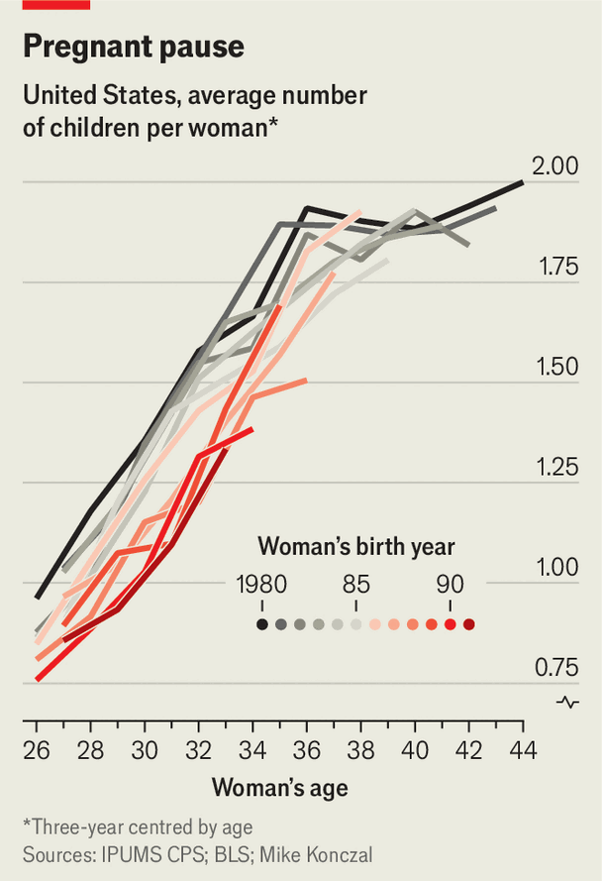
Back on Planet Lizard, the TFR dropped to zero overnight. After ten years, when females started having babies again, it jumped back to 2. The CFR never budged. The timing of births simply shifted, and eventually the tfr caught up with the cfr. In a doomsday scenario, in which the asteroid did render the lizards infertile, the cfr would have dropped to meet tfr.
Which scenario is playing out in the West? Many demographers, including Lyman Stone, of the Institute for Family Studies, a think-tank, point out that tfr is typically a strong predictor of cfr. But there is evidence that women are deferring, not forgoing, childbirth. In 2000 by age 26 the average American woman had produced one child; the average 32-year-old, 1.6 children; the average 40-year-old, 1.9. In 2024 the average 26-year-old had 0.6 children and the average 32-year-old 1.2. But the average 40-year-old has still had 1.9, having delayed in her 20s and caught up in her 30s.
Does this mean, as with the lizards, that tfr will rise to meet cfr? Historical examples are suggestive. As women delayed childbearing in Sweden the tfr dropped sharply in the 1980s, before recovering in the 1990s (though it has fallen since). The cfr, at around 2, barely budged. In America the question is pertinent. The commonest ages are 33 and 34, because of a baby boom in 1990 and 1991. Women aged 34 have had, on average, 1.46 children each. As this group approaches their 40s, many more births may be on the way. As for younger women, those born in 2000 have had fewer children than those born in 1990 had had by 2015. Perhaps they will catch up—but that won’t be known for at least a decade.
To be sure, an average of just under two births per woman is still not “replacement level”. But if that truly is the long-term average, panic is scarcely justified. It would mean a gradual population decline: tricky, but much more manageable than implied by TFR. It is easy to fear the end times. But the problem may be one that humans, like our faraway lizards, never face. ■
Subscribers to The Economist can sign up to our Opinion newsletter, which brings together the best of our leaders, columns, guest essays and reader correspondence.
This article was downloaded by zlibrary from https://www.economist.com//finance-and-economics/2025/12/18/watch-who-youre-calling-childless

Science & technology
- A debate is raging over the origins of an elusive cousin to modern humans
- Saudi Arabia wants to host the world’s cheapest data centres
- How dogs make teens feel less anxious
- Are some types of sugar healthier than others?
Science & technology | Palaeontology

A debate is raging over the origins of an elusive cousin to modern humans
Who were the Denisovans?

December 18th 2025

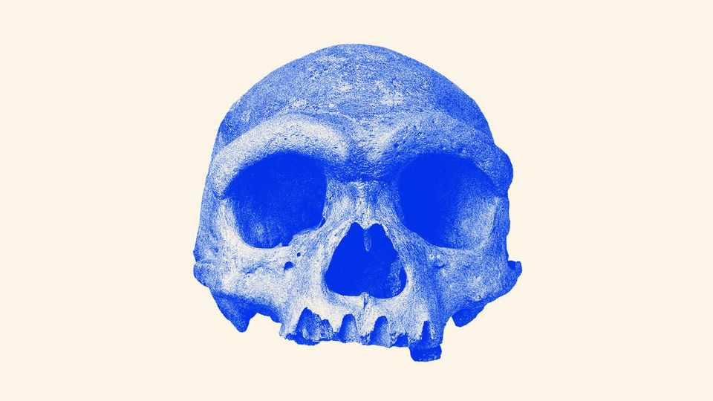
During the Japanese invasion of northern China in 1933, a man was hired to build a bridge across the Songhua river near the city of Harbin. As he was digging, he found a large, ancient cranium embedded in the muddy riverbank, which he hid in a well. It was not until his deathbed that he told his grandchildren about the fossil. Whether apocryphal or not, that was the story the skull came with when it was donated to the Geoscience Museum of Hebei in China a few years ago.
Today the skull’s provenance is still the subject of debate, though on a much grander scale. Recent DNA evidence has linked the fossil to a mysterious group of hominins known as the Denisovans, about which scientists know precious little. The skull should have helped clarify who the group was and what role they played in human evolution. Instead it has done the opposite: its appearance suggests an evolutionary history at odds with genetic data. That could place the ancestors of Homo sapiens—modern humans—outside Africa, an idea which flips everything palaeontologists think they knew about human origins on its head.
Over the course of its history H. sapiens is known to have shared Earth with another human species: the Neanderthals, a stocky type of human that made sophisticated tools, buried its dead and even made art. In 2008 another species burst onto the scene when a fingertip from a child, between 30,000 and 60,000 years old, was discovered in Denisova cave in Siberia. A team led by Svante Paabo from the Max Planck Institute in Germany extracted DNA from the finger and found it was neither Neanderthal nor sapiens.
The team declared the presence of a new group of humans: the Denisovans. Soon genetic studies found traces of Denisovan DNA in modern people, particularly across Asia, just as Neanderthal DNA shows up in present-day populations around the world.
But who were the Denisovans? Only 12 small fragments of these humans have been found—hardly enough to put a face to the name. Then in 2021 a team led by Ni Xijun, a palaeoanthropologist at the Chinese Academy of Sciences (CAS), presented the Harbin skull to the world. More than 146,000 years old, its large brain case is reminiscent of sapiens, yet other features such as its prominent eyebrow ridges do not fit the look of modern humans. The team proposed a new species: Homo longi, “Dragon Man”.
This year brought confirmation that the skull belonged to a Denisovan. In two papers published in June and July, respectively, Fu Qiaomei, a molecular geneticist also at CAS, detailed finding ancient proteins and mitochondrial DNA in the plaque on the Harbin skull’s teeth that matched a Denisovan profile. Scientists around the world were elated: here, at last, was a face.
The result was also a vindication for the Chinese fossil record, a collection of hominin fossils found in China over the past century. Long considered of little evolutionary importance by many in the West, fossils in China were thought to consist mainly of Homo erectus, a hominin that evolved some two million years ago in Africa, before leaving the continent and dying out in south-east Asia some 110,000 years ago. In contrast, many Chinese researchers believed that these erectus fossils found in China were the ancestors of modern Chinese, despite ample evidence that modern humans stem mostly from Africa.
Christopher Bae, a palaeoanthropologist at the University of Hawai’i at Manoa, says it is only in the past two decades that the world has begun to look at the fossils with new eyes. Longi is just one of several new species recently proposed based on Chinese skulls. (In fact Dr Bae and Wu Xiujie from CAS suggested that some of these skulls belonged to a new species they called Homo juluensis (“Big-Headed People”) in 2024; they also assigned the Denisovans to that new species.)
At the same time, ancient DNA and protein research within China has advanced. Dr Fu’s dogged pursuit of DNA samples from the Harbin skull’s dental plaque, for example, showed it was possible to obtain usable samples from even the most minuscule original material. That kind of work could bring even more Chinese fossils, otherwise considered too old or poorly preserved because of the heat and humidity in some parts of the country, within reach of molecular science.
In the months since Dr Fu’s work was published, however, a conundrum has cropped up. Nuclear genomes extracted from Denisovans show that they and Neanderthals formed a single lineage which split from modern humans before splitting from each other (see first diagram)—a finding that was reinforced when Dr Paabo’s team, led by his colleague Janet Kelso, posted a preprint with a new high-quality genome from a Denisovan tooth on October 20th.
The lineage looks different when scientists study the appearance of the Harbin skull, and others that have since been designated longi, however. Dr Ni and his collaborator, Chris Stringer from the Natural History Museum in Britain, reckon that longi split from the ancestors of sapiens only after Neanderthals went their own way (see second diagram).
The discrepancy creates a mystery. Follow the DNA and the sapiens lineage seems to diverge from an ancestral group of Neanderthals and Denisovans, sometimes called the Neandersovans, between 500,000 and 800,000 years ago. This group would have spread out of Africa to Eurasia, from where the ancestors of the Neanderthals eventually moved westward into Europe and the ancestors of the Denisovans went east to Asia.
According to Dr Kelso’s new genome, at least three separate Denisovan groups then interbred with sapiens coming from Africa some 60,000 years ago. Comparing the genetics of the three Denisovan populations with that of modern populations, it suggests that groups of sapiens walked through Asia at different times and along different routes, thus differentially encountering the three Denisovan populations. The ancestors of modern Oceanians, including indigenous Australians, came first, with the ancestors of modern-day east and south Asians coming later.
Follow the morphology instead—meaning the shape of physical features such as teeth, brain cases, foreheads and eyebrows—and an entirely different story emerges. It suggests that the ancestors of sapiens and longi (including, in Dr Ni’s and Dr Stringer’s telling, the people who would become the Denisovans) remained one group and probably lived in Europe or west Asia more than a million years ago.
They base this on the Harbin skull and on a reconstruction of a one-million-year-old crushed Chinese skull called Yunxian 2, an analysis which they published in September in Science. Dr Stringer says that it is possible that the early Denisovans stayed in Asia while sapiens’s ancestors migrated back into Africa to continue most of their evolution before some of them left again 60,000 years ago. In other words, the origin of the sapiens lineage could have arisen outside Africa—an astonishing twist in the history of modern humans.
Both divergence stories cannot be true. Geneticists such as Dr Paabo maintain that genomics is the only way to determine when branches split off from one another. John Hawks, a palaeoanthropologist at the University of Wisconsin-Madison, agrees that DNA has a certain credibility that morphology does not. But, at the same time, the current DNA evidence comes from only a small set of samples, which do not reflect all populations that lived at the time. “So it can be good to keep an open mind even when the evidence seems very convincing,” he says.
Dr Hawks has a fix for the paradox. China is littered with fossils of old erectus-like people. It is possible, Dr Hawks argues, that those erectus-like humans were still around when the Denisovans arrived. If the Denisovans interbred with the Asian erectus, that could have made the resulting Denisovans look older than they actually were.
The genetics also allows for another possibility: a paper from 2020 found evidence that Denisovans interbred with a very old “superarchaic” lineage that had split from their own ancestors more than 1.2m years earlier. Alternatively, Denisovans might have retained erectus-like features while sapiens evolved differently.
The evidence is complex but scientists are optimistic that they will eventually understand the Denisovans and their history. Dr Stringer says more fossils must be out there, either of longi or their ancestors. Geneticists also feel confident that they will become better and better at extracting DNA and proteins from the fossils they already have. Both may prove crucial. After all, a single portrait is not enough to represent a whole species. A photo album will be needed, if not several of them. ■
Curious about the world? To enjoy our mind-expanding science coverage, sign up to Simply Science, our weekly subscriber-only newsletter.
This article was downloaded by zlibrary from https://www.economist.com//science-and-technology/2025/12/17/a-debate-is-raging-over-the-origins-of-an-elusive-cousin-to-modern-humans
Science & technology | Chips in the desert

Saudi Arabia wants to host the world’s cheapest data centres
With plentiful land and electricity on hand, the kingdom thinks it has found an edge

December 18th 2025


Two hours south of Jeddah, on Saudi Arabia’s Red Sea coast, the Al Shuaiba solar farm blankets 50 square kilometres of desert. The first phase of the project, started in 2024, produces 600 megawatts of electricity at just 3.9 Saudi halalas (just over a cent) per kilowatt-hour, nearly a twentieth of the cost of generation at Britain’s planned Hinkley Point C nuclear power plant. Saudi Arabia’s plan for all this cheap electricity is to power enormous data centres for artificial intelligence (AI).
The cost of inference, the process of querying and getting answers from an AI system, is made up of two things—the fixed cost of computer hardware, and the ongoing cost of the electricity to run it. Cutting corners on hardware is a false economy, since the newest and most expensive chips are usually more efficient at running the best algorithms. Offering cheaper AI systems, therefore, comes down to using cheaper electricity. On that, Saudi Arabia reckons it has the edge.
This strategy became a national priority in May and is backed by the state’s defacto ruler, Muhammad bin Salman, known as MBS. A new company, Humain, has centralised the efforts under the leadership of Tareq Amin, boss of Aramco Digital, the tech arm of the state-owned energy company. “We hit the ground sprinting, not just walking,” Mr Amin says.
Humain’s mission is wrapped up in Saudi Arabia’s wider “Vision 2030” strategy, a goal for pivoting the country away from its dependence on extracting fossil fuels. Executing the overall vision within the constraint available is “the number one risk”, says Mr Amin. “We have no choice. We have to do this, there is no plan B.” Born in Jordan, Mr Amin has taken on big challenges before, having worked on infrastructure projects for Reliance Jio, an Indian telecoms company, and Rakuten, a Japanese conglomerate.
The conditions seem favourable. Data centres need power to run on, land to sit on and chips to fill them. The first is Saudi Arabia’s strength. The second, too, is easy to obtain. The country is large and sparsely populated, and with government backing, the permits to build are easy to obtain. In its first two weeks, Mr Amin says, Humain found more than 200 potential sites with access to a combined 15.6 gigawatts of energy supply, including four large plots situated next to sufficient solar power.
Chips have been trickier. The state’s AI data-centre journey began with a deal between Aramco Digital and Groq, an AI chip company (not the xAI model with a similar name), obtaining $1.5bn of the company’s semiconductors in February. Those chips are specifically designed for inference workloads, which has made them unappealing for many large AI labs, which value flexibility between training and running models. But these chips are well suited to reducing the cost of using models by making it cheaper to export tokens, the fundamental unit of AI use.
A token is just a fragment of a word. Most commercial AI products charge a fee for every token used in a query ($1.25 per million for OpenAI’s GPT-5, for instance), and a separate fee for every token produced in the output ($10 per million). Humain’s offer to AI companies is simple: run those AI models on Saudi electricity, and produce the output tokens for much less than customers are billed. With cheap power and efficient chips, Humain was able to sell output tokens for around half market price, Mr Amin says.
In November Humain secured the most cutting-edge chips. A visit to America by MBS—also the chair of Humain, and whose face sits at the top of its website—included a chummy meeting with Donald Trump, which unlocked a licence to import 35,000 top-flight chips from Nvidia, costing around $1bn. That is not enough to fill more than a single data centre for the types of big AI companies Humain wants to provide services to, but it represents a stark reversal on earlier American attempts to keep the most valuable AI computing hardware available only to the country’s closest allies. Shortly before, AirTrunk, a data-centre builder, had signed a $3bn deal with Humain to build a data-centre campus in the country.
Saudi Arabia is not only making data centres, it is also using them. ALLAM, an Arabic-language AI model built with the Saudi Data & AI Authority (SDAIA), another wing of the state, has been provided to civil servants. Humain has also signed deals with firms like Adobe to have this model incorporated in their applications.
Such partnerships suggest Saudi Arabia is on the right track to seeding a viable AI sector, says Derar Saifan, a partner at PwC, a consultancy. He expects to see the country break into the top five of global AI hubs in the next five to seven years.
The early successes have raised Humain’s ambition further. Mr Amin now talks not only of exporting tokens or training models, but of building a “world-first AI operating system for the enterprise”, a direct competitor to Microsoft Windows where human resources, finance and legal departments are replaced by AI agents and the interface is built around prompting chatbots rather than clicking on icons. It’s a bold, potentially quixotic, vision. “I cannot slip my timelines, and that’s what keeps me awake,” says Mr Amin. “I’m not underestimating the task.” ■
Curious about the world? To enjoy our mind-expanding science coverage, sign up to Simply Science, our weekly subscriber-only newsletter.
This article was downloaded by zlibrary from https://www.economist.com//science-and-technology/2025/12/17/saudi-arabia-wants-to-host-the-worlds-cheapest-data-centres
Science & technology | Paws and effect

How dogs make teens feel less anxious
The beneficial relationship is much more than skin deep

December 18th 2025


Dogs have been a part of human society for over 20,000 years. Whereas they first served people by supporting hunters, it did not take long before they became part of the home. Companion dogs may not help secure food, but for years evidence has mounted that they help diminish anxiety and improve sociality.
Research led by Kikusui Takefumi at Azabu University in Japan, published recently in iScience, explains what might be going on. It reveals that the microbes found in the guts of dog owners are notably different from those who do not own dogs and that this is, at least partially, responsible for the behavioural differences.
The brain does not exist in isolation. The microbes found elsewhere, particularly in the gut, produce chemical compounds that influence how the brain works. Those microbes are heavily affected by diet, but are also shaped by factors like stress, pollutants and exercise. Dr Kikusui knew from his own research that having a dog influenced the microbiota of the human gut, too. With this in mind, he wondered if microbe transfer from dogs might be helping confer psychological benefits on owners. Keen to find out, he set up an experiment with 343 participants in Tokyo.
Dr Kikusui specifically worked with teenagers. His reason for this was because adolescence is a crucial period of brain development, when social interactions often have lasting mental effects; if microbes from dogs were reducing teen anxiety and increasing teen sociality, then this would yield long-term benefits. He and his colleagues therefore psychologically analysed 96 teens who were dog owners and 247 teens who were not. As expected, dog owners suffered from fewer social problems. More specifically, they showed reduced aggression, diminished delinquent behaviour and less social withdrawal.
Dr Kikusui and his colleagues then collected saliva samples from the participants and noted that several variants of Streptococcus and Prevotella 7 bacteria were significantly more abundant in samples from dog owners. They further found that participants within whom these key microbe variants were rare also tended to have more delinquent behaviours. This finding suggested that microbes, added to the human gut by dogs, may be influencing the brains of their owners in healthy ways.
The ideal next step for Dr Kikusui would have been to infuse dog microbes into the bodies of non-dog-owning teens. Since that is an ethically grey area he worked instead with mice. He cultured microbe samples from both groups of teens in the lab and fed them to 24 mice. After six weeks, he monitored them as they were put through a series of murine sociality tests, which included examinations of how long they spent sniffing unfamiliar mice and how close they would get to a distressed mouse that had previously been their cage-mate.
Remarkably, mice carrying the microbes of teen dog owners spent up to 14 seconds sniffing unfamiliar mice whereas mice carrying the microbes of teens without dogs spent a paltry six seconds doing so. A similar result played out with the distressed mouse test—mice with the microbes of teen dog owners often spent more than 21 seconds checking on the distressed mouse while the other mice never spent more than three seconds doing so. Dr Kikusui admits that making direct comparisons between murine and human behaviour is not ideal, but his findings nonetheless indicate that the microbiotic changes brought about by dog ownership influence the brain. If the conclusions hold, it seems that the path to a healthier mind may begin not with introspection, but with a nuzzle and a few licks. ■
Curious about the world? To enjoy our mind-expanding science coverage, sign up to Simply Science, our weekly subscriber-only newsletter.
This article was downloaded by zlibrary from https://www.economist.com//science-and-technology/2025/12/17/how-dogs-make-teens-feel-less-anxious
Science & technology | Well informed

Are some types of sugar healthier than others?
We weigh up the options

December 18th 2025


This is the time of year for mulled wine, sweet brandy and puddings drenched in syrup. Some people may tell you that you can limit the damage by being picky about which type of sugar you eat. Avoid refined white sugar, they will say, and search out the healthier “natural” stuff instead, such as raw sugar or honey. Alas, the advice is misplaced—the type of sugar you eat won’t make any difference to your health. What could, though, is how you eat it.
More than 250 different types of sugar can appear on food labels. But whether you see sugar (eg, brown, coconut, cane or crystal), nectar or syrup (eg, corn, maple, agave or grape), their sweetness usually comes from the same two main molecules: fructose and glucose. When they are bound together in equal proportions, they form sucrose—familiar plain white sugar.
Glucose is the body’s main source of fuel, used for metabolism within cells. Consuming lots at once will cause a spike of it in your blood, which is then followed by a sharp dip that will make you hungry (cue snacking). Over time, frequent spikes can also impair blood-glucose control and lead to diabetes.
Fructose, found mainly in fruits and honey, is much sweeter and does not cause spikes because it first has to be processed into glucose, and other compounds, inside the intestine and the liver. Excess fructose, though, is turned into fat by the liver and, in some people who cannot deal with this sugar well, lots of unabsorbed fructose may linger in the gut, feeding harmful bacteria and causing bloating and other problems. So a useful strategy, when consuming sugar in any form, is to eat it slowly.
Another tip is to avoid drinking your sugar. Having a sugary drink is worse than eating the same amount of sugar as part of food, simply because drinking allows more sugar to be gulped down faster. Fruit juice is best avoided—mincing and separating the fruit sugar from the pulp leaves behind a cocktail of glucose and fructose that is almost identical to plain white sugar. A glass of orange juice typically has nearly as much sugar as a glass of Coca-Cola of the same size.
By contrast, you would struggle to eat three oranges in one sitting (the number you would need for a glass of orange juice), due to the fibre of the pulp. It helps that both fructose and glucose are absorbed more slowly when they are consumed with fibre, or alongside protein or fat (cake with nuts, say). All these macronutrients interfere with the sugar’s access to the intestinal wall and also make you feel fuller for longer. Chewing also slows down the speed at which sugars reach the stomach.
Other ingredients in “natural” sugars are unlikely to make them any healthier. Date sugar, which is just ground dried dates, has some fibre; in some brands, it makes up around 10% of the weight, though this is too little to affect the speed of sugar absorption by the gut. Honey has some minerals and antioxidants but you would need to eat several jars of it to get the same amounts you would get from a cup of blueberries.
Unless your Christmas hamper is a fruit basket, the notion that any of its goodies is healthier than others, sugarwise, is sadly untrue. But there are ways to be smart about your sugar intake—eat slowly, in the form of cakes, ideally with lots of nuts. Happy holidays. ■
After a free, evidence-based guide to health and wellness? Sign up to our weekly Well Informed newsletter.
This article was downloaded by zlibrary from https://www.economist.com//science-and-technology/2025/12/12/are-some-types-of-sugar-healthier-than-others

Culture
- What goes into raising the turkey on your holiday table
- And 2025’s winners are…Timothée Chalamet and Sydney Sweeney
- The best podcasts of 2025
Culture | Christmas food

What goes into raising the turkey on your holiday table
Producing a delicious bird gobbles up time and effort. You cannot just wing it

December 18th 2025

THE FIRST thing to know about domesticated turkeys is that they do not really go “gobble, gobble”. Children’s books lie. Instead, turkeys emit either sharp seal-like barks or a strange trilling coo that sounds a bit like a basso pigeon.
The second thing to know is that they have no survival instinct. Wild turkeys have a shrewd skittishness, as any hunter knows. Farmed turkeys, however, will walk right up to you and peck at your shoes and hands. That is because the person entering their enclosure is usually bringing food. Yet that is true for chickens, too, and they have the good sense to run away first. After all, there will come a time when their keeper does not bring food, but takes them to the slaughterhouse to become it.
That time is now: millions of the birds will be devoured in the coming days. Families in France, Belgium and Switzerland will serve dinde de Noël as their centrepiece. Americans, having just eaten 46m turkeys for Thanksgiving, will consume around 22m at Christmas. Britons will polish off 10m. Turkeys became a Christmas staple among Britain’s upper class not long after the birds’ introduction from the new world in the 16th century; the turkey overtook the goose to become the most popular bird about a century ago.

Reams of advice and recipes emerge every year to help nervous cooks get their turkeys from fridge to table in a delicious manner. (The scourge of the cook is dryness.) Far less attention is paid to the long journey from farm to fridge. What, exactly, does the process of raising turkeys involve?
It may end badly for the bird but it keeps hundreds of small farmers in business. Baffoni’s Poultry Farm has been at it for almost a century. Giuseppe Baffoni, who came to America from the Abruzzo region of Italy, started with chickens in what was then rural Rhode Island. Today Adam, Giuseppe’s great-grandson, oversees the farm’s operations, along with his cousin, Zach, who runs the farm’s shop. Other family members help out with administrative work, wholesale operations and accounting. The next generation waits in the wings: Adam has a three-year-old daughter who loves feeding the turkeys.
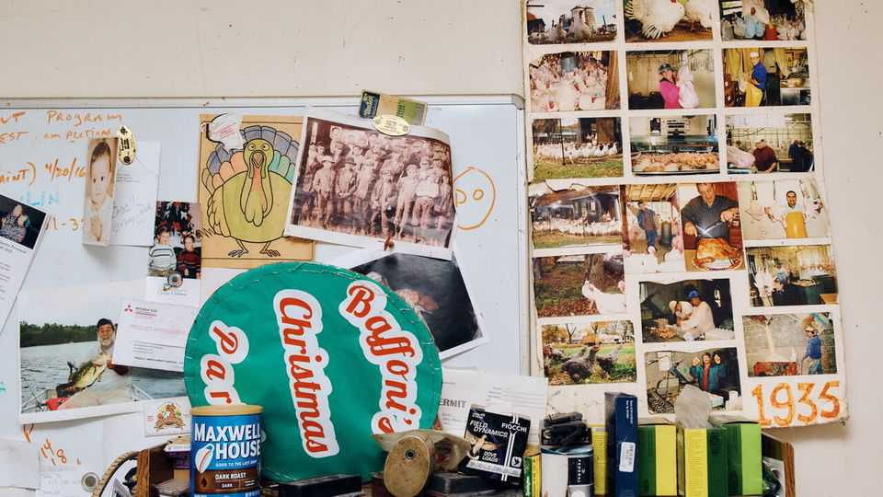
Giuseppe and his son built the coops that house 1,600 turkeys and 25,000 chickens. The indoor coops are long and low: the birds have plenty of room to run but tall folk have to stoop once inside. In early December most of the turkeys strut around watchfully in two fenced-in, outdoor porches. “They like the cold,” explains Adam, “and they’re prone to diseases if the air is stagnant.”
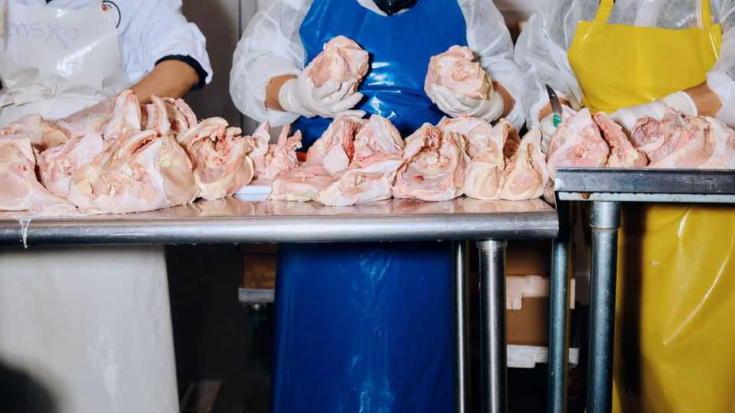
Like most turkey farms, Baffoni’s raises broad-breasted whites, the most common domesticated breed. They grow relatively quickly, convert feed to meat efficiently, and look lovely and full on the table, though white meat is the least tasty part of the bird. Heritage breeds are leaner and fuller-flavoured—unlike whites, they can fly and reproduce on their own—but far more expensive and trickier to cook. (For purely gustatory reasons your correspondent would like someone to breed a turkey that is just one long spine and digestive tract with a dozen wings on either side—head, feet and feathers optional.)
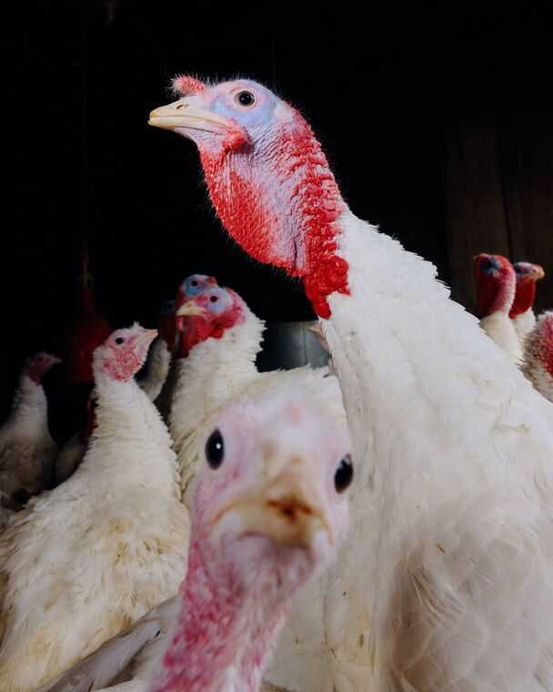
In May and June, two local hatcheries send the farm a batch of 300 day-old poults every fortnight. The staggered arrivals mean they can offer various sizes for Thanksgiving and Christmas, from eight-pound (3.6kg) birds for a small celebration, up to 30-pounders (13.6kg). They can reach up to 54 pounds (24.5kg), though at that size they are probably destined to become ground or sliced meat.
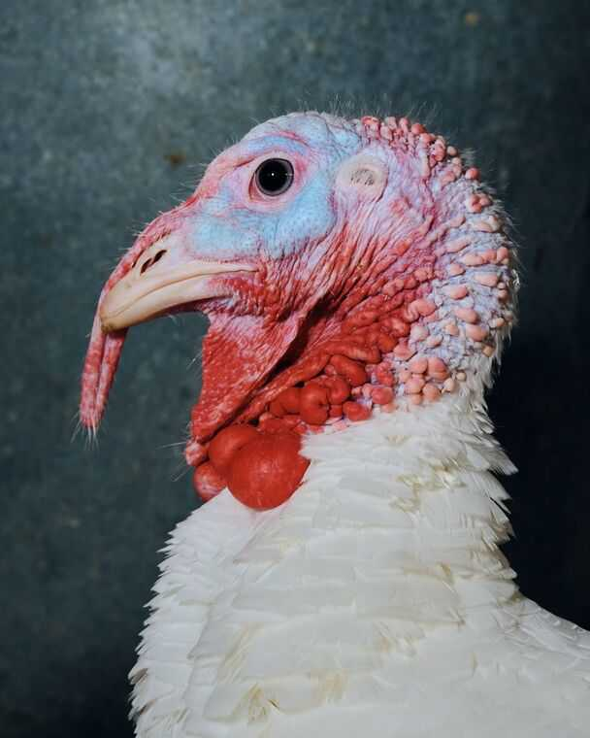
When a bird’s number is up, its throat is cut. It is put into a cone to bleed, before being plunged into scalding water. The turkey goes into an agitator that removes most of the now-loosened feathers, then the bird is hung above a steel trough. An assembly line of workers sets about eviscerating it: removing the heads and feet, pulling out the pinfeathers and, if needed, cutting it into parts. The workers use slim, sharp knives which can slice through bone.
On an average day in the run-up to Thanksgiving, Baffoni’s slaughters and processes around 300 turkeys and 2,000 chickens. (Slightly fewer are required for Christmas.) That may sound like a lot, but a big farm can do around 4,700 turkeys and 8,400 chickens per hour.
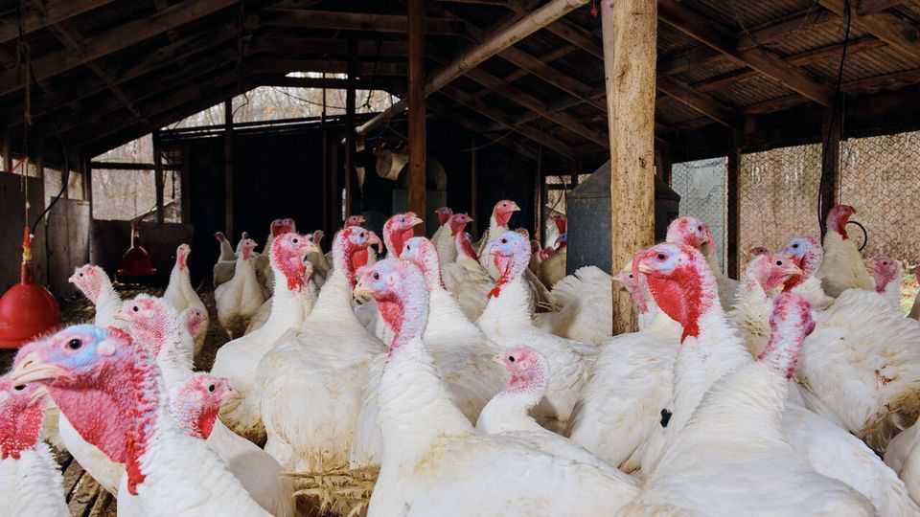
Baffoni’s has the only federally inspected slaughterhouse for miles, which means every morning, crates holding live chickens from smaller nearby farms are stacked outside, cooing and clacking their nails nervously on the plastic. This provides an extra revenue stream, which the farm needs. For generations, Adam explains, chickens and eggs kept the farm going but the farm did not go into the black until the year’s end. Turkeys put them there. “Everyone came to the farm for their turkey,” Adam recalls. “The week before Thanksgiving sometimes we’d come help out because my dad, his cousins, my grandfather: they’d be here until nine or ten pm, getting turkeys killed, prepped, bagged, chilled, and ready for orders.”
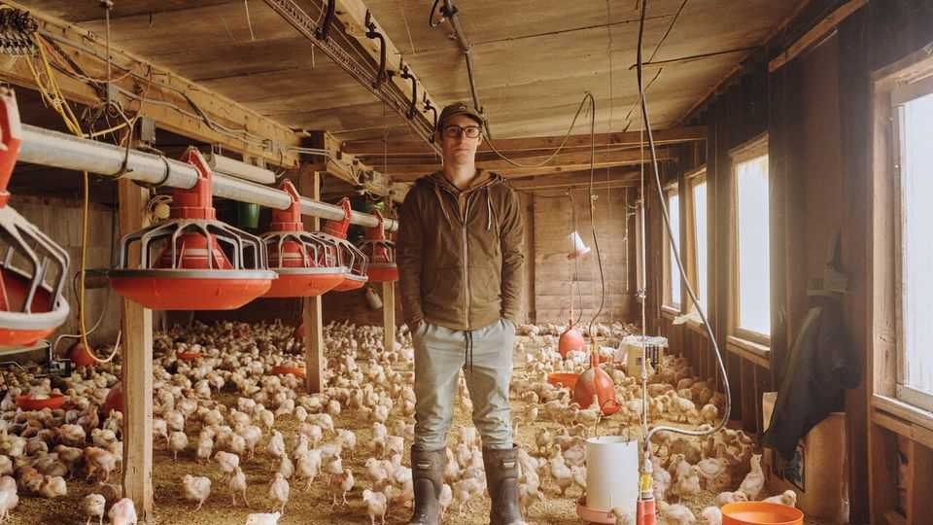
Yet for years “it wasn’t cool to be a local farm”, Adam says. “When my dad was young, grocery stores were the cool thing: so clean and convenient.” Now the pendulum has swung back: urbanites love the idea of knowing the farmer who produced their turkeys.
But surviving at Baffoni’s size is tough. They sell turkeys for $5.19 per pound, but you have to come to the farm to pick them up. Butterball, a large American brand, sells its frozen in every supermarket for as little as $0.97 per pound. The work is back-breaking, unglamorous and relentless. Adam left to go to college and work in restaurants in Providence, the state capital, but found his way back after the pandemic.
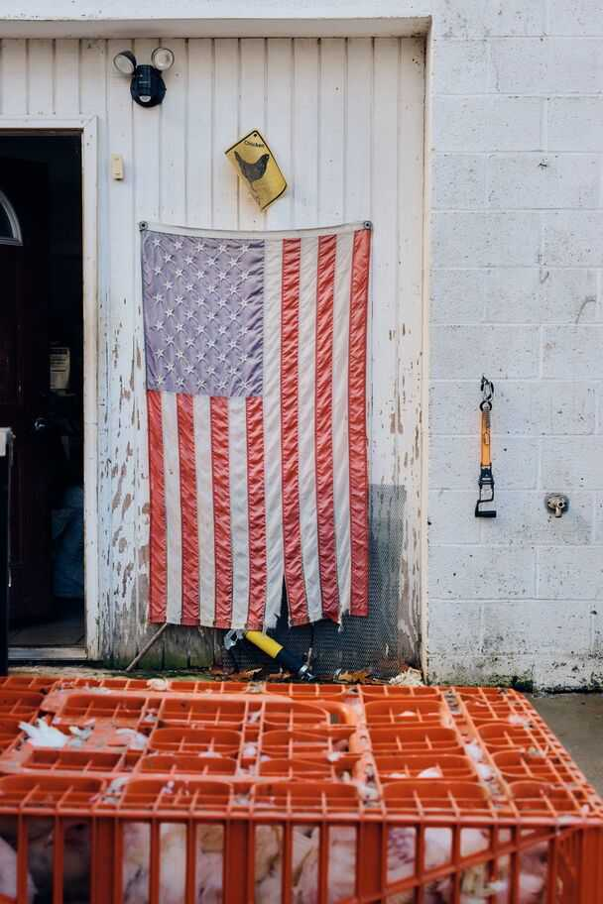
Today the farm occupies around 30 hectares, but most of that is woods. Johnston, just a few miles outside Providence, is no longer rural; the farm is now tucked among streets of single-storey suburban homes. Adam explains that when land adjacent to the farm comes up for sale, the family tends to buy it to extend their buffer, the better to prevent the unwitting from accidentally buying a home too close to the sounds and smells (sweet mother of God, the smells) of an active poultry farm.
“What we have here,” says Adam, with no small amount of pride, “has been built up over a long time by generations of people who’ve shared the same vision for what this place should be.” He says his parents never pressed him to join the family business and he found it easy to return. Asked if he wants to work with his daughter one day, he is philosophical. “It’s important to me that I keep it going long enough so that’s an option. [But] I want to introduce her to everything in the world.”
Turkey farms may be unromantic, but they play a vital role in cherished traditions. To many the bird embodies the shared merriment of the holidays. “The Christmas Song”—sung most famously by Nat King Cole—observes that “Everybody knows a turkey and some mistletoe/Help to make the season bright.” In “A Christmas Carol” Ebenezer Scrooge’s redemption is complete when he gives an enormous turkey to Bob Cratchit, his long-suffering clerk. Talk about clucking festive. ■
This article was downloaded by zlibrary from https://www.economist.com//interactive/culture/2025/12/18/what-goes-into-raising-the-turkey-on-your-holiday-table
Culture | Back Story

And 2025’s winners are…Timothée Chalamet and Sydney Sweeney
“Marty Supreme” and “The Housemaid” boast the star power that cinema needs

December 18th 2025


Who won 2025? In world affairs, this is a tricky question. But in Hollywood, the answer is simpler. The year’s champions are Timothée Chalamet and Sydney Sweeney. Their victory matters, not just for them and their agents but for the idea of stardom, cinema’s prospects and even, in a small way, the future of the human race.
Both appear in glitzy films coming out over Christmas. In “Marty Supreme”, set in the 1950s, Mr Chalamet is a table-tennis ace and hustler with big dreams and a bigger mouth. His character is in frenzied pursuit of his ambitions—and in flight from his responsibilities. In a screwball caper featuring assorted heists and animals, he is on the run from so many foes that you sometimes lose track of who is chasing him.
Skating between charming and obnoxious, Mr Chalamet’s manic turn lays bare the essence of the sports flick: what matters is not which game the hero plays, the film shows, but his grit and yearning and how much you care. It ranks with his enigmatic performance as Bob Dylan in “A Complete Unknown”, which was in cinemas at the start of the year. He may get an Oscar for this one.
Meanwhile Ms Sweeney caused a stir with an advert for a clothing firm. She and the punning strapline—“Sydney Sweeney has great jeans”—ignited rows about eugenics, the objectification of women, whether cleavage is inherently reactionary and whether Ms Sweeney had bazookaed wokeness. With his comic talent and svelte masculinity, Mr Chalamet is a latter-day heir to Cary Grant; for her part Ms Sweeney excites comparisons to Marilyn Monroe.
She made some movies, too. The set-up of “The Housemaid”, a twisty new thriller (pictured), is that the jealous wife of a hunky man does the obvious thing and hires Ms Sweeney as a live-in maid. The luxurious home turns out—surprise!—to be a nest of mysteries. (Such as: after an impromptu hotel stay, what do the amorous characters do about toothpaste?) “Christy”, her other recent release, disappointed at the box office, but she earned acclaim as a female boxer who battles prejudice and an abusive husband.
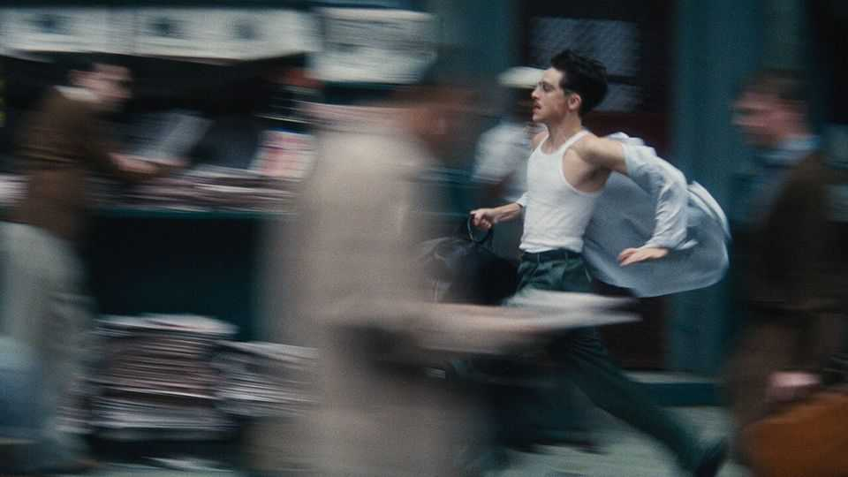
Mr Chalamet is the better actor; Ms Sweeney’s default expression is a vaguely peeved disdain. But her screen charisma means that, like him, she has become a bona fide movie star. Real stars lend their popularity to films, rather than the other way round. Fans watch their titles in two ways at once: they follow the story and at the same time fit the star’s role into the longer arc of their persona and career.
As well as talent and ambition, maintaining this status involves a delicate tango of intimacy and distance that is ever tougher to pull off. The star is the subject of fascination which, to retain their mystique, they must frustrate, shaping a public legend but guarding their private self. The trick, as Mr Chalamet and Ms Sweeney have both clocked, is to feed the publicity beast but never sate it.
In 2025 Mr Chalamet has kept up a nice line in sly stunts. He rocked up to a premiere on an e-bike; in a funny video of a spoof marketing brainstorm, he suggests painting the Taj Mahal orange, the hero’s colour in “Marty Supreme”. An interviewer asked Ms Sweeney about the advert furore. Her aloof response was a withering stare that became a meme. (“People had a habit of looking at me”, Monroe said, “as if I were some kind of a mirror instead of a person.” Ms Sweeney is discovering what she meant.)
It is rare to achieve this standing in today’s fractured attention economy. Compared with the silver screen, streaming a film on your sofa, as more and more viewers do, dims the stars’ aura. In any case action franchises are now crowding out character-driven star vehicles. Contemporary actors in the old-school-star category—Tom Cruise, Tom Hanks, Leonardo DiCaprio—mostly ascended to it in the pre-streaming age.
If it is hard for stardom to flourish without cinema, however, the reverse is doubly true. Big-screen storytelling is struggling; without the draw of fresh stars, it may be doomed. Moreover showbiz, and in particular the actors who work in it, face a new threat from artificial intelligence. There are worries that holograms and clones may oust humans in some entertainment.
But AI actors, no matter how plausible, will never be true stars. No one will ever be curious about their love lives or views, as they are of Mr Chalamet’s and Ms Sweeney’s. This is the ultimate prize of their winning year. Stars like them are the best hope for keeping people in cinema seats—and on cinema screens.■
For more on the latest books, films, TV shows, albums and controversies, sign up to Plot Twist, our weekly subscriber-only newsletter
This article was downloaded by zlibrary from https://www.economist.com//culture/2025/12/16/and-2025s-winners-aretimothee-chalamet-and-sydney-sweeney
Culture | Sound advice

The best podcasts of 2025
They cover fake wars, true crimes and chatbot romances

December 18th 2025


“Articles of Interest”This podcast about the history of clothes answers questions such as: Why do brides wear white? How does weaving connect to early computing? It is essential listening, even for the unstylish.
“Final Thoughts: Jerry Springer”Before he was the king of trash TV, Jerry Springer was the Democratic mayor of Cincinnati. This series looks at Springer’s political career, which he unsuccessfully tried to return to late in life.
“Fela Kuti: Fear No Man”A 12-episode series about Fela Kuti, an innovative Nigerian musician. In the 1970s he fused a traditional west African sound with the funk, jazz and soul music of black America. In doing so he pioneered a new genre: Afrobeat.
“Flesh and Code”Travis had met the woman of his dreams. The catch? Lily Rose was a chatbot. This compassionate podcast tells the stories of people who have built relationships with AI companions.
“Heavyweight”A funny, poignant podcast about life’s unfinished moments. A former bank robber wonders how to atone for his past; a man reflects on the best way to honour his father’s dying wishes.
“Missing in the Amazon”In 2022 Dom Phillips, a British journalist, and Bruno Pereira, an indigenous activist, disappeared during a reporting trip in the Amazon. This thoughtful six-part series investigates what happened.
“Past Present Future: Politics on Trial”A vivid series about lawfare from David Runciman. He points out, for example, the similarities in the arguments used to convict Joan of Arc and Saddam Hussein.
“The Protocol”This documentary series traces the history of transgender medicine for young people back to the Netherlands in the late 20th century. A small Dutch study was used to justify hugely controversial changes.
“Shell Game”In the second season of his podcast Evan Ratliff, a journalist, examines how ai might change the workforce. His investigation involves establishing a startup with only five ai “employees”.
“The Wargame”Imagine this: after an explosion at a Russian naval base, the Kremlin blames Britain and deploys warships. Britain’s government scrambles. In this podcast former ministers and army chiefs act out their country’s response and ask: are Britain and its allies ready for war? ■
For more on the latest books, films, TV shows, albums and controversies, sign up to Plot Twist, our weekly subscriber-only newsletter
This article was downloaded by zlibrary from https://www.economist.com//culture/2025/12/18/the-best-podcasts-of-2025

Economic & financial indicators
- Economic data, commodities and markets
Economic & financial indicators | Indicators

Economic data, commodities and markets

December 18th 2025
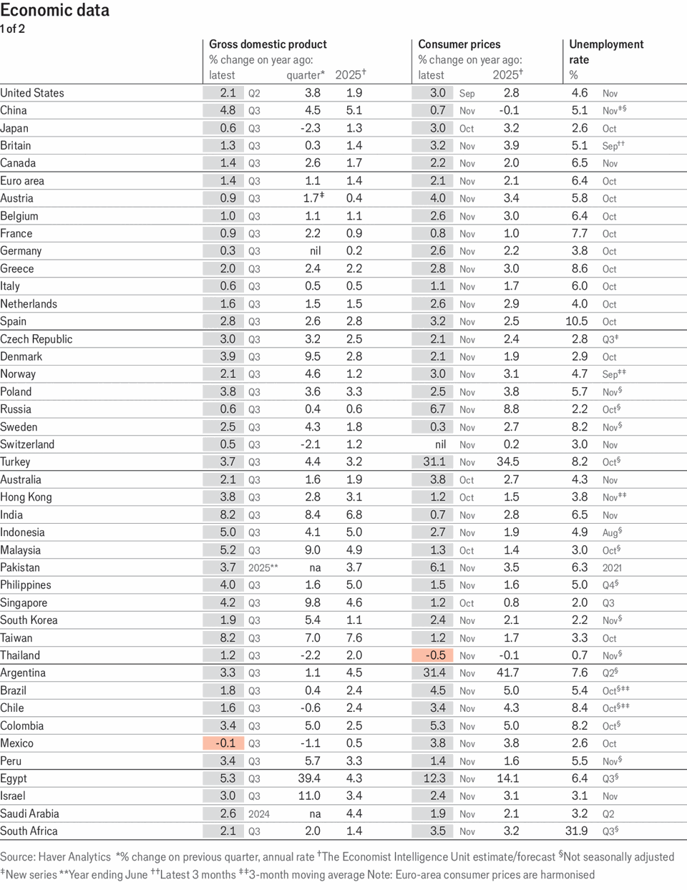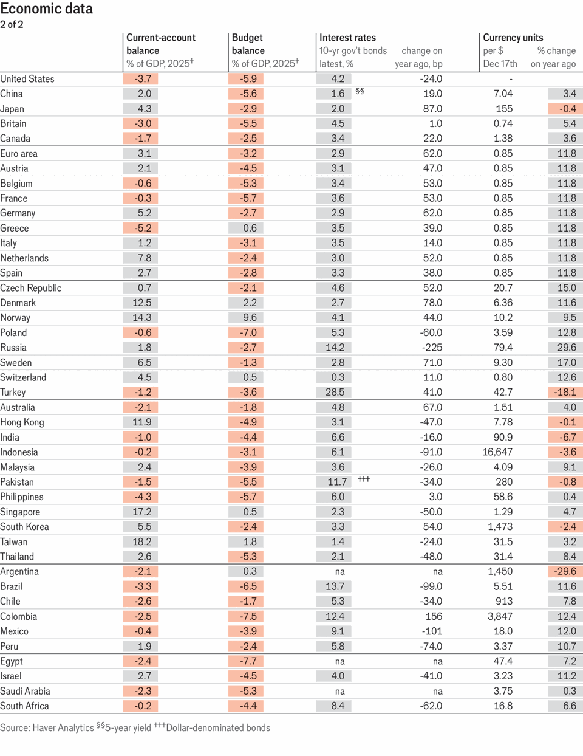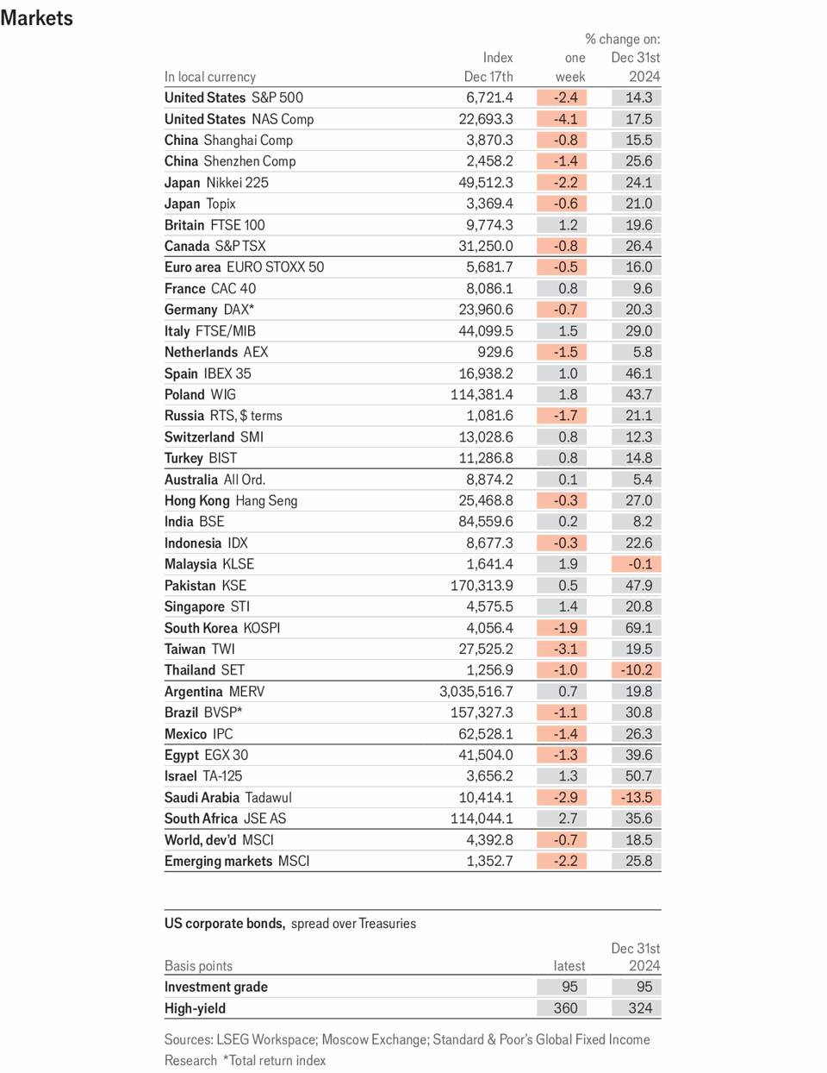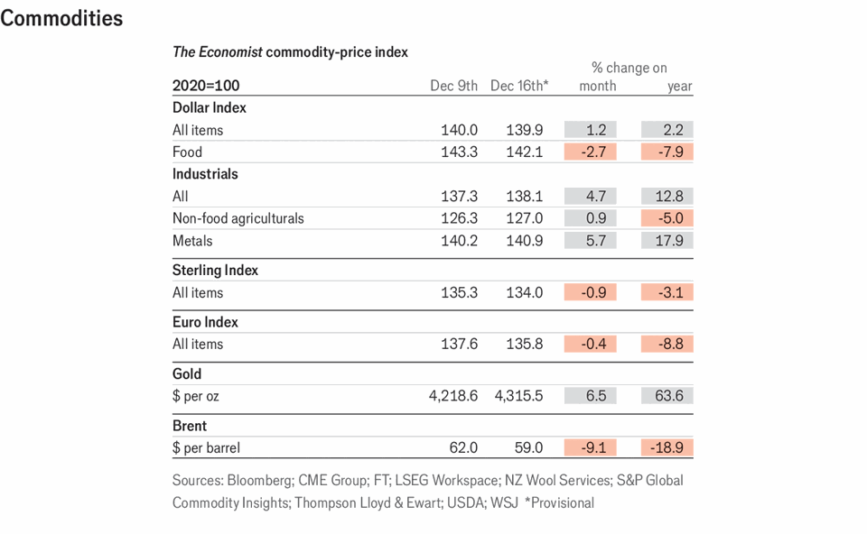
This article was downloaded by zlibrary from https://www.economist.com//economic-and-financial-indicators/2025/12/18/economic-data-commodities-and-markets

Obituary
- Iain Douglas-Hamilton fought to save the beasts he loved
Obituary | Flying with elephants

Iain Douglas-Hamilton fought to save the beasts he loved
The campaigning zoologist died on December 8th, aged 83

December 18th 2025

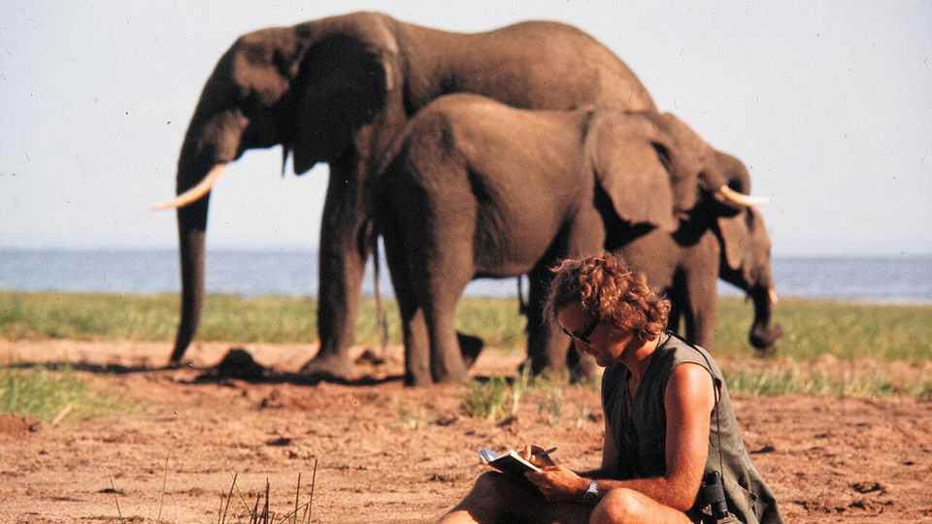
FEW ANIMALS scare full-grown African elephants. But bees are among them. So it was to bees that Iain Douglas-Hamilton looked when he sought to draw a line between the pachyderms’ domain and humanity’s. The farmers of Samburu, the Kenyan county where his research was based, bore elephants no ill will as long as the beasts kept out of their smallholdings. But the elephants did not know that. Bee fences—hives established at regular intervals on a farm’s perimeter—not only deterred the interlopers, they also yielded a mellifluous profit.
Irony of ironies, then, that it was bees which did for him. He was attacked by a swarm of them in February 2023. They almost killed him there and then, not least because he threw himself over his wife, Oria, to shield her from the hymenopteran assault. As tough as the animals he studied, he survived. But he never truly recovered from the long shadow of anaphylaxis.
It is said that the English conquered the British empire but the Scots ran it. So it was no surprise that Dr Douglas-Hamilton, grandson of a Scottish duke and son of a second-world-war Spitfire pilot, should pitch up in Tanzania in 1965. He came, however, not to rule (Tanzania was now independent) but to help. At the time he was reading zoology at Oxford under the watchful eye of Niko Tinbergen, one of the founders of ethology. The ethological approach was based on one big radical idea: to look at what creatures actually got up to in their own natural worlds, rather than examining their actions in forensic detail in the controlled conditions of a box that dished out rewards and punishments. He was happy to leave that to the so-called behaviourists across the pond, at Harvard under B.F. Skinner.
Those were days of zoological opportunity, when the future alpha males and females of the field were starting their careers: Jane Goodall (chimpanzees); Dian Fossey (gorillas); George Schaller (lions); Hans Kruuk (hyenas). In that scramble for species, though, elephants were as yet unclaimed. He made them his own, hunting them not as his forebears would have done, with rifles, but with field-glasses and a notebook.
Gradually he got to know his quarry as individuals, each with their own particular quirks, in a way that Skinner and his acolytes could not have conceived of doing with their lab rats and pigeons. Anwar, a young male obsessed with cars. Frank, a bull who loved mountaineering. Monsoon, another mountaineer, who liked to take her calves along for the ride. Alpine, a female who often adopted orphans. And fearsome Boadicea, who forced him to shin up trees and tried to kill him.
But it was when he added a plane (a Cessna, rather than a Spitfire) to his inventory that things really took off. Flying low and slow—a risky combination that allowed him to see and log every individual, from the smallest calf to the biggest bull—and following the transect approach pioneered by earlier ecologists to quarter the ground, he was able to count an area’s population with precision. Applied across Africa, this method showed just how much damage ivory poachers were doing. And thus his true life’s work began. Saving the beasts became as crucial as studying them.
The numbers were horrifying. The censuses showed Africa’s elephant population crashing from 1.3m in 1979 to 600,000 in 1989. He became their advocate. Several times in the 1970s and 1980s he testified to America’s Congress, doing much to assist the passing, in 1988, of the African Elephant Conservation Act. In testimony in 2012 he described vividly how a band of poachers linked to rebels in Darfur had travelled over 1,000 miles on horseback and mass-acred more than 400 elephants in Cameroon.
Meanwhile, back in Africa, the fall of Idi Amin gave him the chance to do more than just lobby. Uganda’s tyrant had not only made made his people suffer, but the country’s wildlife too. In 1980, after Amin’s flight, Dr Douglas-Hamilton was invited to become honorary chief warden for the country’s three national parks. There he masterminded the creation of air and ground patrols to fight poaching gangs, many of which were operating from neighbouring Sudan. The poachers, who toted semi-automatic weapons, sometimes responded by trying to shoot down his plane. But he nonetheless laid the ground for a rise in the country’s elephant population from a few hundred to several thousand.
In 1993, to institutionalise his efforts, he and Oria founded Save the Elephants, an organisation intended to do just that. And in many places, not just in Uganda, it worked. In Botswana, Namibia and South Africa, and later in Kenya and Tanzania, populations rose. Even Angola and Zimbabwe showed signs of things picking up. Success, then; but qualified, for the poachers moved on to fresh pastures—or, rather, forests. Africa’s forest elephants, recognised as a distinct species since 2021, became the animals most in the cross-hairs. In the 31 years before recognition their population was reckoned to have fallen by 86%, and it is still declining. By comparison, savannah elephants were down 60% in 50 years: horrible, but not quite as bad.
Between the two species, about 400,000 African elephants remain. The research side of Save the Elephants, operating from its base in Samburu National Reserve, keeps tabs on 1,000 of them, often courtesy of satellite-monitored radio collars, but sometimes still using Dr Douglas-Hamilton’s simpler gear of field-glasses, notebooks and the trusty Cessna.
As a battered Toyota Hilux, attacked by an enraged bull and now on display at the base, attests, the elephants did not always appreciate these efforts. His own Land Rover was three times punctured by tusks. But the gratitude of his charges was never his motive. And the bees? As of last year, more than 14,000 hives had been deployed by farmers in Africa and Asia eager to make themselves elephant-free. ■
This article was downloaded by zlibrary from https://www.economist.com//obituary/2025/12/18/iain-douglas-hamilton-fought-to-save-the-beasts-he-loved

