Anthem Digital Portfolio DigitalQ MVP

[DRAFT]

A **methodological manual** is being drafted for the DigitalQ work intake process for Digital Portfolio at Anthem based on analysis of historical examples for Broker and Employer.

# 

# Version History

|  |  |  |  |
| --- | --- | --- | --- |
| **Version** | **Name** | **Comments** | **Contributor(s)** |
| 0.1 | Anthem-DigitalQ-V0.1.docx | [DRAFT] Example work is Broker Onboarding and Smart Broker Assistant | James Flynn james.flynn2@anthem.com |

# 

# Contents

**Version History** **2**

**Contents** **3**

**Digital Portfolio Scope** **5**

**Background** **5**

Foundry 5

10x Engineering 6

Platform Teams 6

**DigitalQ Flow** **7**

Phase 1: From Proposal to Classification 7

Why Classification is the First Phase 7

Outcomes 7

Process 8

Question A - Is the proposed solution an improvement to an existing solution? 8

Why do we ask this question? 8

Question B - Is the proposed solution understood? 9

Why do we ask this question? 9

Question C - (If the answer to B is no) Can we reduce risk by dividing into MVPs? 9

Why do we ask this question? 10

Process Diagram 10

Phase 2: From Classification to Value Assessment 12

Why Value Assessment is the Second Phase 12

Value Assessment for Platform-Appropriate Work 12

V1: Value Comparison - Solution Improvement 12

Step 1 - Gather Data on Existing Solution 12

Step 2 - Estimate Impact of Proposed Solution 13

Step 3 - Estimate Cost to Implement 13

Step 4 - Calculate Delivered Value and Return on Investment of Proposed Solution 13

EXAMPLE Value Comparison: Broker Onboarding 14

V2: Value Estimation - New Solution 15

Step 1 - Estimate Impact of Proposed Solution 15

Step 2 - Estimate Cost to Implement 15

Step 3 - Calculate Delivered Value and Return on Investment of Proposed Solution 15

Comparing Apples to Apples 16

Value Assessment for Foundry-Appropriate Work 17

V3: Value Validation - Solution Improvement [PLACEHOLDER] 17

V4: Value Validation - New Solution [PLACEHOLDER] 17

**References** **17**

# 

# Digital Portfolio Scope

**Functional Scope:** Classify, evaluate, prioritize, and assign incoming work to Foundry and Platform teams such that maximum value is delivered to Anthem stakeholders.

Where value is realized by:

* Revenue increase
* Cost reduction
* Risk mitigation
* Higher rates of software utilization
* Employee productivity increase
* Customer satisfaction increase
* ...

# Background

Product development teams under the Anthem Digital organization are of the following types:

* Foundry (Discovery Teams)
* Platform (Delivery Teams)
* 10x (Process Support Teams) - ??

## Foundry

The Foundry comprises cross-functional teams with expertise in prototyping, UX, and rapid testing of software in pseudo-real-world environments — building and deploying MVPs. Their core function is to (in)validate hypotheses quickly. They are not expected to deliver production grade code.

MVP - “The minimum set of features required to validate a hypothesis”

Because Foundry are conducting a *search* among novel configurations and technologies - the long-run value delivered by the Foundry will be directly impacted by the speed at which they can iterate. Most hypotheses fail, so it is crucially important that they *fail fast*.

Therefore, the Foundry is structured, operationalized, and assigned work such that the maximum time between hypotheses statements and results from an MVP test is <**12**> weeks.

Longer projects are not appropriate for Foundry as they severely impact the foundational value proposition.

**Foundry Objective:** Rapid Value Discovery

**Foundry Priorities:** Identification of Value, Usability, Technical Feasibility, Business Viability

## 10x Engineering

[[[[[TBD - Placeholder What is 10x differentiation? How is their operation and structure differentiated. Tech-for-tech? Dev Ops?]]]]]

## Platform Teams

The Platform Teams implement production-quality work with a greater emphasis on quality, and reliability.

**Platform Team Objective:** Consistently Provisioning Value

**Platform Priorities:** Reliability, Scalability, Performance, Maintainability

# 

# DigitalQ Flow

## Phase 1: From Proposal to Classification

The first stage of the DigitalQ flow is to classify the proposed work as appropriate for Foundry, Platform Teams, or neither.

### Why Classification is the First Phase

We classify the work first because all following methods of value assessment differ, based on what is knowable about the proposal. The classification ultimately directs work into the Foundry or Platform Team pipelines based on the feasibility of understanding likely value at this pre-implementation stage.

### Outcomes

Proposed work is classified as..

1. S*OLUTION IMPROVEMENT* [Platform Pipeline V1]
   * Moves into Value Comparison Process (the comparison is between the value delivered by the proposed solution and that of the current solution)
2. N*EW SOLUTION* [Platform Pipeline V2]
   * Moves into Value Estimation Process (Estimation is the delivered value of proposed solution)
3. S*OLUTION IMPROVEMENT HYPOTHESIS* [Foundry Pipeline V3]
   * Moves into Value Hypothesis Process
4. N*EW SOLUTION HYPOTHESIS*, [Foundry Pipeline V4]
   * Moves into Value Hypothesis Process
5. POSTPONED [V5]
   * Moves to back of DigitalQ due to technical/implementation risk being over threshold (unknown technology + indivisible hypotheses)

### Process

Refer to Diagram Below

#### Question A - Is the proposed solution an improvement to an existing solution?

Is there a way, today, for a user with this need, to have that need met, no matter how inefficient it might be currently?

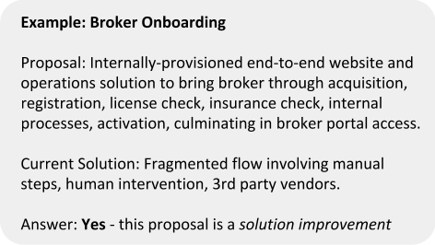

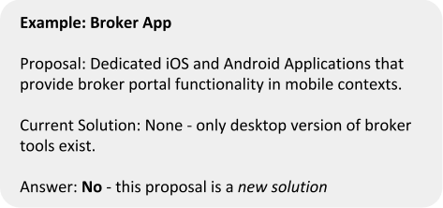

#### Why do we ask this question?

When a solution currently exists, we have a benchmark for delivered value, and we can better estimate the value of the proposed solution using **existing internal data** - an important step in the next phase. When a solution does *not yet* exist, we will need to employ different value-determination methods.

#### Question B - Is the proposed solution understood?

Can we provision the proposed solution using a set of familiar technologies - technologies where we have a high degree of implementation certainty.

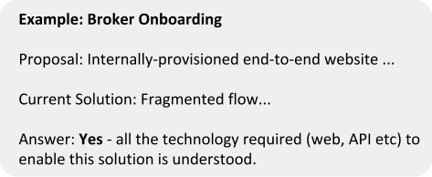

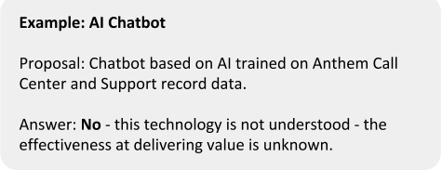

#### Why do we ask this question?

When a technology is familiar, we know how it works, and what it can do. This allows us to understand how it will deliver value when implemented. This, in turn allows us to estimate business value with a much higher degree of certainty.

When the performance of a technology is unknown, we cannot estimate the delivered business value that will result, because that value will be directly affected by the performance of this technology. It is impossible to estimate business value with certainty, and it is therefore risky to implement.

#### Question C - (If the answer to B is no) Can we reduce risk by dividing into MVPs?

Can we divide up the hypotheses and design fast self-contained experiments such that each one is possible to resolve in an amount of time appropriate for our business?

#### Why do we ask this question?

With new technologies, the overwhelming majority of hypotheses turn out to be **invalid**. For our process of value discovery to be worthwhile - we must understand the performance of new technologies very quickly. We must **fail fast,** therefore the experiments must occur in a short time, therefore they must be small.

### Process Diagram

<See next page>

### 

## Phase 2: From Classification to Value Assessment

The second stage of the DigitalQ flow is to assess the business value of the proposed work

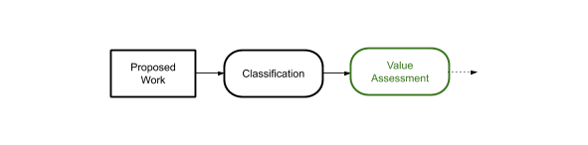

### Why Value Assessment is the Second Phase

Having classified proposed work in Phase 1, we now need to understand the business value of the work proposal. Depending on the classification of the work, this is done differently, but ultimately will provide an apples-to-apples comparison.

For the work headed to Platform teams (knowable value) we calculate **Delivered Value** (sometimes called Net Present Value - NPV) and **Return on Investment** (ROI).

For the work headed to Foundry teams (less-knowable value) we calculate **Risk-Adjusted Hypothetical Value** (If this works what will it be worth? And what is the chance it will work?)

[We need to understand the **standalone** business impact of projects **before** we can move into the next phase, which will factor in resource availability, cross-project dependencies, and strategic alignment.]

### Value Assessment for Platform-Appropriate Work

#### V1: Value Comparison - Solution Improvement

If the proposed work is classified in Phase 1 - Classification, as a *solution improvement*, we assess the value of the project by the Value Comparison method.

This process may vary in specific details but is generally always applicable - if we generalize the concept of a ‘user’ as someone, or some system, trying to get a ‘job’ done.

|  |  |  |
| --- | --- | --- |
| Step 1 - Gather Data on Existing Solution  * Number of Users/Incidents * Value of User Success * Operating Costs (OpEx)   + 3rd Party Costs     - Vendors     - Licenses     - ...   + Support Costs     - Customer Support     - ...   + Provisioning Costs     - Infrastructure Costs     - ... * Performance   + Number of Users at top of funnel   + Number of successful journeys through solution   + Attrition/failure rate   + …  Step 2 - Estimate Impact of Proposed Solution  * Value of User given proposed solution * Operating Costs of proposed solution * Performance of proposed solution  Step 3 - Estimate Cost to Implement  * NRE + * Capital Expenditure | Abbr.  **N**  **VE**  **OpExE**  **PE**  **VP**  **OpExP**  **PP**  **CP** | Units  units  S  $  %  $  $  %  $ |

##### Step 4 - Calculate Delivered Value and Return on Investment of Proposed Solution

First, in English:

*The amount of business value we are realizing from an operating solution is the number of users or incidents, multiplied by the value of those users/incidents conditional on success, multiplied by the performance of the solution, minus the cost of providing that solution.*

Current Solution Delivered Value = **N . VE . PE - OpExE**

Proposed Solution Delivered Value **= N . VP . PP - OpExP**

Therefore the delivered business value of the proposed solution is the difference between the value of the proposed solution and the value of the current solution.

Delivered Value (DV) = Proposed Solution Delivered Value - Current Solution Delivered Value

DV =  **N . [ (VP . PP - OpExP) - (VE . PE - OpExE)]**

And the ROI of the proposed solution is this delivered value divided by the implementation cost.

ROI = DV / **CP**

##### EXAMPLE Value Comparison: Broker Onboarding

[[All data except Implementation Cost is placeholder - waiting on Broker Team]]

Internal Data from Current Solution:

**Lifetime Value** of a Broker: **VE** = $100,000

Brokers **acquired** at top of Onboarding Funnel: **N** = 3000

**Performance** of Current Solution: **PE** = 73% success rate

**OpEx** of Current Solution: **OpExE** = $1409** per broker (due to high frequency of support calls, 3rd party licenses etc)

Estimated Impact of Proposed Solution:

**Lifetime Value** of a Broker (stays the same): **VP** = $100,000

Brokers **acquired** at top of Onboarding Funnel (stays the same): **N** = 3000

**Target Performance** of proposed Solution: **PE** = 91% success rate (increase is due to improved UX, reductions in delay, and automation)

**Target OpEx** of proposed Solution: **OpExP** = $217 per broker due to automation and removal of 3rd party dependencies

Estimated Cost to Implement:

**USD 2.9M**

Current Solution Delivered Value  **=** 3000 x $100,000 x 0.73 - 3000 x $1409

= 21M

Proposed Solution Delivered Value = 3000 x $100,000 x 0.91 - 3000 x $217

= 27M

DV = 27M - 21M

= **8 M**

ROI = 8M / 2.9M

= **275%**

So this proposal has a direct Business Value of **$8,000,000** with a Return on Investment of **275%**

#### V2: Value Estimation - New Solution

If the proposed work is classified in Phase 1 - Classification, as a *new solution*, we assess the value of the project by the Value Estimation method.

|  |  |
| --- | --- |
| Step 1 - Estimate Impact of Proposed Solution  * Value of User * Operating Costs of proposed solution * Performance of proposed solution  Step 2 - Estimate Cost to Implement  * NRE + * Capital Expenditure | **VP**  **OpExP**  **PP**  **CP** |

##### Step 3 - Calculate Delivered Value and Return on Investment of Proposed Solution

We use the same process as in Steps 2 and 3 above for Value Comparison. This time we do not have data upon which to benchmark the numbers of users, and their value.

[[[ WIP - Summarize some high-level methods to get data from existing interactions, from market research, and modeling ]]]

Estimated Impact of Proposed Solution:

**Lifetime Value** of a User - Estimated via market research, data, and modeling

Users **acquired** at top of Funnel - Estimated via market research, data, and modeling

**Target Performance** of proposed Solution: **PE**

**Target OpEx** of proposed Solution: **OpExP**

Estimated Cost to Implement: **CP**

Delivered Value (DV) = Proposed Solution Delivered Value

DV =  **N . VP . PP - OpExP**

And the ROI of the proposed solution is this delivered value divided by how much it costs to implement.

ROI = DV / **CP**

#### 

#### Comparing Apples to Apples

We will consider the two values for each proposal to help prioritize work, but we’re not done yet, we have to factor in resource availability, cross-project dependencies, and strategic alignment, which will happen in subsequent phases.

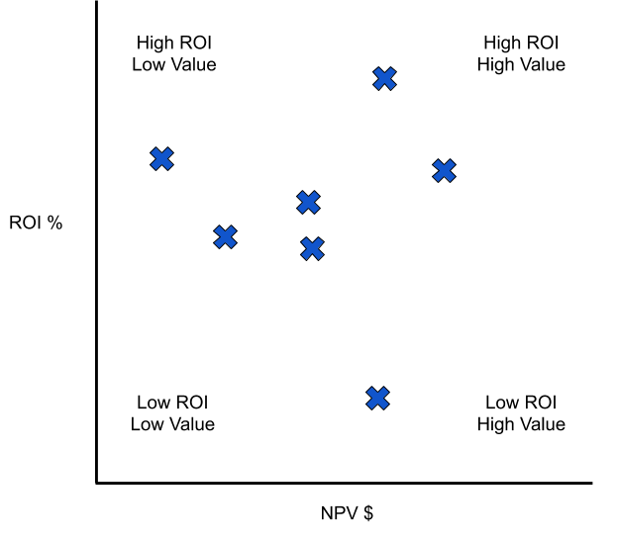

### 

### 

### Value Assessment for Foundry-Appropriate Work

Let’s recap the type of work that makes it to this stage. This is work where the proposed technology is **not** well understood, but the **hypotheses can be divided** into appropriately-sized experiments.

#### 

#### V3: Value Validation - Solution Improvement [PLACEHOLDER]

The Value Validation for Solution Improvement process is the same as Value Comparison - Solution Improvement (X1) except that the Proposed Solution performance variable (**PE**) is unknown. Recall:

Delivered Value (DV) = Proposed Solution Delivered Value - Current Solution Delivered Value

DV =  **N . [ (VP . PP - OpExP) - (VE . PE - OpExE)]**

And this time we are unsure of **PE**

But we can build a model of the delivered value of a project by trying different values for **PE** in our delivered value equation and estimating the likelihood of achieving that performance.

Step 1 -

#### V4: Value Validation - New Solution [PLACEHOLDER]

The Value Validation for New Solution process is the same as V2 except

# References

“NPV and Capital Budgeting” - Timothy Luehrman - Harvard Business School Core Curriculum [[link](https://hbsp.harvard.edu/product/5176-PDF-ENG?itemFindingMethod=Collections)]

**<<<<<<SCRATCH>>>>>>>**

1. Value Estimation [Platform Teams]

By estimating the absolute value of the proposed solution, we can determine the expected business value of the completed project, and the return on capital invested.

1. Value Hypothesis [Foundry]

(causal modeling etc)

By asking ‘What would this be worth, if it works?’, and ‘What are the chances it will work?’ we can determine the statistical expected value of a project, and work on projects in order from highest to lowest expected value.