## **Describe and use common Design Patterns, Algorithms and programming language Idioms.**

### Design patterns

According to (Bautista, n.d.)

* + - Design patterns are optimized and reusable solutions to common problems that developers often deal with. If used correctly it can be very effective but if used in wrong situation it could be very divesting (double edge sword, swing it to the right direction).
    - It consist of 3 types of design patterns. Structural creational, and behavioural.
    - Structural - the relationships of entities to make them work together.
    - Creational - how objects are created for more effective process.
    - Behavioural -how communications between entities to create simple and more flexible usability.

### Use Design Pattern

* + - I implemented the model, view, and controller.
    - In my application I reused multiple codes (classes, methods) to provide the same solutions to the same problems.

These are my own code 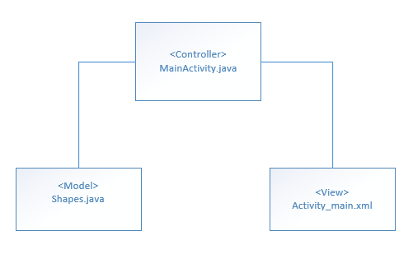

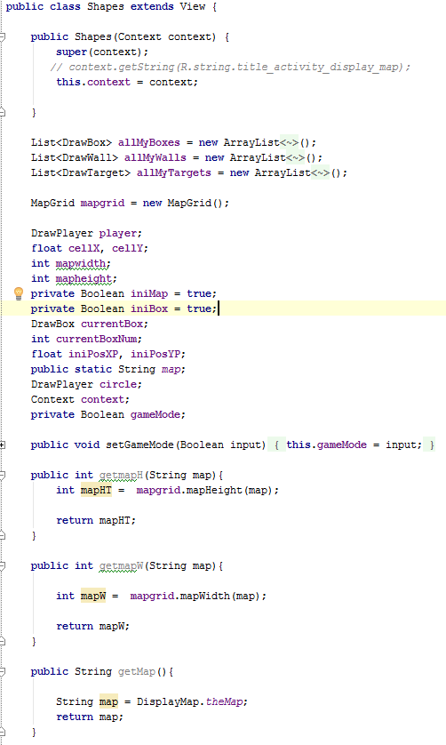

This is my model (Shapes.java). Most of the processing is done on this class (building map, moving player, boxes).

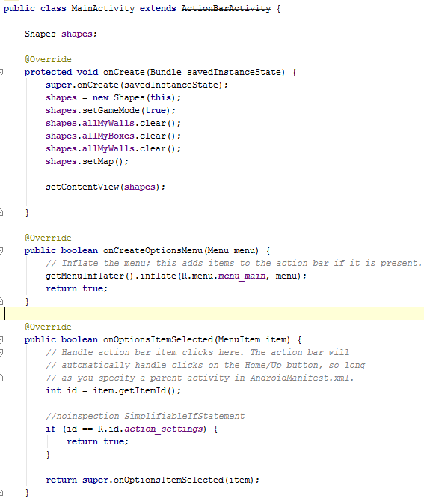

This is my Controller, it talks to the model and send data to it.

View

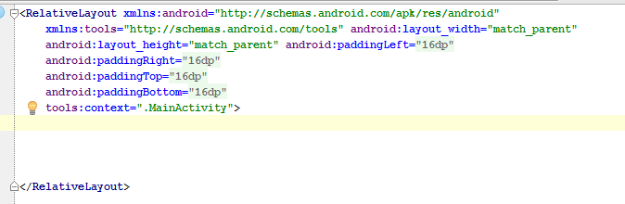

This is my view. The view follows this layout.

### **Algorithms and Programming language Idioms.**

(UNM, n.d.) suggested that Idioms are a form and structure for knowledge that helps us bridge the differences between patterns as abstract descriptions of a problem and its solutions and an understanding of how best to implement that solution in a given programming language. A language idiom is the expression of a design pattern in a given language. In this sense, design patterns + idioms = quality programs.

## **Use appropriate software life-cycle models and software construction steps.**

* (tutorialspoint, 2015) Suggested that SDLC, Software Development Life Cycle is a process used by software industry to design, develop and test high quality softwares. The SDLC aims to produce a high quality software that meets or exceeds customer expectations, reaches completion within times and cost estimates.
* The SDLC model that I used in this project is the waterfall model. I used waterfall model because the project is small, requirements are not very complex and design is simple (game is simple to play but hard to code).
* The main process are:
  + - **Requirements Analysis**- Here I made a list of features that the application needs for the level designer.
      1. Read from String.
      2. Compute the width and height.
      3. Create a new level(width, height).
      4. Construct the map from String.
      5. addBlock on the map.
      6. addFloor on the map.
      7. addCrate on the map.
      8. addPerson on the map.
      9. addCrateOnTarget on the map.
      10. addTarget on the map.
      11. addPlayerTarget on the map.
      12. Edit Cell to Block on the map
      13. Edit Cell to Floor on the map.
      14. Edit Cell to Crate on the map.
      15. Edit Cell to Player on the map.
      16. Edit Cell to Target on the map.
      17. Edit Cell to Player on target on the map.
      18. Edit Cell to Crate on target on the map.
      19. Undo action.
      20. Redo action.
      21. Error handler for invalid undo action.
      22. Error handler for invalid redo action.
      23. Load the map.
      24. Display the map with cells represented as characters.
    - **Design**- here I made a design level diagram to create a picture of what needs to be done.

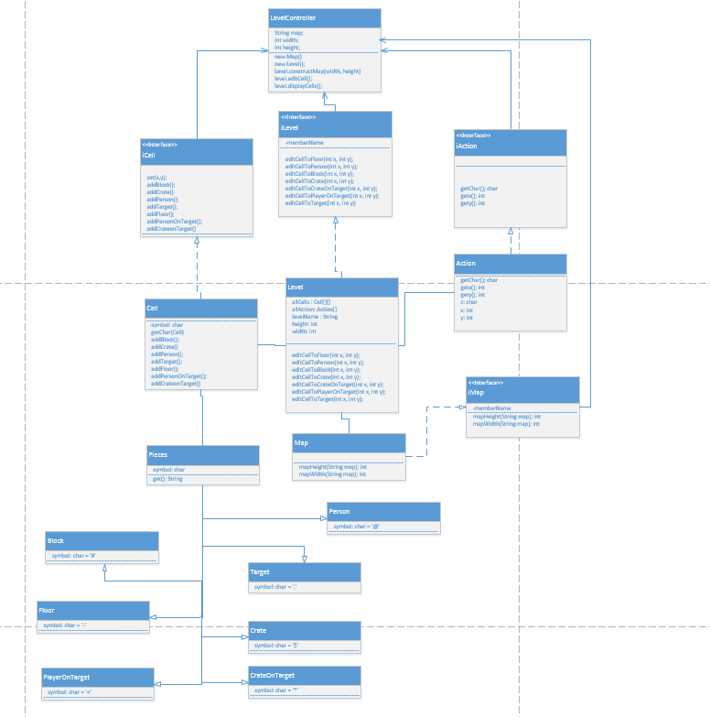

* **Implementation-** here I implemented the design and build the game in java.

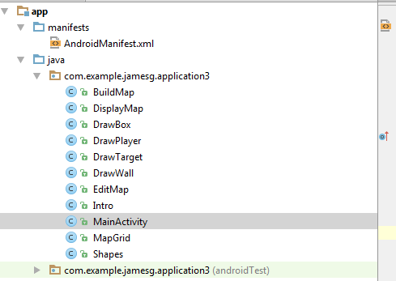

* **Testing -** here I tested the game several times to get it right. I tested:
  + If the player moves up, down, left, right.
  + If the boxes up, down, left, or right with the player direction.
  + If the map is build, edit, correctly, centred even if the screen is rotated.

Using waterfall approach on my project is the best approach compared to others because the project is small, requirements are clear and simple. If I used other model such as the iterative and incremental approach, then it require more unnecessary work.

This approach is effective because it requires less management works, less time, and simple to implement.

I could have improved by creating more documentations, manage time more effectively.

## **Design programs.**

(Garner, 2012) Suggested that in design, you need to think about the algorithms you will use, the program design, record design time in the time recording log. UML modelling is performed which is called the Unified modelling language.

### **Wireframe**

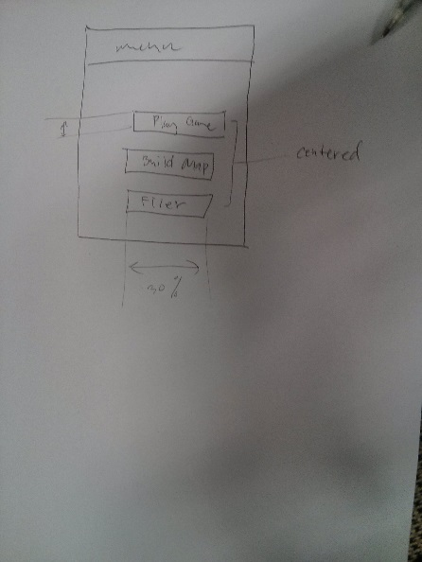

### **Activity Diagram**

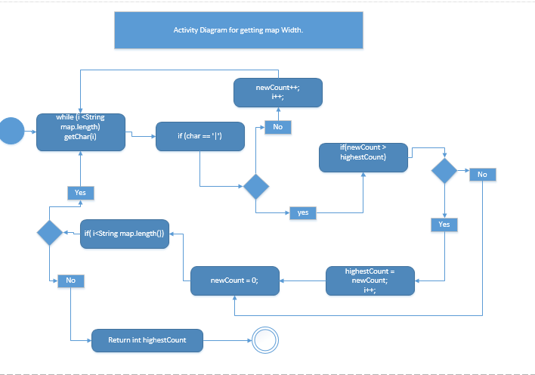

### **Design Level Diagram**

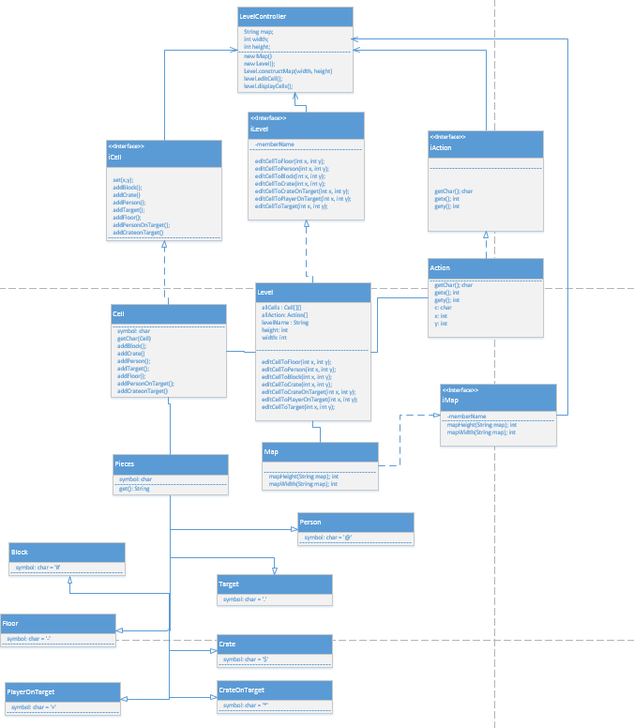

## **Design user interfaces which conform to recognised usability criteria.**

* According to (usability.gov, 2015), User Interface (UI) Design focuses on anticipating what users might need to do and ensuring that the interface has elements that are easy to access, understand, and use to facilitate those actions. UI brings together concepts from interaction design, visual design, and information architecture.
  + **Suitability for the Task (appropriate functionality)**

The system should meet the needs and requirements of users when carrying out tasks.

* + **User Control (controllability, user explicit control)**

The system should be designed to let users control the interface as much as possible.

* + **Flexibility (suitability for individualization, adaptability)**

The interface should be sufficiently flexible in structure, in the way information is presented and in terms of what the user can do, to suit the needs and requirements of all users.

* + **Error Management (error tolerance, error prevention and correction)**

The system should be designed to minimize the possibility of user errors, with built-in facilities for detecting and handling those which do occur.

* + **Compatibility (conformity with user expectations, natural and intuitive)**

The way the system looks and works should be compatible with user conventions and expectations.

* + **Self-descriptiveness (information feedback, user guidance and support)**

Information feedback, guidance and support should be provided to help the user understand and use the system.

* + **Consistency (consistency in location, format, syntax, and naming)**

The way the system looks and works should be consistent at all times.

* + **User Workload (minimal memorization, brevity, mental load)**

The system should be designed to keep the user's mental load (particularly memory load) within acceptable limits and to increase the speed of interaction by increasing brevity.

### **What I implemented.**

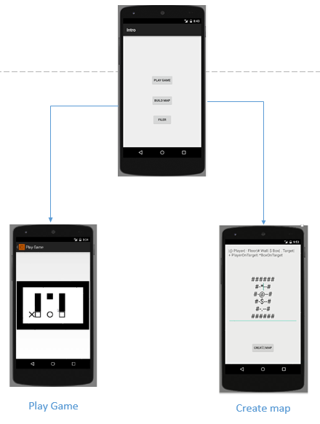

* I could have added more features to make my app more usable by creating swipe features, allows user to drag objects on the screen when creating a map (wall, boxes). Also I should have built an error handler which tells user what they need to do when they put wrong input. Should provide a guide or help option.

## **Code programs in the specified language using the prescribed standards.**

(Mytton, 2004) Suggested that a coding standards document tells developers how they must write their code. Instead of each developer coding in their own preferred style, they will write all code to the standards outlined in the document. This makes sure that a large project is coded in a consistent style — parts are not written differently by different programmers. Not only does this solution make the code easier to understand, it also ensures that any developer who looks at the code will know what to expect throughout the entire application.

In my application I followed JSlint coding standard. Example of coding standards below(my own code).

**THESE ARE MY OWN CODE**

### **Code Example 1**

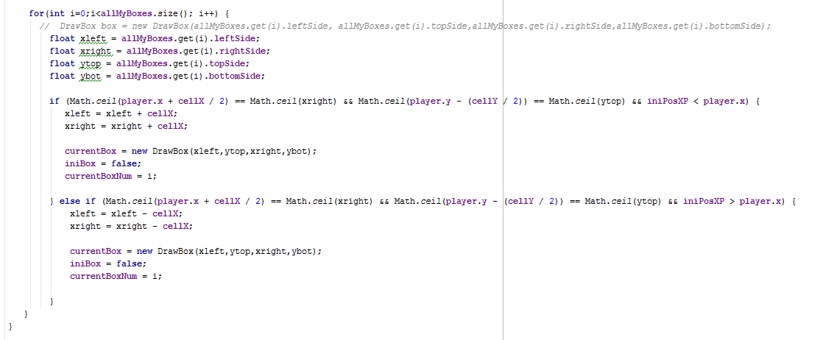

These codes coding standard are effective because the variables names are related to what they do, indentation are stated and clear, easy to read because of good spacing.

### **Code Example 2**

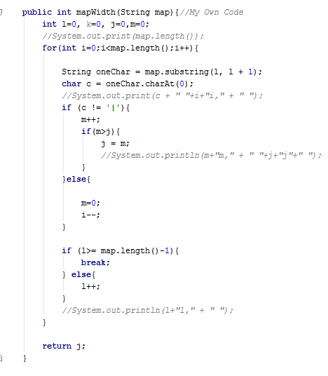

### **Code Example 3(These are my own code)**

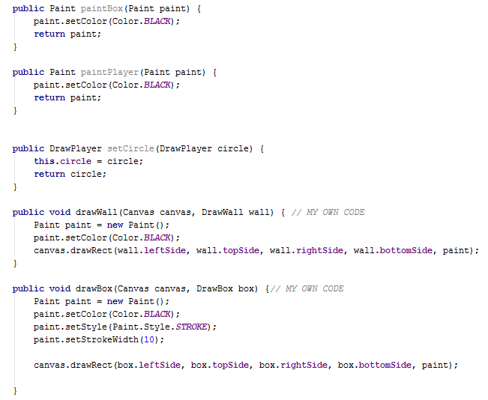

Improvements:

I could have added more comments on the code to make it easier to maintain.

## **Produce and execute testing strategies at the systems level using a unit testing framework.**

According to (tutorialspoint, 2015) Testing is the process of evaluating a system or its component(s) with the intent to find whether it satisfies the specified requirements or not. Testing is executing a system in order to identify any gaps, errors, or missing requirements in contrary to the actual requirements.

The Testing framework that I used in Java Junit testing. JUnit is a simple framework to write repeatable tests. It is an instance of the xUnit architecture for unit testing frameworks.

**These are my OWN CODES**

### **Example 1**

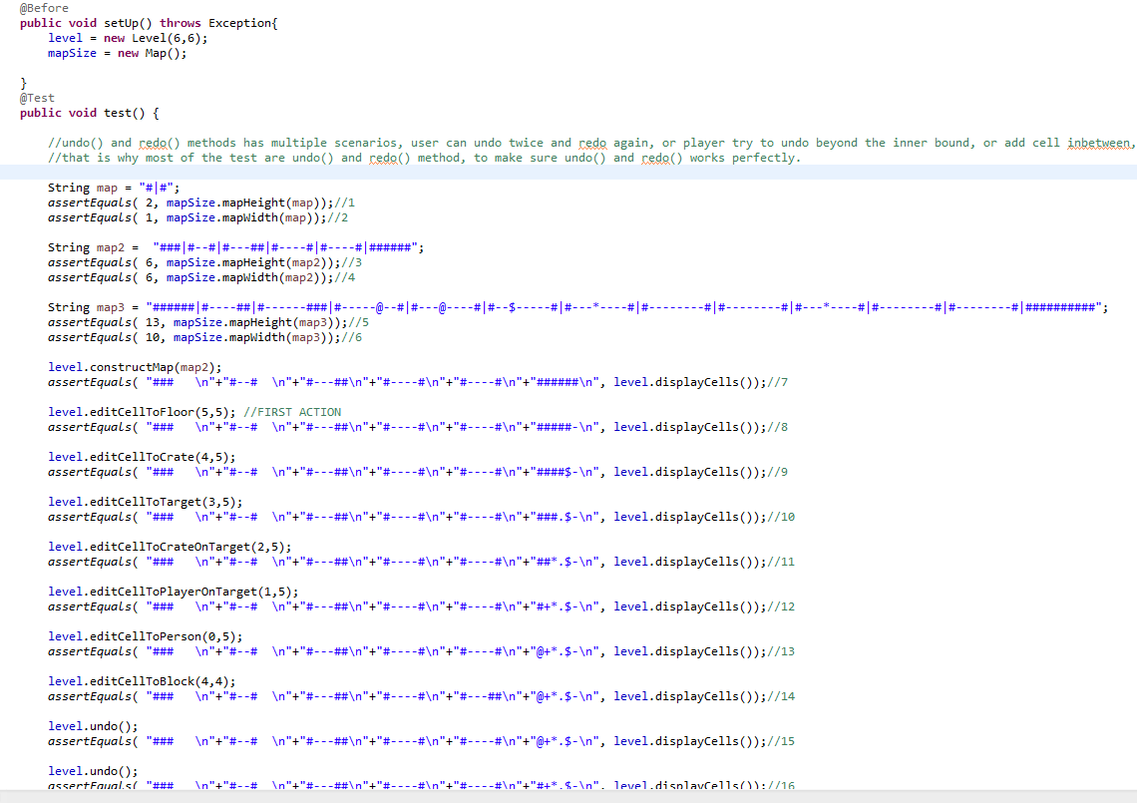

This is the testing that I implemented as a Sokoban level designer in eclipse.

### **Example 2**

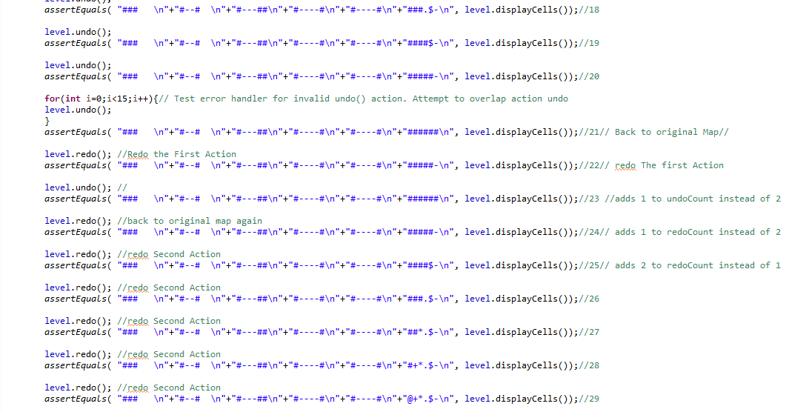

### **Example 3**

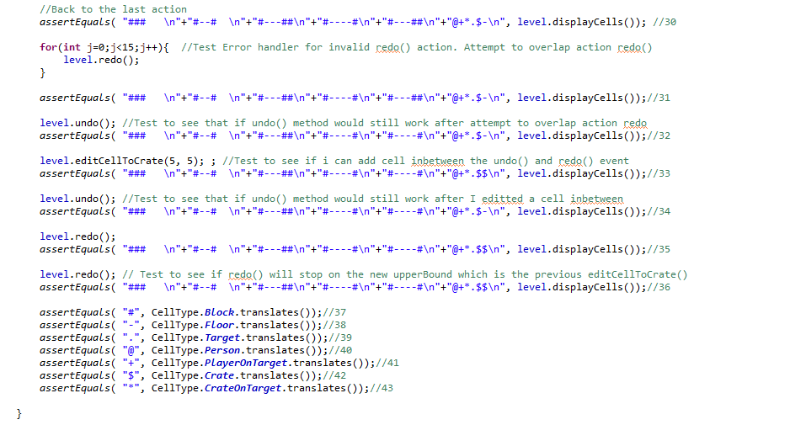

My approach is simple and easy to implement. JUnit testing allows me to use class inheritance which helps me automate the testing easily.

## **Debug and test programs to the systems level.**

(seas, n.d.) Suggested that debugging is the activity of finding the causes that produced undesirable program effects. Two basic techniques are used to debug a program. In one technique, called tracing, a program can be instrumented to produce a trace. In tracing, a program runs to completion without external intervention and information about several selected states of the program are saved. After a program is executed, this information is studied to find the causes of a program's malfunction. A program malfunction is called a bug.

**These are my own code**

### **Example 1**

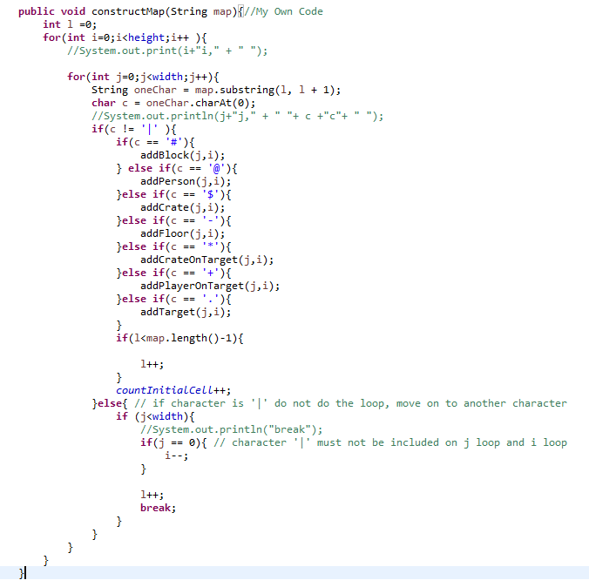

This is an example of debugging technique that I used. To be able to understand what causing the error, you need to output the value of variables that you are using inside the method.

On my examples, I am trying to build to map using nested loop and nested if, if else conditions.

Using system.out.println to output the value of the variables, for example int I, I was able to detect the problem that causing my method to build the map incorrectly.

I learned that the character “|” was causing the bug and it should not be included in the count.

### **Example 2**

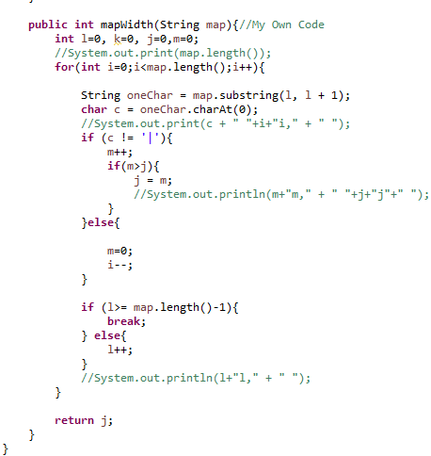

I should try and avoid complicated loops and nested loops if possible, should find a more simple way to do things.

### **Example 3**

## **Provide all appropriate systems level documentation.**

Dr. Mike Lance stated that “The important Systems level documentation is COMMENTS in the code! You could extend the comments by using JAVADOC format, and then automatically generate documentation about the code. Other tools within Eclipse or Android studio that help generate documentation are also useful”.

“A class diagram of the final build or a UML dynamic diagram which explains how you <<MODELL>> and <<VIEW>> and <<OTHER_STUFF>> would be useful systems level documentation” (Dr. Lance, 2015).

**THESE ARE MY OWN CODE**

### **Example 1**

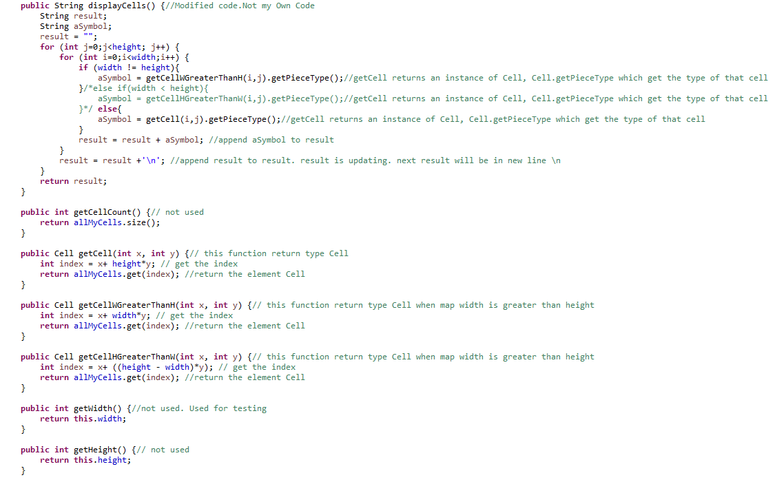

On my examples I put comments on almost every line of code, so when I come and look at this after 2 months, I think I would still be able to work on this code again easily.

### **Example 2**

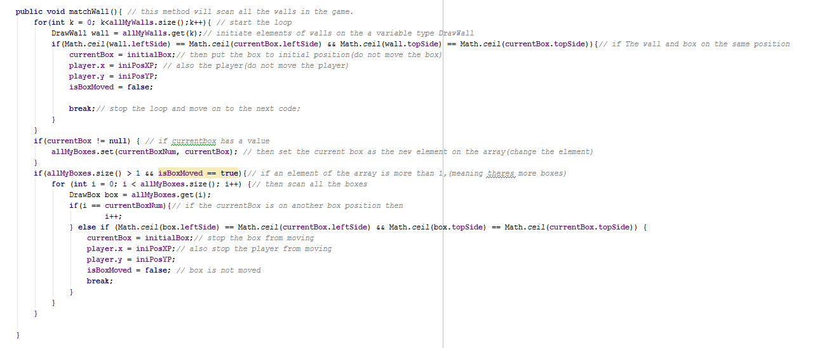

## **Maintain existing programs and update documentation.**

### **Example1**

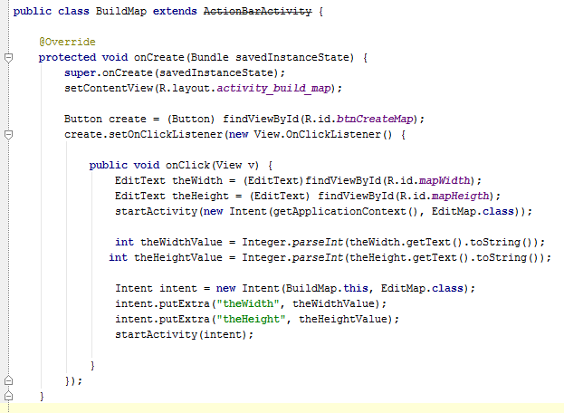

Here I had to make modification, to make get the data and pass it to another activity, so that the map can be built using The String map.

### **Example 2**

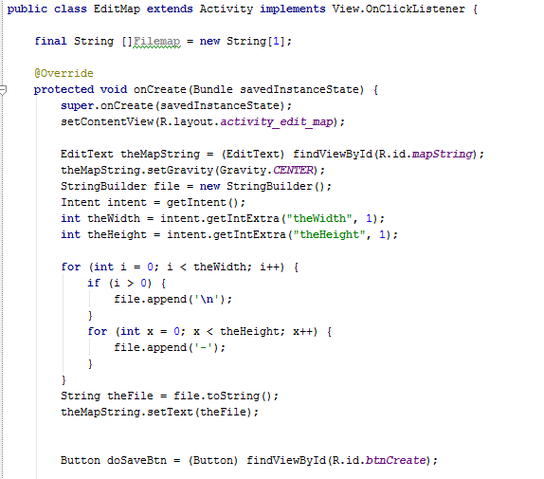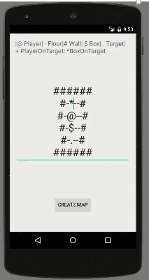

Here I had to modify some codes to view the string of map as multi-dimensional string view.

## **Compare and contrast the features and uses of different programming languages.**

### **Java**

According to (Rouse, 2014), JAVA is a programming language expressly designed for use in the distributed environment of the Internet. It was designed to have the "look and feel" of the C++ language, but it is simpler to use than C++ and enforces an object-oriented programming model. Java can be used to create complete applications that may run on a single computer or be distributed among servers and clients in a network. It can also be used to build a small application module or applet for use as part of a Web page.

### **Advantages of JAVA**

* Object Oriented
* Platform independence
* Automatic import class feature (alt + enter) in android studio
* Java is platform independent
* Java is distributed
* Java is more simple to learn

### **Uses of JAVA**

* Android applications
* Server Apps at financial services Industry
* JAVA web applications
* Software tools
* Big data technologies
* Scientific Applications

### **Disadvantages**

* More memory required for processing instruction.
* A bit slower than other languages.

### **PHP**

PHP is a programming language that can do all sorts of things: evaluate form data sent from a browser, build custom web content to serve the browser, talk to a database, and even send and receive cookies (little packets of data that your browser uses to remember things, like if you're logged in to a website.

### **Advantages of PHP**

* Open source: It is developed and maintained by a large group of PHP developers, this will helps in creating a support community, abundant extension library.
* Speed: It is relative fast since it uses much system resource.
* Easy to use: It uses C like syntax, so for those who are familiar with C, it’s very easy for them to pick up and it is very easy to create website scripts.
* Stable: Since it is maintained by many developers, so when bugs are found, it can be quickly fixed.
* Powerful library support: You can easily find functional modules you need such as PDF, Graph etc.
* Built-in database connection modules: You can connect to database easily using PHP, since many websites are data/content driven, so we will use database frequently, this will largely reduce the development time of web apps.
* Can be run on many platforms, including Windows, Linux and Mac, it’s easy for users to find hosting service providers.

### **Disadvantages of PHP**

* Security : Since it is open sourced, so all people can see the source code, if there are bugs in the source code, it can be used by people to explore the weakness of PHP
* Not suitable for large applications: Hard to maintain since it is not very modular.
* Weak type: Implicit conversion may surprise unwary programmers and lead to unexpected bugs. For example, the strings “1000” and “1e3” compare equal because they are implicitly cast to floating point numbers.

### **Conclusion**

PHP and JAVA are both great programming languages, however both has its own advantages and disadvantages. For me application created by using either two languages depends on how the developer code the program, if the app is insecure then it’s not just the language, it’s mainly on how you built/created the code.

However, for me JAVA is the best language for creating mobile applications. It’s simpler and the error report it gives you is detailed enough to debug a problem. PHP is more on the web applications, queries and data exchange.

# Bibliography

Bautista, N. (n.d.). Retrieved from Code.tutsplus.com: http://code.tutsplus.com/articles/a-beginners-guide-to-design-patterns--net-12752

Dr. Lance, M. (2015). *Moodle*. Retrieved from http://moodle.cpit.ac.nz/mod/forum/discuss.php?d=83947

Garner, S. (2012). Retrieved from dragonpoint.com: http://www.dragonpoint.com/whats-the-design-phase-of-a-software-development-project/

Mytton, D. (2004, September 23). Retrieved from http://www.sitepoint.com/coding-standards/

Rouse, M. (2014). Retrieved from http://searchsoa.techtarget.com/definition/Java

seas. (n.d.). Retrieved from www.seas.gwu.edu: http://www.seas.gwu.edu/~adagroup/concurrency/lopes/2softwar.htm

Toyotaro Suzumura, S. T. (2008). *Performance Comparison of Web Service Engines in PHP, Java, and C.* Retrieved from http://citeseerx.ist.psu.edu/viewdoc/download?doi=10.1.1.508.3995&rep=rep1&type=pdf

tutorialspoint. (2015). Retrieved from www.tutorialspoint.com: http://www.tutorialspoint.com/sdlc/sdlc_overview.htm

UNM. (n.d.). *www.cs.unm.edu*. Retrieved from https://www.cs.unm.edu/~luger/ai-final/supplement-ch1final.pdf

usability.gov. (2015). Retrieved from usability.gov: http://www.usability.gov/what-and-why/user-interface-design.html