

Dynamics 365 Higher Education Accelerator

Installation Guide

Contents

Installing the Higher Education Accelerator Solutions 2

Step 1: Acquire Prerequisite Files 2

Step 2: Perform the following main solution installs 2

Option 1: Use Package Deployer to Install Solutions 2

Option 2: Import Solutions Manually 3

Step 3: Check Power Automate Flows 6

Step 4: Installing Higher Education Portal 7

1. Create a Blank Portal 7

2. Import Higher Education Portal Solution & Data using Package Deployer Tool 7

3. Update Portal Binding 8

4. Set up Portal user login for Anton Chew 8

5. Set up Bing Map Key in Portal Configurations 9

References 9

Manually Importing Solutions 9

Acquiring Configuration Migration tool 10

Importing Data using Configuration Migration Tool 10

Acquiring Package Deployer tool 10

# Installing the Higher Education Accelerator Solutions

## Step 1: Acquire Prerequisite Files

* To import the Main Solutions, acquire the following managed solution files:
  + Education Accelerator Common (EducationAcceleratorCommon_managed.zip)
  + Dynamics 365 Higher Education Accelerator (HigherEducationAccelerator_managed.zip)
  + Dynamics 365 Higher Education Accelerator Canvas Model Apps (HigherEducationAcceleratorCanvasModel_managed.zip)
  + Dynamics 365 Higher Ed Portal (Dynamics365HigherEdPortal_managed.zip)
  + Education Accelerator Connection Roles (EducationAcceleratorConnectionRoles_managed.zip)
  + Education Accelerator Anchor - Higher Ed (EducationAnchorHigherEd_managed.zip)
  + EducationAnchorHigherEdEduPortal (Education Accelerator Anchor - Higher Ed Portal.zip)
  + Package Deployer file (PackageDeployer.zip)
* To import the Sample Data, acquire the following data files:
  + Higher Education Default Data (HIED-DefaultData.zip)
  + Higher Education Portal Data (HIED-PortalData.zip)

## Step 2: Perform the following main solution installs

Please use either one of the options below. If you are familiar with Package Deployer tool, option 1 is easier and installs all the main solutions together.

### Option 1: Use Package Deployer to Install Solutions

#### Download Package Deployer Tool

To import using the Package Deployer, you’ll need to download Package Deployer and the following package deployer file:

* + Package Deployer
    - For Download Instructions see reference on “Acquiring Package Deployer” below
  + Package Deployer file (PackageDeployer_HiEd.zip)

#### Install Higher Education Accelerator using Package Deployer

* + Use the below command script to import the solutions using package deployer:

**PackageDeployer.exe /Settings:"EducationAnchorHigherEd=true|EducationAcceleratorCommon=true|EducationAcceleratorConnectionRoles=true|Dynamics365HigherEducationAccelerator=true|Dynamics365HigherEducationAcceleratorCanvasModel=true|SkipSampleData=false"**

* + Expected Result: Import should be successful and have green checkmarks for every step and install following solutions and sample data.
    - Education Accelerator Common (EducationAcceleratorCommon_managed.zip)
    - Dynamics 365 Higher Education Accelerator (HigherEducationAccelerator_managed.zip)
    - Dynamics 365 Higher Education Accelerator Canvas Model Apps (HigherEducationAcceleratorCanvasModel_managed.zip)
    - Education Accelerator Connection Roles (EducationAcceleratorConnectionRoles_managed.zip)
    - Education Accelerator Anchor - Higher Ed (EducationAnchorHigherEd_managed.zip)
    - Higher Education Default Data (HIED-DefaultData.zip)

### Option 2: Import Solutions Manually

**Solutions must be installed in the following order:**

*To import, follow steps in the reference section for “Manually Import Solutions” section below.

#### Education Accelerator Anchor - Higher Ed (EducationAnchorHigherEd_managed.zip)

* Time to complete – 2 to 5 minutes
* Post installation message

#### Education Accelerator Common (EducationAcceleratorCommon_managed.zip)

* Time to complete – 2 to 6 minutes
* Post installation message

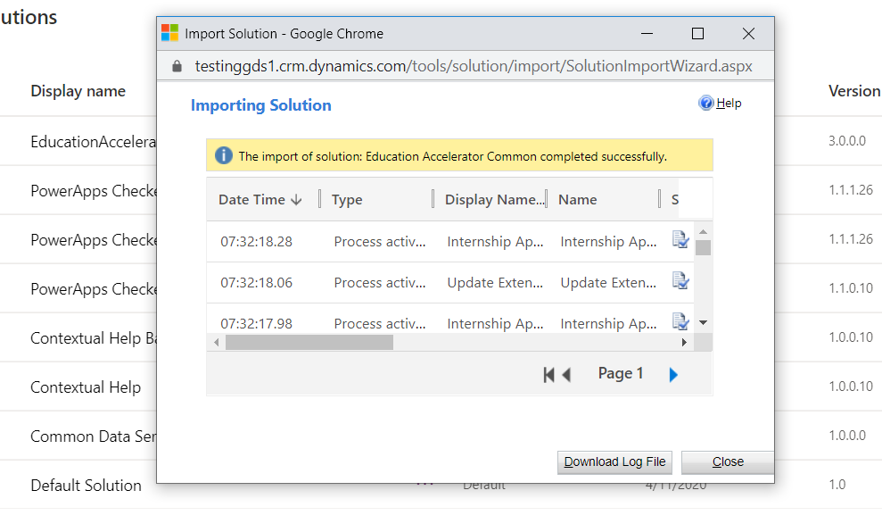

#### Education Accelerator Connection Roles (EducationAcceleratorConnectionRoles_managed.zip)

* Time to complete – 2 to 5 minutes
* Post installation message

#### Dynamics 365 Higher Education Accelerator (Dynamics365HigherEducationAccelerator_managed.zip)

* Time to complete – 2 to 5 minutes
* Post installation message

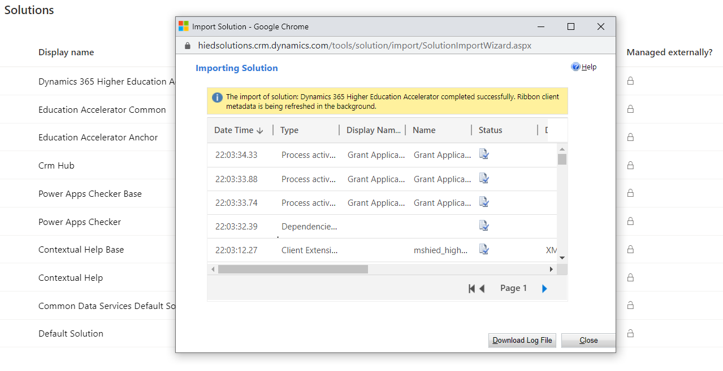

#### Dynamics 365 Higher Education Accelerator Canvas Model Apps (Dynamics365HigherEducationAcceleratorCanvasModel_managed.zip)

* Time to complete – 2 to 5 minutes
* Post installation message

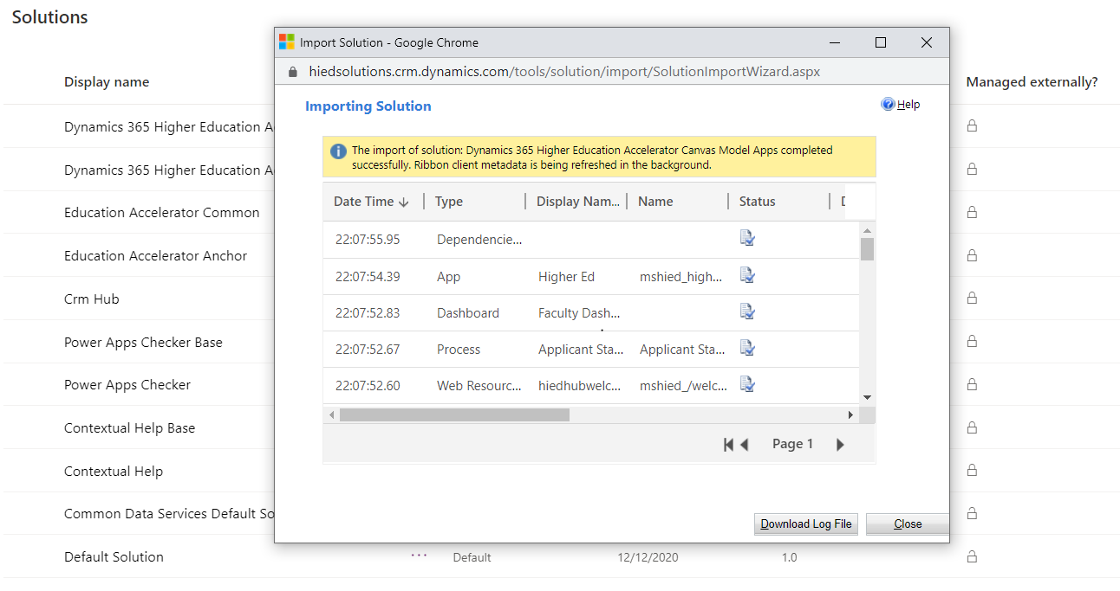

#### Import Sample Data for Main Solutions

Acquire Configuration Migration Tool using the steps as described in section – “Acquiring Configuration Migration Tool”

To import, follow steps in the reference section on “Import Data using Configuration Migration Tool” below.

* Higher Education Default Data (HIED-DefaultData.zip)
  + Time to complete – 8 to 25 minutes
  + Post Installation Message

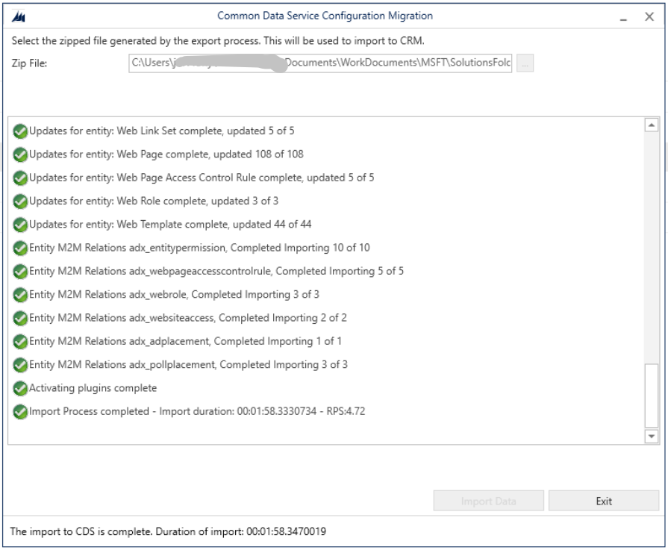

## Step 3: Check Power Automate Flows

For our Education Accelerator Common some of the flows in the solutions may already be turned on, if so please move onto the next flow that is in the off state to complete the steps below.

**Follow the below steps for each flow in our individual solutions: Education Accelerator Common:**

* 1. Go to each **Solution** from the solution explorer and click on it to view solution components
  2. In the top right filter please select **Cloud flow**.
  3. On each flow that is set to off, click the **Edit** button.
  4. **Add** in any missing Connections.
  5. Click **Save**.
  6. Activate the flow by clicking on “**Turn on**".
  7. Repeat these steps for each solution.

|  |  |
| --- | --- |
| **Solution** | **Flow** |
| Education Accelerator Common | Accept Appointment |
| Education Accelerator Common | Appointment - Add Regarding as Required Attendee |
| Education Accelerator Common | FL - > Course Histories -> Update Is Course Required |
| Education Accelerator Common | FL - > Course History -> Update Is Course Completed |
| Education Accelerator Common | FL - Course History -> Update Academic Period |
| Education Accelerator Common | FL -> Appointments -> Update StatusCode and StateCode |

## Step 4: Installing Higher Education Portal

### Create a Blank Portal

Create a new Blank Portal with the **Portal from blank template** by following [these](https://docs.microsoft.com/en-us/powerapps/maker/portals/create-portal) directions

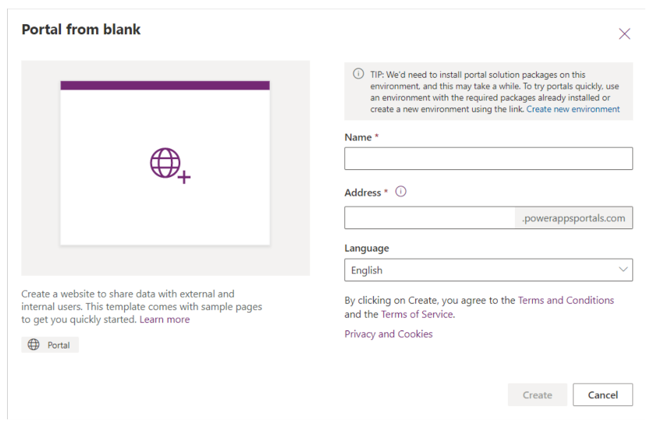

* Time to complete – 12 – 25 minutes
* Post installation message

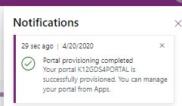

**Note**: Do not proceed to install the Dynamics 365 Higher Ed Portal (Dynamics365HigherEdPortal_managed.zip) solution (Import Higher Education Portal Solution & Data using Package Deployer Tool) until the Blank Portal is fully provisioned.

### Import Higher Education Portal Solution & Data using Package Deployer Tool

Please use either one of the options below. If you are familiar with Package Deployer tool, option 1 is easier and installs all the portal solutions together.

#### Download Package Deployer Tool

To import using the Package Deployer, you’ll need to download Package Deployer and the following package deployer file:

* + Package Deployer
    - For Download Instructions see reference on “Acquiring Package Deployer” below
  + Package Deployer file (PackageDeployer_HiEdPortal.zip)

#### Install Higher Education Accelerator Portal using Package Deployer

* + Use the below command script to import the solutions using package deployer:

**PackageDeployer.exe**

* + Expected Result: Import should be successful and have green checkmarks for every step and install following solutions and sample data.
    - Education Accelerator Common (EducationAcceleratorCommon_managed.zip)
    - Dynamics 365 Higher Education Accelerator (Dynamics365HigherEducationAccelerator_managed.zip)
    - Education Accelerator Connection Roles (EducationAcceleratorConnectionRoles_managed.zip)
    - Dynamics 365 Higher Ed Portal (Dynamics365HigherEdPortal_managed.zip)
    - EducationAnchorHigherEdEduPortal (Education Accelerator Anchor - Higher Ed Portal)
    - Higher Education Portal Data (HIED-PortalData.zip)

### Update Portal Binding

1. Click on Apps, locate the newly created Portal and click the ellipses to select **Settings**
2. Within the Portal Settings, under the Advanced Settings, click on **Administration** link (will open in a window/tab).
3. Within the Portal Details, find ‘**Update Portal Binding**’
4. Change ‘Select Website Record’ to “**Higher Ed Portal (Custom)**”
5. Click ‘Update’
   1. After this change, it may take up to 5 minutes for website binding data to sync.
   2. Please wait a few minutes before attempting to open the portal URL

### Set up Portal user login for Anton Chew

1. Navigate to the Portal Management model driven app
2. Select Contacts in the sitemap
3. Navigate to Anton Chew’s contact form
4. Click Create Invitation in the top horizontal bar

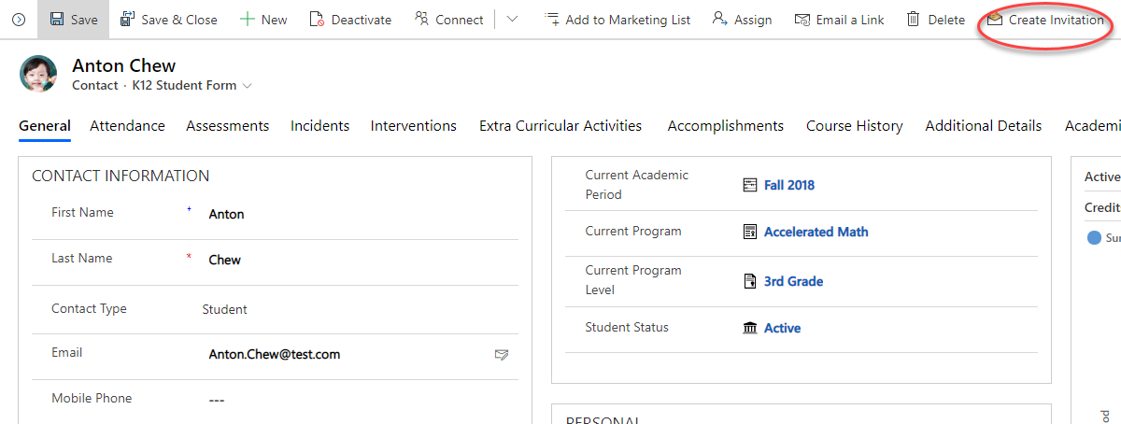

1. On the invitation form click Save
2. Navigate to the Advanced tab on the Invitation form
3. Copy the invitation code to your clipboard
4. Navigate to the Parent Student Portal
5. Click Sign In
6. Click Redeem Invitation
7. Paste the invitation code and click register
8. Complete registration by entering a username and password and saving
9. Confirm user details in the portal
10. Navigate to the coursework page of the portal to view Anton Chew’s Education records

### Set up Bing Map Key in Portal Configurations

**Note: This step is only required if you are using HigherEd Portal in an environment where Marketing App is available.**

Follow instructions to Generate Bing Map key: [Getting a Bing Maps Key - Bing Maps | Microsoft Docs](https://docs.microsoft.com/en-us/bingmaps/getting-started/bing-maps-dev-center-help/getting-a-bing-maps-key)

Follow below steps to add key in Portal:

* + - 1. Navigate to the **Portal Management** model driven app.
      2. Select ‘Site Settings’ in the Sitemap.
      3. Search for Site Settings 🡪 “MRP_Bing_Key”.
      4. Open the record & Update the Value field with the Bing map Key.

# References

## Manually Importing Solutions

To manually import a main solution:

1. Navigate to <https://make.powerapps.com/home> > Select your Environment > Click Solutions in left-hand Navigation
2. Click Import button in ribbon
3. Click Choose File button and select managed solution zip file

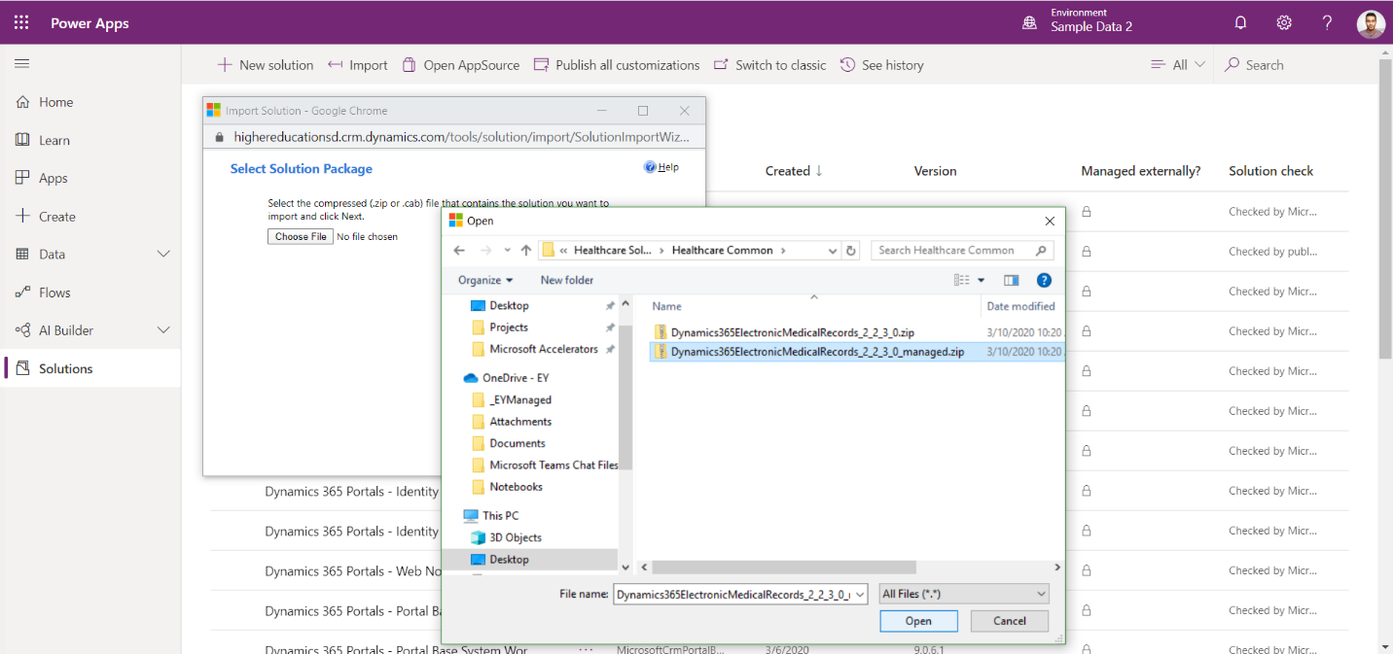

1. Click Open button
2. Click Next through all steps and then Import

**\*Note:** Some imports may take up to an hour to install

## Acquiring Configuration Migration tool

1. Navigate [here](https://docs.microsoft.com/en-us/powerapps/developer/common-data-service/download-tools-nuget) to acquire the Configuration Migration tool
2. Click the NuGet package link for the Configuration Migration Tool
3. Follow directions to download the Configuration Migration tool via Package Manager

## Importing Data using Configuration Migration Tool

To Import an additional solution using the Configuration Migration Tool:

1. Open Configuration migration tool
   1. Select “Import Data”
   2. Connect to the org to import the data to the environment of your choice
   3. Select the appropriate data zip file
   4. Perform the import

## Acquiring Package Deployer tool

1. Navigate [here](https://docs.microsoft.com/en-us/powerapps/developer/common-data-service/download-tools-nuget) to acquire the Package Deployer tool
2. Click the NuGet package link for the Package Deployer tool
3. Follow directions to download the Package Deployer tool via Package Manager