

Dynamics 365 Insurance

Installation Guide

Contents

Installing the Dynamics 365 Insurance Accelerator 2

Step 1: Acquire Prerequisite Files 2

Step 2: Manually Import Main Solutions 2

Step 3: Import Data Packages via Configuration Migration Tool 2

References 3

Manually Import Main Solutions 3

Acquiring Configuration Migration tool 3

Import Additional Solutions with Configuration Migration Tool 3

# Installing the Dynamics 365 Insurance Accelerator

## Step 1: Acquire Prerequisite Files

* To import the Main Solutions, acquire the following managed solution files:
  + InsuranceCommon_X.X.X.X_managed.zip
  + InsuranceApps_X.X.X.X_managed.zip
  + InsurancePowerApps_X.X.X.X_managed.zip
* To import the Additional Solutions, you’ll need to acquire the **Configuration Migration Tool** and following data files:
  + DefaultData.zip

## Step 2: Manually Import Main Solutions

For a list of all entities and attributes, find the Metadata Document amongst the included documentation. To import, follow steps in the “Manually deploy Main Solutions” section below. Solutions must be installed in the following order:

* InsuranceCommon_X.X.X.X_managed.zip
  + Installation time to complete: 5 minutes
  + Post Installation Result: completed successfully
* InsuranceApps_X.X.X.X_managed.zip
  + Installation time to complete: 5 minutes
  + Post Installation Result: completed successfully
* InsurancePowerApps_X.X.X.X_managed.zip
  + Installation time to complete: 5 minutes
  + Post Installation Result: completed successfully

## Step 3: Import Data Packages via Configuration Migration Tool

These solutions contain Sample Data for the Insurance Accelerator. To import, follow steps in the “Import Additional Solutions with Configuration Migration Tool” section below.

* DefaultData.zip
  + Data load time to complete: 15 minutes
  + Post data load result: Import process completed

# References

## Manually Import Main Solutions

To manually import a main solution:

1. Navigate to <https://make.powerapps.com/home> > Select your Environment > Click Solutions in left-hand Navigation.
2. Click Import button in ribbon.
3. Click Choose File button and select managed solution zip file.

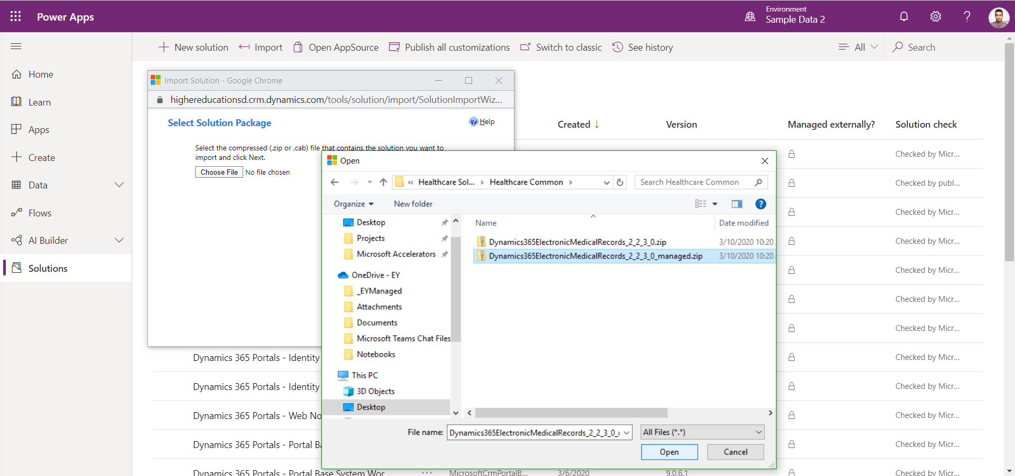

1. Click Open button.
2. Click Next through all steps and then Import.

## Acquiring Configuration Migration tool

1. Navigate [here](https://docs.microsoft.com/en-us/powerapps/developer/common-data-service/download-tools-nuget) to acquire the Configuration Migration tool
2. Click the NuGet package link for the Configuration Migration Tool
3. Follow directions to download the Configuration Migration tool via Package Manager

## Import Additional Solutions with Configuration Migration Tool

To Import an additional solution using the Configuration Migration Tool:

1. Open “Configuration Migration Tool” folder (**Note:** Make sure folder is on Desktop so directory name is short).
2. Right click “downloadlatest.ps1” and click “Run with PowerShell”, Type 'A', click ENTER and wait for it to complete.
3. Open the new “Tools” folder, then “Configuration Migration”, and run “DataMigrationUtility”.
4. To Import:
   1. Select “Import Data”.
   2. Connect to the org to import the data to.
   3. Select the appropriate data zip file (should be named “DataPackage.zip”).
   4. Perform the import.