Animals of the Bible App
Target Users
This app’s target market is people who are curious about the types of animals that are found in the Bible and have a desire to learn about them. The app will be child-friendly, so that anyone can use it. However, it will provide detailed information that will satisfy the desire for deeper learning that adults will have.
Problem to solve
Users have no easy mobile reference to educate themselves about animals in Scripture in order to understand their imagery, symbolism, what encountering one, or what having one means.
Goal
This app’s purpose is to educate users about animals of the Bible and provide an easy way to see the passages in which a particular animal is used in order that users may understand Scripture referencing animals better.
Features of the App/Use Cases
Allow users to select an animal
A user will be presented with a list of animals to select. From here, the user can select an animal to learn more about it. This list will contain both the pictures and names of the animals.
Allow users to sort the list of animals
The user will be allowed to sort the list of animals alphabetically and by order of appearance in Scripture.
Allow users to filter the list of animals
The user will be able to filter the list of animals by book of the Bible they appear in.
Display Information about an animal
An animal’s name, scientific name, classification, description, picture, habitat, and verses in which they appear in the Bible will be displayed. Each entry will show the picture of the animal, name, and scientific name. There will be two tabs that allow the user to switch between the description/classification and the Biblical references. From this view, the user will be able to go back to the list of animals.
Allow users to share information about an animal
Users will be able to post to Facebook or Twitter entries that they want to share.
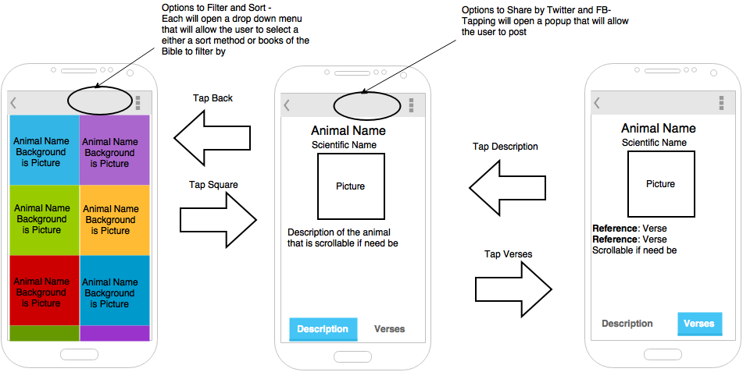
Prototype Implementation
The prototype will contain the list of animals, the animal’s information, and the Bible references of the animals. The prototype will not have the ability to sort or filter the list of animals nor will it have the ability to share information.
API Usage
This app will use four APIs in total.
- Biblia API – This API will be used to get information about verses in which animals appear in the Bible. The API allows the user to enter a search term, and it returns verses that contain this term. This will be used to find verses that have an animal’s name.
- EOL API – The Encyclopedia of Life API will provide images, scientific names, classification, and description of animals. I will find the appropriate ID’s for each of the animals in the Bible beforehand. This way, only the ‘pages’ API needs to be used instead of the ‘Search’ API as well (The Search API’s first result may also not be what you expect). This is not a problem as the animals in the Bible are not changing.
- Facebook API – The Facebook API will be used to allow users to post information about the animals they find on Facebook.
- Twitter API – The Twitter API will be used in the same way as the Facebook API.

