Data Set Name | MYDATA.CREDIT_APPROVAL | Observations | 690
Member Type | DATA | Variables | 16
Engine | V9 | Indexes | 0
Created | Monday, July 02, 2012 01:41:21 PM | Observation Length | 64
Last Modified | Monday, July 02, 2012 01:41:21 PM | Deleted Observations | 0
Protection |  | Compressed | NO
Data Set Type |  | Sorted | NO
Label
Data Representation | SOLARIS_X86_64, LINUX_X86_64, ALPHA_TRU64, LINUX_IA64
Encoding | utf-8 Unicode (UTF-8)

Engine/Host Dependent Information
Data Set Page Size | 131072
Number of Data Set Pages | 1
First Data Page | 1
Max Obs per Page | 2043
Obs in First Data Page | 690
Number of Data Set Repairs | 0
Filename | /courses/u_northwestern.edu1/i_833463/c_3505/SAS_Data/credit_approval.sas7bdat
Release Created | 9.0202M3
Host Created | SunOS
Inode Number | 8256764
Access Permission | rw-r--r--
Owner Name | UNKNOWN
File Size (bytes) | 139264

Alphabetic List of Variables and Attributes
# | Variable | Type | Len | Format
1 | A1 | Char | 1 | $1.
2 | A2 | Num | 8 | 8.3
3 | A3 | Num | 8 | 8.3
4 | A4 | Char | 1 | $1.
5 | A5 | Char | 2 | $2.
6 | A6 | Char | 2 | $2.
7 | A7 | Char | 2 | $2.
8 | A8 | Num | 8 | 8.3
9 | A9 | Char | 1 | $1.
10 | A10 | Char | 1 | $1.
11 | A11 | Num | 8 | 8.3
12 | A12 | Char | 1 | $1.
13 | A13 | Char | 1 | $1.
14 | A14 | Num | 8 | 8.3
15 | A15 | Num | 8 | 8.3
16 | A16 | Char | 1 | $1.

Obs | A1 | A2 | A3 | A4 | A5 | A6 | A7 | A8 | A9 | A10 | A11 | A12 | A13 | A14 | A15 | A16
1 | b | 30.830 | 0.000 | u | g | w | v | 1.250 | t | t | 1.000 | f | g | 202.000 | 0.000 | +
2 | a | 58.670 | 4.460 | u | g | q | h | 3.040 | t | t | 6.000 | f | g | 43.000 | 560.000 | +
3 | a | 24.500 | 0.500 | u | g | q | h | 1.500 | t | f | 0.000 | f | g | 280.000 | 824.000 | +
4 | b | 27.830 | 1.540 | u | g | w | v | 3.750 | t | t | 5.000 | t | g | 100.000 | 3.000 | +
5 | b | 20.170 | 5.625 | u | g | w | v | 1.710 | t | f | 0.000 | f | s | 120.000 | 0.000 | +

A1 | Frequency | Percent | Cumulative  Frequency | Cumulative  Percent
? | 12 | 1.74 | 12 | 1.74
a | 210 | 30.43 | 222 | 32.17
b | 468 | 67.83 | 690 | 100.00

A4 | Frequency | Percent | Cumulative  Frequency | Cumulative  Percent
? | 6 | 0.87 | 6 | 0.87
l | 2 | 0.29 | 8 | 1.16
u | 519 | 75.22 | 527 | 76.38
y | 163 | 23.62 | 690 | 100.00

A5 | Frequency | Percent | Cumulative  Frequency | Cumulative  Percent
? | 6 | 0.87 | 6 | 0.87
g | 519 | 75.22 | 525 | 76.09
gg | 2 | 0.29 | 527 | 76.38
p | 163 | 23.62 | 690 | 100.00

A6 | Frequency | Percent | Cumulative  Frequency | Cumulative  Percent
? | 9 | 1.30 | 9 | 1.30
aa | 54 | 7.83 | 63 | 9.13
c | 137 | 19.86 | 200 | 28.99
cc | 41 | 5.94 | 241 | 34.93
d | 30 | 4.35 | 271 | 39.28
e | 25 | 3.62 | 296 | 42.90
ff | 53 | 7.68 | 349 | 50.58
i | 59 | 8.55 | 408 | 59.13
j | 10 | 1.45 | 418 | 60.58
k | 51 | 7.39 | 469 | 67.97
m | 38 | 5.51 | 507 | 73.48
q | 78 | 11.30 | 585 | 84.78
r | 3 | 0.43 | 588 | 85.22
w | 64 | 9.28 | 652 | 94.49
x | 38 | 5.51 | 690 | 100.00

A7 | Frequency | Percent | Cumulative  Frequency | Cumulative  Percent
? | 9 | 1.30 | 9 | 1.30
bb | 59 | 8.55 | 68 | 9.86
dd | 6 | 0.87 | 74 | 10.72
ff | 57 | 8.26 | 131 | 18.99
h | 138 | 20.00 | 269 | 38.99
j | 8 | 1.16 | 277 | 40.14
n | 4 | 0.58 | 281 | 40.72
o | 2 | 0.29 | 283 | 41.01
v | 399 | 57.83 | 682 | 98.84
z | 8 | 1.16 | 690 | 100.00

A9 | Frequency | Percent | Cumulative  Frequency | Cumulative  Percent
f | 329 | 47.68 | 329 | 47.68
t | 361 | 52.32 | 690 | 100.00

A12 | Frequency | Percent | Cumulative  Frequency | Cumulative  Percent
f | 374 | 54.20 | 374 | 54.20
t | 316 | 45.80 | 690 | 100.00

A13 | Frequency | Percent | Cumulative  Frequency | Cumulative  Percent
g | 625 | 90.58 | 625 | 90.58
p | 8 | 1.16 | 633 | 91.74
s | 57 | 8.26 | 690 | 100.00

A16 | Frequency | Percent | Cumulative  Frequency | Cumulative  Percent
+ | 307 | 44.49 | 307 | 44.49
- | 383 | 55.51 | 690 | 100.00

Y | N Obs | Variable | 5th Pctl | 10th Pctl | 25th Pctl | 50th Pctl | 75th Pctl | 90th Pctl | 95th Pctl
0 | 383 | A2  A3  A8  A11  A14  A15 | 17.0800000  0.1650000  0  0  0  0 | 18.5800000  0.3750000  0  0  0  0 | 22.0000000  0.8350000  0.1250000  0  100.0000000  0 | 27.3300000  2.2100000  0.4150000  0  167.5000000  1.0000000 | 34.8300000  5.0000000  1.5000000  0  272.0000000  67.0000000 | 44.2500000  11.0000000  3.5000000  2.0000000  372.0000000  400.0000000 | 51.9200000  12.6250000  5.0850000  3.0000000  460.0000000  1000.00
1 | 307 | A2  A3  A8  A11  A14  A15 | 18.8300000  0.1650000  0  0  0  0 | 20.3300000  0.3750000  0.0400000  0  0  0 | 23.1700000  1.5000000  0.7500000  0  0  0 | 30.5000000  4.4600000  2.0000000  3.0000000  120.0000000  221.0000000 | 41.3300000  9.5400000  5.0000000  7.0000000  280.0000000  1210.00 | 52.8300000  12.7500000  8.5000000  11.0000000  399.0000000  4159.00 | 58.4200000  15.0000000  13.0000000  14.0000000  470.0000000  8000.00

Obs | A1 | A2 | A3 | A4 | A5 | A6 | A7 | A8 | A9 | A10 | A11 | A12 | A13 | A14 | A15 | A16 | Y
1 | b | 30.830 | 0.000 | u | g | w | v | 1.250 | t | t | 1.000 | f | g | 202.000 | 0.000 | + | 1
2 | a | 58.670 | 4.460 | u | g | q | h | 3.040 | t | t | 6.000 | f | g | 43.000 | 560.000 | + | 1
3 | a | 24.500 | 0.500 | u | g | q | h | 1.500 | t | f | 0.000 | f | g | 280.000 | 824.000 | + | 1
4 | b | 27.830 | 1.540 | u | g | w | v | 3.750 | t | t | 5.000 | t | g | 100.000 | 3.000 | + | 1
5 | b | 20.170 | 5.625 | u | g | w | v | 1.710 | t | f | 0.000 | f | s | 120.000 | 0.000 | + | 1

Obs | A1 | A2 | A3 | A4 | A5 | A6 | A7 | A8 | A9 | A10 | A11 | A12 | A13 | A14 | A15 | A16 | Y | A2_discrete
1 | a | 58.670 | 4.460 | u | g | q | h | 3.040 | t | t | 6.000 | f | g | 43.000 | 560.000 | + | 1 | 6
2 | b | 27.830 | 1.540 | u | g | w | v | 3.750 | t | t | 5.000 | t | g | 100.000 | 3.000 | + | 1 | 3
3 | a | 23.250 | 5.875 | u | g | q | v | 3.170 | t | t | 10.000 | f | g | 120.000 | 245.000 | + | 1 | 3
4 | b | 25.000 | 11.250 | u | g | c | v | 2.500 | t | t | 17.000 | f | g | 200.000 | 1208.000 | + | 1 | 3
5 | a | 27.420 | 14.500 | u | g | x | h | 3.085 | t | t | 1.000 | f | g | 120.000 | 11.000 | + | 1 | 3

Obs | A3_discrete | A8_discrete | A11_discrete | A14_discrete | A15_discrete | A1_a | A1_b | A4_l | A4_u | A4_y | A5_g | A4_g
1 | 1 | 4 | 3 | 1 | 5 | 1 | 0 | 0 | 1 | 0 | 1 | .
2 | 1 | 4 | 3 | 1 | 1 | 0 | 1 | 0 | 1 | 0 | 1 | .
3 | 1 | 4 | 5 | 2 | 4 | 1 | 0 | 0 | 1 | 0 | 1 | .
4 | 5 | 3 | 5 | 3 | 5 | 0 | 1 | 0 | 1 | 0 | 1 | .
5 | 6 | 4 | 1 | 2 | 2 | 1 | 0 | 0 | 1 | 0 | 1 | .

Obs | A5_gg | A5_p | A6_aa | A6_c | A6_cc | A6_d | A6_e | A6_ff | A6_i | A6_j | A6_k | A6_m | A6_q | A6_r | A6_w | A6_s | A7_bb
1 | 0 | 0 | 0 | 0 | 0 | 0 | 0 | 0 | 0 | 0 | 0 | 0 | 1 | 0 | 0 | 0 | 0
2 | 0 | 0 | 0 | 0 | 0 | 0 | 0 | 0 | 0 | 0 | 0 | 0 | 0 | 0 | 1 | 0 | 0
3 | 0 | 0 | 0 | 0 | 0 | 0 | 0 | 0 | 0 | 0 | 0 | 0 | 1 | 0 | 0 | 0 | 0
4 | 0 | 0 | 0 | 1 | 0 | 0 | 0 | 0 | 0 | 0 | 0 | 0 | 0 | 0 | 0 | 0 | 0
5 | 0 | 0 | 0 | 0 | 0 | 0 | 0 | 0 | 0 | 0 | 0 | 0 | 0 | 0 | 0 | 0 | 0

Obs | A7_dd | A7_ff | A7_h | A7_j | A7_n | A7_o | A7_v | A7_z | A9_f | A12_f | A13_g | A13_p
1 | 0 | 0 | 1 | 0 | 0 | 0 | 0 | 0 | 0 | 1 | 1 | 0
2 | 0 | 0 | 0 | 0 | 0 | 0 | 1 | 0 | 0 | 0 | 1 | 0
3 | 0 | 0 | 0 | 0 | 0 | 0 | 1 | 0 | 0 | 1 | 1 | 0
4 | 0 | 0 | 0 | 0 | 0 | 0 | 1 | 0 | 0 | 1 | 1 | 0
5 | 0 | 0 | 1 | 0 | 0 | 0 | 0 | 0 | 0 | 1 | 1 | 0

Analysis Variable : Y
A1 | N Obs | Mean
a | 52 | 0.5961538
b | 113 | 0.6991150

Analysis Variable : Y
A2_discrete | N Obs | Mean
1 | 1 | 1.0000000
2 | 24 | 0.4166667
3 | 81 | 0.6419753
4 | 35 | 0.8000000
5 | 18 | 0.8333333
6 | 6 | 0.6666667

Analysis Variable : Y
A3_discrete | N Obs | Mean
1 | 139 | 0.6618705
5 | 20 | 0.7000000
6 | 6 | 0.6666667

Analysis Variable : Y
A4 | N Obs | Mean
u | 134 | 0.6791045
y | 31 | 0.6129032

Analysis Variable : Y
A5 | N Obs | Mean
g | 134 | 0.6791045
p | 31 | 0.6129032

Analysis Variable : Y
A6 | N Obs | Mean
aa | 9 | 0.7777778
c | 40 | 0.6250000
cc | 13 | 1.0000000
d | 3 | 1.0000000
e | 3 | 0.6666667
ff | 5 | 0.2000000
i | 6 | 0.5000000
k | 9 | 0.3333333
m | 13 | 0.5384615
q | 26 | 0.6538462
w | 24 | 0.6250000
x | 14 | 1.0000000

Analysis Variable : Y
A7 | N Obs | Mean
bb | 8 | 0.7500000
dd | 2 | 0.5000000
ff | 5 | 0.2000000
h | 41 | 0.7560976
n | 1 | 0
v | 108 | 0.6574074

Analysis Variable : Y
A8_discrete | N Obs | Mean
1 | 40 | 0.4000000
2 | 12 | 0.5000000
3 | 76 | 0.7631579
4 | 30 | 0.8333333
6 | 7 | 0.7142857

Analysis Variable : Y
A9 | N Obs | Mean
f | 43 | 0
t | 122 | 0.9016393

Analysis Variable : Y
A10 | N Obs | Mean
t | 165 | 0.6666667

Analysis Variable : Y
A11_discrete | N Obs | Mean
1 | 73 | 0.4109589
2 | 14 | 0.7857143
3 | 40 | 0.8500000
4 | 12 | 1.0000000
5 | 26 | 0.8846154

Analysis Variable : Y
A12 | N Obs | Mean
f | 80 | 0.7250000
t | 85 | 0.6117647

Analysis Variable : Y
A13 | N Obs | Mean
g | 165 | 0.6666667

Analysis Variable : Y
A14_discrete | N Obs | Mean
1 | 42 | 0.7857143
2 | 31 | 0.5806452
3 | 43 | 0.5348837
4 | 26 | 0.7692308
5 | 23 | 0.6956522

Analysis Variable : Y
A15_discrete | N Obs | Mean
1 | 16 | 0.1250000
2 | 33 | 0.3939394
3 | 17 | 0.4705882
4 | 16 | 0.7500000
5 | 83 | 0.9036145

Model Information
Data Set | WORK.TEMP2
Response Variable | Y
Number of Response Levels | 2
Model | binary logit
Optimization Technique | Fisher's scoring

Number of Observations Read | 165
Number of Observations Used | 165

Response Profile
Ordered  Value | Y | Total  Frequency
1 | 0 | 55
2 | 1 | 110

Probability modeled is Y=1.

Model Convergence Status
Quasi-complete separation of data points detected.

Warning: |  | The maximum likelihood estimate may not exist.
Warning: | The LOGISTIC procedure continues in spite of the above warning. Results shown are based on the last maximum likelihood iteration. Validity of the model fit is questionable.

Model Fit Statistics
Criterion | Intercept Only | Intercept and Covariates
AIC | 212.050 | 82.438
SC | 215.156 | 88.650
-2 Log L | 210.050 | 78.438

Testing Global Null Hypothesis: BETA=0
Test | Chi-Square | DF | Pr > ChiSq
Likelihood Ratio | 131.6119 | 1 | <.0001
Score | 116.3115 | 1 | <.0001
Wald | 0.0063 | 1 | 0.9368

Analysis of Maximum Likelihood Estimates
Parameter | DF | Estimate | Standard  Error | Wald  Chi-Square | Pr > ChiSq
Intercept | 1 | 2.2156 | 0.3040 | 53.1112 | <.0001
A9_f | 1 | -16.6737 | 210.3 | 0.0063 | 0.9368

Association of Predicted Probabilities and Observed Responses
Percent Concordant | 78.2 | Somers' D | 0.782
Percent Discordant | 0.0 | Gamma | 1.000
Percent Tied | 21.8 | Tau-a | 0.350
Pairs | 6050 | c | 0.891

Odds Ratio Estimates and Profile-Likelihood Confidence Intervals
Effect | Unit | Estimate | 95% Confidence Limits
A9_f | 1.0000 | <0.001 | . | 0.005

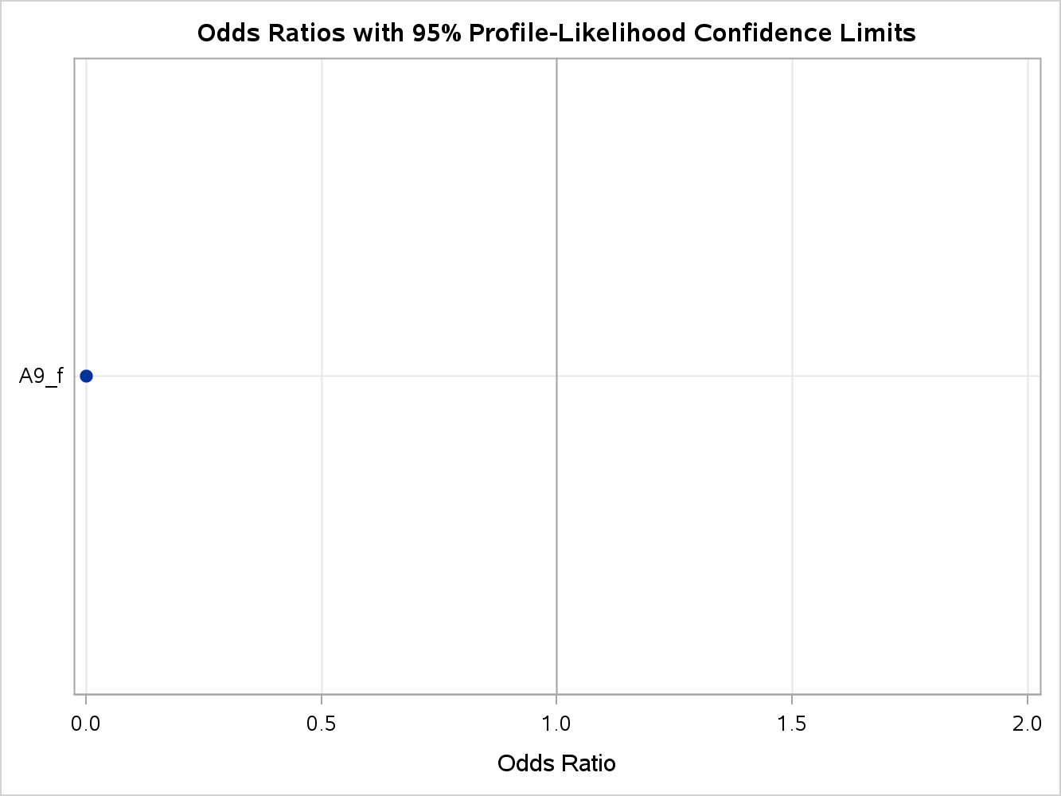

Model Information
Data Set | WORK.TEMP2
Response Variable | Y
Number of Response Levels | 2
Model | binary logit
Optimization Technique | Fisher's scoring

Number of Observations Read | 165
Number of Observations Used | 131

Response Profile
Ordered  Value | Y | Total  Frequency
1 | 0 | 43
2 | 1 | 88

Probability modeled is Y=1.

Note: | 34 observations were deleted due to missing values for the response or explanatory variables.

Note: | The following variables are not used in the SCORE selection since they are a linear combination of other variables as shown.

A1_b = | Intercept - A1_a
A4_l = | 0
A4_u = | Intercept
A4_y = | 0
A5_g = | Intercept
A5_gg = | 0
A5_p = | 0
A6_j = | 0
A6_r = | 0
A6_s = | 0
A7_ff = | A6_ff
A7_j = | 0
A7_o = | 0
A7_v = | Intercept - A6_ff - A7_bb - A7_dd - A7_h - A7_n
A7_z = | 0
A13_g = | Intercept
A13_p = | 0

Regression Models Selected by Score Criterion
Number of  Variables | Score  Chi-Square | Variables Included in Model
1 | 101.5931 | A9_f
1 | 13.0424 | A11
1 | 5.8677 | A6_cc
1 | 4.9751 | A12_f
1 | 4.8999 | A8
1 | 4.0553 | A15
1 | 3.2700 | A2
1 | 2.8881 | A3
1 | 2.1519 | A7_h
1 | 2.0623 | A7_n
1 | 1.7673 | A6_m
1 | 1.7411 | A6_k
1 | 1.5947 | A6_ff
1 | 1.0149 | A1_a
1 | 0.9924 | A6_d
1 | 0.5512 | A6_w
1 | 0.4405 | A6_c
1 | 0.3877 | A7_bb
1 | 0.2717 | A7_dd
1 | 0.1502 | A6_q
1 | 0.1214 | A6_i
1 | 0.0607 | A6_aa
1 | 0.0009 | A14
1 | 0.0004 | A6_e

