James, and Abishek,

Here are some ideas I was hoping to get your feedback on. I think there are basically three “levels” of visualization and associated development – (1) the “overview” map level where the user is interacting with a (Google) map of the Chesapeake Bay as a whole (and seeing some basic information about the water quality sample locations on top of the Google base map), (2) the “details on demand” which would include interactive charts showing values at specific monitoring stations, and ideally (3) a filter that would highlight which water quality values would support habitat requirements for various fish species. For the time being, please forget #3! #3 may end up being optional and just an additional filter on #2. What would be really helpful would be for you to review my thoughts on the following and let me know what you think we can accomplish based on the data I sent to you. This is somewhat arbitrary, but maybe James could focus on #1 and Abishek #2. If there is a better approach please let us all know!

1. For the overview map (the Google Base map with locations of sampling stations plotted based on their latitude and longitude), here are some questions regarding possible enhancements.

* Can the symbols be color-coded (or otherwise differentiated with visual markings) based on values in the data set? Here are some possibilities that the user could toggle/filter among:
  + Color coded based on **maximum depth** (Maximum value for TotalDepth at that station location), or …
  + Color coded based on **mean summer surface salinity** (Mean value for “Parameter = Salinity” and “Layer = S” and “Sample_Date is > 6/1/15” and “Sample_Date is < 9/1/15”
  + I may suggest other filters that would be of interest and based on combinations of data parameters but first I wanted to understand if this could be done and how much work it would be
  + Example: 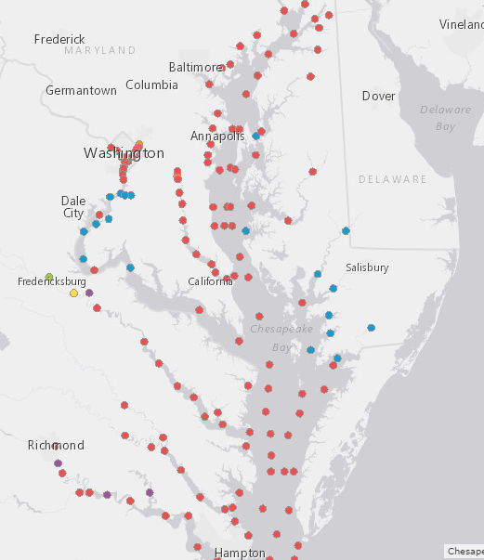
* Can we enable the feature that swaps out other Google base maps (e.g. – imagery)? 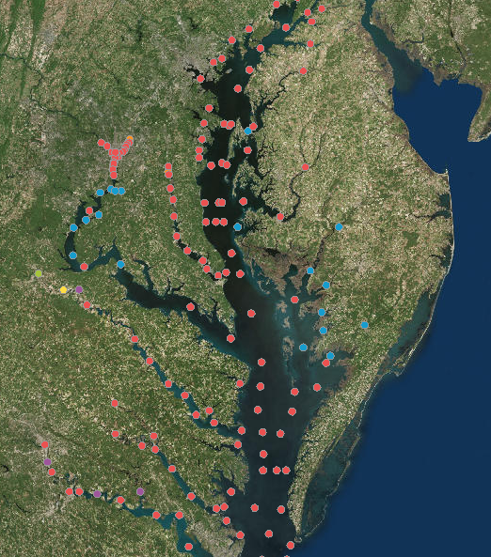
* Can the Google Maps API display other data layers on top of the Google Base Map? For example, if I create a GIS layer and make it available in GeoJSON or some other format, can it be displayed in Google maps along with the point symbols showing monitoring locations (see salinity example below) 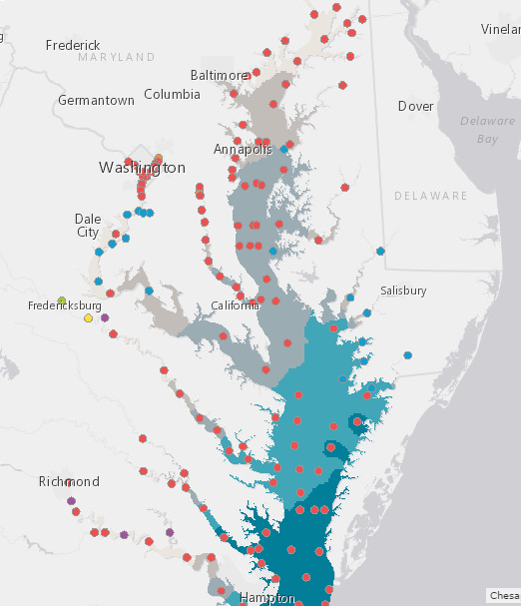

2. For “Details on Demand”, here are some thoughts with references to various examples.

The paper that (I think) captures my ideas better than anything else is this one *-* ***IGODS: An Important New Tool for Managing and Visualizing Spatial Data*** (Shisko et al) – attached. I will reference some figures in that paper as examples, and you guys can tell me what is feasible based on the data I sent.

* Figure 1 – this is just a small multiples approach to showing plots for different sample locations. I can envision something similar with sample locations for the Chesapeake Bay, but I’m not sure if it is necessary. I just thought I would raise it as a possibility for showing multidimensional data at various geographic locations. I’d appreciate your thoughts.
* Figure 2 – this would be the “details on demand” for a given sample location, where we would be showing a scatter plot (unless you guys can come up with something fancier) with scaling for the y-axis based on **TotalDepth** and actual plot locations based on **Depth** (y axis value) and **MeasureValue** (x axis value) of the Parameter of interest (for our purposes, we could limit it to **Parameter = DO, CHLA, or SALINITY**) on the x axis.
* Figure 3 – If we wanted to, we could include the three Parameters of interest in the same scatter plot chart. The example in the Shisko paper displays multiple variables on the same chart, and includes multiple x-axes labels that correspond to each parameter. Again – just raising this as an option.
* Figure 4 – Shows all stations overlaid with a locator map. This might be nice if a given station’s values were highlighted when the user mouses over sample values corresponding to that location. If we did this, it would probably need to be done one parameter (CHLA, DO, or SALINITY) at a time. Perhaps the user could filter his/her selections based on the parameter of interest.
* Ideally, all of the above would be filterable based on a date range. This is important because water quality measurements change throughout the course of the year, with problems typically occurring in the summer. If there was a way for a user to select a month and have all charts/graphics refresh based on the selected date range that would be ideal.
* Figure 5.2D and Figure 6.3D – This is probably outside the scope of what could reasonably be done, but I thought I would raise it anyway in case it prompts any thoughts. The visualization approach shown in these two figures are very relevant to the work of the Chesapeake Bay restoration effort. These graphics represent transects of parameters in 3D geographic space. Again, probably way too much for our project but if you want to pursue something beyond this semester and any of these are appealing to you we could talk further.
* The remaining figures in this paper are also very relevant to the Chesapeake and our project, but I think we need to limit ourselves to what can be reasonably accomplished. Again, if any of this is of greater interest to you, we can talk further.