CareerFrench Site Plan

Brandon Phillips

WDD 130

Overview

Purpose
The purpose of CareerFrench is to help users learn French vocabulary and skills directly tied to a
specific job they are pursuing, by using an AI chatbot that analyzes a real job posting and builds
a personalized learning path, so users can confidently list French as a marketable language skill
on their resume and use it in that professional context.

Audience
The intended audience is working adults and college students who are applying for or planning
to pursue jobs that value French language skills, and who want AI-personalized, job-specific
French practice rather than generic language learning.

Branding

Website Logo

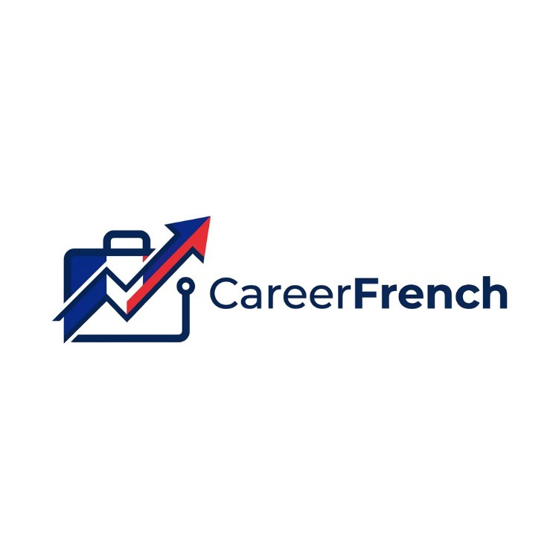

Primary

Secondary

Accent 1

Accent 2
#003580
#EDEFF4
#C8102E
#F5C242

Typography

Heading Font: Playfair Display

Paragraph Font: Lato

Navigation
Home Resources Career Checklist

Style Guide

Color Palette





Content
HOME PAGE

Hero Headline:
Learn French That Gets You Hired

Subheadline:
Stop studying random French words. Paste in the job you want, and CareerFrench uses AI to
build the exact French vocabulary and learning path for that role — so you can confidently add
French to your resume and mean it.

How It Works Section:
Step 1: Paste your target job’s posting or website URL into the CareerFrench AI chatbot. Step 2:
The AI analyzes the job requirements and instantly generates a personalized French vocabulary
list, learning goals, and practice checklist built specifically for that role. Step 3: Track your
progress and check off milestones as you build a real, resume-ready French skill tied directly to
that job.

Why CareerFrench Section:
Language learning without a purpose leads to forgotten vocabulary. CareerFrench fixes this by
anchoring every word you learn to a real job you actually want. Instead of following a generic
course, the AI reads your target job posting and identifies exactly which French skills,
vocabulary, and phrases will matter to that employer — so every minute you study is working
toward something specific.

Home Page Images:

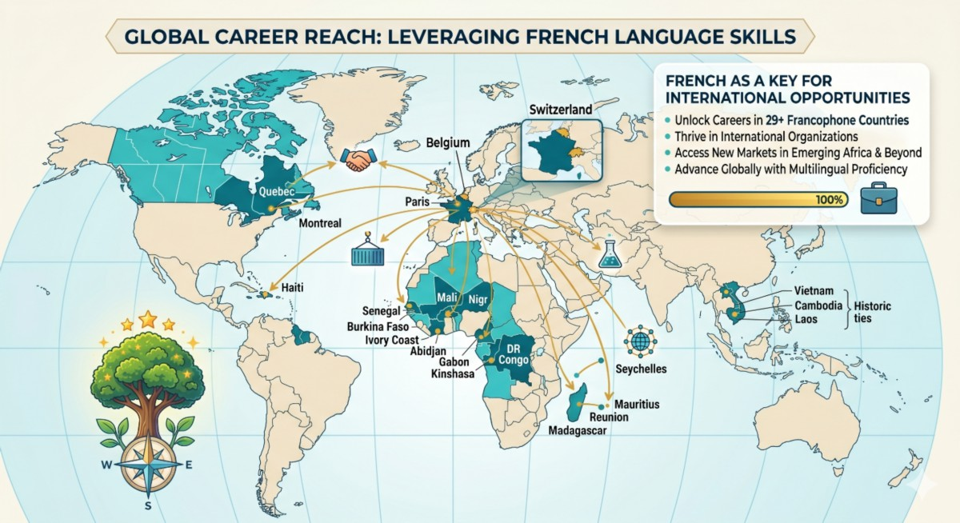


RESOURCES PAGE

Page Title:
French Learning Resources — Career-Focused Tools for Every Learner

Vocabulary Lists by Career Section:
When you submit a job URL to the CareerFrench AI chatbot, it scans the posting for role-
specific language and generates a custom vocabulary list built for that exact position. Each word
comes with pronunciation guides, an example sentence in a workplace context, and a note on
why it is relevant to your target job. No two lists are the same because no two jobs are identical.

Grammar Essentials Section:
Focus on grammar patterns that matter most in professional settings — formal email writing,
meeting vocabulary, and professional presentations in French. We skip the grammar rules you
will never use at work so you can focus on what employers will actually hear and read.

Resources Page Images:

CAREER CHECKLIST PAGE

Page Title:
Your Career French Checklist — Track Your Progress Toward a Resume-Ready Skill

Set Your Career Goal Section:
Paste your target job posting or company website into the CareerFrench AI chatbot and it will
generate a personalized checklist of French language skills, vocabulary milestones, and
proficiency goals built specifically for that role. Your checklist updates as you complete items so
it always reflects your current progress and what to focus on next.

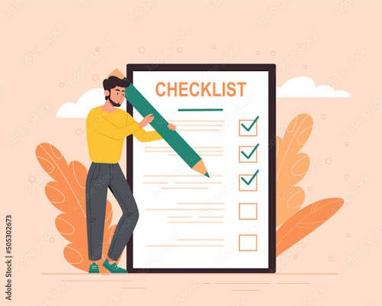

Sample Milestone Checklist:
Complete your AI-generated vocabulary list for your target job. Complete 5 job-specific
dialogue exercises. Write one professional email in French tailored to your industry. Reach A2
proficiency in your role-specific vocabulary. Complete a mock job interview practice session in
French. Add French (Intermediate) to your resume.

Why Tracking Matters Section:
Research shows that tracking progress increases motivation and improves language retention.
Your CareerFrench checklist gives you clear, achievable goals that connect directly to your
career timeline, so you stay motivated and build skills with real professional purpose.

Career Checklist Page Images:

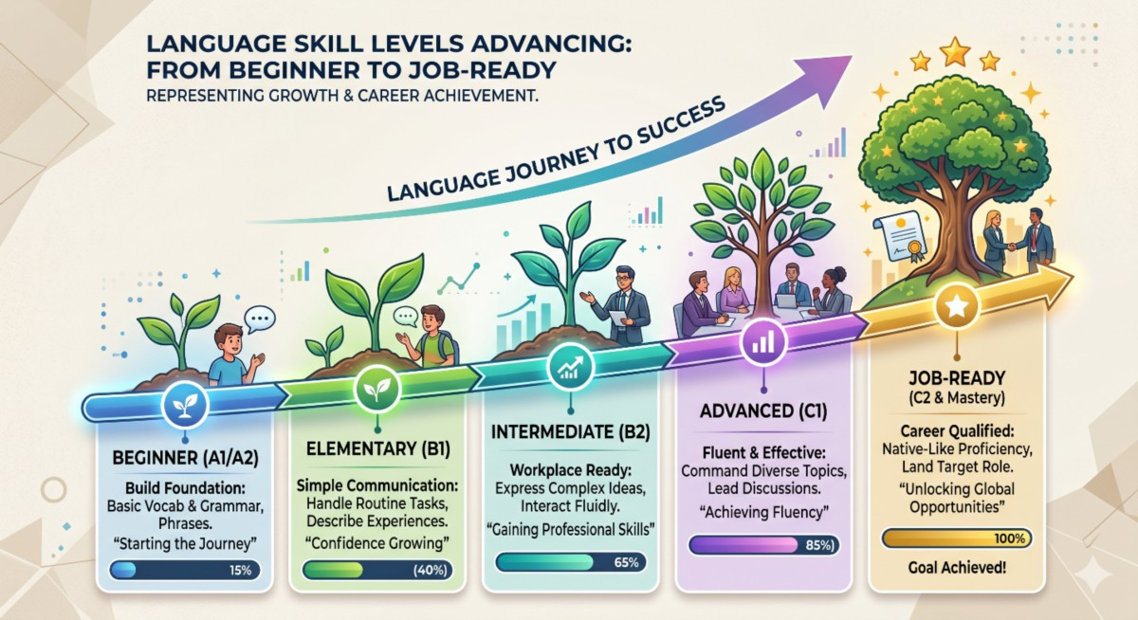

Wireframes

Home

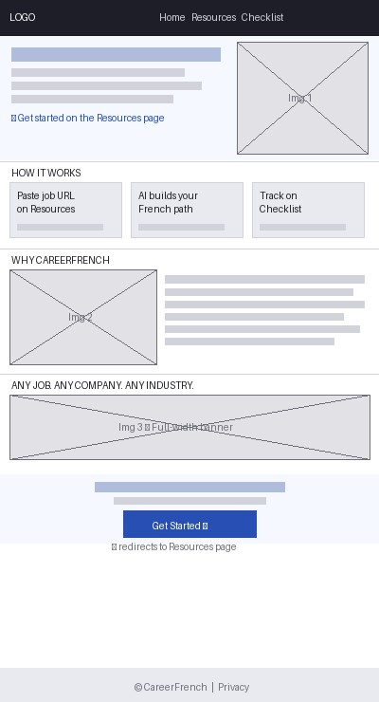

Resources

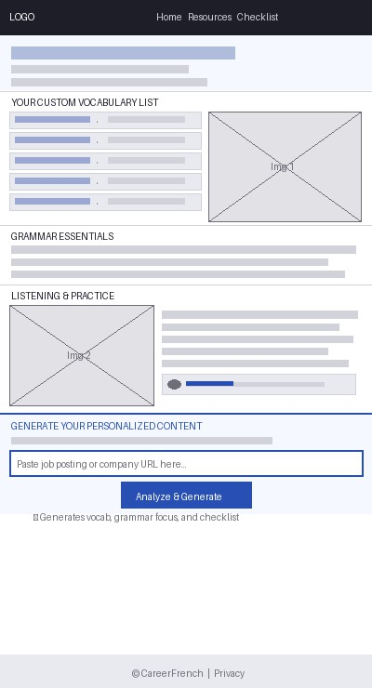

Career Checklist

