[Site name] Site Plan

[James Gurr]

WDD 130

Overview

Purpose
Our platform will offer real-time help through live chat, phone, and video services staffed exclusively by background-checked, credentialed experts. By prioritizing encrypted, view-only screen sharing over invasive remote control, we ensure users always stay in the driver's seat.

Audience
The intended audience is those that are over the age of 50 or are prone to fall for scams related to technology assistance.

Branding

Website Logo

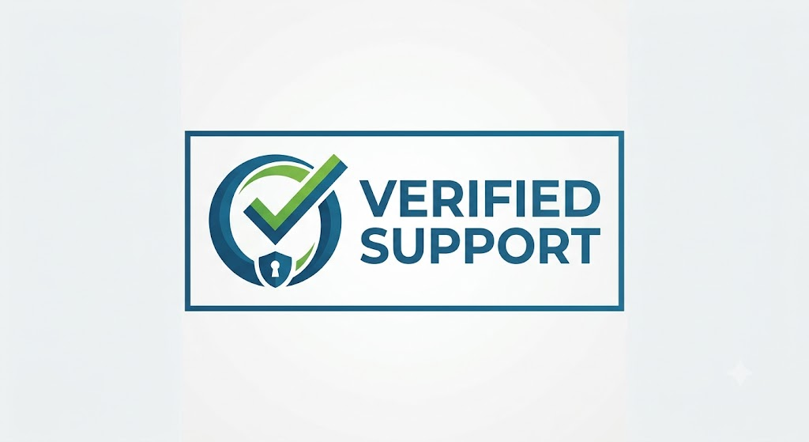

Style Guide

Color Palette
Primary | Secondary | Accent 1 | Accent 2
#1A5276 | #52BE80 | #FFFFFF | #F4F6F7

Typography

Heading Font: Inter(Bold), DM Sans, Work Sans

Paragraph Font: Inter, Lexend, IBM Plex Sans

Navigation
Home Self-help About

Content









Wireframes
Home: Self-Help:
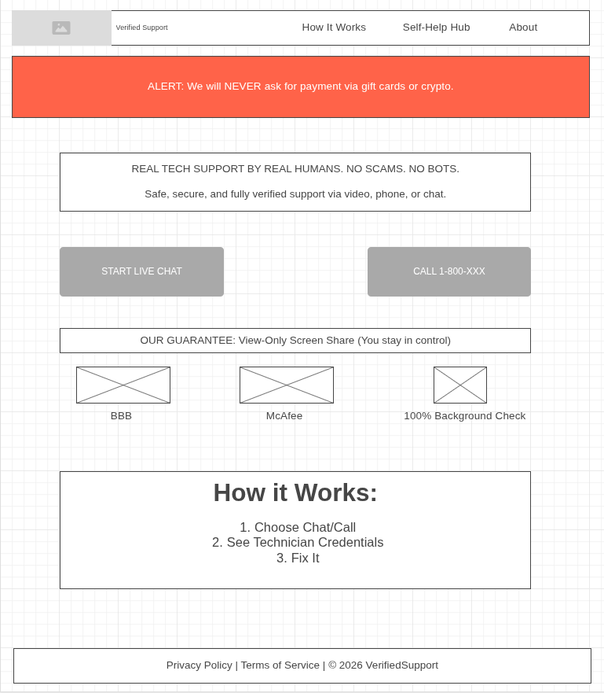
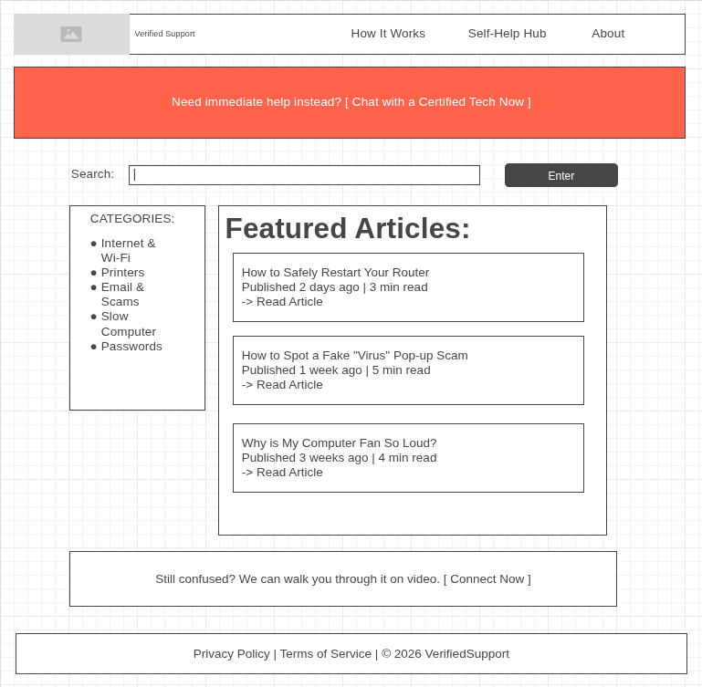

About:
