BS2202: Object-Oriented Development Portfolio
James Hayzen
Tutor: Aimee Robinson
Word count:

Contents
Project Scope 2
Introduction: 2
Client requirements: 2
Functional requirements: 2
Non-Functional Requirements (NFR): 4
User Interface Diagrams: 5
Sign in page: 5
Employee Dashboards: 6
Admin dashboards: 8
Class and Database Diagrams 10
Class diagrams: 10
ER Diagrams: 10
Testing Documentation 12
Testing Plan 12
Testing Strategy 12
Test Environment: 13
Evidence of testing results 13
Junit Test Scripts 14
Database Connection Script 14
References 15
Figures 15
Tables 15
Appendix 16

Project Scope

Introduction:
This document provides insight into the development of my chosen case study around designing and developing a stock management system using the coding language Java and its in-depth package library, as well as integrating a developed backend database using MySQL. The products being managed by the system could be chosen for the project if they were items that could be bought and sold. Furthermore, the project that I will be developing is not for customers or members of the public, but for employees of the company only.
My focus for this project will be designing and building a computer hardware component stock management system. I selected this area as I have experience in understanding the different components that come together to build a personal computer and identified an opportunity to introduce and practise object-oriented design, making each hardware component a unique class, as there are many different brands and generations of hardware, but all share common attributes.

Client requirements:
Client requirements are the features of the system/product being designed and developed that the Client wants to see in the final product. For software, they describe the services that a system must provide and, under certain constraints, operate in; they can vary from high-level abstract statements to detailed mathematical functional specifications (Davis, 1993). The requirements I will list shall be split into two sections, functional and non-functional requirements, as well as the minimum features that are required by the project assignment brief.

Functional requirements:
In software development, functional requirements describe what a system should do, such as behaviours, functions and features. They provide a good guideline for developers as they can engineer what requirements have the highest priority for implementation based on the core functionality of the system and based on how long they will take to implement.

Project brief: functional requirements
Req.ID | Requirement | Priority
PFR.01 | More than one type of product to be managed | High
PFR.02 | More than one option of product i.e. different brands of components | Medium
PFR.03 | Ability to see the current number of each product available for purchase | Low
PFR.04 | Ability to sell products, including pricing | High
PFR.05 | Ability to buy products to increase stock | High
PFR.06 | Ability to print information about a single product to a text file, and should include details | Low
PFR.07 | Ability to print information about stock available to a file and including the total value of the stock | Medium
PFR.08 | A login system that includes different account types and the ability to register with admin approval | High
Table 1 Project Brief Functional Requirements

My functional requirements:
Ideally, I would perform primary research with my clients to identify and discuss what kind of functional requirements they would want in their system. I would have carried out a focus group with the client to discuss what they would like by asking open-ended questions and showing them examples of other features that mainstream stock managers have, like Amazon Web Services now have built-in Artificial Intelligence managers to maintain databases. Another method of research I would have carried out would be surveys open to a target audience of a select few. The questions I would have asked would be open-ended so that I would have answers based on honesty and reduce bias, a form of question I would use would be a Likert scale.
Req.ID | Requirement | Priority
FR.01 | The system can store and display products by details such as brand, model, specifications or price | High
FR.02 | Using Filters, users can search the database for products such as name, ID, category or specification | High
FR.03 | An alert is generated for the admin when stock levels fall below a certain threshold | Low
FR.04 | User passwords, when generated, are encrypted using a one-way hashing algorithm | High
FR.05 | E-mail confirmation is sent once a new user has been approved | Low
FR.06 | Auto logout feature after a certain amount of time is passed AFK (Away from Keyboard) | Medium
Table 2 Additional Functional Requirements

Non-Functional Requirements (NFR):
Non-functional requirements define how a system should behave rather than what it should do. They are a fundamental part of the design and development process as they ensure the system's quality and user experience. NFRs are not mandatory to a development process but are often included as they guide common aspects such as performance, scalability, usability and availability (Altexsoft, 2022).
Req.ID | Requirement | Priority
NFR01 | A user interface/experience that is friendly to use, making it accessible to all working age groups as well as easy to understand, making training easy | High
NFR02 | A inclusive application/software that caters to as many different groups as possible, such as people who are visually impaired, colour blind, mobility issues such as arthritis | High
NFR03 | Only authorised users are allowed to access the system | High
NFR04 | Performance is maintained while the system is running, such as sales and transactions are processed under certain time limits, easy to read and maintain coding which ensures performance can be increased | Low
NFR05 | Scalability is ensured, for example allowing space to have the system compatible with all operating systems like MacOS or Linux. | Medium
NFR06 | Maintaining Accountability for data by preventing duplicate product entries and ensuring referential integrity | Medium
NFR07 | Usability is ensured by following the Wcag and SDS inclusion acts | High
Table 3 Non-Functional Requirements

User Interface Diagrams:
Wireframes are an integral part of the design process; they lay out how a system may be laid out visually. It helps the developer understand the flow of the system with the layout of buttons and fields, as well as identify how other users may interact with the system too.
Part of my brief states that my designs should meet the Web Content Accessibility guidelines (WCAG) and show how my designs meet Sustainable Development Goal 10: Reducing inequalities (SDG 10). WCAG is a collaboration between individuals and organisations to provide a single set of guidelines for website content accessibility so that the needs of individuals, organisations and governments are met internationally; the document refers to how content (including natural information such as text, images and sound as well as code or markup so that the structure of content is standardised) should be laid out so that people with disabilities can interact with them easier (w3c_wai, 2018). SDG 10 is the goal of reducing inequalities within and amongst countries; The focus is to minimise the differences in income, opportunities and access to resources and is based on various factors such as age, race, sex, ethnicity, disability, religion and economic status (UNDP, 2024)

Sign in page:
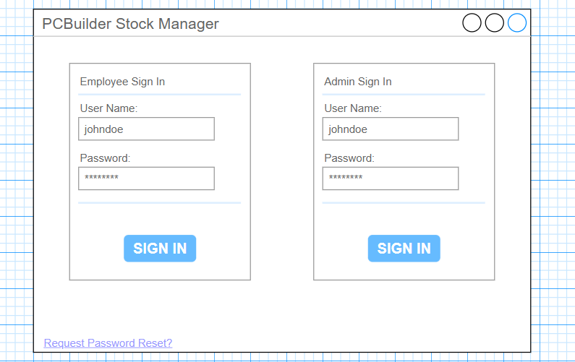
Figure 1 Sign in Wireframe
I decided while designing to have a clear focus on digital inclusion; by separating elements clearly and using a conventional login system, it makes the interface easy to use and therefore means technical expertise is not needed. Additionally, having a link to reset the password is a crucial part, as forgetting passwords is common amongst users and can prevent users from being locked out completely, helping certain users who are less familiar with technology or have cognitive disadvantages.

Employee Dashboards:
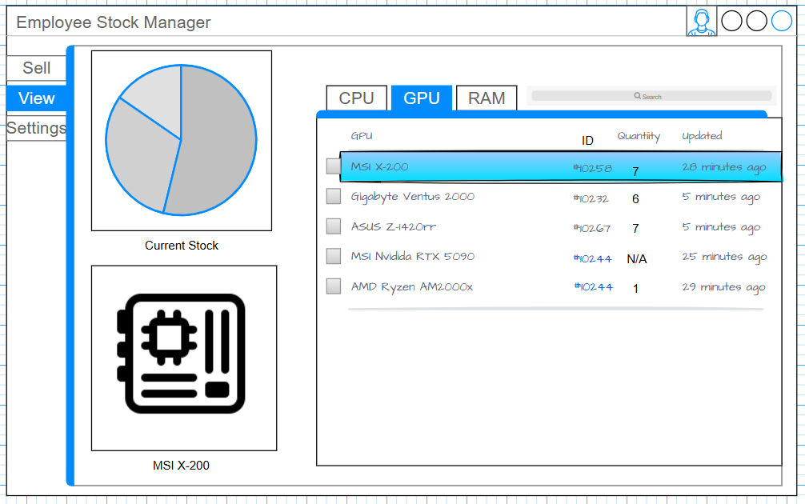
Figure 2 Employee Dashboard 1
For the employee dashboard, it first seems more visually complex, but I tried to keep it clean and simple by utilising high-contrast colours so that it’s easy to read, as well as using images and a pie chart to visually demonstrate what products are selected and available. The interactive elements are laid out, the user can select which component to view the stock of, with easy-to-read information about the product, such as the ID and quantity of the selected product. To help with inclusion, I designed the stock management view to require little input from a keyboard, everything should be able to be navigated with just the arrow keys or a mouse.
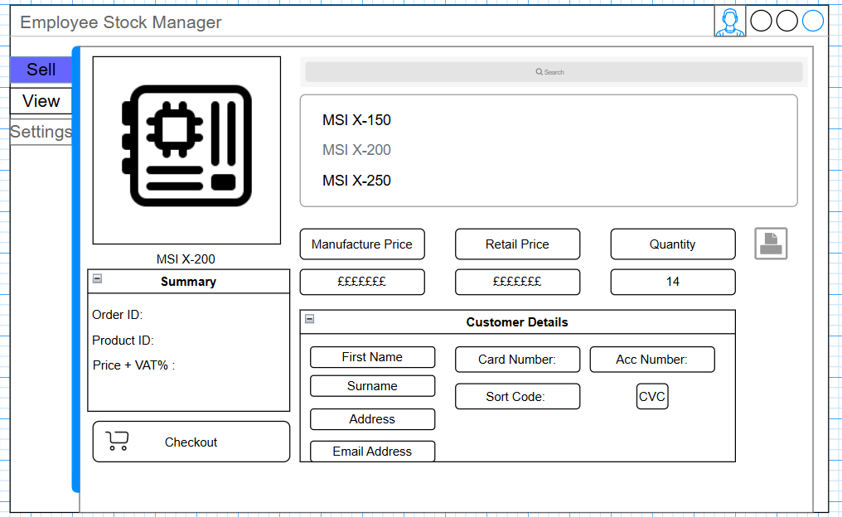
Figure 3 Sell Screen
With the selling tab, I had to make it more complex as it required a lot of features, however, I tried to make it intuitive and easy to understand by having a clear separation of text fields and labels, as well as large buttons, ensuring that everything was fully accessible
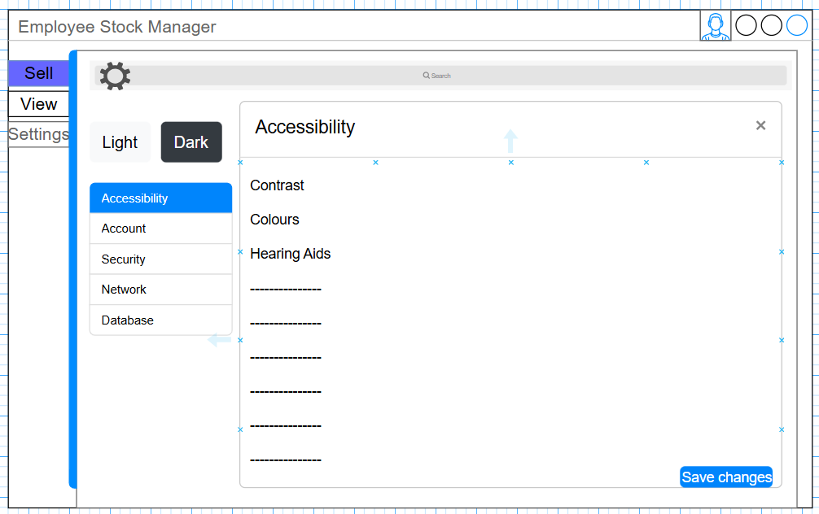
Figure 4 Settings tab
This is a crucial screen to meet my non-functional requirements for accessibility, and also to make sure inequalities are reduced through inclusive design. Having features that can include other users that require them shows the compliance with WCAG and SDG 10, the features I included in the design are contrast settings, so people can change the brightness of the application, helping people who are visually impaired or have difficulty reading, there are setting to change the colours of the application so that people are colour blind can use the application easily; I would include different presets that cover certain colours people are deficient in such as tritanope or deuteranope. I left some blanks to introduce more settings further down the development process or add others that stakeholders may recommend.

Admin dashboards:
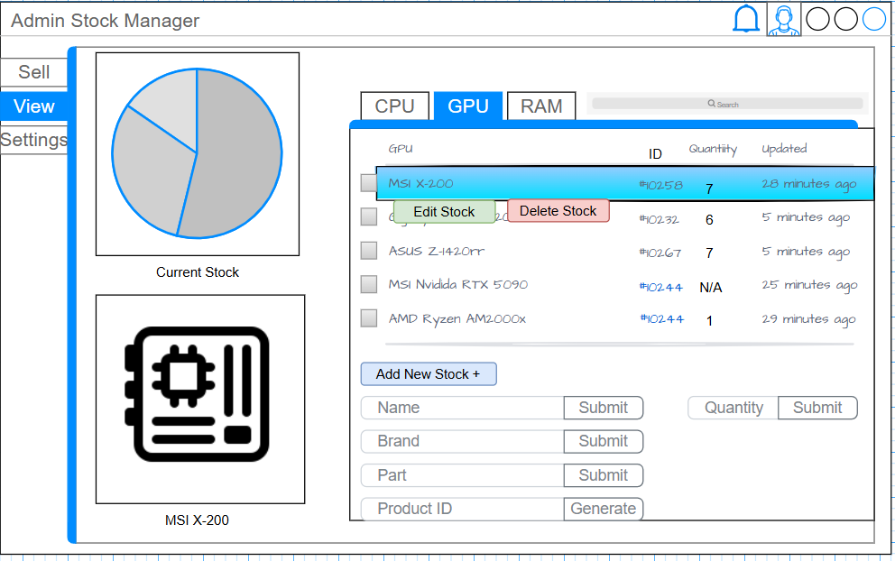
Figure 5 Admin view tab
The Admin dashboard doesn’t change too much from the employee one for the sake of scalability and accessibility. If an employee becomes an admin, it means that little training would have to be done for them to use it. The additional features I added are from the functional requirements I discussed earlier, like the ability to add new stock to the databases or edit and delete the current stock. However, with the additional features, I committed to ensuring that they were still easy to use and read, utilising different colours for adding, editing and deleting stock; additionally, they would not rely on hover functionality but clickable buttons so that it still adheres to SDG 10.
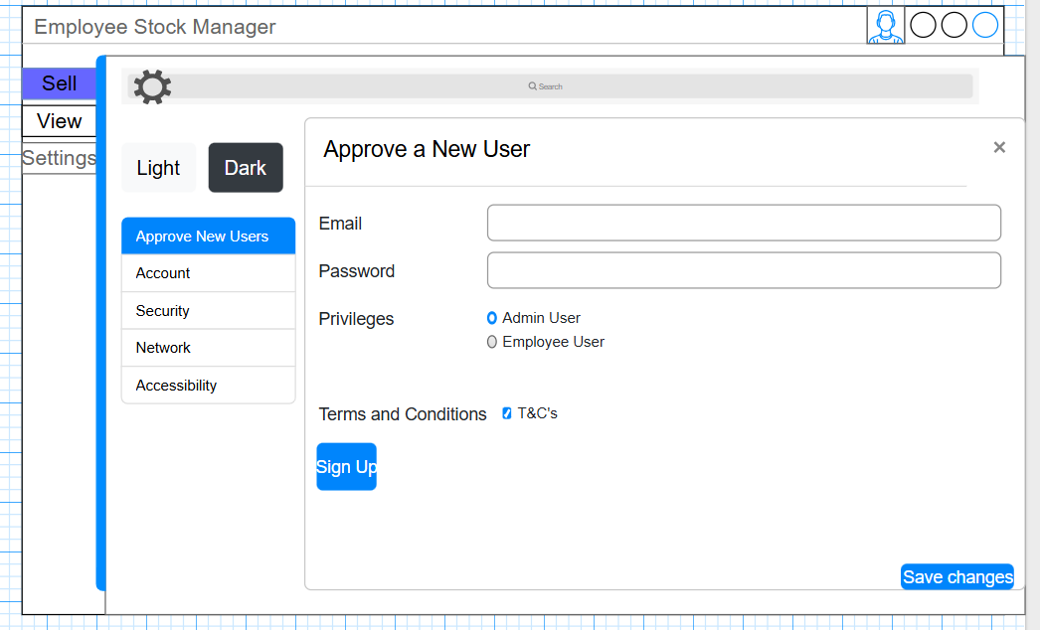
Figure 6 Approve new users
The additional feature added to the Admin settings was the ability to add new users to the system as part of the functional requirements of the Admin. All the form fields I added were clearly linked to one another as well as visible to users, the radio buttons help distinguish what privilege the user gets and are easy to click on. One thing I would change with my design is a guide on password policies, making sure the Admin clearly knows what characters, symbols and minimum amounts of characters are required to have a strong password, enforcing security

Class and Database Diagrams

Class diagrams:
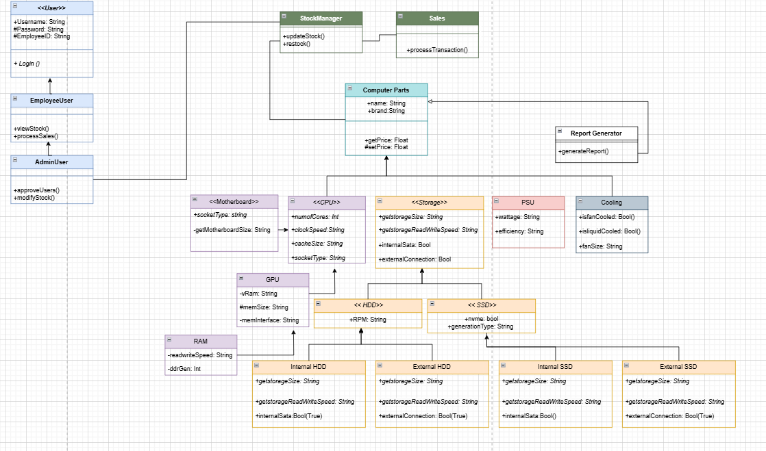
Figure 7 UML Class Diagram
The User class acts as a base for the authentication and security of the system. With inheritance, I had Employee user and AdminUser use methods and attributes that are defined in the User class, such as the attributes Username(), Password() and EmployeeID or the method Login(). However, the AdminUser has its unique methods that EmployeeUser can’t use, as it is protected; that being the ability to approve new users and modify the stock. This allows for role-based access control and functionality.
The ComputerParts class is a general overview of common attributes and methods like name, brand, and +price(). I used specialised subclasses to define the hardware components like CPU, RAM, GPU and Motherboard as they all have unique methods compared to a general parts class. Additionally, Storage is an abstract class to further separate into HDD and SSD; I decided on this route as it diversifies the nature of the components and makes it simpler as they all share very common attributes, such as read, write speeds.
Regarding design patterns, I followed a standard OOP structure instead of a complex creational or behavioural pattern. A factory pattern could have been beneficial to create multiple instances of the ComputerParts subclassed, but I decided that I wanted my structure to excel in inheritance and encapsulation, as it provides me a solid, understandable foundation to work off, as well as leaving room for expansion in the future.

ER Diagrams:
The diagrams I illustrated detail the progression amongst the different ERD versions of the normalisation process, which shows how I organised and separated the data into multiple different tables to improve data integrity and simplify the complex structure of the data involved into smaller tables, reducing redundancy (Rajeev Kaula, 2019).

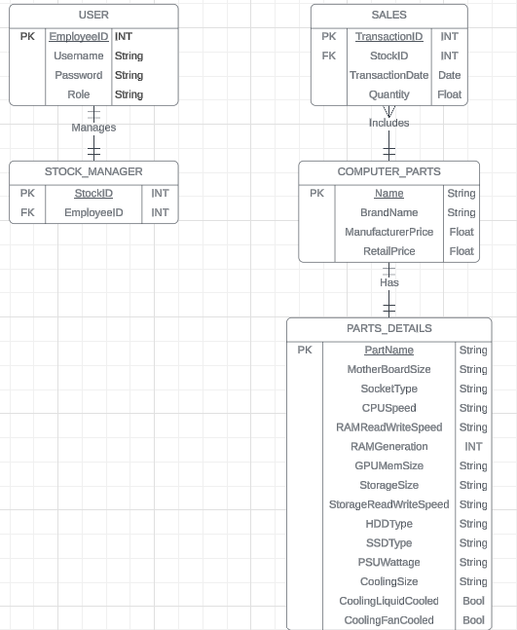
Figure 8 1NF ERD
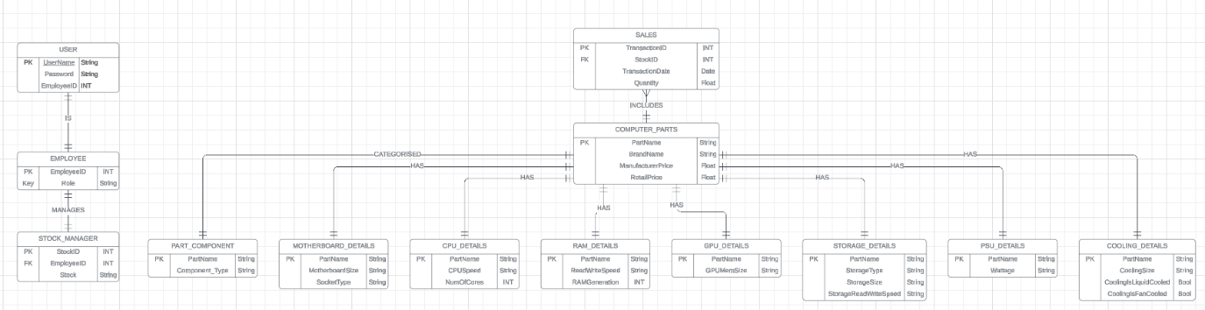
Figure 9 2NF ERD
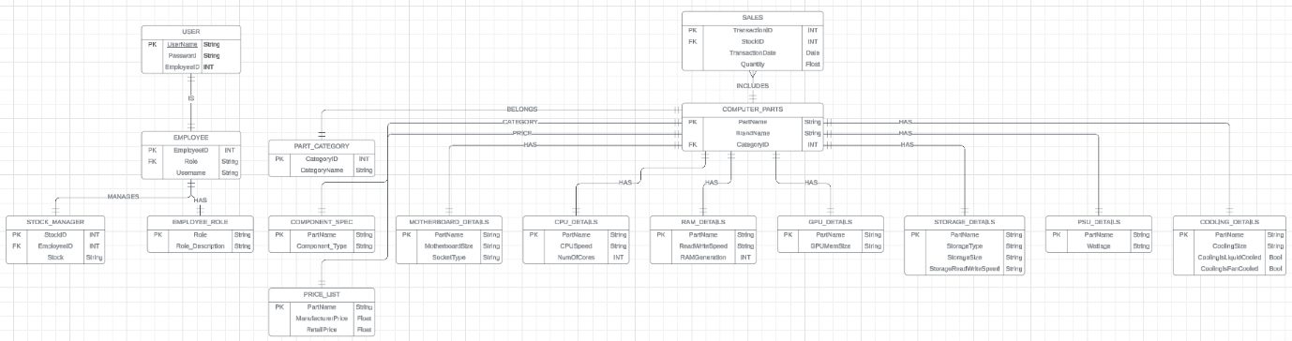
Figure 10 3NF ERD
A significant aspect of my design in Fig.9 and Fig.10 is that it mirrors the inheritance structure of the Class Diagram (Fig.7), using a table per subclass approach is a common strategy for mapping inheritance to a relational database and often helps the normalisation process by reducing redundancy (Dybka, 2014). For example, in Fig.10, introducing PART_CATEGORY to separate and categorise parts and having a linked PRICE_LIST helps further refine the data organisation.

Testing Documentation

Testing Plan
The purpose of a testing plan is to outline the strategy, scope, and resources needed to test my system. The aim is to ensure that my system meets the functional requirements and is free of critical errors so that a smooth user experience is catered for.
The scope of the tests is User authentication (Login, logout and user roles), Admin dashboard testing for product management and user management, as well as reporting. Employee dashboard testing for sales processing and inventory checks. I shall also be testing basic UI responsiveness and navigation and testing the database integration and connection.

Testing Strategy
Unit Testing:
- Focus: testing individual methods and the classes, such as the Data Access Layers (DAO)
- Tool: JUnit API
- Approach: testing each method in isolation, such as database interactions, which involves creating a mock database connection to verify that the JDBC drivers are working correctly
Integration Testing:
- Focus: Interactions between components are tested, such as UI communicating correctly with the DAO classes
- Tool: JUnit API and TestFx for user interface
- Approach: Test the data flow between classes and objects
UI Acceptance Testing:
- Focus: Validating and verifying the user interface and experience so that they meet the project requirements
- Tool: Manual Testing, Automated testing using TestFX
- Approach: Test cases that simulate real user experience, such as buttons and text field interactions, are executed

Test Environment:
Software:
- JavaFX SDK
- JUnit 5 API
- JDK
Hardware:
- Personal Laptop/Device
Database:
- Mocked or in-memory
- Dedicated test database, such as a local Mysql testing workbench

Evidence of testing results
Table 4 Test Case Table and Results
Test Case ID | Module/Class |  | Scenario |  | Conditions |  | Test Data |  | Expected Result |  | Actual Result | Status
User Authentication Login
TC_LOG1 | Login |  | Valid Admin login |  | The application is running and admin user exists |  | Username: James  Password:admin123  Usertype: Admin |  | Login successful. Admin Dashboard is displayed. "Login successful as Administrator" message shown. |  | Successful Login | Passed
TC_LOG2 | Login |  | Valid Employee login |  | Employee user exists |  | Username: employee  Password:emp123  Usertype: employee |  | Employee dash is displayed |  | Successful Login | Passed
TC_LOG3 | Login |  | Invalid Username, password |  | App is running |  | Username: invalid user  Password:any passwords  Usertype: employee |  | Invalid username and password, user remains on login |  | See Appendix | Passed
TC_LOG4 | Login |  | Valid Username, Password |  | User employee exists |  | Username: employee  Password:wrong passwords  Usertype: employee |  | Invalid username and password, user remains on login |  | See Appendix | Passed
TC_LOG5 | Login |  | Empty Username and password |  |  |  | Username: empty  Password:any password  Usertype: any |  | Error message, fields cannot be empty |  | See Appendix | Passed
TC_LOG6 | Login |  | Login as Admin with employee credentials |  |  |  | Username: employee  Password:emp123  Usertype: Admin |  | Invalid credentials message |  | See Appendix | Passed
TC_LOG7 | Login |  | Login as employee as admin credentials |  | Admin user exists |  | Username: Admin  Password:admin123  Usertype: Employee |  | Invalid credentials message |  | See Appendix | Fail
Database Connection
TC_DB_Connection1 |  | Database |  | Test Connection to the MySQL Server |  | MySQL server is running with correct tables |  | JDBC Driver and ForName |  | Connection should be valid | See Appendix |  | Fail

Junit Test Scripts

Database Connection Script
package stockmanagementsystem;

import java.sql.Connection;
import java.sql.SQLException;
import java.sql.DriverManager;
import org.junit.jupiter.api.Test;
import static org.junit.jupiter.api.Assertions.*;

public class DatabaseConnectionTest {
private static final
String URL = "jdbc:mysql://127.0.0.1:3306/stock_management_system?useSSL=false&allowPublicKeyRetrieval=true&serverTimezone=UTC";
private static final String USER = "root";
private static final String PASSWORD = "james123";

public static Connection getConnection() throws SQLException {
try {
// Explicitly load the MySQL JDBC driver
Class.forName("com.mysql.cj.jdbc.Driver");
} catch (ClassNotFoundException e) {
throw new SQLException("MySQL JDBC Driver not found", e);
}
return DriverManager.getConnection(URL, USER, PASSWORD);
}

@Test
public void testDatabaseConnection() {
try {
Connection connection = getConnection();
assertNotNull(connection, "Connection should not be null");
assertTrue(connection.isValid(1), "Connection should be valid");
connection.close();
} catch (SQLException e) {
fail("Failed to connect to the database: " + e.getMessage());
}
}
}

References
https://www.inf.ed.ac.uk/teaching/courses/ip/CS2Ah0405-SoftwareRequirements.pdf
altexsoft (2022). Non-functional Requirements: Examples, Types, How to Approach. [online] AltexSoft. Available at: https://www.altexsoft.com/blog/non-functional-requirements/.
w3c_wai (2018). Web Content Accessibility Guidelines (WCAG) Overview. [online] Web Accessibility Initiative (WAI). Available at: https://www.w3.org/WAI/standards-guidelines/wcag/#iso.
UNDP (2024). Sustainable Development Goals | United Nations Development Programme. [online] UNDP. Available at: https://www.undp.org/sustainable-development-goals/reduced-inequalities.
Rajeev Kaula (2019). TDAN.com. [online] TDAN.com. Available at: https://tdan.com/normalizing-with-entity-relationship-diagramming/4583.
Dybka, P. (2014). How to Model Inheritance in a Relational Database. [online] Vertabelo Data Modeler. Available at: https://vertabelo.com/blog/inheritance-in-a-relational-database/.

Figures
Figure 1 Sign in Wireframe 5
Figure 2 Employee Dashboard 1 6
Figure 3 Sell Screen 7
Figure 4 Settings tab 7
Figure 5 Admin view tab 8
Figure 6 Approve new users 9
Figure 7 UML Class Diagram 10
Figure 8 1NF ERD 11
Figure 9 2NF ERD 11
Figure 10 3NF ERD 12
Figure 11 TC_LOG3 16
Figure 12 TC_LOG5 17
Figure 13 TC_LOG2 18
Figure 14 TC_LOG7 19
Figure 15 TC_LOG1 20
Figure 16 TC_DB_Connection1 20

Tables
Table 1 Project Brief Functional Requirements 3
Table 2 Additional Functional Requirements 3
Table 3 Non-Functional Requirements 4
Table 4 Test Case Table and Results 13

Appendix
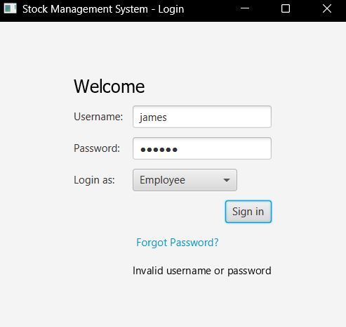
Figure 11 TC_LOG3
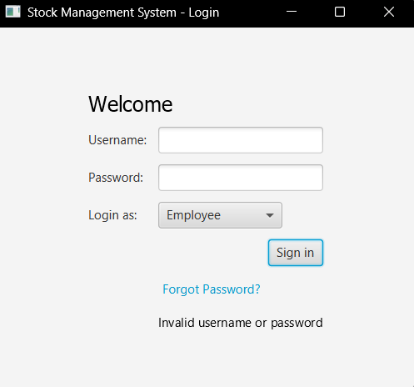
Figure 12 TC_LOG5
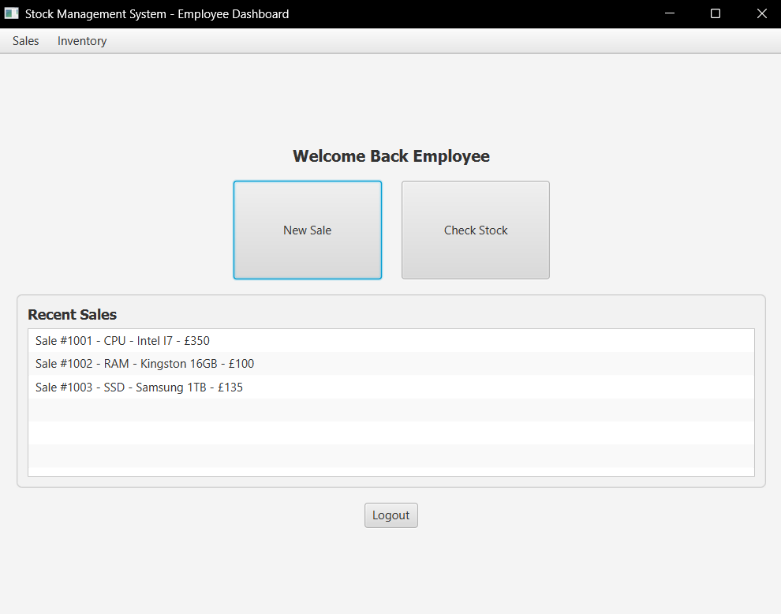
Figure 13 TC_LOG2
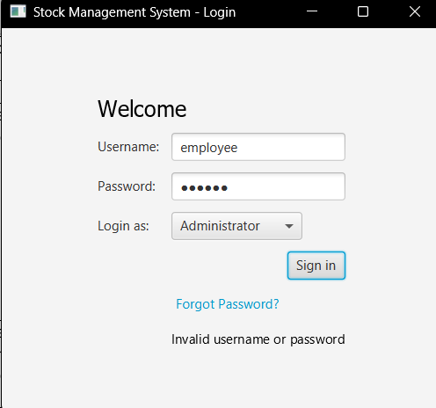
Figure 14 TC_LOG7
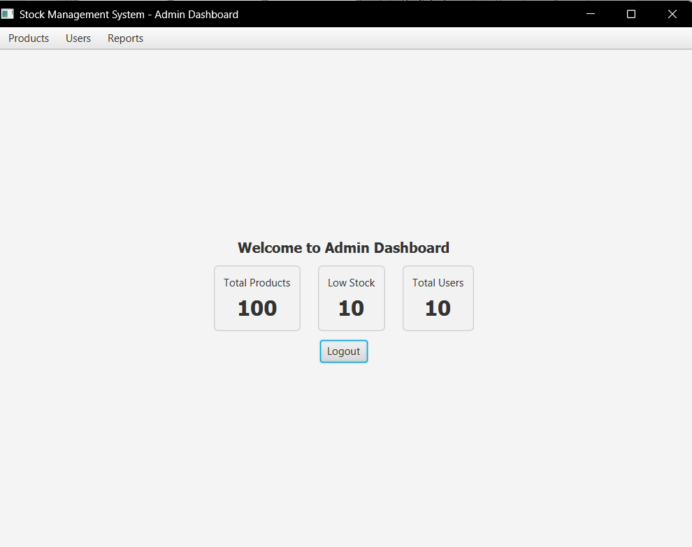
Figure 15 TC_LOG1
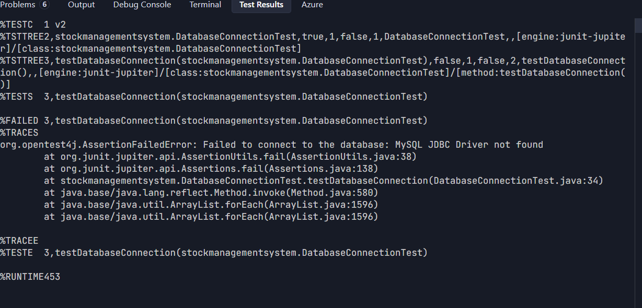
Figure 16 TC_DB_Connection1

