Week 7 ,Agents Course & Your Own Agent
James H. Logan III · CSC 595 AI Agent Architecture & Development · Saint Martin's University

Submission details
Name: James H. Logan III
Hugging Face Space: Per Prof. Hegney's approval, the agent is not hosted on a Hugging Face Space, HF now requires a paid PRO plan for Gradio/compute Spaces on new accounts (see week7-environment-setup.md). The agent runs via the Anthropic Claude API; code, full run log, and screenshots are in the repo folder.
Unit 1 certificate: Earned, Fundamentals of Agents, Hugging Face Agents Course (2026-10-26); shown below.

Part 1 ,Complete Unit 1 and Earn the Certificate
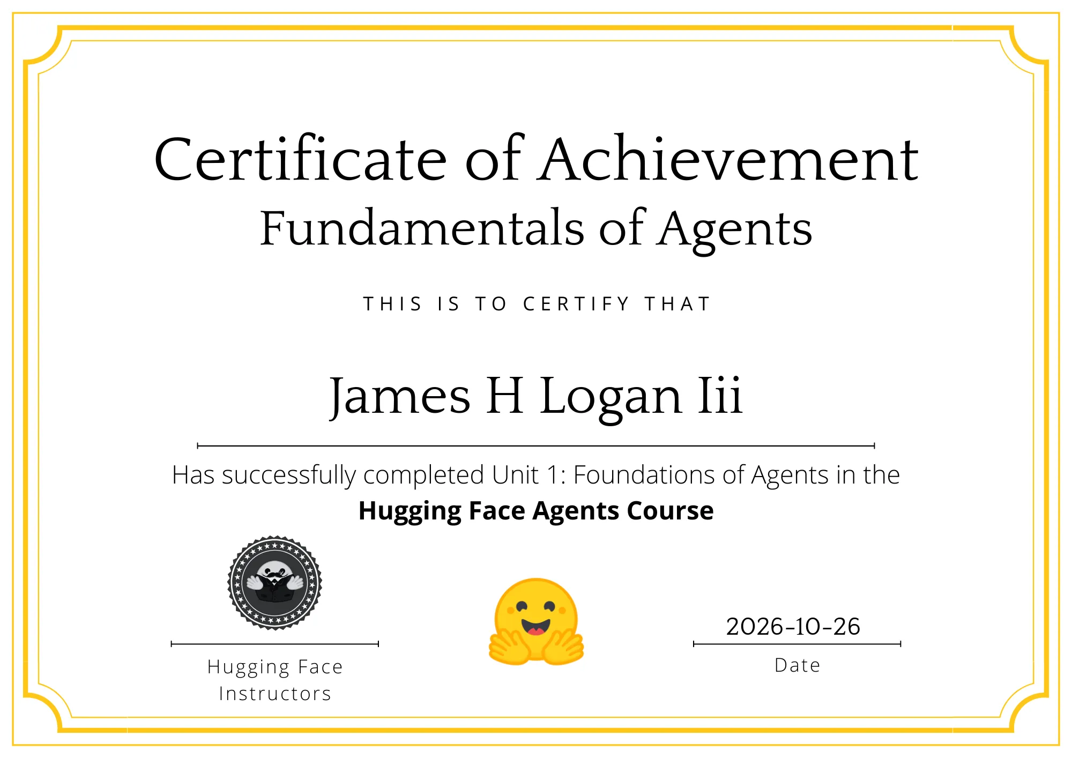
Certificate of Achievement ,Fundamentals of Agents (James H. Logan III, 2026-10-26)
Think → Act → Observe, in my own words (example from my agent):
When I asked my agent whether general-ledger's review was overdue and what MFA it uses, it ran the cycle twice. Think: it reasoned it first needed the application's record, so it decided to call my lookup_cmdb_record tool. Act → Observe: it ran lookup_cmdb_record("general-ledger") and observed owner=Priya Shah, mfa=none, last_review=2026-01-20, then, thinking it still needed the review's age ,acted again with days_since("2026-01-20") and observed 282 days – STALE. Think → final answer: using those observations it concluded the review is overdue (282 days, past the 90-day threshold) and the app uses no MFA.

Part 2, Build Your Agent
Custom tools: lookup_cmdb_record (plus a second custom tool, days_since).
What they do: lookup_cmdb_record looks up an application in a small synthetic CMDB and returns its owner, owner status, MFA type, last review date, crown-jewel flag, and SOX scope. days_since calculates how old a review date is and flags anything over 90 days as stale. Together they let the agent run a basic CMDB-hygiene check, modeled on my term project.
Tool code:
from datetime import date

CMDB = {
"payroll-gateway": {"owner": "Dana Reyes", "owner_status": "active", "mfa": "phishing-resistant", "last_review": "2026-08-15", "crown_jewel": True, "sox": True},
"hr-portal": {"owner": "Marcus Lee", "owner_status": "terminated", "mfa": "push", "last_review": "2025-11-02", "crown_jewel": False, "sox": False},
"general-ledger": {"owner": "Priya Shah", "owner_status": "active", "mfa": "none", "last_review": "2026-01-20", "crown_jewel": True, "sox": True},
"vpn-access": {"owner": "", "owner_status": "missing", "mfa": "certificate", "last_review": "2026-06-30", "crown_jewel": False, "sox": False},
"customer-billing": {"owner": "Alan Brooks", "owner_status": "on leave", "mfa": "push", "last_review": "2026-09-01", "crown_jewel": True, "sox": False},
"wiki": {"owner": "Sam Ortiz", "owner_status": "active", "mfa": "none", "last_review": "2024-12-10", "crown_jewel": False, "sox": False},
}

@tool
def lookup_cmdb_record(app_name: str) -> str:
"""Looks up one application's record in the company CMDB.
Use this whenever a question mentions a specific application, or asks about an app's
owner, owner status, MFA, review date, crown jewel status, or SOX scope.
Pass "list" to get every app name in the CMDB.
Args:
app_name: The application name, e.g. "payroll-gateway", or "list".
"""
key = app_name.strip().lower()
if key == "list":
return "Applications in the CMDB: " + ", ".join(sorted(CMDB))
record = CMDB.get(key)
if record is None:
return f"No CMDB record for '{app_name}'. Known applications: " + ", ".join(sorted(CMDB))
owner = record["owner"] or "NONE LISTED"
return (
f"{key}: owner={owner}, owner_status={record['owner_status']}, mfa={record['mfa']}, "
f"last_review={record['last_review']}, crown_jewel={record['crown_jewel']}, sox={record['sox']}"
)

@tool
def days_since(date_string: str) -> str:
"""Calculates how many days have passed since a date. Use this to check whether a
CMDB review date is stale (more than 90 days old). Pass dates as the CMDB shows them.
Args:
date_string: A date in YYYY-MM-DD format, for example "2026-01-20".
"""
try:
then = date.fromisoformat(date_string.strip())
except ValueError:
return f"Error: '{date_string}' is not a valid date. Use YYYY-MM-DD."
days = (date.today() - then).days
status = "STALE (over 90 days)" if days > 90 else "current (90 days or less)"
return f"{days} days since {then.isoformat()} - review is {status}."

Tool descriptions, did I revise them?
With the Claude model (claude-haiku-4-5) I did not need to revise the descriptions, the agent matched each tool to the task by name and used the exact YYYY-MM-DD format from the argument description on the first run. Testing against a weaker local model (llama3.2:3b) showed the limit of descriptions alone: it ignored them, invented a web search tool, and indexed fields my tool never returns. The lesson: clear descriptions let a capable model use a tool correctly but cannot compensate for a model too weak to follow them.
Three multi-step tasks:
# | Task (short) | Tools called, in order | Steps | Succeeded?
1 | Is general-ledger's review overdue, and what MFA? | lookup_cmdb_record → days_since | 3 | yes
2 | List crown-jewel apps with a stale review or non-active owner | lookup_cmdb_record (list) → lookup_cmdb_record x6 → days_since x3 | 4 | yes
3 | Current time in New York + app with the oldest review date | get_current_time_in_timezone → lookup_cmdb_record (list) → lookup_cmdb_record x6 | 4 | yes
Tasks 1 and 2 each combine two different tools (lookup_cmdb_record + days_since); Task 3 combines the time tool with lookup_cmdb_record. Full step logs are in run_claude_output.txt.

Part 3 ,Failure Analysis
This failure is from running the same agent on a weaker local model, ollama_chat/llama3.2:3b (full log in week7-failure-run-ollama.txt).
Model: ollama_chat/llama3.2:3b

# TASK 1, Step 1 - invented a tool that was never provided
review_date = web_search("general-ledger application review date")["review_date"]
-> InterpreterError: Forbidden function evaluation: 'web_search' is not among
the explicitly allowed tools

# TASK 1, Step 2 - treated plain-text output as a dict; wrong app name
review_date = lookup_cmdb_record(app_name="general-ledger application")["review_date"]
-> InterpreterError: Could not index "No CMDB record for 'general-ledger
application'. Known applications: ..." with 'review_date'

# TASK 3, Step 2 - lookup_cmdb_record("list") returns a STRING; the agent
# looped over it one character at a time
for app in lookup_cmdb_record(app_name="list"):
...
Application: A -> No CMDB record for 'A'. Known applications: ...
Application: p -> No CMDB record for 'p'. ...
(continues letter by letter; never completes; hits max steps)

Part 1 & 2: Failure Analysis & Prevention

Which kind of failure (Huyen Ch. 6)?
This was primarily a tool-use failure: the agent hallucinated a web search tool it was never given and invoked valid tools with distorted arguments and completely wrong assumptions about their output format. This was further complicated by a planning/reasoning failure, instead of adapting after an error, the agent looped on the exact same flawed pattern until it hit the step limit. These are textbook tool-selection and parameter errors as outlined by Chip Huyen, exacerbated here by running a model simply too small to reliably follow strict system prompts and tool specifications.

What change would prevent it?
The root cause was model capability, so the most effective fix was swapping out llama3.2:3b for a stronger model like Claude (claude-haiku-4-5). With the capable model, the agent called both tools correctly on the first attempt across all three tasks.
To bullet proof the design further, we can apply a few supporting fixes:
- Structure tool outputs: Return clearly structured text and explicitly state in the tool description that "list" returns a comma-separated string that needs to be split.
- Provide concrete examples: Add an exact valid app-name example right into the argument description.
- Keep the safety net: Retain the max_steps cap so a flailing agent halts immediately instead of burning tokens in an infinite loop.

Part 3: The Workflow & RAG vs. Agents
The course's Think → Act → Observe walkthrough (the weather-agent example) made the loop concrete in a way textbook prose alone couldn't. Watching my own agent call lookup_cmdb_record, read the observation, and only then decide to call the date calculation made the "observe, then re-plan" cycle genuinely click. Meanwhile, Huyen Ch. 6 provided the exact vocabulary, tool-selection errors, parameter mismatches, planning failures, needed to classify the exact failure modes I watched the weak model stumble into.
Tool descriptions mattered enormously, but conditionally. With Claude, clean names and explicit argument descriptions (YYYY-MM-DD) were enough for flawless first-try usage; with llama3.2:3b, those exact same descriptions were completely ignored. A good description is necessary but not sufficient: it enables a capable model to use a tool correctly, but it cannot rescue a model too weak to follow instructions. The design takeaway is clear: write descriptions for a capable model and pick a model strong enough to honor them.
Looking back at last week's RAG pipeline versus this week's agent, it's clear they solve entirely different problems:
- RAG is for retrieval: "What does our policy say about X?" is a single lookup over a document store.
- Agents are for action: "Book me a meeting with X" requires acting in the world, checking availability, creating events, and managing multi-step dependencies.
The golden rule: Retrieve for knowledge; use an agent for action.

Part 4: Reflection & Personal Perspective
My Milestone 1 project, a CMDB-hygiene assistant, genuinely benefits from being an agent, but a bounded one. The multi-step tasks here (looking up a record, computing staleness, and rendering a judgment) are exactly what a tool-calling loop does best.
Drawing on my background in security and identity management, looking at asset inventories, configuration data, and CMDB hygiene through a Zero Trust lens brings a very specific risk profile to mind. In enterprise security, a "stale" asset or unreviewed configuration item isn't just dirty data, it’s an invisible vulnerability vector.
Automating CMDB hygiene with an agent is a massive force multiplier for stretched engineering teams, but in production over real identity and config data, you cannot run an agent unbounded.
When pitching an agentic workflow to executive leadership, you don't lead with hype of the LLM loop; you lead with risk reduction, toil elimination, and ironclad auditability.
You frame it as a secure automation layer governed by strict boundaries:
- Controlled Access: Read-only tools by default, requiring human-in-the-loop approval for any mutation or state change.
- Infrastructure Reliability: Relying on paid APIs or robust self-hosted models rather than dealing with free-tier rate limits and 503s.
- Strict Guardrails: Enforcing hard step caps and defensive error-handling so that an unexpected output never cascades into unauthorized system actions.

Part 5, Graduate Extension: MCP Fundamentals
MCP Unit 1 quiz result (all 5 correct):
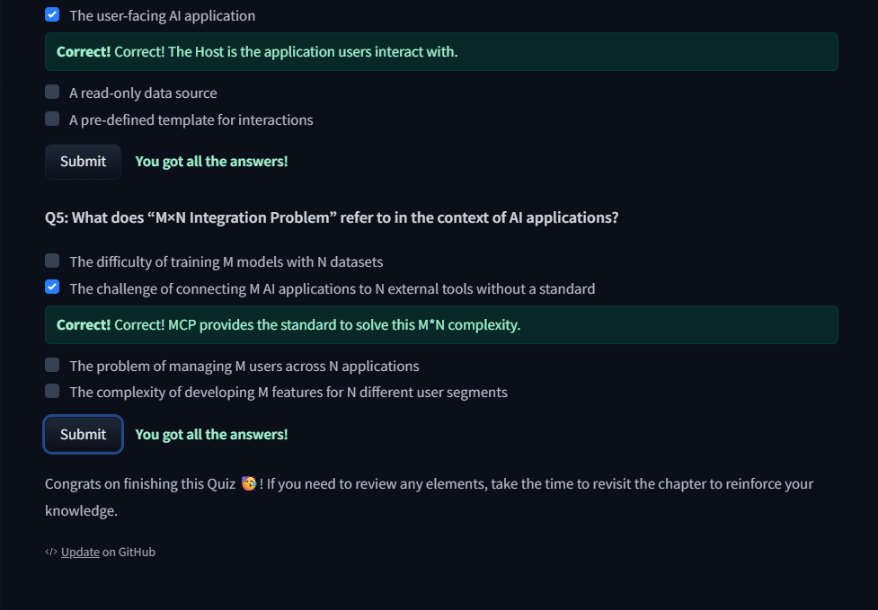
Hugging Face MCP Course, Unit 1 quiz ,"You got all the answers!"

Part 5: Graduate Extension MCP Fundamentals

Hugging Face MCP Course, Unit 1 Quiz Result: 5/5 Correct

Architectural Analysis: Where Should Tools Live?
When evaluating my three tools, lookup_cmdb_record clearly belongs on a Model Context Protocol (MCP) server, while days_since and get_current_time_in_timezone should remain defined locally in the agent's code.
- lookup_cmdb_record (MCP Server): This is a look up against a live enterprise data source. In production, it connects to a live system, like a ServiceNow CMDB or an asset-inventory API, that needs to be shared across multiple tools. A help-desk assistant, an IDE extension, and a security-review chatbot might all need to query that same CMDB. Exposing it via an MCP server means writing that integration once and letting any MCP-capable client reuse it against a single, authenticated, audited source of truth. In the unit's terms, my agent application acts as the host, smolagents' MCPClient holds the connection, and the CMDB server exposes the tool and its schema.
  - The trade-off: We gain reuse across clients, access to live data, and central control over authentication and logging. What we give up is simplicity, we now must run and secure a server, trust its code (since a compromised MCP server could execute harmful code on the host), manage network latency, and handle additional failure points.
- days_since & get_current_time_in_timezone (In-Code): These are pure, self-contained computational utility functions requiring no external state or data dependencies. Exposing them over MCP would introduce an external server, latency, and unnecessary trust risk for zero functional benefit.
The architecture rule of thumb: Expose a tool through MCP when it wraps a shared or live enterprise system that other clients need to reuse. Keep trivial, self-contained computational logic local to the agent.
Conclusion
Ultimately, building effective AI agents isn't just about crafting clever system prompts or picking the latest model variant, it requires treating them as production software that demands rigorous architectural boundaries. Whether we are engineering secure MCP servers for shared enterprise data or clamping hard step limits on a CMDB helper, the real challenge isn't just making an agent smart; it is harnessing its autonomy safely. Moving past fragile demos into dependable enterprise automation means balancing capability with control every step of the way.

Supporting files (in the week 7 repo folder)
- certificate-agents-unit1.webp, Unit 1 certificate
- mcp-quiz-result.png, MCP Unit 1 quiz result
- run_claude.py, the agent (Anthropic Claude API) with the two custom CMDB tools
- run_claude_output.txt, full step logs of the three successful tasks
- week7-failure-run-ollama.txt, the llama3.2:3b failure run (Part 3 evidence)
- custom_tools.py, the custom tools
- week7-environment-setup.md, model-selection workflow and why no HF Space

